Jagatpura, Jaipur



Frontend Development With ReactJS Lab
Lab Manual

Bachelors of Computer Applications
Specialization in Full Stack Development(BCA FSD in Colla. with ImaginXP)

(Academic Session: 2025-2026)

School of Computer and System Sciences

Submitted BySubmitted To
Name: Nisha Kumawat Mr. Simranjeet Singh
RID No.: 53953
Semester: III Signature:
Table of Contents
S No. | Activities | Page No.
1. | Variable Declaration in JavaScript
2. | Data Types in JavaScript
3. | Operators in JavaScript
4. | Operator Precedence( or Priority)
5. | Type conversion in js
6. | Core Concepts(Hoisting/ Scope) in js
7. | Arrays/ Operation on Array/ Array Methods
8. | How to create Object and Class in Js
9. | All type function in js
10. | DOM Manipulation
11. | Loops in JavaScript(For of loop/for Each)
12. | JavaScript Code Patterns & Foundations for Simple React
13. | Playing with Advanced Js using HTML/CSS/ Simple React
14. | All basic Project using HTML/CSS/JS

Activity 1:Variable Declaration in JavaScript

Steps:
1. A new JavaScript file named classNotes.js was created.
- First, I declared a variable var1 with the character 'a' and displayed it using console.log().
- Then, I declared two number variables var2 and var3, added them, stored the result in var4, and printed the output.
- A string "Nisha" was stored in str, concatenated with itself, and stored in newstr, then printed.
- Different variables (num, sr, ch, n1, n2, n3, n4) were declared and the typeof operator was used to check their data types.
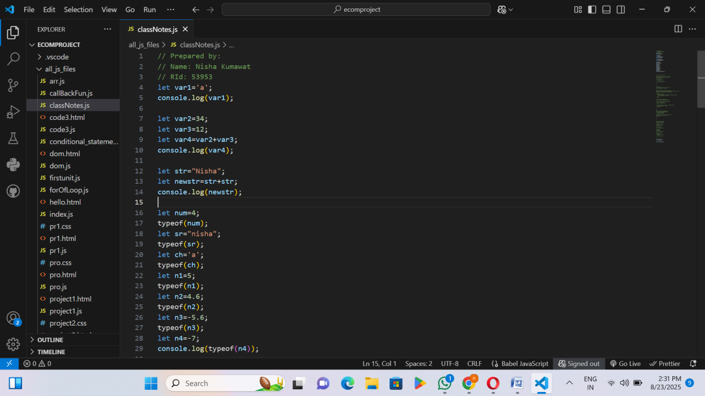

- I saved this file and then ran it.
- Finally, the output was printed directly in the console.

RID 53953 page 1
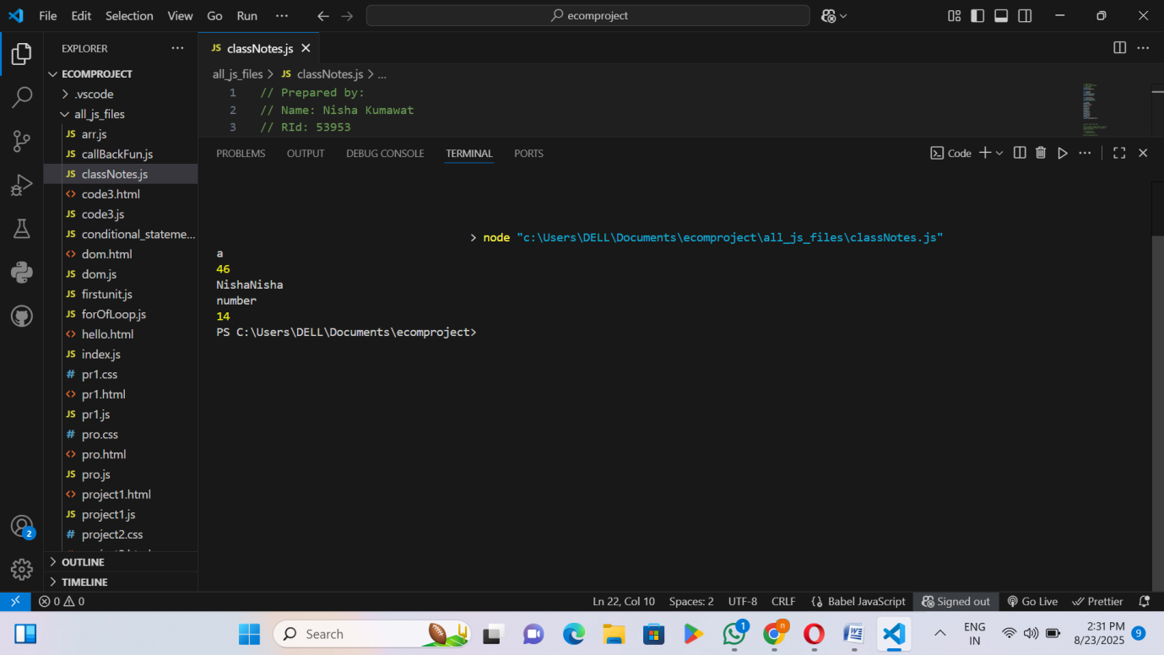

RID 53953 page 2

Activity 2: Data Types in JavaScript
Steps:
- A new JavaScript file named classNotes.js was created.
- A string variable was declared (str) and its value and type were displayed using console.log().
- Two number variables (num1, num2) were declared (integer and decimal) and their type was printed.
- Two boolean variables (isStudent, isComplete) were declared with values true and false, and their type was shown.
- A variable x was declared without assigning any value, so it became undefined, and its type was checked.
- A variable y was assigned the value null, and its type was displayed (note: in JavaScript, typeof null gives "object" as a special case).
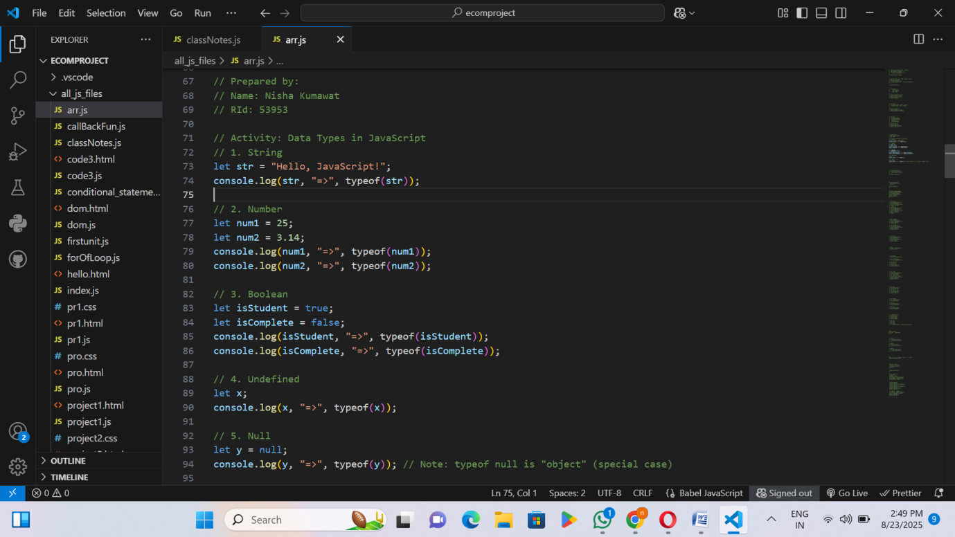

- I saved this file and then ran it.
- Finally, the output was printed directly in the console.

RID 53953 page 3
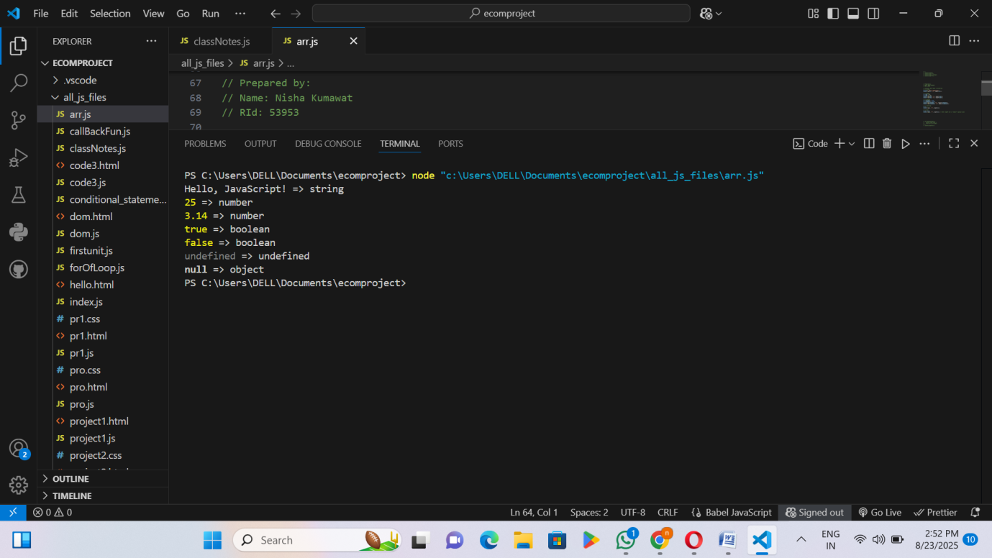

RID 53953 page 4

Activity 3: Operators in JavaScript
Steps:
- A new JavaScript file named classNotes.js was created
- Arithmetic operators (+, -, *, /, %, **) were used to perform basic mathematical operations between two numbers.
- Assignment operators (+=, -=, *=, /=) were applied on a variable x to update its value.
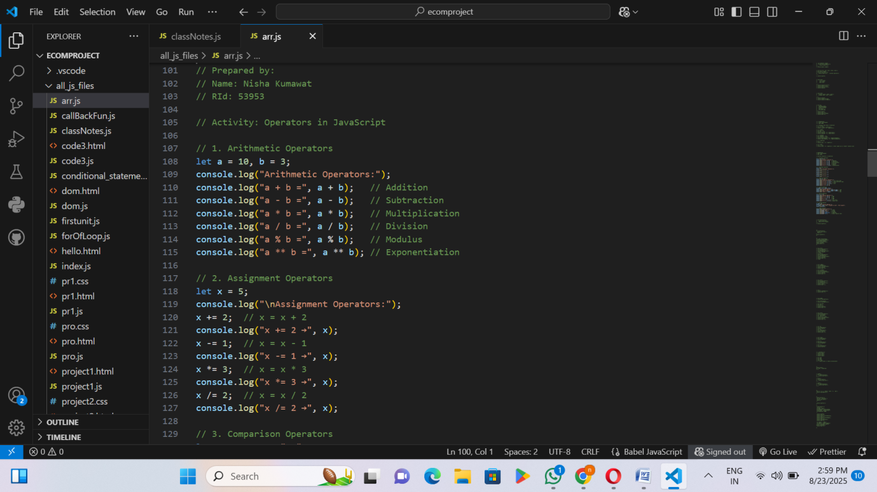
- Comparison operators (==, ===, !=, !==, >, <) were demonstrated to compare values and check equality or inequality.
- Logical operators (&&, ||, !) were used to evaluate boolean expressions with AND, OR, and NOT operations.
- Bitwise operators (&, |, ^, ~, <<, >>) were shown to perform operations at the binary level.

RID 53953 page 5
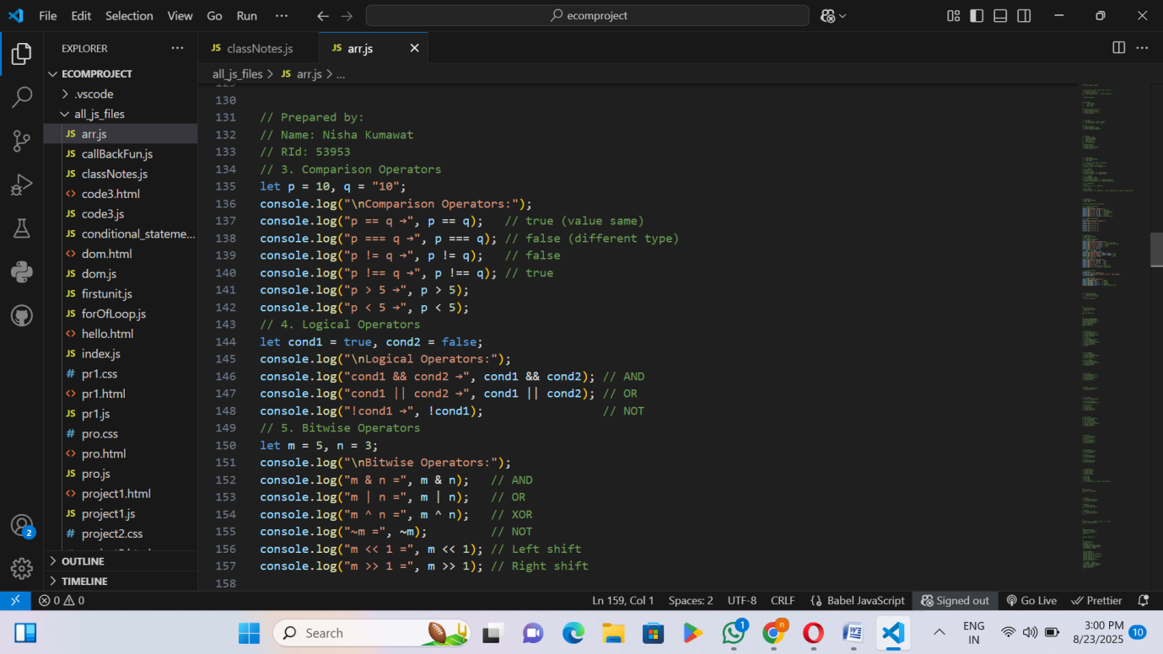
- The Ternary operator (condition ? value1 : value2) was used to check voting eligibility in a single line.
- The typeof operator was used to find the data type of different values such as number, string, boolean, undefined, and null.

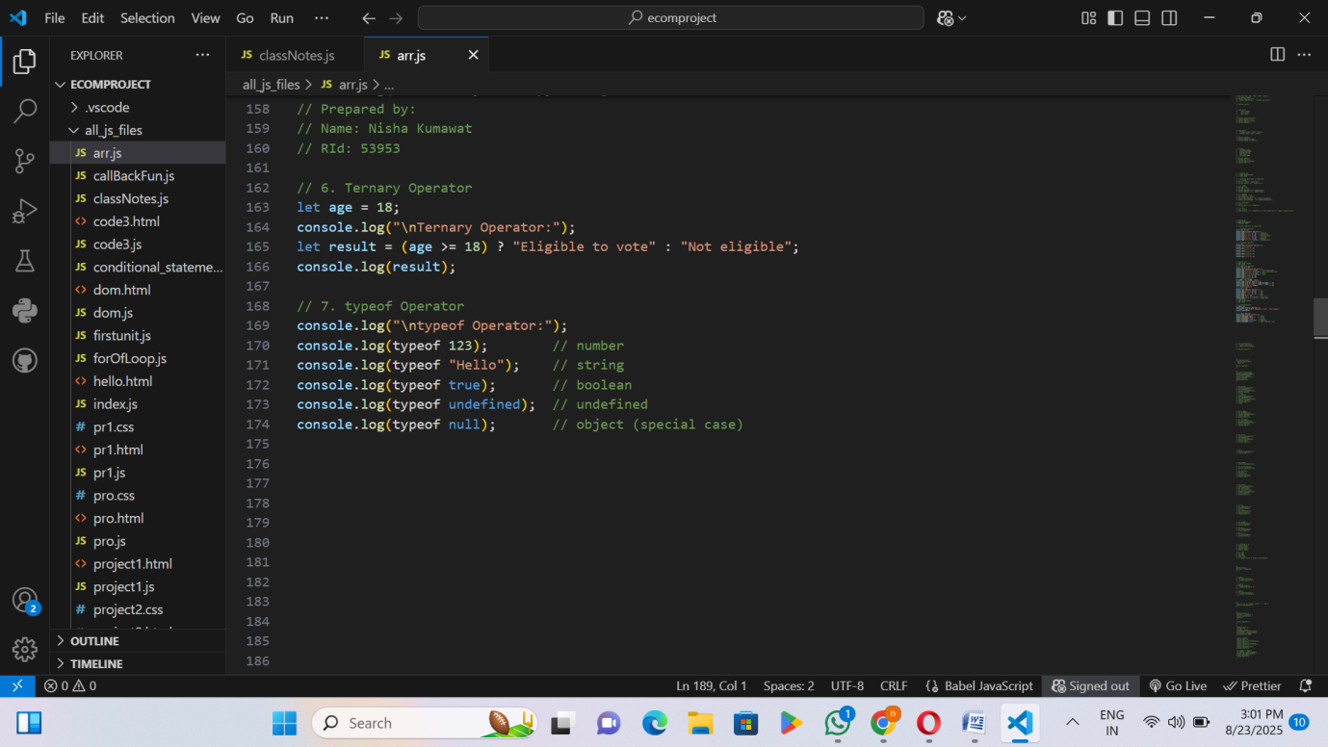

- I saved this file and then ran it.
- Finally, the output was printed directly in the console.
RID 53953 page 6
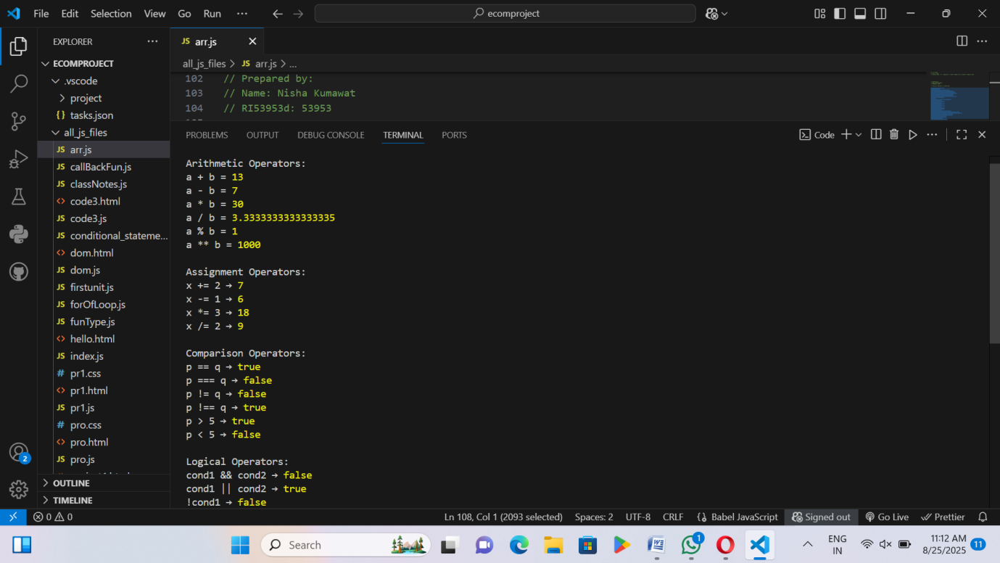
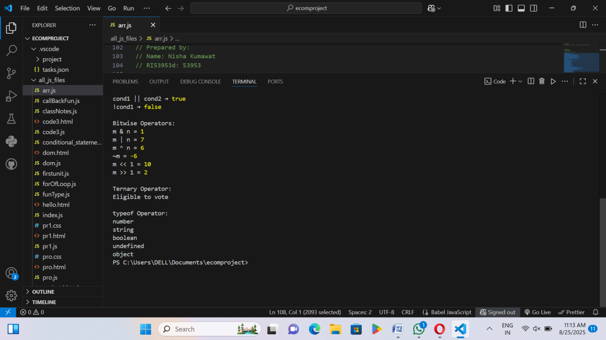

RID 53953 page 7
Activity 4: Operator Precedence( or Priority)
Steps:
- A new JavaScript file named arr.js was created
- The code demonstrates how operator precedence determines the order in which operations are performed in JavaScript.
- Example 1: Multiplication * has higher precedence than addition +, so b * c is evaluated first.
- Example 2: Parentheses () change the precedence, forcing a + b to be calculated before multiplying by c.
- Example 3: Multiplication and division have the same precedence and are evaluated left to right.
- Example 4: Exponentiation ** has higher precedence than multiplication, so it is executed first.
- Example 5: Assignment = has lower precedence, so all arithmetic operations are evaluated before assigning the value to the variable.
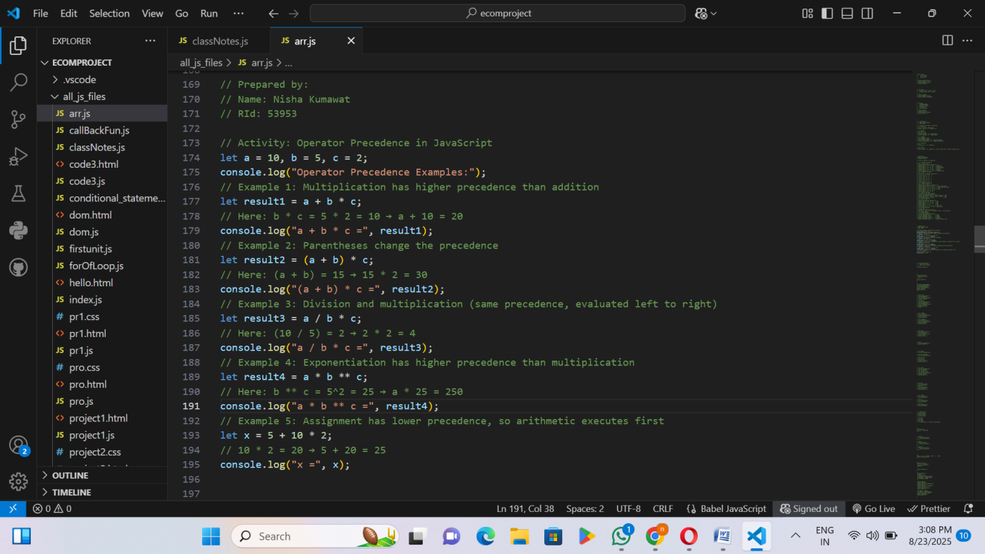

- I saved this file and then ran it.
- Finally, the output was printed directly in the console.

RID 53953 page 8
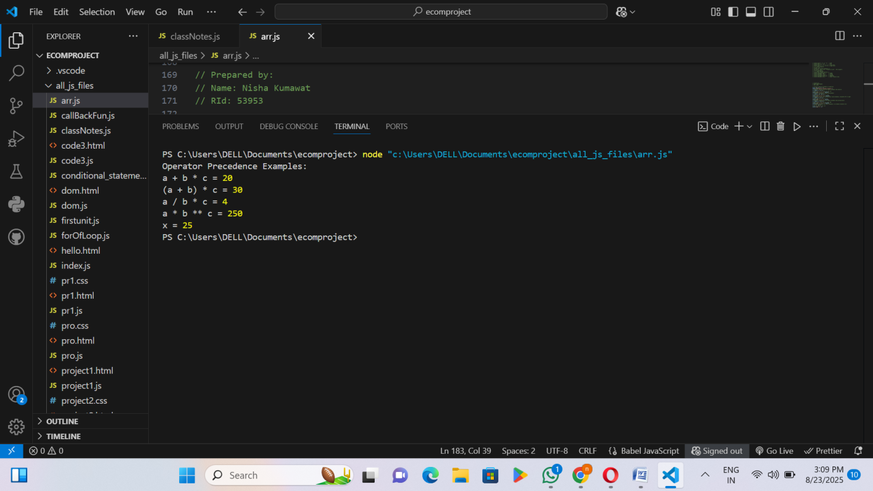

RID 53953 page 9
Activity 5:Type Conversion in Js
Steps:
- A new JavaScript file named arr.js was created
- Number to String: The number 123 was converted to a string using String().
- String to Number: The string "456" was converted to a number using Number().
- Boolean to String: The boolean value true was converted to a string using String().
- String to Boolean: An empty string "" was converted to a boolean using Boolean(). Empty strings are false.
- Number to Boolean: The number 0 was converted to a boolean. 0 is false, any non-zero number would be true.
- Boolean to Number: The boolean true was converted to a number using Number(). true becomes 1 and false becomes 0.
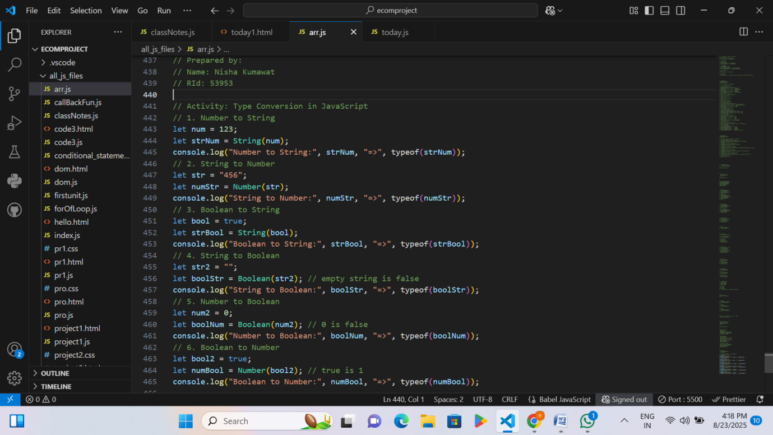
- I saved this file and then ran it.
- Finally, the output was printed directly in the console.

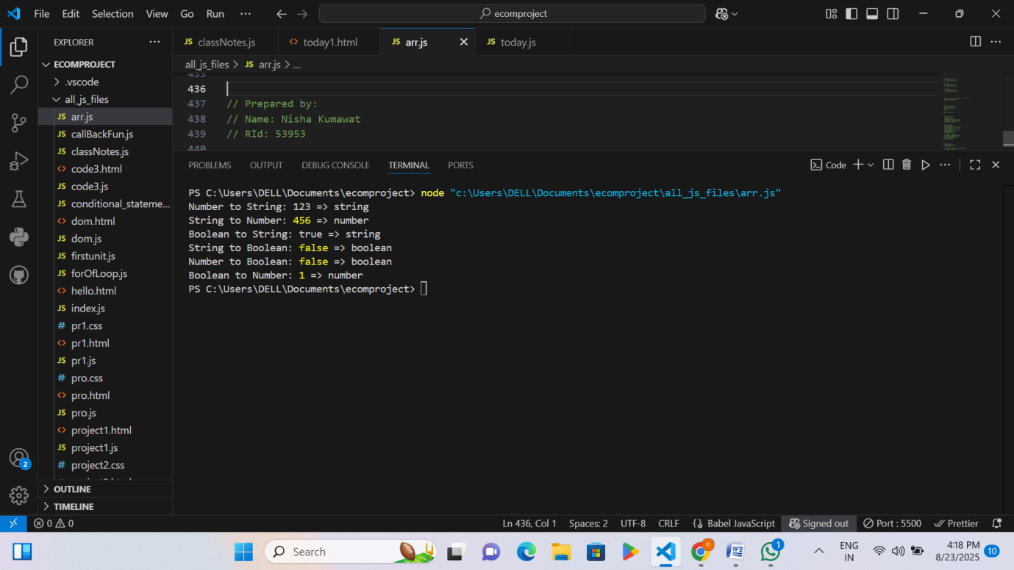

Activity 6: Core Concept(Hoisting/Scope)in Js
1.Hoisting=
Steps:
- A new JavaScript file named arr.js was created
- Variable Hoisting with var: The variable a is declared with var.
  - It is hoisted, so it exists before the declaration but is undefined until initialized.
  - After assigning 10, console.log(a) prints 10.
- Function Hoisting: The function hoistFunction() is fully hoisted, so it can be called even before its declaration.
- let and const Hoisting: The variable b is declared with let.
  - It is hoisted but cannot be accessed before initialization (Temporal Dead Zone).
  - After initialization with 20, console.log(b) works correctly.
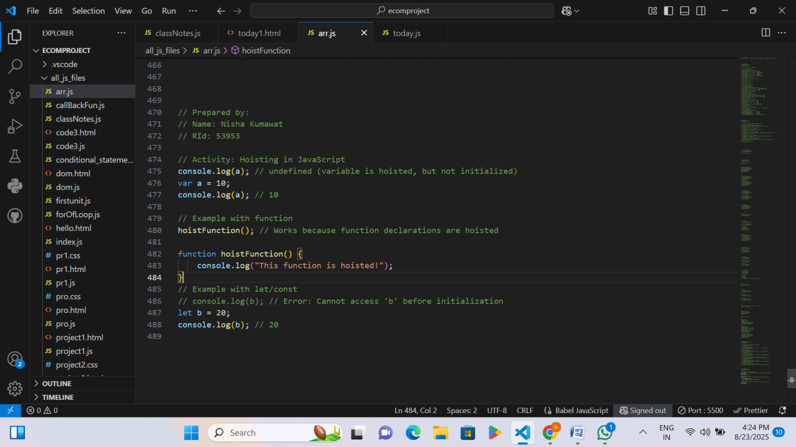
5. I saved this file and then ran it.
- Finally, the output was printed directly in the console.

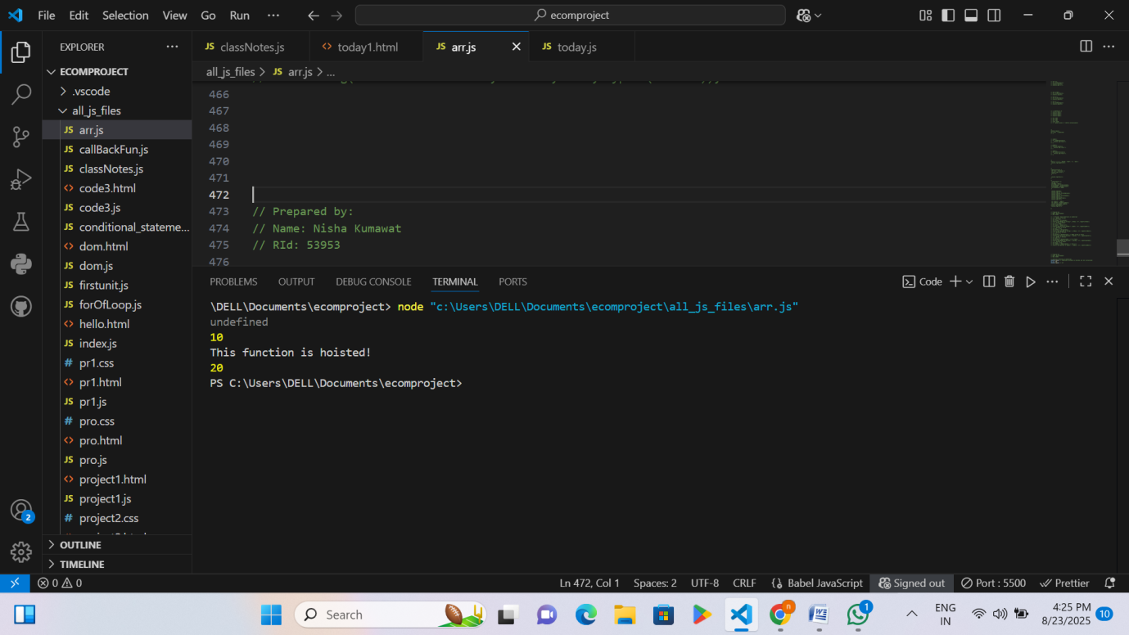
2.Scope =
Steps:
- A new JavaScript file named today.js was created
- Function fun1:
  - A variable f1 is declared with let inside an if block.
  - let has block scope, so f1 is accessible only inside the block.
  - When accessed outside, it causes an error because it is not defined outside the block.
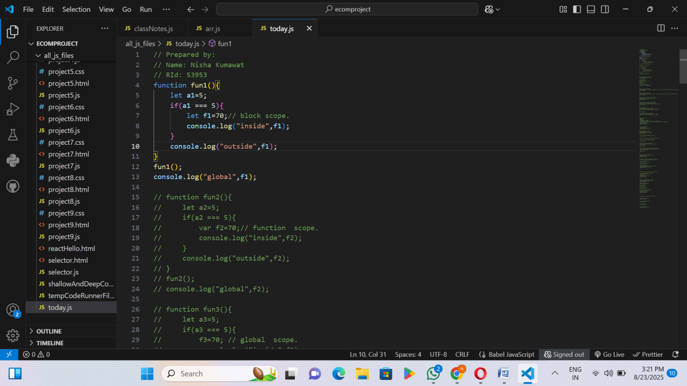
Steps:

- I saved this file and then ran it.
- Finally, the output was printed directly in the console.

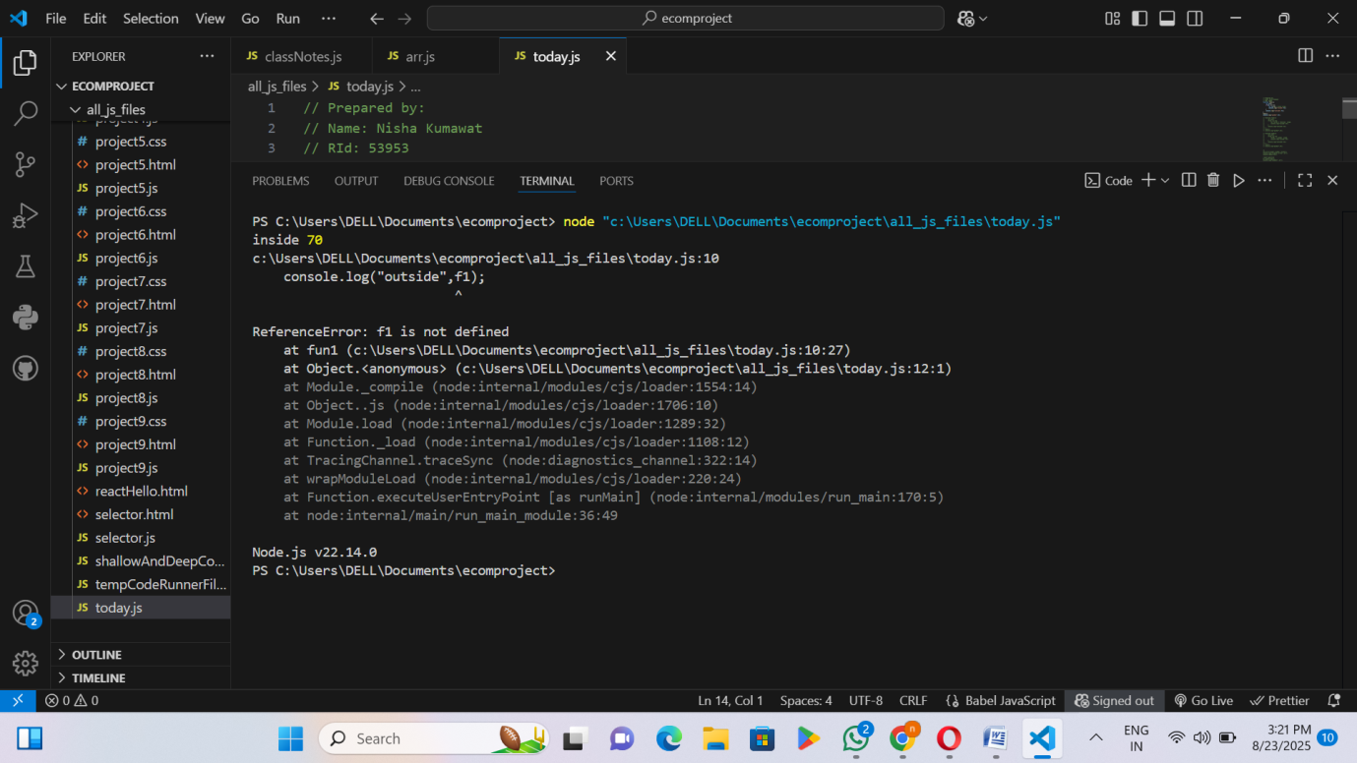
- A new JavaScript file named today.js was created
- Function fun2:
  - A variable f2 is declared with var inside an if block.
  - var has function scope, so it can be accessed anywhere inside the function.
  - When accessed outside the function, it causes an error because it is not global.
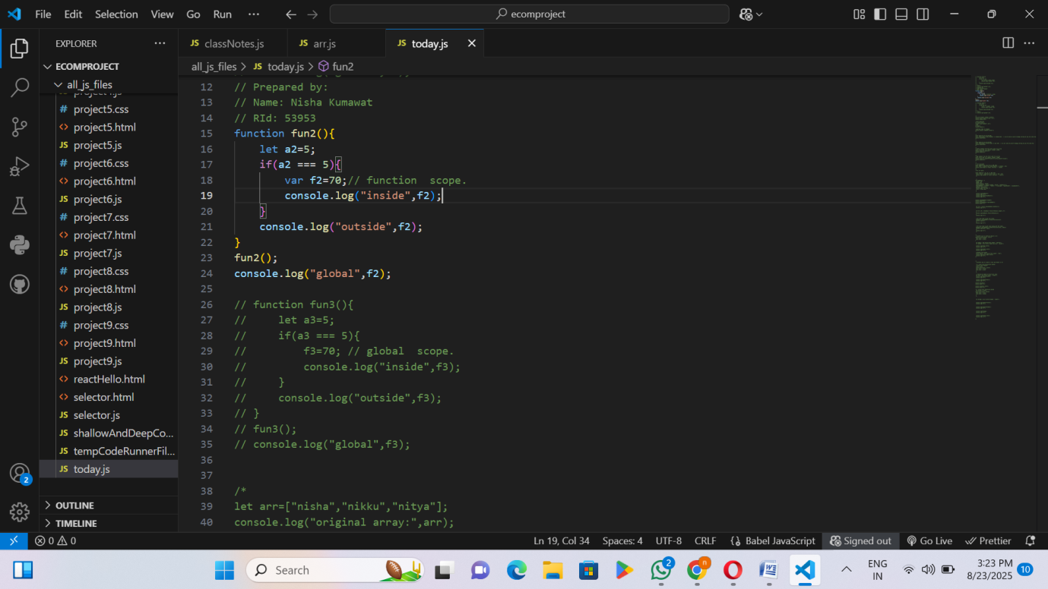

- I saved this file and then ran it.
- Finally, the output was printed directly in the console.

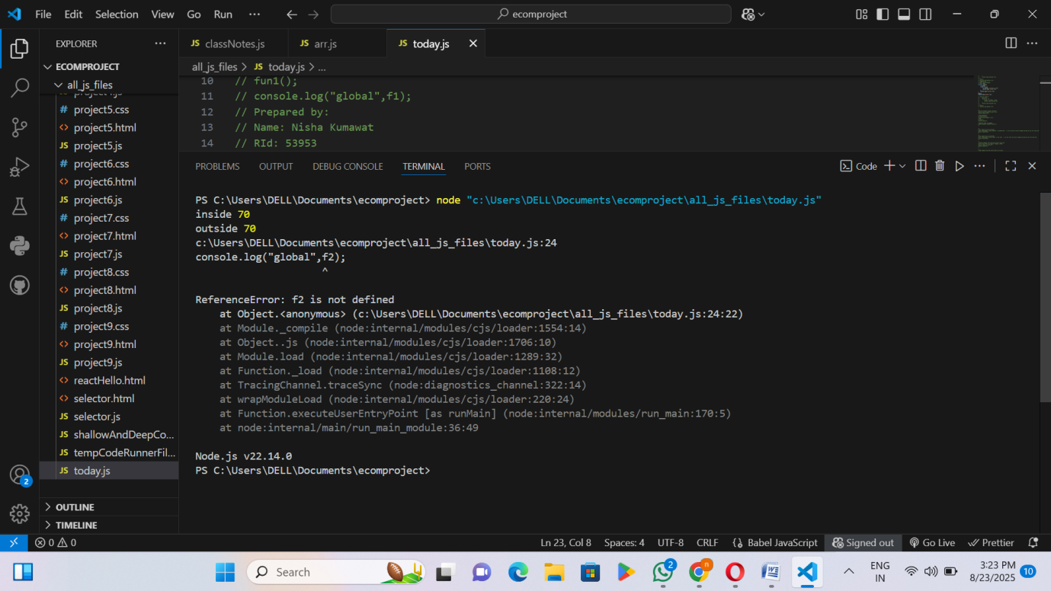
- A new JavaScript file named today.js was created.
- Function fun3:
- A variable f3 is assigned a value without using let or var.
- Such variables automatically become global in JavaScript.
- Therefore, f3 can be accessed inside the function, outside the function, and globally.

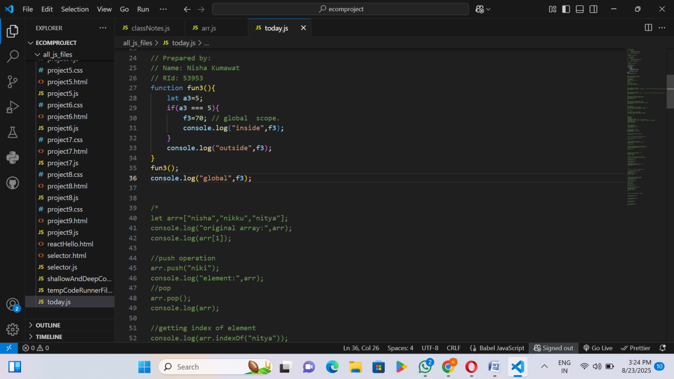
- I saved this file and then ran it.
- Finally, the output was printed directly in the console.
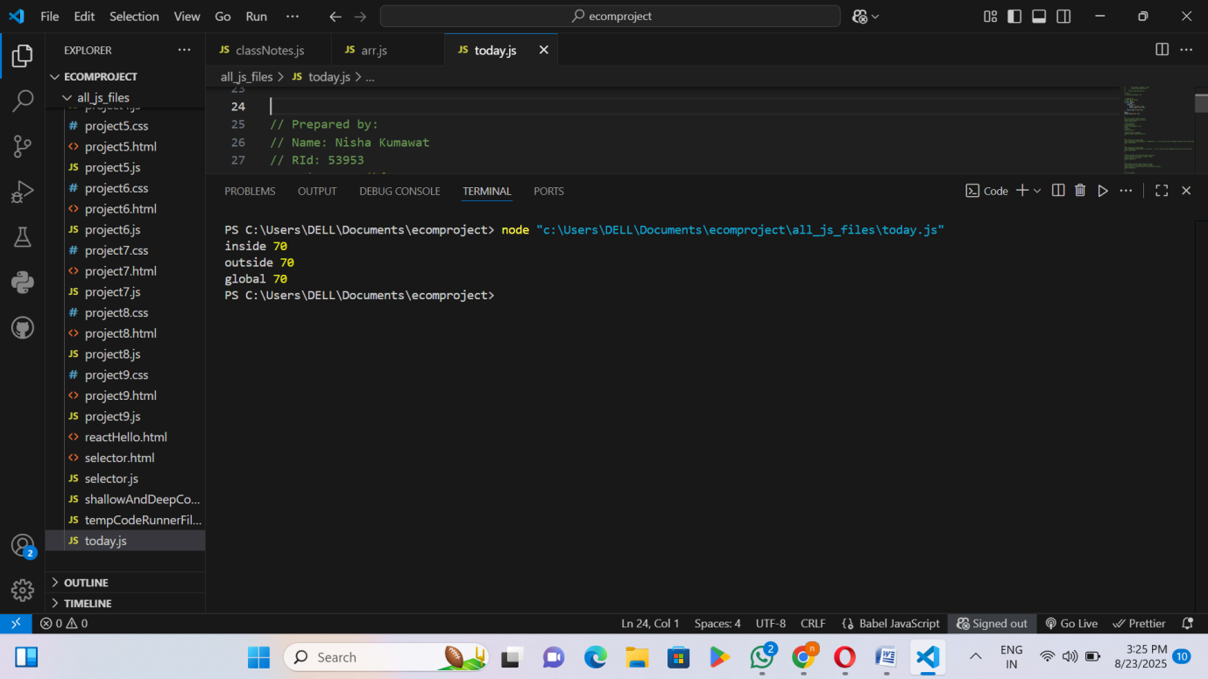
- A new JavaScript file named today.js was created.
- We created an outer function that has a variable outerVar.
- Inside outer, we defined another function inner.
- inner has its own variable innerVar.
RID 53953 page 13
- When we run inner, it can use:
- Its own variable (innerVar)
- The variable from outer (outerVar)
- Plus any global variables if needed.
- This happens because of lexical scope → the inner function is written inside outer, so it automatically gets access to outer’s variables.
- But the reverse is not true → outer cannot access innerVar (because lexical scope flows inward, not outward).
- I saved this file and then ran it.
- Finally, the output was printed directly in the console.
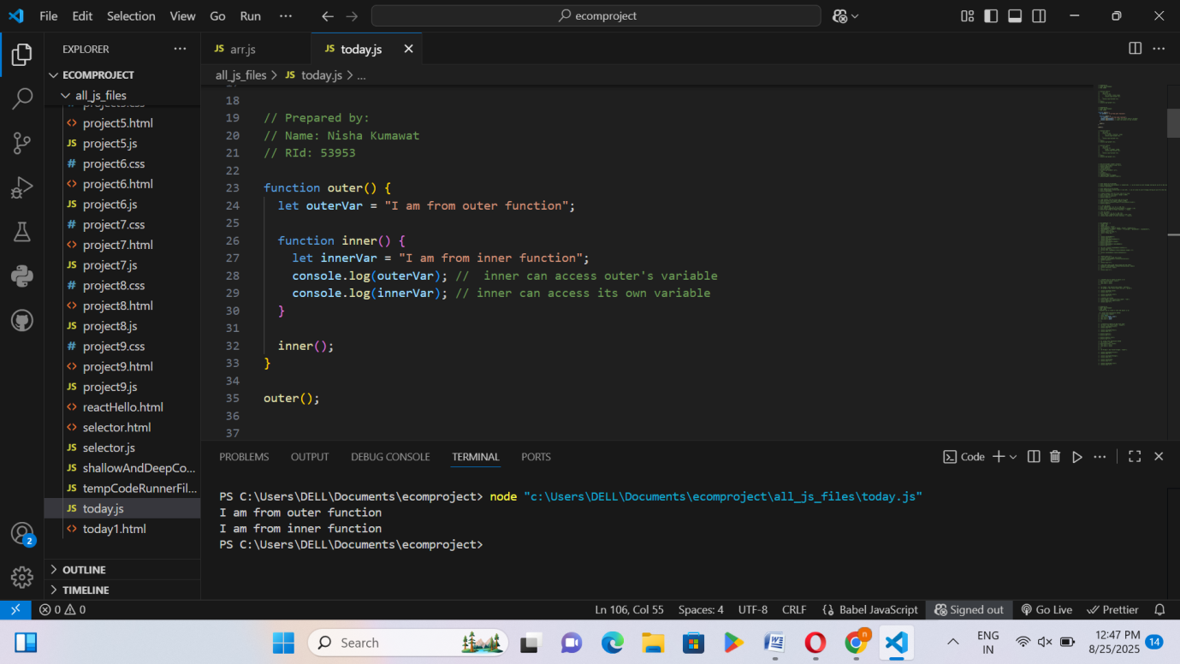

RID 53953 page 14
Activity 7: Arrays/ Operation on Array/ Array Methods
Code1.
Steps:
- A new JavaScript file named arr.js was created.
- An array arr was created with three string elements: "nisha", "nikku", and "soniya".
- The property arr.length was used to find the number of elements in the array and stored in the variable length.
- A for loop was used to print each element of the array.
- the length of the array was printed using console.log(arr.length).
- I saved this file and then ran it.
- Finally, the output was printed directly in the console.
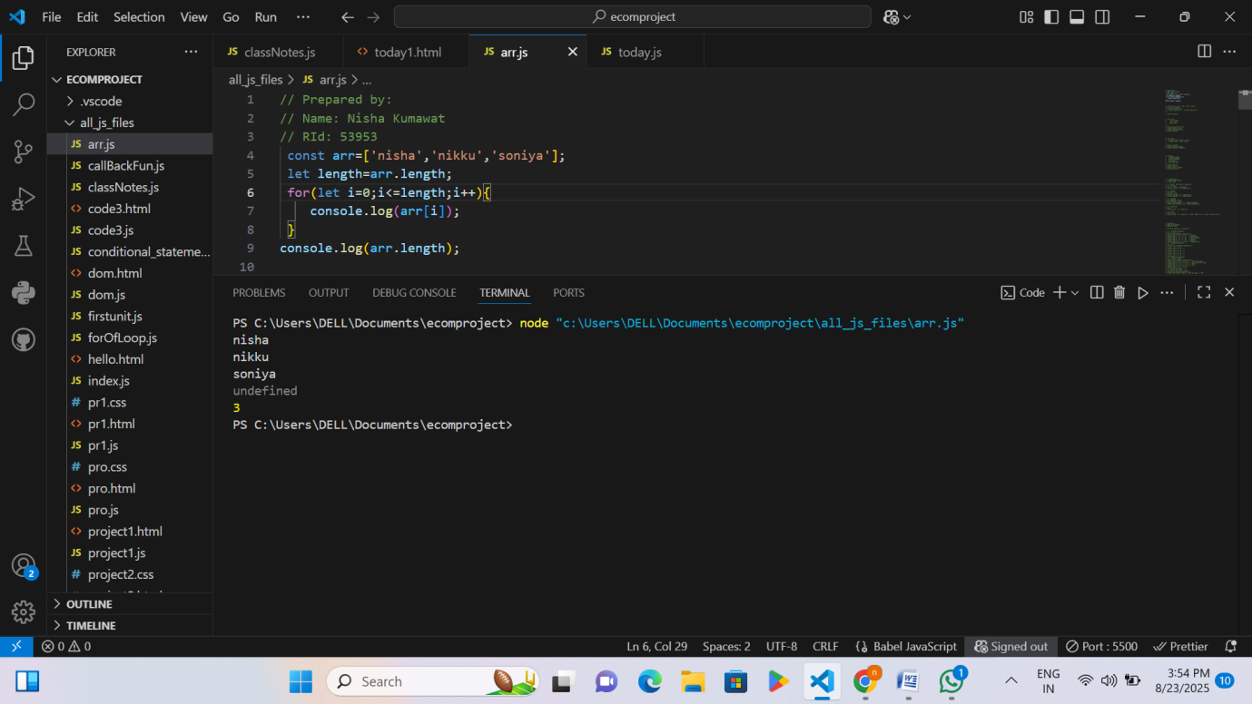
Code 2
Steps:
- A new JavaScript file named arr.js was created.
- An array arr was created with three elements: "nisha", "nikku", and "nitya".
  - The original array was printed using console.log().
  - A specific element was accessed using its index (arr[1]).
- Push operation:
  - Added a new element "niki" to the end of the array using arr.push().

- Pop operation:
  - Removed the last element of the array using arr.pop().
- Index of element:
  - Found the index of "nitya" using arr.indexOf("nitya").
- I saved this file and then ran it.
- Finally, the output was printed directly in the console.
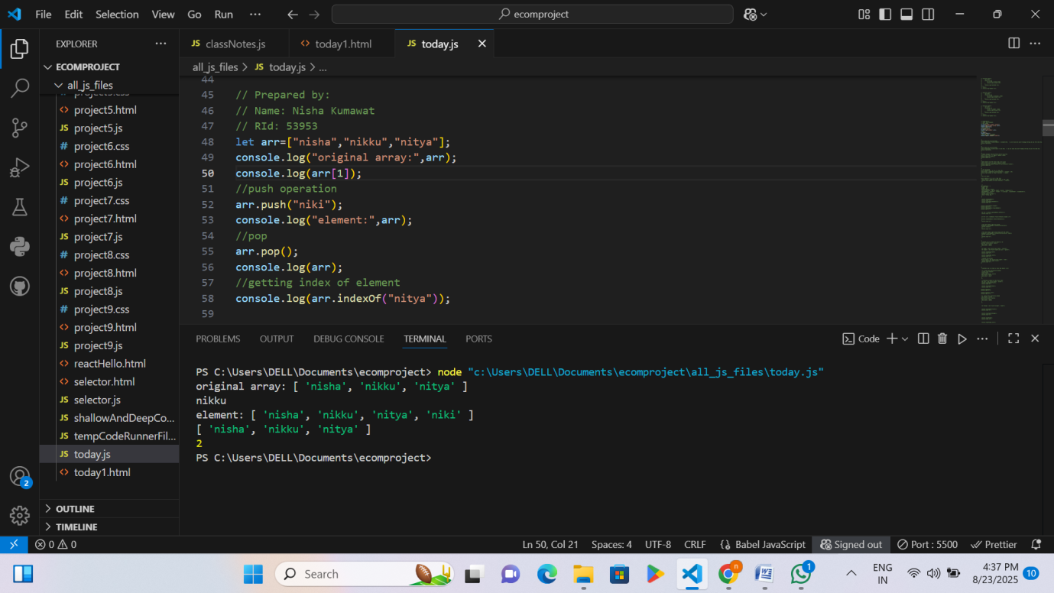
Code3
Steps:
- A new JavaScript file named arr.js was created.
- find() method:
  - Returns the first element in an array that satisfies a given condition.
  - Example: num.find(element => element > 10) prints the first number greater than 10.
- filter() method: Returns all elements in an array that satisfy a given condition.
  - Example: numarr.filter(num => num > 10) prints all numbers greater than 10.
- shift() method:
  - Removes the first element from an array and returns it.
- unshift() method:
  - Adds one or more elements to the beginning of an array and returns the new length.

- The code also demonstrates using find() and filter() separately to show one match vs all matches in an array.
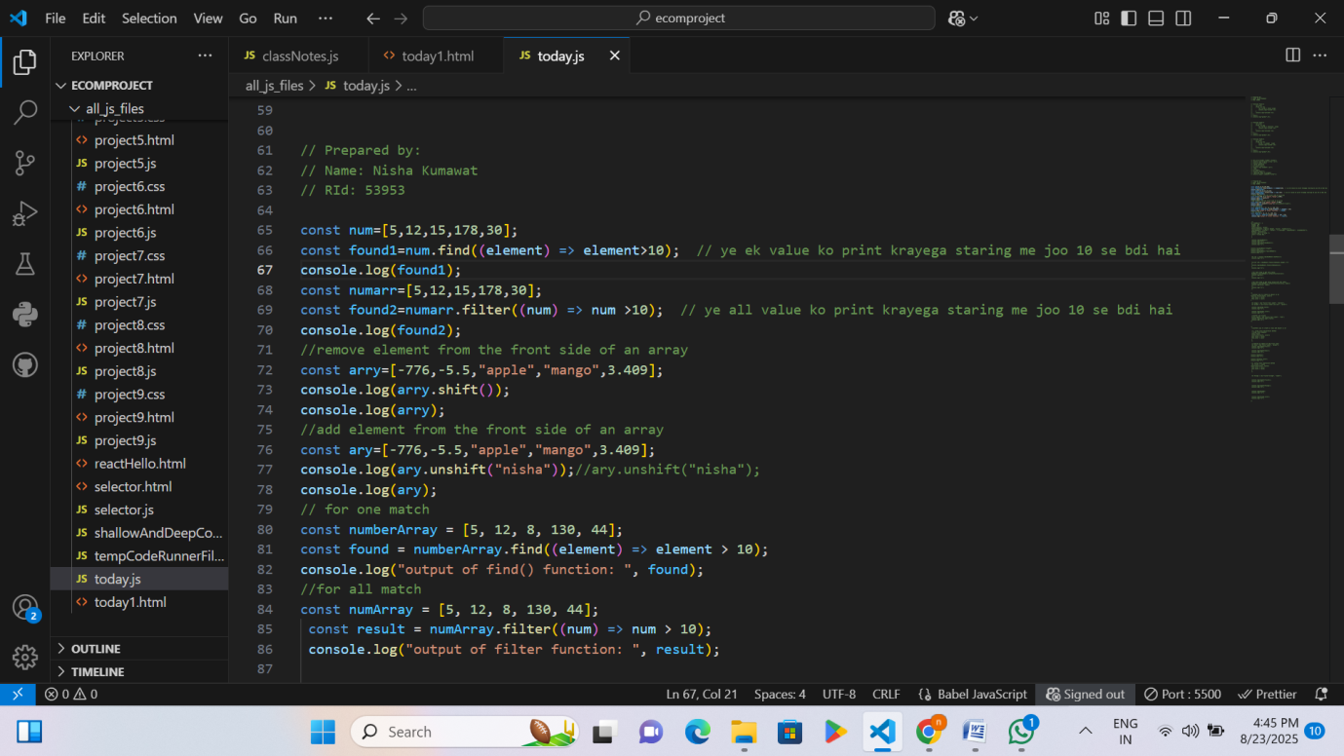
- I saved this file and then ran it.
- Finally, the output was printed directly in the console.
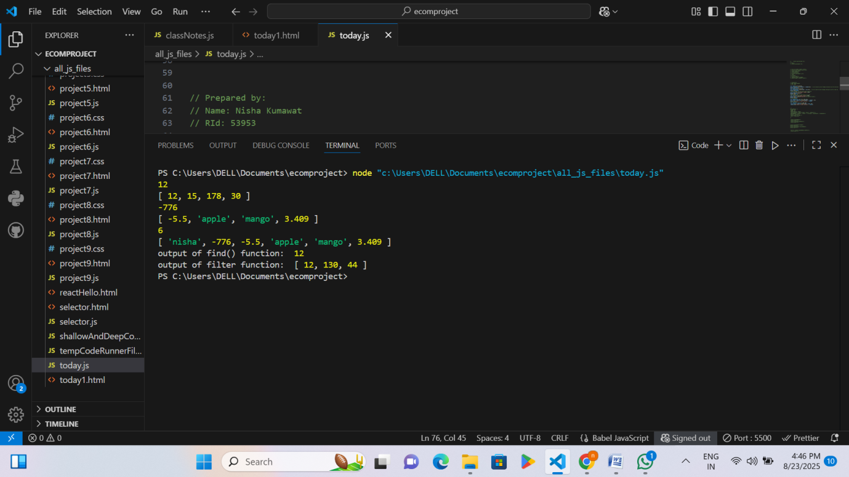

Activity 8: How to create Object and Class in Js
Code1
Steps:
- A new JavaScript file named arr.js was created
- An object oj1 was created with properties: first, last, and date.
  - You accessed object values using dot notation (oj1.first) and bracket notation (oj1["first"]).
  - Finally, the whole object was printed with console.log(oj1).
- Another object ob2 was created with two arrays inside it:
  - string1 contains ['nisha','nikku','nittu'].
  - string2 contains ['Ravi','hari','ashok'].
- You printed:
  - The full object ob2.
  - Only the first array ob2.string1.
  - A specific element from the second array → "hari" using ob2.string2[1].
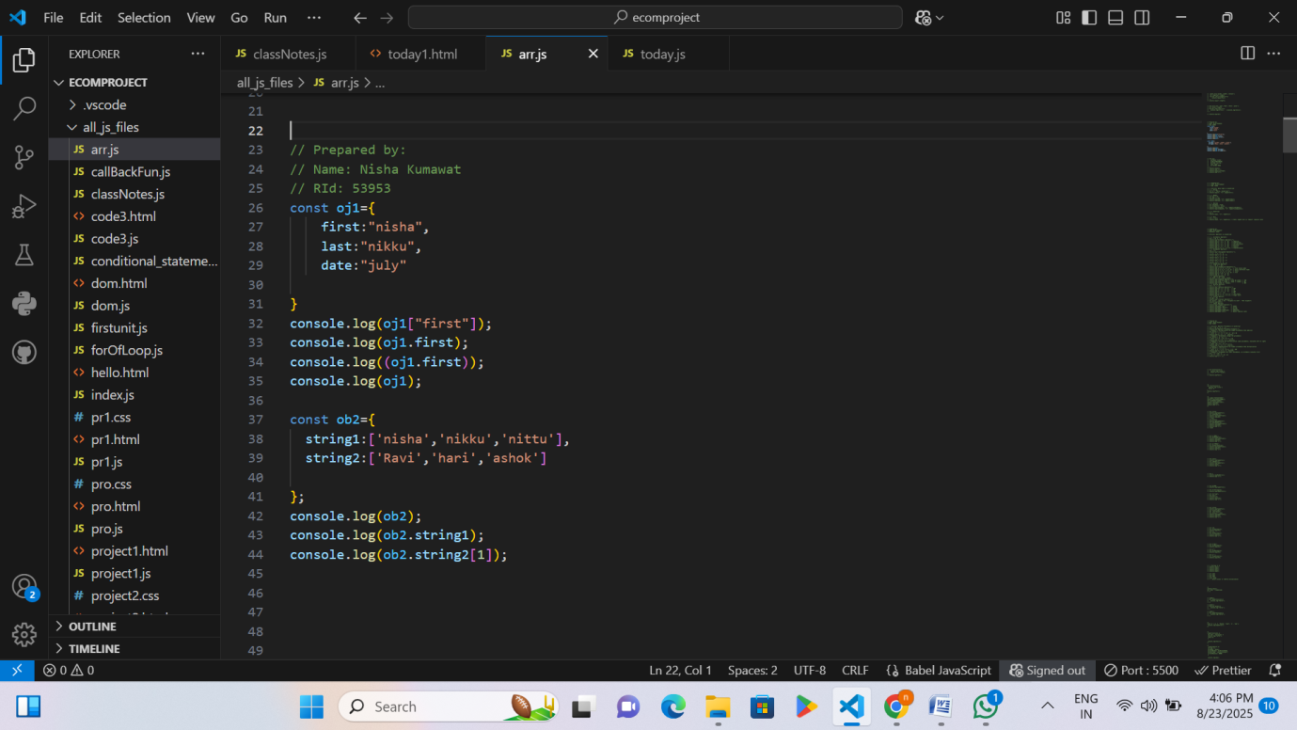
- I saved this file and then ran it.
- Finally, the output was printed directly in the console.

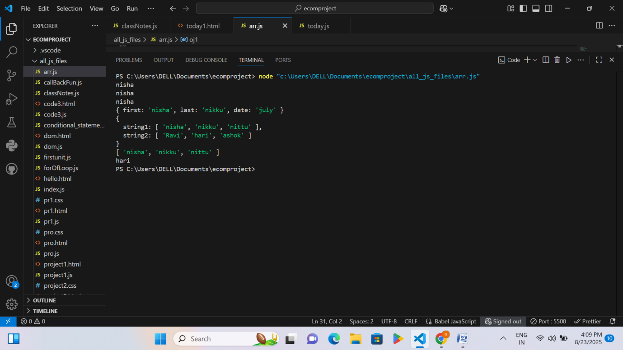
Code 2
Steps:
- A new JavaScript file named today.js was created
- Object Creation:
  - An object boyObject was created with properties: height, weight, favouriteColor, favouriteSnacks (array), familyMembers (array), and a method boyFunc().
  - Accessed object properties using dot notation (boyObject.height) and printed the object with console.log().
  - The type of the object was checked using typeof.
- Object Method:
  - The method boyFunc() was called, which prints a message and returns a string.
- Array Iteration inside Object:
  - A for loop was used to print each element of the favouriteSnacks array.
  - forEach() was used to iterate through the familyMembers array:
    - First, to print only values.
    - Second, to print values along with their index.

• The forEach() loop is applied on the boyObject.familyMembers array.
• It takes two parameters:

- value → represents each element in the array.
- index → represents the position (number) of that element in the array.
- • Inside the loop, console.log(value, index) prints both the family member name and its index number
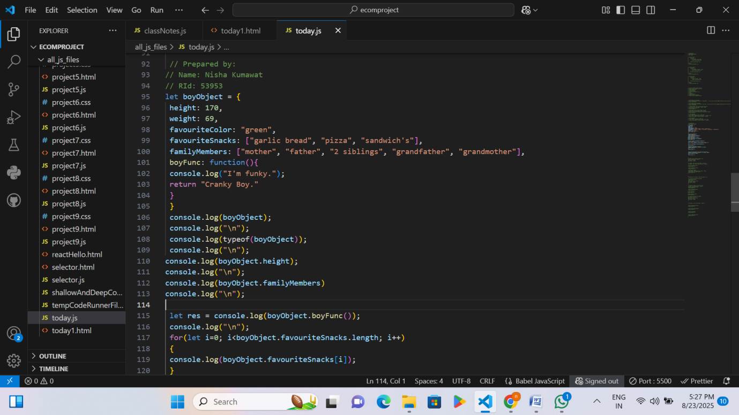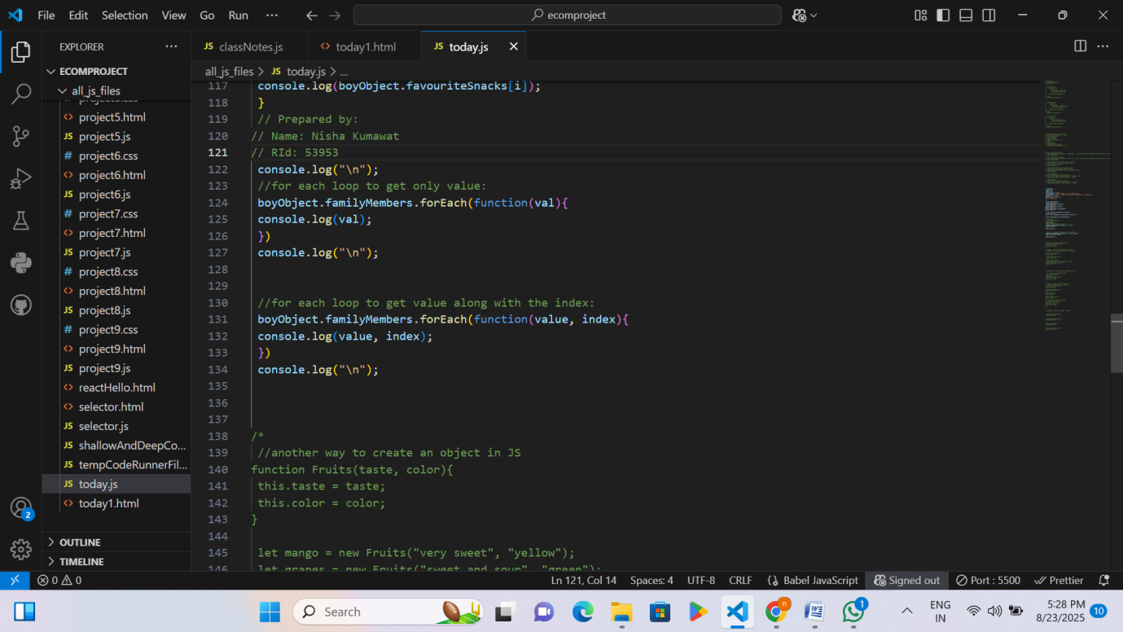
- I saved this file and then ran it.
- Finally, the output was printed directly in the console.

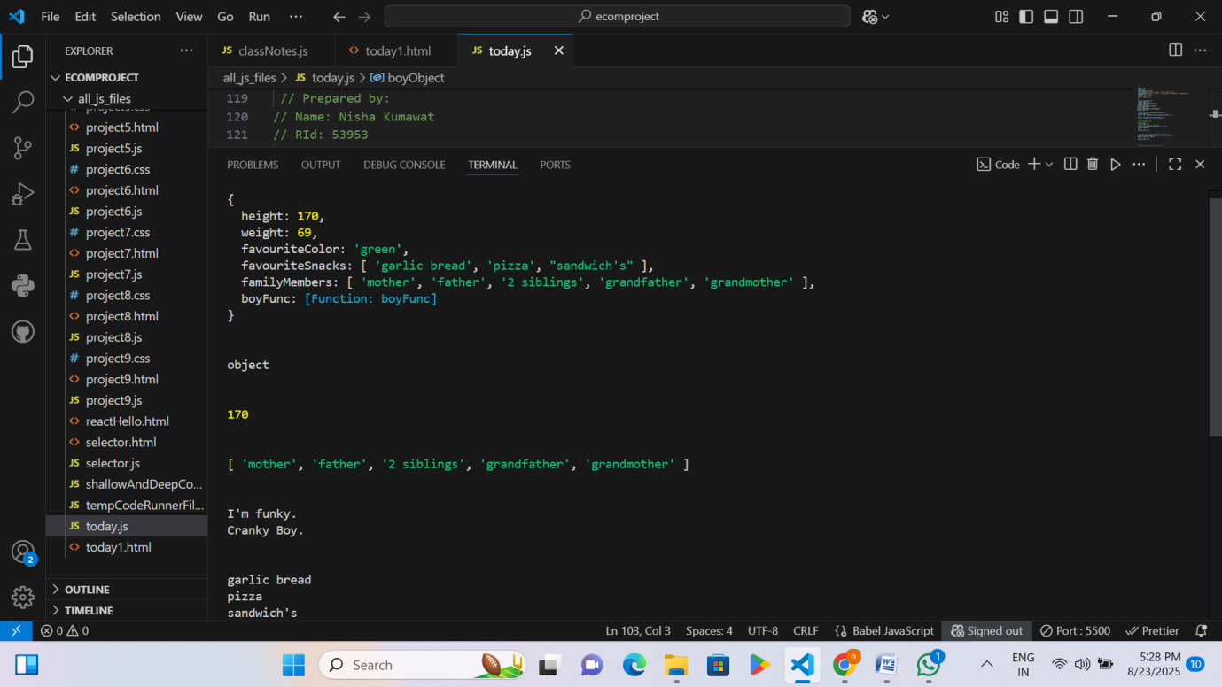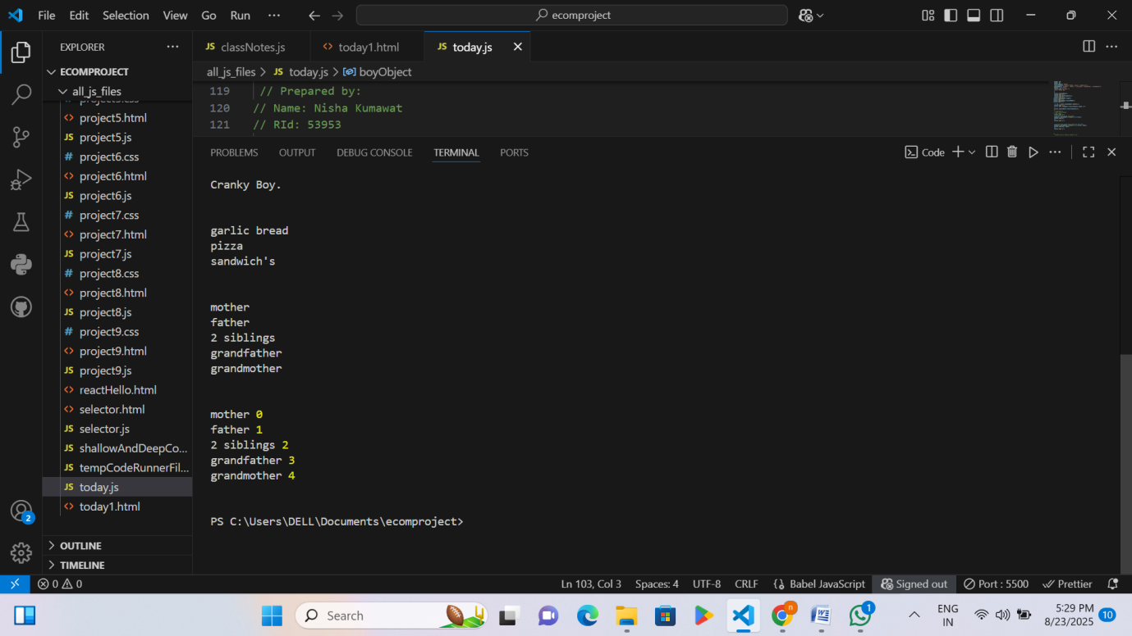
Code3
Object Creation in JS (Constructor Function Method)
Steps:
  - A new JavaScript file named today.js was created

  - Function as Constructor:function Fruits(taste, color){ ... } is a constructor function that creates objects with properties taste and color.
  - Creating Objects with new:
let mango = new Fruits("very sweet", "yellow");
let grapes = new Fruits("sweet and sour", "green");
→ This creates separate objects (mango, grapes) with their own property values.
  - Accessing Properties:
console.log(mango.taste); → prints "very sweet".
console.log(grapes.color); → prints "green".
  - Adding Object as Property of Function:
Fruits.apple = new Fruits("very sweet", "red");
Here, apple is stored directly inside the Fruits function object.
console.log(Fruits.apple.taste); → prints "very sweet".
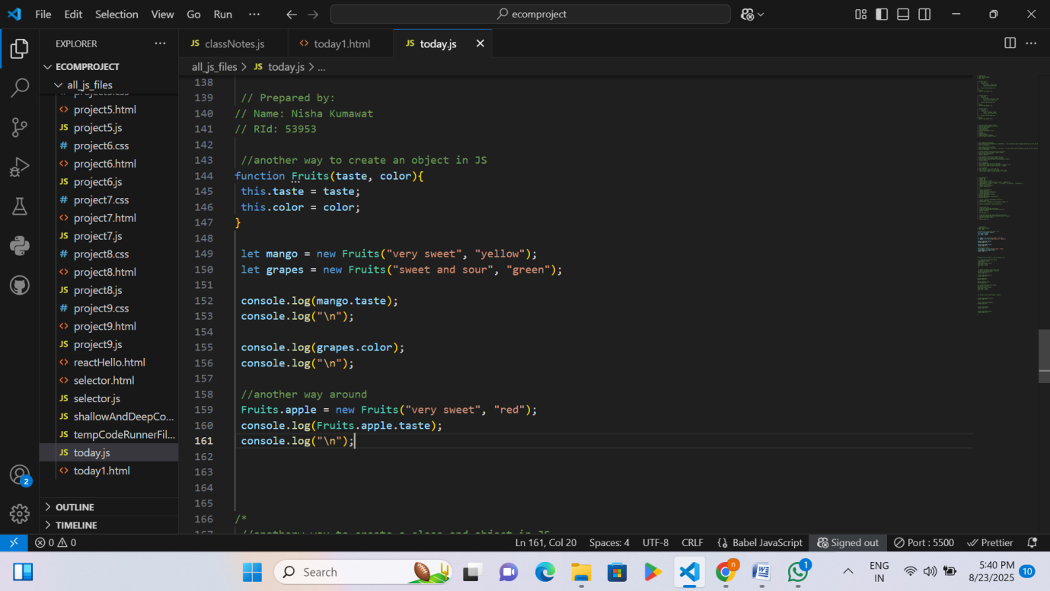
  - I saved this file and then ran it.
  - Finally, the output was printed directly in the console.

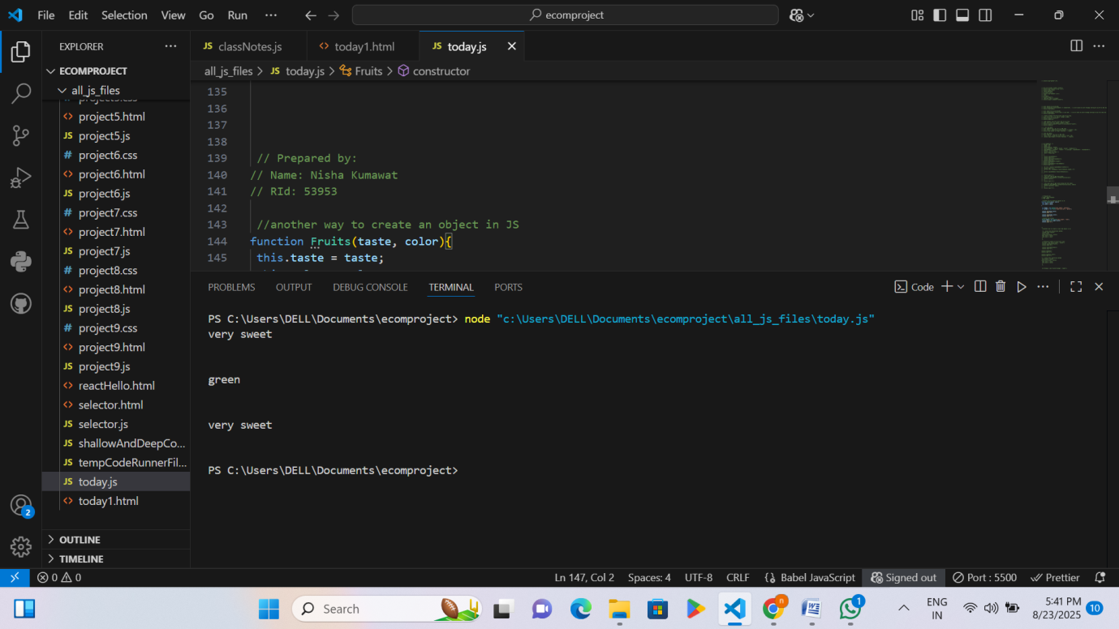
Code 4
Steps:
  - A new JavaScript file named today.js was created
  - Class Declaration Method (using class keyword):
  - class fruit { constructor(taste, color) { ... } } defines a class with properties taste and color.
  - let kiwi = new fruit("sweet", "green"); → creates an object kiwi.
  - Checking type:
    - typeof(fruit) → "function" (because classes in JS are special functions).
    - typeof(kiwi) → "object".
  - console.log(kiwi.color); → prints "green".
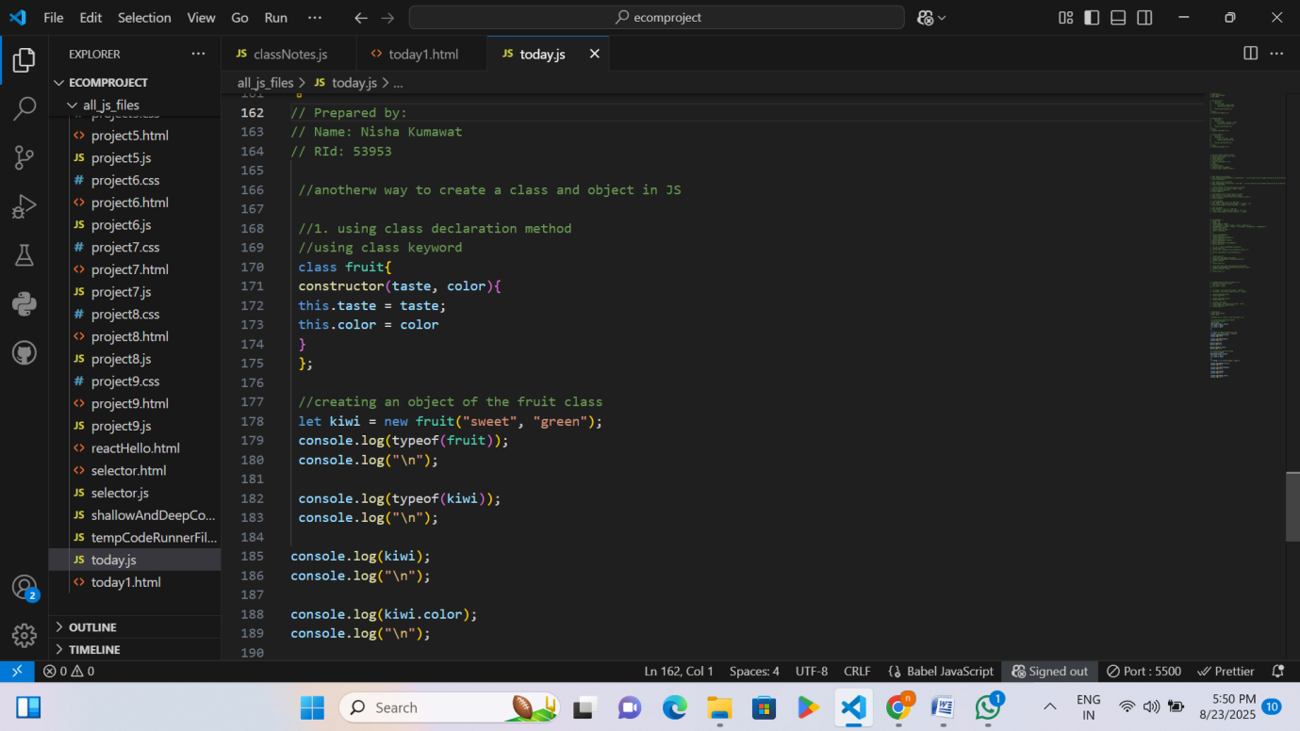
  - Class Expression Method:
  - let fruit2 = class { ... } → another way to define a class, stored inside a variable.
  - let Orange = new fruit2("orange", "sweet"); → creates object Orange.
  - Checking type:
    - typeof(fruit2) → "function".
    - typeof(Orange) → "object".
  - console.log(Orange.color); → prints "orange".
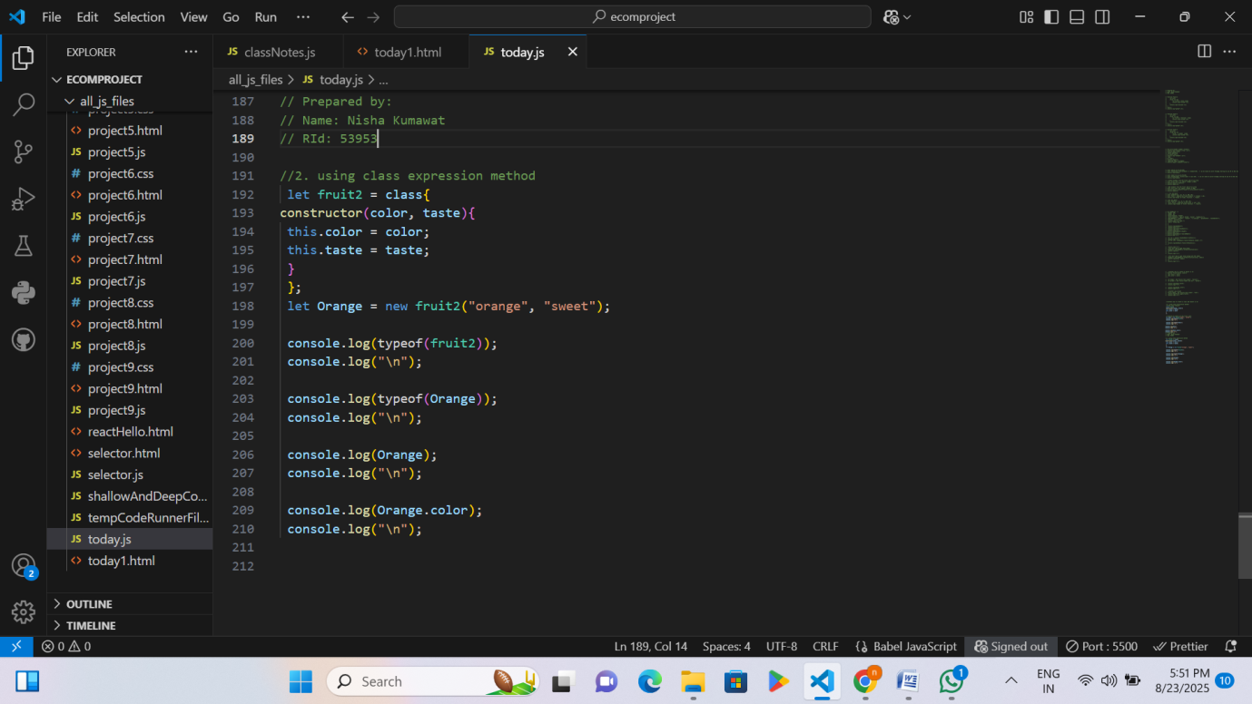

  - I saved this file and then ran it.
  - Finally, the output was printed directly in the console.
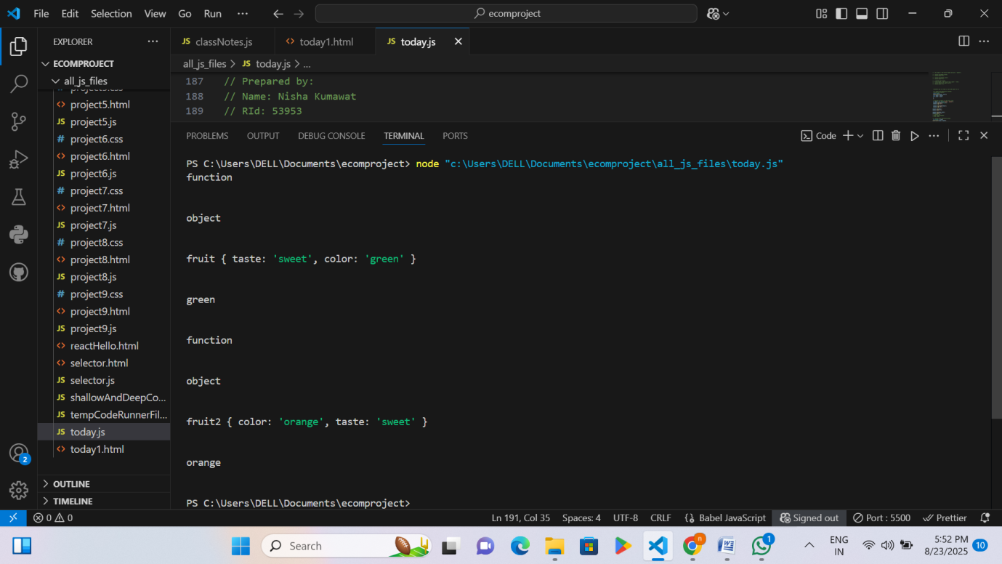
Activity 9: All type function in Js
Code1
Steps:
  - A new JavaScript file named funType.js was created
  - Anonymous functions are functions without a name.
  - They are often stored in a variable or passed as arguments.
  - Example 1 → let greet = function(name){...}; assigns an anonymous function to greet.
  - Example 2 → setTimeout(function(){...}, 1000); uses an anonymous function directly as an argument.
  - I saved this file and then ran it.
  - Finally, the output was printed directly in the console.

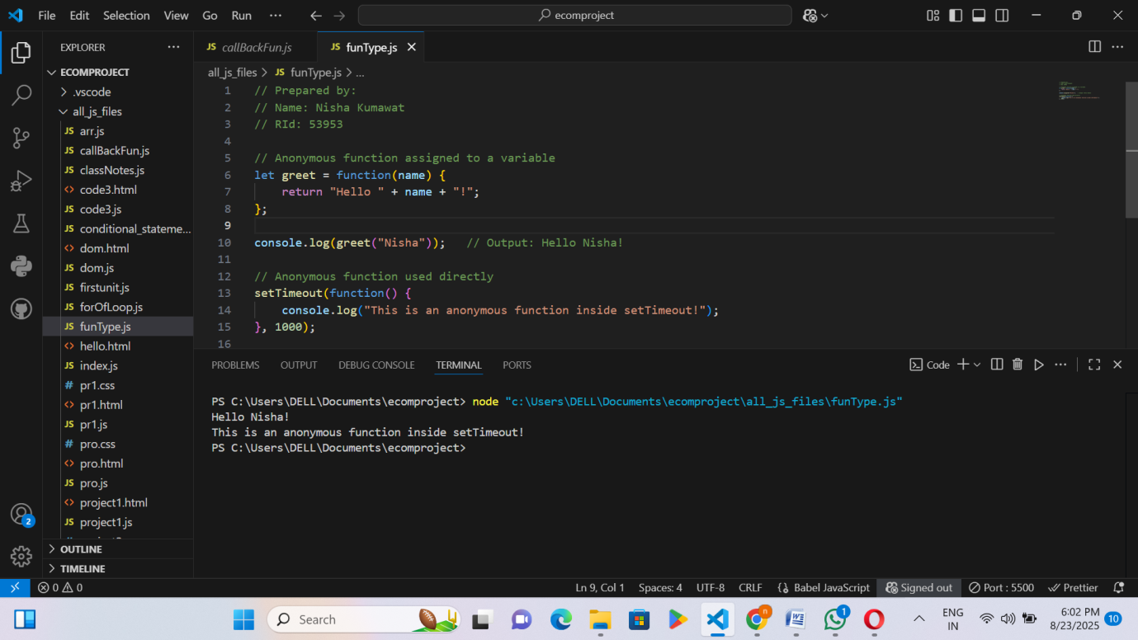
Code 2
Steps:
  - A new JavaScript file named funType.js was created.
  - Inside it, we can use await to wait for a promise to complete.
  - In the example, setTimeout simulates a delay (2 seconds).
  - While waiting, JavaScript continues running the next lines → showing asynchronous behavior.
  - I saved this file and then ran it.
  - Finally, the output was printed directly in the console.
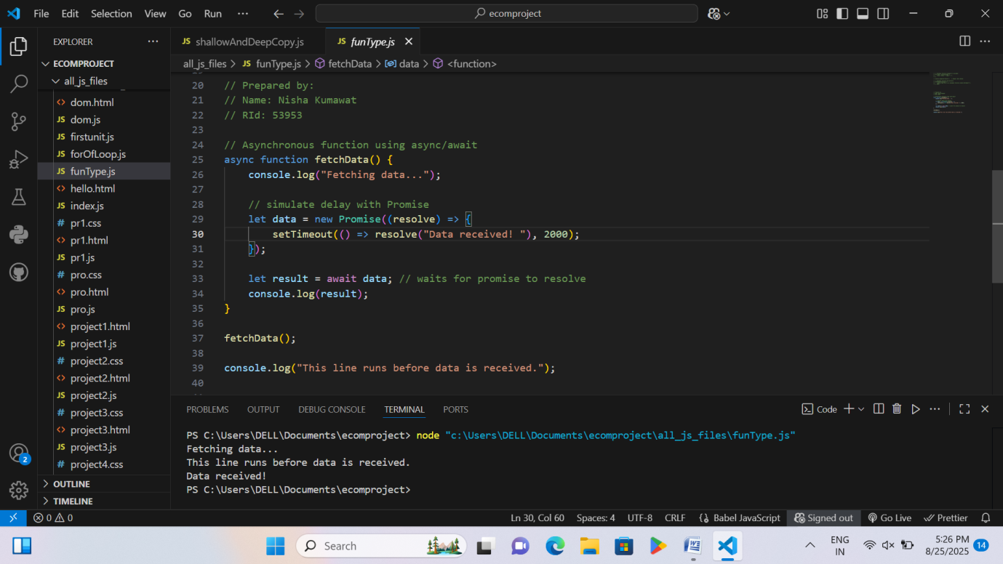

Code 3
Steps:
  - A new JavaScript file named callBackFun.js was created.
  - The sum function takes two numbers and another function (fnToCall) as input, adds the numbers, and then calls that function with the result.
  - displayResult is passed as the callback function, so it prints the result (3) when sum(1,2,displayResult) is executed.
  - I saved this file and then ran it.
  - Finally, the output was printed directly in the console.
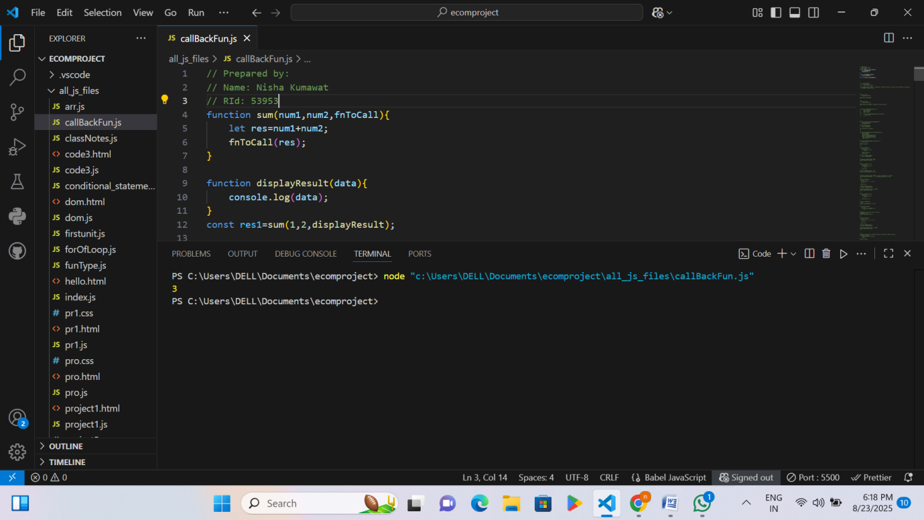
Code 4
Steps:
  - A new JavaScript file named callBackFun.js was created.
  - setTimeout(greet, 3000) → Runs the greet() function once after 3 seconds (prints "nisha").
  - setTimeout(nish, 3000) → Runs the nish() function once after 3 seconds (prints result of 12+13, i.e., 25).
  - setInterval(func, 3000) → Runs the func() function repeatedly every 3 seconds (prints "nis" again and again).

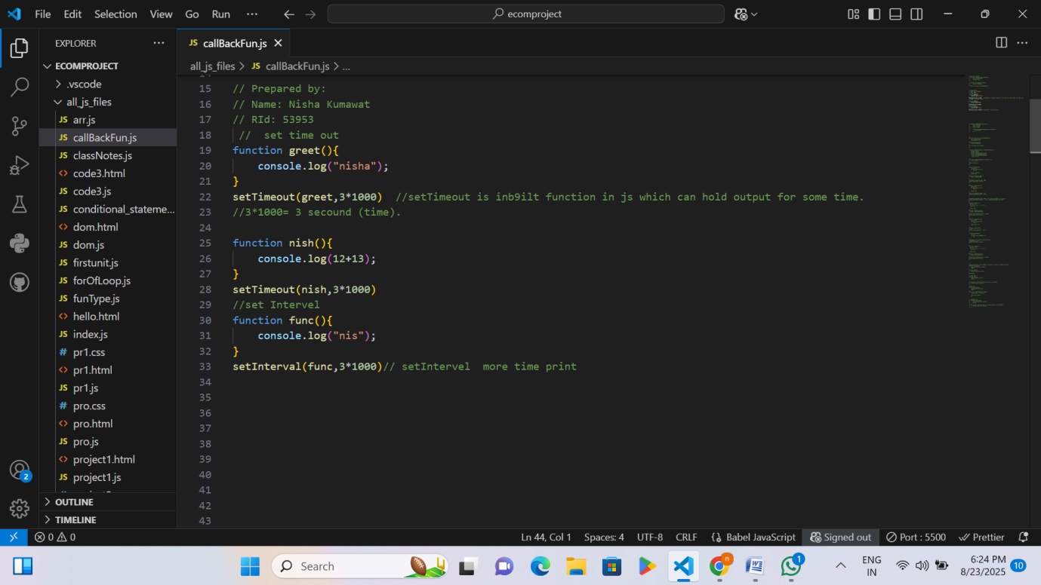
  - I saved this file and then ran it.
  - Finally, the output was printed directly in the console.
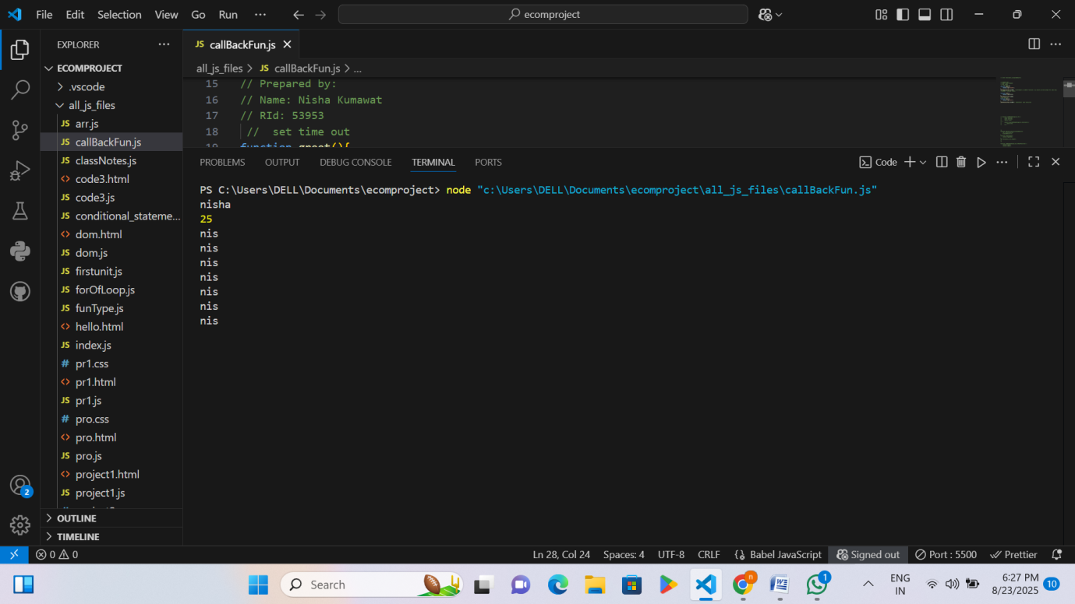

Code 5
Steps:
  - A new JavaScript file named callBackFun.js was created.
  - Pass 2 and 3 with an anonymous function k*k (square).
  - First: v1 = fn(2) = 2*2 = 4.
  - Second: v2 = fn(3) = 3*3 = 9.
  - Return v1+v2 = 4+9 = 13.
Output → 13
  - Numbers 1+2+3+4 = 10 are added.
  - displayResult is a callback → here output().
  - So, it prints 10.
Output → 10
  - I saved this file and then ran it.
  - Finally, the output was printed directly in the console.
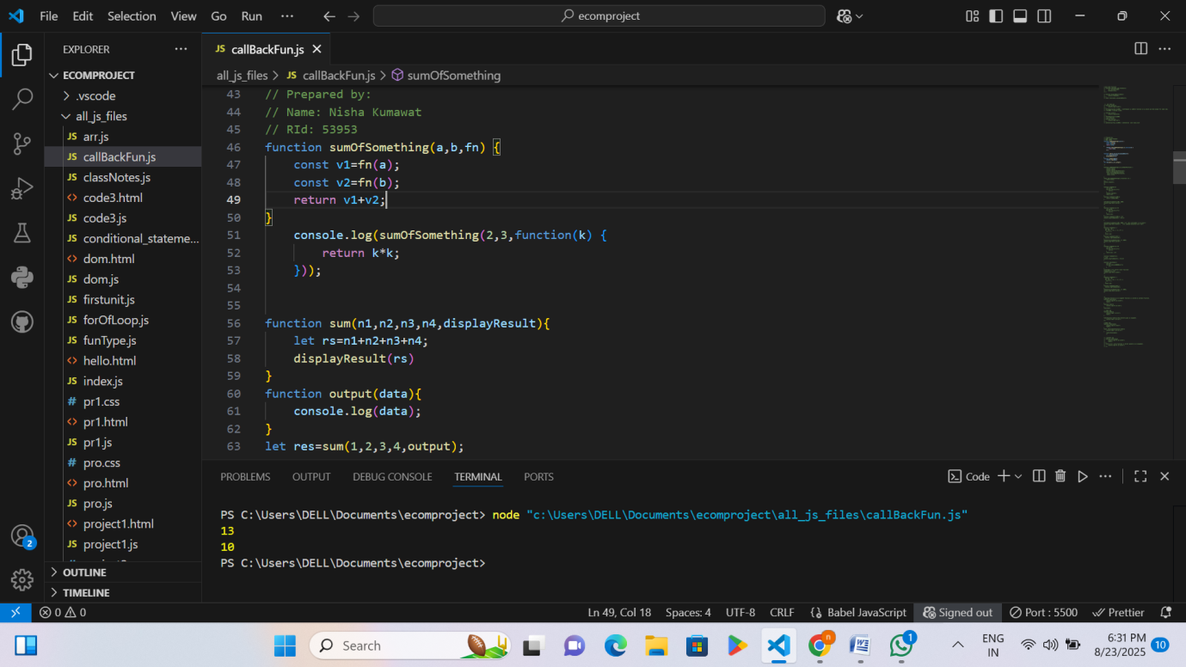
Code 6
Steps:
    - A new JavaScript file named callBackFun.js was created.
    - findSum(n) → calculates the sum of numbers from 0 to n-1.
    - Example: findSum(100) will calculate 0+1+2+3+...+99 = 4950.
    - findSumTill100() → just calls findSum(100) and returns the result.
    - setTimeout(findSumTill100, 1000) → schedules findSumTill100 to run after 1 second (1000 ms).
    - console.log("hello world") → runs immediately before the timeout.
    - I saved this file and then ran it.
    - Finally, the output was printed directly in the console.
    - First: "hello world" is printed immediately.
    - After 1 second: 4950 is printed (sum of 0 to 99).
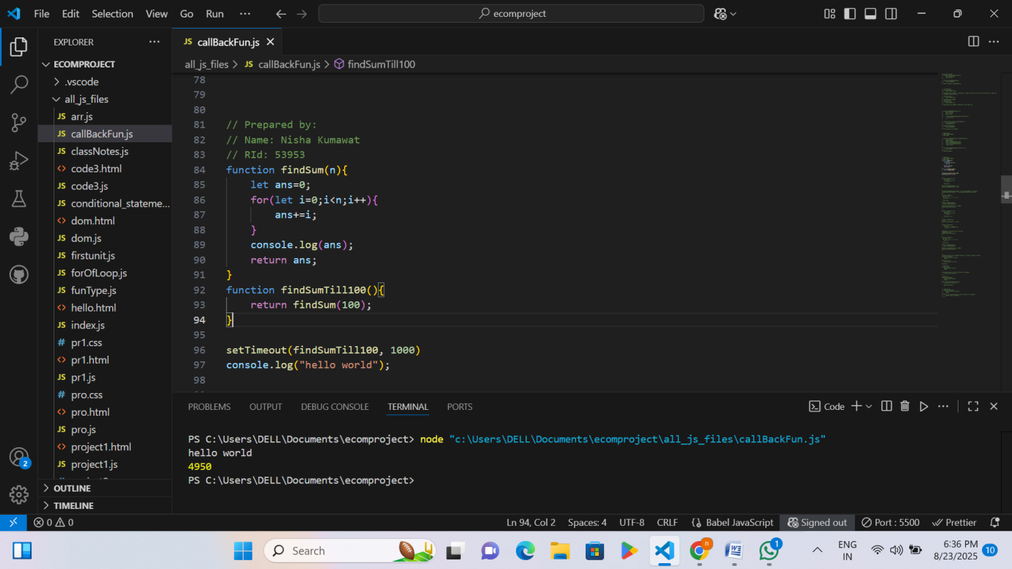
Code 6
Steps:
A new JavaScript file named callBackFun.js was created.
- Example 1 – Normal function as argument:
  - fun2 is passed as an argument to fun1.
  - fun1 executes its own code and then calls fun2.
  - Prints:
  - hi am nisha
  - hi am nik
- Example 2 – Passing function directly inside call:
  - An anonymous function fun4 is passed directly to fun3.
  - fun3 runs its code and then calls the passed function.
  - Prints:
  - i am mi
  - i am now
- Example 3 – Using function reference:
  - Function fun6 is stored in a variable refvariable.
  - fun5 calls the function passed through refvariable.
  - Prints:
  - in buiu
  - i am fun 6
- Example 4 – Using arrow function directly:
  - Arrow function is passed directly to fun7.
  - fun7 runs its code and then executes the arrow function.
  - Prints:
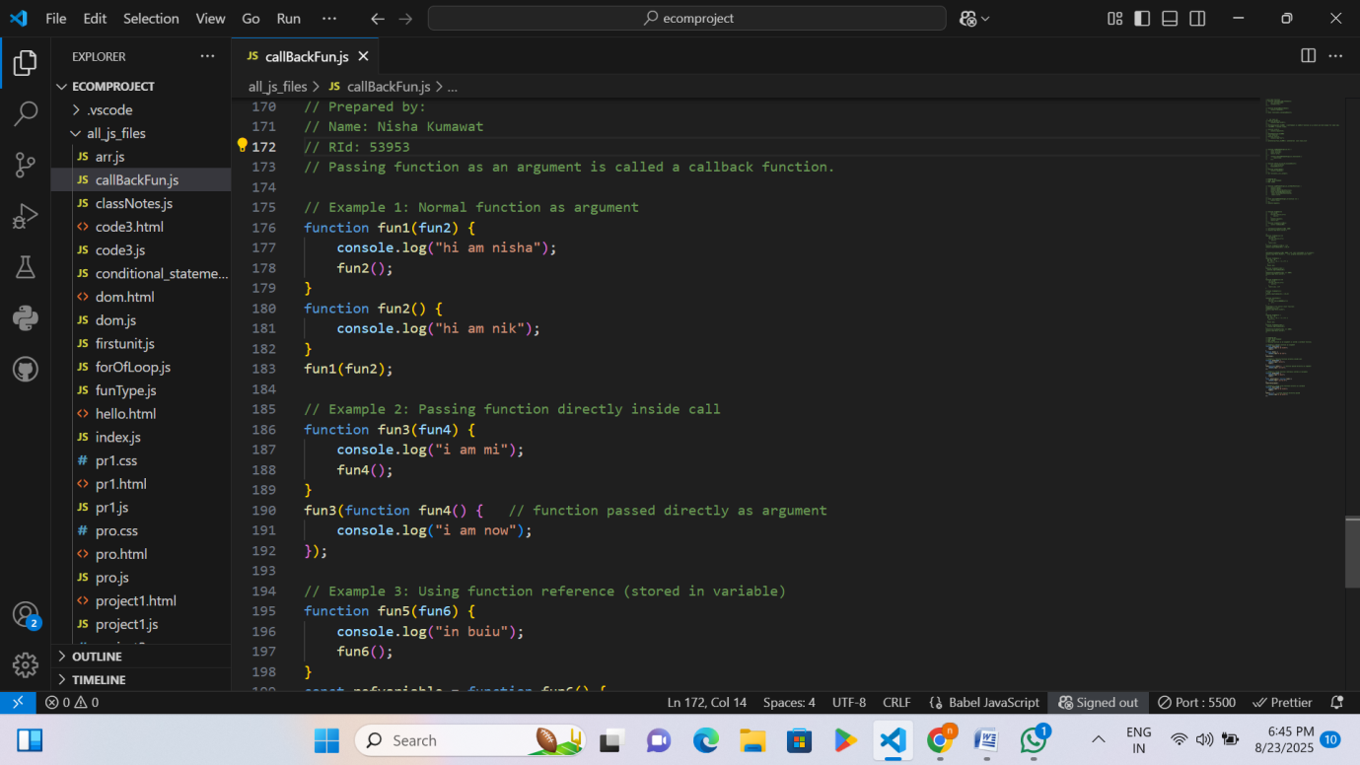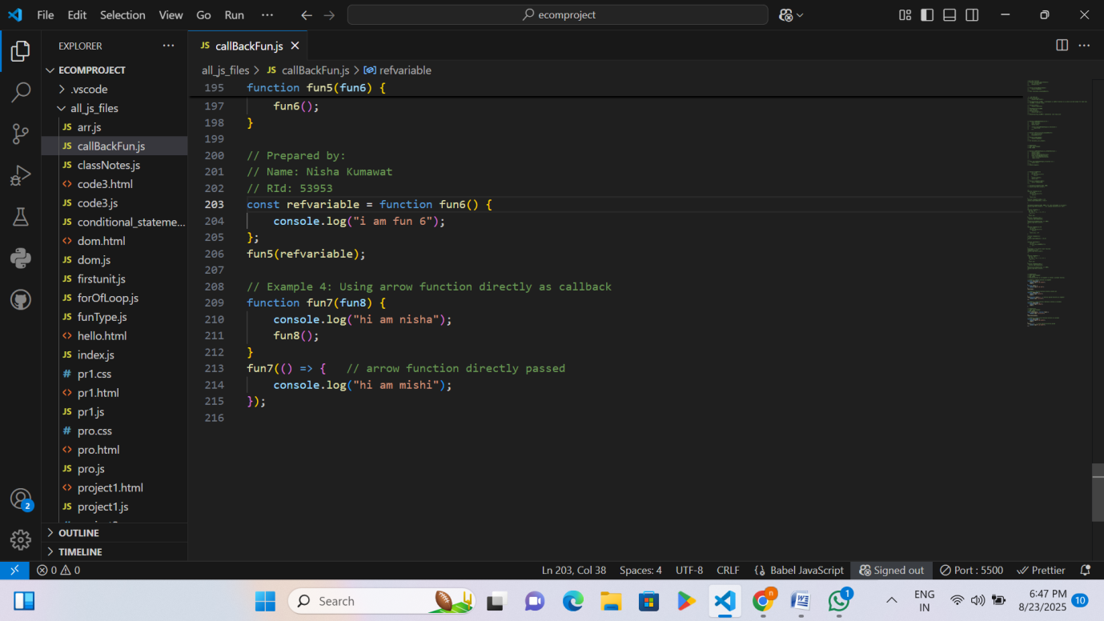
- I saved this file and then ran it.
- Finally, the output was printed directly in the console.

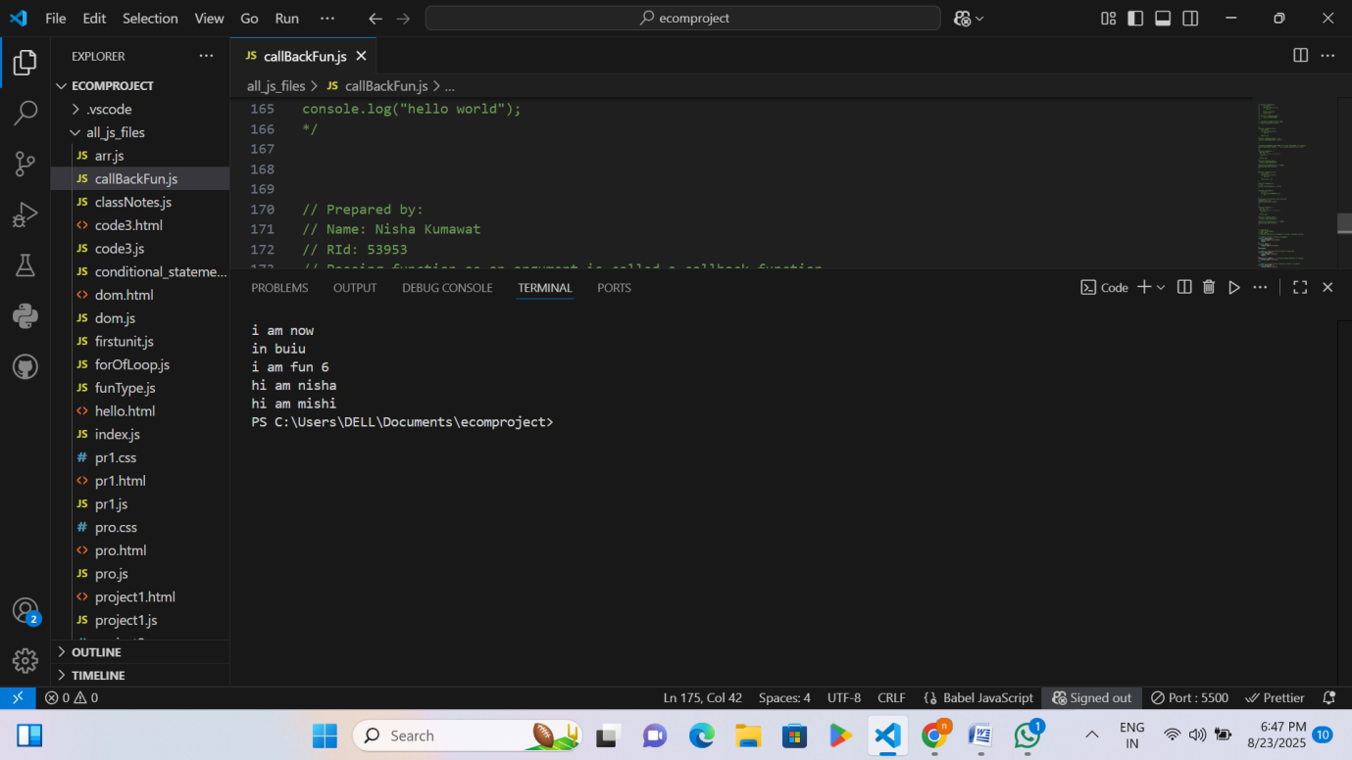

Activity 10: DOM Manipulation
Steps:
- A new JavaScript file named today1.html was created.
- An HTML page was created with a heading (<h2>), a paragraph (<p>), and a button.
- A JavaScript function changeText() was written to perform DOM manipulation when the button is clicked.

- Using document.getElementById, the heading text was changed to "Text Changed!".
- The paragraph text was updated to show a new message using DOM.
- The style of the paragraph was modified by changing its text color to blue.
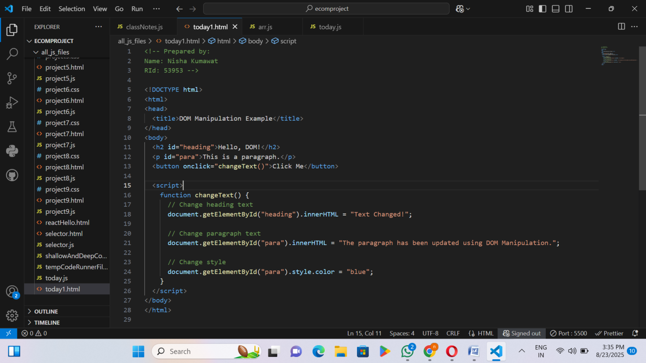
- When I saved the code and ran it, it opened in Live Server where ‘Hello, DOM!’ was printed and a button appeared on one click.

RID 53953 page 15
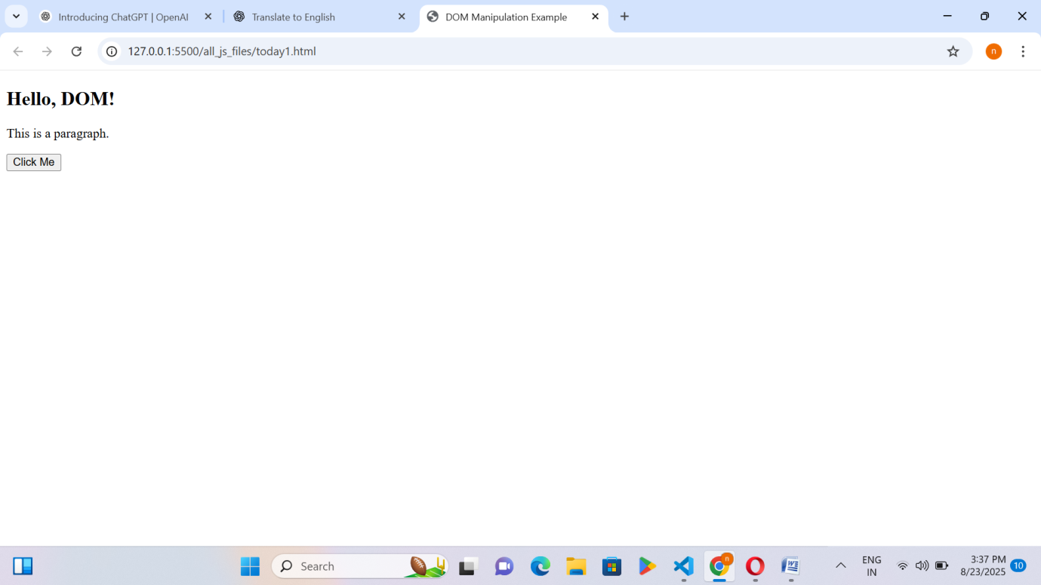
- When I clicked, it printed along with the output 'Text Changed'."
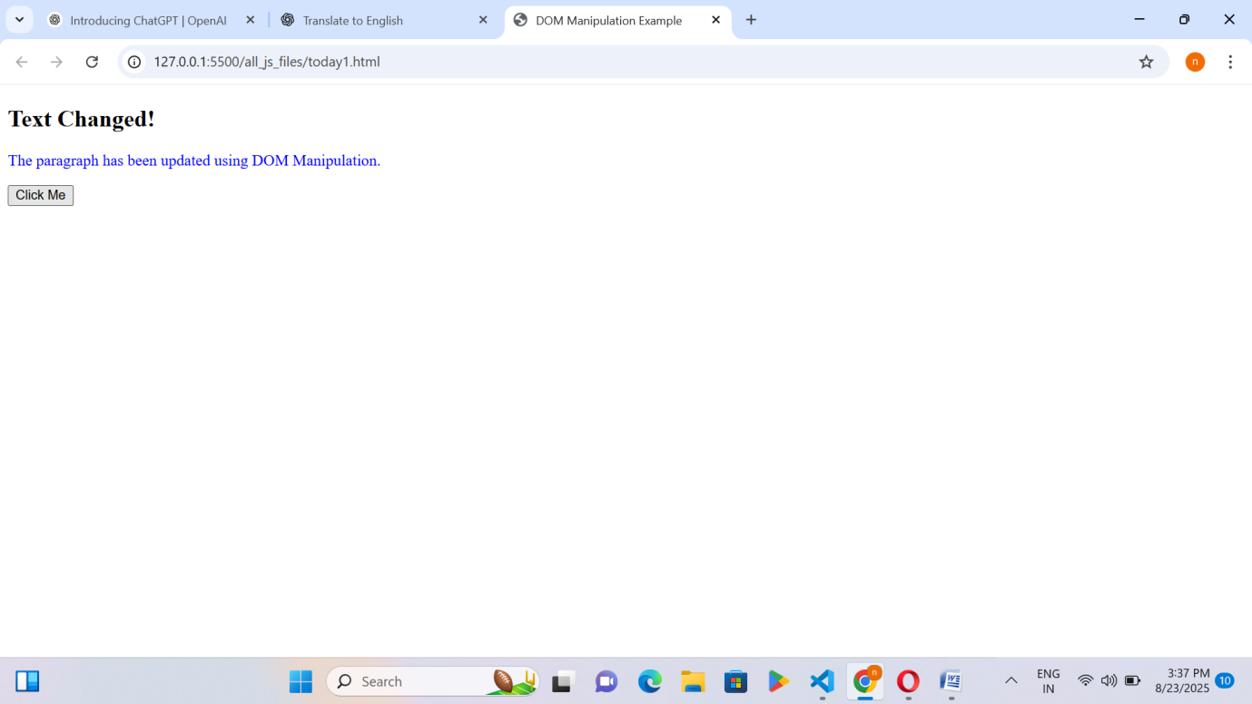

Activity 11: Loops in Js(For of loop/For Each)
Code1
Steps:
- A new JavaScript file named forOfLoop.html was created.
- Header Information
- The code includes your name and ID as comments for documentation.
- For-of loop on Array
- An array ar is created with numbers [10, 20, 30, 40, 50, 60].
- A for...of loop is used to iterate through each element of the array.
- Each element (val) is printed using console.log().
- For-of loop on String
- A string str = "good morning!" is defined.
- A for...of loop iterates through each character of the string.
- Each character (term) is printed individually.
- For-of loop on Object (not directly possible)
- Objects are not iterable directly using for...of.
- An object obj is created with two properties:
  - Name: "nisha"
  - age: 40
- Iterating Object Keys
- Object.keys(obj) is used to extract keys of the object (Name, age).
- A for...of loop goes through each key.
- The key (x) and its corresponding value (obj[x]) are printed.

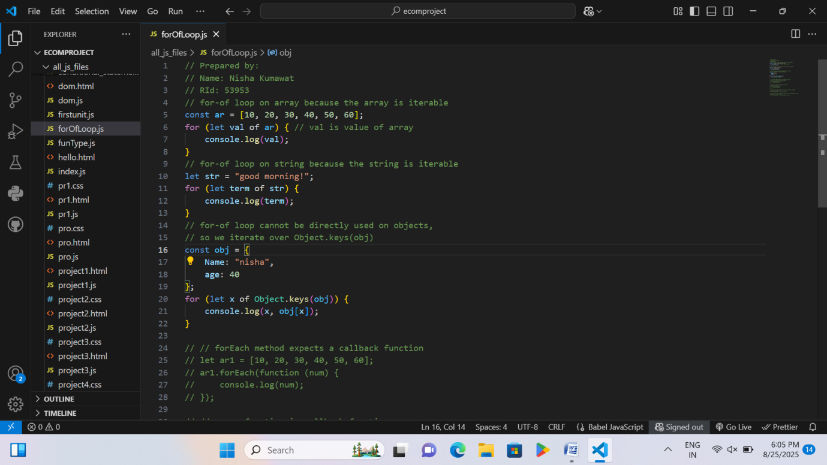
- I saved this file and then ran it.
- Finally, the output was printed directly in the console.
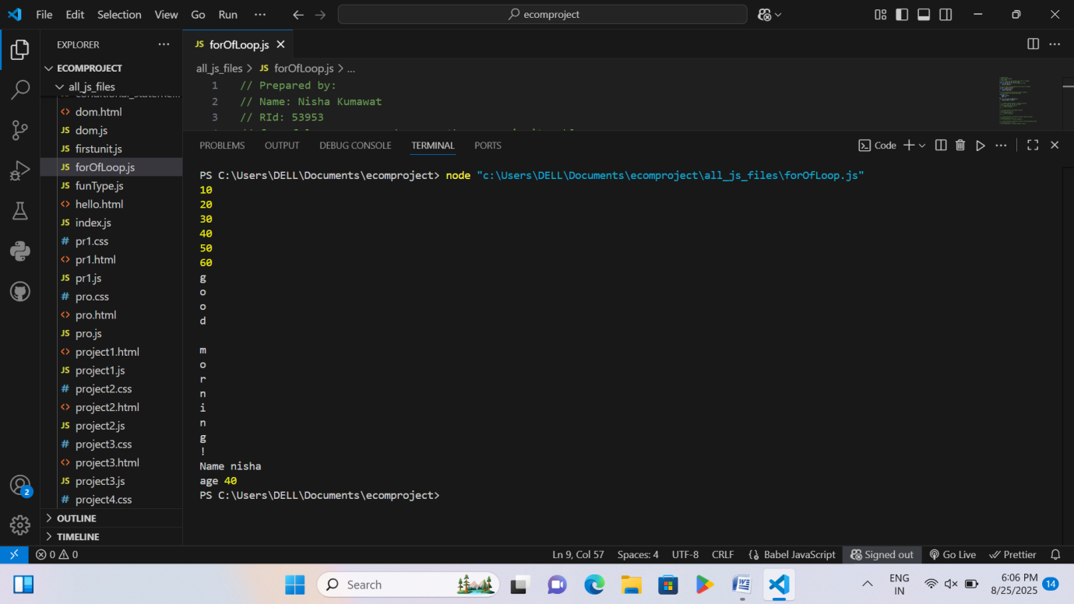

Code2
Steps:
- A new JavaScript file named forOfLoop.html was created.
- forEach with Normal Callback Function
  - An array ar1 = [10, 20, 30, 40, 50, 60] is created.
  - The forEach method loops through each element and prints it using a callback function function(num).
- forEach with Arrow Function
  - Another array arr2 = [1, 2, 3] is created.
  - The forEach method is used with an arrow function (num) => { console.log(num); } to print each number.
- forEach with Shorter Arrow Function
  - An array arr1 = [1, 2, 3] is created again.
  - forEach is written in a shorter way:
  - arr1.forEach(num => console.log(num));
  - It directly prints each element without braces { }.
- forEach with Arrow Function (Performing Operation)
  - An array arr3 = [1, 2, 3, 4] is created.
  - forEach is used with an arrow function to print squared values of each number (num * num).
- Summary
  - The code shows different ways of using forEach with arrays:
    - Normal callback function
    - Arrow function with braces
    - Short arrow function without braces
    - Arrow function with an operation (squaring numbers)

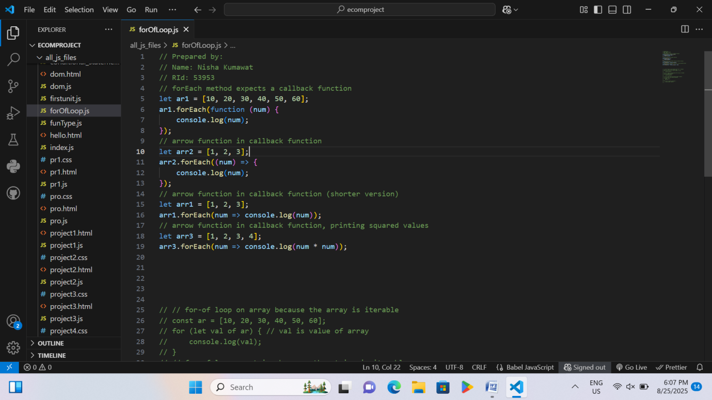
- I saved this file and then ran it.
- Finally, the output was printed directly in the console.

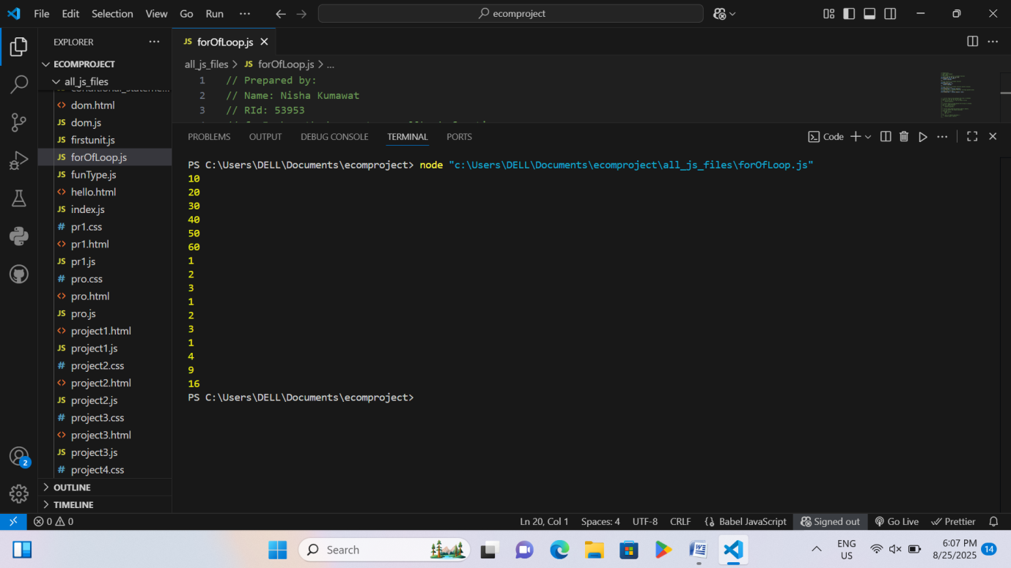

Activity 11: Js code and Foundations of React code
Code 1
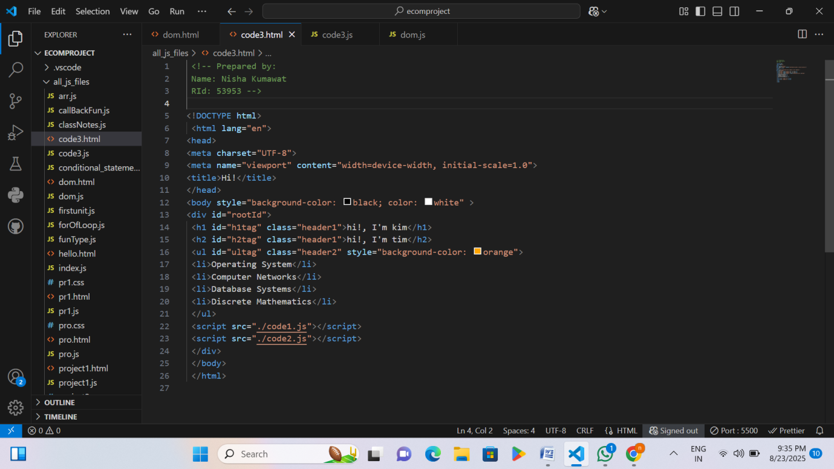
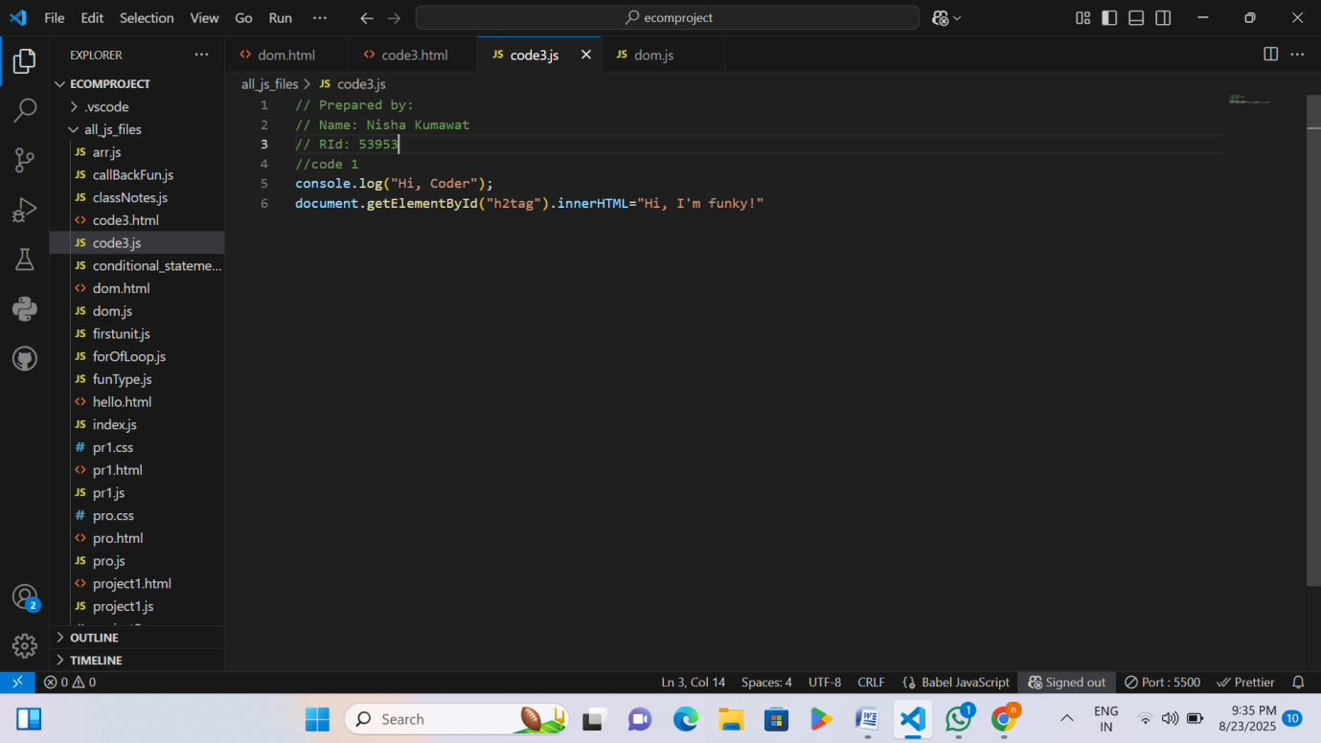

Page 40 RID 53953

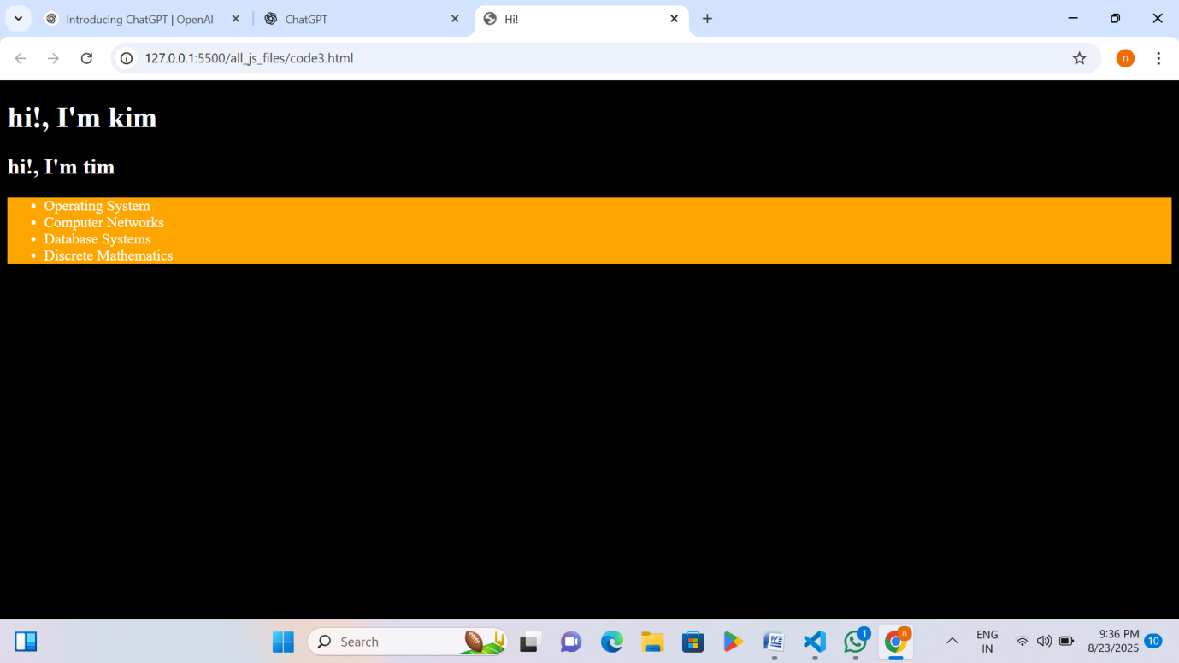

Explanation – Js code and foundations of React code
Code =1.

• HTML Structure and Styling: The HTML file creates a webpage with a black background and white text. It includes headings (h1, h2) and a list (ul) with some subjects. The h2 element and ul have specific IDs and classes for styling and JavaScript manipulation.
• JavaScript Functionality: The first JavaScript file (code1.js) prints "Hi, Coder" in the browser console and changes the text of the h2 heading from "hi!, I'm tim" to "Hi, I'm funky!" using getElementById and innerHTML.
Code 2

Page 41 RID 53953

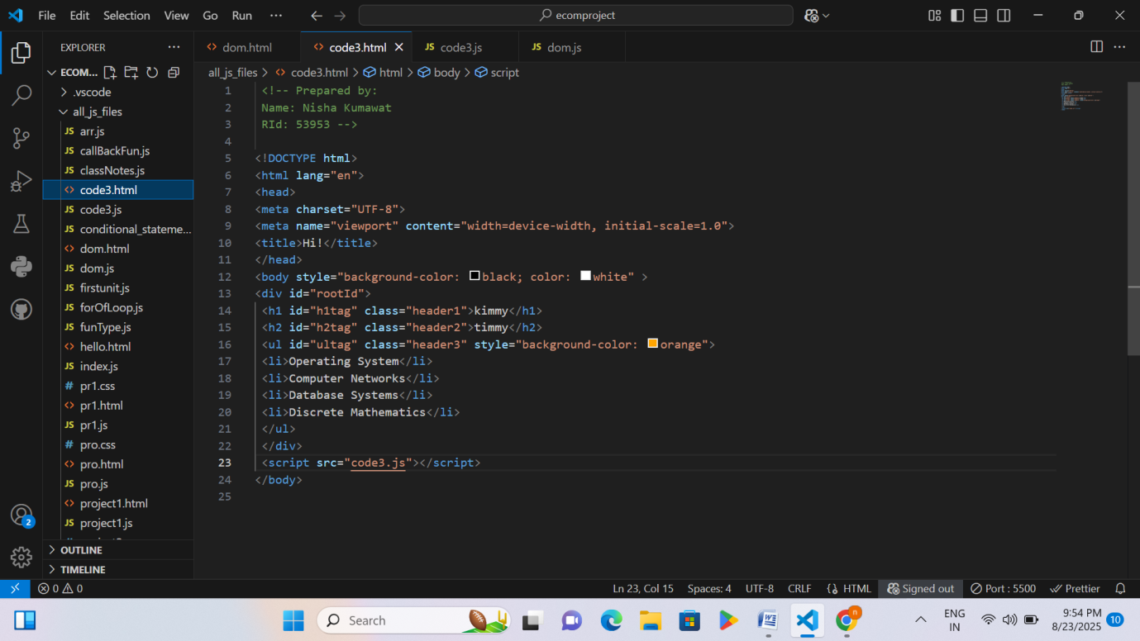
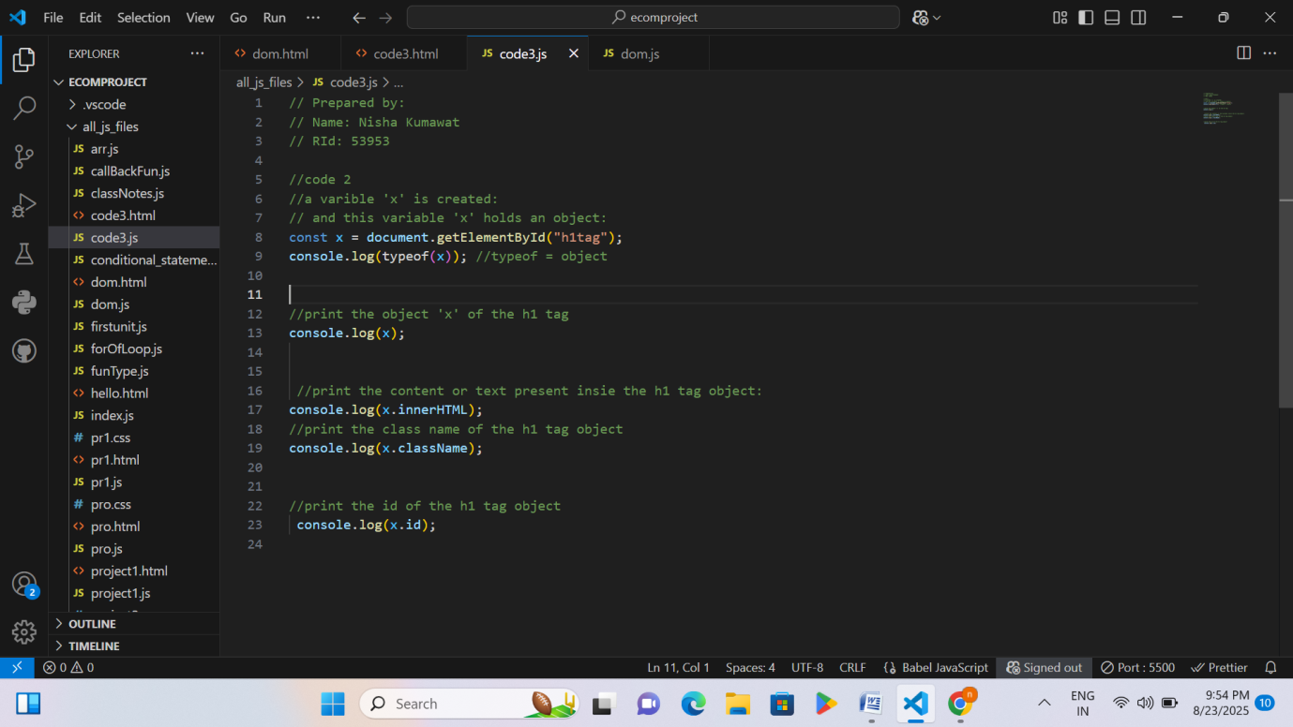

Page 42 RID 53953

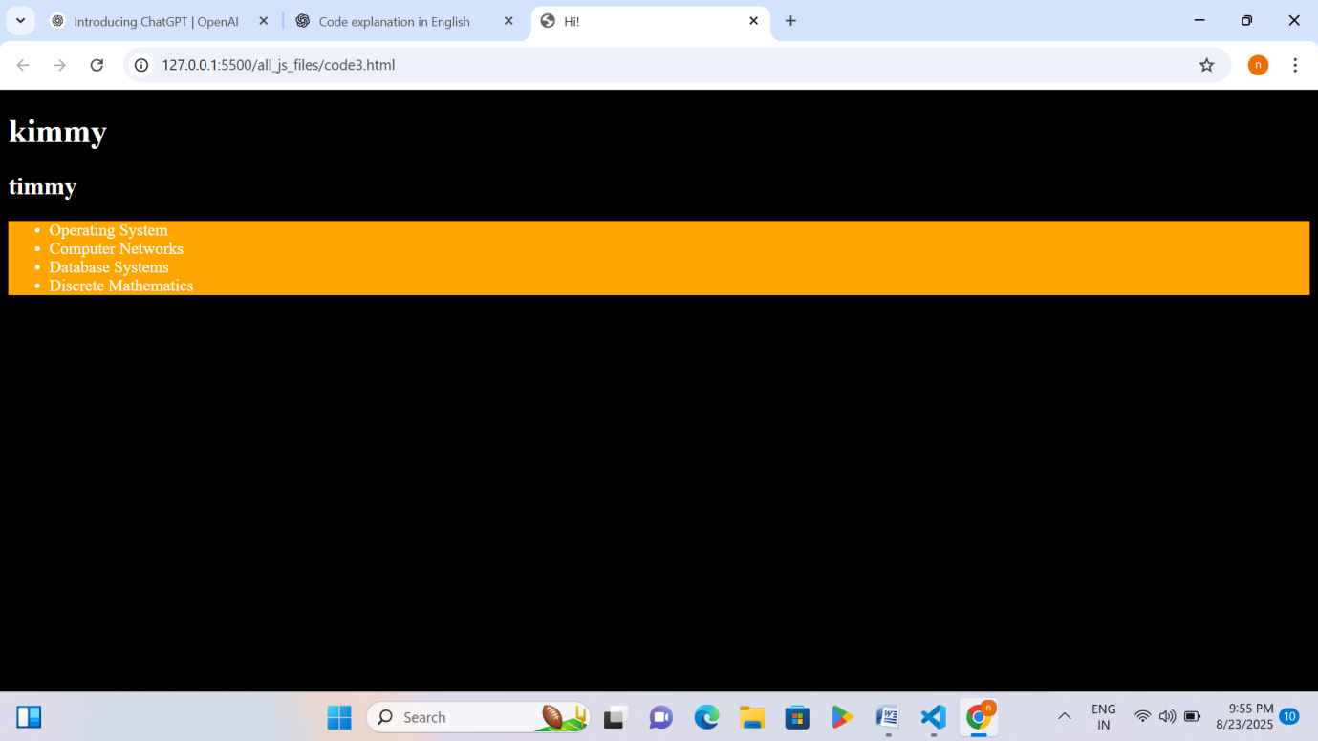

Explanation – Js code and foundations of React code
Code =2.
- Selecting an HTML Element: The JavaScript code selects the <h1> element with the ID "h1tag" and stores it in the variable x. The typeof(x) command confirms that x is an object representing the HTML element.
- Accessing Element Properties: The code then prints different details of the <h1> element: the entire object (x), its text content (x.innerHTML), its class name (x.className), and its ID (x.id) to the browser console.
Code 3

Page 43 RID 53953

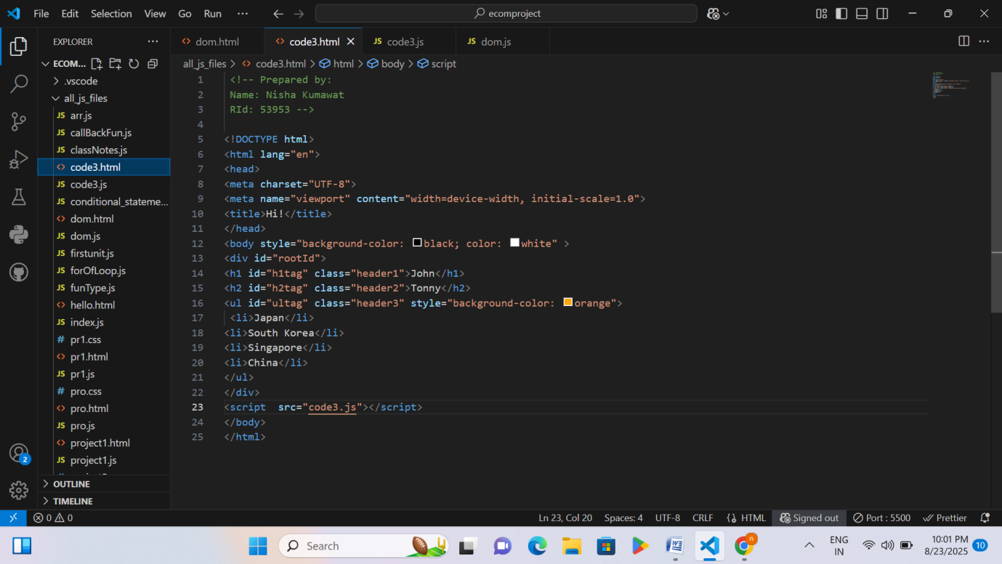
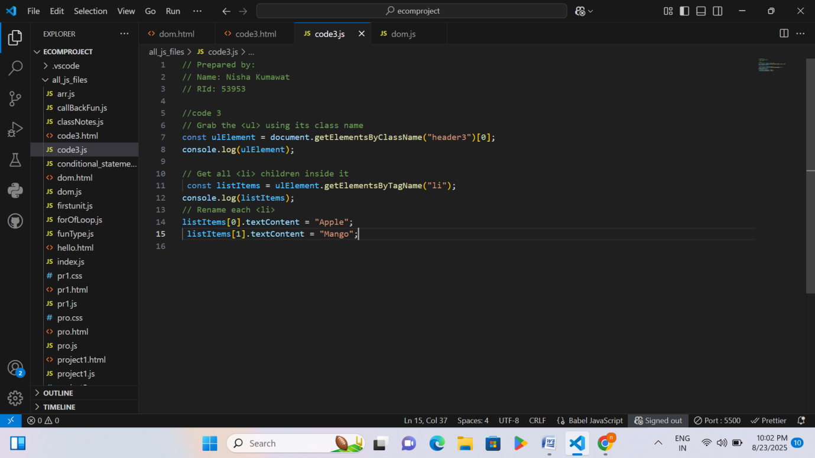

Page 44 RID 53953

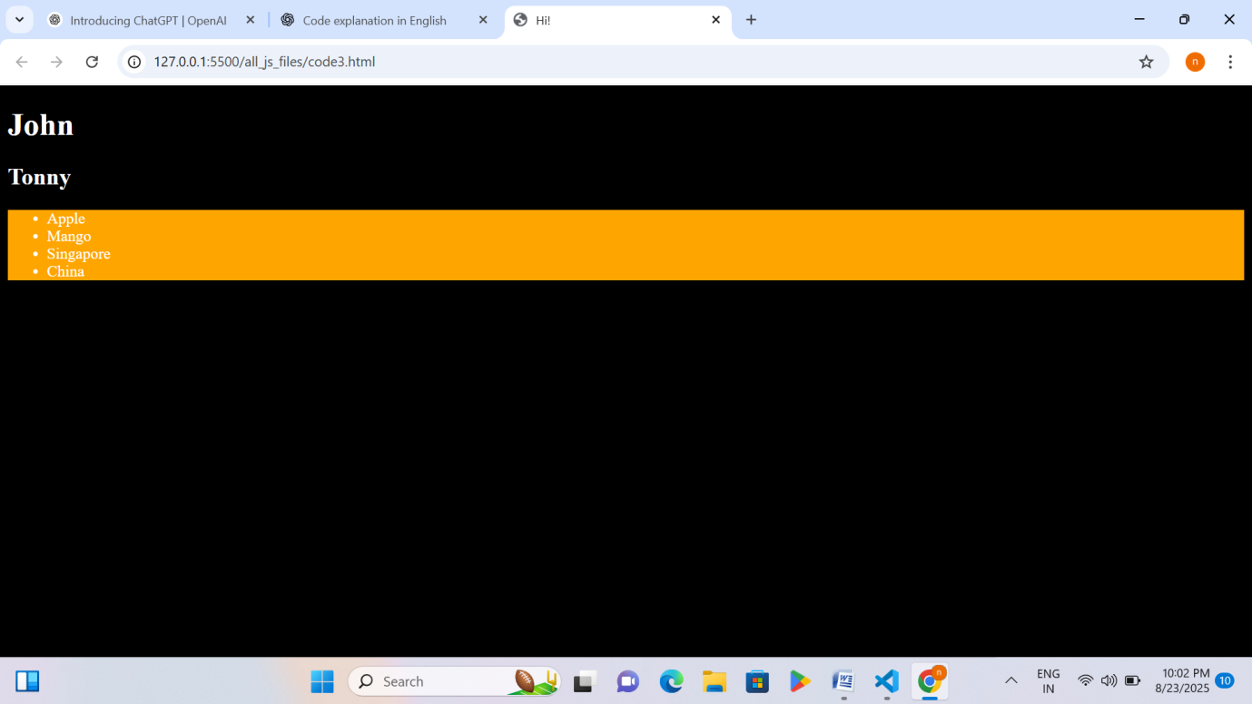

Explanation – Js code and foundations of React code
Code =3.
• Selecting Elements: The JavaScript code selects the <ul> element using its class name "header3" and stores it in ulElement. Then it selects all <li> items inside that <ul> and stores them in listItems.
• Modifying Content: The code changes the text of the first two <li> items: the first item becomes "Apple" and the second item becomes "Mango". The updated elements are also printed in the console.
Code 4

Page 45 RID 53953

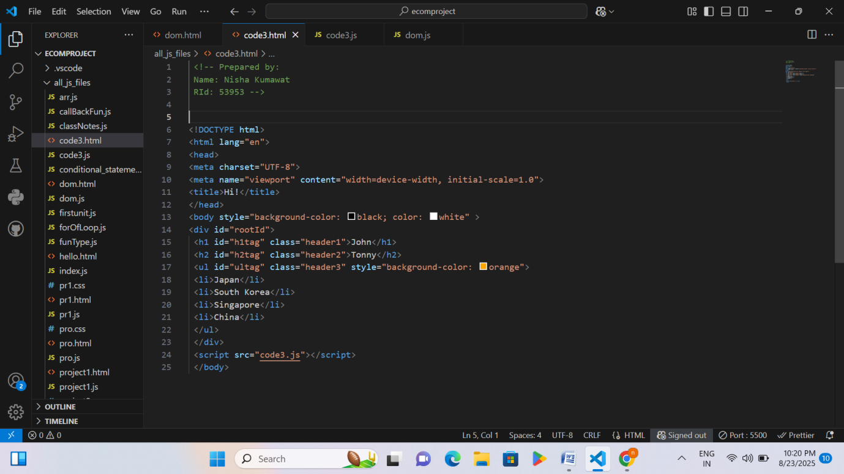
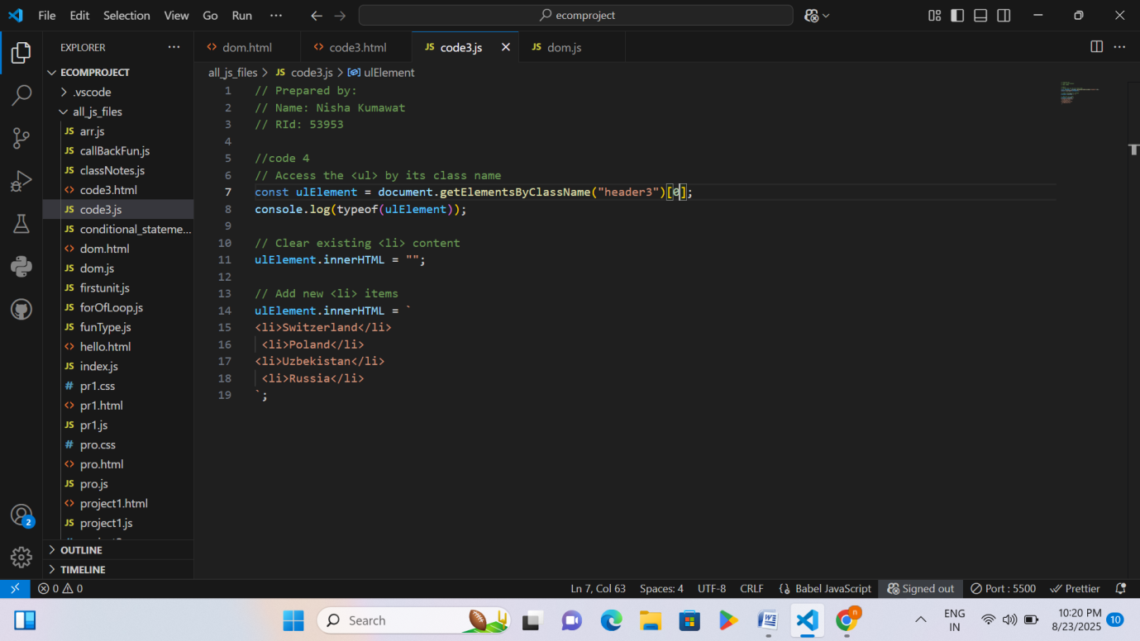

Page 46 RID 53953

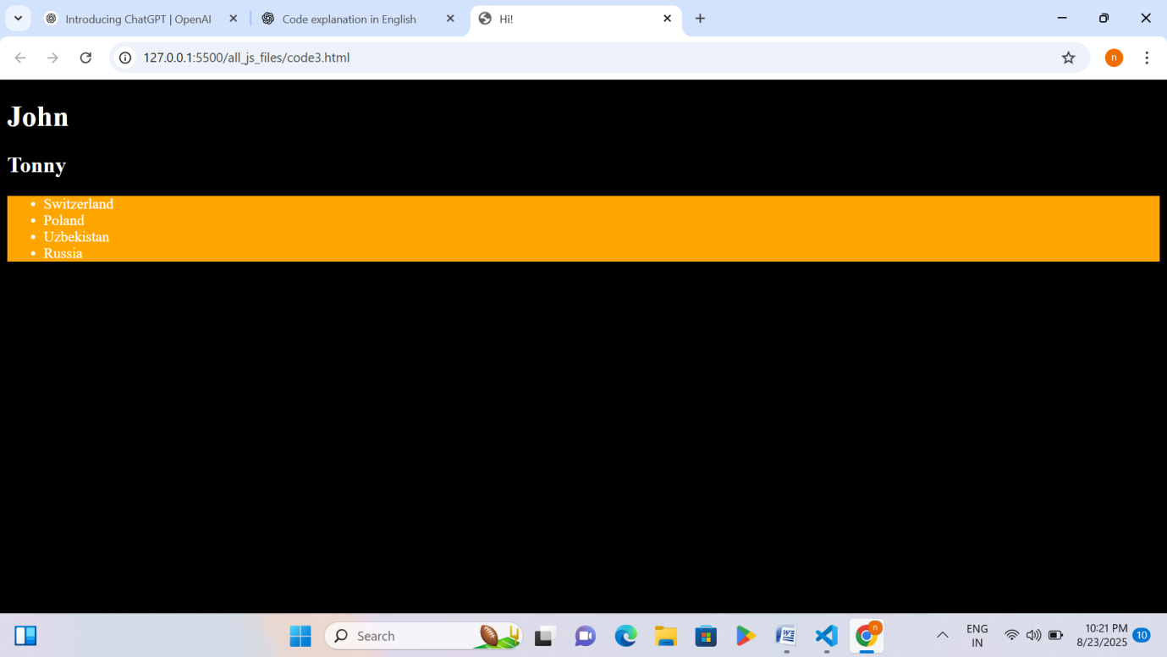

Explanation – Js code and foundations of React code
Code =4
• Selecting the <ul> Element: The JavaScript code selects the first <ul> element with the class name "header3" using getElementsByClassName()[0] and stores it in ulElement.
• Modifying the List: The code first clears all existing <li> items by setting ulElement.innerHTML to an empty string, then adds new <li> items (Switzerland, Poland, Uzbekistan, Russia) by updating innerHTML.
Code 5

Page 47 RID 53953

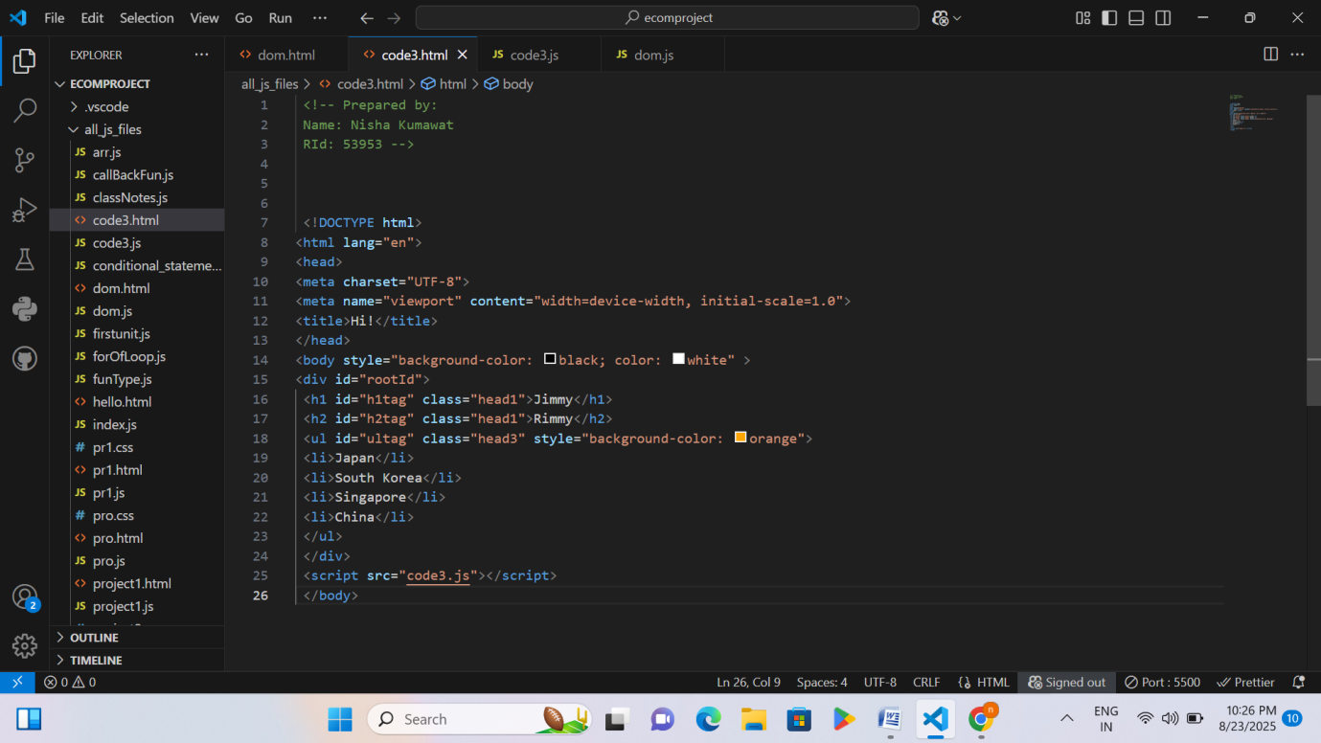
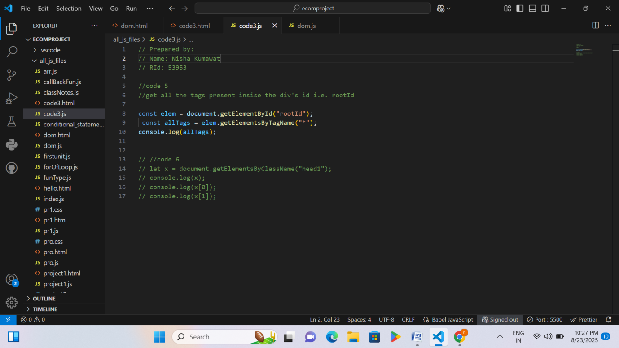

Page 48 RID 53953

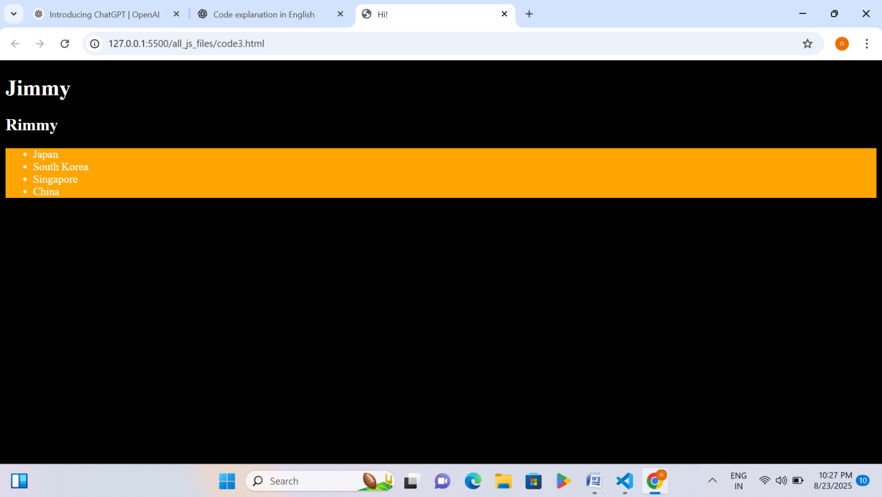
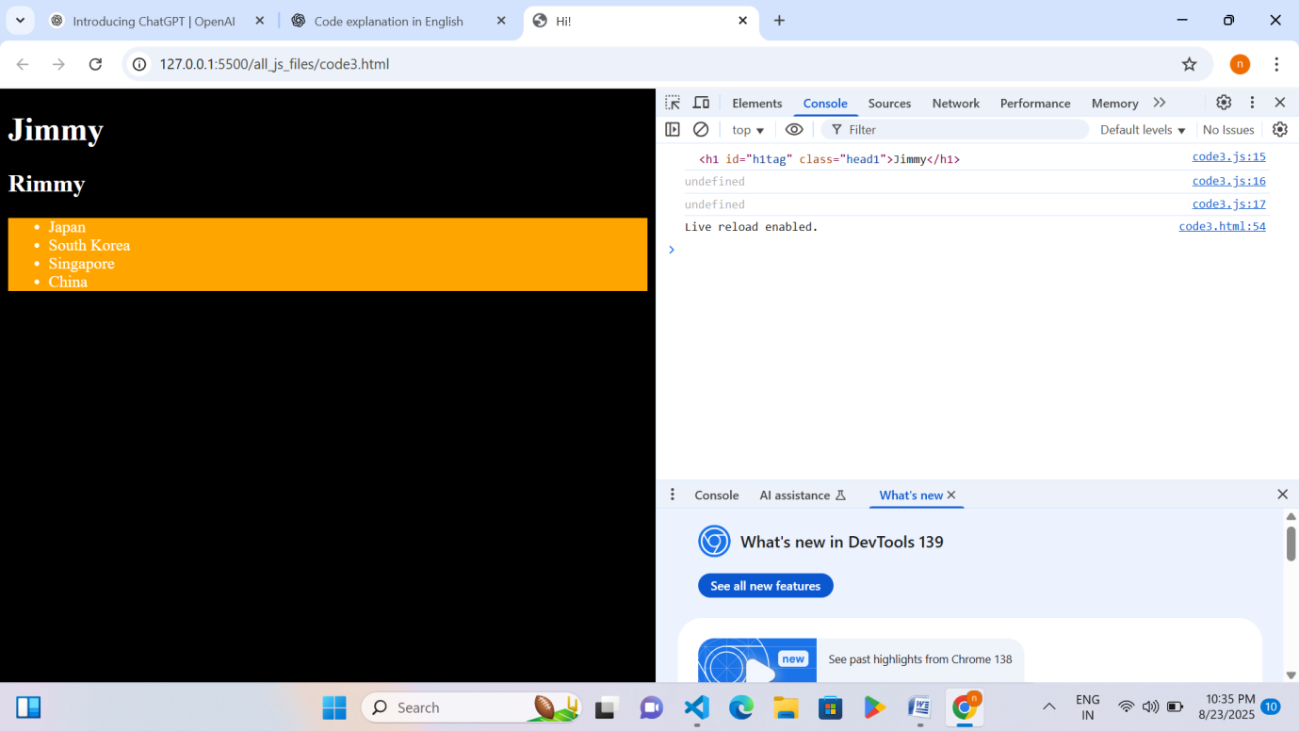

Explanation – Js code and foundations of React code
Code =5

Page 49 RID 53953

• Selecting All Elements Inside a Div: The code selects the <div> with the ID "rootId" and then uses getElementsByTagName("*") to get all HTML elements inside that div. These elements are stored in allTags and printed in the console.
• Accessing Elements by Class Name: The code also selects all elements with the class "head1" using getElementsByClassName("head1") and prints the whole collection (x) as well as the individual elements (x[0] and x[1]) in the console.
Activity 13: For of loop/For Each
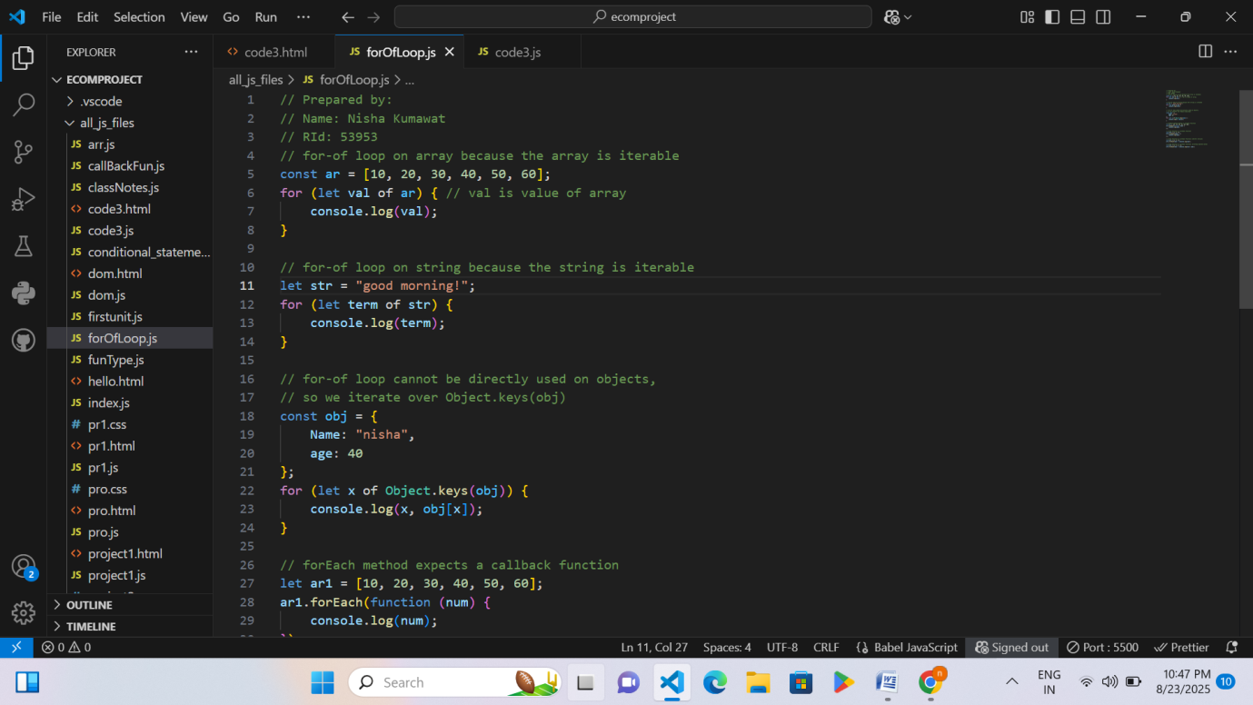

Page 50 RID 53953
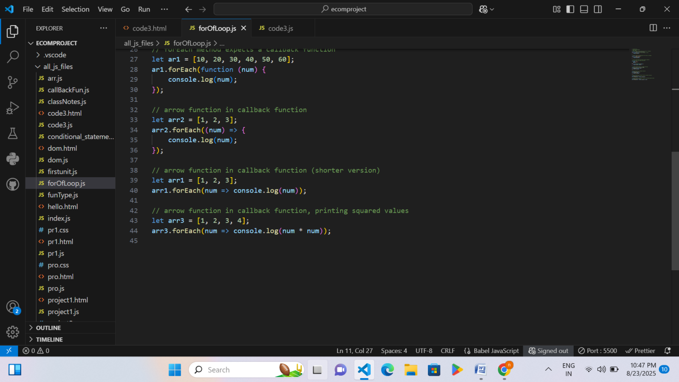

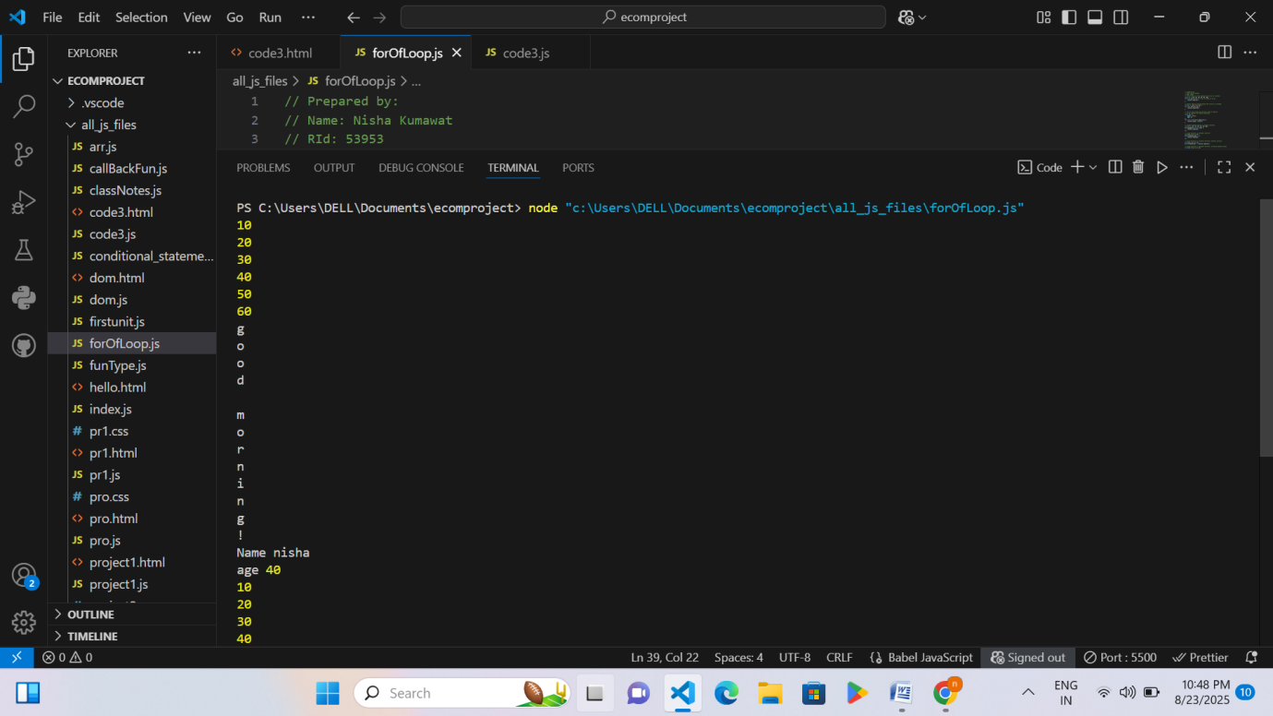

Page 51 RID 53953

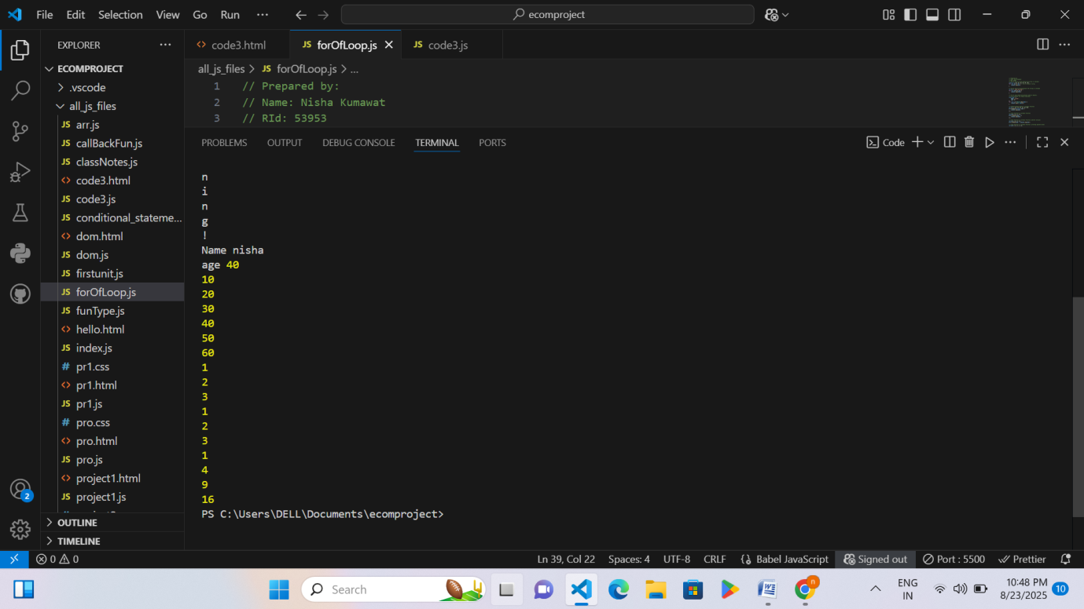

Explanation – For of loop/For Each
- Using for...of Loops: The code demonstrates how for...of loops work with arrays and strings (since they are iterable). For objects, it uses Object.keys(obj) to loop through keys and then prints both keys and their values.
- Using forEach with Callback Functions: The code shows different ways to use the forEach method on arrays — with a normal function, with arrow functions, and even printing transformed values (like squares of numbers) inside the callback.

Code 1=Spread Operator
Steps:
- A new JavaScript file named shallowAndDeepCopy.js was created
- Copying an array:
The spread operator ... takes all elements of arr1 and creates a new array arr2 with the same elements. This way, arr2 is independent, and changes to it (like adding 4) don’t affect arr1.
- Merging arrays:
The spread operator is used to combine two arrays a and b into a new array merged. It takes all elements from both arrays and puts them together in a single array.
- I saved this file and then ran it.
- Finally, the output was printed directly in the console.
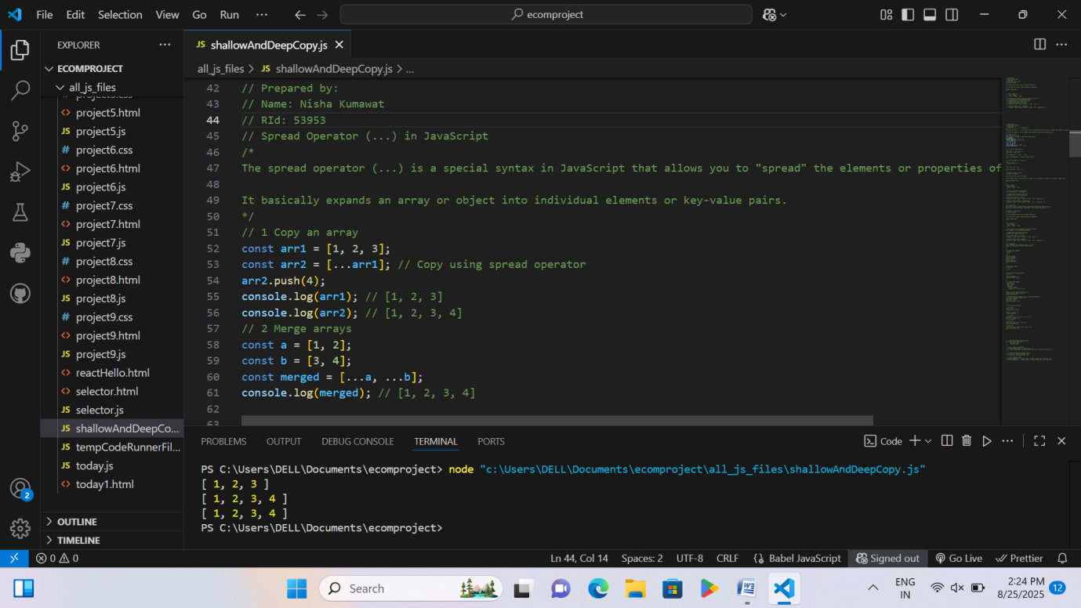

RID 53953 page 7

Activity 14: Playing with Js using HTML/CSS
Code 1

Page 52 RID 53953

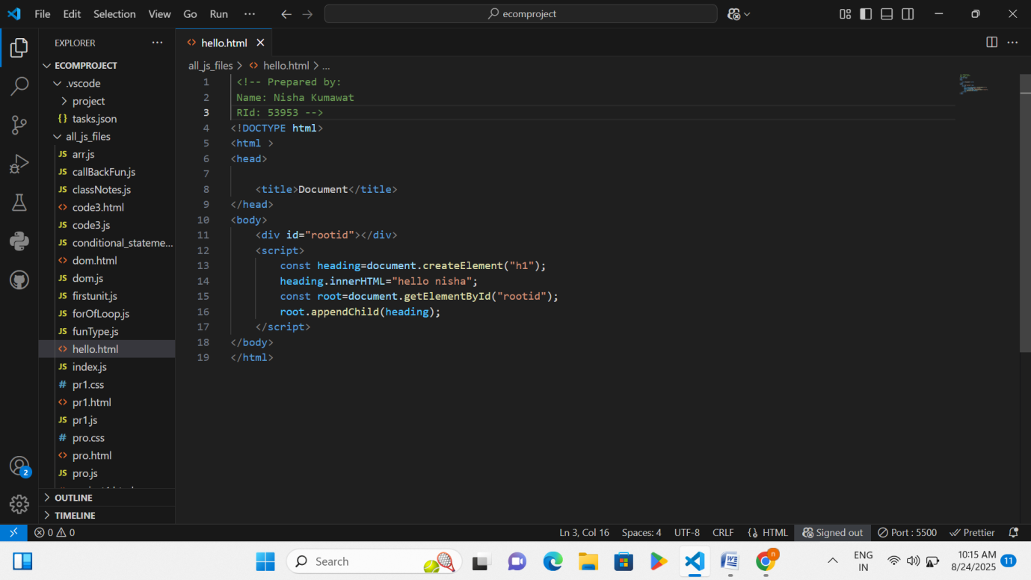
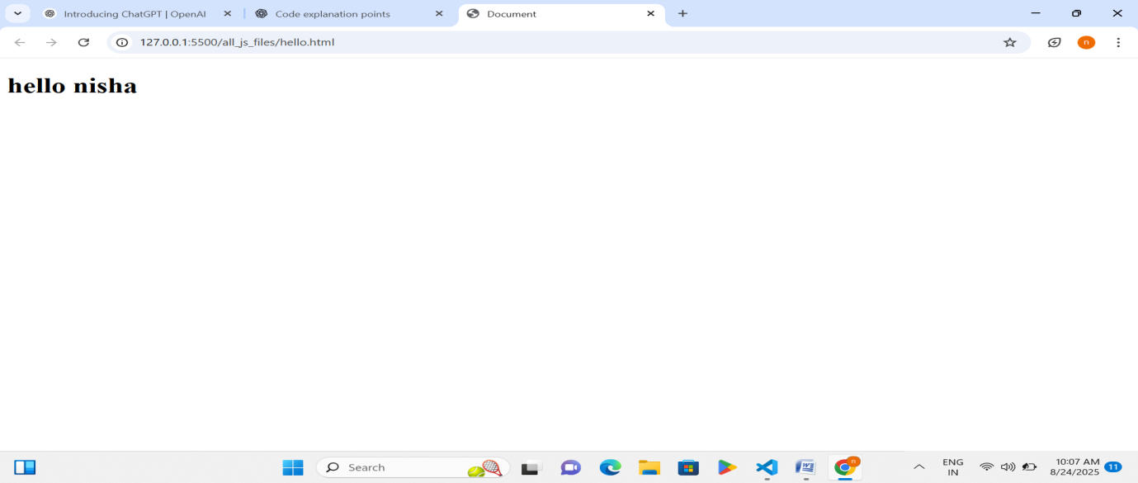

Explanation – Playing with Js using HTML/CSS
Code=1.
1. Creating a New Element
- document.createElement("h1") creates a new <h1> element.
- heading.innerHTML = "hello nisha"; adds the text "hello nisha" inside that element.
- Adding Element to Webpage
Page 53 RID 53953

- document.getElementById("rootid") finds the <div> with id rootid.
- root.appendChild(heading) inserts the new <h1> element inside the <div>, so it shows on the webpage.
Code 2
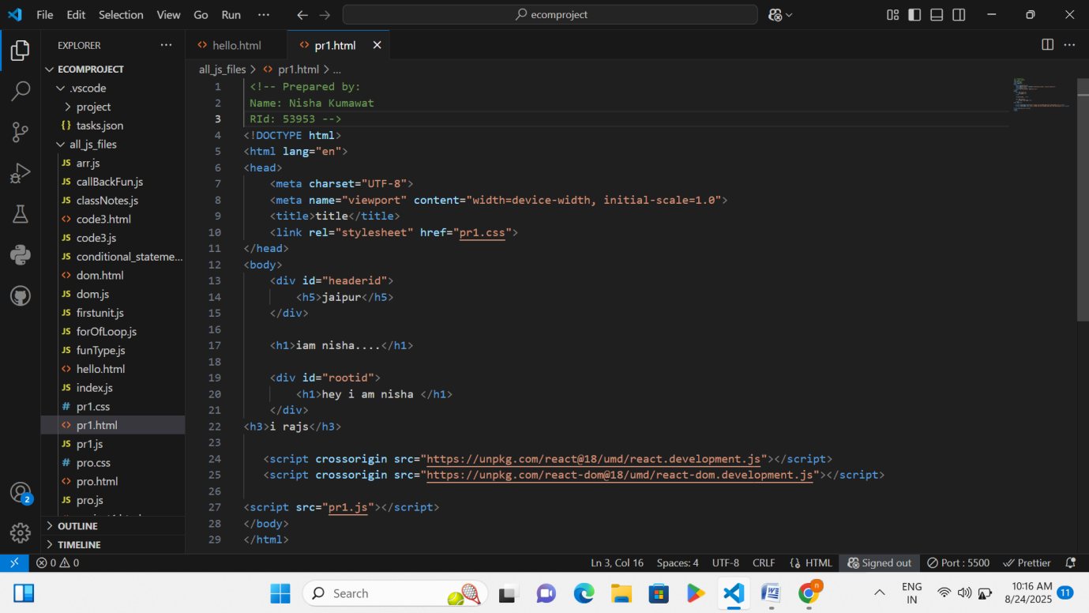
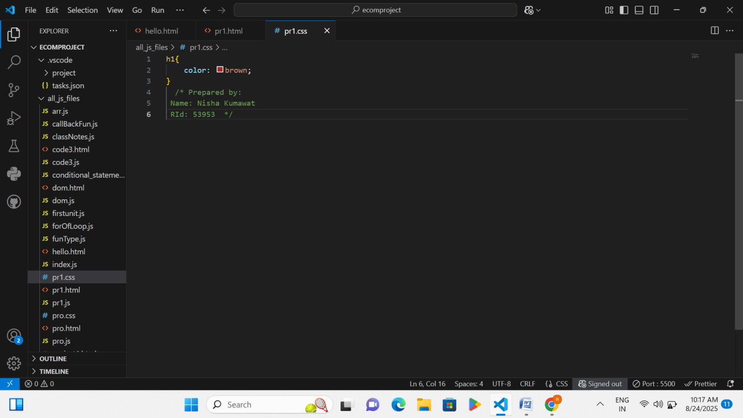

Page 54 RID 53953

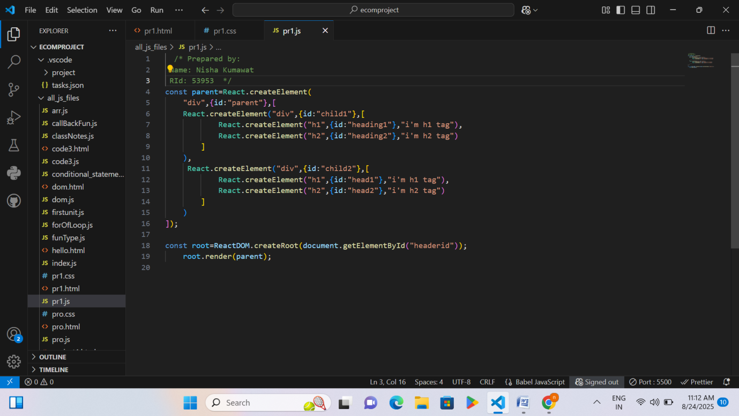
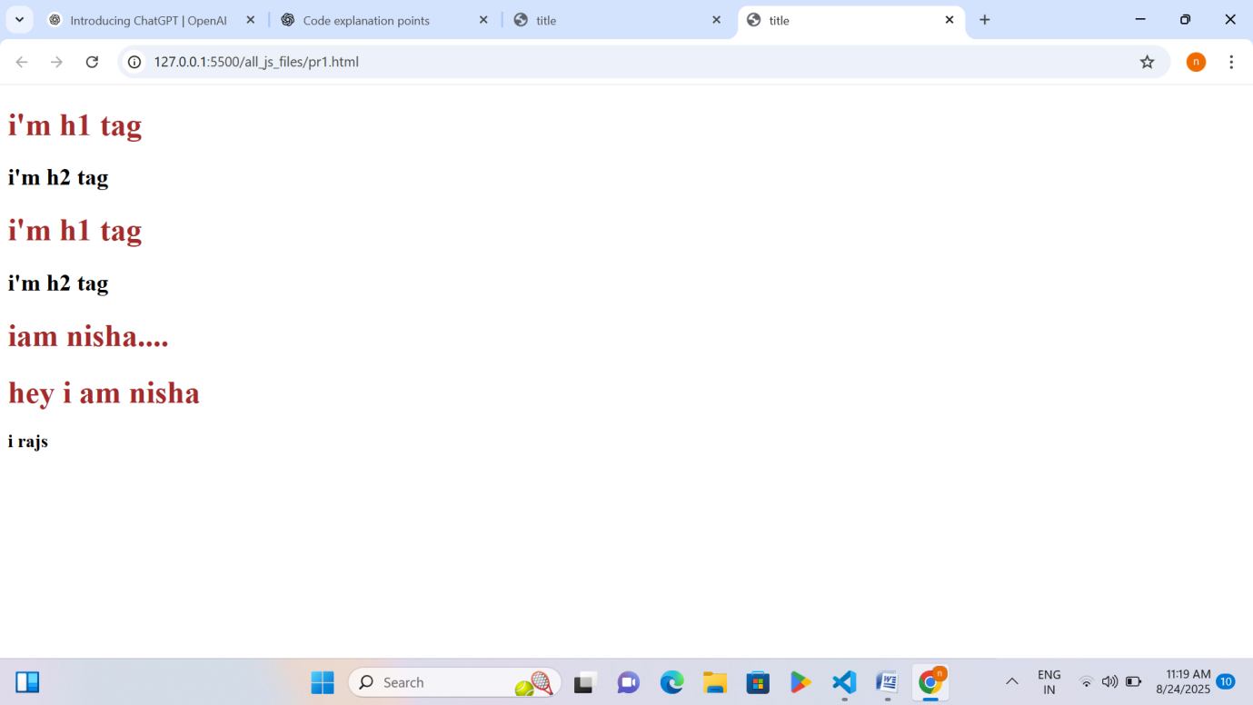

Explanation – Playing with Js using HTML/CSS
Code =2.
1. Creating React Elements
Page 55 RID 53953

- Using React.createElement(), two child <div> elements are created (child1 and child2).
- Each child contains an <h1> and <h2> heading with some text.
- All of these are wrapped inside a parent <div id="parent">.
2. Rendering Elements to Webpage
- ReactDOM.createRoot(document.getElementById("headerid")) selects the <div id="headerid">.
- root.render(parent) displays the parent element (with its children) inside that <div> on the webpage.
Code 3
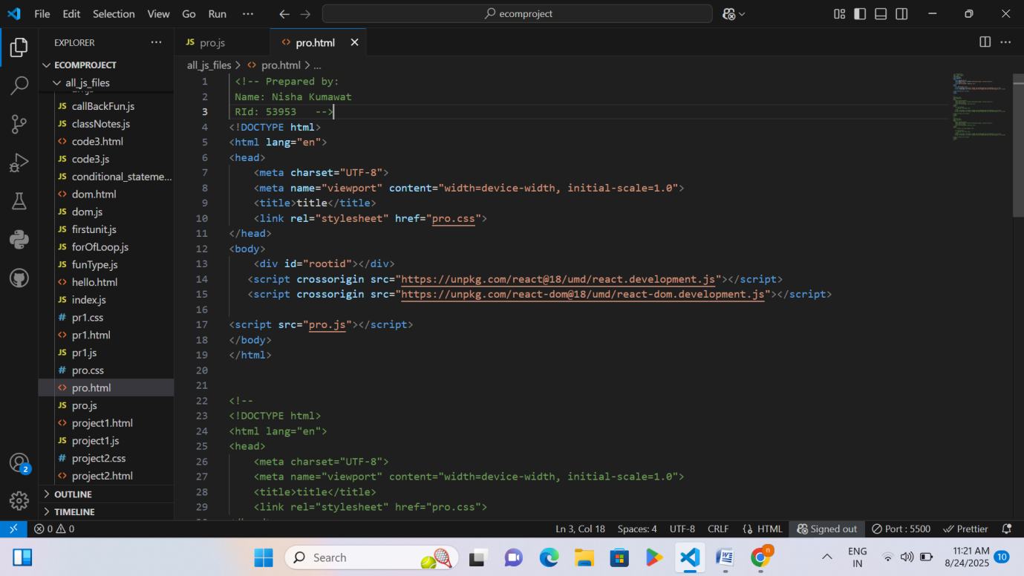

Page 56 RID 53953

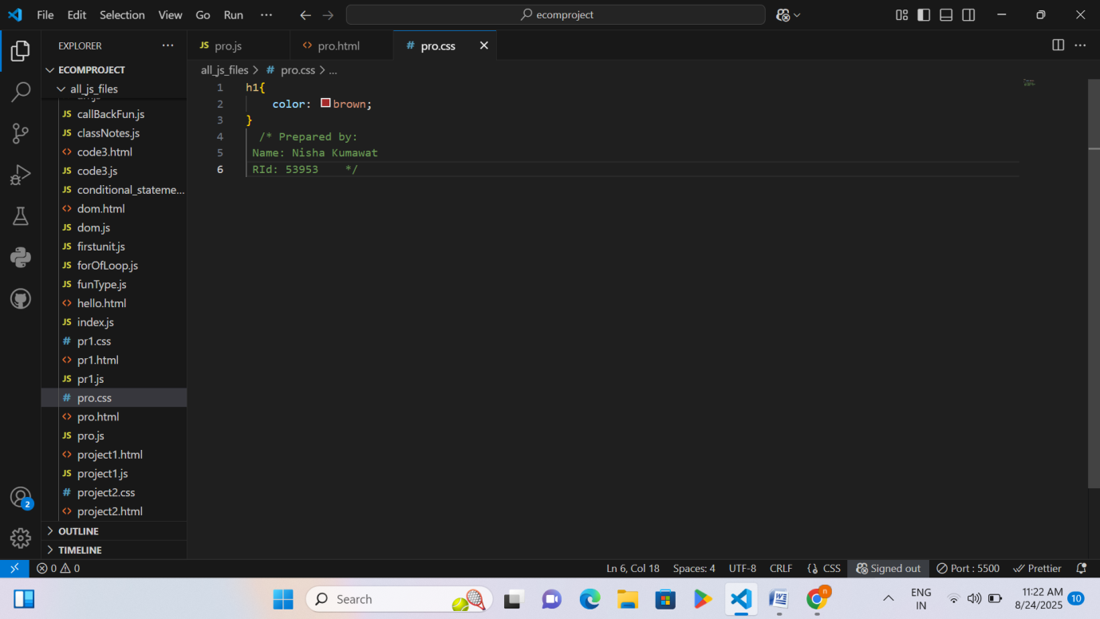
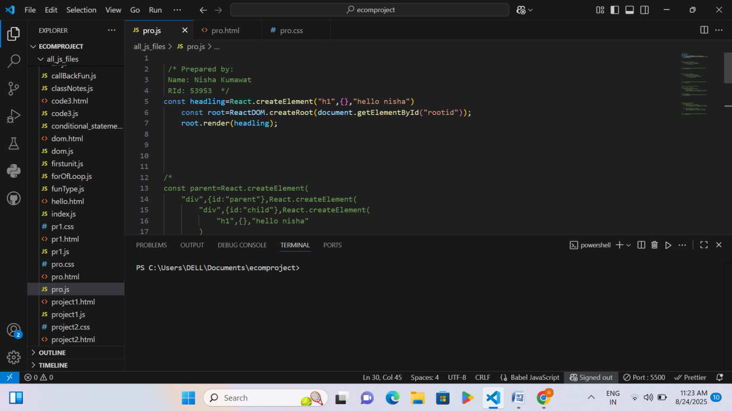

Page 57 RID 53953

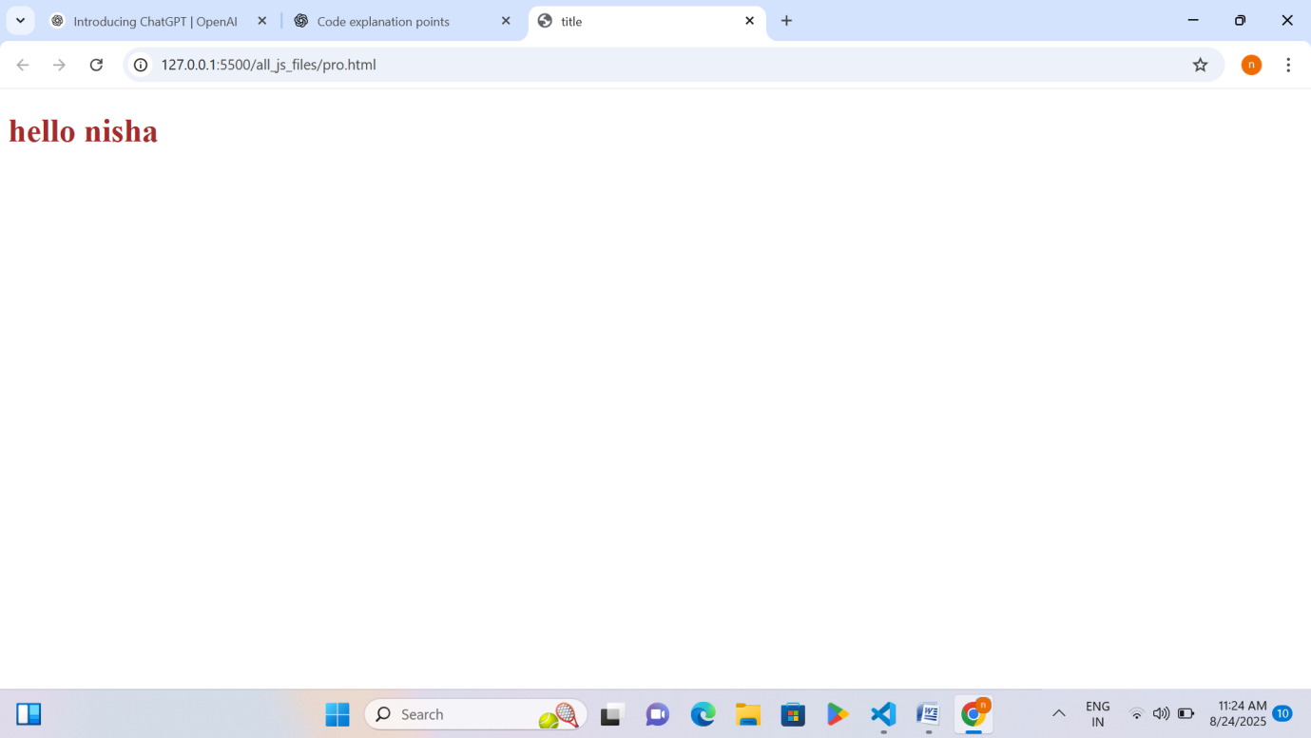

Explanation – Playing with Js using HTML/CSS
Code =3.
1. HTML File
- It makes the basic structure of the webpage.
- It has a container (div) where React will show the content.
- It connects the CSS file for styling and the JavaScript file for logic.
- React libraries are also included so React code can run.
2. CSS File
- It changes the style of the heading.
- The heading text is shown in brown color.
3. JavaScript File
- It creates a heading element using React.
- The text “hello nisha” is added inside the heading.
- That heading is displayed inside the container (div) of the HTML page.
Code 4

Page 58 RID 53953

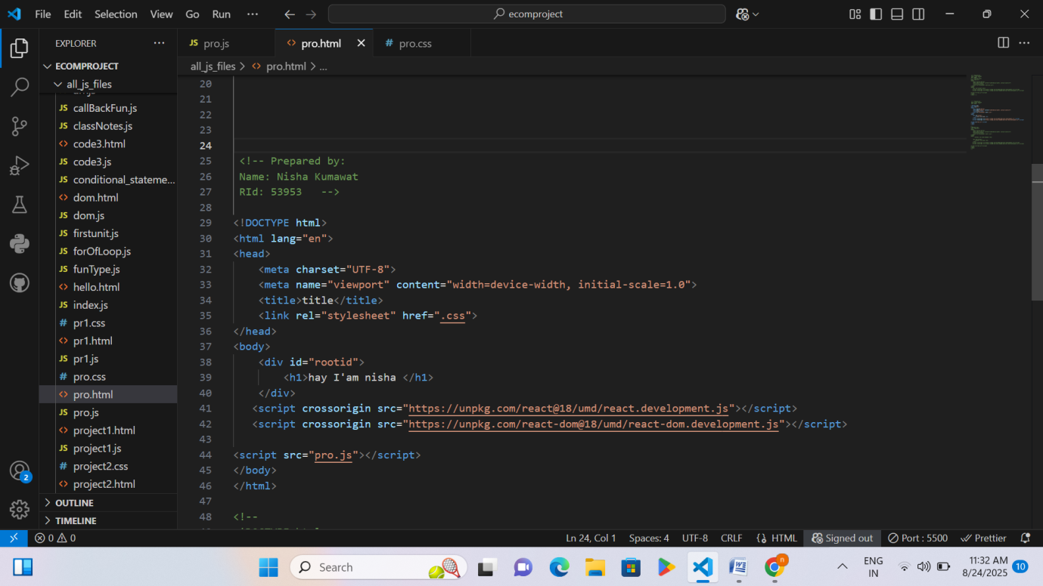
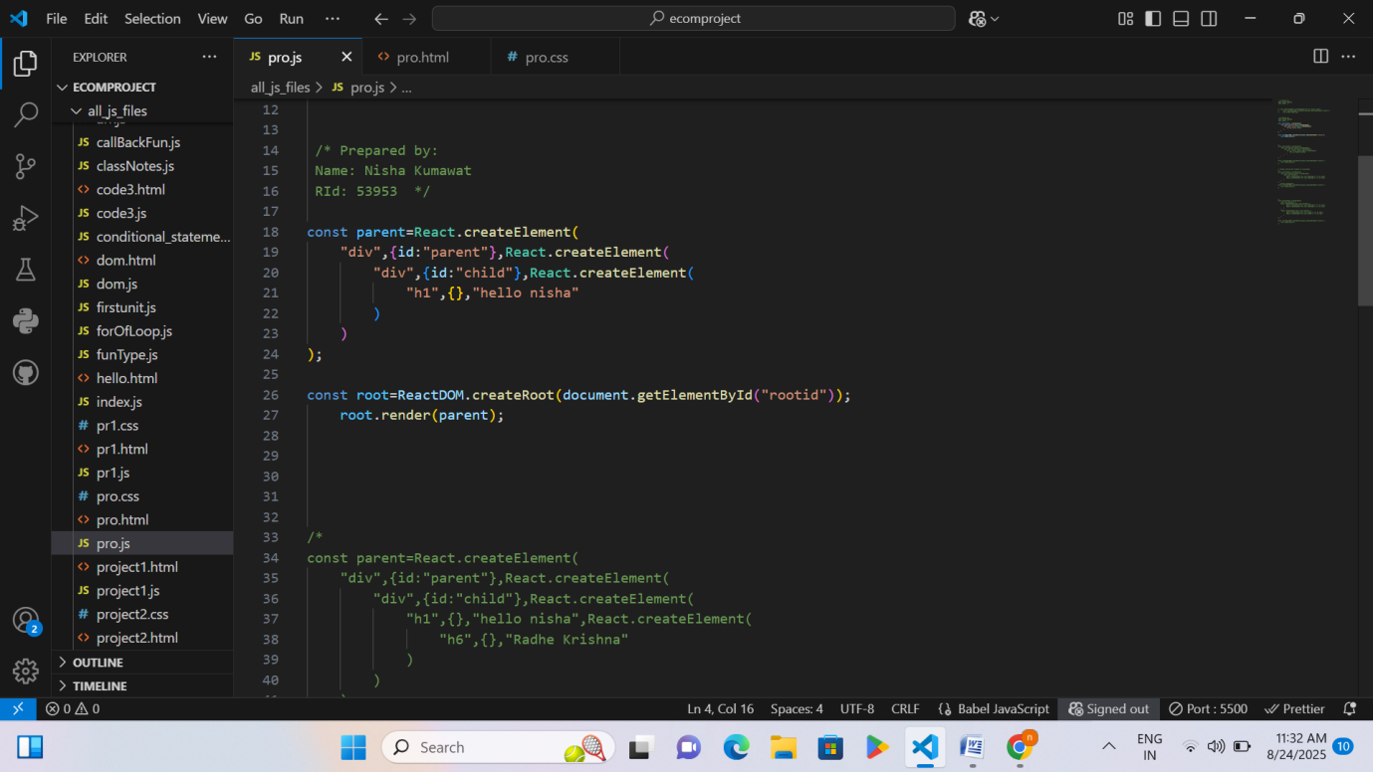

Page 59 RID 53953

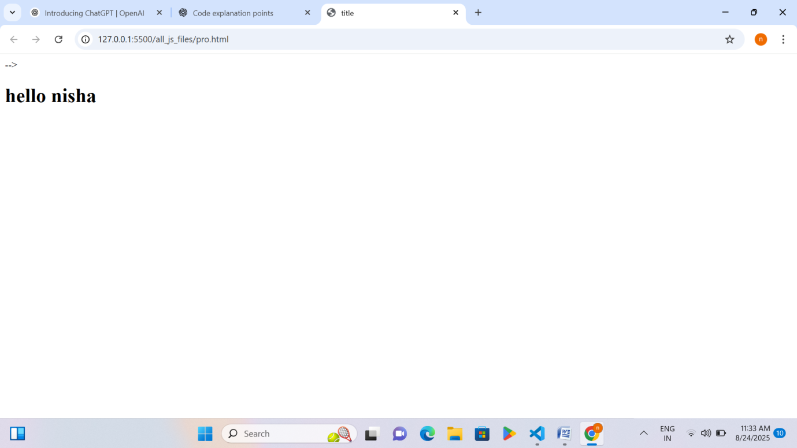

Explanation – Playing with Js using HTML/CSS
Code =4.
HTML File
- Creates the basic structure of the webpage.
Page 60 RID 53953

- Contains a container (div) with an initial heading inside it.
- Links the CSS file for styling (even if it’s empty or simple).
- Includes React and ReactDOM libraries so React code can run.
- Links the JavaScript file (pro.js) where React elements are created and displayed.
JavaScript (React)
- Creates a parent <div> and a child <div> with a heading inside.
- Displays the created React elements inside the HTML container (rootid).
- Replaces or renders the heading dynamically using React.
Code 5
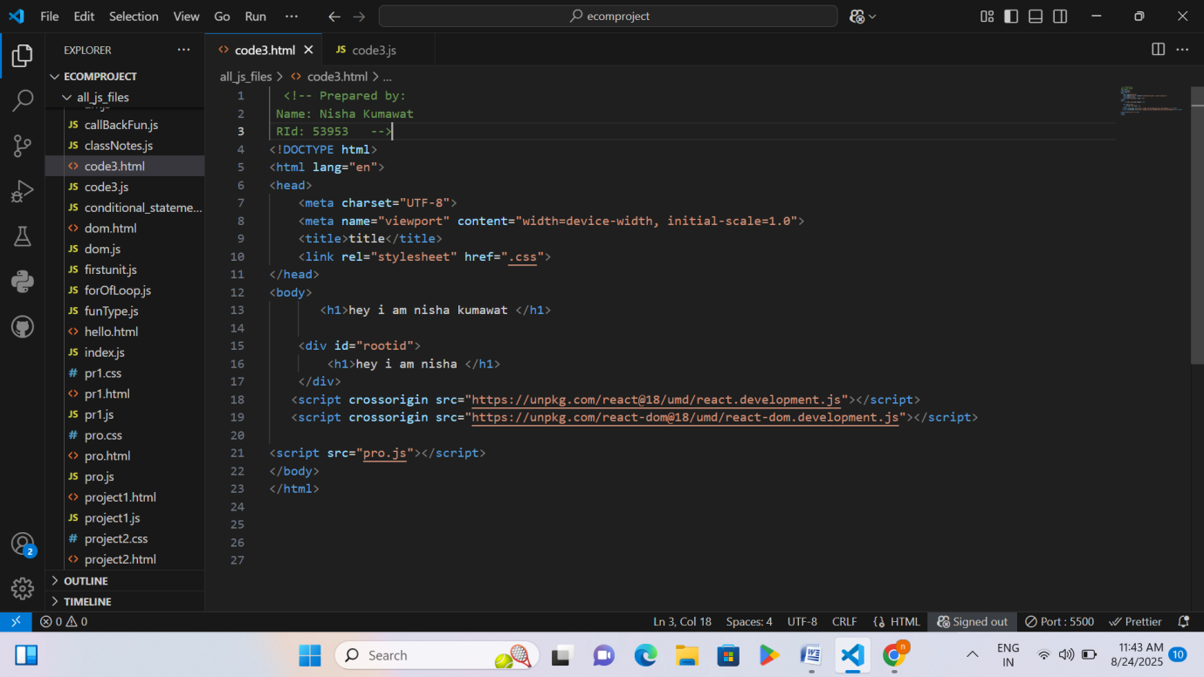

Page 61 RID 53953

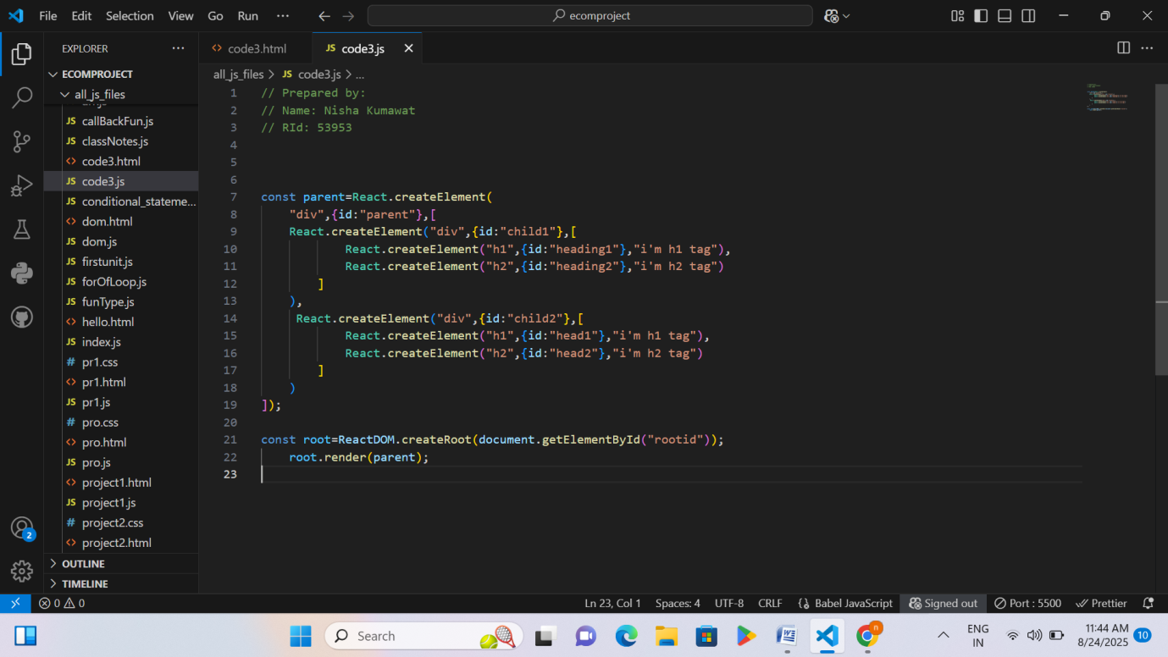
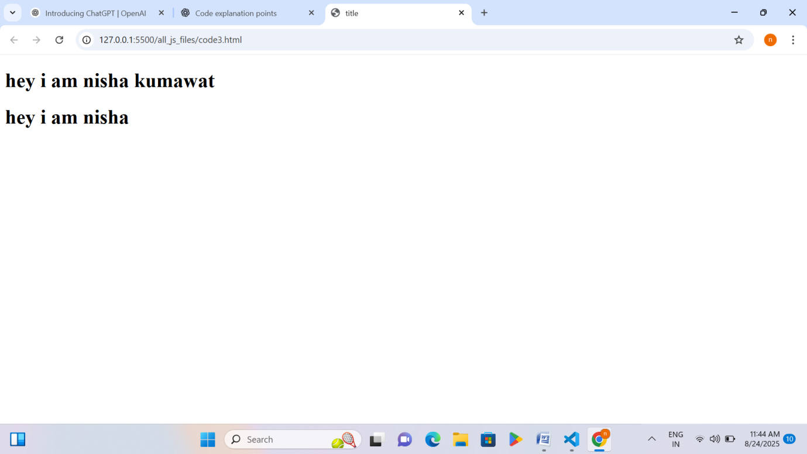

Explanation – Playing with Js using HTML/CSS
Code =5.
HTML File
- Sets up the basic webpage structure.
Page 62 RID 53953

- Includes headings and a container (div) where React content will be displayed.
- Links a CSS file for styling and a JavaScript file for React logic.
- Includes React and ReactDOM libraries so React code can run properly.
CSS (if any)
- Styles the webpage elements like headings or divs.
- Can change colors, fonts, or layout of the React-created elements.
JavaScript (React)
- Creates a parent <div> with two child <div> elements.
- Each child contains a heading (h1) and subheading (h2).
- Renders these elements dynamically inside the container (rootid) on the webpage.
Code 6
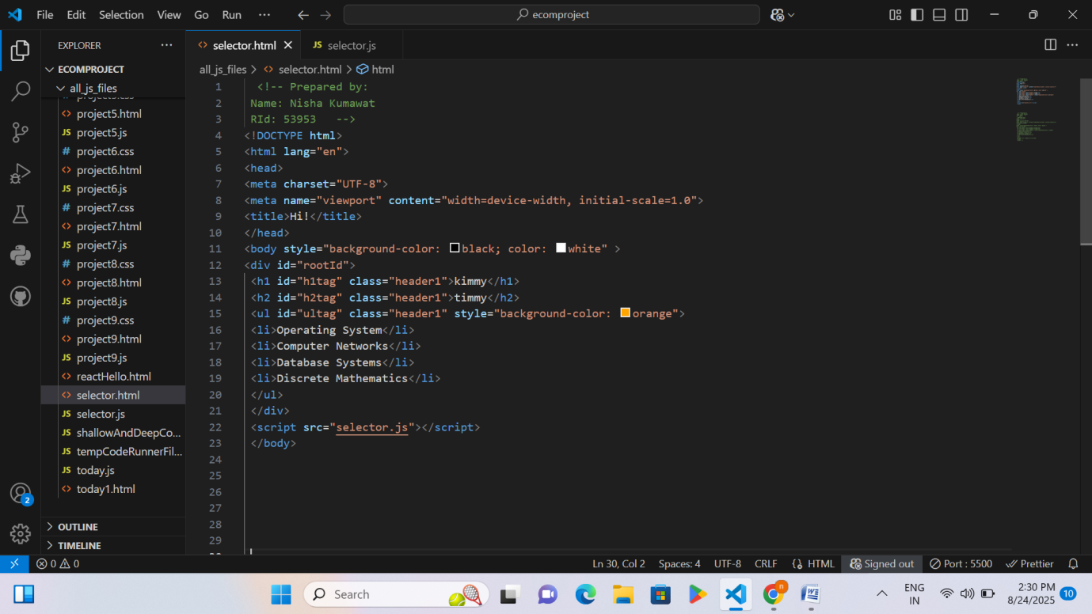

Page 63 RID 53953

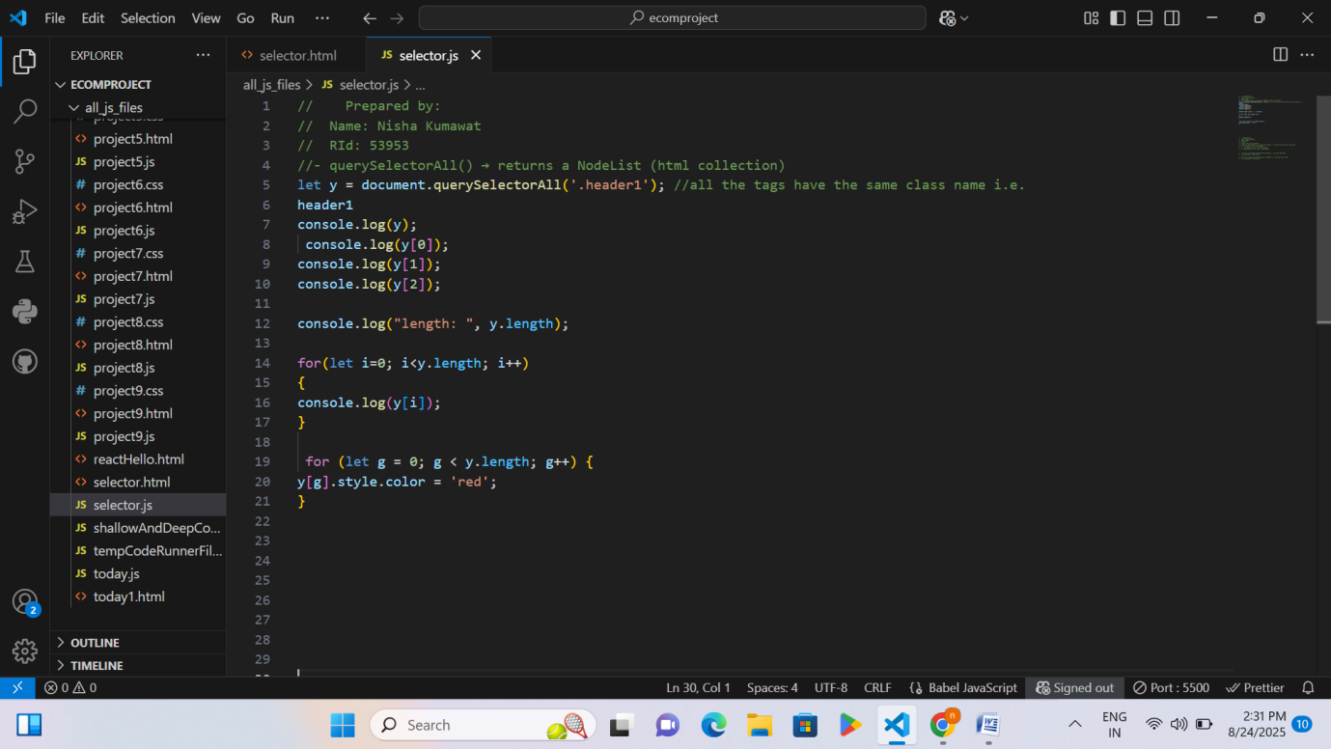
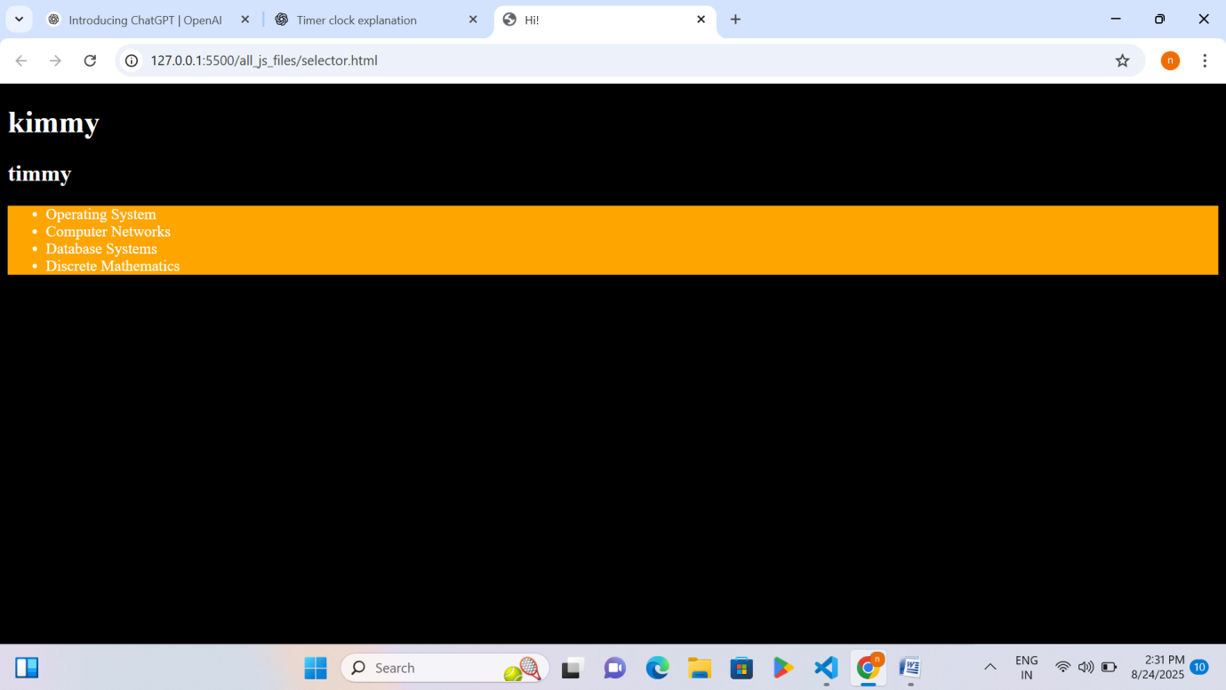

Explanation – Playing with Js using HTML/CSS
Code 6
• The webpage has multiple elements (h1, h2, ul) with the same class header1.
Page 64 RID 53953

• querySelectorAll() is used to select all elements with a specific class.
• It returns a NodeList (a collection of elements).
• You can access elements individually using index numbers like y[0], y[1], etc.
• y.length tells how many elements are in the NodeList.
• A for loop is used to go through each element in the NodeList.
• Another loop is used to change the color of all selected elements to red.
Code 7
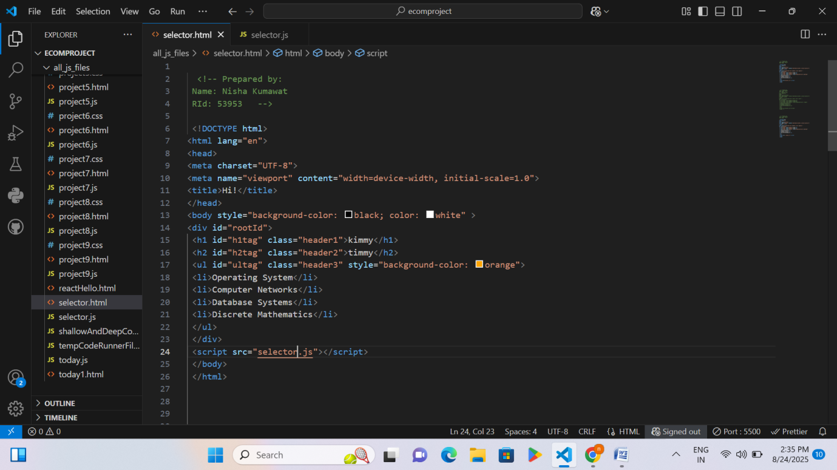

Page 65 RID 53953

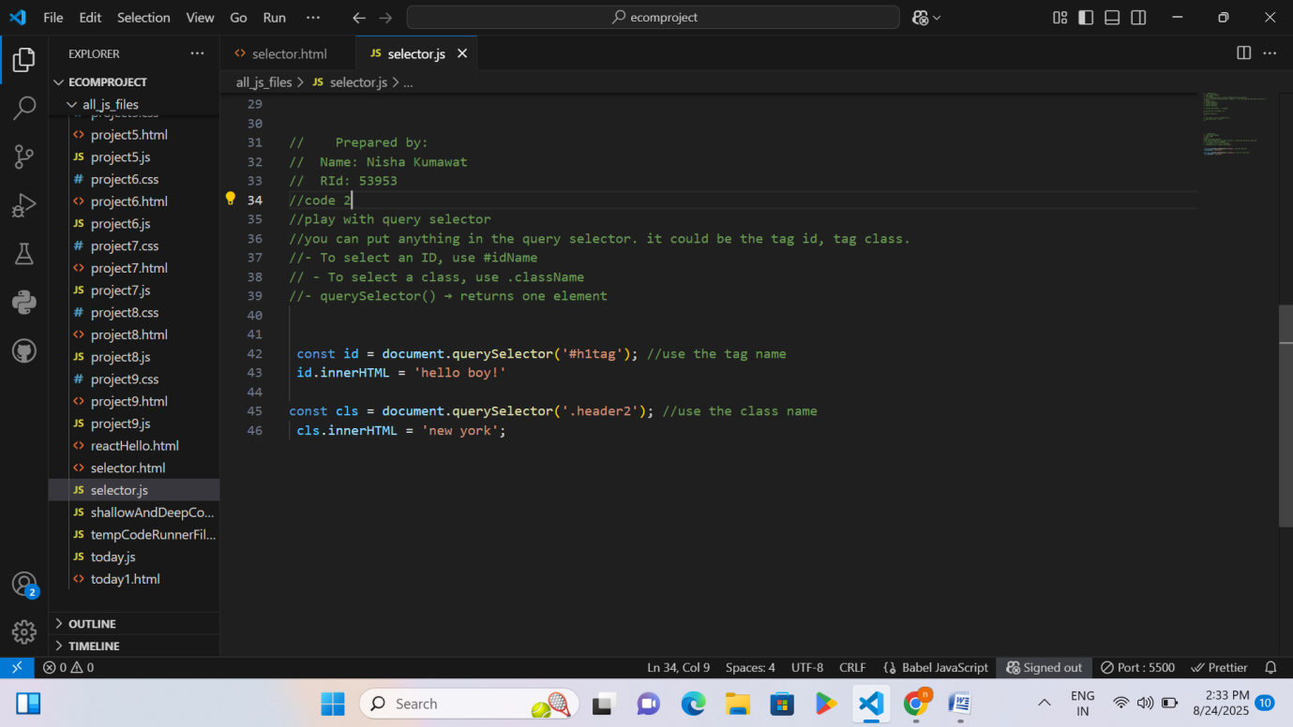
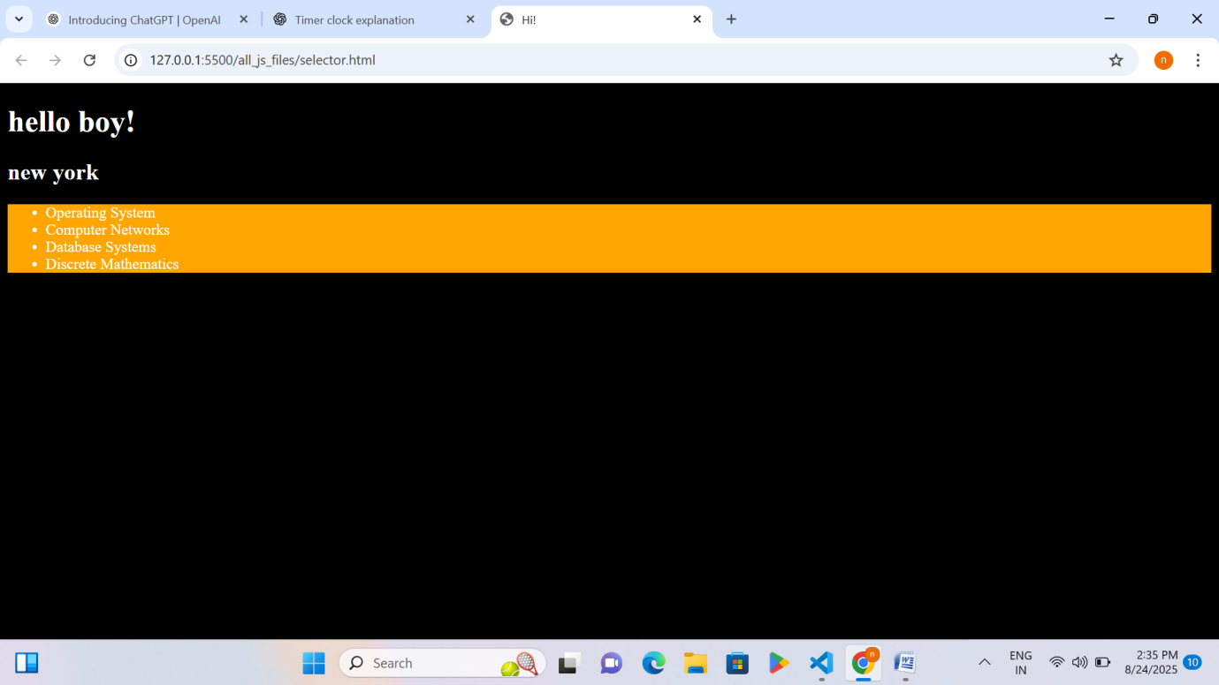

Explanation – Playing with Js using HTML/CSS
Code 7
• The webpage has headings (h1, h2) and a list (ul) with items.
Page 66 RID 53953

• All these elements have IDs and classes assigned.
• querySelector() is used to select one element from the page.
• You can select an element by ID using #idName.
• You can select an element by class using .className.
• After selecting an element, you can change its content using innerHTML.
• In this example:
- The h1 element with ID h1tag is changed to say "hello boy!".
- The script tries to change an element with class header2 to "new york" (but it may not exist).
Activity 15: All basic Project using HTML/CSS/JS
Project 1
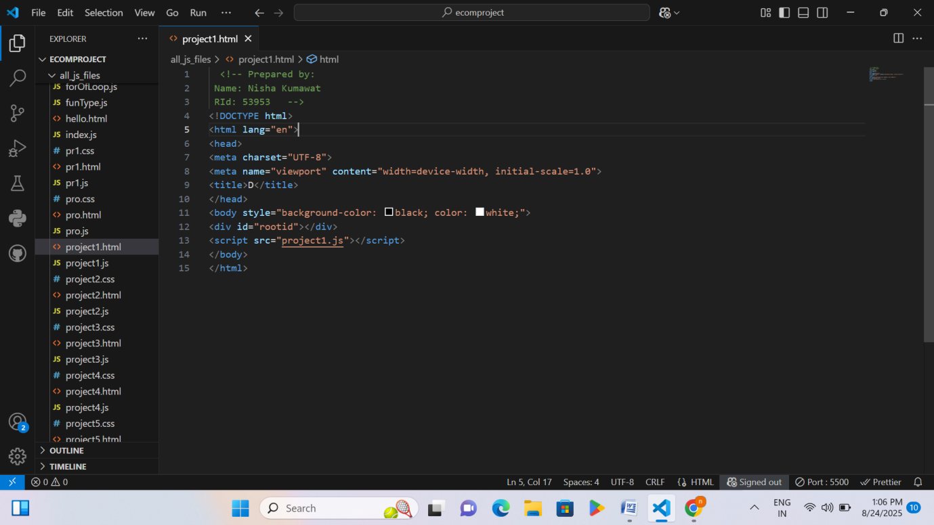

Page 67 RID 53953

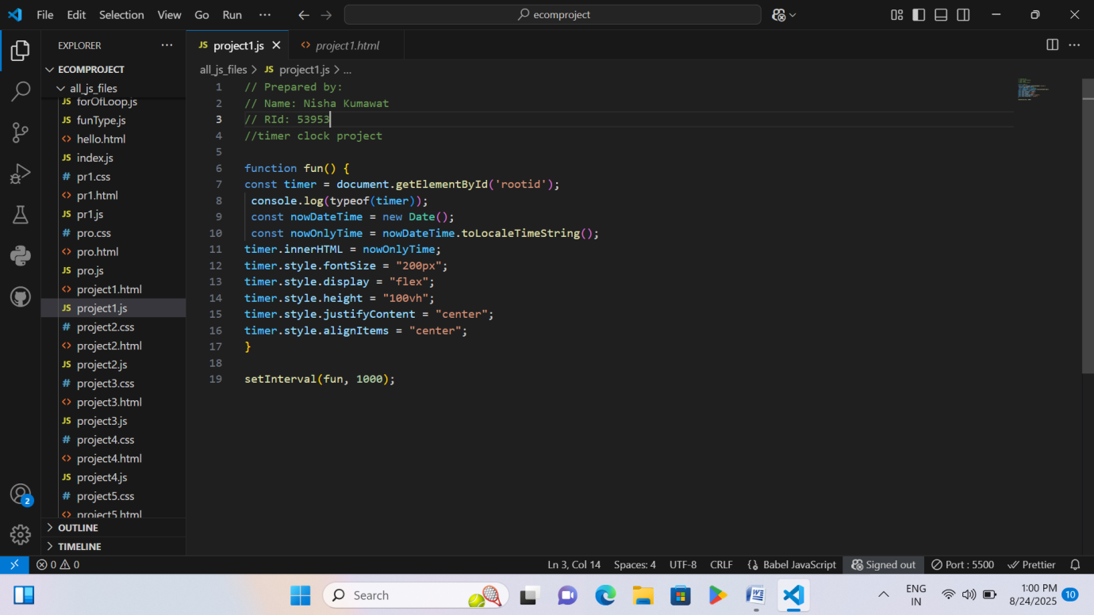
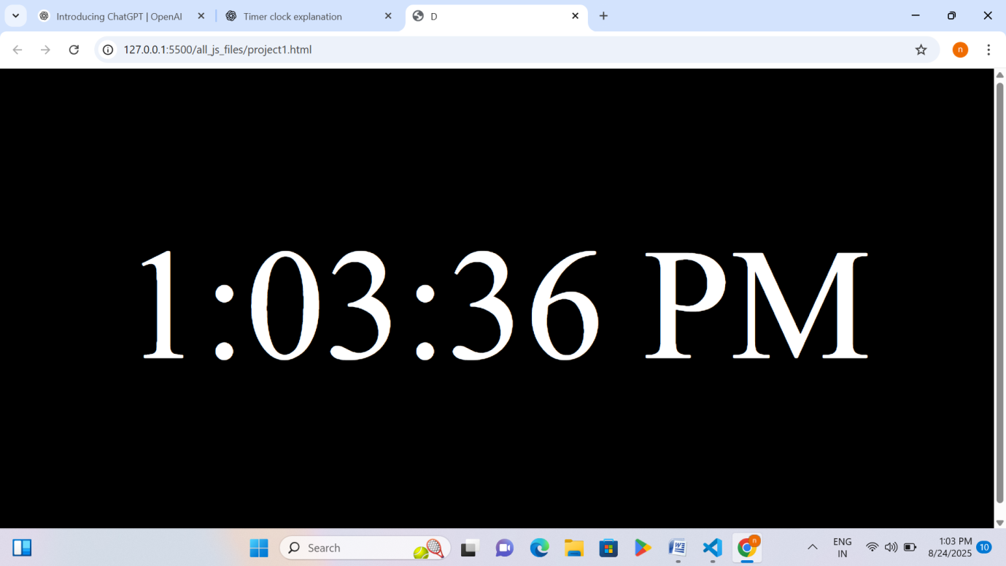

Explanation – Playing with Js using HTML/CSS
Project 1
- The webpage background is black and text color is white.
- A blank box (div) is created to display the clock.
Page 68 RID 53953

- A function runs to:
  - Get the current time from your computer.
  - Show that time inside the box.
  - Make the time big and centered on the screen.
- The function is called every 1 second so the time keeps updating.
- This makes a live digital clock on the webpage.
Project 2
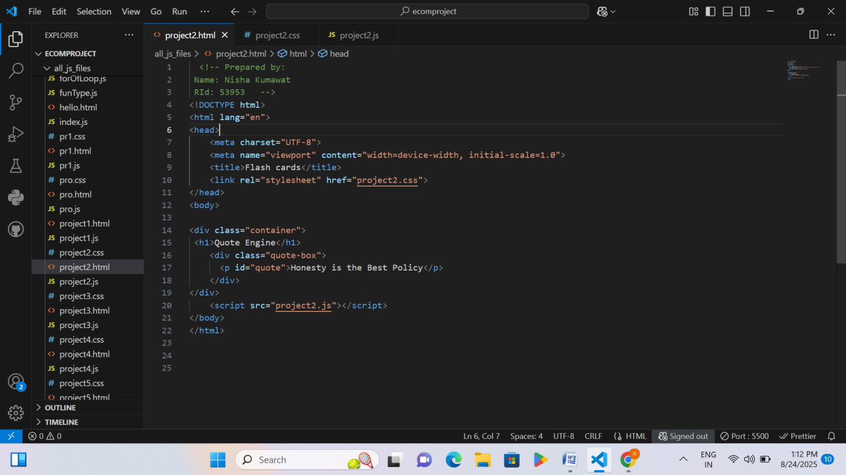
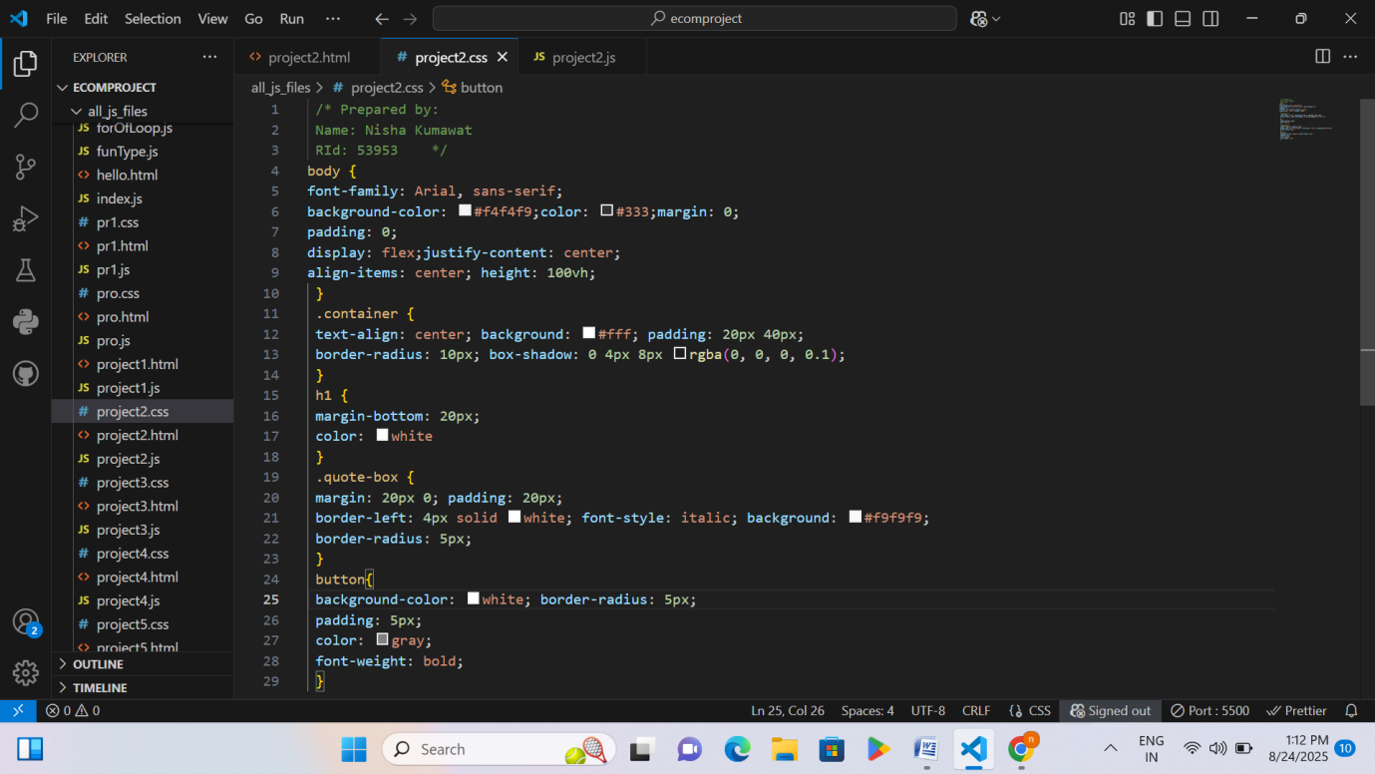Page 69 RID 53953

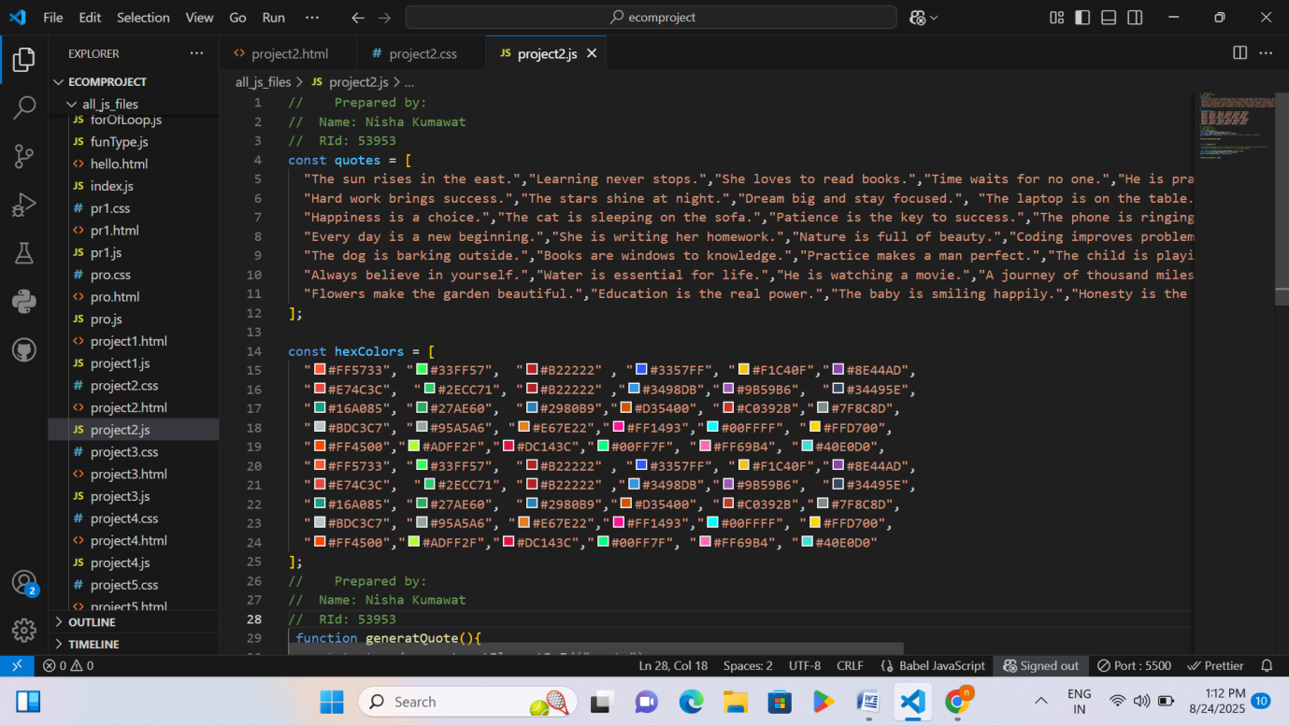
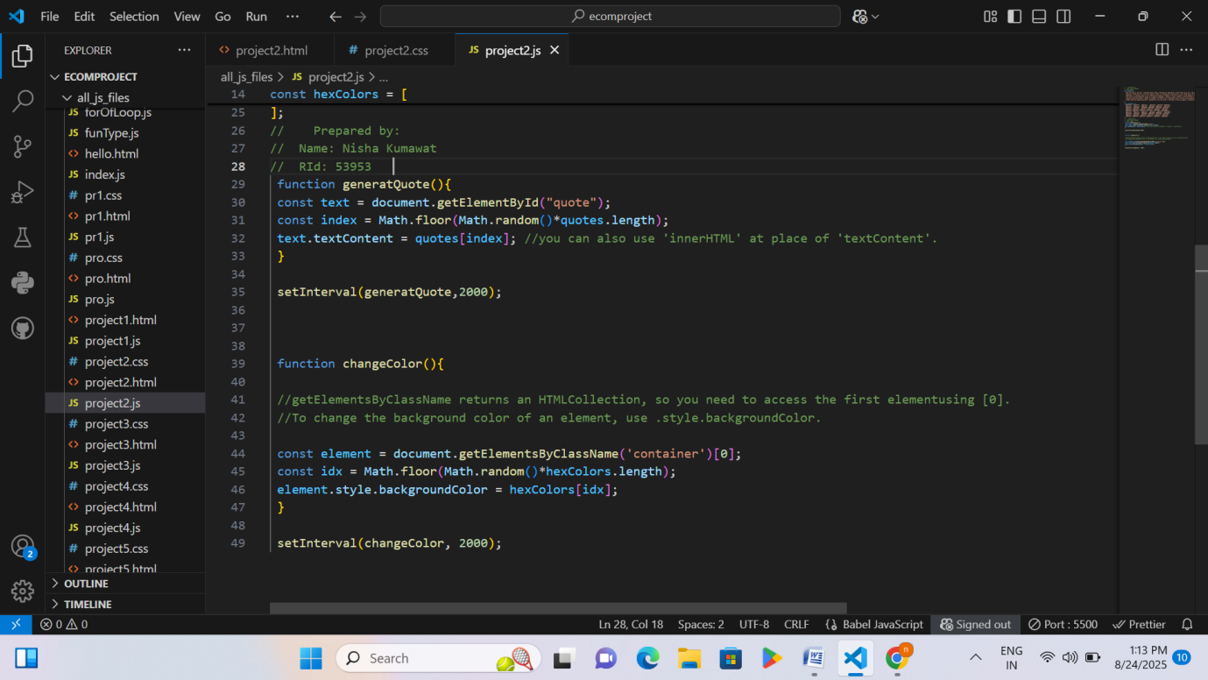

Page 70 RID 53953

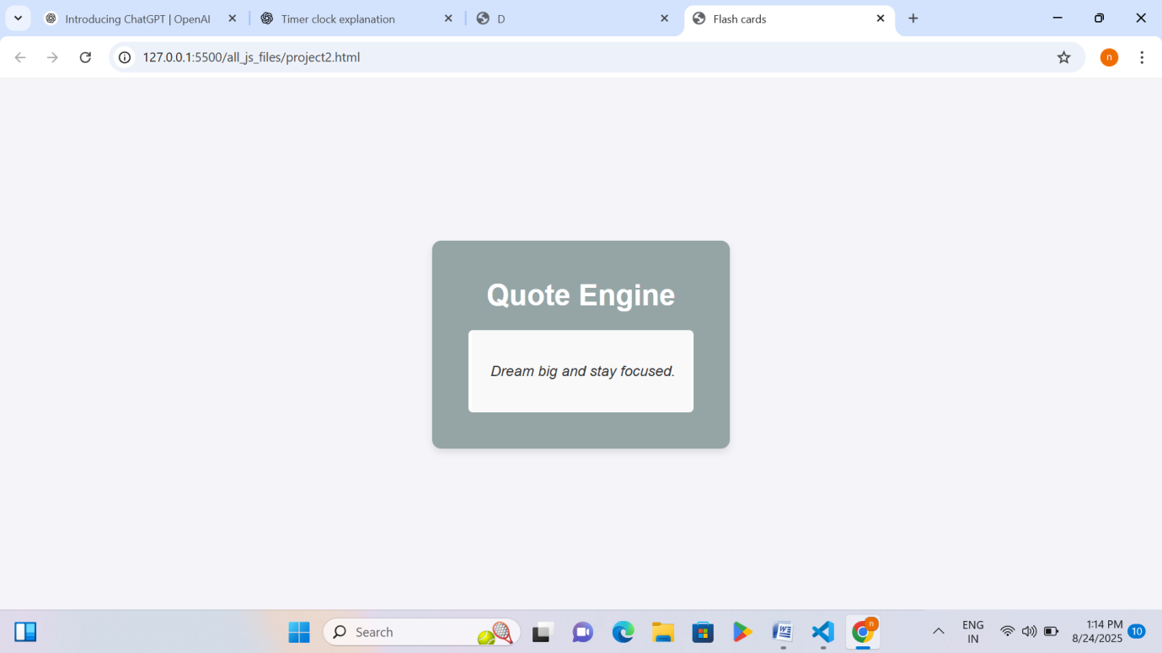

Explanation – Playing with Js using HTML/CSS
Project 2
• A webpage is created with a box in the center.
• The box shows a quote inside it.
• A list of many different quotes is stored in JavaScript.
• A list of different background colors is also stored.
• Every 2 seconds:
- A new random quote is picked and displayed.
- The background color of the box changes randomly.
• This makes the page look like a flash card engine with changing quotes and colors.
Project 3

Page 71 RID 53953

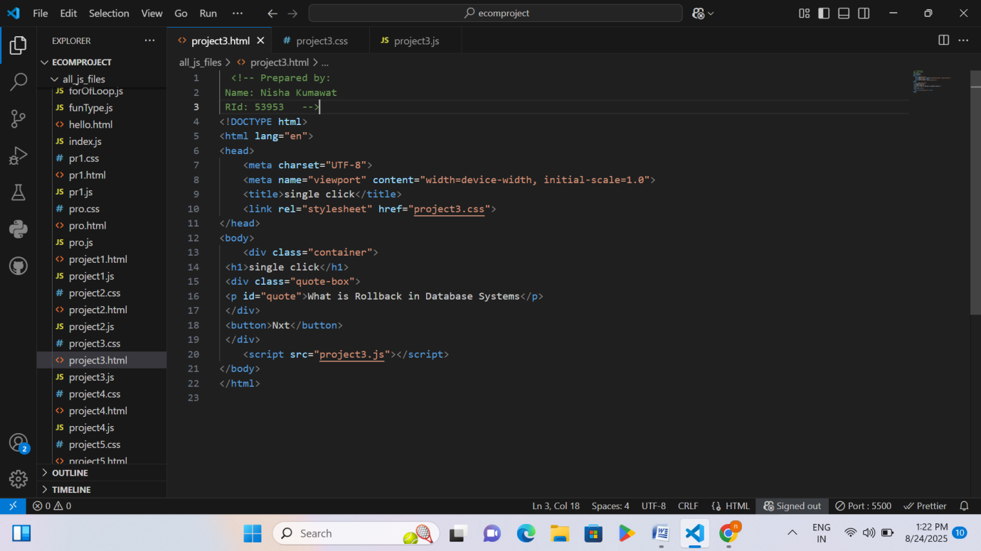
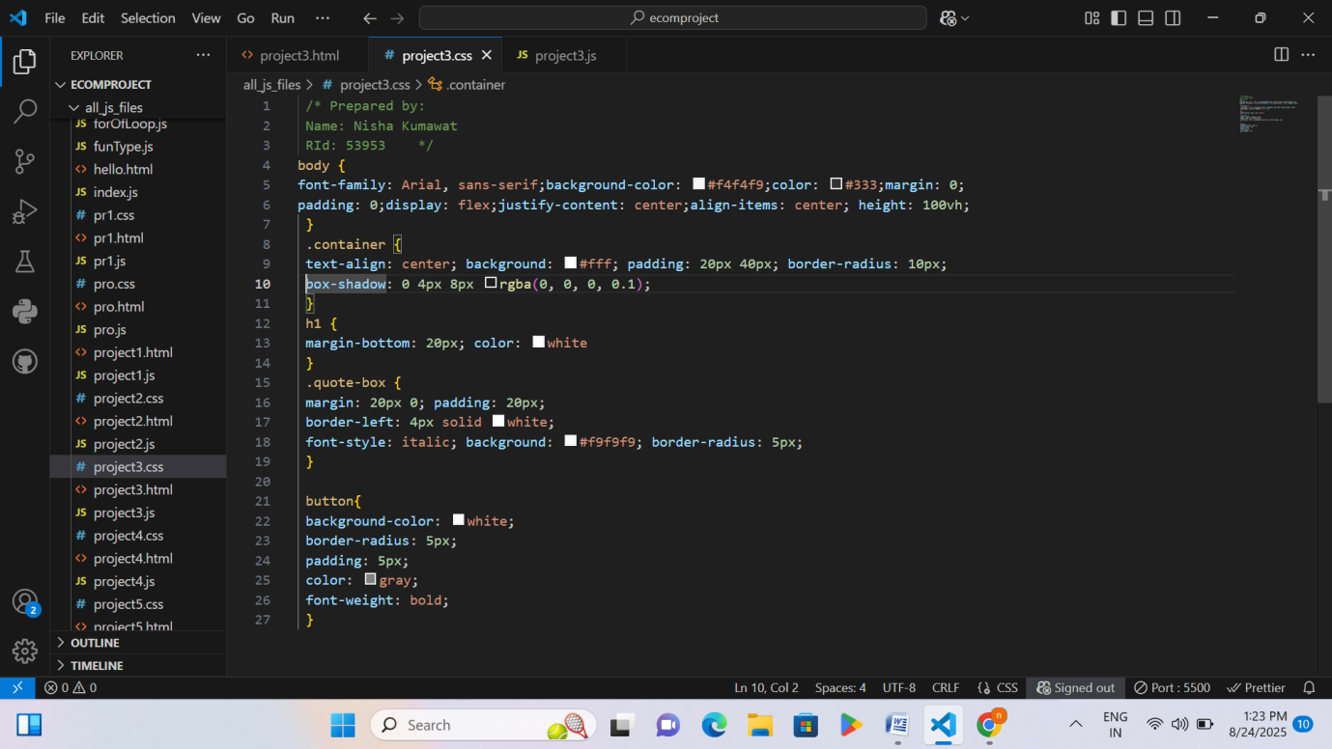

Page 72 RID 53953

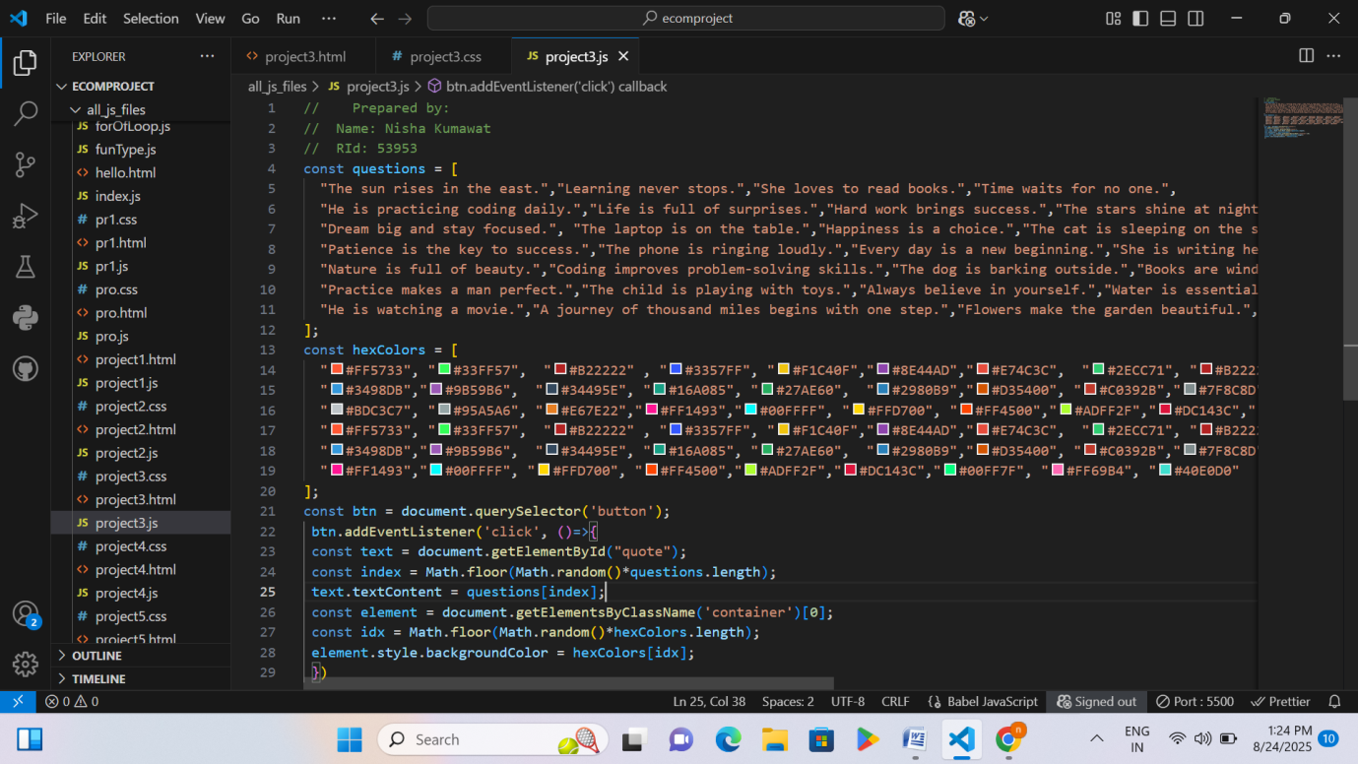
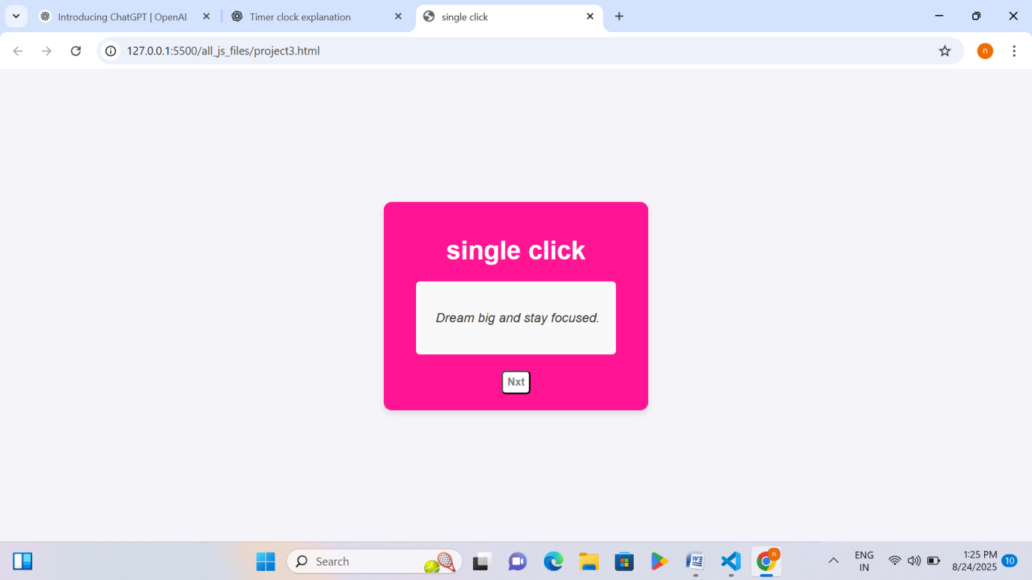

Explanation – Playing with Js using HTML/CSS
Project 3
• A list of sentences (questions/quotes) is stored in JavaScript.
Page 73 RID 53953

• A list of different colors is also stored.
• There is a button on the webpage.
• When the button is clicked:
- A random quote is shown inside the box.
- The background color of the box changes to a random color.
• Unlike the previous version (which changed automatically every 2 seconds), here the changes happen only when the user clicks the button.
Project 4
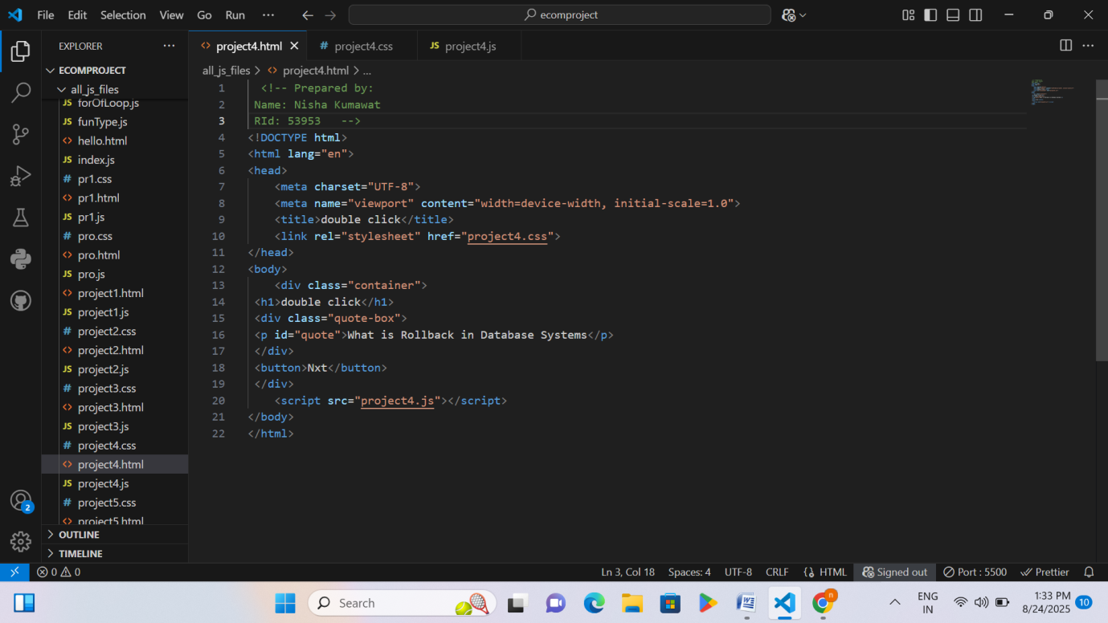

Page 74 RID 53953

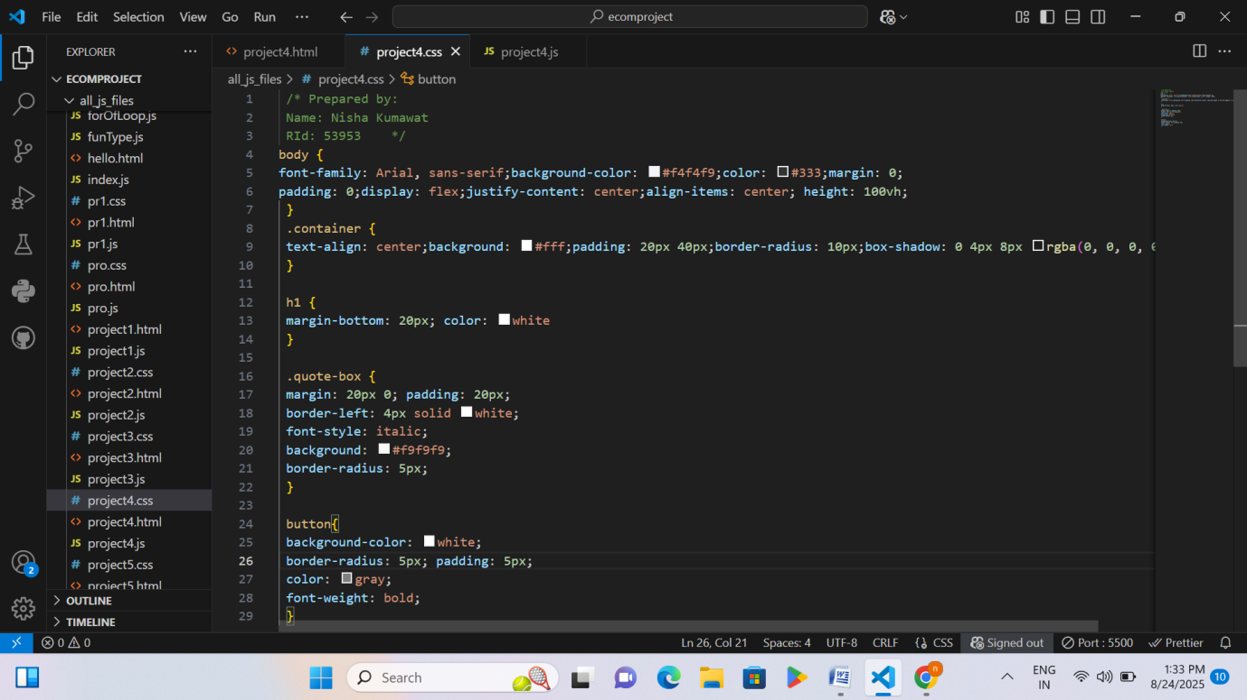
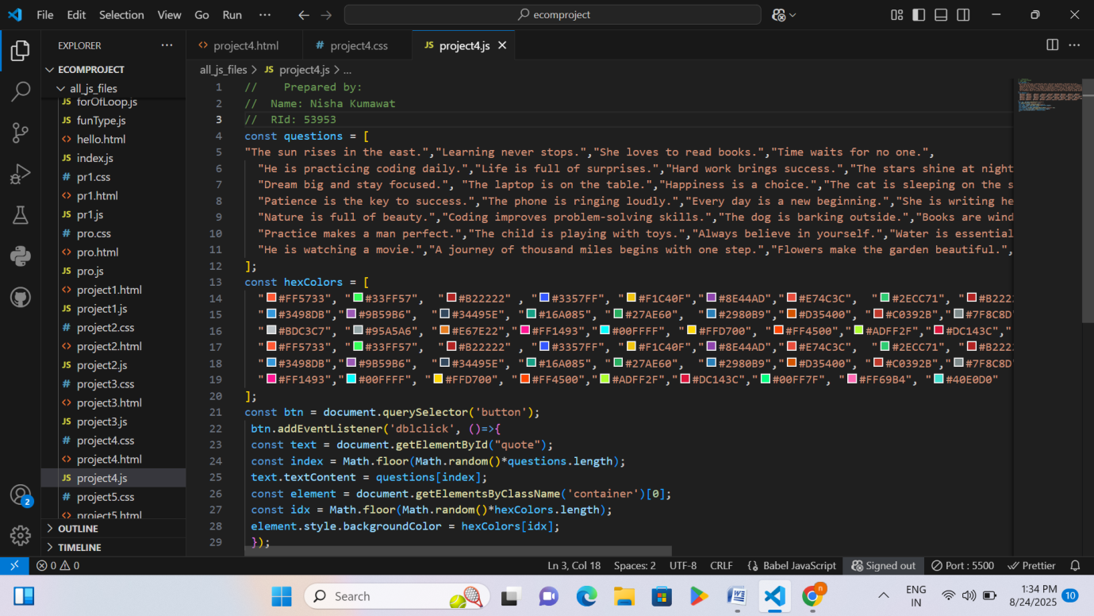

Page 75 RID 53953

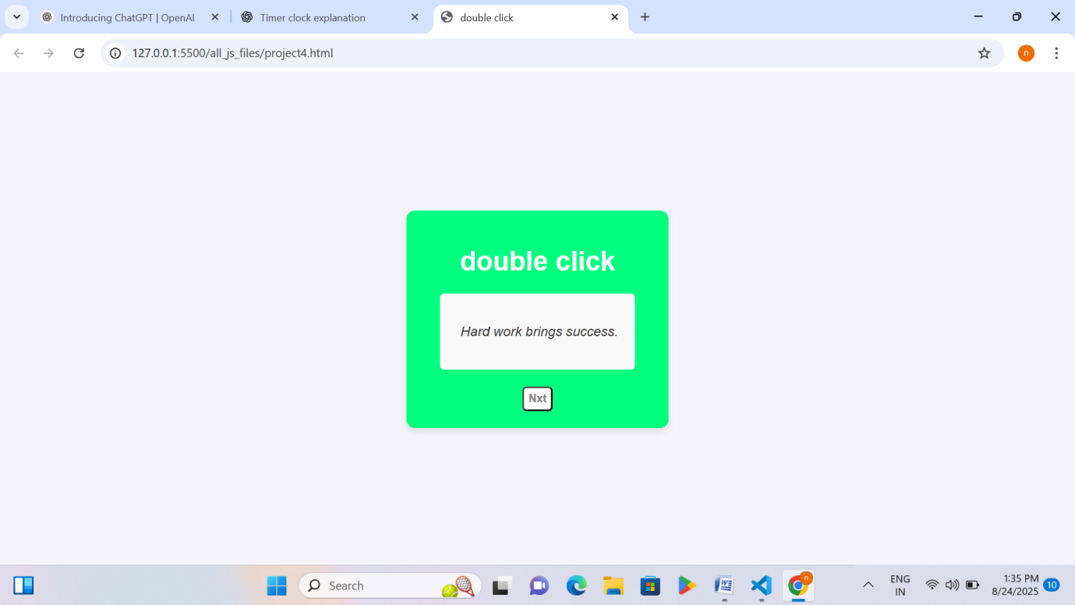

Explanation – Playing with Js using HTML/CSS
Project 4
• A list of sentences (quotes/questions) is saved in JavaScript.
• A list of many colors is also stored.
• There is a button on the webpage.
• When the user double-clicks the button:
- A random quote is shown inside the box.
- The background color of the box changes randomly.
• The difference from the previous version is that this works on double-click, not on a single click or automatic timer.
Project 5

Page 76 RID 53953

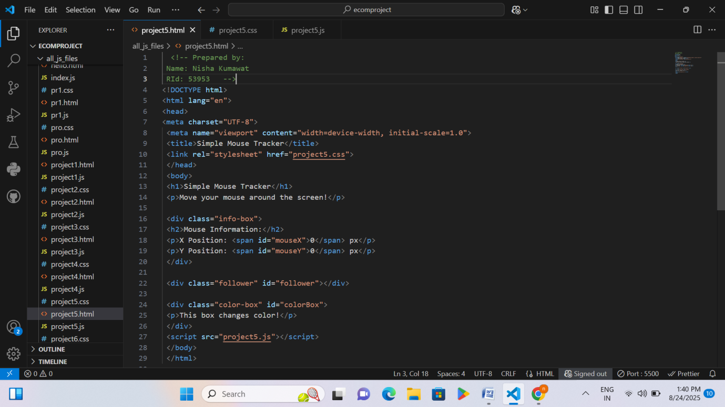
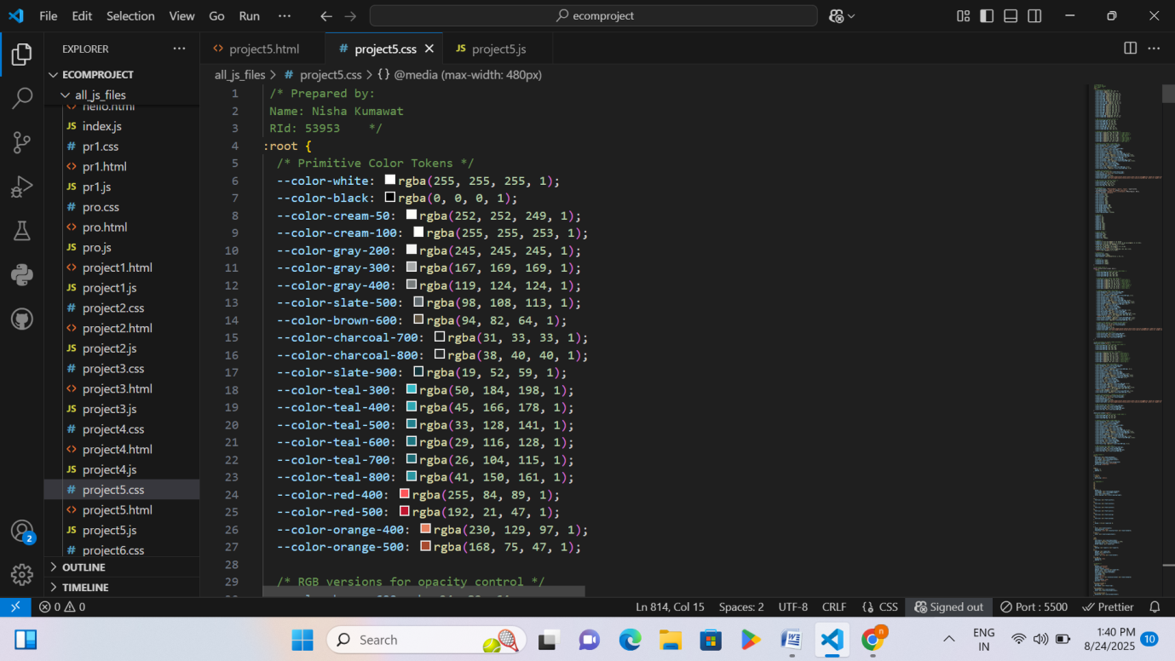

Page 77 RID 53953

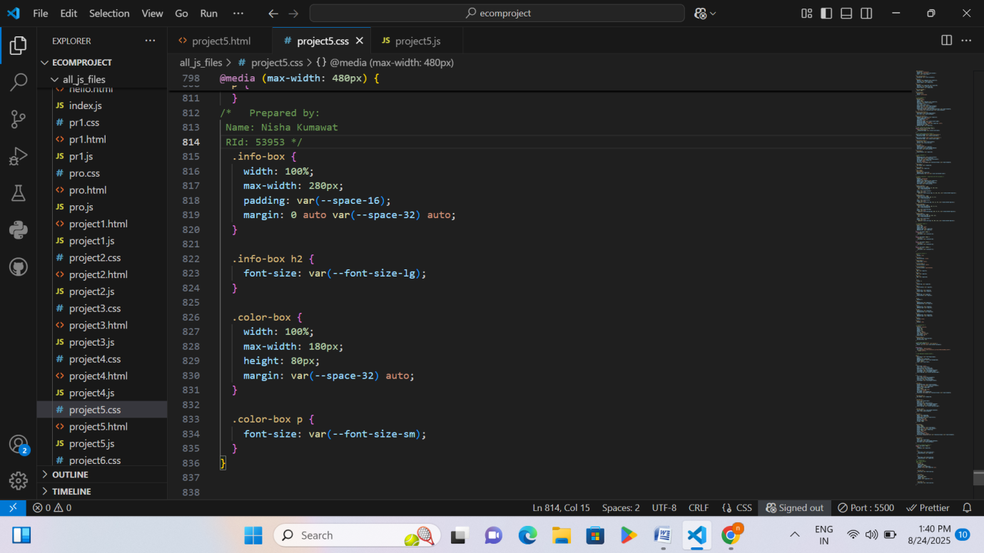
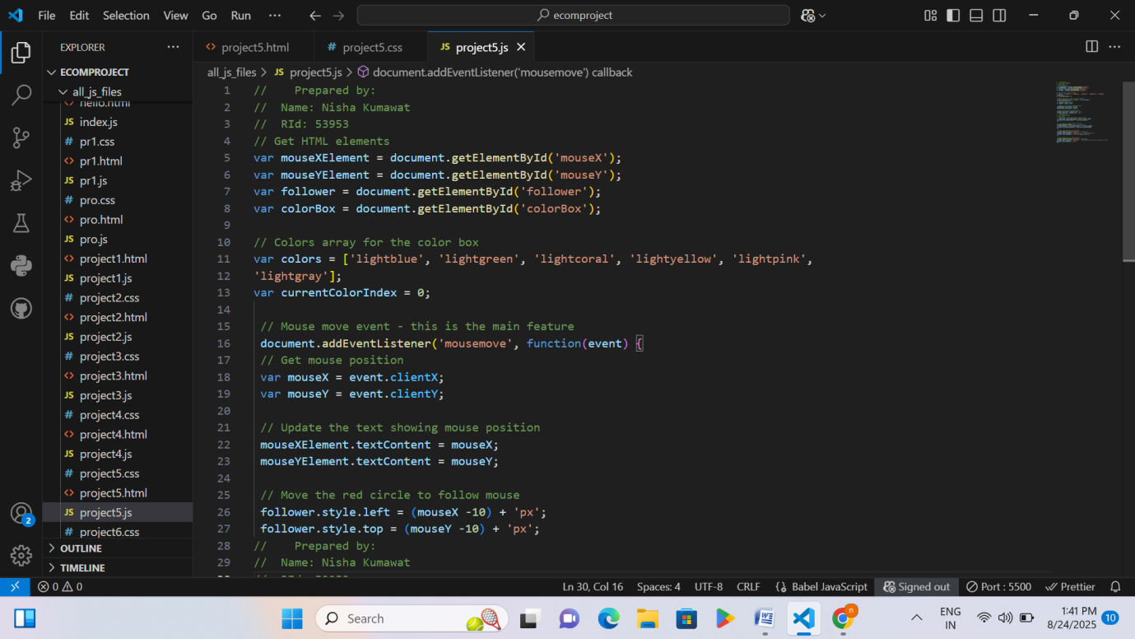

Page 78 RID 53953

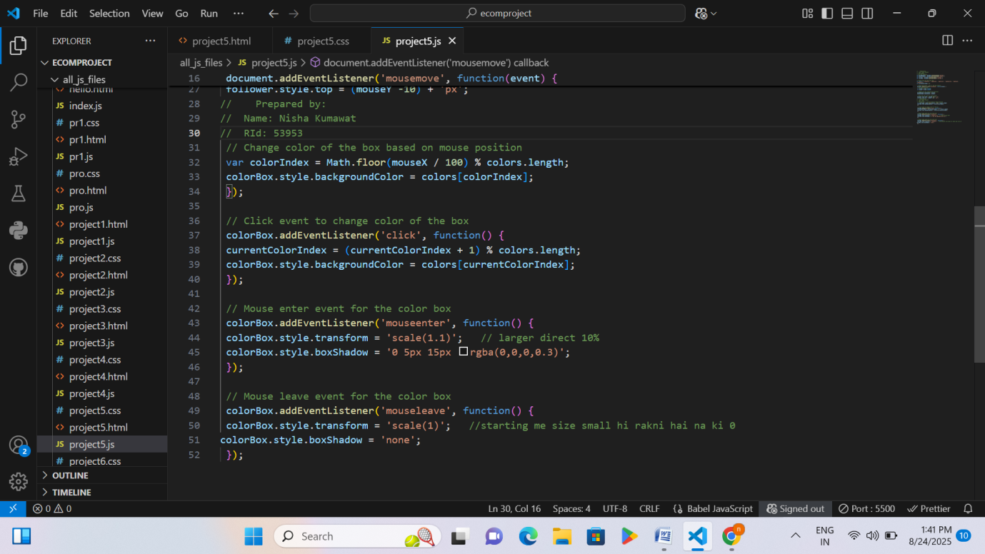
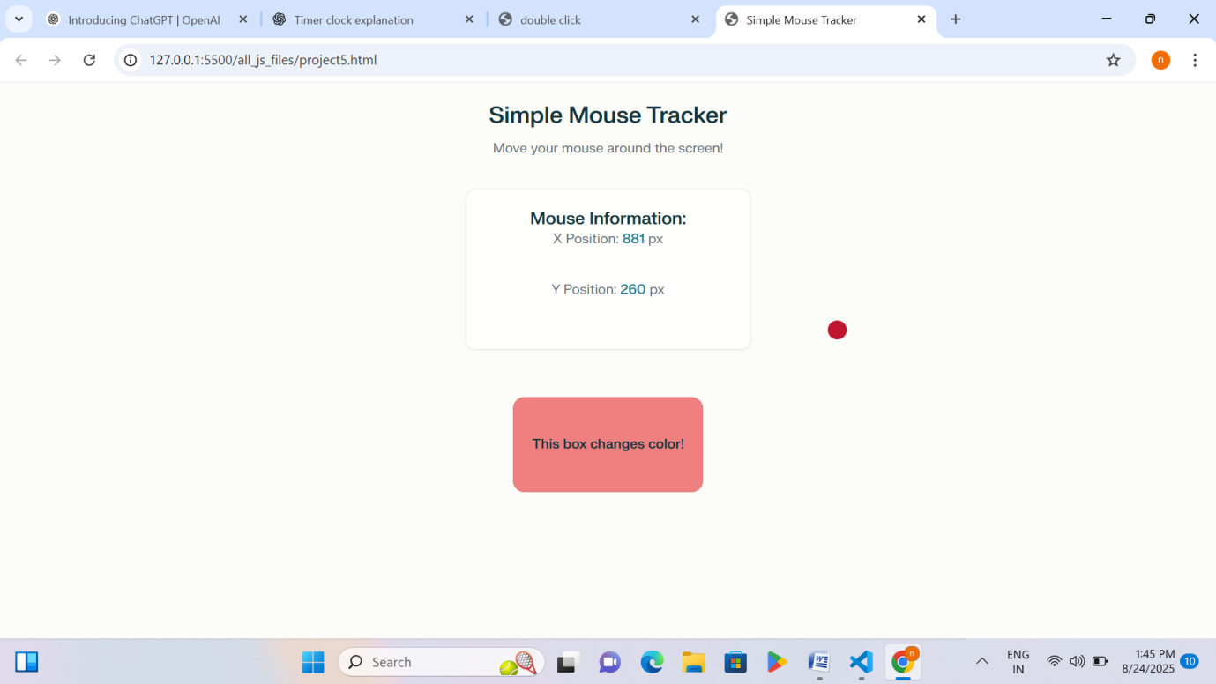

Explanation – Playing with Js using HTML/CSS
Project 5

Page 79 RID 53953
• The webpage tracks the mouse position (X and Y values) and shows them on the screen.
• A small red circle follows the mouse pointer as it moves.
• A color box is present on the page.
• The color of the box changes automatically depending on where the mouse moves on the screen.
• When the box is clicked, its color changes to the next color in the list.
• When the mouse enters the box, it becomes slightly larger and shows a shadow effect.
• When the mouse leaves the box, it goes back to its normal size and the shadow disappears.
Project 6
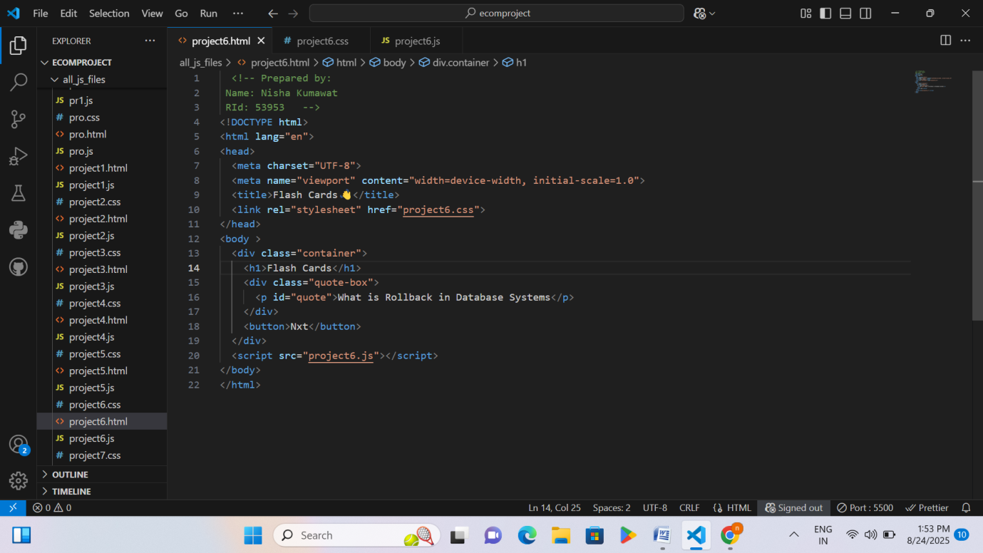

Page 80 RID 53953

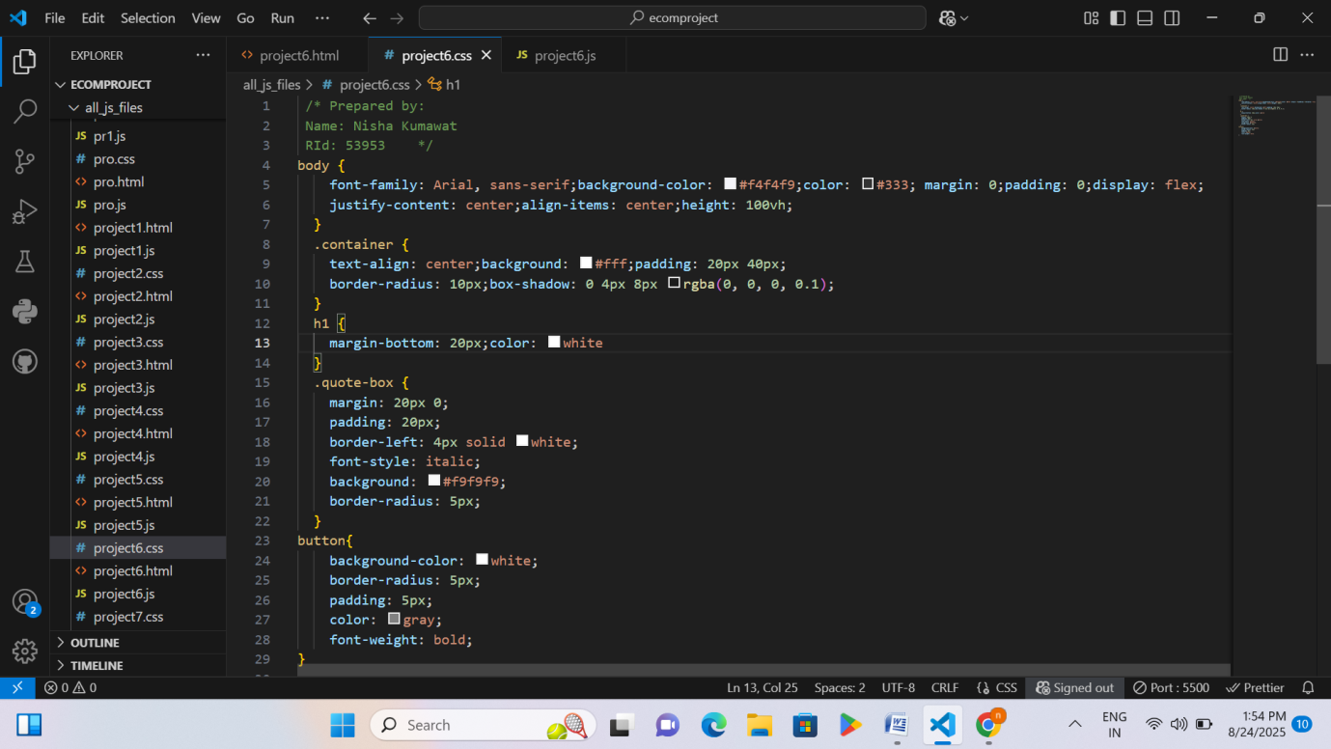
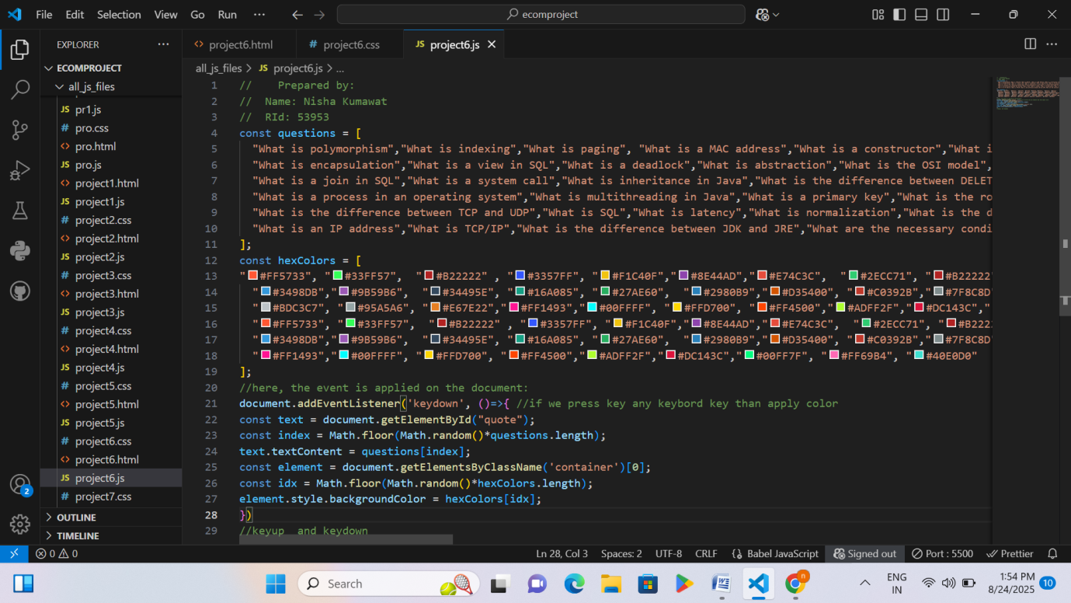

Page 81 RID 53953

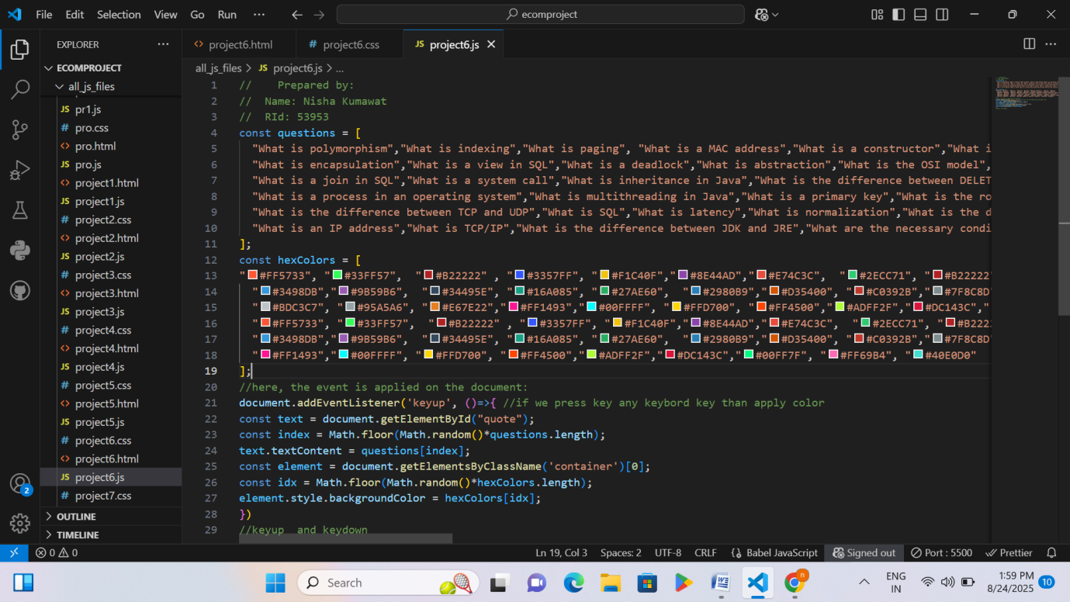
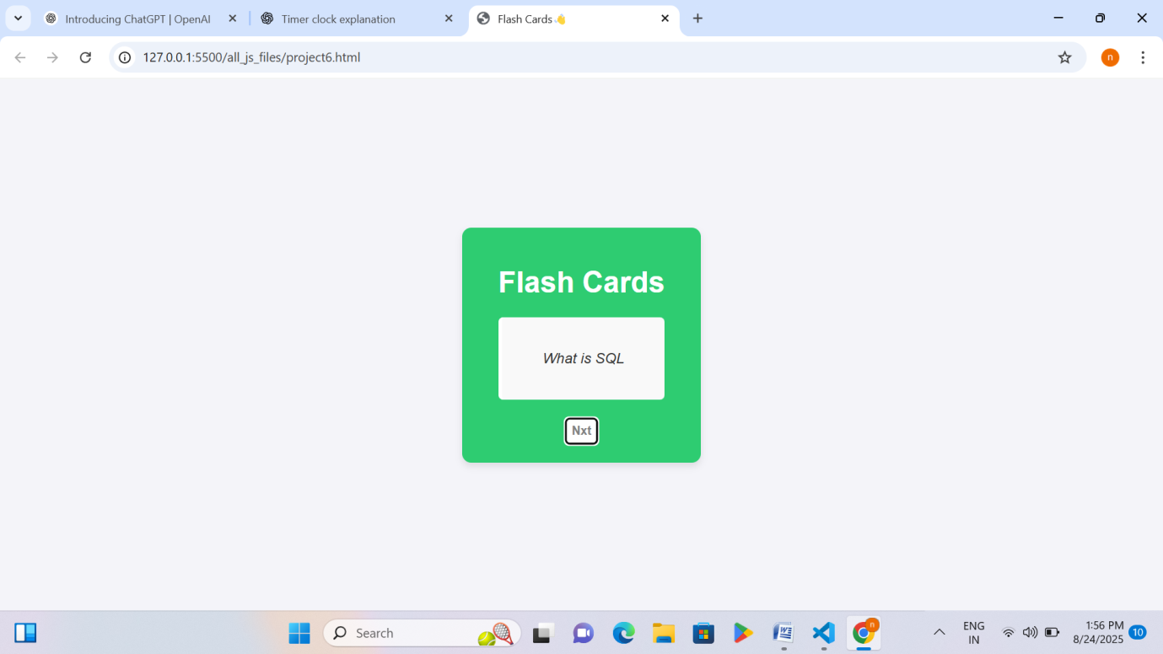

Explanation – Playing with Js using HTML/CSS
Project 6
• A list of technical questions is stored in JavaScript.
Page 82 RID 53953

• A list of many different colors is also stored.
• There is a box on the webpage that displays the questions.
• Whenever the user presses any key on the keyboard:
- A random question appears inside the box.
- The background color of the box changes randomly.
• This uses a keyboard event (keydown) to trigger the changes.
• Similar events like keyup (when key is released) can also be used for interaction.
Project 7
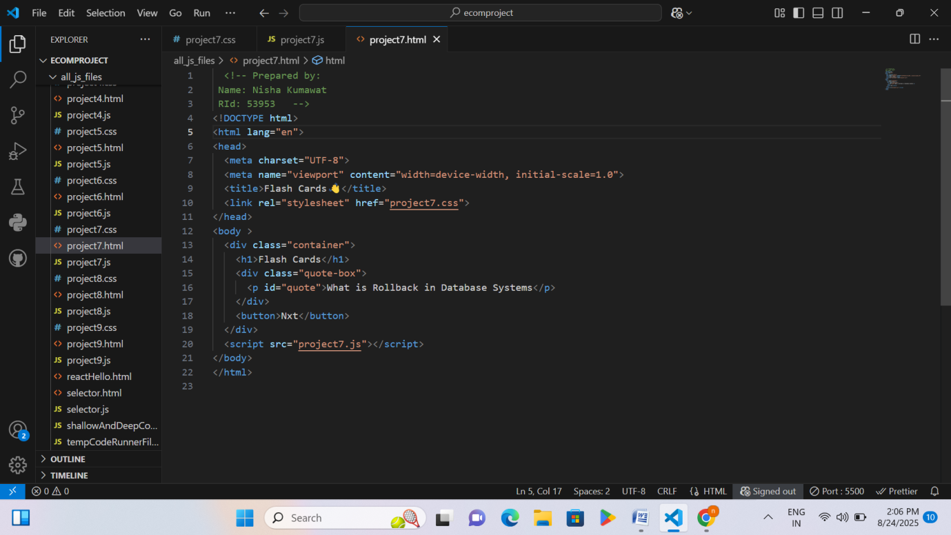

Page 83 RID 53953

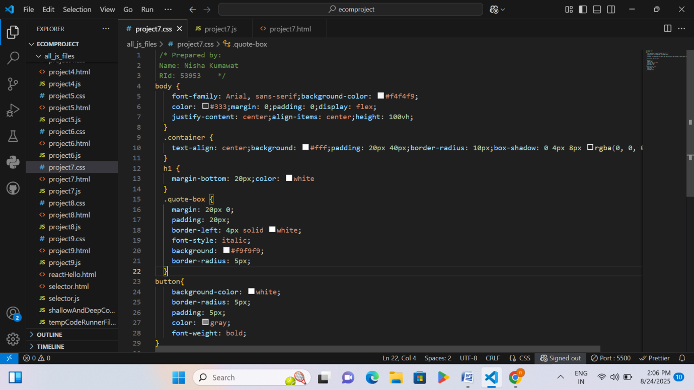
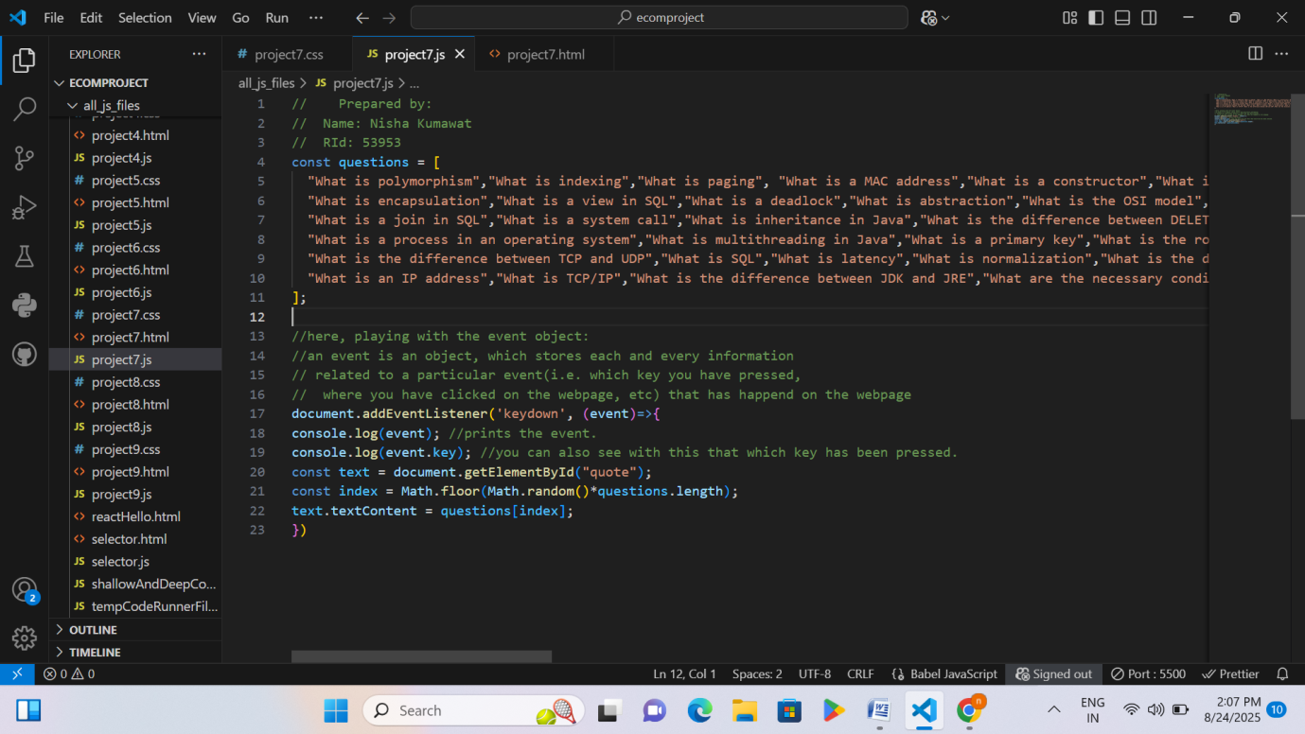

Page 84 RID 53953

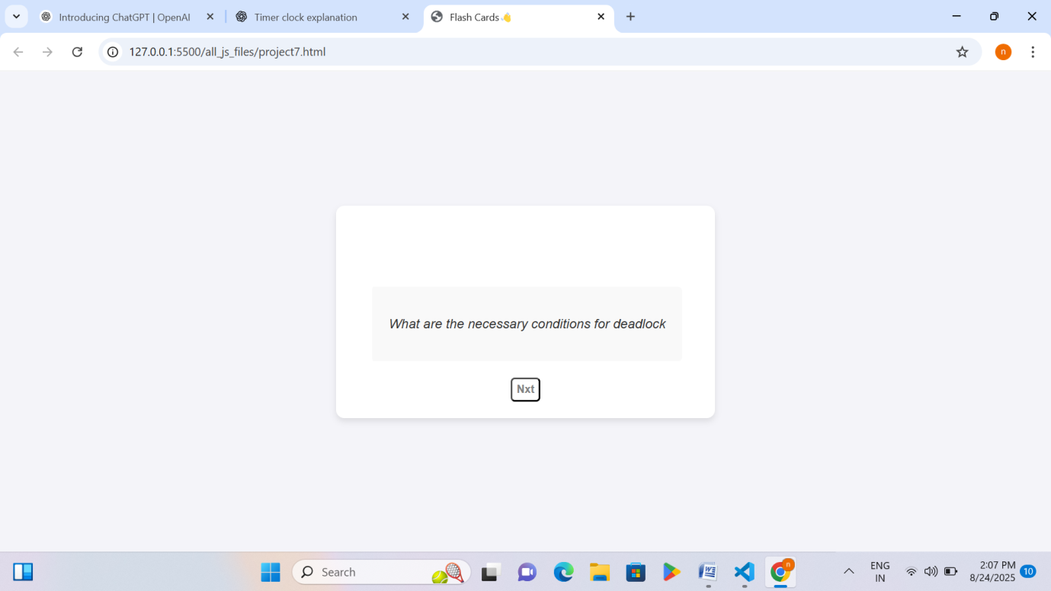

Explanation – Playing with Js using HTML/CSS
Project 7
• A list of technical questions is stored in JavaScript.
• The program listens for a keyboard event (when any key is pressed).
• The event object stores all details about that key press (like which key was pressed, where, etc.).
• The event object is printed in the console to see the full details.
• The specific key pressed is also shown using event.key.
• At the same time, a random question from the list is displayed inside the box on the webpage.
Project 8

Page 85 RID 53953

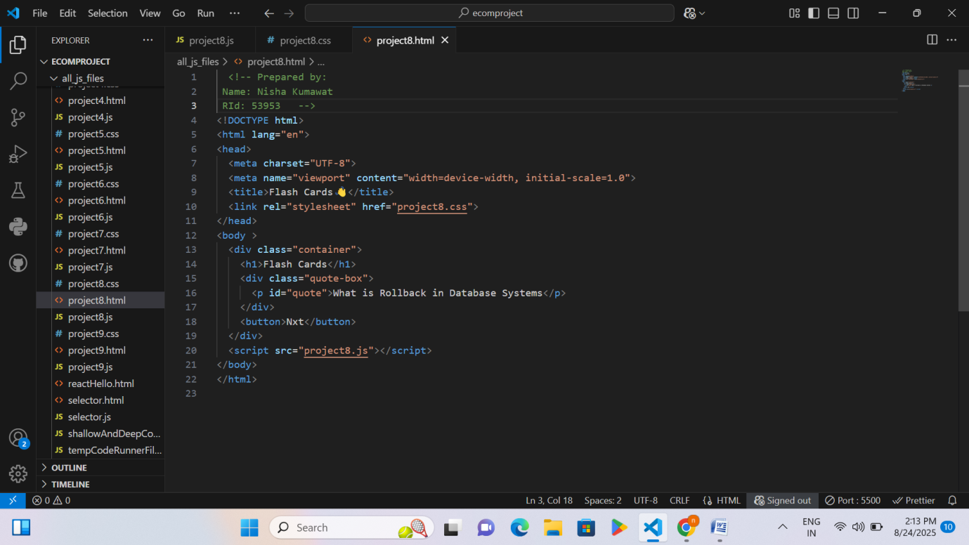
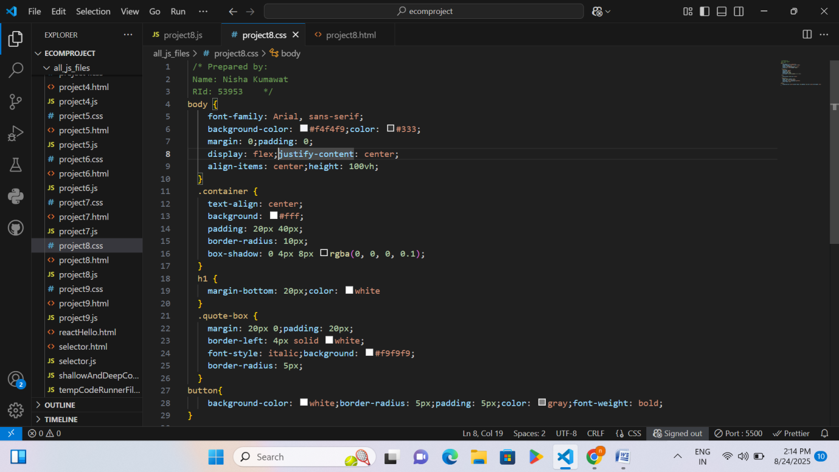

Page 86 RID 53953

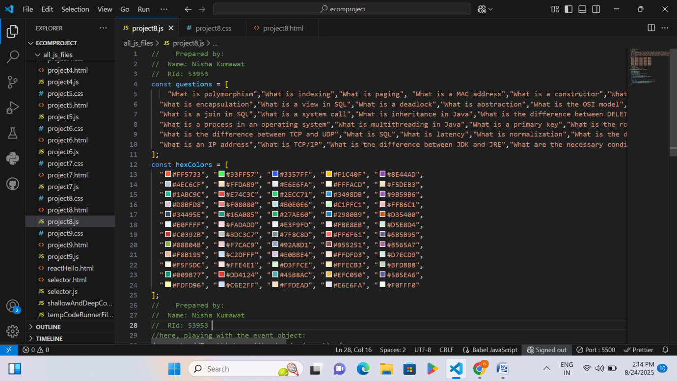
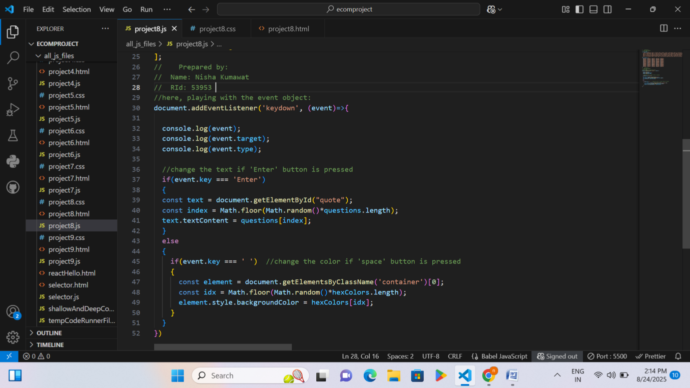

Page 87 RID 53953

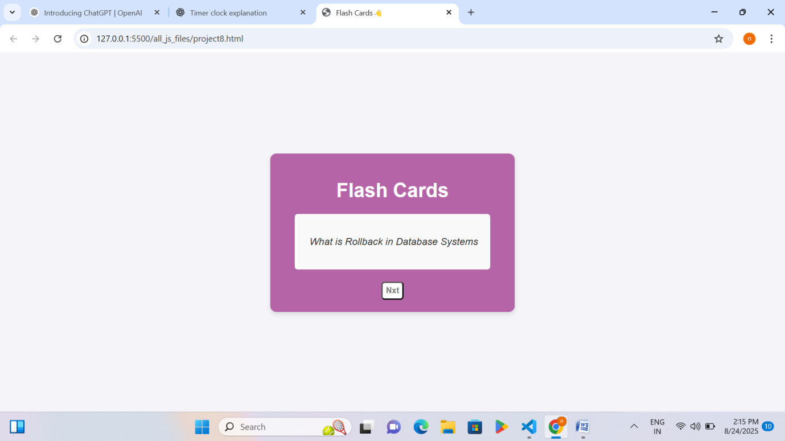
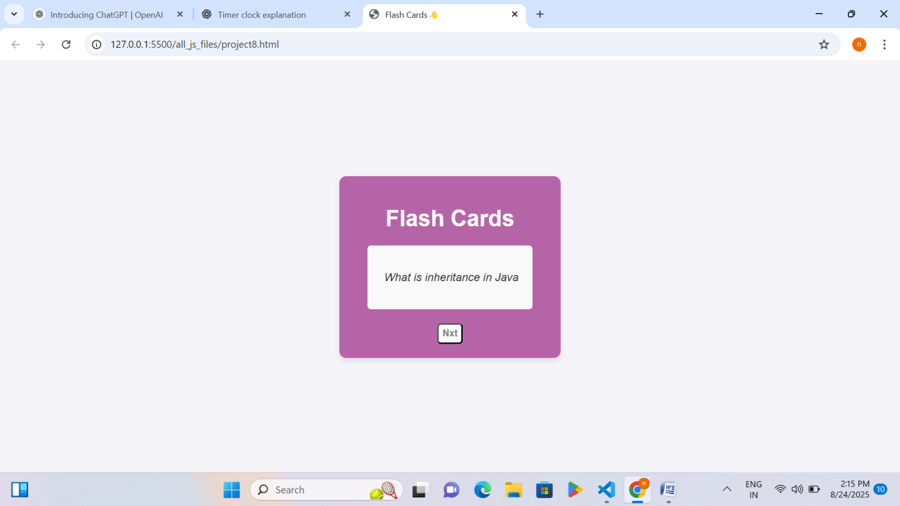

Explanation – Playing with Js using HTML/CSS
Project 8
• A list of technical questions and a list of colors are stored in JavaScript.
Page 88 RID 53953

• The program listens for keyboard events (when any key is pressed).
• The event object is used to check details like the event type, the target, and which key was pressed.
• If the Enter key is pressed → a random question from the list appears in the box.
• If the Space key is pressed → the background color of the box changes randomly.
• Other keys do not trigger any changes.
Project 9
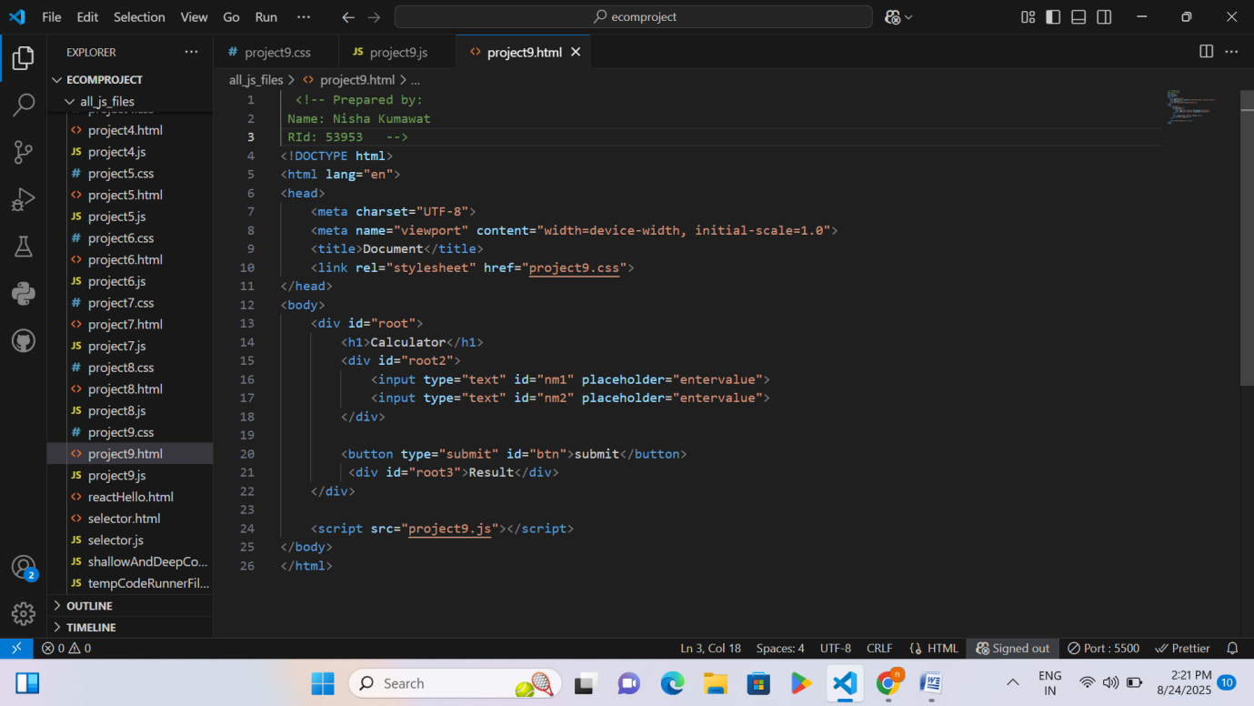

Page 89 RID 53953

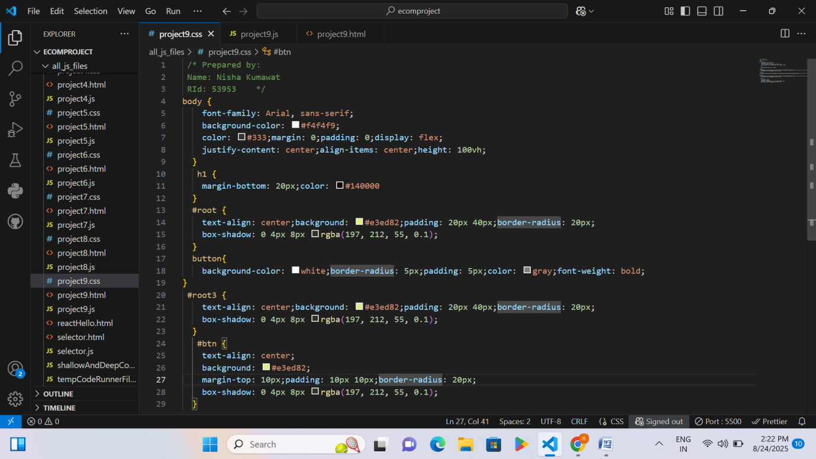
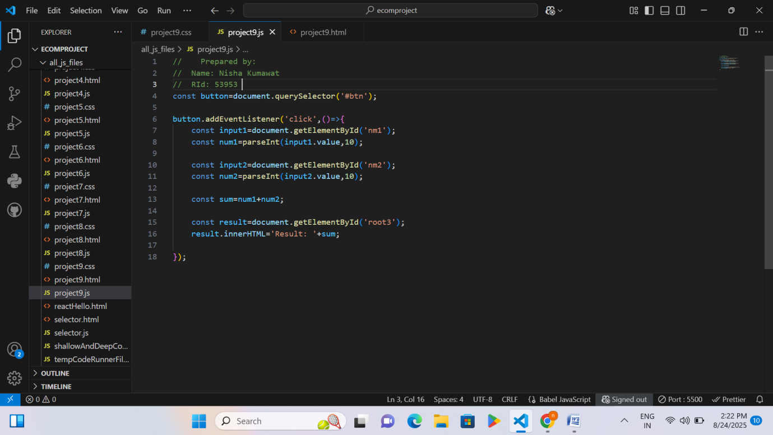

Page 90 RID 53953

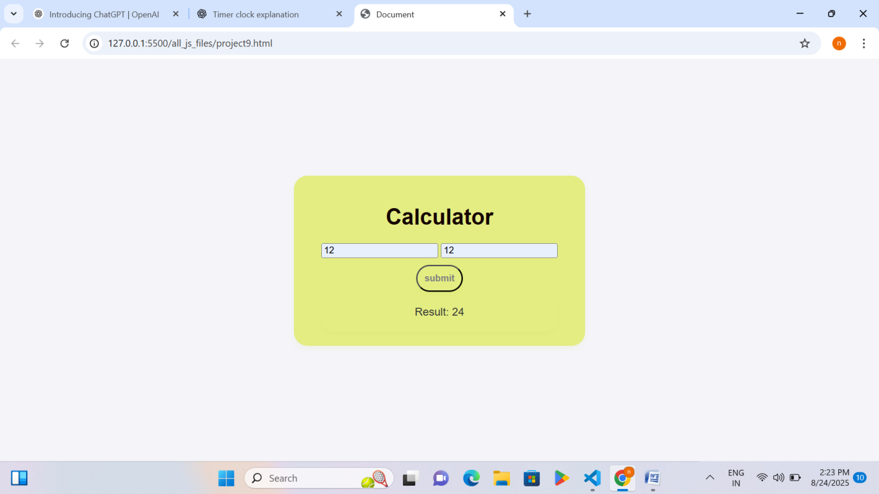

Explanation – Playing with Js using HTML/CSS
Project 9
• A button (#btn) is selected from the webpage.
• When the button is clicked, an action (event) will run.
• It takes the value from the first input box (nm1).
• Converts that value into a number (num1).
• It takes the value from the second input box (nm2).
• Converts that value into a number (num2).
• Adds both numbers (num1 + num2).
• Finds the result area (root3) on the webpage.
• Displays the total sum in that area with the text "Result: ...".

Page 91 RID 53953

