# Is Testing for Drugs Addictive?

At almost $500 billion and representing about 14% of the US Federal Budget, any misuse or abuse of Medicare can have large-scale negative impact on the nation’s finances and ability to maintain a critical component of the overall health care system. It is thus worth investigating the publicly available data on Medicare to determine if abuse of any kind can be uncovered. I have made a small attempt here to do just that. For this exercise, I have considered the *Physician and Other Supplier* portion of the *Medicare Provider Utilization and Payment Data.* This data includes information on the utilization and Medicare payments made for procedures and services rendered in calendar year 2012.

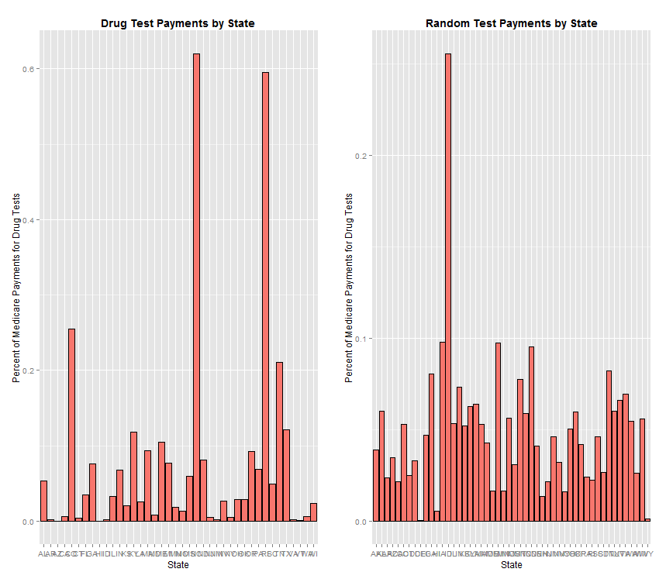

An initial exploration of the number of claims by procedure/service showed some obvious spikes in the data. Some of these were expected, such as claims for office visits, given that most other procedures will have an associated office visit and many office visits will not result in a claim for any other procedure; others, such as tests for cocaine, not so much. In light of this, I set out to answer the questions:

**Are medical practitioners prescribing unnecessary tests for illicit drugs as a means of increasing profits? And, if so, how widespread is the problem?**

I have focused on Medicare payments for tests for opiates, cocaine, barbituates, and amphetamines. The bar chart above shows the distribution of these payments by state. While this clearly shows that some states (North Carolina and Rhode Island, most notably) received a higher percentage of Medicare payments as a result of drug tests, we see similar spikes if we look at a random selection of services paid for by Medicare. The discrepancies between states may simply be due to chance.

To clarify this further, I looked at the relation between payments made to each state (for the 40 states that noted as receiving such payments) and each state’s population of residents 65 and older. As one would expect, total Medicare payments to a state scales with that state’s population of those 65 and older. However, when we look at Medicare payments for drug tests in relation to the same population, we again see some discrepancies between states, with North Carolina again being the most noticeably different, as shown in the first figure on the next page.

Another explanation for the discrepancy could be that certain states have a higher proportion of the population effected by drug use. When we take a look at the data comparing prevalence of drug use by state we again see North Carolina as the most prominent outlier.

It would now appear that something out of the ordinary happened in North Carolina. Perhaps this abnormal number of drug tests, accounting for an extra $30 million in Medicare expenses, can be seen across the state? But when I examined the distribution of drug test payments across the 18 North Carolinian practitioners contained in the dataset, it is highly skewed. The top two highest paid labs in the state account for just over 90% of all drug test payments made.

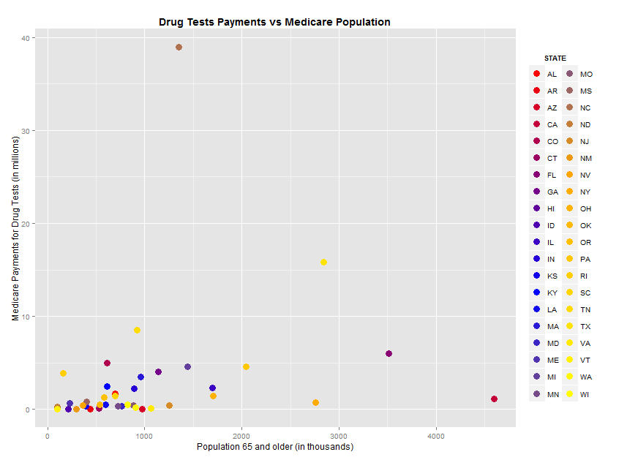

While there are many valid reasons why drug tests would be carried out, and here I have focused on one particular state, the data suggests that there are a handful of states that may be driven by more of a profit motive than a medical one. Although an extra $30 million in Medicare costs is a small fraction of the total, to put it in perspective, this is roughly equal to the total Medicare costs for office visits for the state of Delaware.

Given how lucrative drug testing can be, it would seem that it can be an addictive.

### Methodology

All datasets were either downloaded in, or converted to, CSV format. All subsequent analysis was carried out in RStudio (Version 0.98.1102) with R (version 3.1.1). The main package used beyond the base set up was dplyr (version 0.4.1). All plots were done in ggplot2 (version 1.0.0). The Medicare data was filtered to retain only data pertaining to payments for services taking place in an ‘Office’ setting in the 50 US states plus Washington, DC. The datasets had no missing values. Only 13 of the original 27 columns were kept. Means, standard deviations, and z-scores were calculated using standard formulas.

### Datasets Used

* Medicare Provider Utilization and Payment Data: Physician and Other Supplier, 12 files in Microsoft Excel format (<http://go.cms.gov/OCmyoy>)
* Population data from the US Census (<http://1.usa.gov/1L1qdTB>)
* Data on the prevalence of drug use from the Substance Abuse and Mental Health Services Administration’s *National Survey on Drug Use and Health,* Table 6 (<http://1.usa.gov/1At3f80>)
* General facts on Medicare spending and finance from the Henry J. Kaiser Family Foundation (<http://bit.ly/1DeUpex>)