DATA FLOW DIAGRAMS

A data flow diagram is graphical tool used to describe and analyze movement of data through a system. These are the central tool and the basis from which the other components are developed. The transformation of data from input to output, through processed, may be described logically and independently of physical components associated with the system. These are known as the logical data flow diagrams. The physical data flow diagrams show the actual implements and movement of data between people, departments and workstations. A full description of a system actually consists of a set of data flow diagrams. Using two familiar notations Yourdon, Gane and Sarson notation develops the data flow diagrams. Each component in a DFD is labeled with a descriptive name. Process is further identified with a number that will be used for identification purpose. The development of DFD’S is done in several levels. Each process in lower level diagrams can be broken down into a more detailed DFD in the next level. The lop-level diagram is often called context diagram. It consists a single process bit, which plays vital role in studying the current system. The process in the context level diagram is exploded into other process at the first level DFD.
The idea behind the explosion of a process into more process is that understanding at one level of detail is exploded into greater detail at the next level. This is done until further explosion is necessary and an adequate amount of detail is described for analyst to understand the process.
Larry Constantine first developed the DFD as a way of expressing system requirements in a graphical from, this lead to the modular design.
A DFD is also known as a “bubble Chart” has the purpose of clarifying system requirements and identifying major transformations that will become programs in system design. So it is the starting point of the design to the lowest level of detail. A DFD consists of a series of bubbles joined by data flows in the system.

DFD SYMBOLS:
In the DFD, there are four symbols
- A square defines a source(originator) or destination of system data
- An arrow identifies data flow. It is the pipeline through which the information flows
- A circle or a bubble represents a process that transforms incoming data flow into outgoing data flows.
- An open rectangle is a data store, data at rest or a temporary repository of data

Process that transforms data flow.

Source or Destination of data
Data flow

Data Store

CONSTRUCTING A DFD:
Several rules of thumb are used in drawing DFD’S:

- Process should be named and numbered for an easy reference. Each name should be representative of the process.
- The direction of flow is from top to bottom and from left to right. Data traditionally flow from source to the destination although they may flow back to the source. One way to indicate this is to draw long flow line back to a source. An alternative way is to repeat the source symbol as a destination. Since it is used more than once in the DFD it is marked with a short diagonal.
- When a process is exploded into lower level details, they are numbered.
- The names of data stores and destinations are written in capital letters. Process and dataflow names have the first letter of each work capitalized

A DFD typically shows the minimum contents of data store. Each data store should contain all the data elements that flow in and out.
Questionnaires should contain all the data elements that flow in and out. Missing interfaces redundancies and like is then accounted for often through interviews.

SAILENT FEATURES OF DFD’S
- The DFD shows flow of data, not of control loops and decision are controlled considerations do not appear on a DFD.
- The DFD does not indicate the time factor involved in any process whether the dataflow take place daily, weekly, monthly or yearly.
- The sequence of events is not brought out on the DFD.

TYPES OF DATA FLOW DIAGRAMS
- Current Physical
- Current Logical
- New Logical
- New Physical

CURRENT PHYSICAL:
In Current Physical DFD process label include the name of people or their positions or the names of computer systems that might provide some of the overall system-processing label includes an identification of the technology used to process the data. Similarly data flows and data stores are often labels with the names of the actual physical media on which data are stored such as file folders, computer files, business forms or computer tapes.

CURRENT LOGICAL:
The physical aspects at the system are removed as mush as possible so that the current system is reduced to its essence to the data and the processors that transforms them regardless of actual physical form.

NEW LOGICAL:
This is exactly like a current logical model if the user were completely happy with he user were completely happy with the functionality of the current system but had problems with how it was implemented typically through the new logical model will differ from current logical model while having additional functions, absolute function removal and inefficient flows recognized.

NEW PHYSICAL:
The new physical represents only the physical implementation of the new system.

RULES GOVERNING THE DFD’S

PROCESS
- No process can have only outputs.
- No process can have only inputs. If an object has only inputs than it must be a sink.
- A process has a verb phrase label.

DATA STORE
- Data cannot move directly from one data store to another data store, a process must move data.
- Data cannot move directly from an outside source to a data store, a process, which receives, must move data from the source and place the data into data store
- A data store has a noun phrase label.

SOURCE OR SINK
The origin and / or destination of data.

- Data cannot move direly from a source to sink it must be moved by a process
- A source and /or sink has a noun phrase land

DATA FLOW
- A Data Flow has only one direction of flow between symbols. It may flow in both directions between a process and a data store to show a read before an update. The later is usually indicated however by two separate arrows since these happen at different type.
- A join in DFD means that exactly the same data comes from any of two or more different processes data store or sink to a common location.
- A data flow cannot go directly back to the same process it leads. There must be atleast one other process that handles the data flow produce some other data flow returns the original data into the beginning process.
- A Data flow to a data store means update (delete or change).
- A data Flow from a data store means retrieve or use.

A data flow has a noun phrase label more than one data flow noun phrase can appear on a single arrow as long as all of the flows on the same arrow move together as one package.

DFD Diagrams:
Context Level (0th Level Diagram)

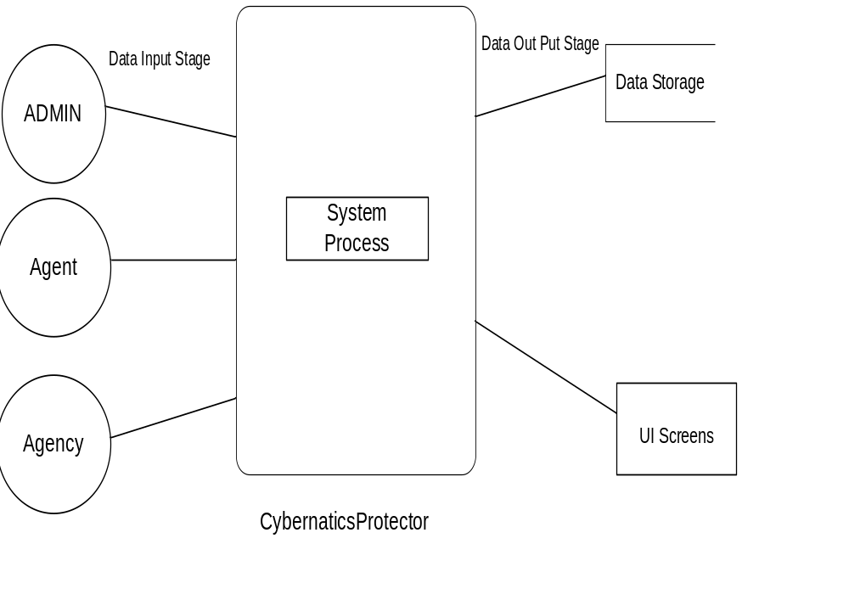

Login DFD

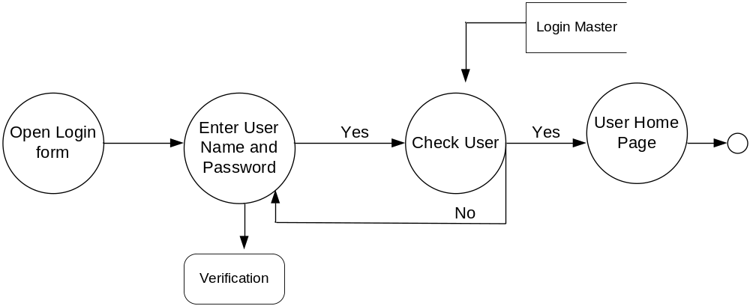

Admin Details Data Flow:
1st Level DFD:

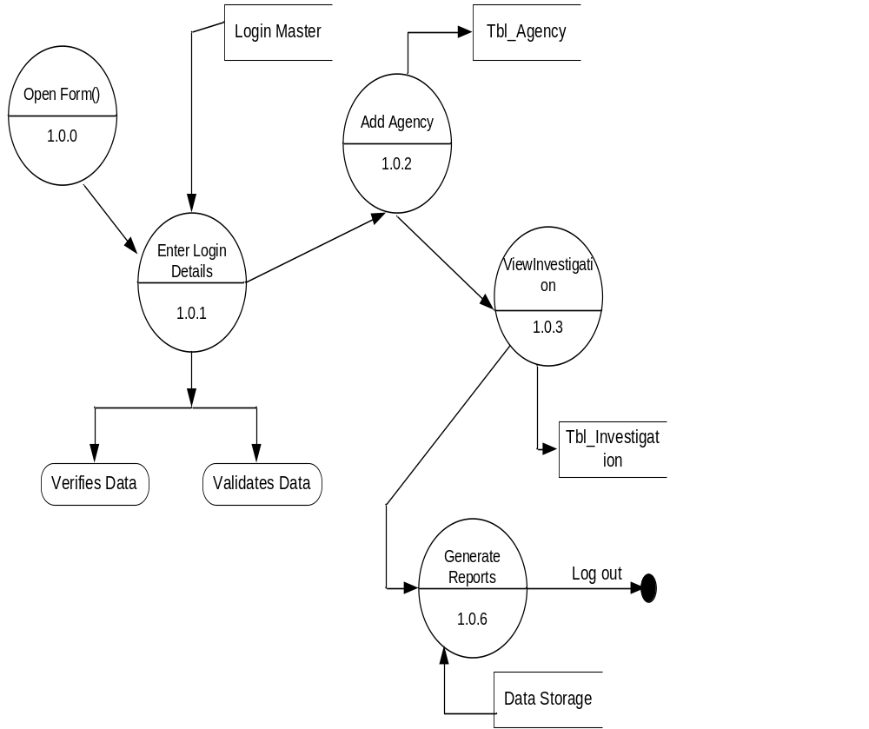

2nd Level DFD

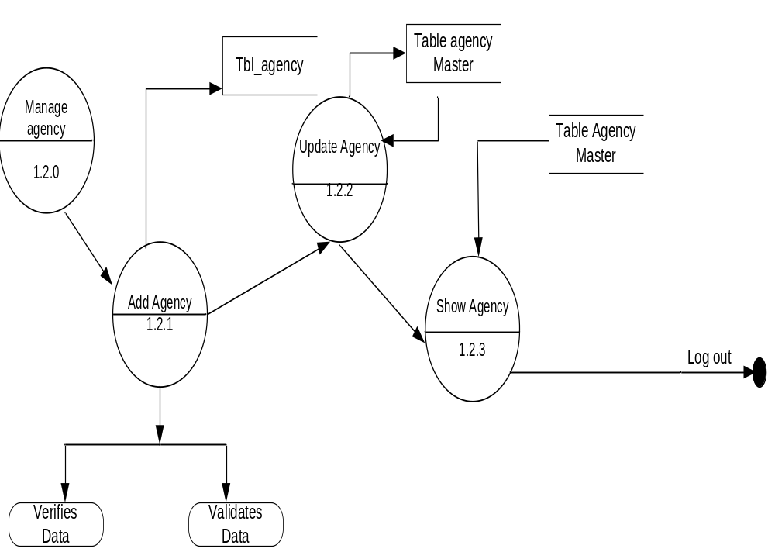

Agency
1st Level DFD:

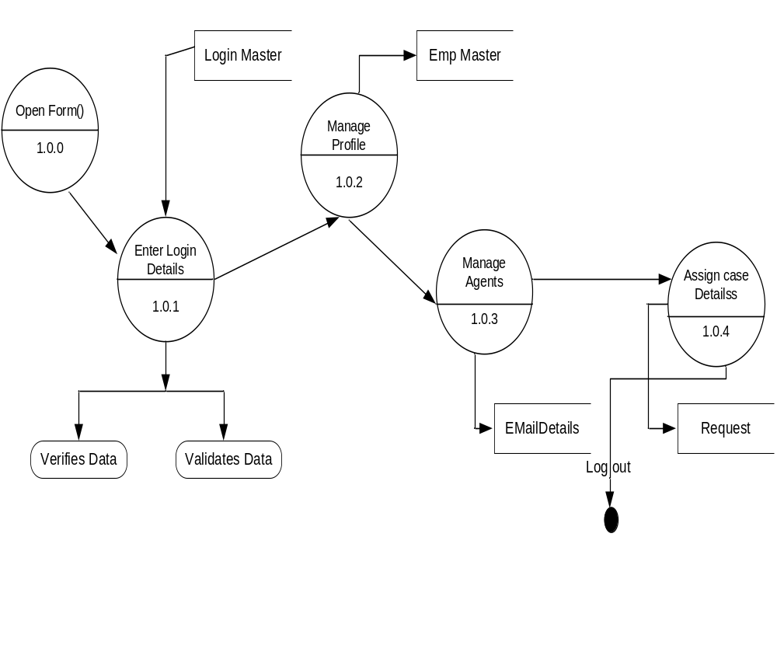

2nd Level DFD

