SYSTEM REQUIREMENT SPECIFICATION
FOR
Cybernetics Protector

Objective:
The main objective of Cybernetics Protector is to provide a secure way of communication and transferring evidences in Secret Intelligence Agency of defence system which has always uses undercover agents to solve complex cases and dismantle criminal organizations.
We are conceptualizing this software as a solution so that Secret Intelligence Agencies and their agents can communicate through this Software for the exchange of evidences in a secure way. And maintain the details of Defence Minister.
PROBLEMS IN THE EXISTING SYSTEM
Existing System:
- This existing system is not providing secure registration and profile management of all the users properly.
- This manual system gives us very less security for saving data and some data may be lost due to mismanagement.
- The system is giving only less memory usage for the users.
- The system doesn’t provide facility to track all the activities of Agency-Chief and under working Agents.
- The system doesn’t provide any facility to maintain any tips & suggestion for Citizen.
- This system doesn’t provide recruitment of agents through online.
SOLUTION OF THESE PROBLEMS
The development of this new system contains the following activities, which try to automate the entire process keeping in the view of database integration approach.
- User friendliness is provided in the application with various controls provided by system rich user interface.
- This system makes the overall project management much easier and flexible.
- Various classes have been used for maintain the details of all the users and catalog.
- Authentication is provided for this application only registered users can access.
- Report generation features is provided using to generate different kind of reports.
- The system provides facilities to track the all activities of Agency-Chief and Agents.
- System also tracks the tips and suggestion online.
- System provides facility to recruit Agents in online.
- System also provides facility to upload evidences in encrypted format and view cases, related resources.
- This system is providing more memory for the users to maintain data.
- This system is providing accessibility control to data with respect to users.
- This system provides citizens to view success Stories.
No. of Modules
Modules:
- Administrator / Defense
- Agency
- Agents
- Registration
- Authentication
Administrator
Administrator is a super user in the system. He will monitor all the users’ activities in the system. He has privileges to do anything at any point of time. Should be able to send resources to Secret Agency. Receive reports. Ability to assign cases to the Agency.
Agency
- Should be able to send resources to Secret Agency.
- Receive reports
- Ability to assign cases to the Agency.

Agents
- Able to view case details.
- Able to view resources from ministry or chief.
- Generate Report.

Registration
The system has a process of registration. Every user need to submit their complete details including user name and password in the form of registration. Whenever a user registration completed then only a user can get log in into the system by using his user id and password.
Authentication:
Authentication is nothing but providing security to the system. Here every must enter into the system throw login page. The login page will restrict the UN authorized users. A user must provide his credential like user Id and password for log into the system. For that the system maintains data for all users. Whenever a user enters his user id and password, it checks in the database for user existence. If the user is exists he can be treated as a valid user. Otherwise the request will throw back.
INPUT AND OUTPUT
The major inputs and outputs and major functions of the system are follows:
Inputs:
- Administrator enter his user id and password for login to authenticate in this system
- Administrator adds Agents details to the system.
- Administrator can add the Cases details in this website.
- Agent can View the case info in this website.
- Agents can give the response for the Case.

Outputs:
- Administrator can have his own home page.
- Agents, Agency can have their own home page after completion of the authentication process.
- Agency gets the Case details from Admin/Defense.
- Agency receives the cases info from the agents
- Admin can generate the reports.

Software Development Life Cycle
SDLC METHDOLOGIES
This document play a vital role in the development of life cycle (SDLC) as it describes the complete requirement of the system. It means for use by developers and will be the basic during testing phase. Any changes made to the requirements in the future will have to go through formal change approval process.
SPIRAL MODEL was defined by Barry Boehm in his 1988 article, “A spiral Model of Software Development and Enhancement. This model was not the first model to discuss iterative development, but it was the first model to explain why the iteration models.
As originally envisioned, the iterations were typically 6 months to 2 years long. Each phase starts with a design goal and ends with a client reviewing the progress thus far. Analysis and engineering efforts are applied at each phase of the project, with an eye toward the end goal of the project.
The following diagram shows how a spiral model acts like:

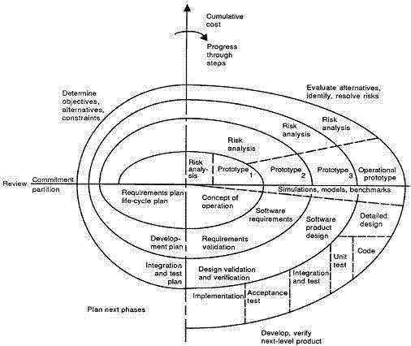

The steps for Spiral Model can be generalized as follows:
- The new system requirements are defined in as much details as possible. This usually involves interviewing a number of users representing all the external or internal users and other aspects of the existing system.
- A preliminary design is created for the new system.
- A first prototype of the new system is constructed from the preliminary design. This is usually a scaled-down system, and represents an approximation of the characteristics of the final product.
- A second prototype is evolved by a fourfold procedure:
- Evaluating the first prototype in terms of its strengths, weakness, and risks.
- Defining the requirements of the second prototype.
- Planning an designing the second prototype.
- Constructing and testing the second prototype.
- At the customer option, the entire project can be aborted if the risk is deemed too great. Risk factors might involved development cost overruns, operating-cost miscalculation, or any other factor that could, in the customer’s judgment, result in a less-than-satisfactory final product.
- The existing prototype is evaluated in the same manner as was the previous prototype, and if necessary, another prototype is developed from it according to the fourfold procedure outlined above.
- The preceding steps are iterated until the customer is satisfied that the refined prototype represents the final product desired.
- The final system is constructed, based on the refined prototype.
- The final system is thoroughly evaluated and tested. Routine maintenance is carried on a continuing basis to prevent large scale failures and to minimize down time.
N-Tier Architecture:
N-Tier Applications can easily implement the concepts of Distributed Application Design and Architecture. The N-Tier Applications provide strategic benefits to Enterprise Solutions. While 2-tier, client-server can help us create quick and easy solutions and may be used for Rapid Prototyping, they can easily become a maintenance and security night mare. The N-tier Applications provide specific advantages that are vital to the business continuity of the enterprise. Typical features of a real life n-tier may include the following:
- Security
- Availability and Scalability
- Manageability
- Easy Maintenance
- Data Abstraction
The above mentioned points are some of the key design goals of a successful n-tier application that intends to provide a good Business Solution.
Definition:
Simply stated, an n-tier application helps us distribute the overall functionality into various tiers or layers:
- Presentation Layer
- Business Object Layer
- Data Access Layer
- Database/Data Store
Each layer can be developed independently of the other provided that it adheres to the standards and communicates with the other layers as per the specifications.
This is the one of the biggest advantages of the n-tier application. Each layer can potentially treat the other layer as a ‘Block-Box’.
In other words, each layer does not care how other layer processes the data as long as it sends the right data in a correct format.
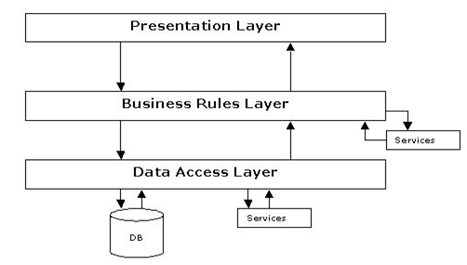
N-Tier Architecture
The Presentation Layer:
Also called as the client layer comprises of components that are dedicated to presenting the data to the user. For example: Windows/Web Forms and buttons, edit boxes, Text boxes, labels, grids, etc.
The Business Object Layer:
This layer encapsulates the Business rules or the business logic of the encapsulations. To have a separate layer for business logic is of a great advantage. This is because any changes in Business Rules can be easily handled in this layer. As long as the interface between the layers remains the same, any changes to the functionality/processing logic in this layer can be made without impacting the others. A lot of client-server apps failed to implement successfully as changing the business logic was a painful process.
The Data Access Layer:
This layer comprises of components that help in accessing the Database. If used in the right way, this layer provides a level of abstraction for the database structures. Simply put changes made to the database, tables, etc do not affect the rest of the application because of the Data Access layer. The different application layers send the data requests to this layer and receive the response from this layer.
The Database Layer:
This layer comprises of the Database Components such as DB Files, Tables, Views, etc. The Actual database could be created using SQL Server, Oracle, Flat files, etc.
In an n-tier application, the entire application can be implemented in such a way that it is independent of the actual Database. For instance, you could change the Database Location with minimal changes to Data Access Layer. The rest of the Application should remain unaffected.
FEASIBILITY STUDY:

Preliminary investigation examine project feasibility, the likelihood the system will be useful to the organization. A Project Feasibility Study is an exercise that involves documenting each of the potential solutions to a particular business problem or opportunity. Feasibility Studies can be undertaken by any type of business, project or team and they are a critical part of the Project Life Cycle.
The purpose of a Feasibility Study is to identify the likelihood of one or more solutions meeting the stated business requirements. In other words, if you are unsure whether your solution will deliver the outcome you want, then a Project Feasibility Study will help gain that clarity. During the Feasibility Study, a variety of 'assessment' methods are undertaken. The outcome of the Feasibility Study is a confirmed solution for implementation.
The main objective of the feasibility study is to test the Technical, Operational and Economical feasibility for adding new modules and debugging old running system. All system is feasible if they are unlimited resources and infinite time. There are aspects in the feasibility study portion of the preliminary investigation:
- Technical Feasibility
- Economical Feasibility
- Operation Feasibility
Technical Feasibility:
- In the feasibility study first step is that the organization or company has to decide that what technologies are suitable to develop by considering existing system.
- Here in this application used the technologies like Visual Studio 2008 and Sql Server 2005. These are free software that would be downloaded from web.
- Visual Studio 2008 –it is tool or technology.

Determining Economic Feasibility
For any system if the expected benefits equal or exceed the expected costs, the system can be judged to be economically feasible. In economic feasibility, cost benefit analysis is done in which expected costs and benefits are evaluated. Economic analysis is used for evaluating the effectiveness of the proposed system.
In economic feasibility, the most important is Cost-benefit analysis. As the name suggests, it is an analysis of the costs to be incurred in the system and benefits derivable out of the system. Click on the link below which will get you to the page that explains what cost benefit analysis is and how you can perform a cost benefit analysis.
Operational Feasibility
Not only must an application make economic and technical sense, it must also make operational sense.
Issues to consider when determining the operational feasibility of a project.
Operations Issues | Support Issues
- What tools are needed to support operations?  - What skills will operators need to be trained in?  - What processes need to be created and/or updated?  - What documentation does operations need? | - What documentation will users be given?  - What training will users be given?  - How will change requests be managed?
Very often you will need to improve the existing operations, maintenance, and support infrastructure to support the operation of the new application that you intend to develop. To determine what the impact will be you will need to understand both the current operations and support infrastructure of your organization and the operations and support characteristics of your new application.
To operate this application END-TO-END VMS. The user no need to require any technical knowledge that we are used to develop this project is Asp.net ,C#.net. That the application providing rich user interface by user can do the operation in flexible manner.

