Cybernetics Protector

Activity Diagrams

Login Activity:
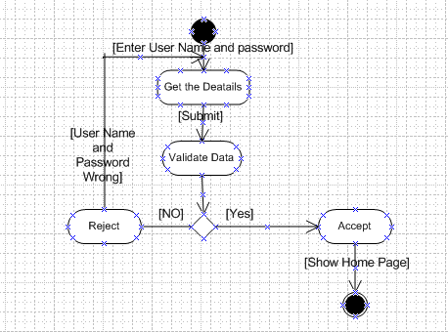

Admin Activity Diagram:

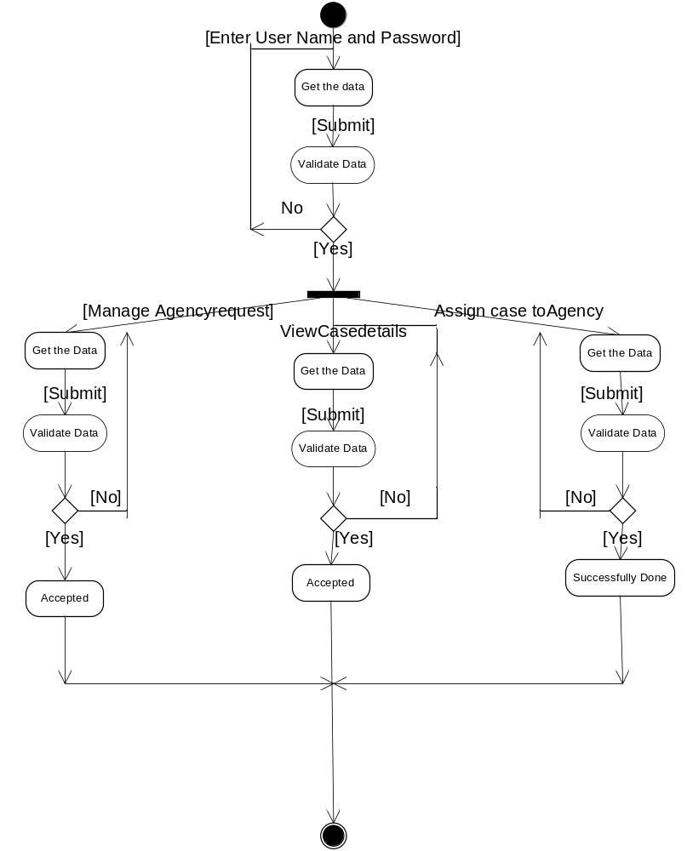

Agency Activity Diagram:

