CyberneticsProtector

UNIFIED MODELING LANGUAGE DIAGRAMS
The unified modeling language allows the software engineer to express an analysis model using the modeling notation that is governed by a set of syntactic semantic and pragmatic rules.
A UML system is represented using five different views that describe the system from distinctly different perspective. Each view is defined by a set of diagram, which is as follows.
User Model View
    - This view represents the system from the users perspective.
    - The analysis representation describes a usage scenario from the end-users perspective.
Structural model view
◆ In this model the data and functionality are arrived from inside the system.
◆ This model view models the static structures.
Behavioral Model View
◆ It represents the dynamic of behavioral as parts of the system, depicting the interactions of collection between various structural elements described in the user model and structural model view.
Implementation Model View
  - In this the structural and behavioral as parts of the system are represented as they are to be built.
Environmental Model View
In this the structural and behavioral aspects of the environment in which the system is to be implemented are represented.
UML is specifically constructed through two different domains they are
- UML Analysis modeling, which focuses on the user model and structural model views of the system?
- UML design modeling, which focuses on the behavioral modeling, implementation modeling and environmental model views.

Use case Diagrams represent the functionality of the system from a user’s point of view. Use cases are used during requirements elicitation and analysis to represent the functionality of the system. Use cases focus on the behavior of the system from external point of view.
Actors are external entities that interact with the system. Examples of actors include users like administrator, bank customer …etc., or another system like central database.
Use case Model

SYSTEM NAME

Use case 1

Use case 2

Use case n

Actor
Actor

USE CASE FOR LOGIN PROCESS

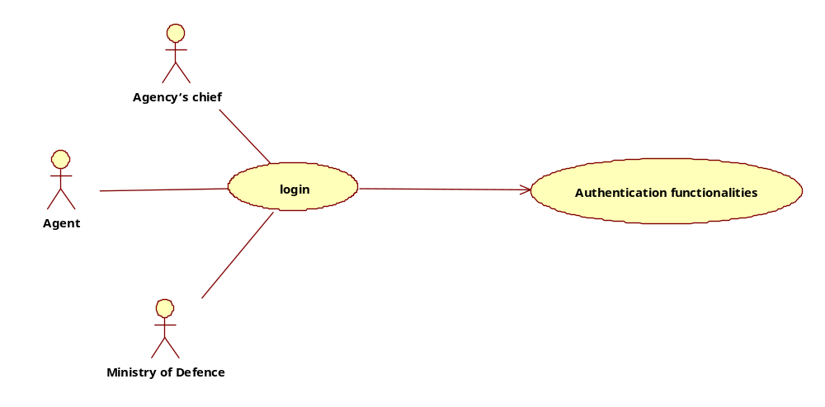

- system Use Case Diagram

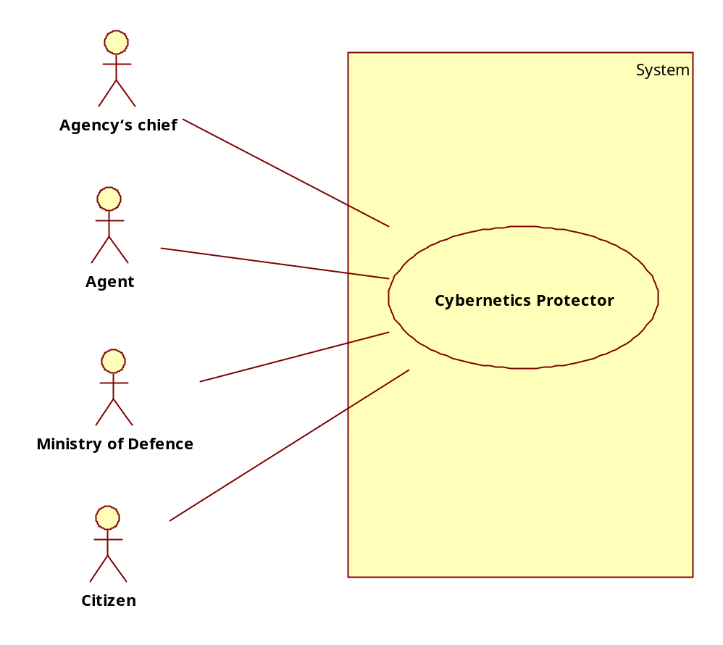

Agency’s Chief
agent
Create Agents
Edit Agents
View Agents
<<include>>
<<include>>
cases
add cases
asign cases
<<include>>
<<include>>
add success stories

Citizen Usecase Diagram
citizen
view success stories
view job resources
tips & suggesition

