Predictive Insights into Banking Customer Churn
DVA Capstone 2 Project Report
Field | Details
Sector | Banking and Financial Services
Team | Section B - Group 09
Institute | Newton School of Technology
Course | Data Visualization and Analytics
Tools Used | Python, Pandas, NumPy, SciPy, Matplotlib, Seaborn, Tableau Public, GitHub
Dataset | Bank Customer Churn Dataset; local file data/churn_prediction.csv
Submission Date | April 29, 2026
Faculty Mentor | To be filled

Team Members (to be filled)
S. No. | Name | Role
1
2
3
4
5
6

1. Executive Summary
This report analyzes banking customer churn across 28,382 customers. The overall churn rate is 18.53%, with 5,260 churned customers and 23,122 retained customers. The project uses Python for extraction, cleaning, EDA, statistical validation and Tableau-ready data preparation, then uses Tableau dashboards for business storytelling.
- Low-balance customers show the highest churn rate at 65.31%.
- Self-employed customers have the highest major occupation churn rate at 19.84%.
- Adult customers show the highest age-group churn rate at 19.98%.
- High and very high activity levels show elevated churn, suggesting possible fund movement before exit.
- Statistical tests confirm significant relationships for balance, gender, and occupation-related behavior.

2. Sector Context and Problem Statement
Customer churn in retail banking leads to lost balances, weaker product cross-sell potential, lower lifetime value, and higher acquisition pressure. The business problem is to identify which customers are most likely to churn and what financial or behavioral factors influence that churn.
- Measure churn and retained customer base.
- Identify high-risk segments by age, gender, occupation, balance, activity, and customer network category.
- Validate findings statistically.
- Prepare KPI tables and dashboards for retention decisions.

3. Data Description
Attribute | Description
Raw dataset size | 28,382 rows x 21 columns
Cleaned dataset size | 28,382 rows x 26 columns
Target | churn / Churn, where 1 = churned and 0 = retained
Main dashboard file | data/tableau_exports/churn_final_tableau.csv

Important columns include age, gender, dependents, occupation, vintage, current balance, previous month balance, current month credit, current month debit, total transactions, activity level, and churn.

4. Cleaning and ETL Methodology
- Loaded raw data from data/churn_prediction.csv.
- Checked structure, missing values, data types, duplicate rows and target distribution.
- Dropped identifier/location fields not needed for analysis: customer_id, branch_code, city.
- Filled gender with mode, dependents with median, and occupation with Unknown.
- Converted last_transaction into date features and added no_transaction_flag.
- Replaced negative monetary values with zero and capped outliers at the 1st and 99th percentiles.
- Created age_group, balance_segment, total_transactions and activity_level.
Notebook | Purpose
01_extraction.ipynb | Raw data loading and profiling
02_cleaning.ipynb | Cleaning and transformation
03_eda.ipynb | Exploratory analysis
04_statistical_analysis.ipynb | Statistical testing
05_final_load_prep.ipynb | KPI and Tableau export preparation

5. KPI and Metric Framework
KPI | Business Meaning
Churn Rate | Overall customer loss risk
Total Customers | Base population
Total Churned | Number of churned customers
Total Retained | Remaining customer base
Avg Current Balance | Financial risk signal
Avg Vintage | Relationship duration proxy
Avg Total Transactions | Activity behavior
Segment Churn Rate | Targeted retention planning

Metric | Value
Total Customers | 28,382.00
Total Churned | 5,260.00
Total Retained | 23,122.00
Overall Churn Rate % | 18.53
Avg Current Balance - Churned | 4,202.91
Avg Current Balance - Retained | 6,734.15
Avg Vintage - Churned | 2,088.42
Avg Vintage - Retained | 2,091.76
Avg Total Transactions - Churned | 7,908.48
Avg Total Transactions - Retained | 3,515.49

6. Exploratory Data Analysis
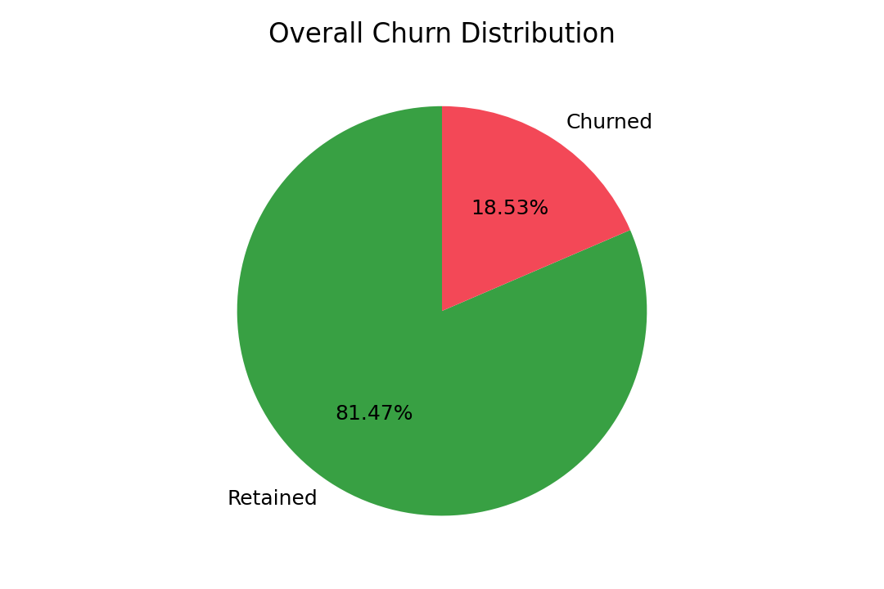
Figure 1: Overall churn distribution.
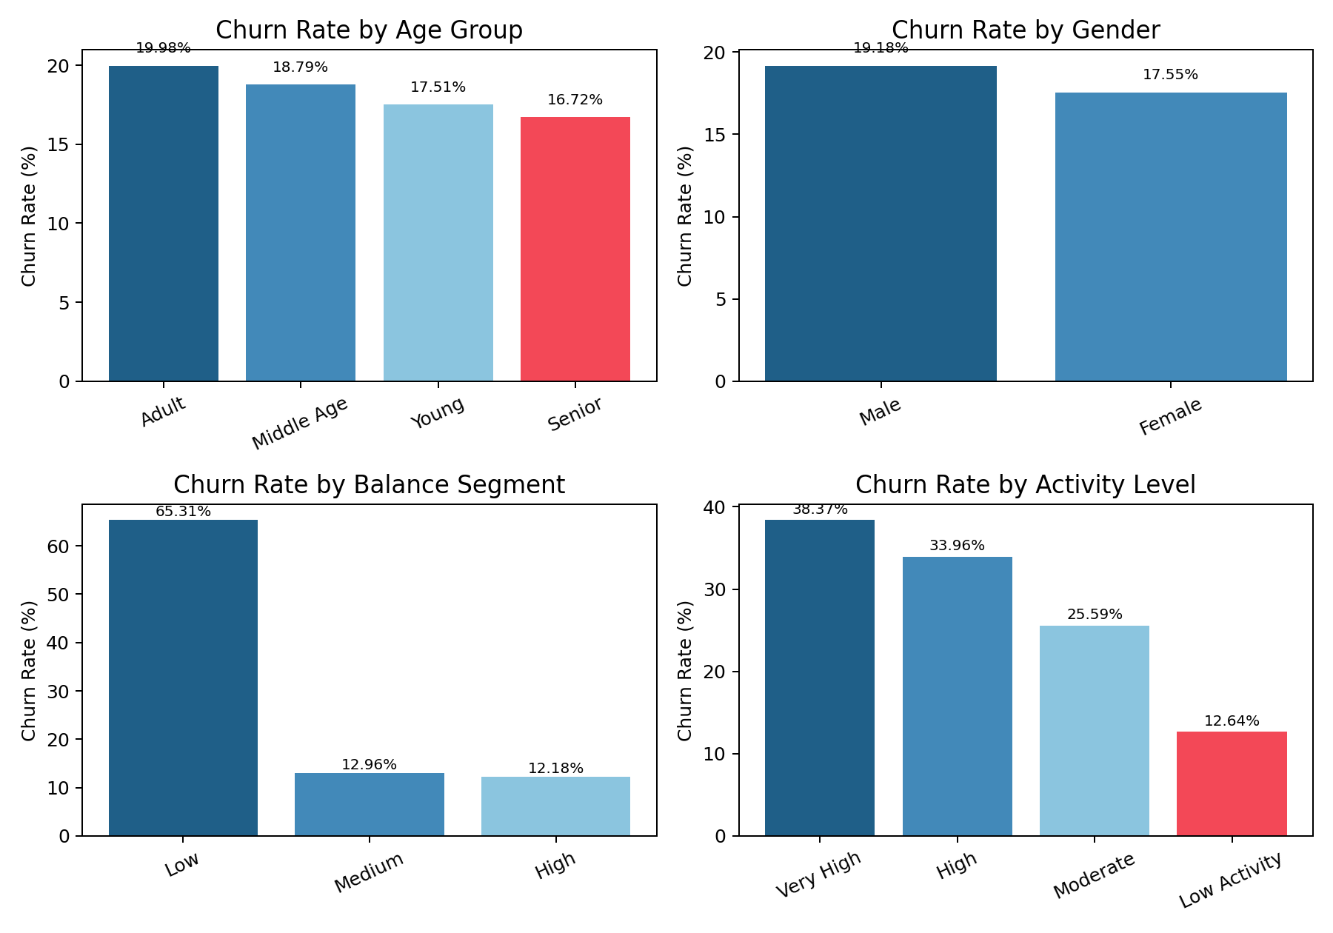
Figure 2: Churn rates by age, gender, balance and activity.
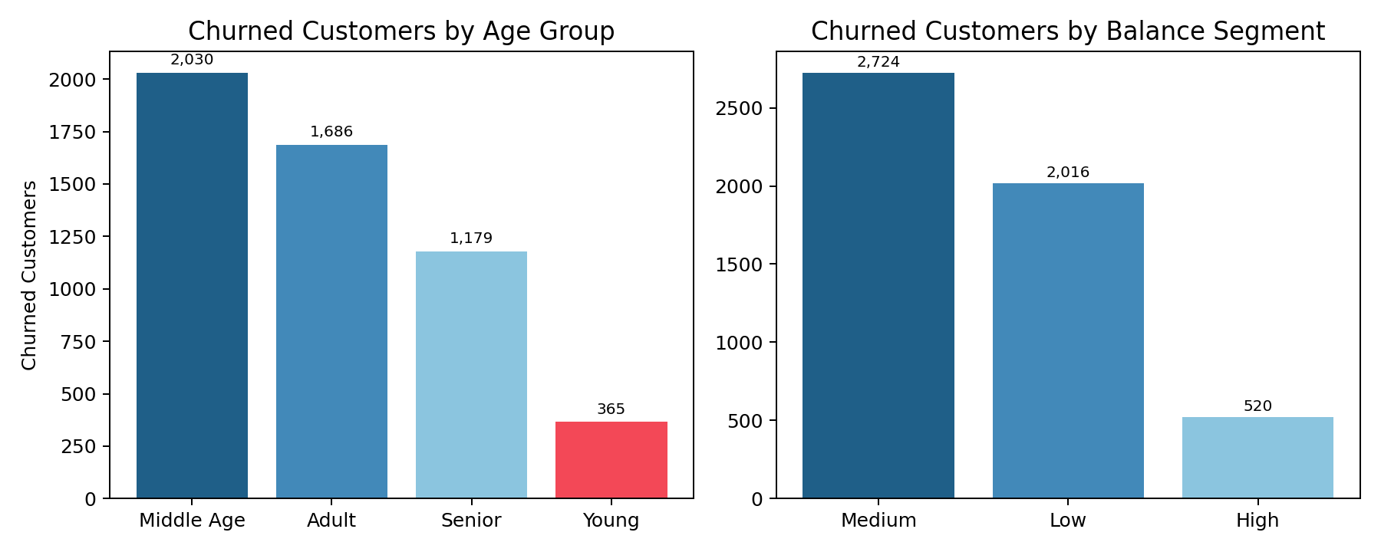
Figure 3: Churn counts by age group and balance segment.
The low-balance segment has the strongest churn rate, while medium-balance customers contribute the largest churn volume. This means retention planning should consider both risk rate and absolute customer count.

7. Statistical Analysis Results
Test | Result | Interpretation
T-test: Balance vs Churn | p = 5.61e-81 | Churned customers have significantly lower balances.
Chi-square: Gender vs Churn | p = 0.00057 | Gender and churn are statistically related.
ANOVA: Occupation vs Balance | p = 1.20e-23 | Occupation groups differ significantly in maintained balance.
Correlation | current_month_debit = 0.186; current_balance = -0.105 | Higher debit/activity and lower balance are useful risk signals.

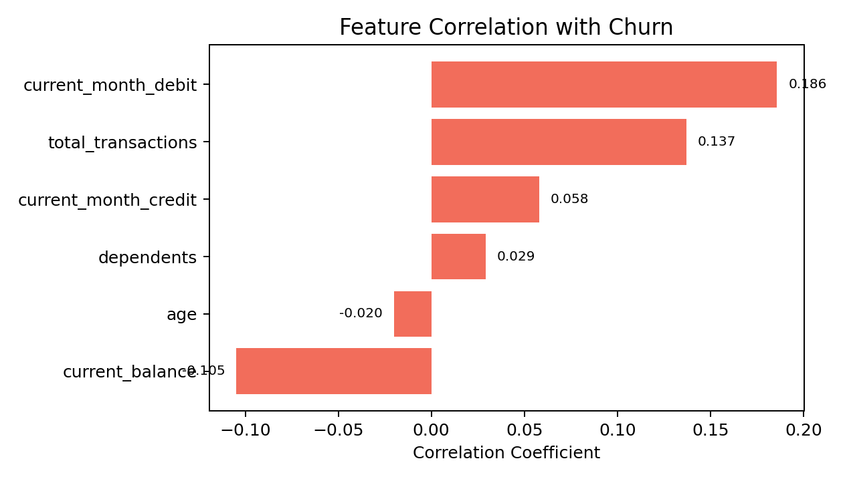
Figure 4: Feature correlation with churn.

8. Dashboard Design and Walkthrough
The Tableau dashboard uses KPI tiles, churn distribution views, filters, bar charts and heatmaps to support both executive review and operational segment analysis.
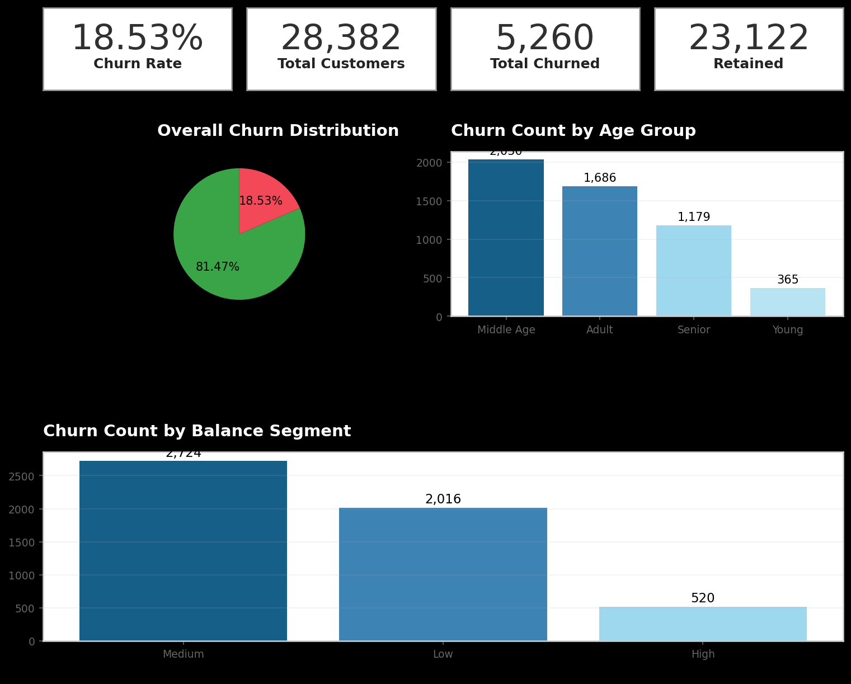
Figure 5: Executive dashboard view.
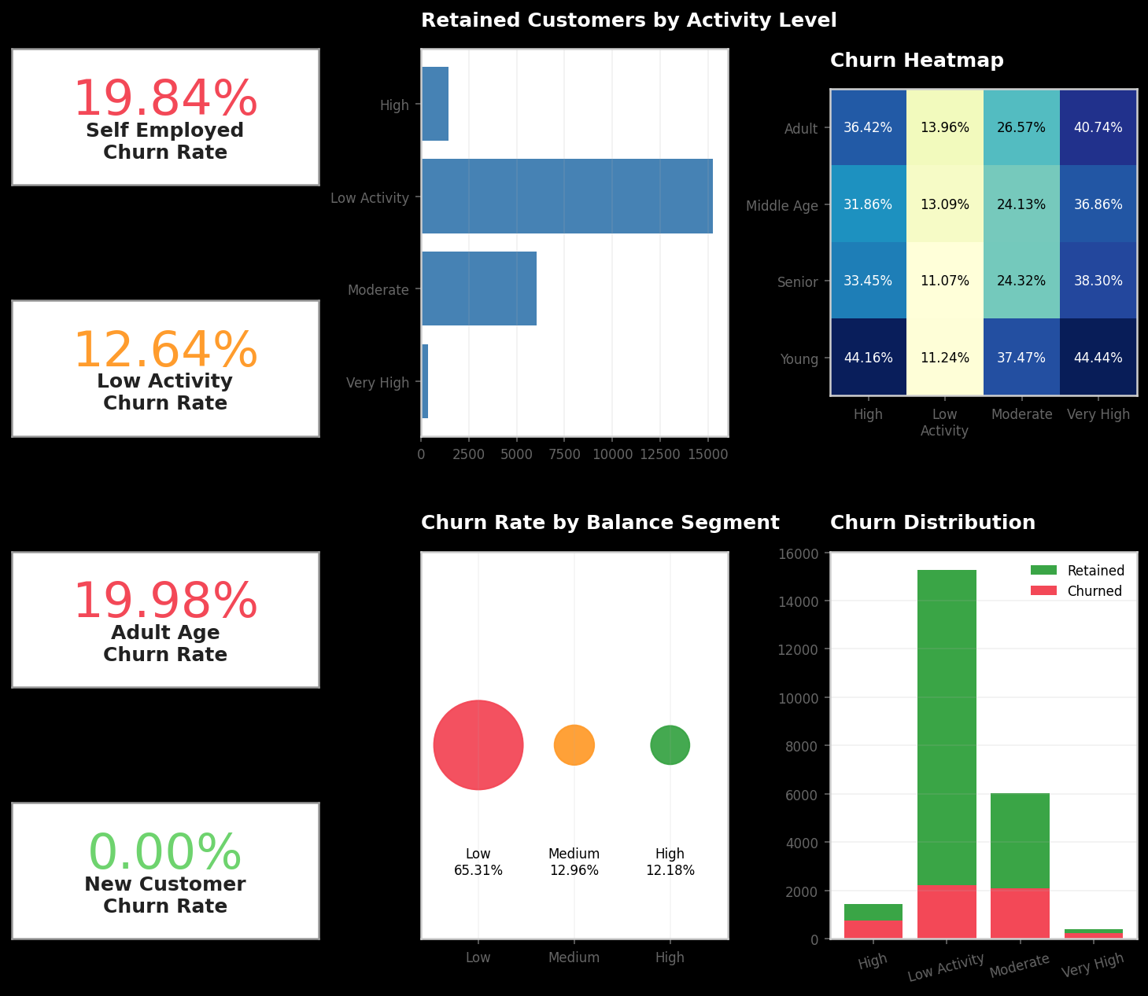
Figure 6: Segment deep-dive dashboard view.
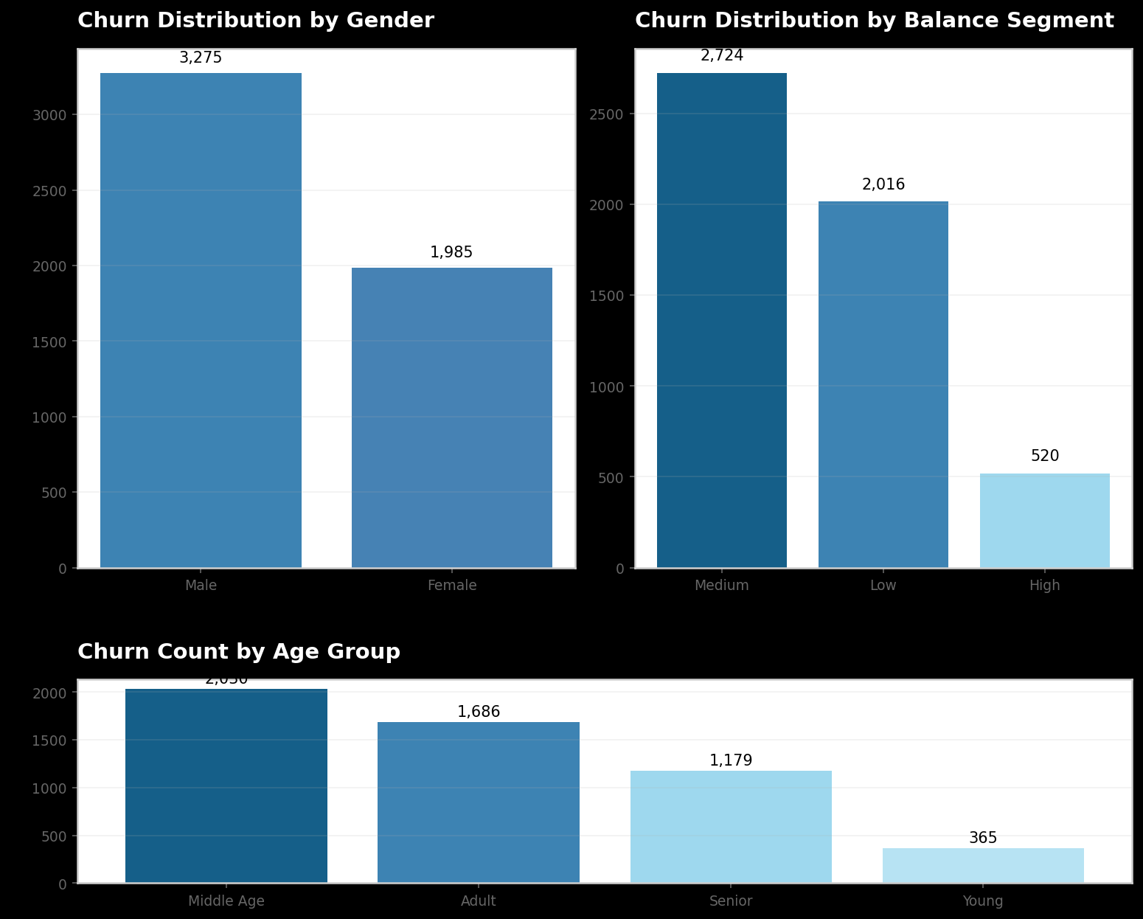
Figure 7: Operational monitoring dashboard view.

9. Key Insights in Decision Language
- Overall churn is 18.53%, meaning nearly one in five customers churned.
- Low-balance customers are the most urgent risk segment with 65.31% churn.
- Medium-balance customers contribute the highest churn volume with 2,724 churned customers.
- Self-employed customers have the highest major occupation churn rate at 19.84%.
- Adult customers have the highest age-group churn rate at 19.98%.
- Middle-age customers contribute the highest churn count.
- Male customers churn slightly more than female customers.
- Very high activity customers show 38.37% churn, suggesting possible exit behavior.
- Current month debit is positively related to churn.
- Current balance is negatively related to churn.
- Network category is less actionable than balance, occupation and activity.
- The dashboard should be used as an early-warning retention tool.

10. Recommendations and Impact Estimation
Recommendation | Action | Estimated Impact
Low-balance retention program | Use fee waivers, balance-building nudges and outreach for low-balance customers. | A 10% relative reduction could retain about 202 low-balance churners.
Transaction-behavior alerts | Flag sudden debit spikes and high transaction movement. | A 10% relative reduction in high/very high activity churn could retain about 98 customers.
Self-employed offers | Offer flexible banking bundles and business banking support. | A 5% relative reduction could retain about 173 self-employed customers.
Segment campaigns | Prioritize adult and male customer cohorts for campaign testing. | Improves targeting and reduces campaign waste.
Monthly dashboard review | Refresh Tableau KPIs and segment views monthly. | Creates a repeatable retention workflow.

11. Limitations and Future Scope
- The dataset is anonymized and lacks income, product ownership, customer revenue, complaints and branch names.
- The analysis is descriptive/statistical and does not prove causation.
- Bucket definitions can affect segment interpretation.
- Future work can add predictive modeling, risk scoring, campaign uplift testing and revenue impact estimation.

12. Contribution Matrix
Blank contribution matrix for six team members. Fill this using actual GitHub commits, branches and pull requests before submission.
S. No. | Team Member Name | Role | GitHub Evidence / PR Link | Primary Contribution | Signature
1
2
3
4
5
6

Appendix: Assets Used
- README.md and capstone project context.
- Notebooks 01 to 05 for Python workflow.
- data/churn_prediction.csv and data/churn_clean.csv.
- data/tableau_exports/ KPI and master files.
- tableau/screenshots/ dashboard screenshots.

