**Thapathali, Kathmandu, Nepal**

**AWE**

**Advance Website Engineering**

**(Documentation of Class Progression)**

|  |  |
| --- | --- |
| Prepared By:  Amit Kumar Karn  c7202634 | Module Tutor:  Mr. Pratik Shrestha |

**Initiation Date:**

**18thOctober, 2020**

Class Details

|  |  |  |  |
| --- | --- | --- | --- |
| **Day** | **Date** | **Topics Covered** | **Details** |
| 1. | Sunday,  12th October, 2020 | Module Introduction and Breakdown | Introduction to the module, guidelines for the learning materials and assessment details. |
| 2. | Monday,  13th October, 2020 | Local Environment Setup | Introduction to setup IDEs such as Eclipse Che, Php Storm, etc. Instructions to update php version to 7.4, integration of xdebug with ides, and introduction to git repositories. |
| 3. | Sunday,  18th October, 2020 | Git and GitHub Tutorial | Walkdown through Git and GitHub basic architecture. Tutorial to initiate local repositories and commit and push them to the remote repositories. Also, looked at the concepts of branches in git. |
| 4. | Monday,  19th October, 2020 | PHP Basics with OOPs Concepts | Interactive class about the PHP basics and key concepts. Also went through the OOP concepts along with some examples. |
| 5. | Sunday, 1st November, 2020 | Understanding Web Applications | Basic concepts of the web application, how they work and http protocols. Also, revisited the OSI model and lastly installed composer for Laravel installation. |
| 6. | Monday, 2nd November, 2020 | Routing and Views | Installed Laravel installer, created Laravel project and learnt the concepts of routing and MVC within the framework. |
| 7. | Sunday, 8th November, 2020 | View Templates and Blades with Laracasts | Learnt about the views from the MVC framework of Laravel. Stored in the resources/views directory and uses the blade.php file extension. Blade is a powerful templating engine provided with Laravel. Also watched a couple of videos from laracasts’ website. |
| 8. | Monday, 9th November, 2020 | Controllers | Downloaded and discussed component-1 assignment from GitHub. Learnt what a controller is and how it works in the MVC framework of Laravel. |
| 9. | Sunday, 22nd November, 2020 | Database and Migrations | Installed node, to install and run Vue for UI components, quick login, and registration by using auth middleware. Learn what migrations file and its up and down functions are and how to create and use them through both manually and by command line. |
| 10. | Monday, 23rd November, 2020 | Models | Learnt models are a class representing logical structure and relationship of underlying data table. Each database table has its own underlying model that allows us to interact with that table in a more dynamic and easy way. Also learnt to make and modify models via terminal or manually. |
| 11. | Sunday, 29th November, 2020 | Form Processing | Learnt the standard conventions for defining routing. Faking put/patch in Laravel as browsers only understand get, post or head method. (by using @method(‘PUT’) inside a form. Learnt about Cross-Site Request Forgery(CSRF) and how to prevent them by putting CSRF inside a form. |
| 12. | Monday, 30th November, 2020 | Forms Continue and Component-2 discission | Discussed how to set up the Laravel project inside local repository for component 2 and the requirements that needs to be completed. |
| 13. | Sunday, 6th December, 2020 | Mass Assignment, Eloquent Relationships, Factories and Seeders | Learnt what mass assignment vulnerability is and how it can be controlled by mentioning fillable and guarder model file. 2 variables define the mass assignment for coming via form. Watched episodes 26 to 30 from laracasts tutorial. |
| 14. | Monday, 7th December, 2020 | Laravel MVC, Authentication, Eloquent and User Roles | Revisited the MVC flow and some Laravel basics. Introduced to User registration and how mail setup can be done through environment variables (.env) file using an account of mailtrap.io. Also Watched laracasts episodes 34, 35 and 50. |
| 15. | Sunday, 13th December, 2020 | Policy, Hooks and User Roles | Learnt about php artisan make policy command and how policies in Laravel help with creating authorization functions for models. Saw how authorization hooks are used for authorizing multiple role-based users which is especially useful for granting all privilege to admin level users. Also saw how middleware authorization helps invoking authorization directly in routes instead of controllers. Learnt about assigning different user roles if logged in or not. Watched laracasts episodes 50, 51,53 and 54. |
| 16. | Monday, 14th December, 2020 | Laravel and Vue for Single Page Applications | Created a single page Laravel vue application from scratch. Learnt the Laravel vue scaffolding and how to use vue components inside Laravel blade files. Also saw how the routings can be handled using JavaScript instead of conventional Laravel routing so that user doesn’t have to request to the server every time they want a new page to display. |

Appendix (Screenshots)

Day 1: module introduction and breakdown

Day 2: local environment setup

* Xampp with PHP version 7.4.11

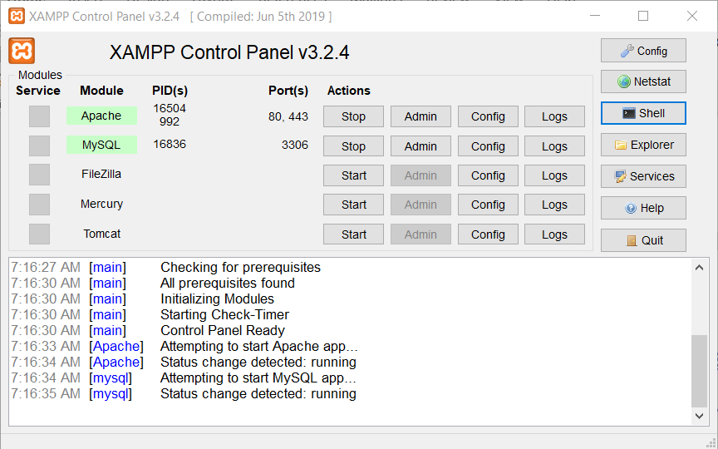

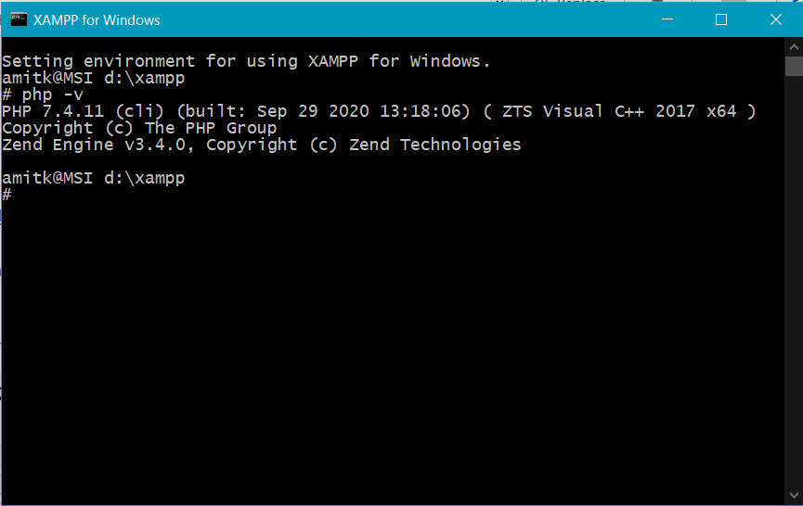

Day 3: git and github tutorial

* Remote Repository on GitHub

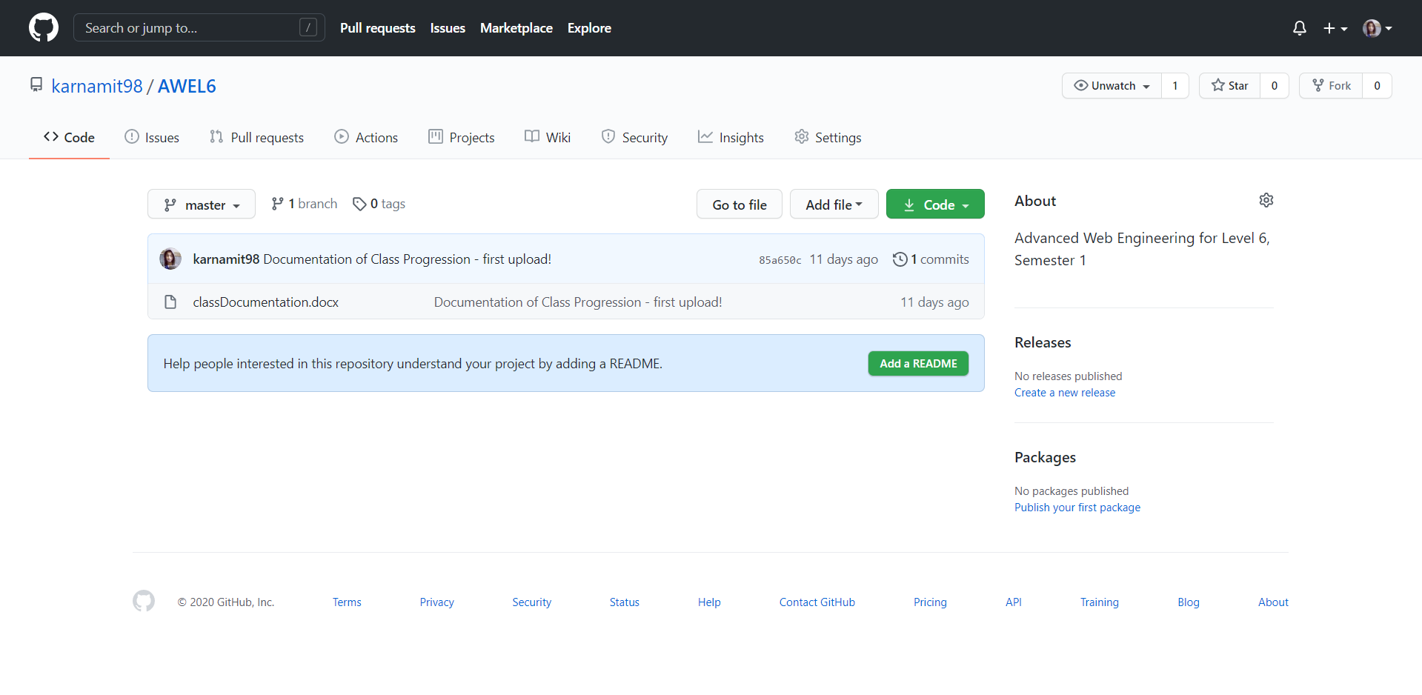

* Git Bash Terminal on Local Repository

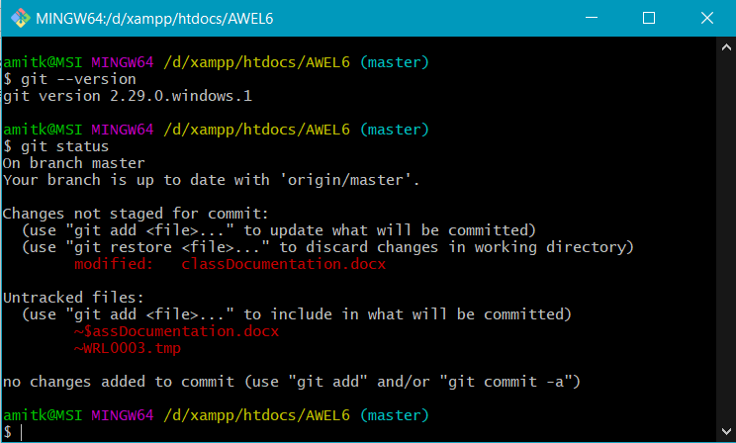

Day 4: php basics and oops concepts

Day 5: understanding web applications

* Composer Installation

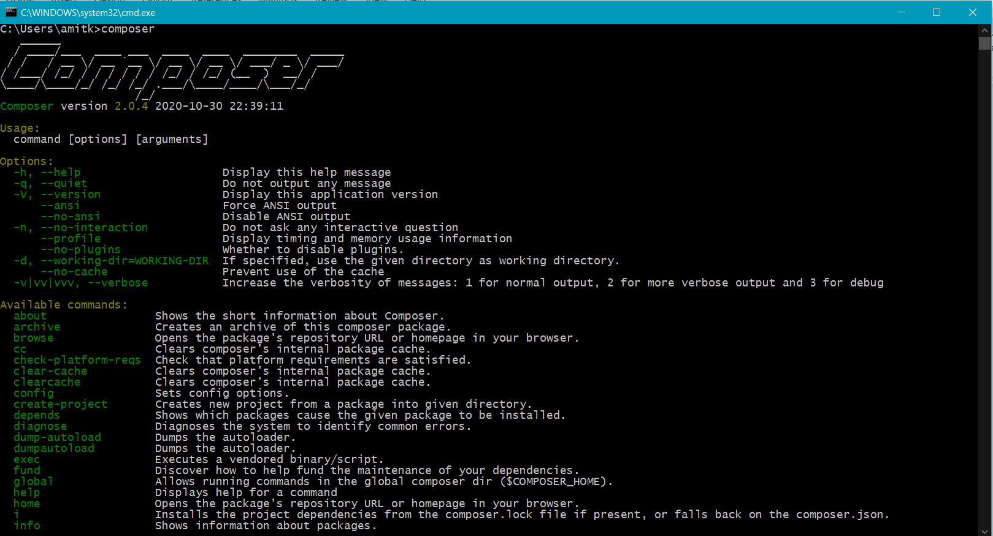

Day 6: routing and views

* Laravel Installation (local) via VSCode’s bash terminal

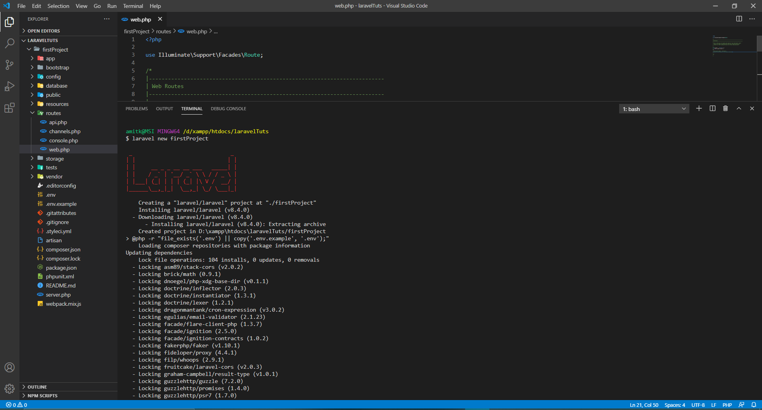

Day 6: view templates and blades with Laracasts

* Watched/Discussed a video on views at laracasts’ website.

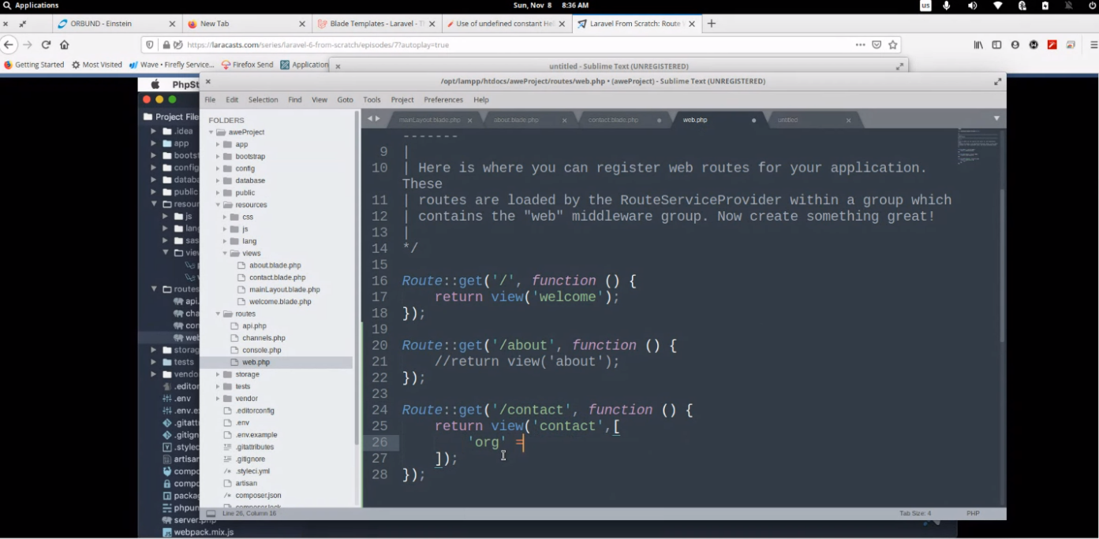

Day 7: controllers

* Got access to the component-1 repository on GitHub and cloned it locally

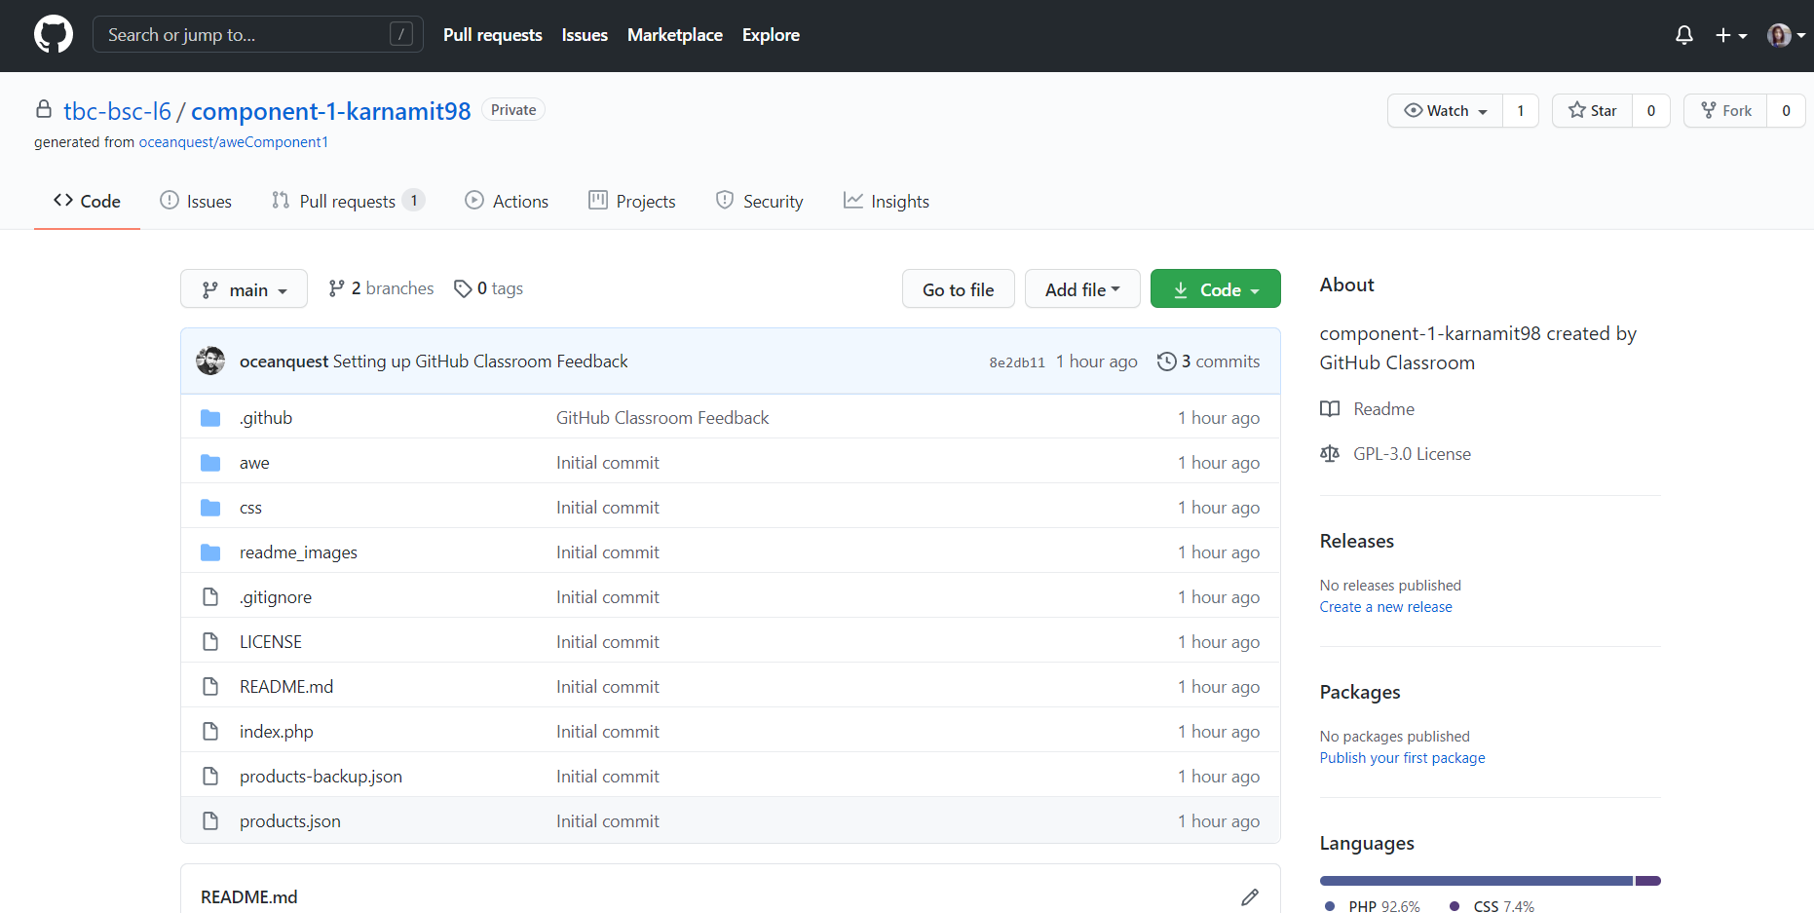

Day 8: controllers

Day 9: database and migrations

* Added UI dependencies using composer and later added login, registration and authorization components using vue

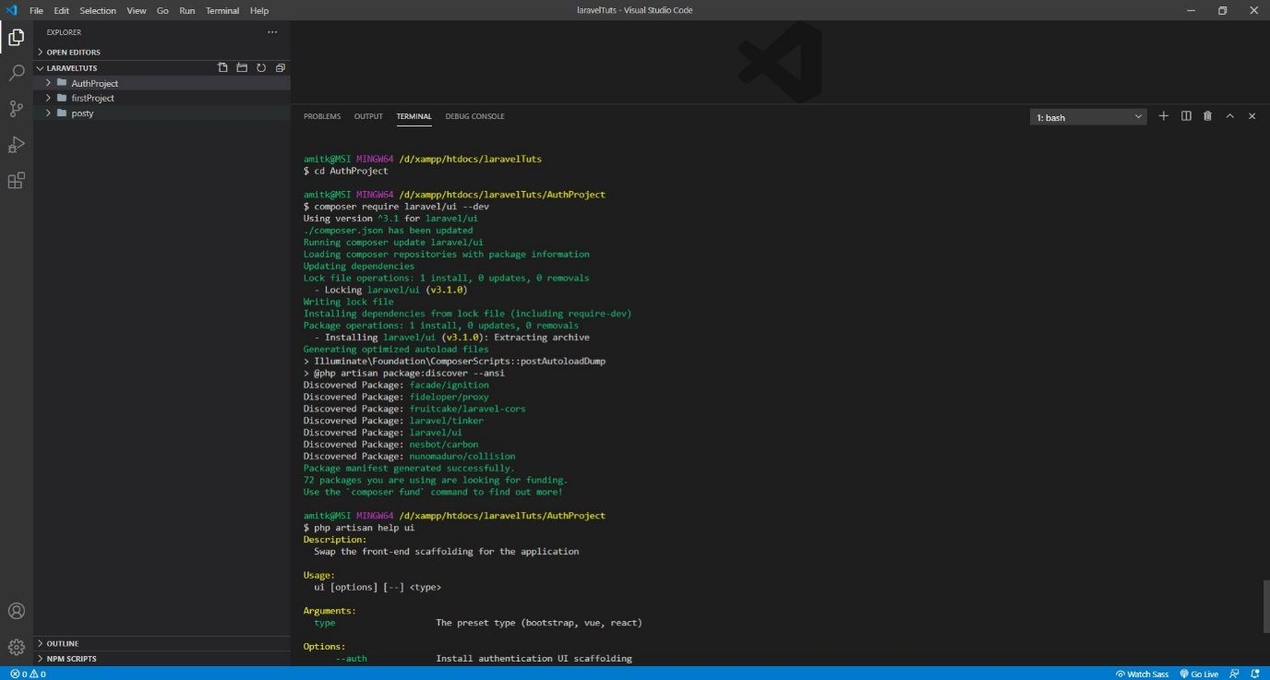

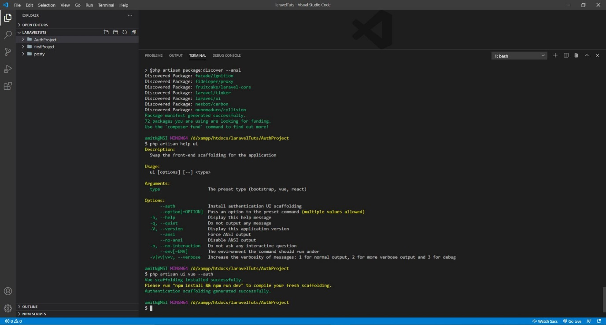

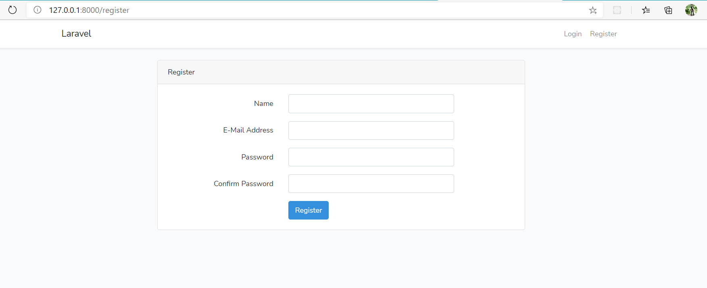

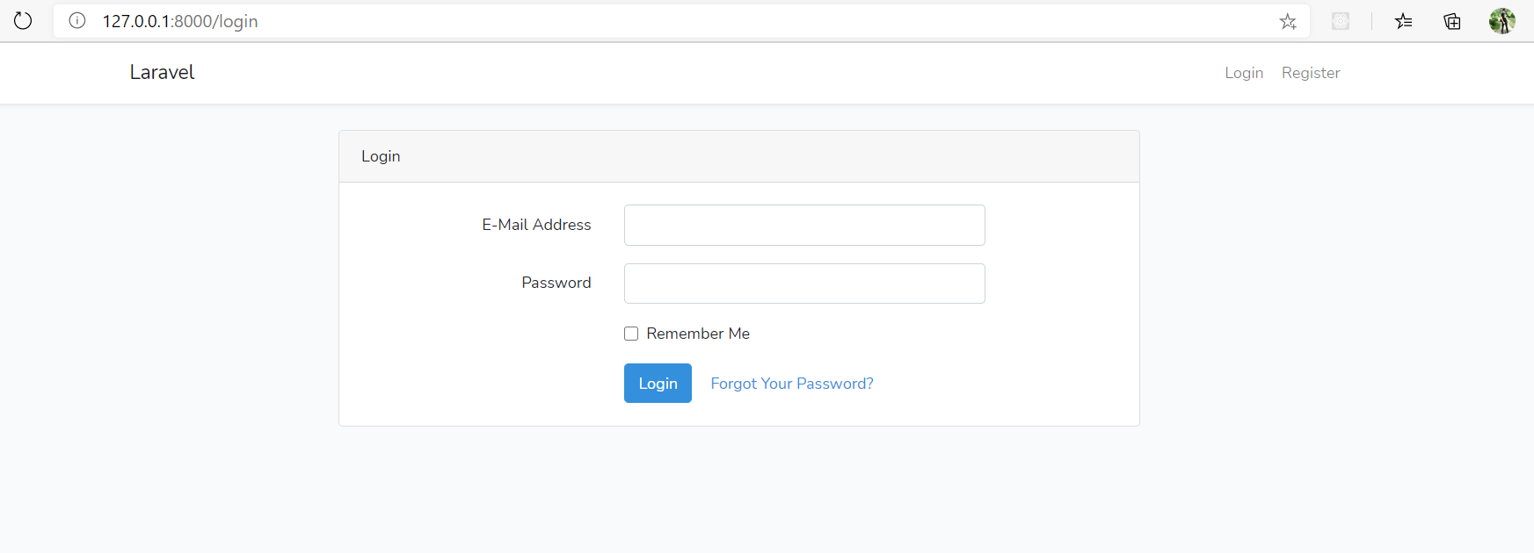

Day 10: models

* Default user model

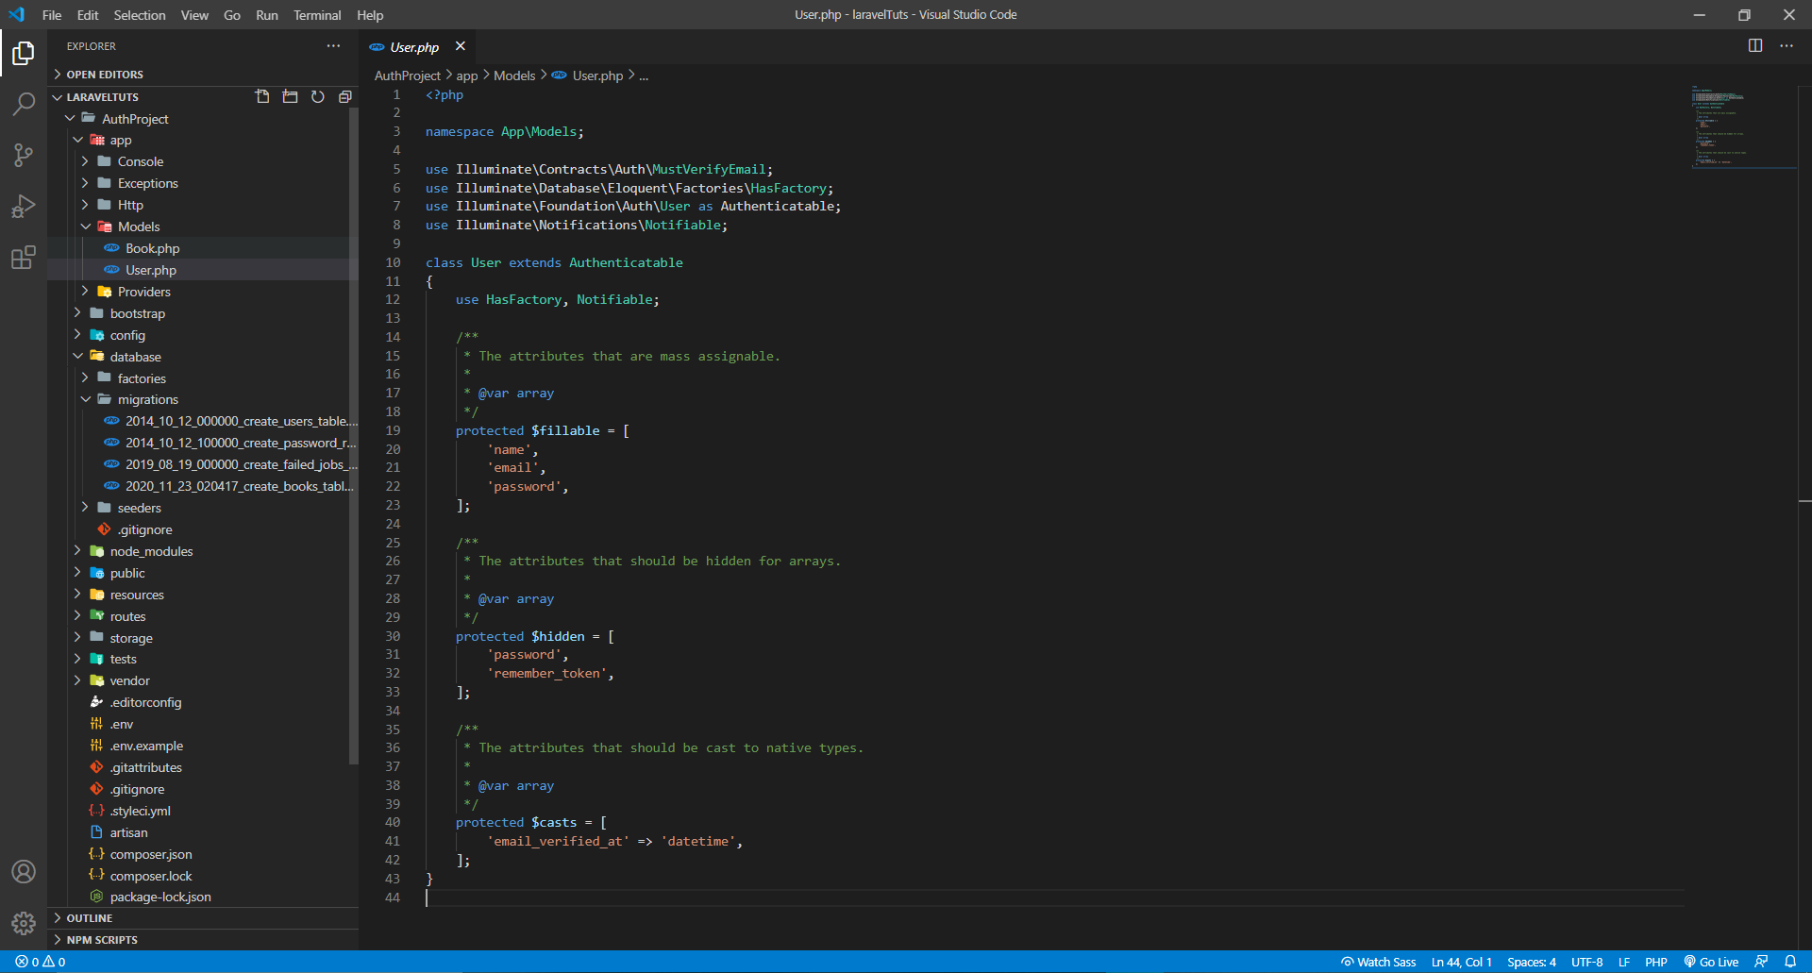

Day 11: form processing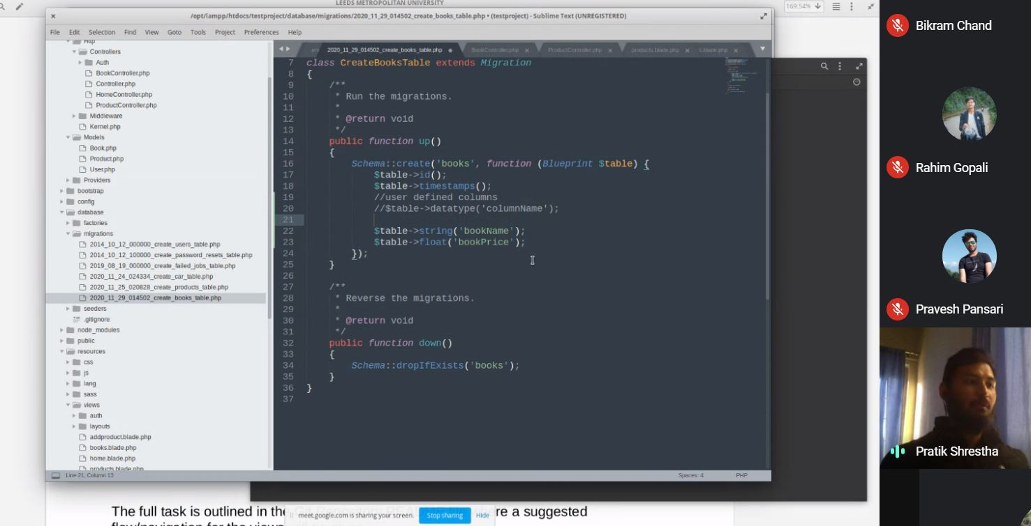

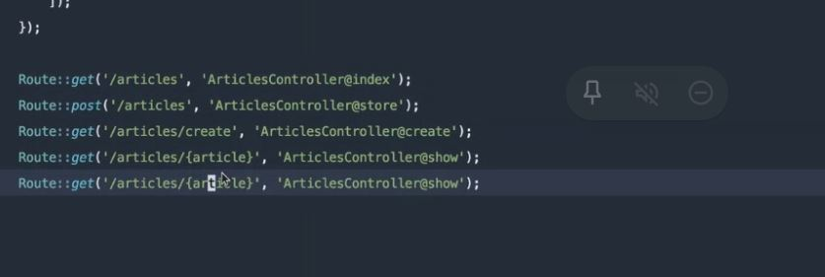

Day 12: form continue and component 2 discussion

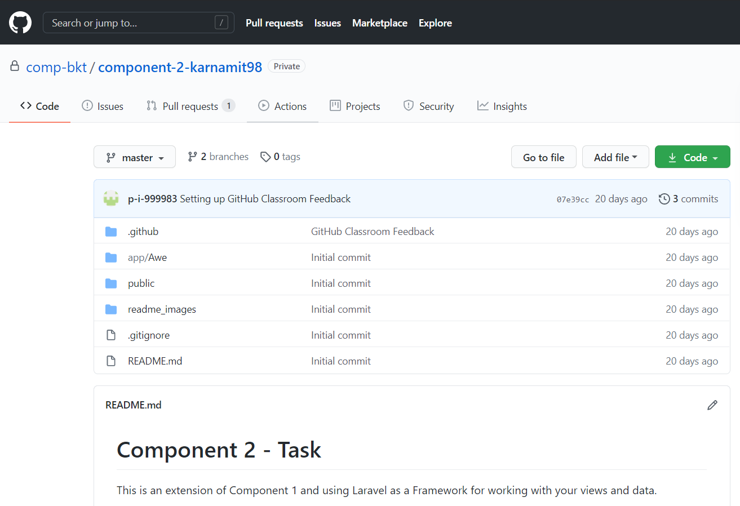

Day 13: mass assignment, eloquent relationships, factories and seeders

Day 14: laravel mvc, authentication and user roles

Day 15: policies, hooks and user roles

Day 16: laravel and vue for single page applications

