# Report:

## Functionality of Shell.java

Shell.java used SysLib to execute commands in the ThreadOS. It can run multiple commands at once with the use of “;” which represents the synchronous function. While “&” represents the asynchronous function. Use of ; after a command will wait for the command to finish before looking at rest of the argument. While & will run the command, while processing the rest of the argument.

First, I made the generateCmd method. The method takes in 3 parameters. The argument, the line of command in shell and the total arguments. First, we check if there is a “;” or a “&” at the end of the argument, and if there is we disregard it for now. Then we check if the argument list is empty, and if it is, we return null. But after those edge cases, we create an array of command that we can use to run the arguments that the user inputs. An array of size (number of arguments – line of argument) is created. In a for loop, that that array is filled with the right commands regarding the line of command that shell is running. Once the for loop is done, the newly created array gets returned.

The I made the algorithm that checks the edge cases for the command. First, checking if the command is “exit” in which case, exit the shell. But if it is not “exit” then we SysLib.exe(command) which executes the command (the array that was created in generateCmd). Then we check if the current argument line is a “&” or “;”. If it is “&” then we continue as is, but if it is “;”, we SysLib.join().

## How to run Shell.java:

1. Put it in the ThreadOS folder
2. Run javac Shell.java to compile the class un a Linux terminal
3. Run java Boot to boot ThreadOS
4. Once booted, type “l Shell”, which will use to the loader to load Shell
5. When “shell[1]%” is displayed, type in a command such a “HelloWorld” or “PingPong abc 100” to test it. You can input multiple commands at the same time by using “&” and “;” delimiters as explained above.

### Chart

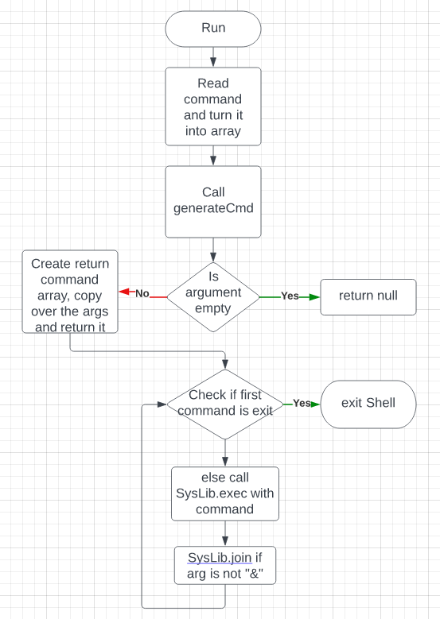

## My Output:

### Test 1:

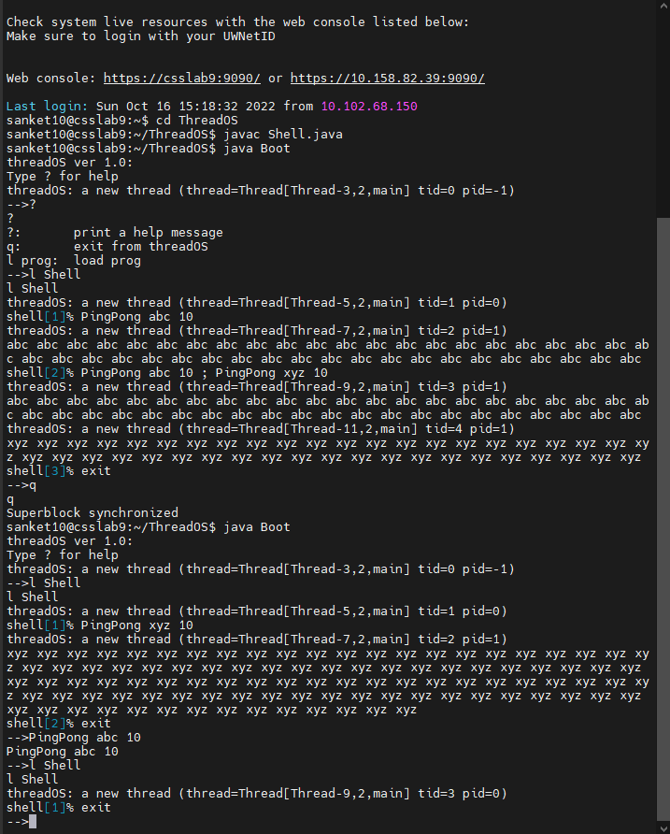

### Test 2

### Test 3

### Test 4

