Step1: - Initialized the project skeleton using Claude Code, then created the corresponding GitHub branches via AI-driven CLI commands.

GitHub Url:- https://github.com/karnatakapuvenkateswara-tech/core-audit-log-service/tree/feature/core-audit

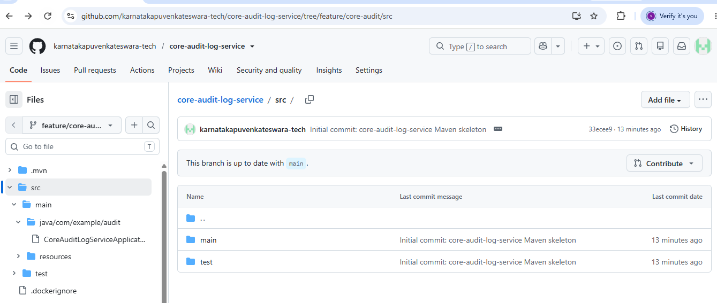

Claude log:-

Requirement:-
- API with basic authentication :- accept event records with eventType, actorId, resourceType, resourceId, payload, timestamp. Records must be append-only — no update/delete operations exposed.

Verification for the first requirement through postman: -
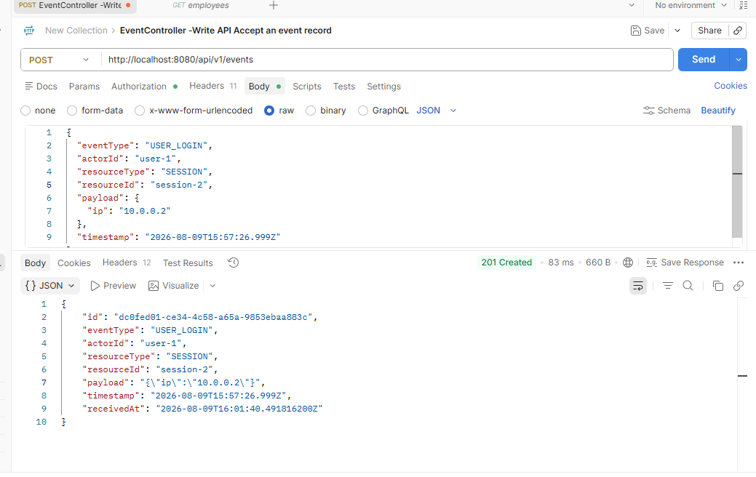
Records saved in DB:-
------------------------------
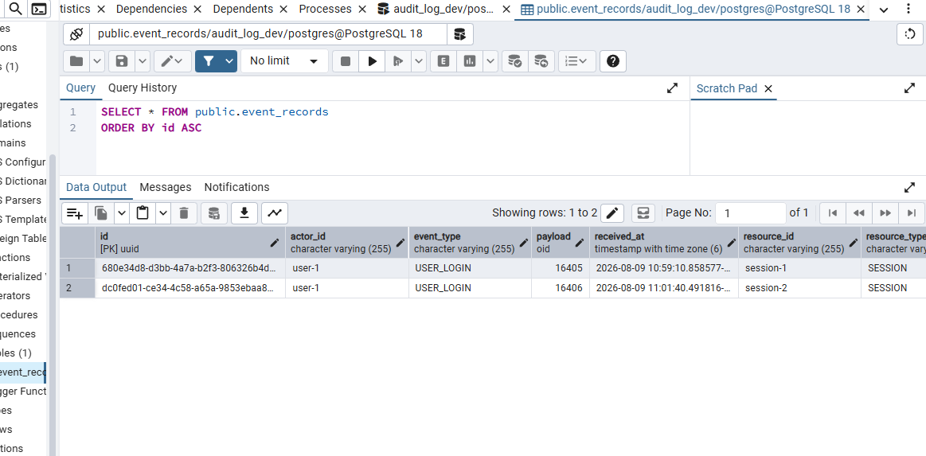

Requirement:-
- Query API: filter by actorId, resourceType+resourceId, eventType, time range; support pagination.

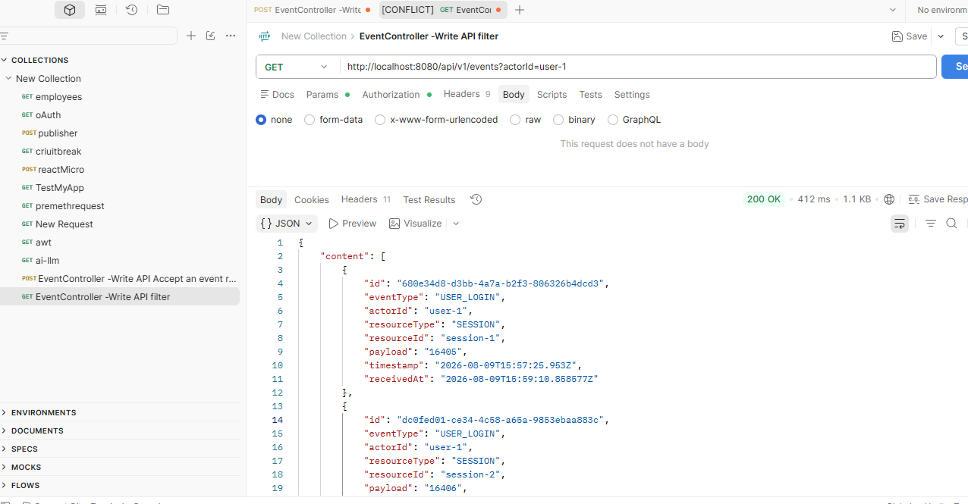

Requirement 3:-
- Tamper evidence via hash chain: each record stores a hash of its own content plus the hash of the preceding record (genesis value for the first).

Created 2 columns:-
ALTER TABLE event_records ADD COLUMN content_hash text NOT NULL DEFAULT ''; ALTER TABLE event_records ADD COLUMN previous_hash text NOT NULL DEFAULT '';

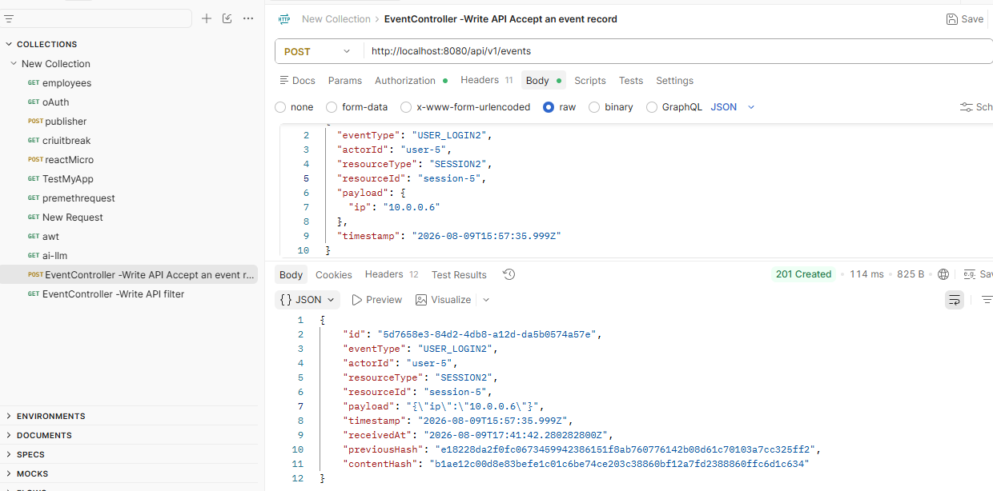

Requirement 4:-
GET /audit/verify: walks the chain and reports whether it's intact, and if not, the first broken record and violation type

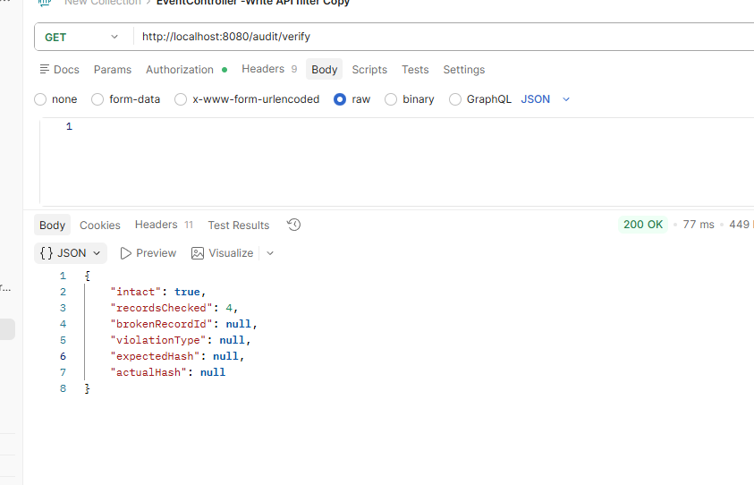

Removed the broker records, it’s received in a proper way.

Negative Scenario:-
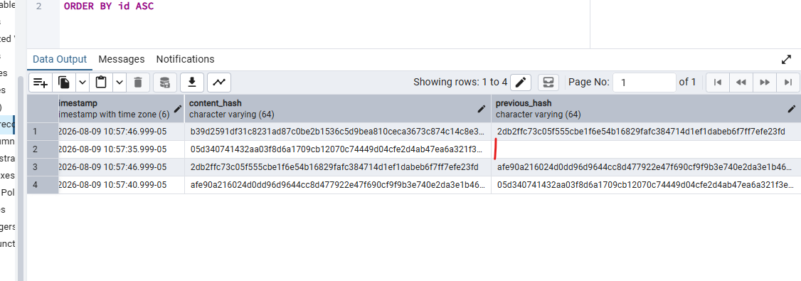
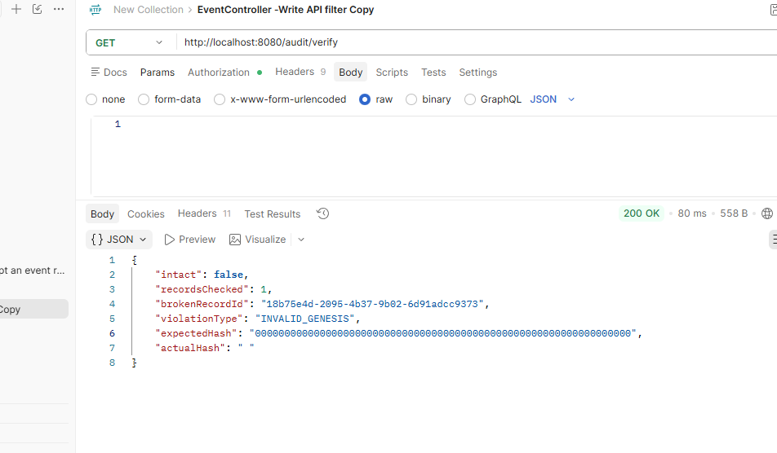

Verification done as part of 5th points end-end.

Scenario 2:-
ALTER TABLE event_records
ADD COLUMN archived boolean NOT NULL DEFAULT false;
ALTER TABLE event_records
ADD COLUMN IF NOT EXISTS content_hash text,
ADD COLUMN IF NOT EXISTS previous_hash text,
ADD COLUMN IF NOT EXISTS payload_hash text,
ADD COLUMN IF NOT EXISTS archived boolean NOT NULL DEFAULT false,
ADD COLUMN IF NOT EXISTS archived_at timestamptz,
ADD COLUMN IF NOT EXISTS redacted boolean NOT NULL DEFAULT false,
ADD COLUMN IF NOT EXISTS redacted_at timestamptz;

Requirement 2 export:-

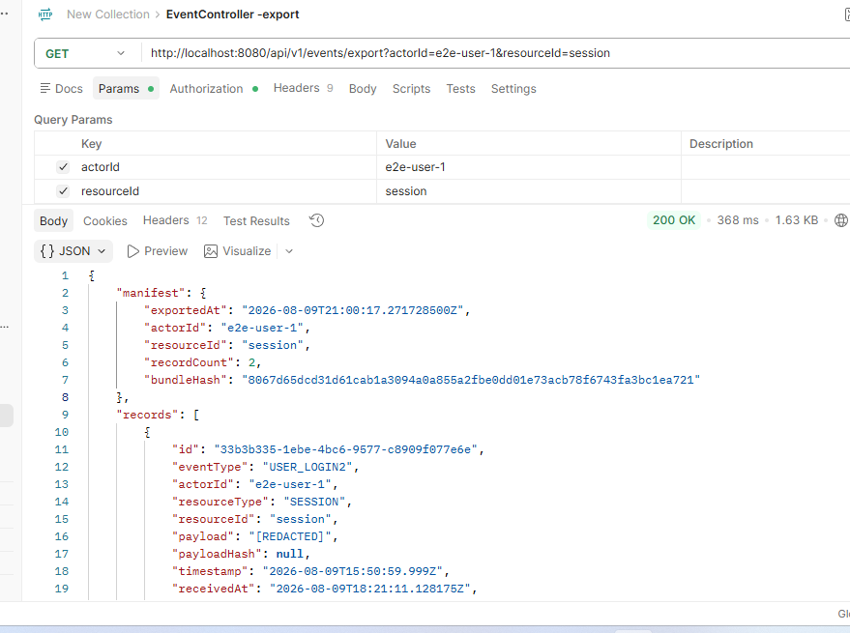

Section 4:-
Scenario C — Ambiguous Requirement (Compliance Reporting)

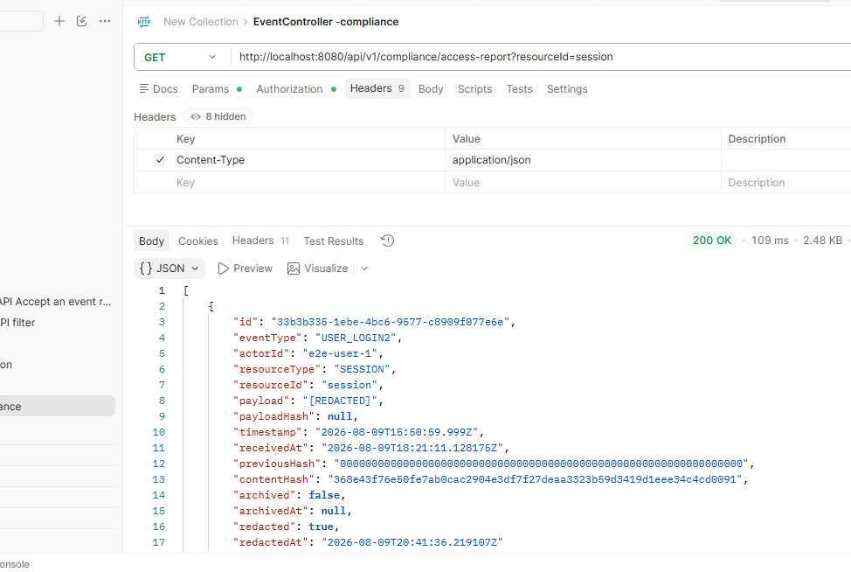

Local Docker Deployment of App using AI command:-

