Statistics for number of transactions:

* mean: 58.643450
* median: 30.000000
* mode: 1.000000
* standard deviation: 78.422609

**Frequency Count vs. Number of Transactions For serialNo**

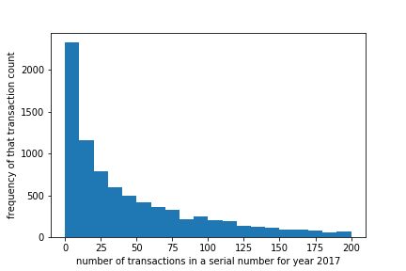

Relevant statistics for histogram:

* mean: 631.594892
* median: 146.695000
* mode: 100.000000
* standard deviation: 2513.154785

