Intro to CSS

Basic syntax
At the most basic level, CSS is made up of various rules. Each rule is made up of a selector (more on this in a bit) and a semicolon-separated list of declarations, with each of those declarations being made up of a property–value pair.
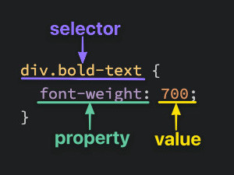

Semantic HTML
A <div> is one of the basic HTML elements. It is an empty container. In general, it is best to use other tags such as <h1> or <p> for content in your projects, but as we learn more about CSS you’ll find that there are many cases where the thing you need is just a container for other elements. Many of our exercises use plain<div>s for simplicity. Later lessons will go into much more depth about when it is appropriate to use the various HTML elements.

