Lab 2: Super Drugs Prescriptions
Submission items:
1. This document, with the visualization screenshot(s) and your brief explanations for the screenshots to each question, in either Word or PDF format.
2. A Tableau Public link to the visualization. Include the link in this document. Instruction on how to publish to Tableau Public.
Data:
An Excel file that contains fictitious pharmaceutical sales information. Create a Tableau worksheet to answer each of the following questions.

FILE to use: SuperDrugsPrescriptions.xlsx – Rx sheet

You are free to use one or more visualizations to answer each question. Focus on using visualization to tell the story. You should provide an explanation that includes:
1. What chart do you use?
2. Why do you choose the visualization?
3. How do the visualization(s) help you answer the question?
The explanation should be brief (no more than several sentences/100 words for each question).

Your Tableau Link:
https://public.tableau.com/app/profile/keano.arnett/viz/Lab_2_17707829888600/Sheet5?publish=yes Questions:
1 Create a visualization to show the average prescription price over time.
- What chart do you use?
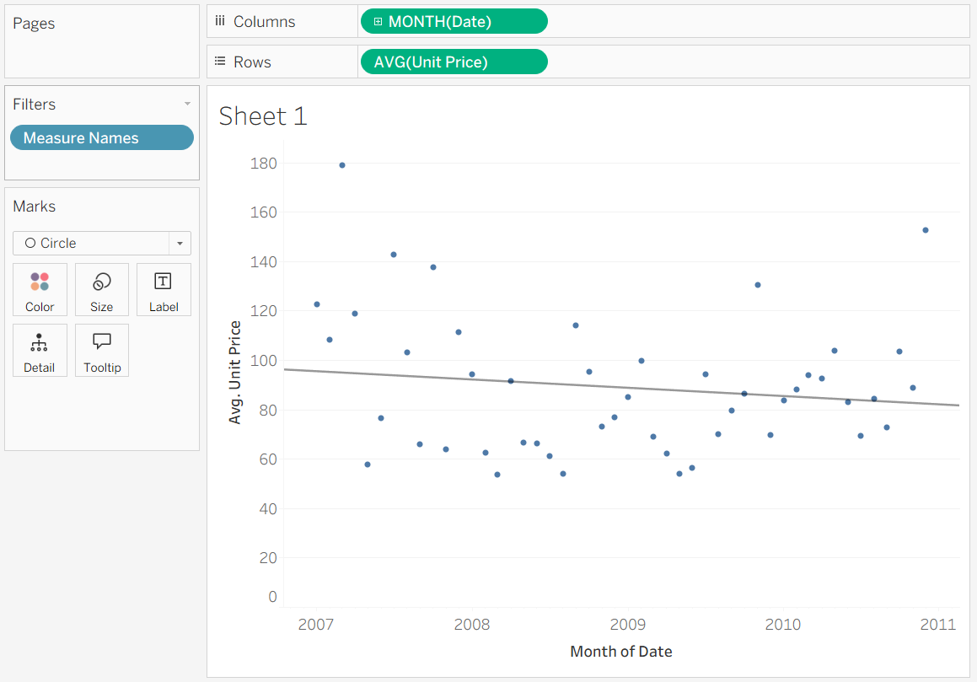
- Why do you choose the visualization?
I chose this scatterplot because it shows the average unit price for prescriptions, per month, over the course of 4 years (two quantitative variables). The trend line in the chart highlights the linear trend, indicating a slight decrease in price over the years.
- How do the visualization(s) help you answer the question?
It helps show that there has been a slight decrease in prescription prices over the 3 4 years.

2 Create a visualization showing the relationship between prescription quantity and profit for pharmacies. How does prescription quantity correlate with profit?
- What chart do you use?
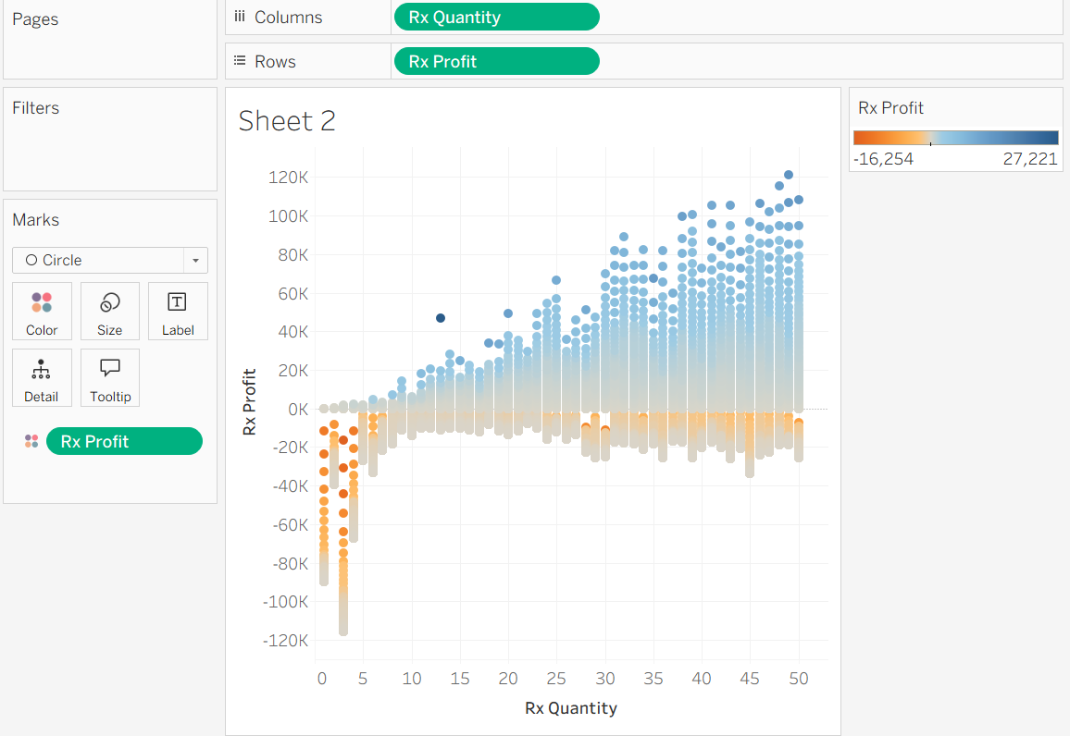
- Why do you choose the visualization?
I think this visualization effectively displays the data, showing both the raw quantity and profit, along with stacked marks. It helps clearly highlight the channels for quantity and profit position of each company.
- How do the visualization(s) help you answer the question?
This visualization helps show an association between the prescription quantity and profits for pharmacies. This is because stacked marks and turning off aggregate measures give a better estimate of the overall volume of each pharmacy, rather than clustering similar values on top of each other. The correlation between quantity and profit is better highlighted using this distribution.

3 Which pharmacy contributes the most to Rx Profit? What factors could explain these differences (e.g., discounts, products dispensed, open question and no ‘wrong’ answers)?
- What chart do you use?
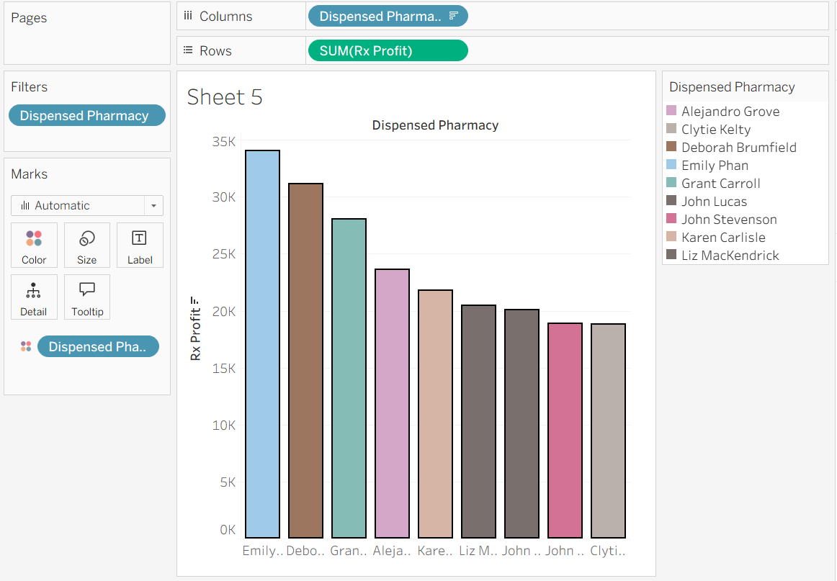
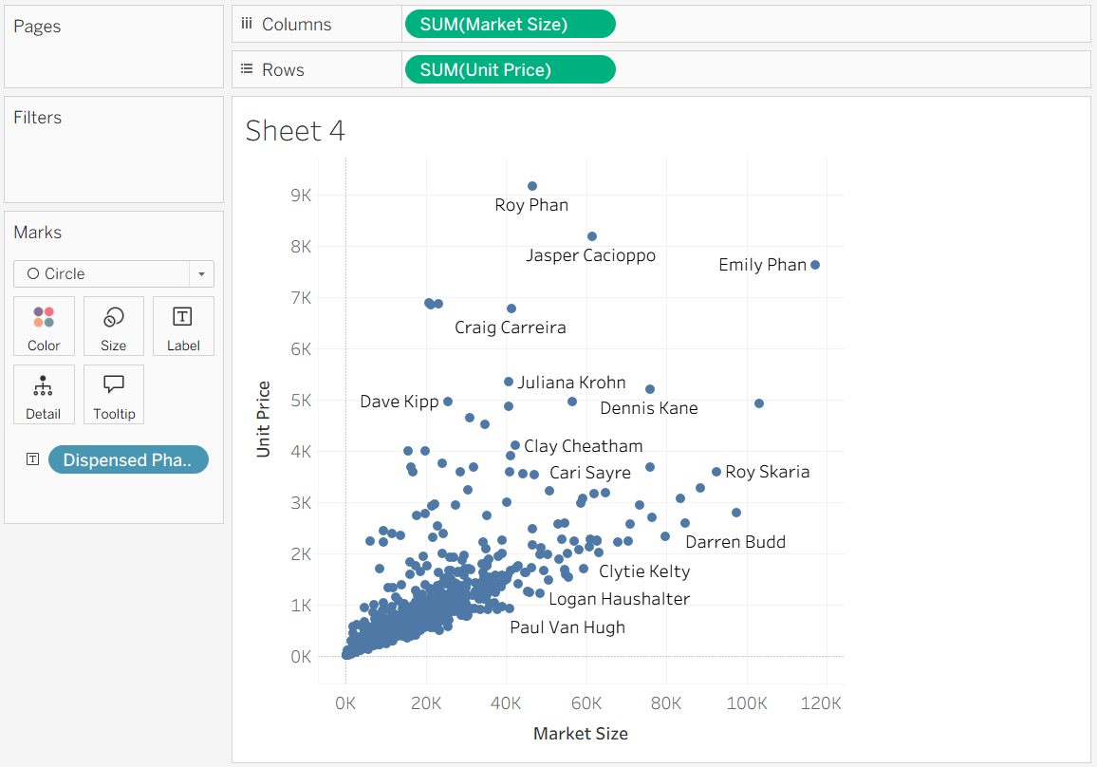
Emily Phan is the pharmacy that contributes the most to Rx profits. Two prominent causes for this are in the scatterplot above. I believe that having an advantage over the rest of the market in pharmacies and having the third-highest unit prices are the main drivers of prescription profits.
- Why do you choose the visualization?
I chose a sorted bar chart to find the pharmacy with the highest profit, using qualitative and quantitative data. Using both market size and unit price, both quantitative, I created a scatter plot to show pharmacies with the highest in both sectors.
- How do the visualization(s) help you answer the question?
These visualizations help show how having more pharmacies in the market and higher unit prices could correlate with higher profits.

