**Theoretical Demo: Effect of Synchrony on Information Transfer**

Our mantra this semester has been that attention acts to change what information is represented in the brain; selecting that information that is relevant to the task-at-hand. We’ve also seen that this selection can be very dynamic; changing from moment-to-moment as our goals, needs, or task changes.

On the mechanistic side, we’ve discussed a couple different neural mechanisms for the boosting of representations via attention. However, it isn’t clear how these would have an impact on information flow between regions (the hallmark of attention is to increase information flow between regions to boost attended representations). Nor is it always clear how these biasing mechanisms can flexibly adapt as we shift our attention between locations/objects.

One mechanism that has been proposed to play a role in attention is synchrony. Synchronizing the activity of a neural population is hypothesized to increase the efficacy of that population in driving downstream neurons. This simply occurs because of the temporal integration of signals by neurons – when inputs co-occur they are integrated together; when they are separated by long time periods the effect of the first inputs wears off by the time the later inputs arrive. Therefore, by modulating synchrony one could modulate the information transferred from the synchronized population of neurons to the downstream neurons. Here we will use a neural network model to test this prediction. Using theoretical models can be extremely informative: 1) constructing a model demonstrates a deep understanding of the underlying mechanisms and 2) we can test hypotheses in theoretical models that are often difficult (or impossible to do in the brain.

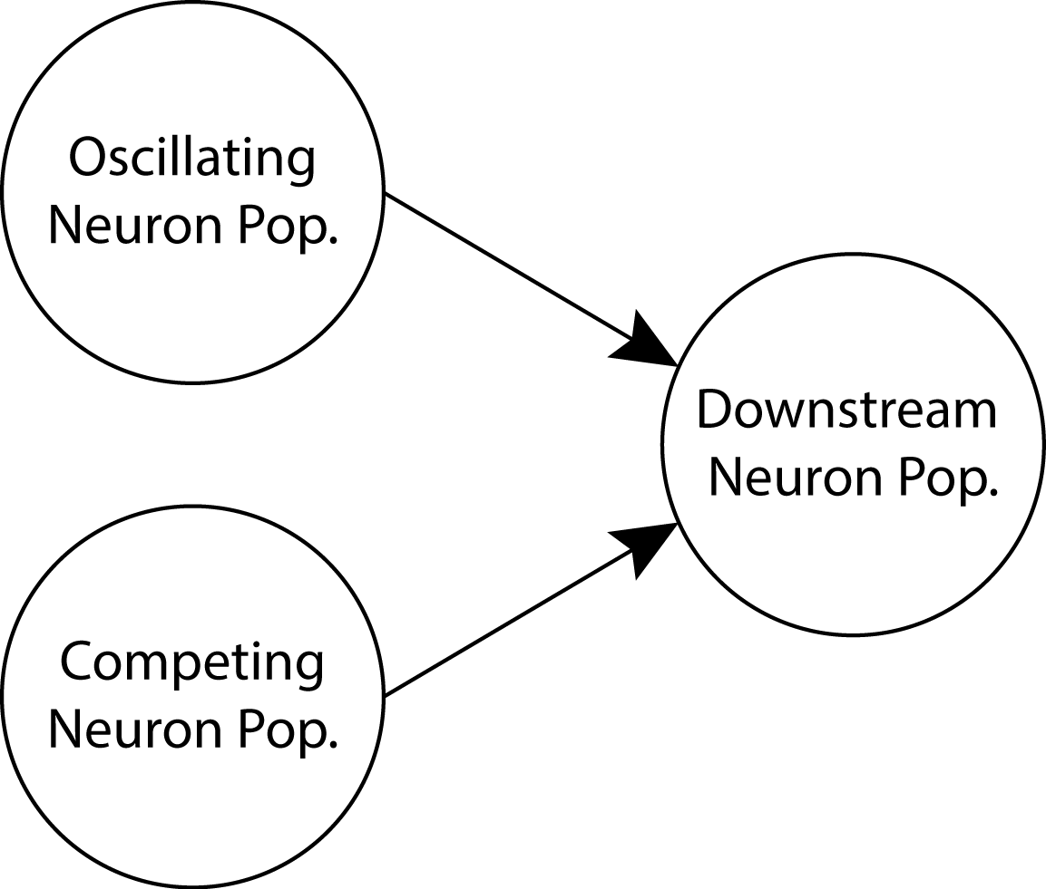

The model is fairly simple: Each neuron population is represented by a population of modeled ‘integrate-and-fire’ neurons. These are biophysically realistic neurons (for details see Izhikevich, 2003) consisting of about 80 excitatory (pyramidal) model neurons and 20 inhibitory (~parvalbumin+) model interneurons. There are two ‘input’ populations that both feed into a second, ‘downstream’ population (see figure to the left). The input populations receive fluctuating, noisy inputs. The ‘controlled’ neural population will be our network receiving oscillations. You can control these oscillations using the two sliders on the ‘Controlled Neural Population’ (see figure below): the frequency of the oscillation (from 1 to 80 Hz) and the amplitude of the oscillation (from the default of 0, all noise; to 1, all oscillation). **Play with these parameters and see how the controlled population responds.** Some things to test:

1. What happens as you increase the amplitude of the oscillation? How does it influence the spiking activity of the network?
2. What frequencies can the network follow completely (as in, spiking on every cycle of the oscillation)? Does the amplitude of the oscillation influence the networks ability to follow? Why do you think the network can follow some frequencies but not others?
3. What phase of the oscillation does the network tend to fire? Why might this be?

Next, we will compare how the two input networks influence the downstream network. In our model, excitatory neurons in both input populations make sparse connections onto the downstream population. As each network receives independent inputs, we can look at the downstream population’s activity to see which 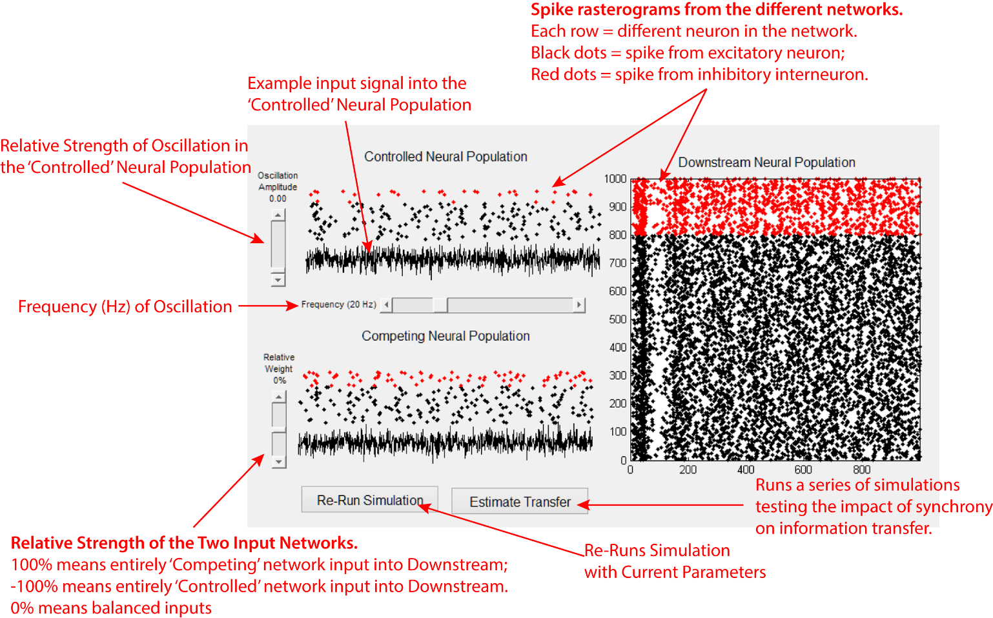population is the one actually ‘driving’ it. In other words, which network population is transferring its information to the downstream population.

This can be done by eye – comparing the response of the downstream network when changing the frequency and/or amplitude of the oscillation. **Play with these parameters for the ‘controlled’ input network and see how the downstream network responds.** Some things to test:

1. Do oscillations seem to increase or decrease the transfer of signal from the controlled network to downstream network? In other words, when you change the oscillations does it change how similar the response in the downstream network look to the controlled network?
2. Are there certain frequency/amplitude combinations for which this transfer is higher or lower?

Alternatively, we can develop a metric that measures the degree of information correlation. In this case we’ll use a simple metric – measuring the strength of correlation between the activity in each input network and the downstream network. The idea behind this statistic is simple: if the input region is transferring its information to the downstream region then this should impact the neural activity in that region, leading to a correlation in the firing rate of the two networks.

Armed with this metric of information flow, we can now methodically change the amplitude of the oscillation and measure its impact on information flow. Pressing the ‘Estimate Transfer’ button does exactly this – watch as it simulates a series of networks with oscillation amplitudes ranging from 0 to 1. It then plots our measure of information flow between the two input networks and the downstream network, as a function of the amplitude of oscillation in the ‘controlled’ input network. **How does oscillation amplitude change information flow? Does this differ for different frequencies?**

Finally, we can compare the effect of the synchronous oscillations with other mechanistic explanations of attention. In particular, we’ve discussed how the competitive enhancement of activity in one network is thought to boost its representation, leading to the neural and behavioral effects of attention. We can model this effect of attention by changing the relative influence of the two networks on the downstream network. This is done using the ‘Relative Weight’ slider next to the graph of the competing network (see above figure). If this is at 0% (default) then the two networks are balanced (they both have equal weightings to the downstream network). If we change this then we are biasing the inputs. For example, if we were to increase this to 50% then it would strengthen the competing networks inputs into the downstream network by 50% while also weakening the controlled networks inputs by 50% (leading to a 3:1 biasing ratio). Likewise, changing to -50% would strengthen the controlled network relative to the competing network.

Now, we want to compare the relative impact of biasing weights and changing temporal synchrony. To do this we will set the network to be biased towards the competing network (somewhere around 60% works well). Then we will again use the ‘Estimate Transfer’ button to test whether synchronous oscillations can overcome a weak connection strength between the controlled and downstream networks:

1. At low oscillation amplitude (left part of the graph), how does changing the network bias influence information flow? How does information flow change as we increase the amplitude of the oscillations?
2. Does this change for different oscillation frequencies?
3. What about really strong/weak connections (i.e. 20% vs. 90%) from the two networks?