Program Structures and Algorithms

Spring 2024

NAME: Meet Karnik

NUID: 002795334

GITHUB LINK: https://github.com/karnikmeet/psa-assignment

**Task:** Random walk experiment

**Relationship Conclusion:** Distance(d) is directly proportional to the number of steps taken(m)

**Evidence to support that conclusion:**

The following table shows the Euclidean distance of the man from the post over a series of experiments conducted 10 times. Here m represents the number of steps taken and d represents the euclidean distance. Now, if we were to derive a relationship between m and d over every single experiment, it would be next to impossible. However, if we were to consider the mean distance, the table clearly demonstrates a growth in the distance as we increase the number of steps.

| **m** | **d1** | **d2** | **d3** | **d4** | **d5** | **d6** | **d7** | **d8** | **d9** | **d10** | **Mean** |
| --- | --- | --- | --- | --- | --- | --- | --- | --- | --- | --- | --- |
| **5** | **1.0** | **1.0** | **4.123** | **1.0** | **2.236** | **3.0** | **3.0** | **3.605** | **2.236** | **1.0** | **2.20** |
| **6** | **3.163** | **1.414** | **1.414** | **4.472** | **3.163** | **2.0** | **2.0** | **2.0** | **4.472** | **3.163** | **2.726** |
| **10** | **1.414** | **3.163** | **4.243** | **4.472** | **1.414** | **3.163** | **4.0** | **4.0** | **2.0** | **4.0** | **3.187** |
| **13** | **2.236** | **3.0** | **4.123** | **2.236** | **3.605** | **3.605** | **3.605** | **8.062** | **2.236** | **3.605** | **3.631** |
| **20** | **5.099** | **5.099** | **3.163** | **5.831** | **5.831** | **4.472** | **3.163** | **4.472** | **4.0** | **2.0** | **4.313** |
| **24** | **5.657** | **7.071** | **7.071** | **8.246** | **5.657** | **7.615** | **2.0** | **4.472** | **1.414** | **4.472** | **5.367** |

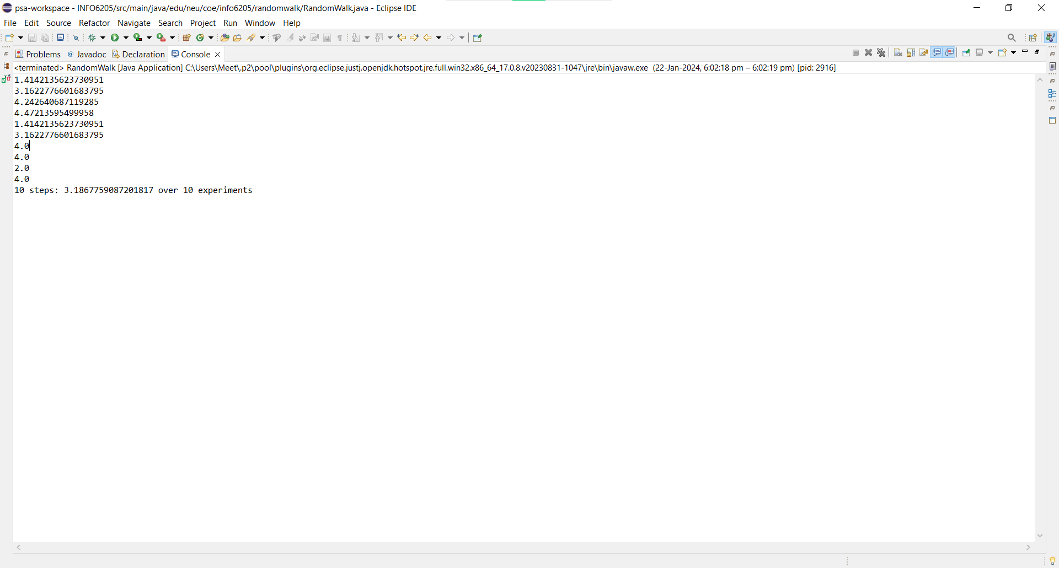

Distance when the number of steps to be taken is 10

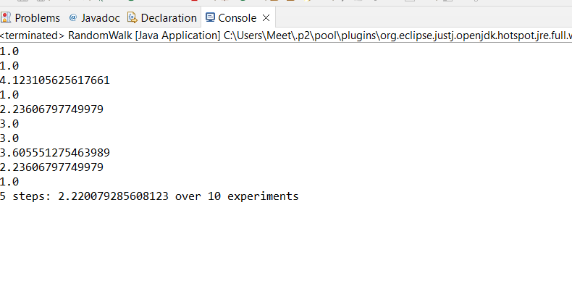

Distance when the number of steps to be taken is 5

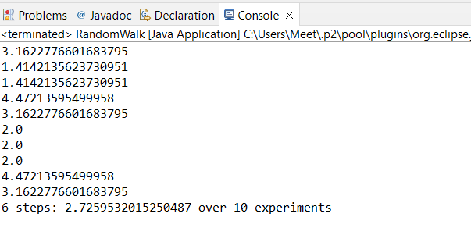

Distance when the number of steps to be taken is 6

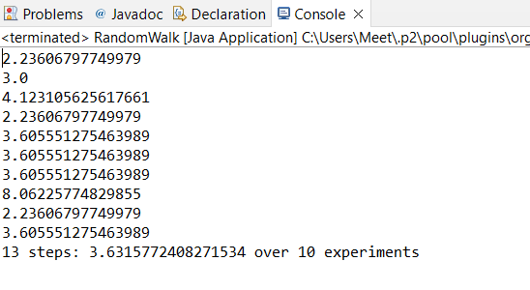

Distance when the number of steps taken is 13.

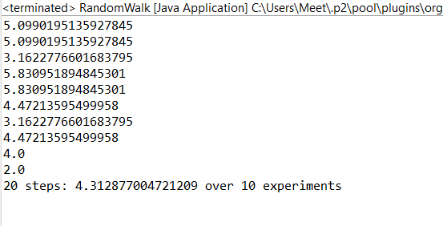

Distance when the number of steps to be taken is 20.

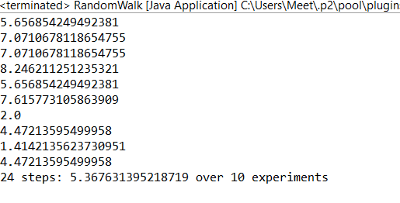

Distance when number of steps to be taken is 24

**Unit Test Screenshots:  
  
