Top Farm ERP
Flock Lifecycle Workflow
Functional Test Report with Analytic Accounting Evidence
Item | Value
System | Odoo 20.0 Enterprise
Modules | top_farm_core, top_farm_operations, top_farm_mortality, top_farm_dashboard 20.0.2.0.0 (revised flock-lot design)
Test database | topfarm20_flock (fresh database, company Top Farm, currency LKR)
Test date | 20 October 2026
Flock followed | IHL-20-10-2026 (Ihalapannawa Estate), from day-old chicks to spent hens
Result | 124 of 124 checks passed, 0 failed; 111 screenshots

Contents
Contents 2
1. Summary 3
1.1 Workflow tested 3
1.2 Results by step 3
1.3 Key figures of flock IHL-20-10-2026 4
1.4 Simulations (read before the figures) 4
2. Test environment and method 5
2.1 How the evidence was produced 5
3. Configuration and products for the flock 6
4. Purchase into the main warehouse with the hatchery batch number 12
5. Transfer to the brooding nursery: a new flock batch number 18
5.1 Approach A: the clerk types the flock batch number 23
6. Brooding stage: feed, vaccines, heating and mortality 26
6.1 Brooding-stage expenses of the batch (analytic accounting) 26
7. Splitting the flock into cages (pre-laying) 35
8. Pre-laying rearing in the cages 39
8.1 Rearing costs per cage (analytic accounting) 39
8.2 Pre-Laying Flock Investment 39
9. Point of lay: the 50 % hen-day transition 47
10. Laying: staged feed, egg collection and manufacturing orders 55
10.1 Laying feed per cage (analytic accounting) 55
10.2 Egg balance 55
11. Sales: eggs and spent hens 62
12. Flock reports and financial reconciliation 68
12.1 Flock lifetime P&L 68
12.2 General ledger 68
12.3 Dashboard figures (13-20 October, flock IHL-20-10-2026) 68
13. Reusing the cages for the next flock 75
14. All checks 81
15. Findings, fixes and notes 85
Appendix A: How to reproduce 86

1. Summary
This report tests the complete life of a layer flock in the revised Top Farm design, where the farm infrastructure (estates, brooding nurseries, sheds, cages) is permanent and the flock batch is a lot that moves through it. Every step was performed in a fresh Odoo 20 database: master data and the daily records were entered by scripts, and the key actions (validating receipts and transfers, confirming feed logs, submitting and approving mortality, allocating the flock to the cages, producing eggs, starting the Laying Phase, confirming sales) were clicked in the browser, with a screenshot before and after.

1.1 Workflow tested
- Products set up for the flock: the bird product (lot-tracked, Is Live Farm Bird), feed and vaccines with their Farm Input Type, graded egg products.
- Purchase of 10,000 day-old chicks, received into the main warehouse under the hatchery batch number 20_10_2026; purchase of feed and medicine.
- Transfer of 5,000 chicks to the Ihalapannawa brooding nursery: a new flock batch number IHL-20-10-2026 is created on validation (Approach B), with its own analytic account. The other 5,000 go to Baddegama with a batch number typed by the clerk (Approach A).
- Brooding (weeks 0-4): starter feed, vaccines, electrolytes and LPG heating given to the flock, brooding mortality with the 2 % manager approval, and the brooding-stage expenses of the batch in analytic accounting.
- Split of the flock into 5 cages with the Brooding-to-Cage wizard; the flock moves to Pre-Laying.
- Pre-laying rearing in the cages: grower feed and vitamins expensed directly, debeaking labour, cage mortality; analytic items carry the flock and the cage.
- First eggs and the 50 % rolling hen-day alert; the Farm Manager starts the Laying Phase and the pre-laying investment is locked.
- Laying: feed staged per cage, egg collections, graded manufacturing orders consuming the feed, egg lots linked to the flock, laying analytics.
- Sale of the eggs and of the spent hens, invoices tagged to the flock, flock marked Spent; lifetime P&L and ledger reconciled.
- Reuse of the permanent cages: the next chick purchase becomes a new flock in the same brooding nursery and the same 5 cages; the cage analytic accounts keep both flocks apart.

1.2 Results by step
Step | Checks | Passed | Result
Configuration and master data | 5 | 5 | PASS
Purchase into the main warehouse | 5 | 5 | PASS
Dispatch to brooding, automated flock lot (Approach B) | 3 | 3 | PASS
Dispatch with manual flock lot (Approach A) | 8 | 8 | PASS
Brooding: feed, vaccines, heating, mortality | 3 | 3 | PASS
Cage allocation and pre-laying rearing | 6 | 6 | PASS
Point of lay: 50 % hen-day transition | 9 | 9 | PASS
Laying: staged feed and graded egg MOs | 6 | 6 | PASS
Sales: eggs and spent hens | 7 | 7 | PASS
Independent verification (analytics, investment, P&L, ledger) | 50 | 50 | PASS
Cage reuse by the next flock | 22 | 22 | PASS
All 124 checks are listed in section 14. Section 15 records the defects found and fixed during this test.

1.3 Key figures of flock IHL-20-10-2026
Figure | Value
Birds placed / at point of lay / sold as spent hens | 5,000 / 4,882 / 4,882
Pre-laying investment (locked at point of lay) | LKR 1,479,500.00 = LKR 303.05 per bird (target LKR 1,200.00 - 1,300.00)
Brooding-stage expenses (weeks 0-4) | LKR 601,500.00
Egg revenue / spent hen revenue | LKR 249,000.00 / LKR 3,173,300.00
Total direct cost / gross operating profit | LKR 1,545,500.00 / LKR 1,876,800.00

1.4 Simulations (read before the figures)
- Time: all transactions are posted on the test day (20 October 2026). To reach the Laying Phase, the flock's chick arrival date was moved back 18 weeks (16 June 2026) and its cage allocation 14 weeks, and the first egg collections were dated 13-19 October. The flock ages, the 17-week minimum and the rolling hen-day therefore behave as in real life; the brooding and rearing records themselves carry the test date.
- End of cycle: the spent hens are sold right after the first laying day instead of after 70-75 weeks, so that the flock's lifetime P&L can be closed within the test.
- Quantities are reduced to one or two feed logs per stage; the amounts are realistic per bird (LKR 150 chick, LKR 120-140 per kg feed).

2. Test environment and method
Item | Value
Odoo | 20.0 Enterprise, Python 3.12, PostgreSQL 16, Windows 11
Apps installed | Top Farm (4 modules), Inventory, Purchase, Sales, Manufacturing, Accounting
Company | Top Farm, currency LKR, time zone Asia/Colombo
Users | Farm Manager (Admin): Farm Manager and Mortality Manager roles; Farm Operator: Farm Operator and Mortality Operator roles. The operator records the daily feed, mortality and egg logs and submits the brooding mortality in the browser; the manager allocates, approves and starts the Laying Phase.
Valuation | All farm product categories in automated (perpetual) valuation; consumption, mortality and production locations carry their expense / clearing accounts
Analytic plans | Flock Batches (one account per flock, created automatically) and Farm Cages (one account per cage)

2.1 How the evidence was produced
- Data phases (test_scripts/data/p*.py) run in odoo-bin shell as the Farm Operator or the Farm Manager and record their checks in results/checks.json.
- Browser phases (test_scripts/browser/s*.js, Playwright + Chrome, 1600 px) click the business buttons and save every screenshot with its caption in results/shots.json.
- Phase p10 recomputes every expected amount from the source documents (quantity x purchase price, birds x standard cost) and compares it with the analytic items, the reports and the general ledger.
- The whole run (run_all.sh) was executed once, in order, on a freshly installed database; the screenshots of this report all come from that run.

3. Configuration and products for the flock
The Top Farm settings choose the flock lot generation (Approach B, automated, from the chick arrival date), create one analytic account per flock, and set the laying benchmark (50 % rolling 7-day hen-day from 17 weeks, manager confirmation). The infrastructure is permanent: two estates with their estate codes, a brooding nursery each, a laying shed with 5 cages (each with its own cage analytic account) at Ihalapannawa, and a battery row at Baddegama.
Product | Type | Tracking | Cost (LKR) | Used for
Layer Bird - Brown (Hy-Line) | Live Farm Bird | Lots (hatchery, then flock) | 150.00 | Chicks to spent hens
Starter Crumbs (Weeks 0-4) | Feed | - | 140.00 / kg | Brooding
Grower Mash (Weeks 5-18) | Feed | - | 130.00 / kg | Rearing in cages
Layer Mash (Week 19+) | Feed | - | 120.00 / kg | Laying (egg MO component)
Marek's Vaccine (dose) | Medication / Vaccine | - | 58.00 | Brooding
Newcastle ND-IB Vaccine (dose) | Medication / Vaccine | - | 12.00 | Brooding
Electrolyte & Vitamin Mix (L) | Medication / Vaccine | - | 900.00 / L | Brooding and rearing
Egg - Large / Medium / Jumbo / Damaged | Graded eggs | Lots (daily flock egg lot) | from production | Sold at 45 / 40 / 50 / 20

Figure 1: Top Farm settings
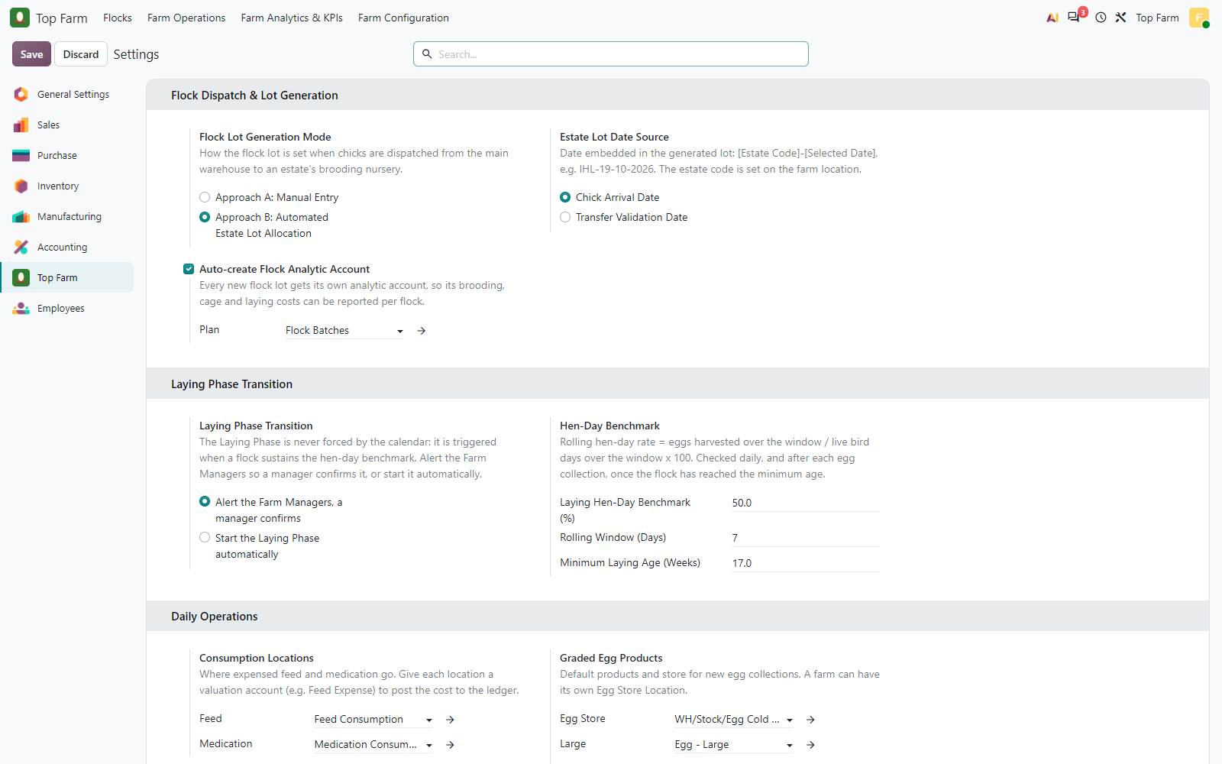
Figure 1. Top Farm settings: Approach B (automated estate flock lot allocation) dated by the Chick Arrival Date, with an automatically created Flock analytic account in the Flock Batches plan.

Figure 2: Laying Phase transition
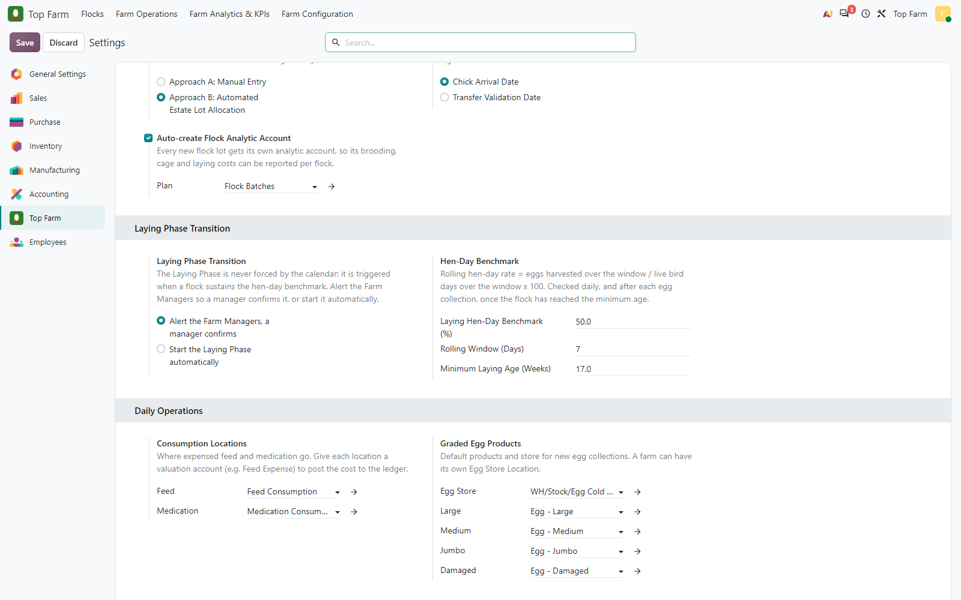
Figure 2. Laying Phase transition: the Farm Managers are alerted at a 50 % rolling 7-day hen-day rate from 17 weeks; daily operations: feed and medication consumption locations, egg store and graded egg products.

Figure 3: Analytic accounts of the Flock Batches and Farm Cages plans
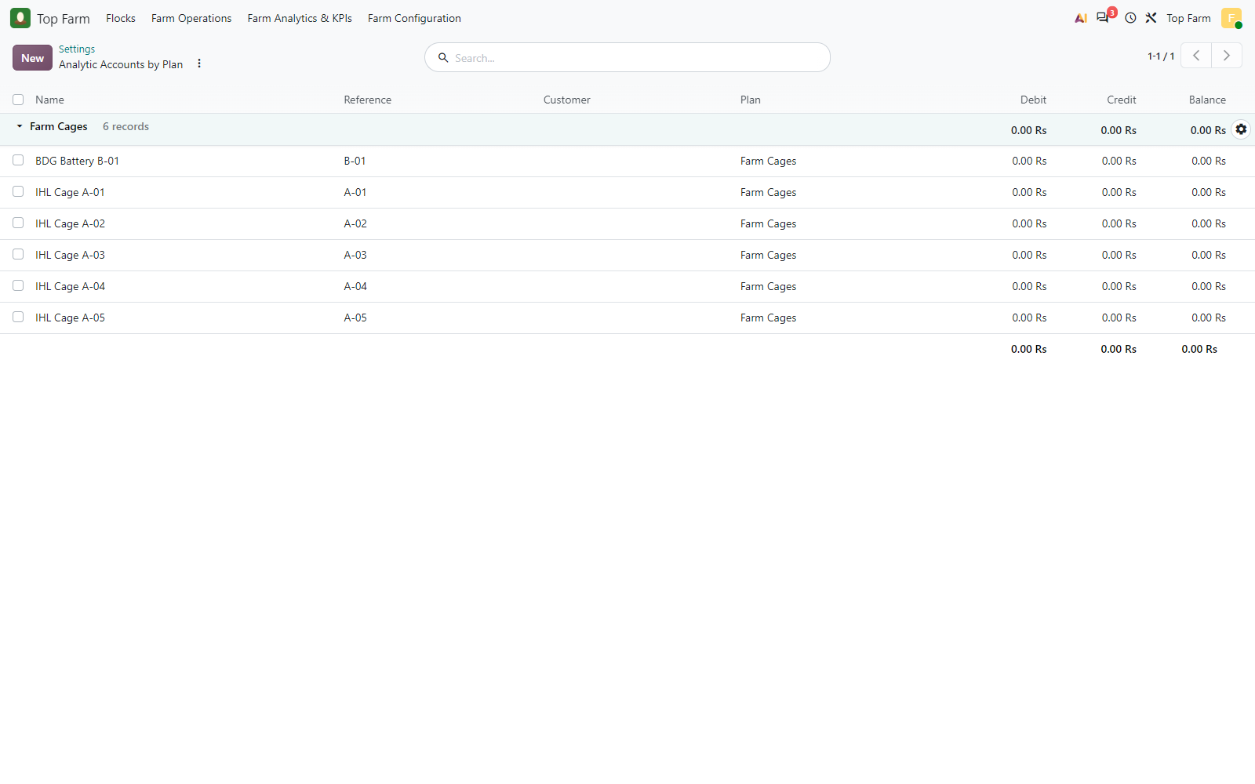
Figure 3. Analytic accounts of the Flock Batches and Farm Cages plans, grouped by plan: only Farm Cages has accounts yet, one per cage (IHL Cage A-01 to A-05, BDG Battery B-01). Flock accounts are created automatically when a flock is dispatched.

Figure 4: Permanent farm infrastructure
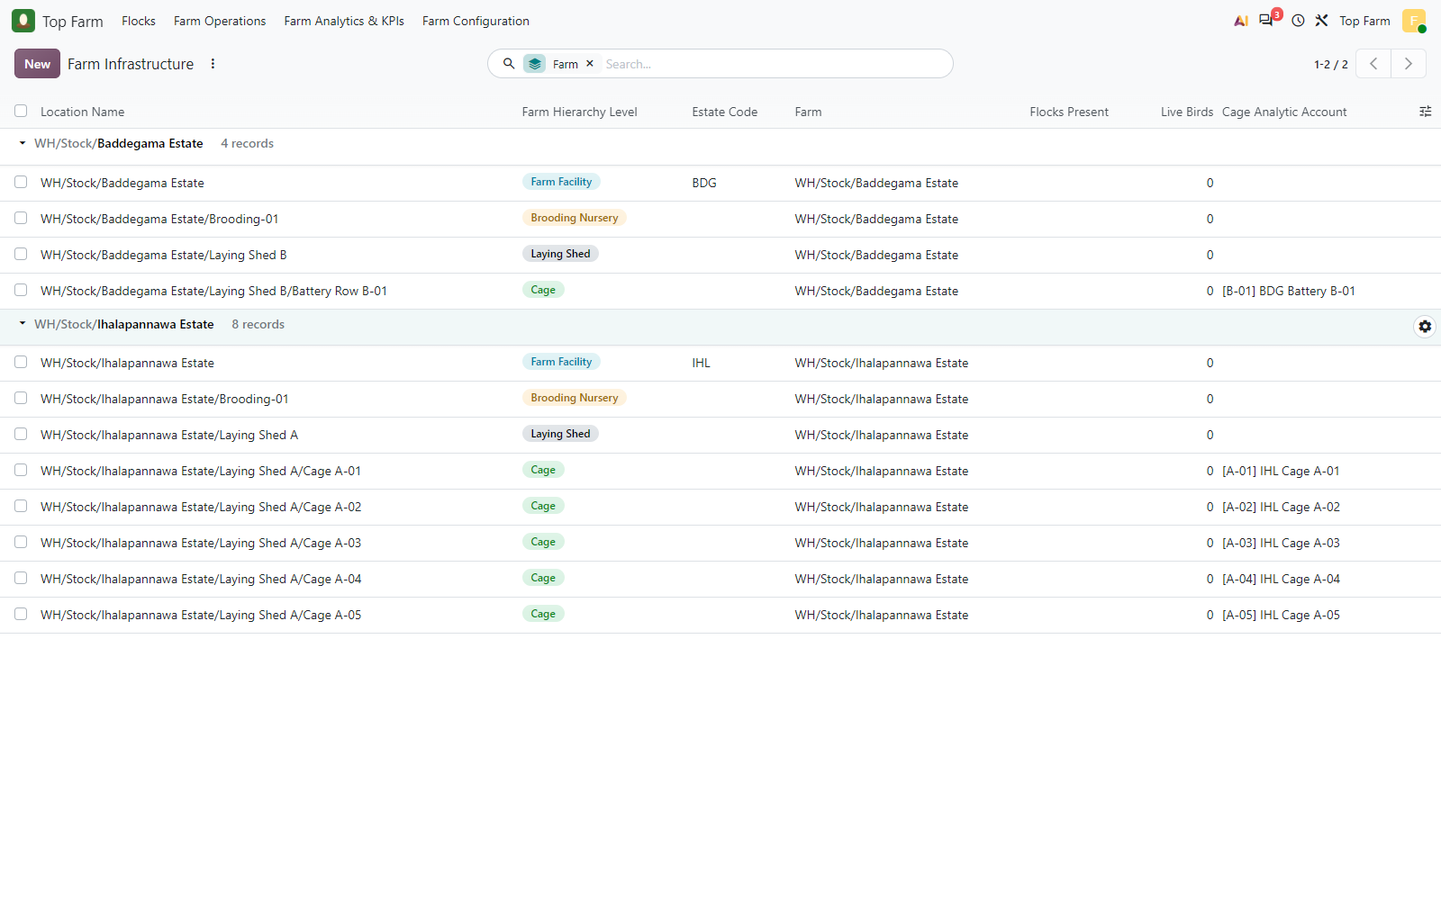
Figure 4. Permanent farm infrastructure: two estates with their estate codes, a brooding nursery each, laying sheds grouping the cages, and the cages with their cage analytic accounts. No batch locations.

Figure 5: Farm Facility Ihalapannawa Estate with estate code IHL (used to name its ...
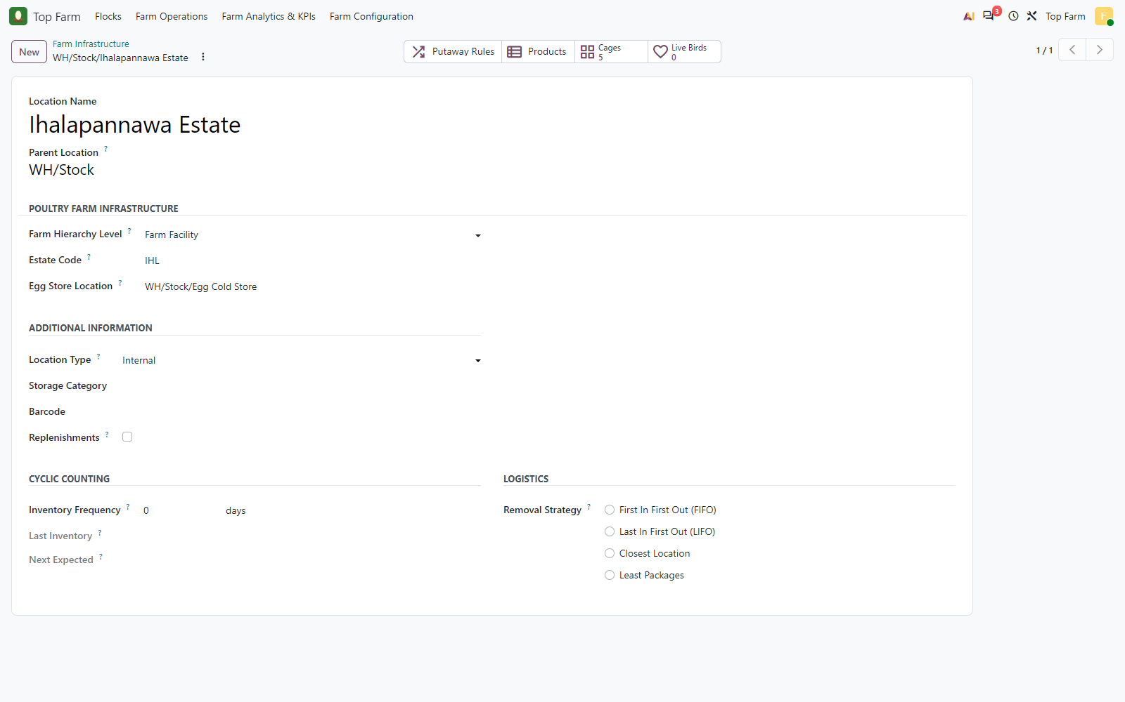
Figure 5. Farm Facility Ihalapannawa Estate with estate code IHL (used to name its flock lots) and its egg store.

Figure 6: Cage A-01 in Laying Shed A, mapped to its permanent cage analytic ...
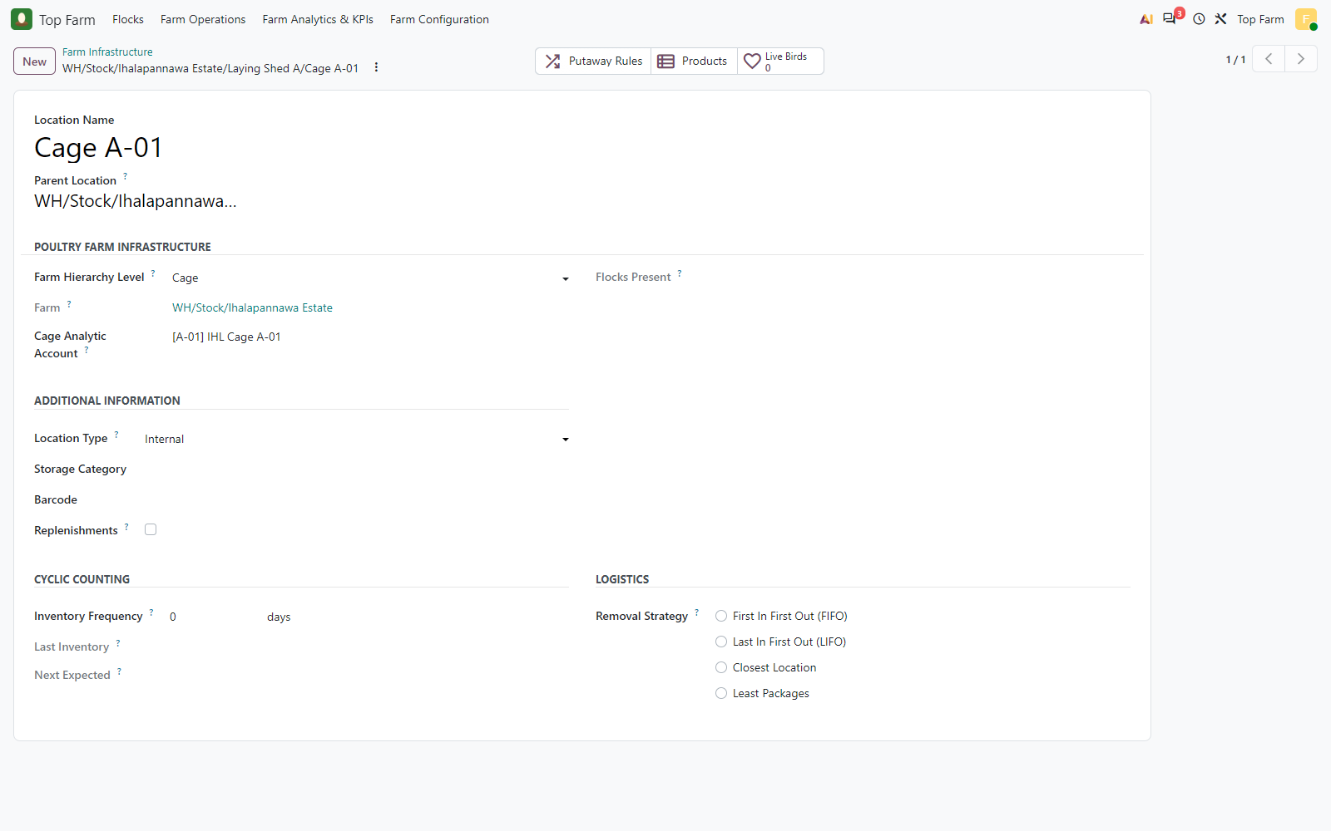
Figure 6. Cage A-01 in Laying Shed A, mapped to its permanent cage analytic account [A-01] in the Farm Cages plan.

Figure 7: Bird product
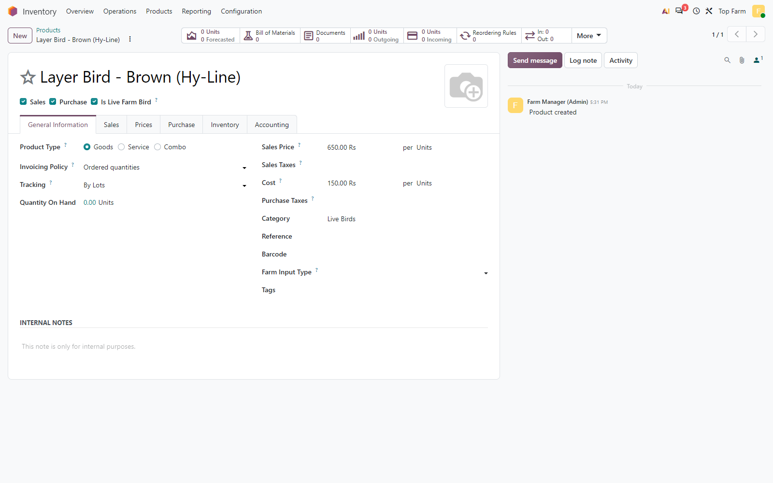
Figure 7. Bird product: Is Live Farm Bird, tracked By Lots (hatchery lot, then flock lot), category Live Birds, cost LKR 150.

Figure 8: Feed product Starter Crumbs (Weeks 0-4)
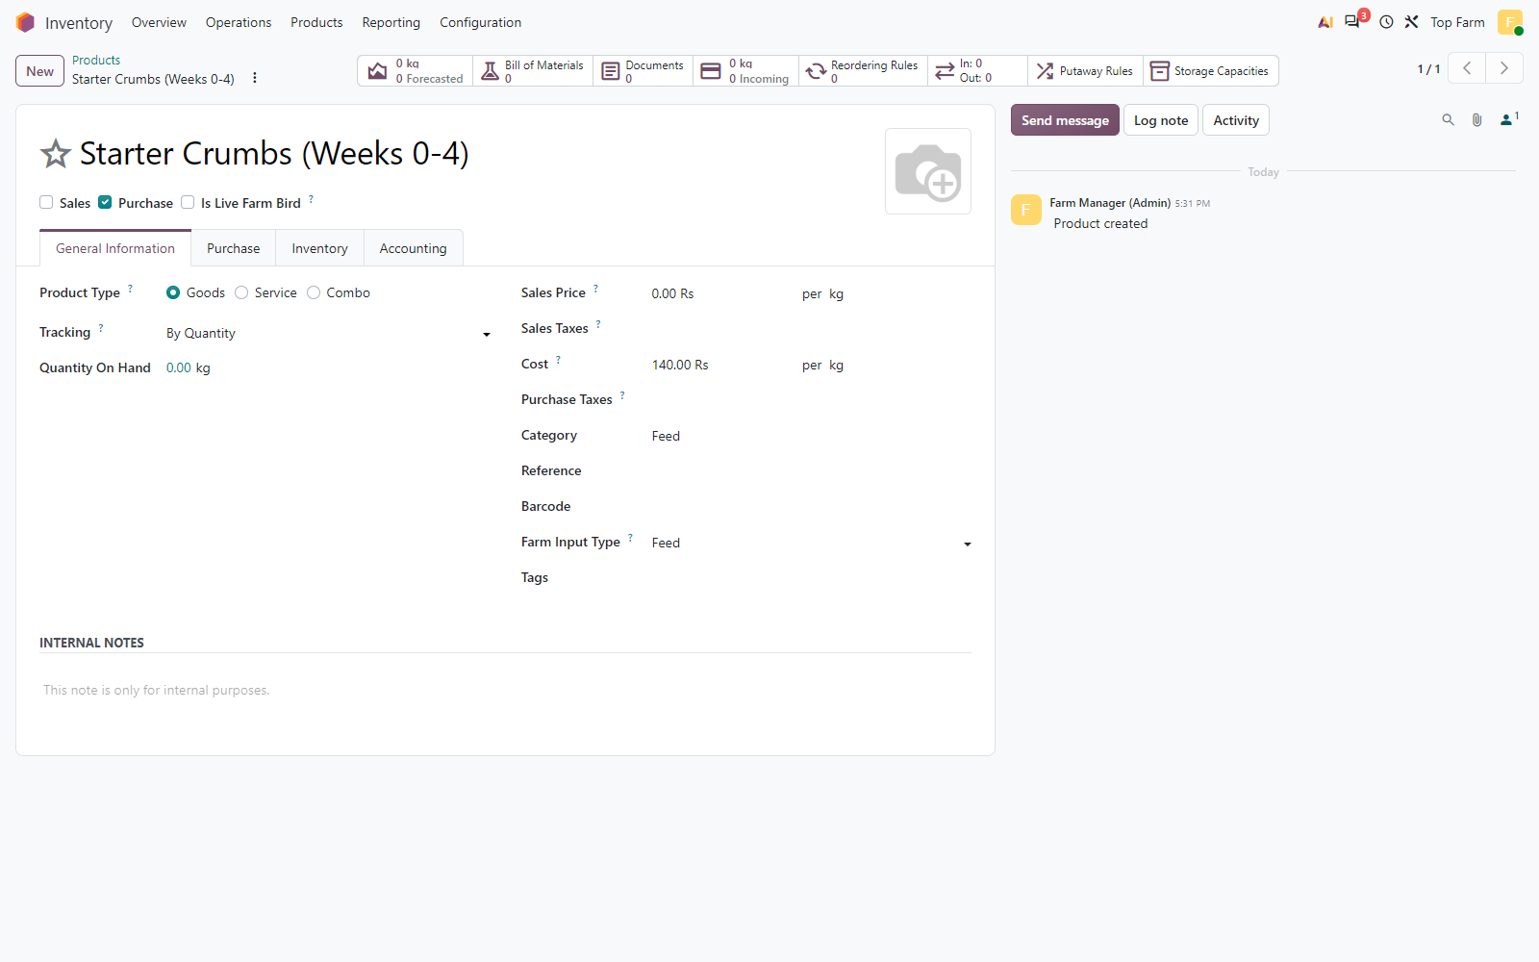
Figure 8. Feed product Starter Crumbs (Weeks 0-4): Farm Input Type = Feed, category Feed, cost LKR 140 per kg.

Figure 9: Medicine product Marek's Vaccine (dose)
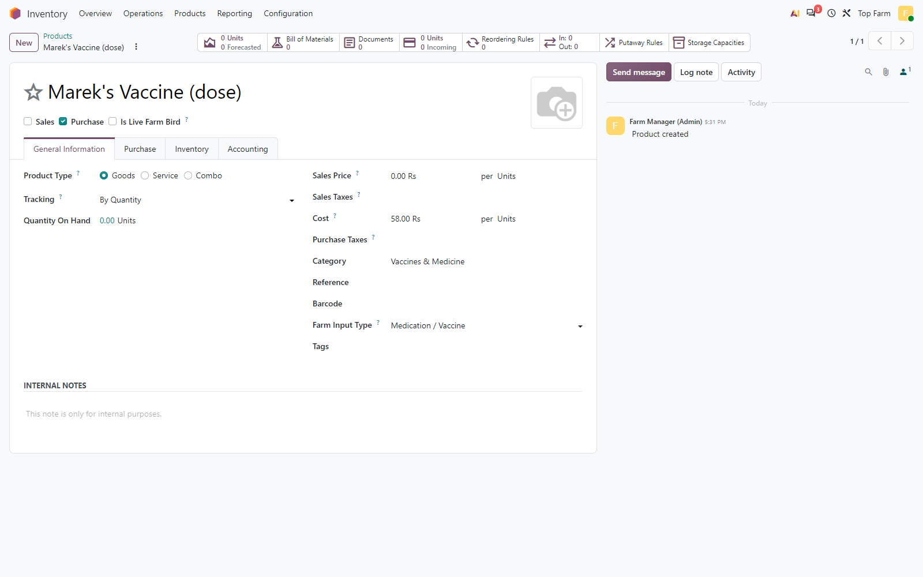
Figure 9. Medicine product Marek's Vaccine (dose): Farm Input Type = Medication / Vaccine, cost LKR 58.

Figure 10: Product category Live Birds
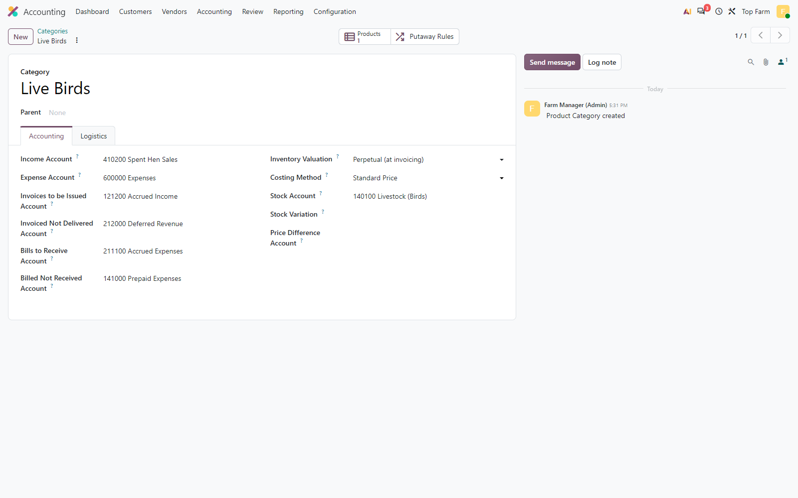
Figure 10. Product category Live Birds: automated (perpetual) inventory valuation at standard price, stock account 140100 Livestock (Birds).

4. Purchase into the main warehouse with the hatchery batch number
The chicks are bought from the hatchery and received into the main warehouse (WH/Stock). The hatchery batch number 20_10_2026 is entered on the receipt line, so the chicks are stored under that lot; validating the receipt stamps the lot with the Chick Arrival Date. The hatchery lot is not a flock: the flock batch number is created when the chicks leave for an estate.
PO | Vendor | Product | Qty | Unit | Price | Subtotal
P00001 | Hatchery Supplier (Test) | Layer Bird - Brown (Hy-Line) | 10,000 | Units | 150.00 | 1,500,000.00
P00002 | Feed Mill Supplier (Test) | Starter Crumbs (Weeks 0-4) | 1,000 | kg | 140.00 | 140,000.00
P00002 | Feed Mill Supplier (Test) | Grower Mash (Weeks 5-18) | 1,500 | kg | 130.00 | 195,000.00
P00002 | Feed Mill Supplier (Test) | Layer Mash (Week 19+) | 1,000 | kg | 120.00 | 120,000.00
P00003 | Vet Pharma Supplier (Test) | Marek's Vaccine (dose) | 10,000 | Units | 58.00 | 580,000.00
P00003 | Vet Pharma Supplier (Test) | Newcastle ND-IB Vaccine (dose) | 10,000 | Units | 12.00 | 120,000.00
P00003 | Vet Pharma Supplier (Test) | Electrolyte & Vitamin Mix (L) | 50 | L | 900.00 | 45,000.00

Figure 11: Purchase order P00001 for the day-old chicks
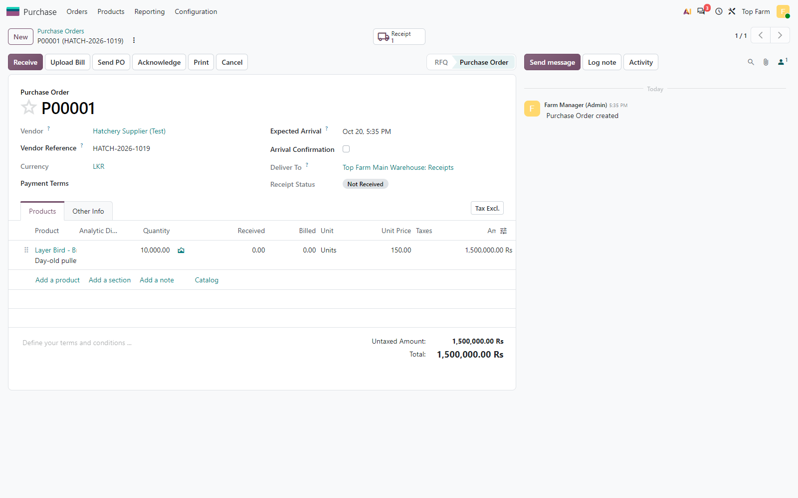
Figure 11. Purchase order P00001 for the day-old chicks: 10,000 pullets at LKR 150 from the hatchery, confirmed.

Figure 12: Chick receipt into the main warehouse (WH/Stock), Ready
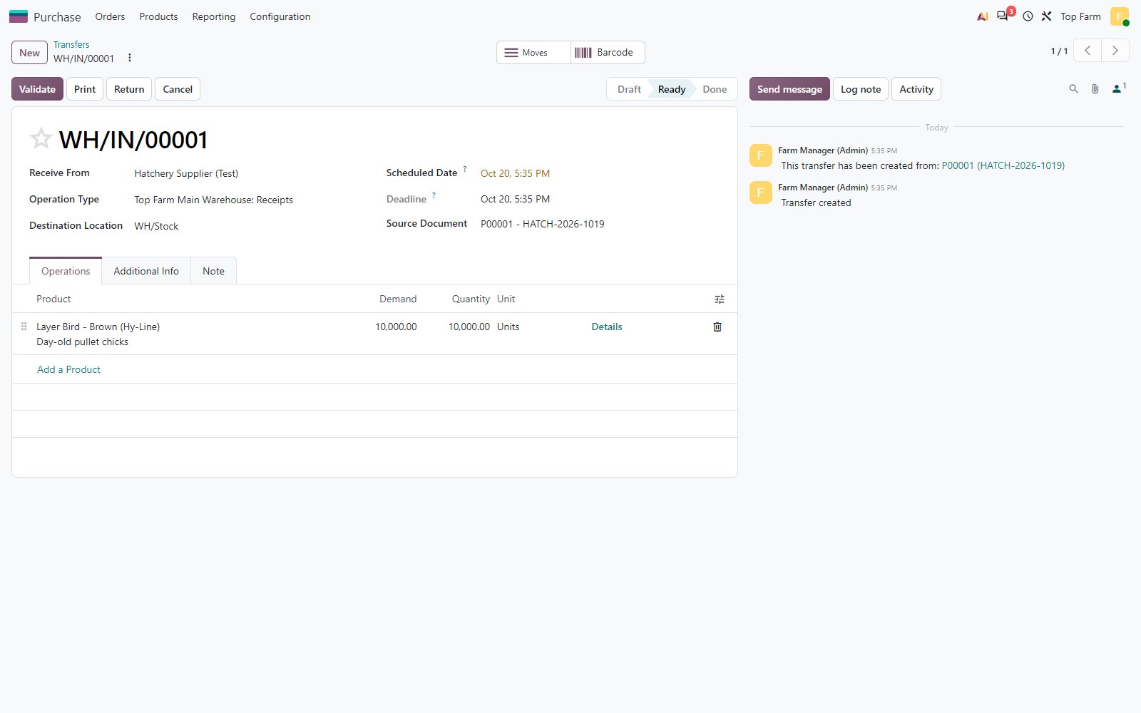
Figure 12. Chick receipt into the main warehouse (WH/Stock), Ready.

Figure 13: Receipt line detail
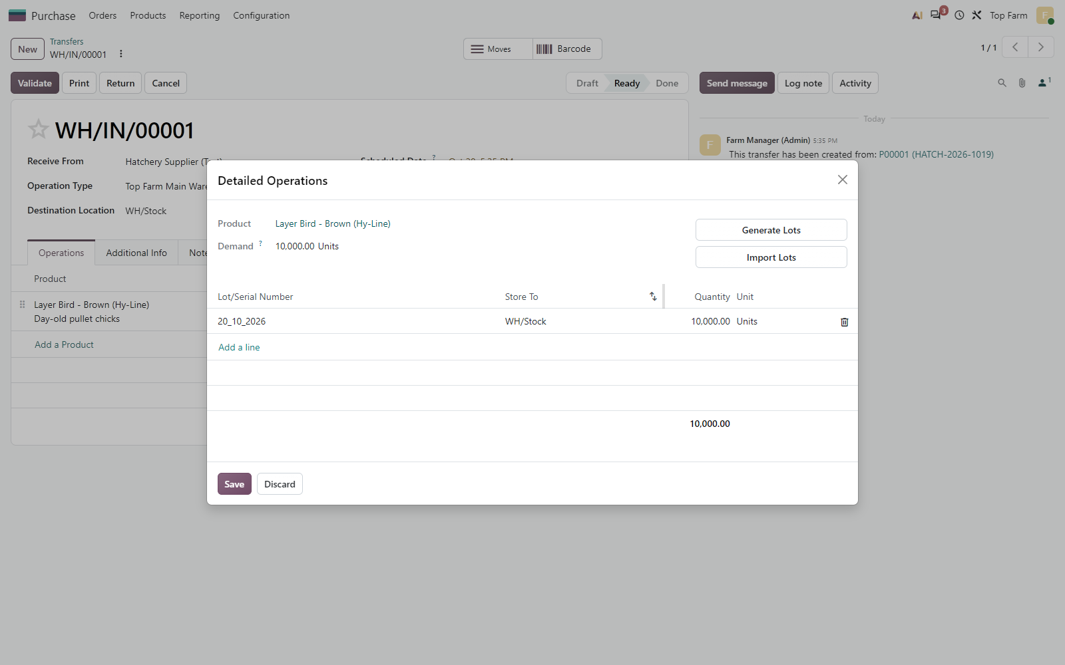
Figure 13. Receipt line detail: the hatchery batch number 20_10_2026 is entered as the lot of the 10,000 chicks.

Figure 14: Chick receipt WH/IN/00001 validated (Done)
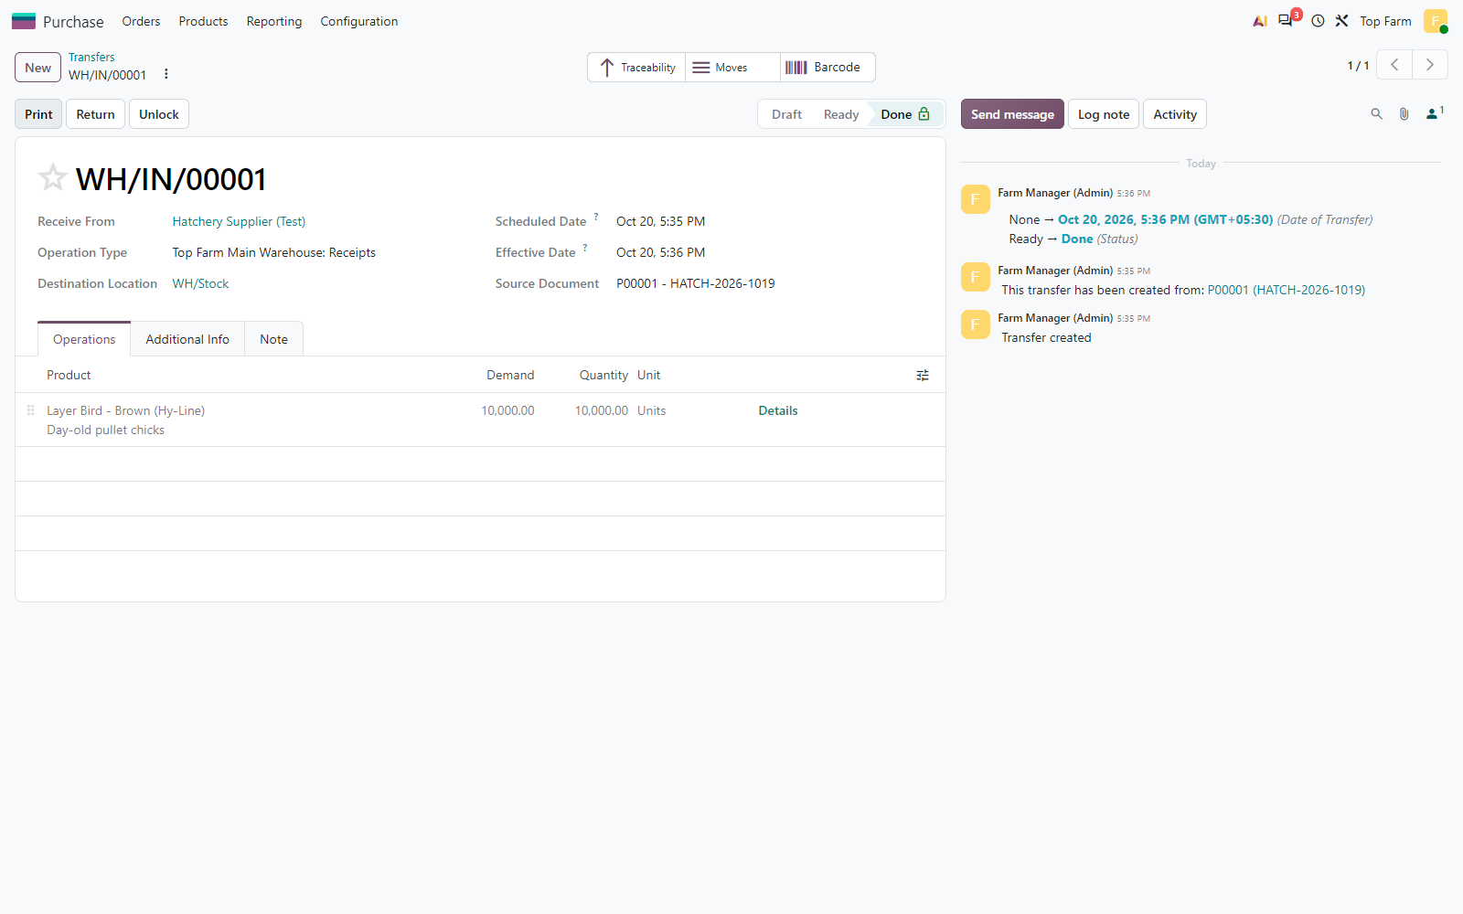
Figure 14. Chick receipt WH/IN/00001 validated (Done): 10,000 birds received into the main warehouse WH/Stock (their lot 20_10_2026 is shown on the previous and the next figure).

Figure 15: Hatchery lot 20_10_2026
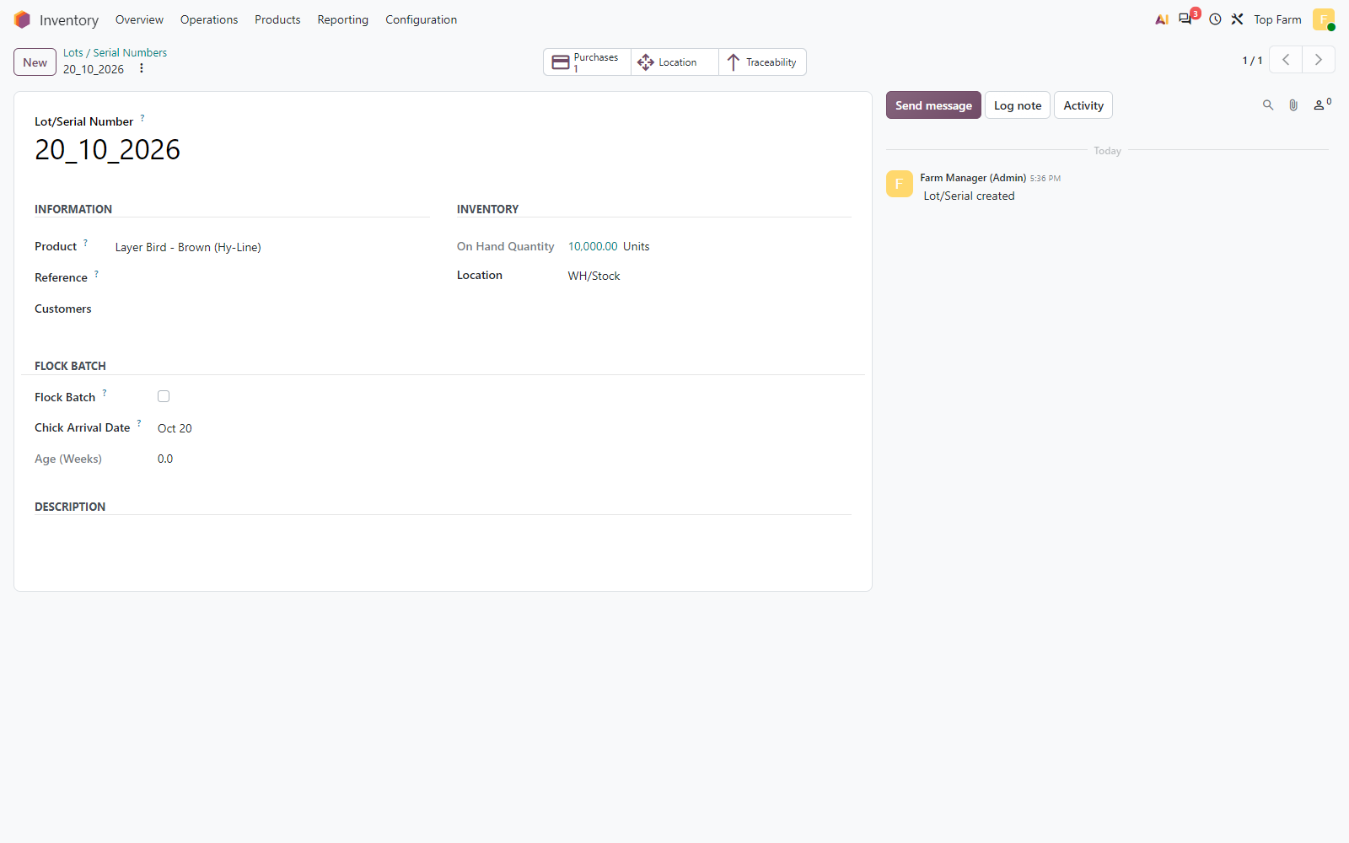
Figure 15. Hatchery lot 20_10_2026: Chick Arrival Date stamped by the receipt; it is not a flock (Flock Batch unticked).

Figure 16: Feed purchase
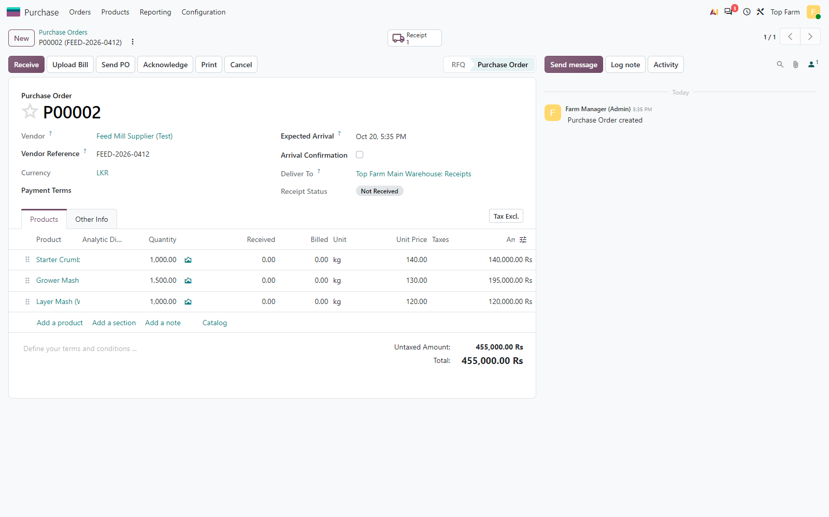
Figure 16. Feed purchase: Starter Crumbs 1,000 kg, Grower Mash 1,500 kg, Layer Mash 1,000 kg.

Figure 17: Feed receipt validated into WH/Stock
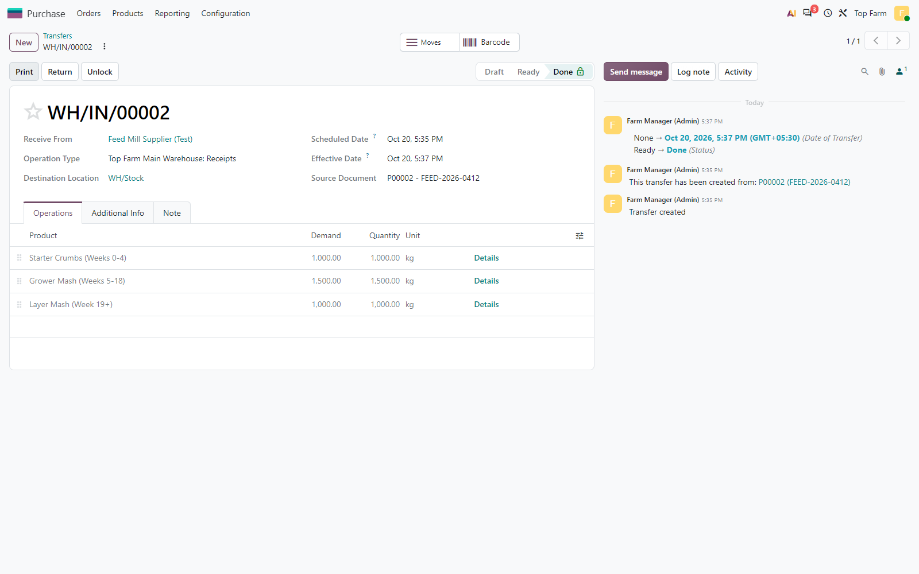
Figure 17. Feed receipt validated into WH/Stock.

Figure 18: Medicine purchase
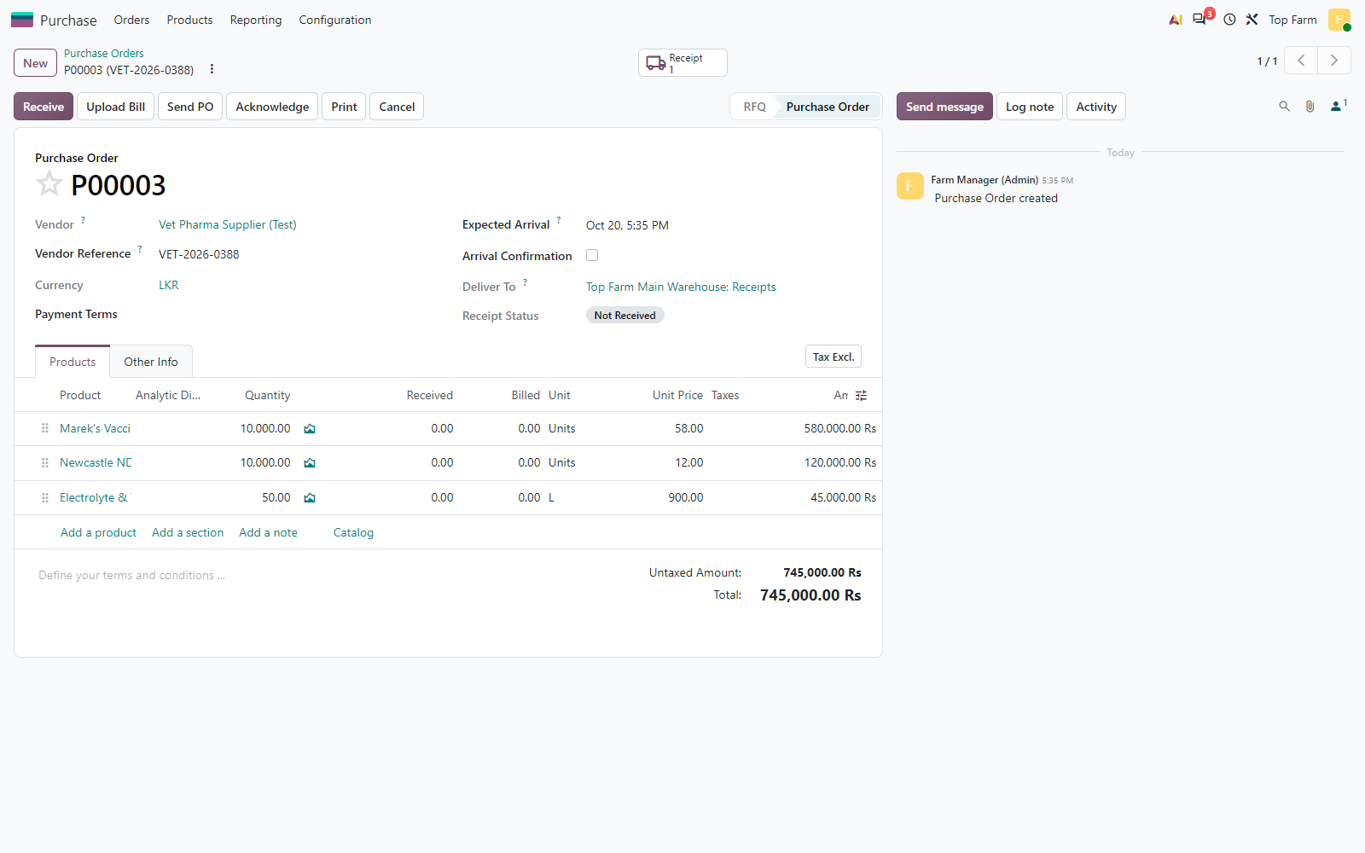
Figure 18. Medicine purchase: Marek's 10,000 doses, Newcastle ND-IB 10,000 doses, Electrolyte & Vitamin Mix 50 L.

Figure 19: Medicine receipt validated into WH/Stock
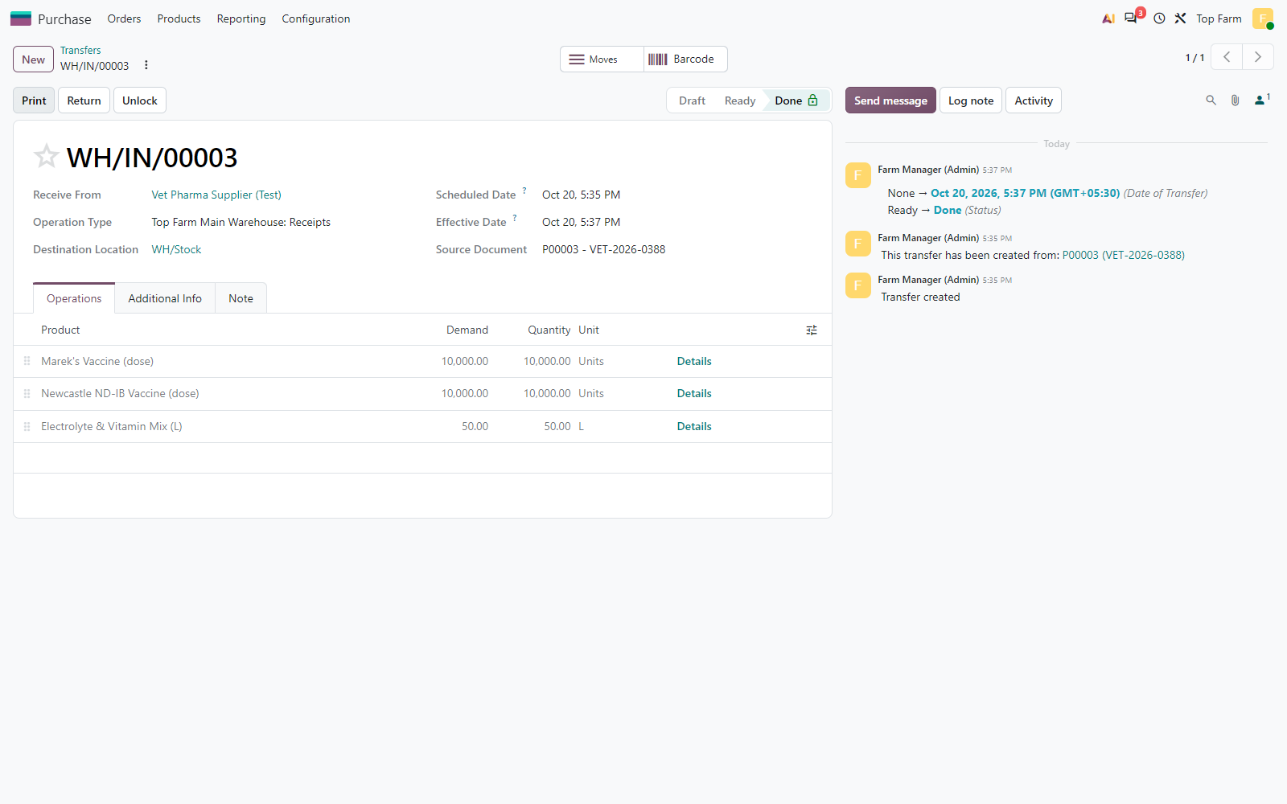
Figure 19. Medicine receipt validated into WH/Stock.

Figure 20: Main warehouse stock after the purchases
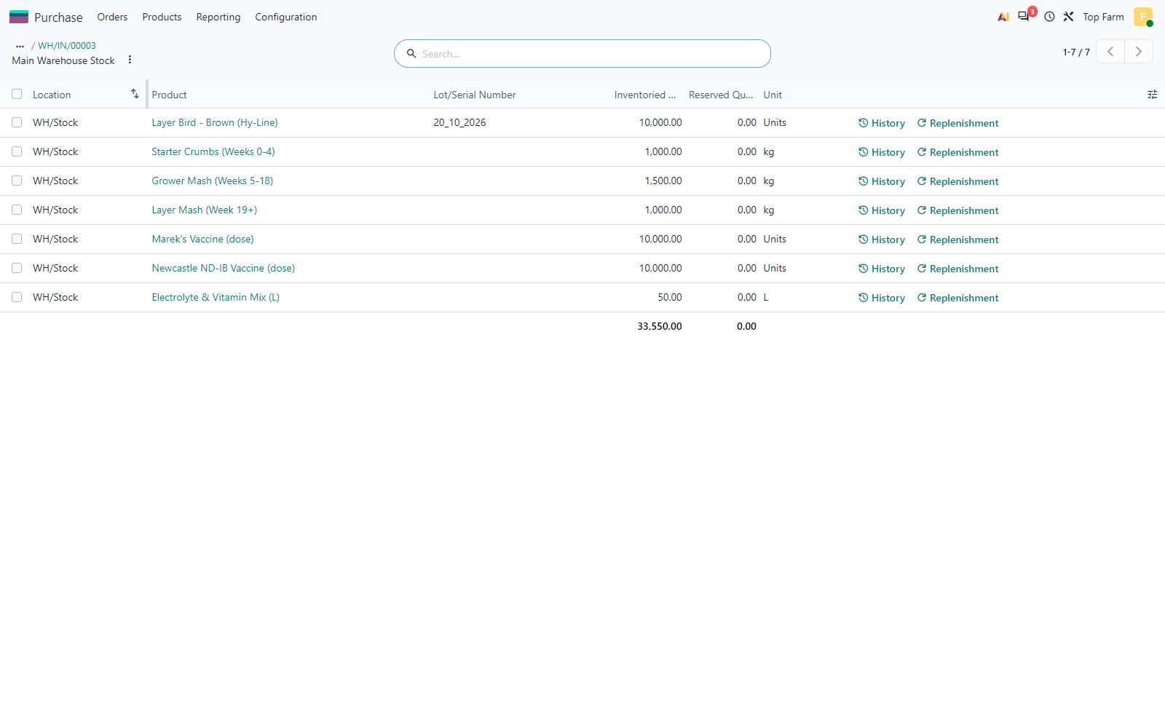
Figure 20. Main warehouse stock after the purchases: 10,000 chicks under hatchery lot 20_10_2026, the feed (kg) and the medicine (doses, litres). The footer total adds different units and has no meaning.

5. Transfer to the brooding nursery: a new flock batch number
The 5,000 chicks for Ihalapannawa are transferred from WH/Stock to Brooding-01. Odoo moves a lot unchanged, so on validation the chicks arrive under the hatchery lot and are immediately re-labelled under the flock lot through the virtual location *Flock Lot Conversion*: out under 20_10_2026, back in under the new flock lot, at the same value. The flock lot is named [Estate Code]-[Chick Arrival Date] = IHL-20-10-2026, gets the Brooding stage and its own analytic account in the Flock Batches plan.
Flock lot | Estate | Lot creation | From hatchery lot | Birds placed | Chick cost (LKR) | Analytic account | Stage at end of test
IHL-20-10-2026 | Ihalapannawa Estate | Approach B - automated (arrival date) | 20_10_2026 | 5,000 | 750,000.00 | [IHL-20-10-2026] IHL-20-10-2026 | Spent / Depleted
BDG-20-10-2026 | Baddegama Estate | Approach A - manual entry | 20_10_2026 | 5,000 | 750,000.00 | [BDG-20-10-2026] BDG-20-10-2026 | Brooding
The re-labelling posts no journal entry and leaves the stock value of the birds unchanged (checks TC-10-02 and TC-10-03).

Figure 21: Estate supply transfer WH/INT/00001 (Ready) from WH/Stock to the ...
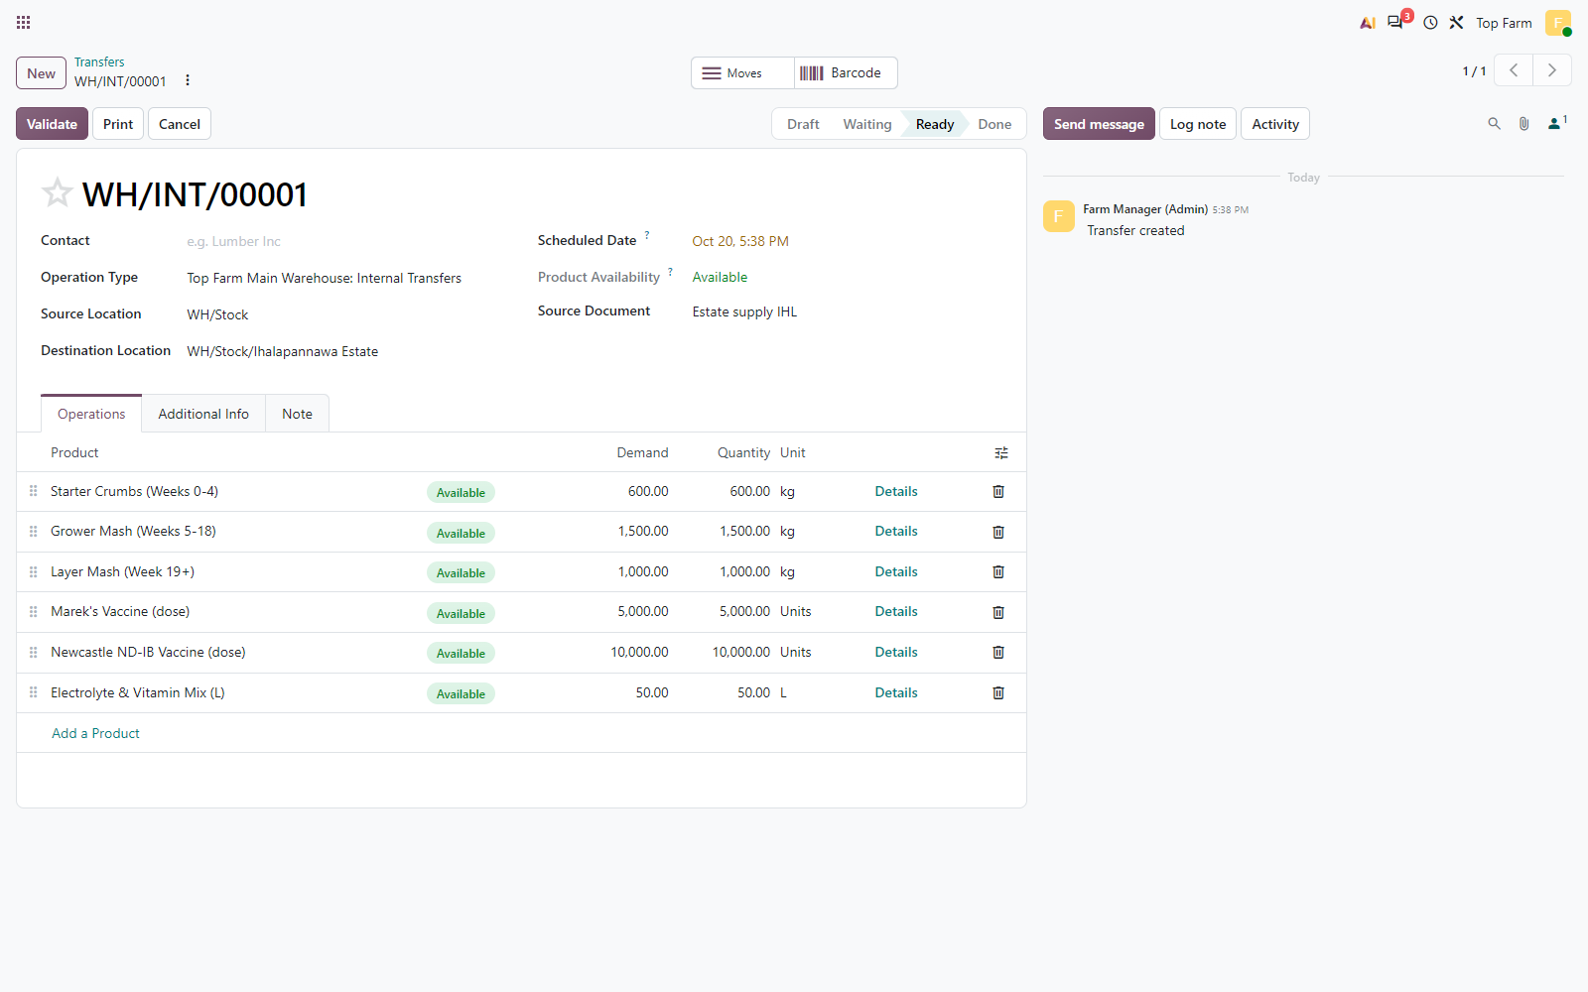
Figure 21. Estate supply transfer WH/INT/00001 (Ready) from WH/Stock to the Ihalapannawa Estate: Starter Crumbs 600 kg, Grower Mash 1,500 kg, Layer Mash 1,000 kg, Marek's 5,000 doses, Newcastle ND-IB 10,000 doses, Electrolyte & Vitamin Mix 50 L.

Figure 22: Estate supply validated
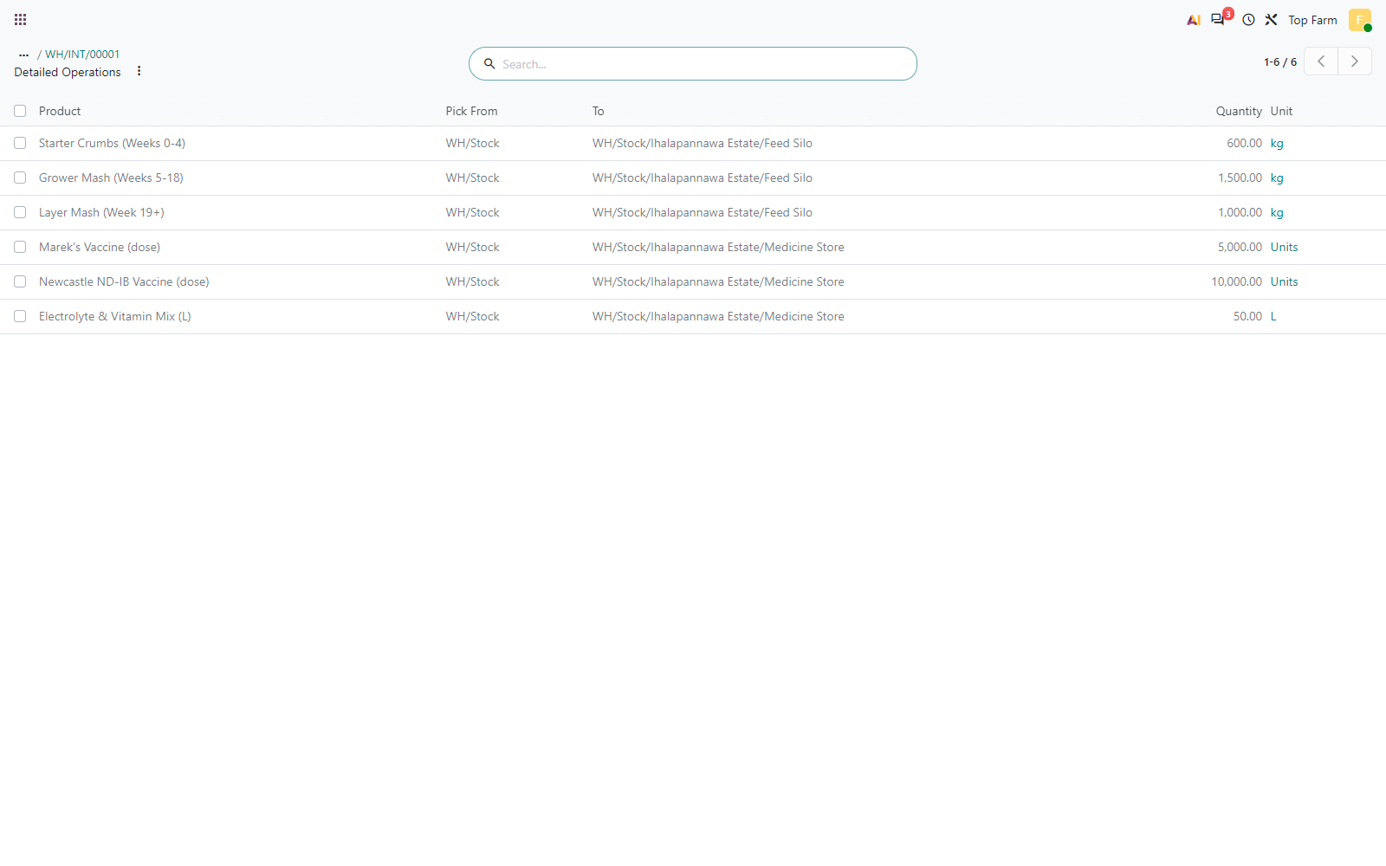
Figure 22. Estate supply validated: its moves show the feed put away in the IHL Feed Silo and the medicine in the IHL Medicine Store.

Figure 23: Dispatch of 5,000 chicks from WH/Stock to Ihalapannawa Brooding-01
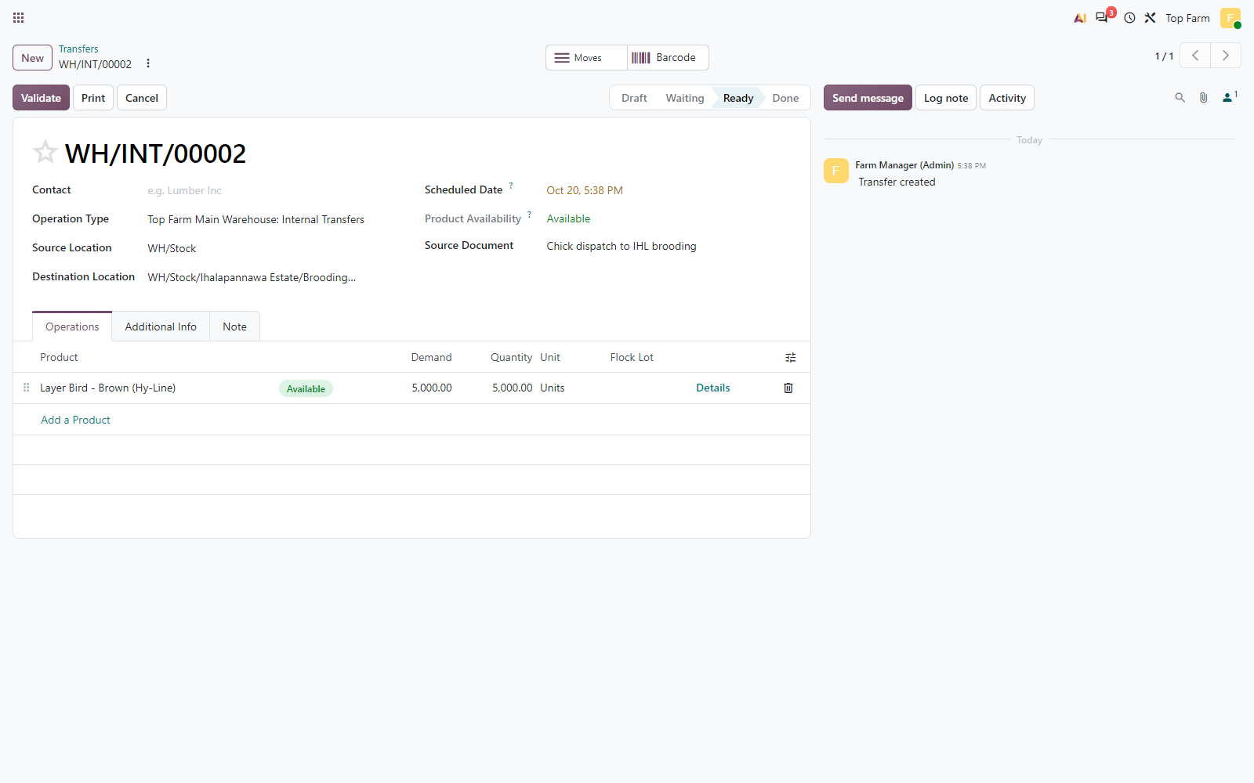
Figure 23. Dispatch of 5,000 chicks from WH/Stock to Ihalapannawa Brooding-01. The Flock Lot column appears for a dispatch to brooding; in Approach B it is generated on validation.

Figure 24: The dispatch takes the chicks out of the main warehouse under their ...
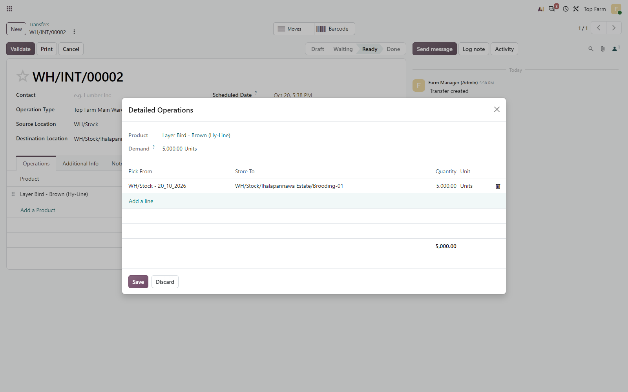
Figure 24. The dispatch takes the chicks out of the main warehouse under their hatchery batch number 20_10_2026.

Figure 25: Dispatch validated
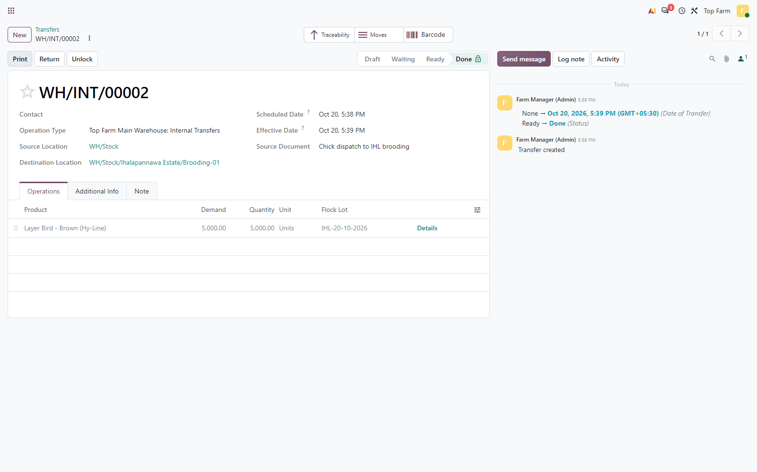
Figure 25. Dispatch validated: the new flock lot IHL-20-10-2026 ([Estate Code]-[Chick Arrival Date]) is shown on the line.

Figure 26: Flock lot IHL-20-10-2026
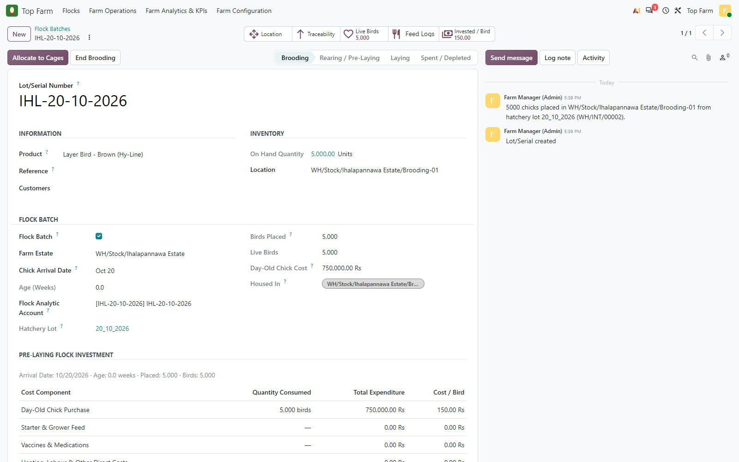
Figure 26. Flock lot IHL-20-10-2026: Flock Batch in Brooding stage, Ihalapannawa Estate, chick arrival date, own Flock analytic account, 5,000 birds placed at LKR 750,000.

Figure 27: Moves history of the birds
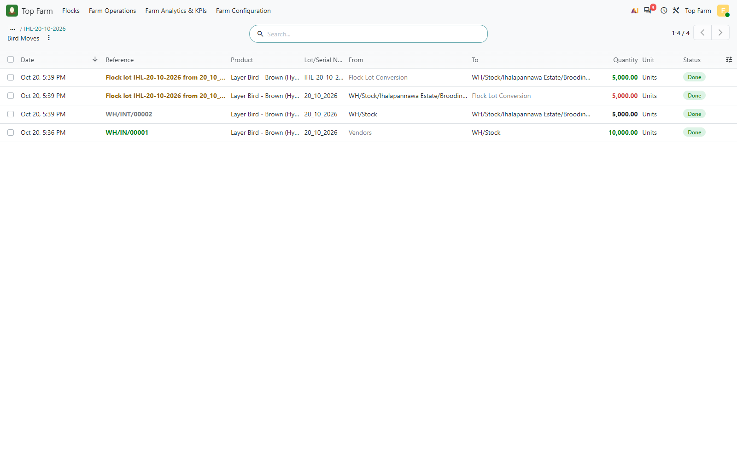
Figure 27. Moves history of the birds: receipt under 20_10_2026, dispatch to Brooding-01, then re-labelling through Flock Lot Conversion (out under 20_10_2026, back in under IHL-20-10-2026).

Figure 28: Brooding-01 now holds the flock IHL-20-10-2026
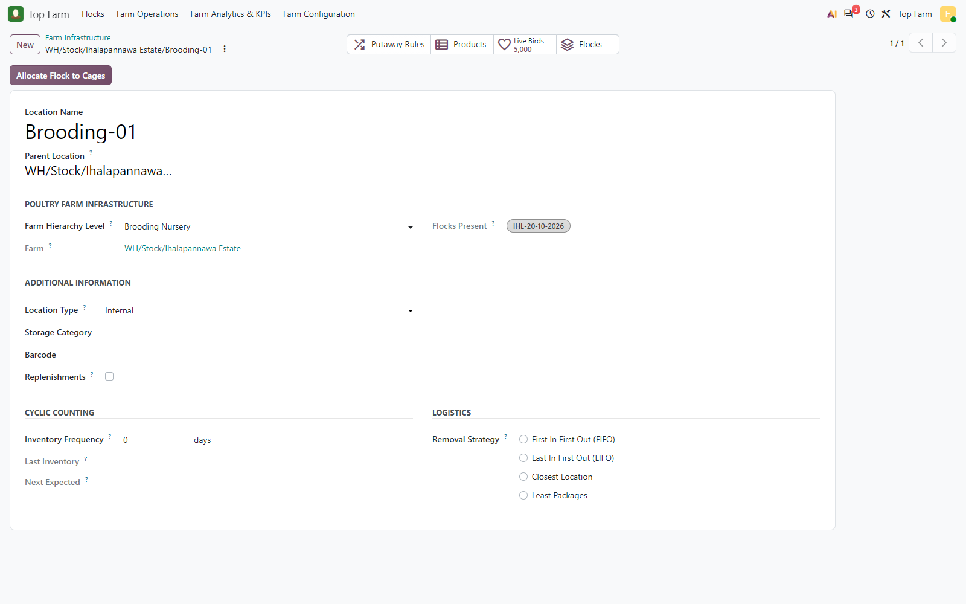
Figure 28. Brooding-01 now holds the flock IHL-20-10-2026: 5,000 live birds.

Figure 29: The Flock Batches plan now holds the account IHL-20-10-2026
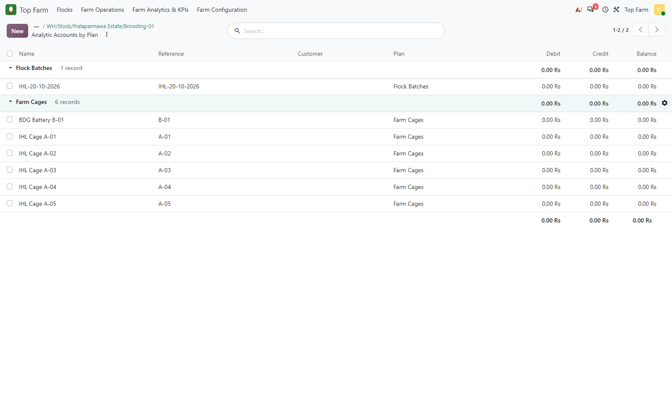
Figure 29. The Flock Batches plan now holds the account IHL-20-10-2026, created automatically with the flock lot; cages keep their Farm Cages accounts.

5.1 Approach A: the clerk types the flock batch number
With the Flock Lot Generation Mode set to manual entry, a dispatch to a brooding nursery cannot be validated until the clerk enters the flock lot in the Flock Lot column of the transfer line. The Baddegama chicks were dispatched this way as BDG-20-10-2026; the lot was completed on validation (Flock Batch, estate, arrival date, analytic account) exactly like a generated one.

Figure 30: Approach A (manual entry)
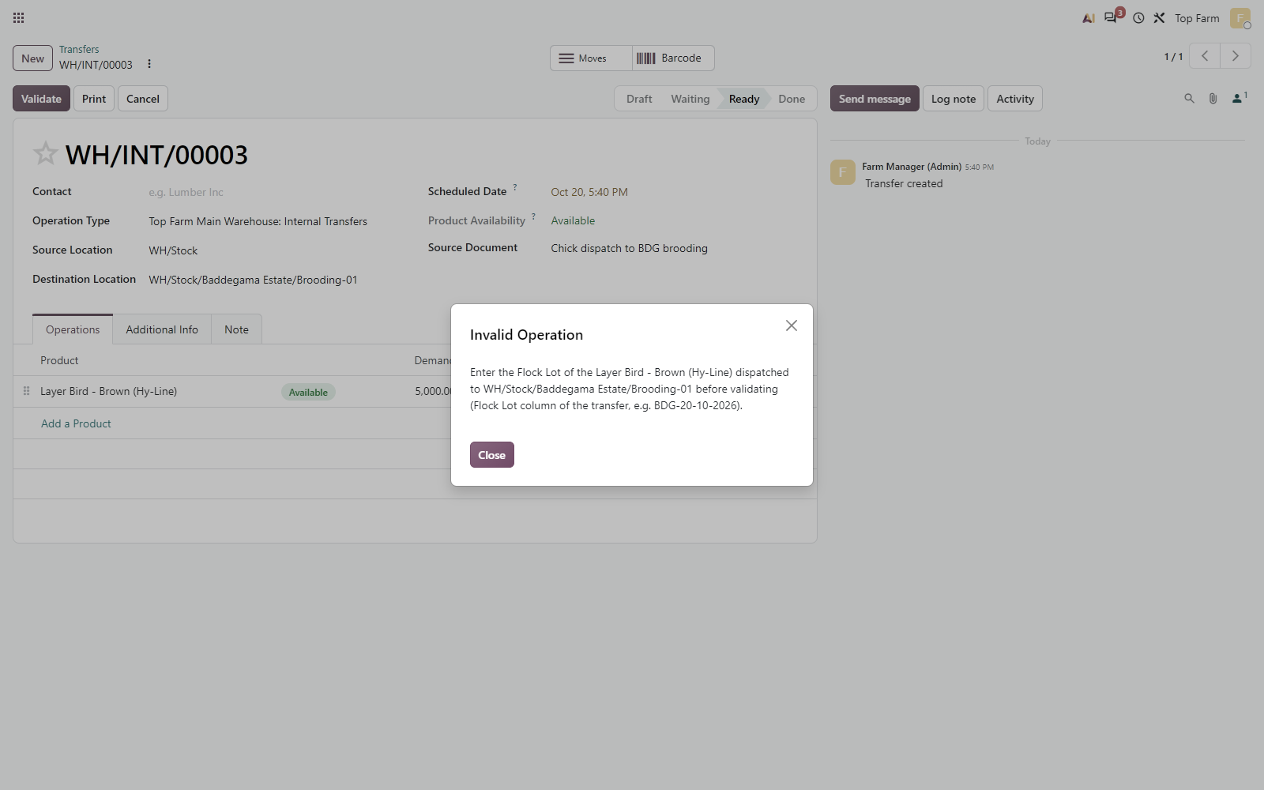
Figure 30. Approach A (manual entry): validating the dispatch to Baddegama Brooding-01 without a flock lot is refused; the message suggests the name built from the estate code and the arrival date.

Figure 31: The clerk types the flock lot BDG-20-10-2026 in the Flock Lot column of ...
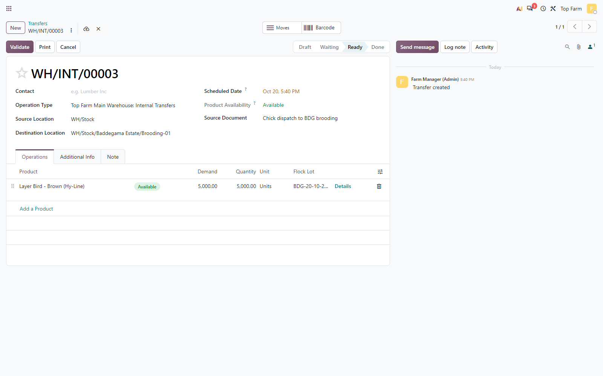
Figure 31. The clerk types the flock lot BDG-20-10-2026 in the Flock Lot column of the dispatch line.

Figure 32: Dispatch WH/INT/00003 validated (Done)
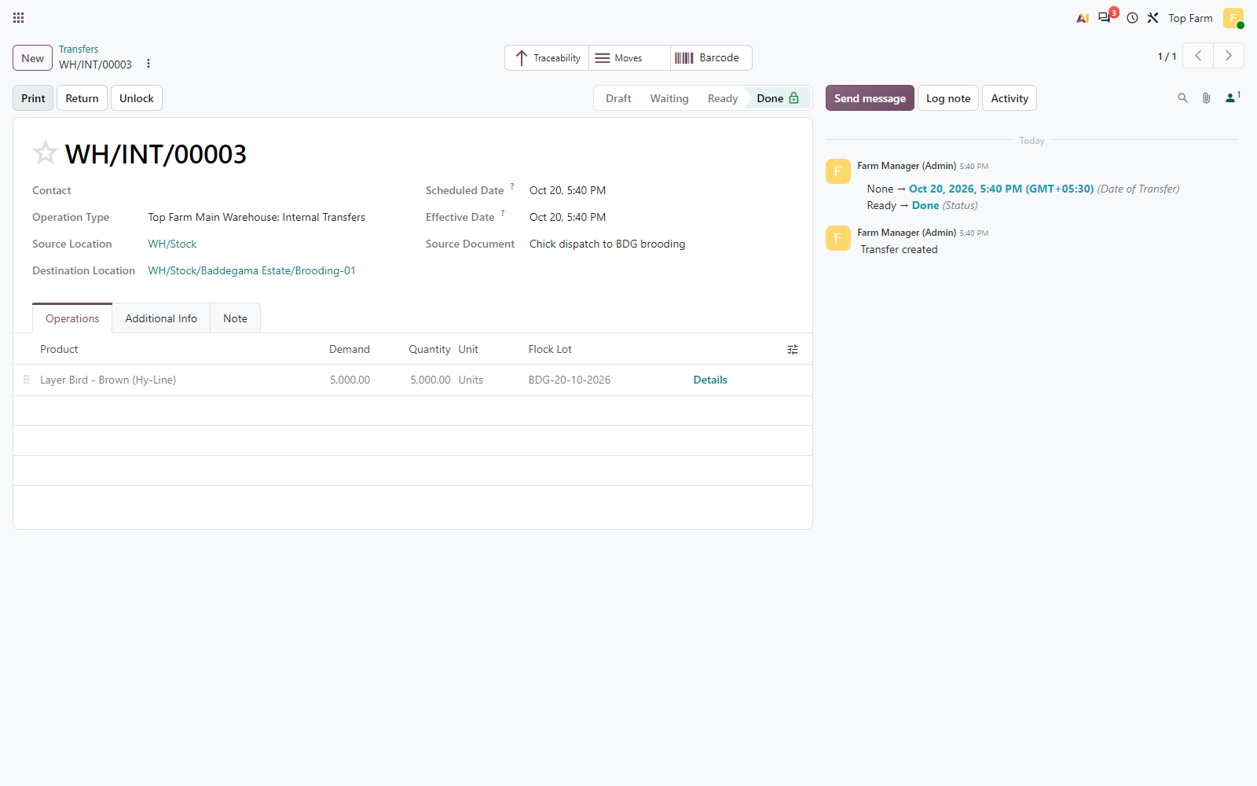
Figure 32. Dispatch WH/INT/00003 validated (Done): the line carries the clerk-entered flock lot BDG-20-10-2026. The 5,000 chicks were re-labelled from hatchery lot 20_10_2026 on validation, as the flock lot's chatter shows on the next figure.

Figure 33: Flock lot BDG-20-10-2026 completed at validation
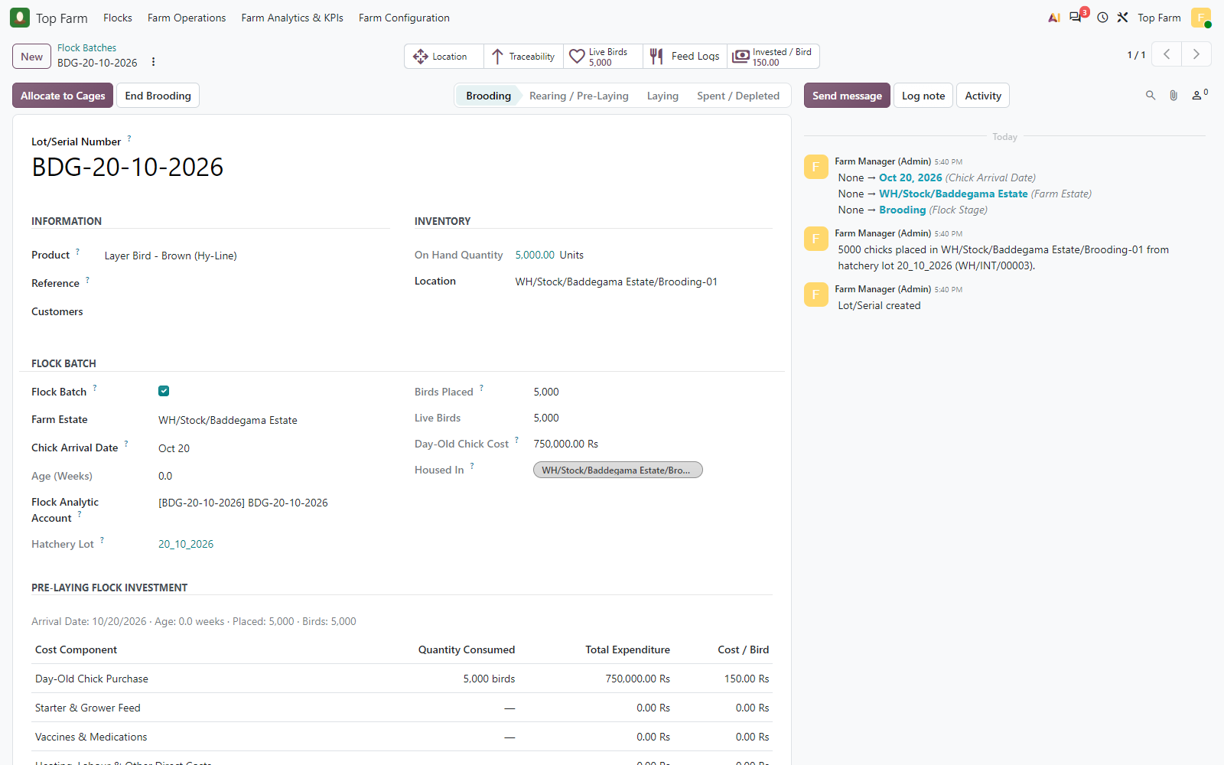
Figure 33. Flock lot BDG-20-10-2026 completed at validation: Brooding stage, Baddegama Estate, arrival date from the hatchery lot, own Flock analytic account.

6. Brooding stage: feed, vaccines, heating and mortality
During weeks 0-4 the chicks stay under heat in Brooding-01. The Farm Operator logs the feed and medication on the brooding nursery (no cage); the flock is filled in automatically. Brooding feed and medication are a direct expense of the flock and are consumed at once. The LPG heating bill is charged to the flock analytic account. Two brooding logs were recorded: FEED/2026/00001 (shown being confirmed) and FEED/2026/00002 (confirmed by the Farm Operator). Brooding mortality is checked against the 2 % cumulative daily threshold of the flock in the nursery: the operator submits, the manager approves above the threshold.

6.1 Brooding-stage expenses of the batch (analytic accounting)
Every brooding cost is an analytic item on the flock account IHL-20-10-2026 only (Farm Cages column empty). Expected amounts are recomputed from the logs and bills:
Expense | Quantity | Unit cost | Expected (LKR) | Analytic actual (LKR) | Accounts | Result
Starter Crumbs (Weeks 0-4) | 400 | 140.00 | 56,000.00 | 56,000.00 | Flock only | PASS
Marek's Vaccine (dose) | 5,000 | 58.00 | 290,000.00 | 290,000.00 | Flock only | PASS
Newcastle ND-IB Vaccine (dose) | 5,000 | 12.00 | 60,000.00 | 60,000.00 | Flock only | PASS
Electrolyte & Vitamin Mix (L) | 10 | 900.00 | 9,000.00 | 9,000.00 | Flock only | PASS
Layer Bird - Brown (Hy-Line) (mortality) | 110 | 150.00 | 16,500.00 | 16,500.00 | Flock only | PASS
LPG & electricity bill (brooding heat) | 1 | 170,000.00 | 170,000.00 | 170,000.00 | Flock only | PASS
Total brooding stage |  |  | 601,500.00 | 601,500.00 |  | PASS

Figure 34: Daily feed & medication log FEED/2026/00001 in Brooding-01
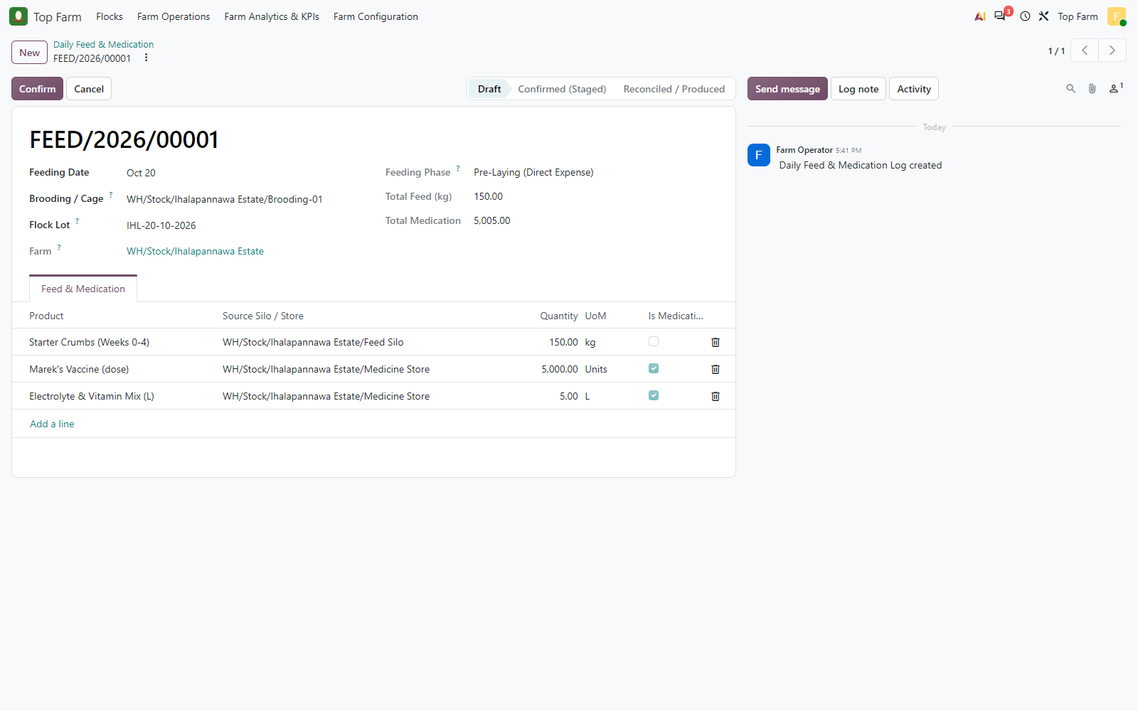
Figure 34. Daily feed & medication log FEED/2026/00001 in Brooding-01, recorded by the Farm Operator: the flock IHL-20-10-2026 is filled in from the nursery, no cage is needed. Starter Crumbs 150 kg, Marek's vaccine 5,000 doses, Electrolyte & Vitamin Mix 5 L (the Total Medication field adds doses and litres).

Figure 35: Confirmed
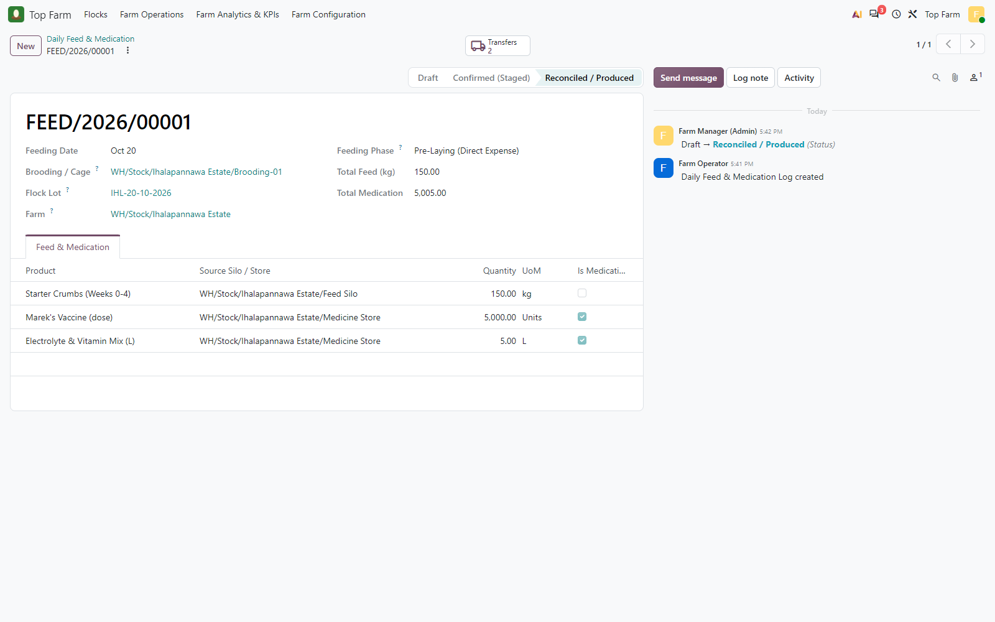
Figure 35. Confirmed: brooding feed and medication are expensed at once (Pre-Laying, Reconciled), through two consumption transfers.

Figure 36: Consumption transfer
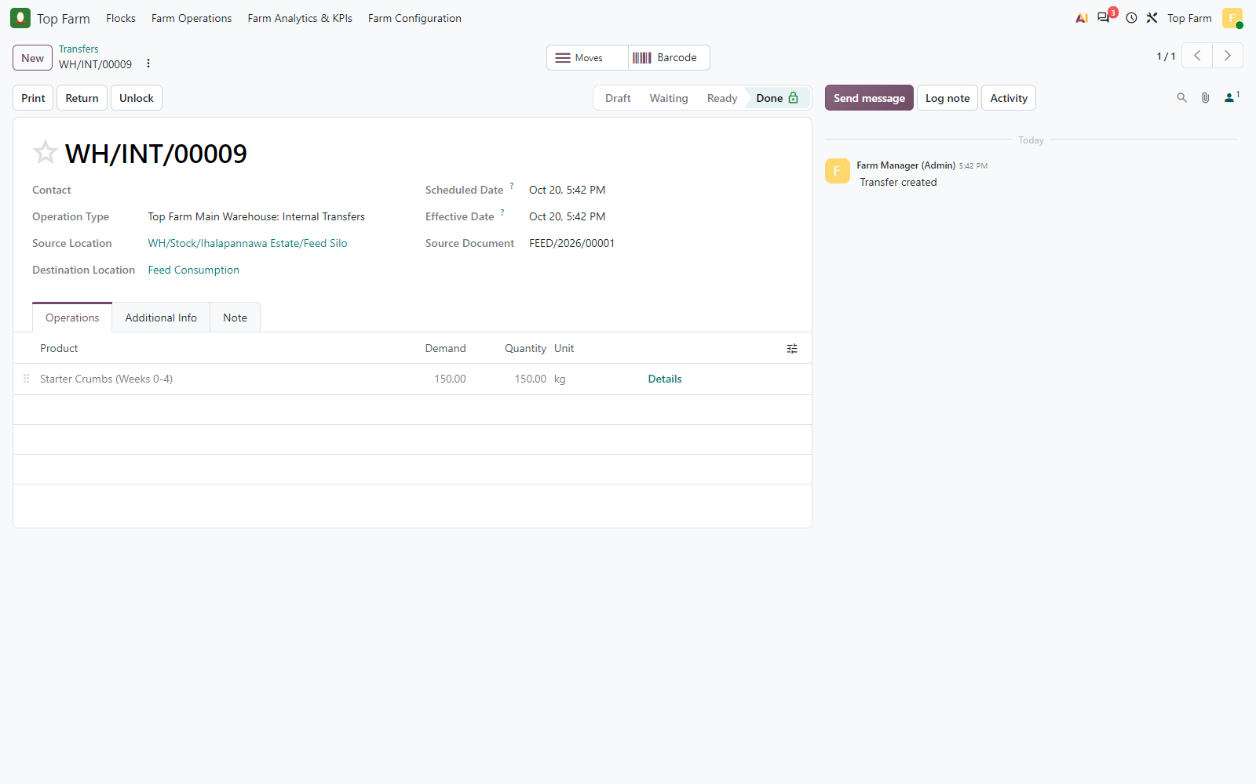
Figure 36. Consumption transfer: Starter Crumbs from the IHL Feed Silo to the Feed Consumption virtual location.

Figure 37: Journal entry of the brooding feed
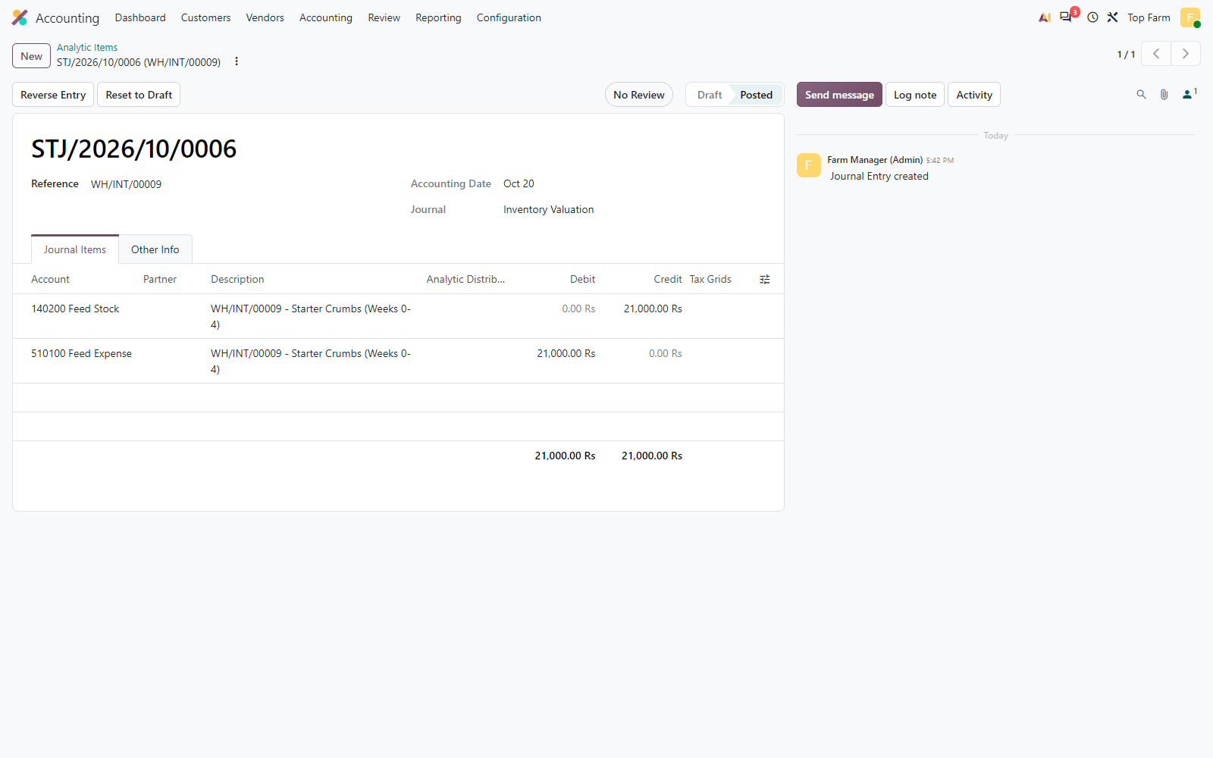
Figure 37. Journal entry of the brooding feed: 510100 Feed Expense debited, 140200 Feed Stock credited, LKR 21,000 = 150 kg x 140.

Figure 38: Second brooding log FEED/2026/00002 (confirmed by the Farm Operator)
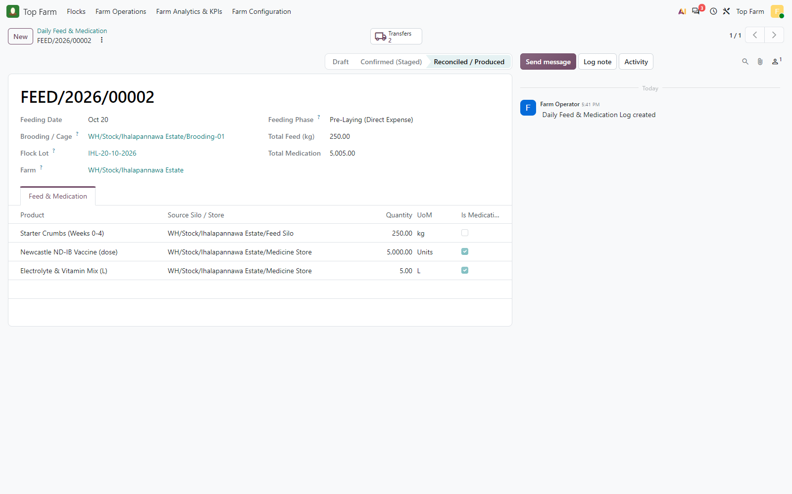
Figure 38. Second brooding log FEED/2026/00002 (confirmed by the Farm Operator): Starter Crumbs 250 kg, Newcastle ND-IB vaccine 5,000 doses, Electrolyte & Vitamin Mix 5 L.

Figure 39: Vendor bill for LPG & electricity, 4 brooding weeks (LKR 170
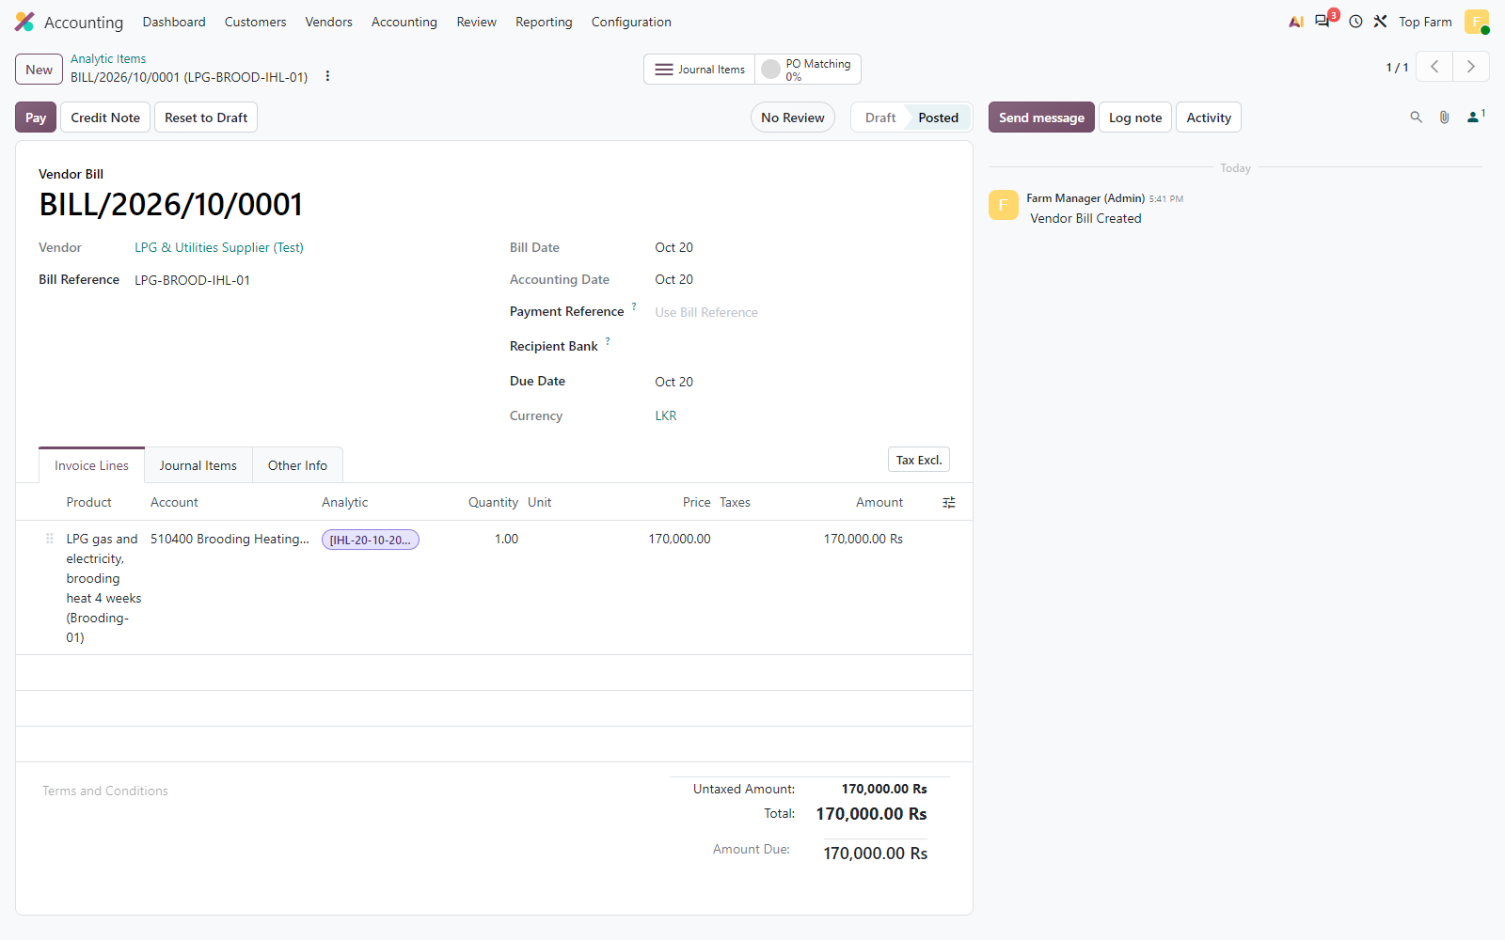
Figure 39. Vendor bill for LPG & electricity, 4 brooding weeks (LKR 170,000 on 510400 Brooding Heating), charged 100 % to the flock analytic account IHL-20-10-2026 (see the analytic items further on).

Figure 40: The Farm Operator records 50 dead chicks of flock IHL-20-10-2026 in ...
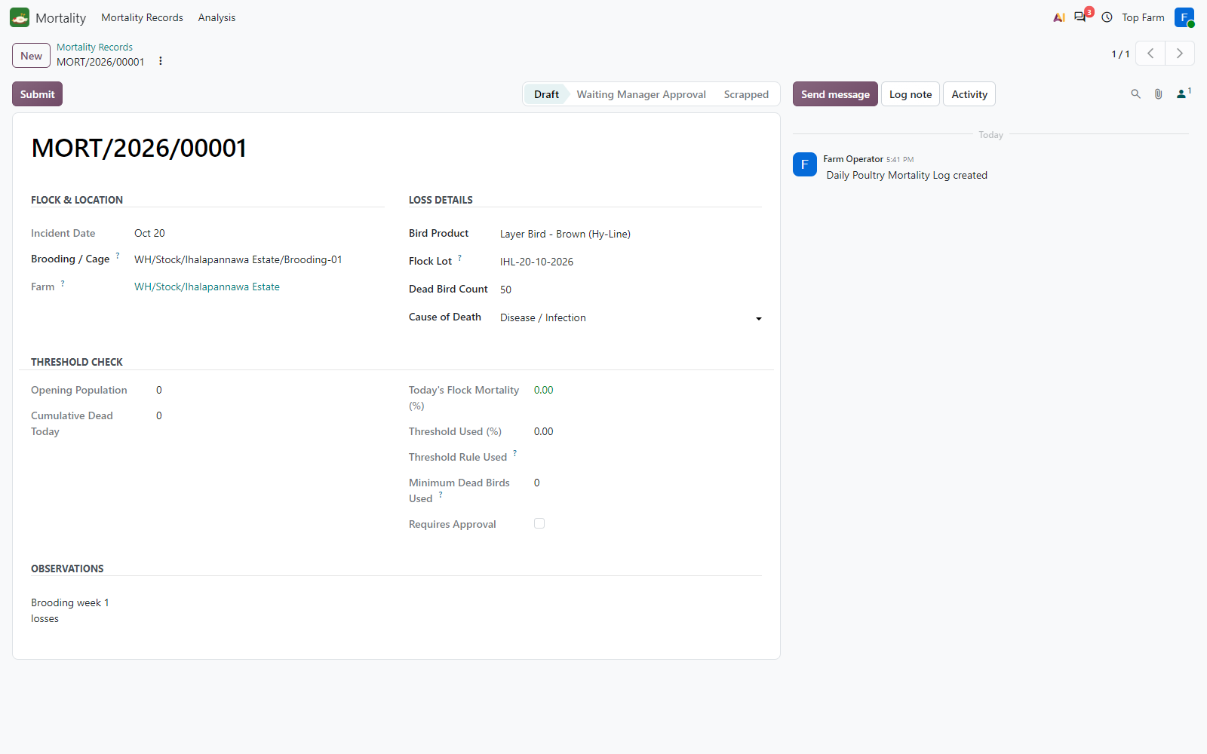
Figure 40. The Farm Operator records 50 dead chicks of flock IHL-20-10-2026 in Brooding-01 (cause Disease / Infection), in Draft.

Figure 41: Submitted by the Farm Operator
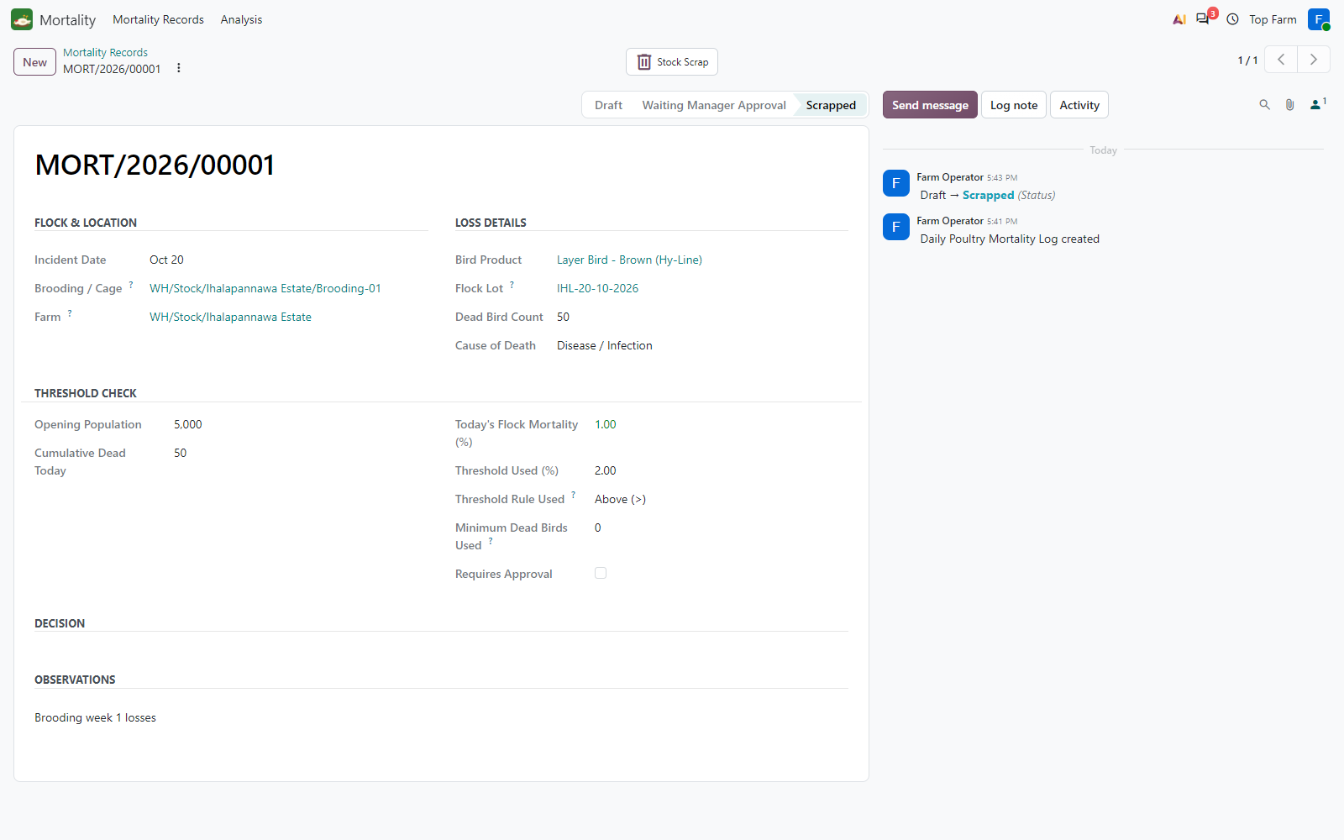
Figure 41. Submitted by the Farm Operator: 50 of the 5,000 opening birds (1.00 %, not above the 2 % threshold) are scrapped at once.

Figure 42: Another 60 chicks the same day
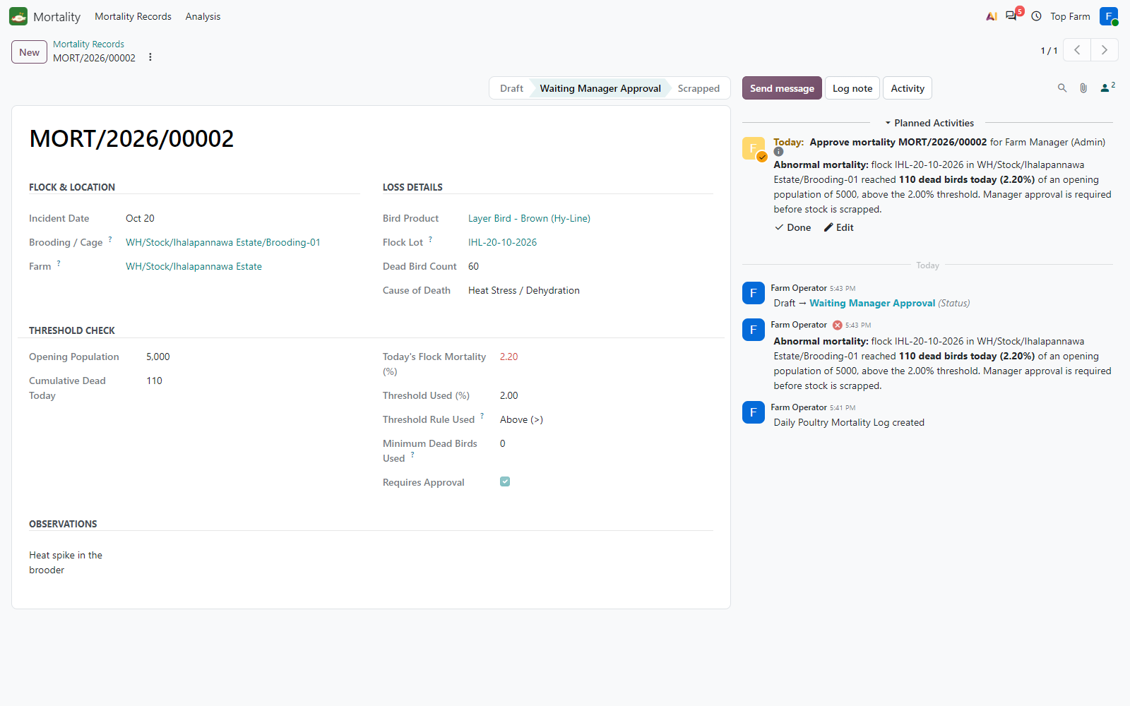
Figure 42. Another 60 chicks the same day: 110 cumulative = 2.20 % > 2 %. The operator cannot scrap them: the log waits for the Farm Manager, who gets a chatter alert and a To-Do.

Figure 43: The Farm Manager approves
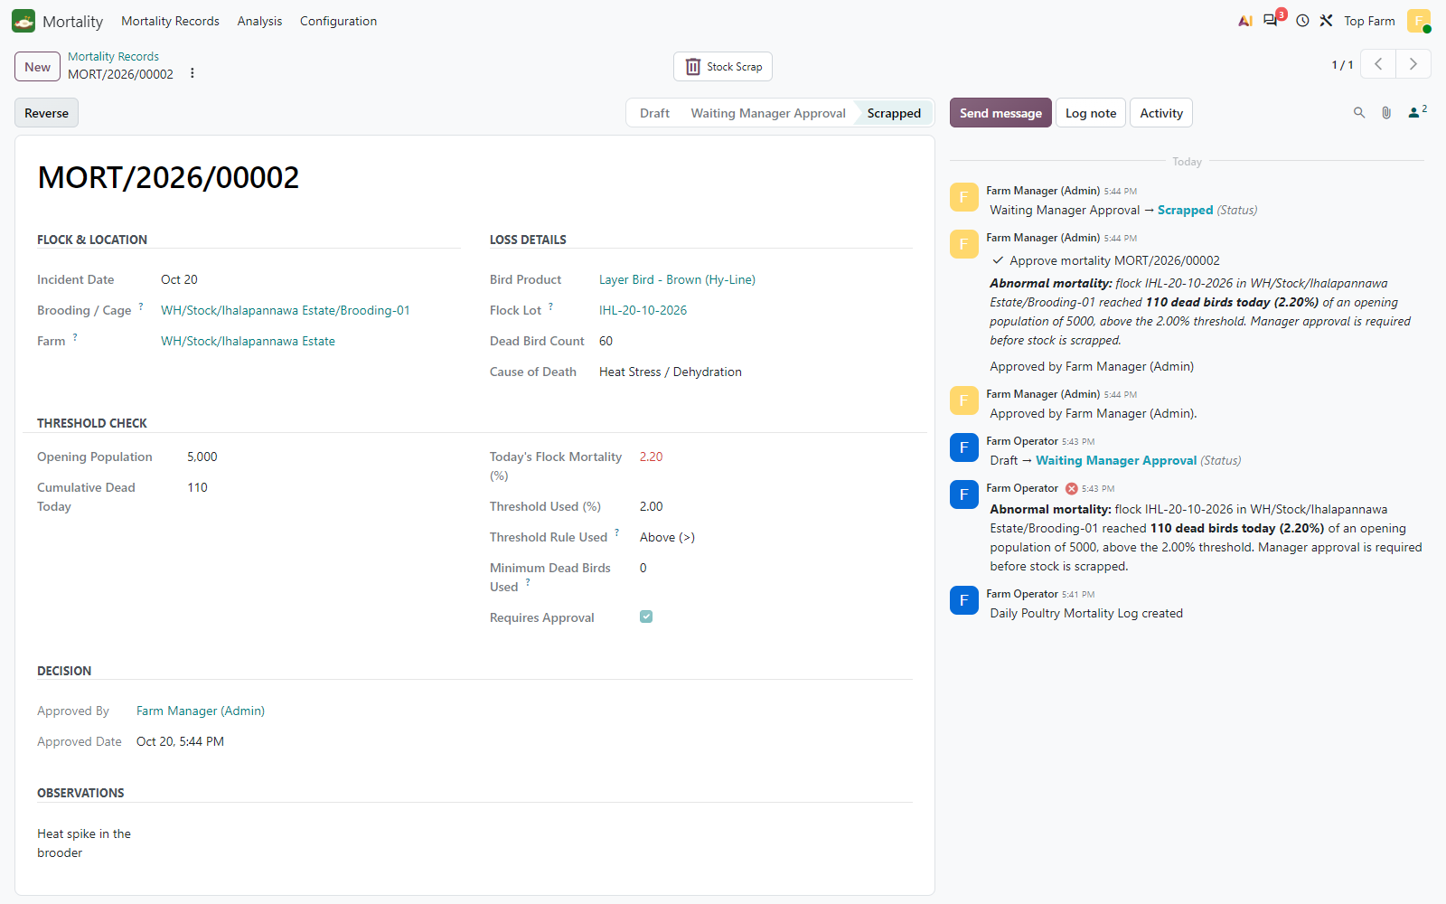
Figure 43. The Farm Manager approves: the 60 chicks are scrapped; Approved By and Approved Date are recorded, the To-Do is closed.

Figure 44: Mortality records of Brooding-01 for flock IHL-20-10-2026
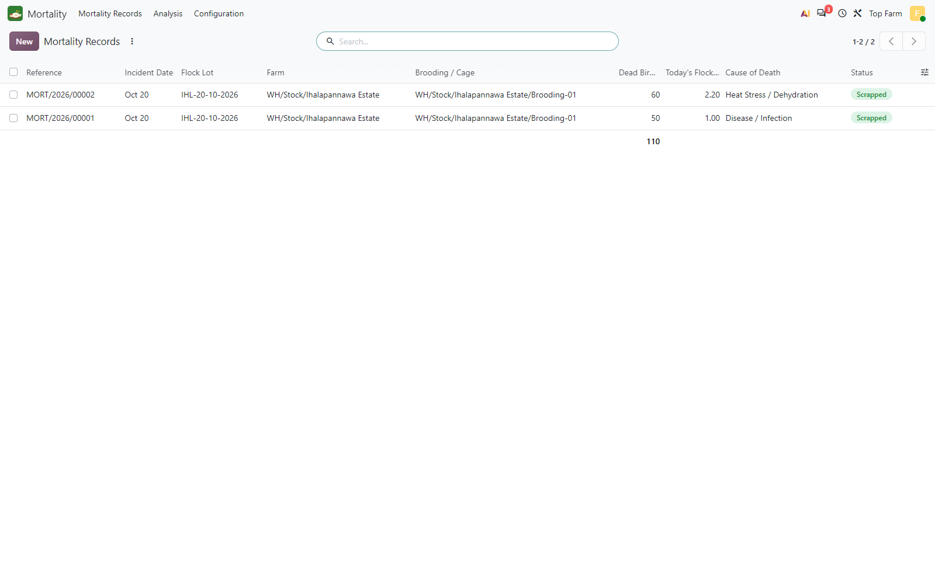
Figure 44. Mortality records of Brooding-01 for flock IHL-20-10-2026: MORT/2026/00001 (50 chicks, 1.00 %) and MORT/2026/00002 (60 chicks, 2.20 % cumulative), both Scrapped: 110 dead.

Figure 45: Analytic items of flock IHL-20-10-2026 in the brooding stage (LKR -601,500)
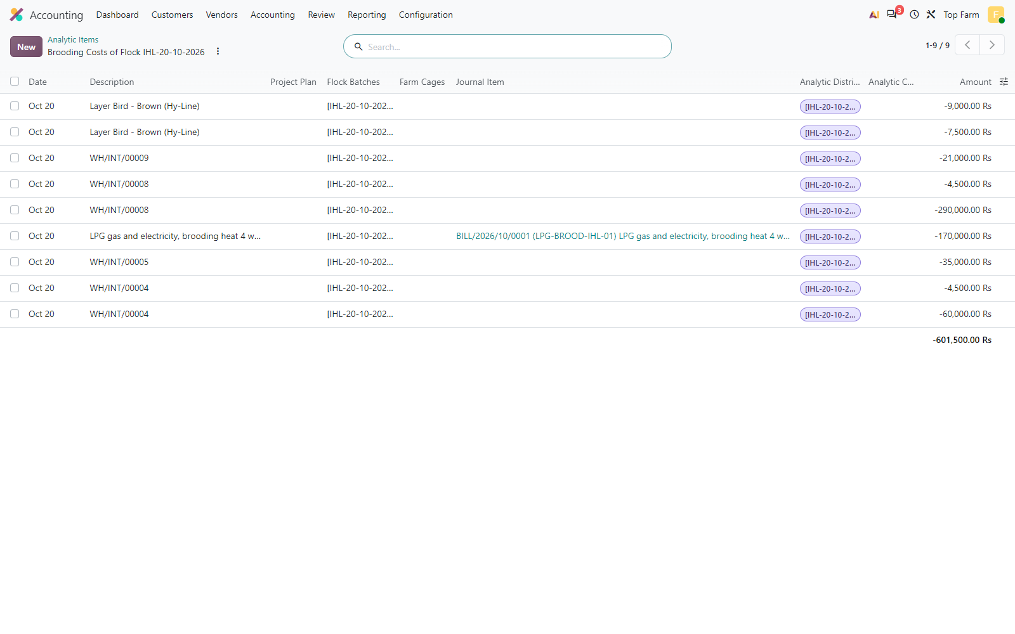
Figure 45. Analytic items of flock IHL-20-10-2026 in the brooding stage (LKR -601,500): the transfers of FEED/2026/00001 and FEED/2026/00002 (starter feed, Marek's and Newcastle vaccines, electrolytes), the two mortality scraps (50 + 60 chicks, shown with the bird product name) and the LPG bill. Every line carries the Flock account only; the Farm Cages column is empty.

Figure 46: Brooding-stage expenses of the batch by product (negative = cost)
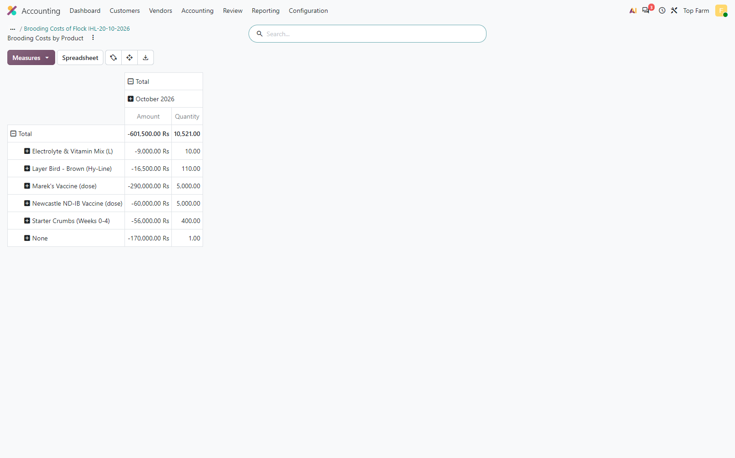
Figure 46. Brooding-stage expenses of the batch by product (negative = cost): starter feed 400 kg, vaccines, electrolytes 10 L, mortality 110 birds; the line without product is the LPG heating bill. Total LKR 601,500.

Figure 47: Pre-Laying Flock Investment after the brooding records (still dated on ...
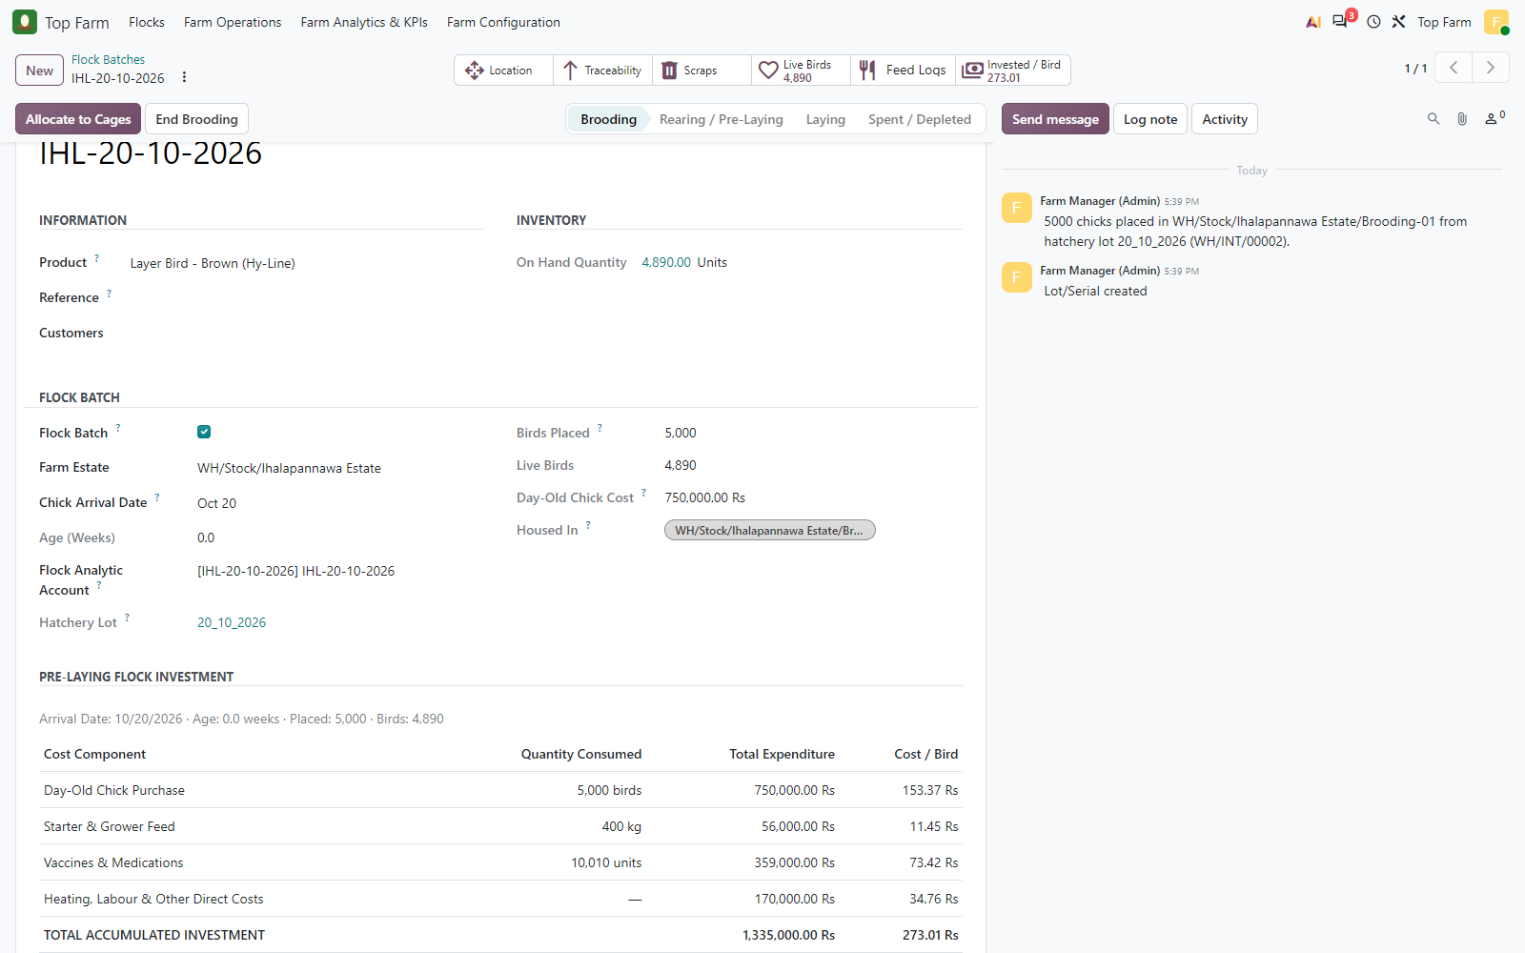
Figure 47. Pre-Laying Flock Investment after the brooding records (still dated on the test day, age 0.0 weeks, before the arrival date is moved back): chicks LKR 750,000, starter feed LKR 56,000, vaccines and electrolytes LKR 359,000 (the quantity mixes doses and litres), LPG heating LKR 170,000 = LKR 273.01 per live bird. Brooding mortality is not added: the dead chicks are already in the chick cost.

7. Splitting the flock into cages (pre-laying)
At the end of brooding (about week 4 in production; on the test day here) the Farm Manager opens the Brooding-to-Cage Allocation wizard from the nursery: it detects the flock and its 4,890 surviving birds and lists the cages of the estate with their occupancy. Split Equally gives 978 birds to each of the 5 cages. One validated transfer moves the birds, keeping the flock lot IHL-20-10-2026, and the flock advances to Rearing / Pre-Laying.

Figure 48: Brooding-01 holds 4,890 surviving birds of flock IHL-20-10-2026 (5
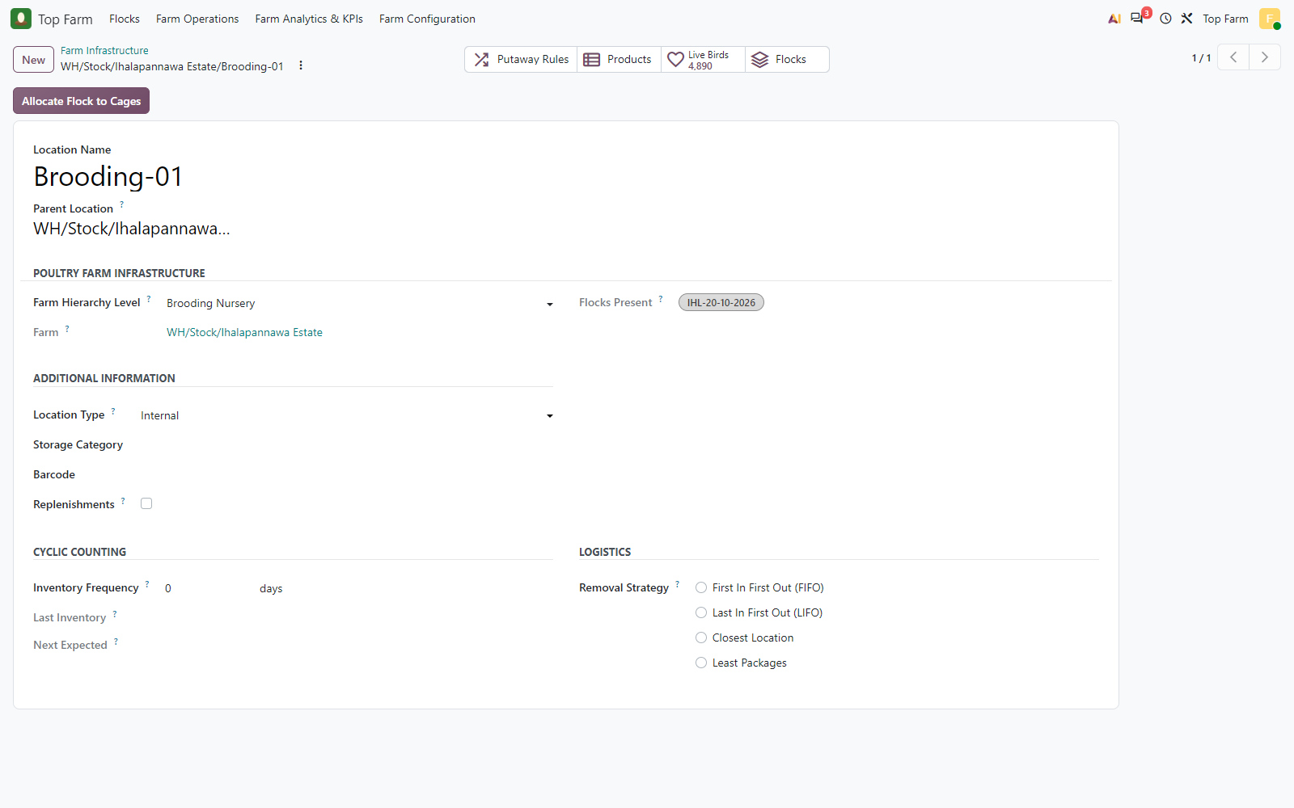
Figure 48. Brooding-01 holds 4,890 surviving birds of flock IHL-20-10-2026 (5,000 placed - 110 dead); the Farm Manager clicks Allocate Flock to Cages. In production this happens at about week 4; in the test it is done on the test day, before the flock age is simulated.

Figure 49: Brooding-to-Cage Allocation wizard
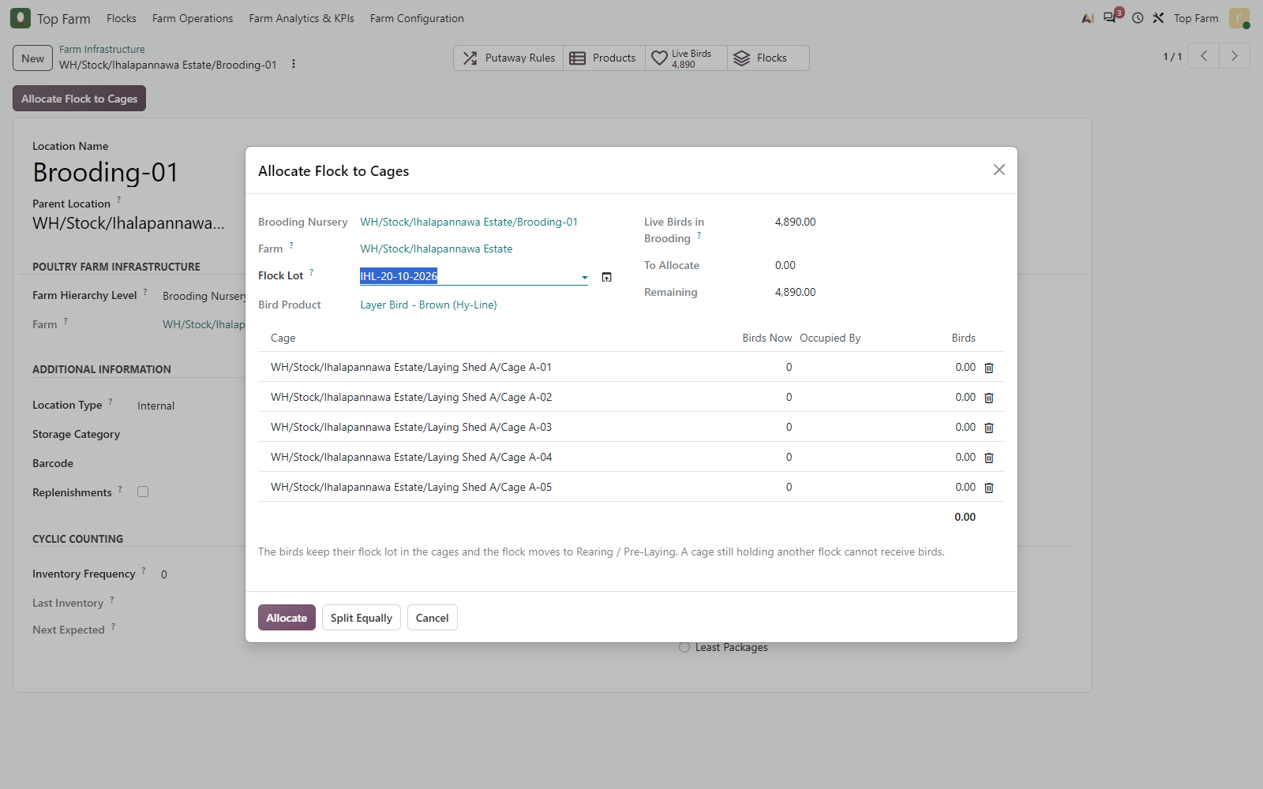
Figure 49. Brooding-to-Cage Allocation wizard: source nursery and flock lot detected, 4,890 live birds, the 5 cages of the estate listed with their current occupancy (all empty).

Figure 50: Split Equally
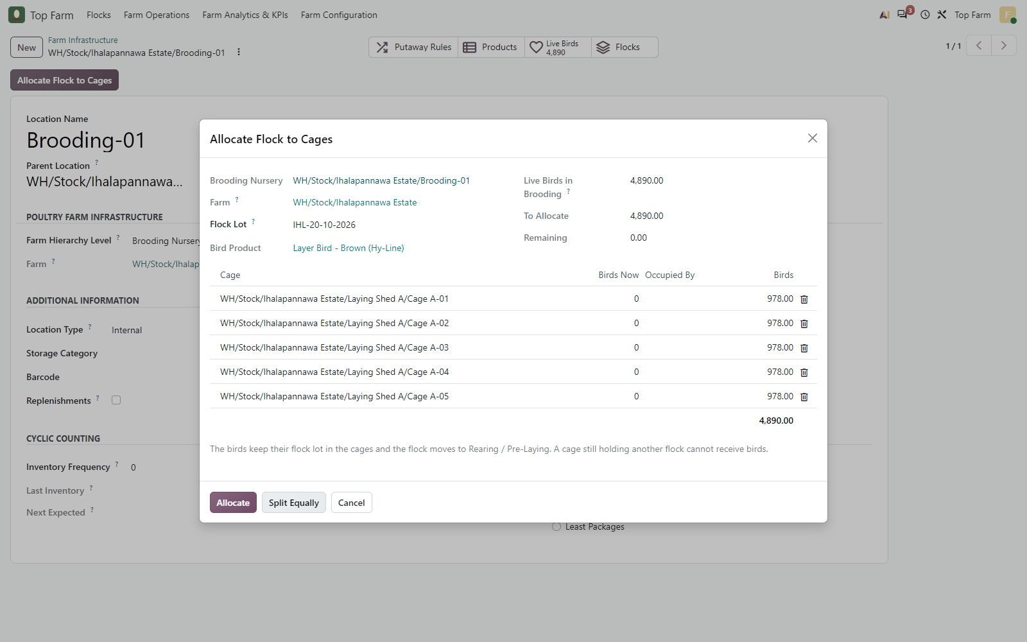
Figure 50. Split Equally: 978 birds per cage (5 x 978 = 4,890), nothing left in brooding.

Figure 51: The flock keeps its lot number IHL-20-10-2026 in the cages and moves to ...
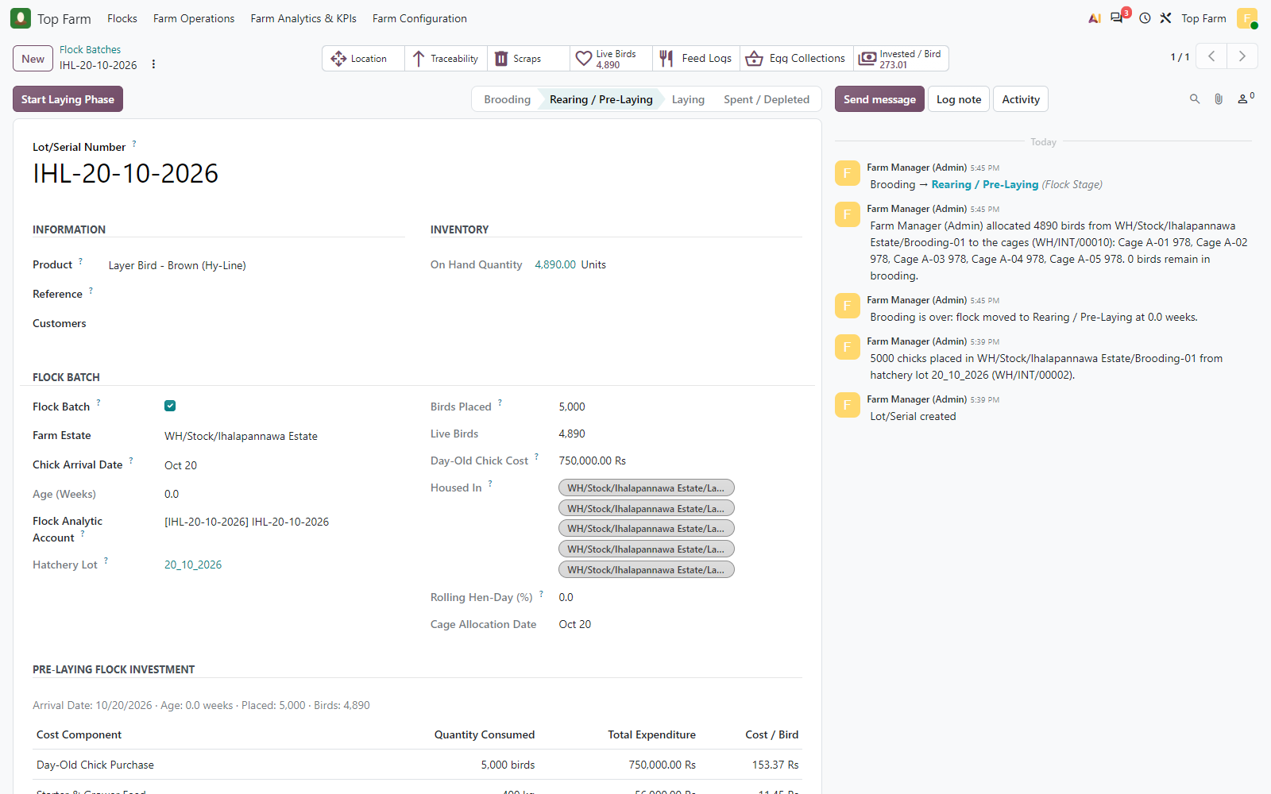
Figure 51. The flock keeps its lot number IHL-20-10-2026 in the cages and moves to Rearing / Pre-Laying; the chatter records the allocation. (Age 0.0 weeks and allocation on 20 October: the flock age is simulated later, before the point of lay.)

Figure 52: Moves of the allocation transfer
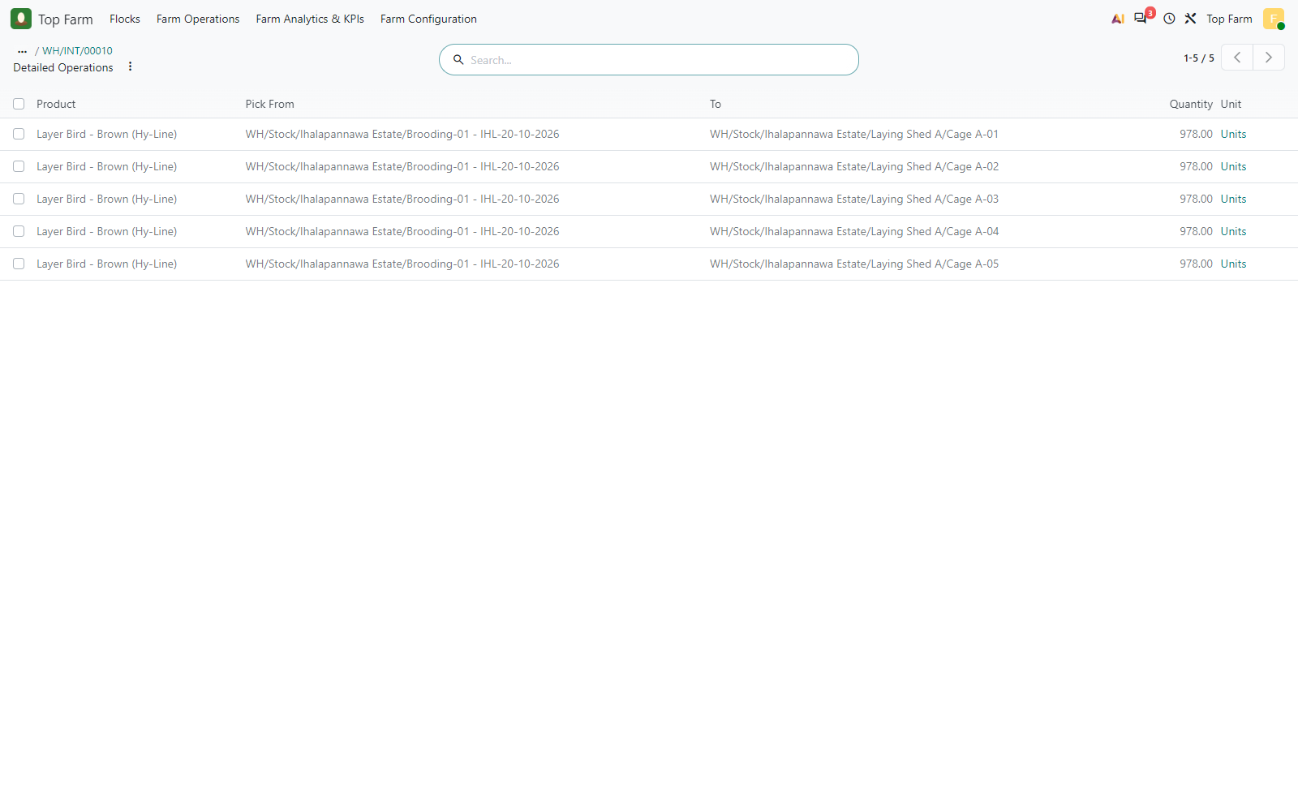
Figure 52. Moves of the allocation transfer: 978 birds from Brooding-01 to each of Cage A-01 to A-05, all under flock lot IHL-20-10-2026.

Figure 53: Farm infrastructure after the allocation
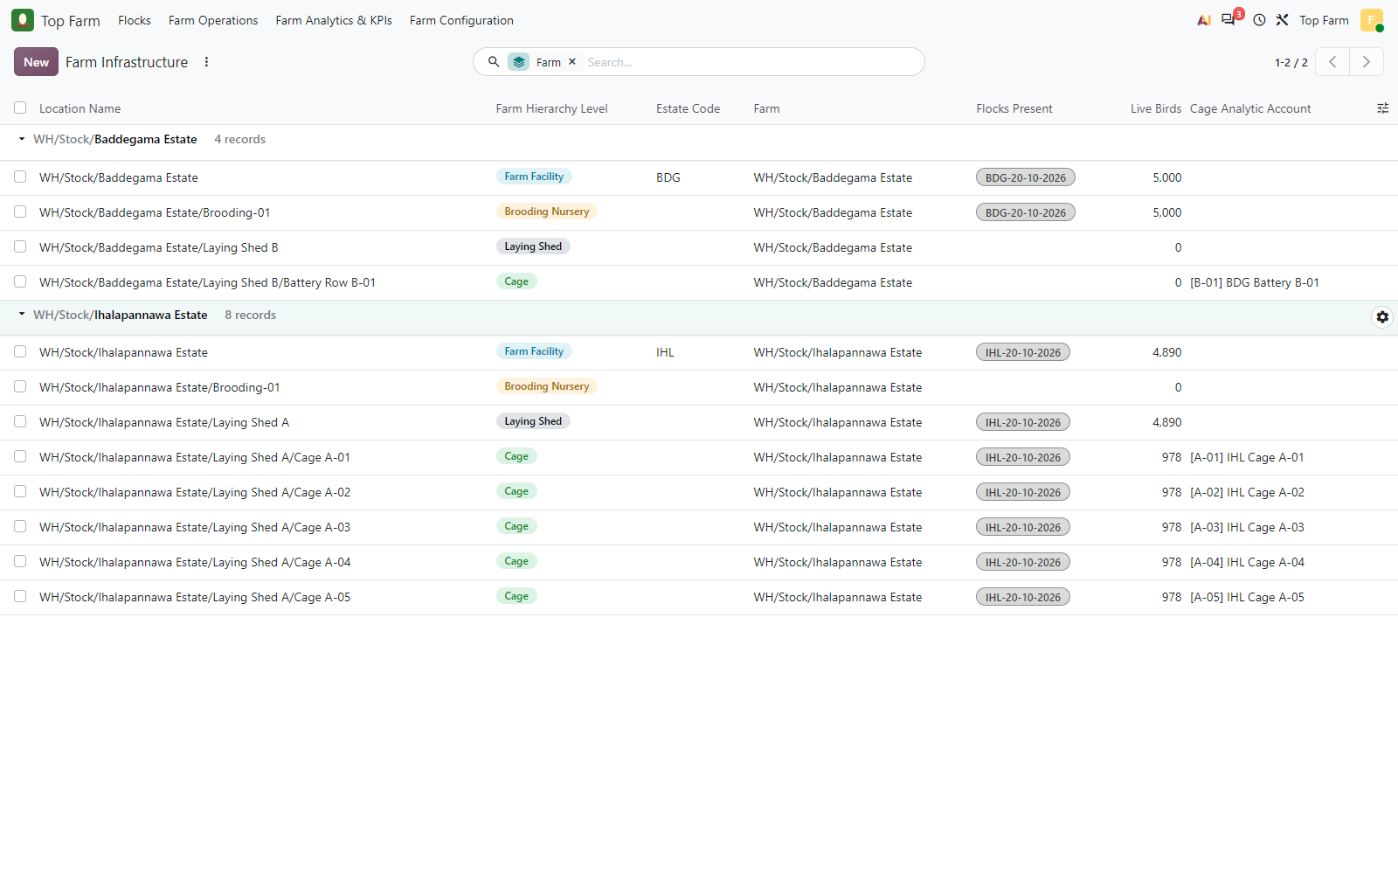
Figure 53. Farm infrastructure after the allocation: Brooding-01 is empty and each cage of Laying Shed A holds 978 birds of IHL-20-10-2026.

8. Pre-laying rearing in the cages
From now on the daily logs are per cage. Rearing feed and medication are still a direct expense of the flock (they build the pre-laying investment), but each cost lands on one analytic line holding both the flock account and the cage account, so the cost is reported per flock and per cage without being counted twice.

8.1 Rearing costs per cage (analytic accounting)
Cage | Grower Mash 100 kg | Vitamins 1 L | Mortality | Expected (LKR) | Analytic actual (LKR) | Result
Cage A-01 | 13,000.00 | 900.00 | 750.00 | 14,650.00 | 14,650.00 | PASS
Cage A-02 | 13,000.00 | 900.00 | 0.00 | 13,900.00 | 13,900.00 | PASS
Cage A-03 | 13,000.00 | 900.00 | 450.00 | 14,350.00 | 14,350.00 | PASS
Cage A-04 | 13,000.00 | 900.00 | 0.00 | 13,900.00 | 13,900.00 | PASS
Cage A-05 | 13,000.00 | 900.00 | 0.00 | 13,900.00 | 13,900.00 | PASS
The debeaking labour bill (LKR 75,000) is charged to the flock account only, like the LPG bill.

8.2 Pre-Laying Flock Investment
The investment report accumulates, per flock, the chicks placed and every feed, medication and direct cost tagged to the flock until the Laying Phase starts; laying feed and mortality scraps are excluded (the chick cost already counts every bird placed). Locked on 2026-10-20 over 4,882 birds at point of lay:
Cost component | Expected (LKR) | Report (LKR) | Per bird (LKR) | Result
Day-Old Chick Purchase | 750,000.00 | 750,000.00 | 153.63 | PASS
Starter & Grower Feed | 121,000.00 | 121,000.00 | 24.78 | PASS
Vaccines & Medications | 363,500.00 | 363,500.00 | 74.46 | PASS
Heating, Labour & Other Direct Costs | 245,000.00 | 245,000.00 | 50.18 | PASS
TOTAL ACCUMULATED INVESTMENT | 1,479,500.00 | 1,479,500.00 | 303.05 | PASS
Target benchmark LKR 1,200.00 - 1,300.00 per bird; remaining pre-laying budget at lock: LKR 896.95 per bird (the test flock only received a few sample feed logs: two brooding logs and one rearing log per cage).

Figure 54: Rearing feed log FEED/2026/00004 in Cage A-01 of Laying Shed A
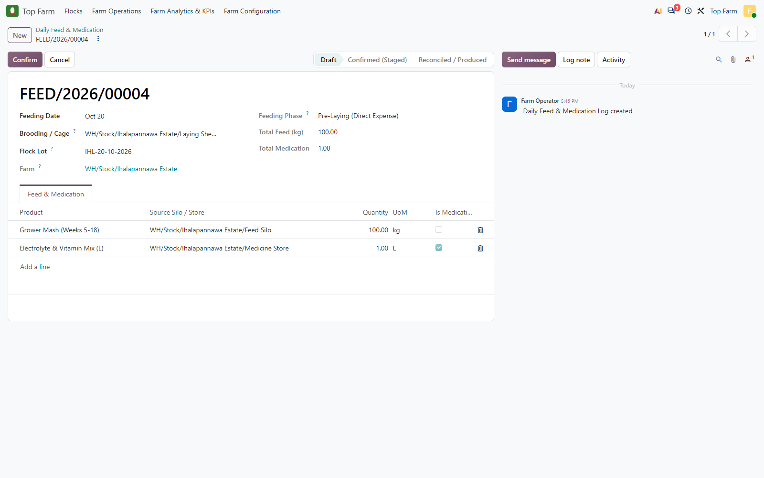
Figure 54. Rearing feed log FEED/2026/00004 in Cage A-01 of Laying Shed A: the flock IHL-20-10-2026 is filled in from the cage. Grower Mash 100 kg and Electrolyte & Vitamin Mix 1 L.

Figure 55: Confirmed
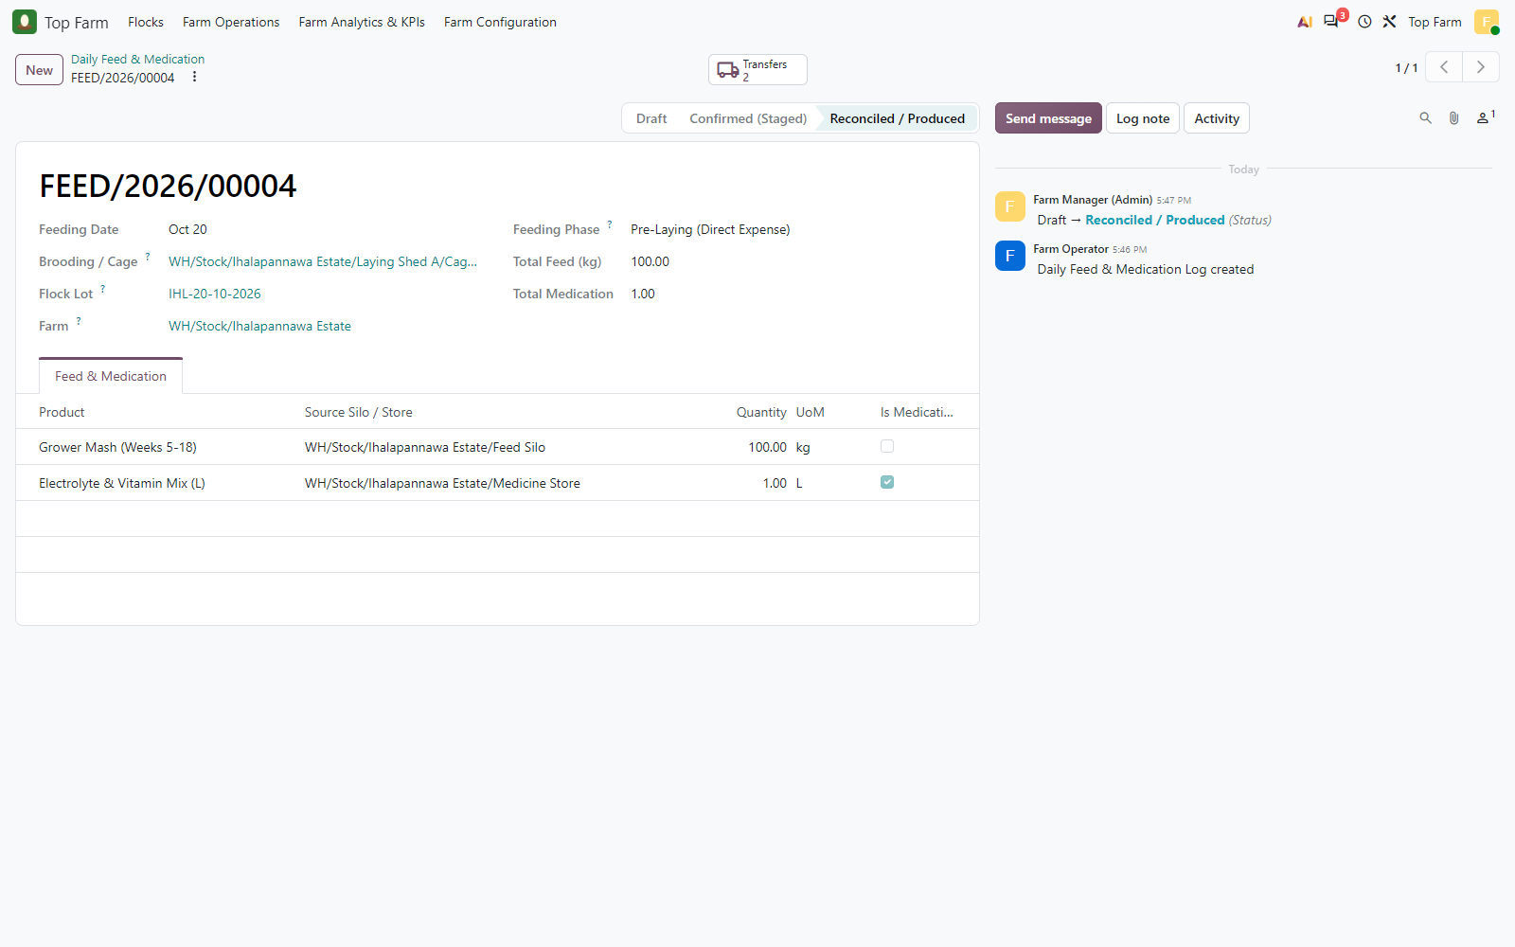
Figure 55. Confirmed: pre-laying feed is still a direct expense of the flock (Pre-Laying, Reconciled), now also charged to the cage.

Figure 56: Daily feed & medication logs, newest first
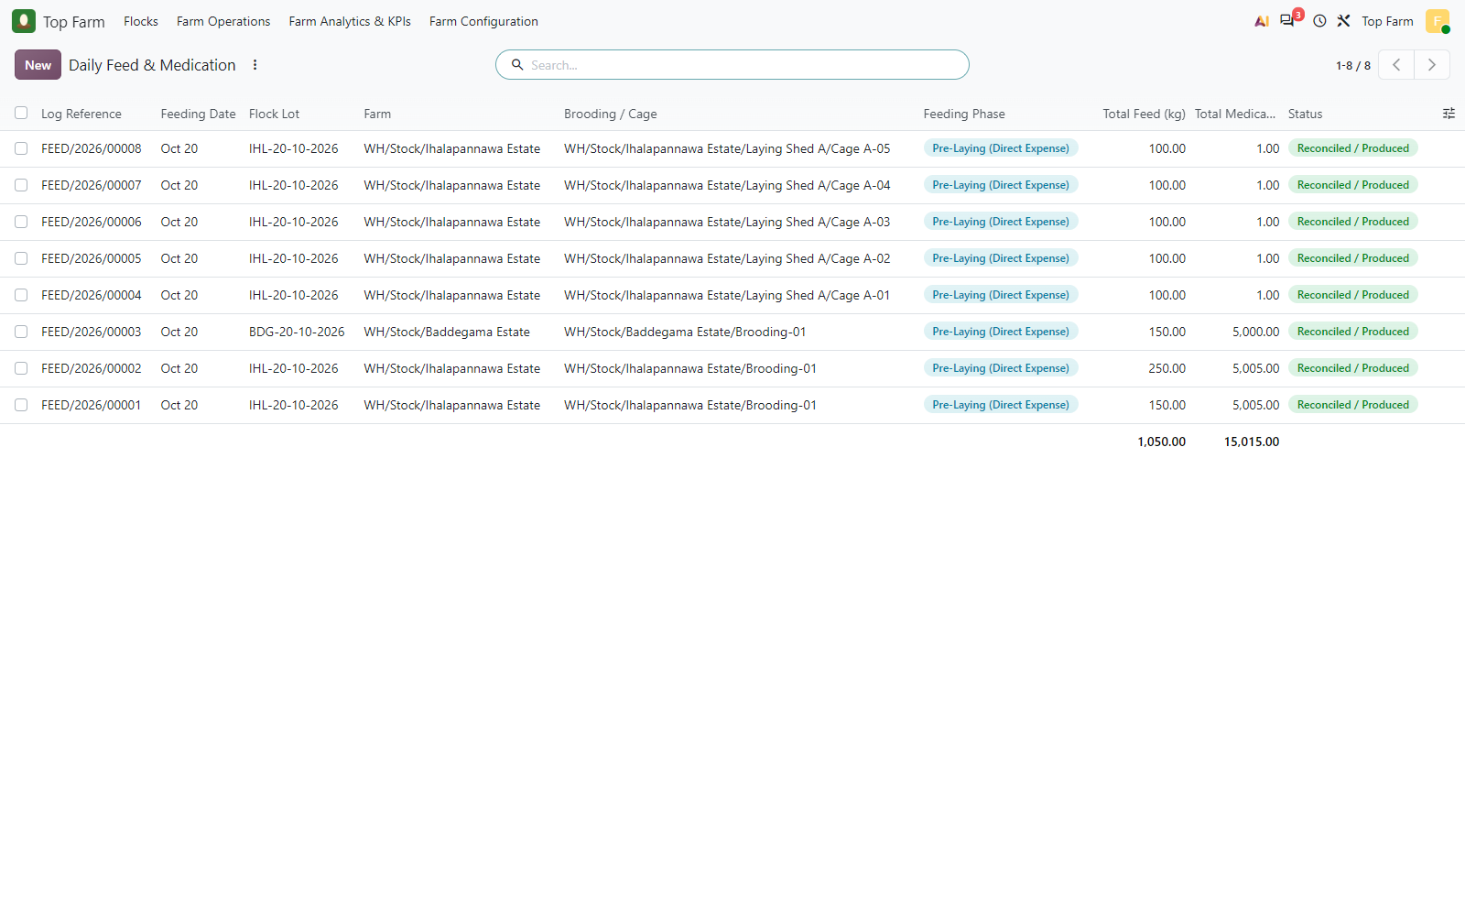
Figure 56. Daily feed & medication logs, newest first: one rearing log per cage of Laying Shed A (100 kg Grower Mash + 1 L vitamins each, flock IHL-20-10-2026), then the brooding logs of BDG-20-10-2026 (Baddegama) and IHL-20-10-2026 (Ihalapannawa); all Pre-Laying, Reconciled. The Total Medication footer adds doses and litres.

Figure 57: Cage mortality MORT/2026/00003
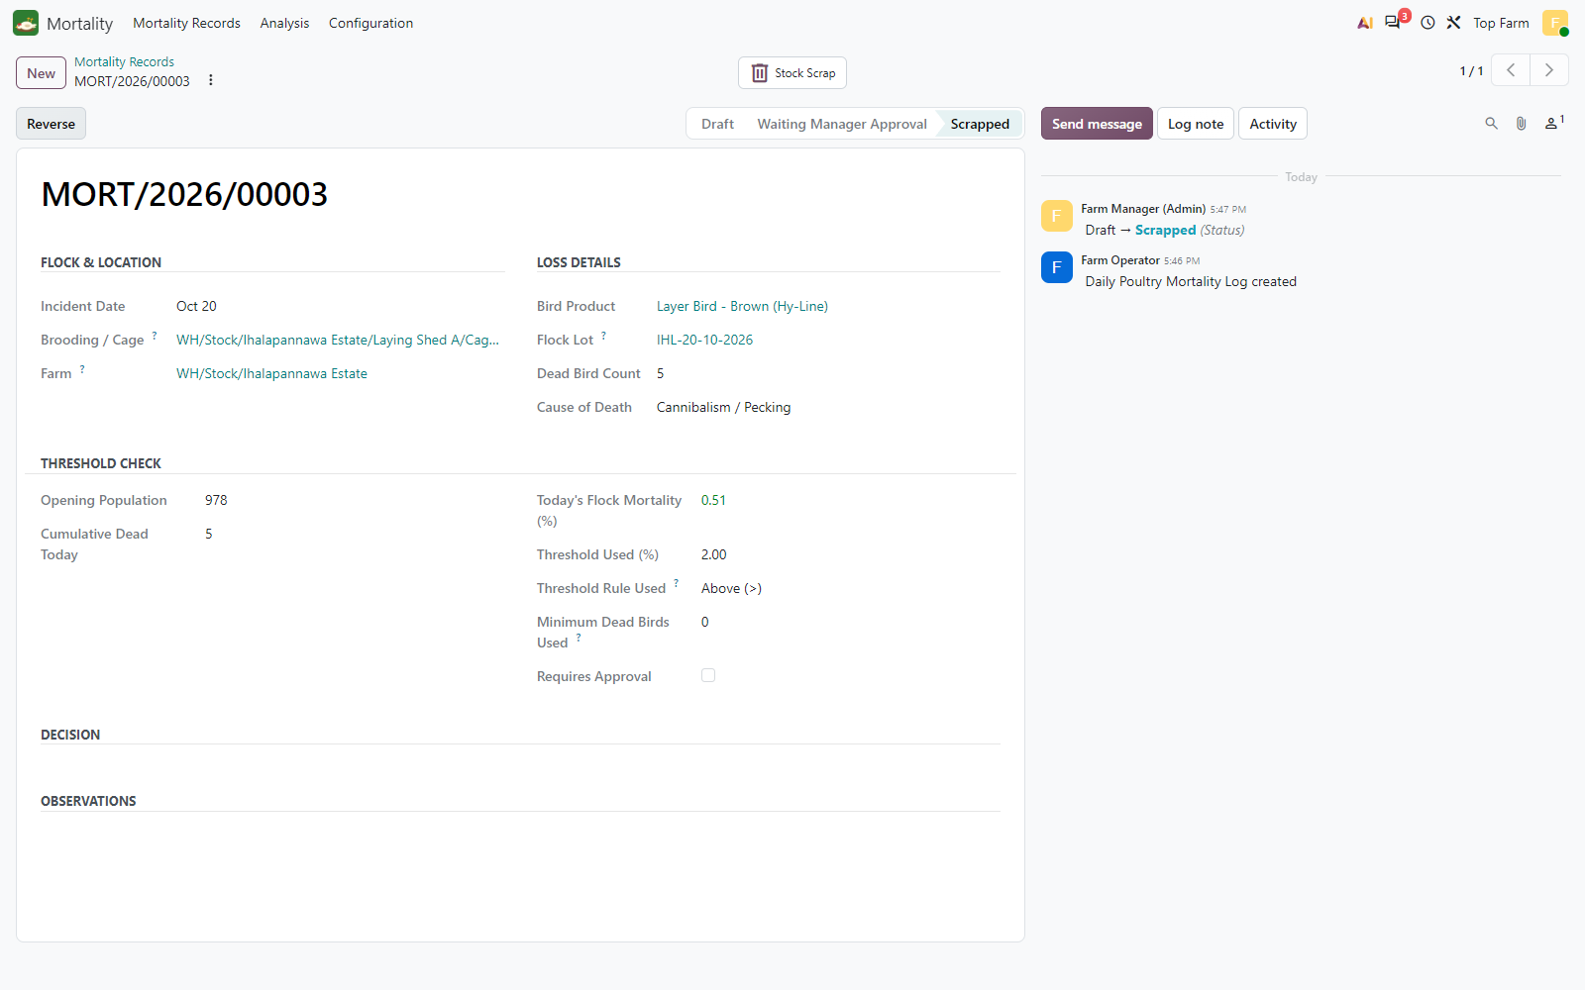
Figure 57. Cage mortality MORT/2026/00003: 5 birds of the flock in Cage A-01 (0.51 % of its 978 birds), scrapped at once.

Figure 58: Debeaking & bird care labour bill (LKR 75,000 on 510500 Bird Care Labour)
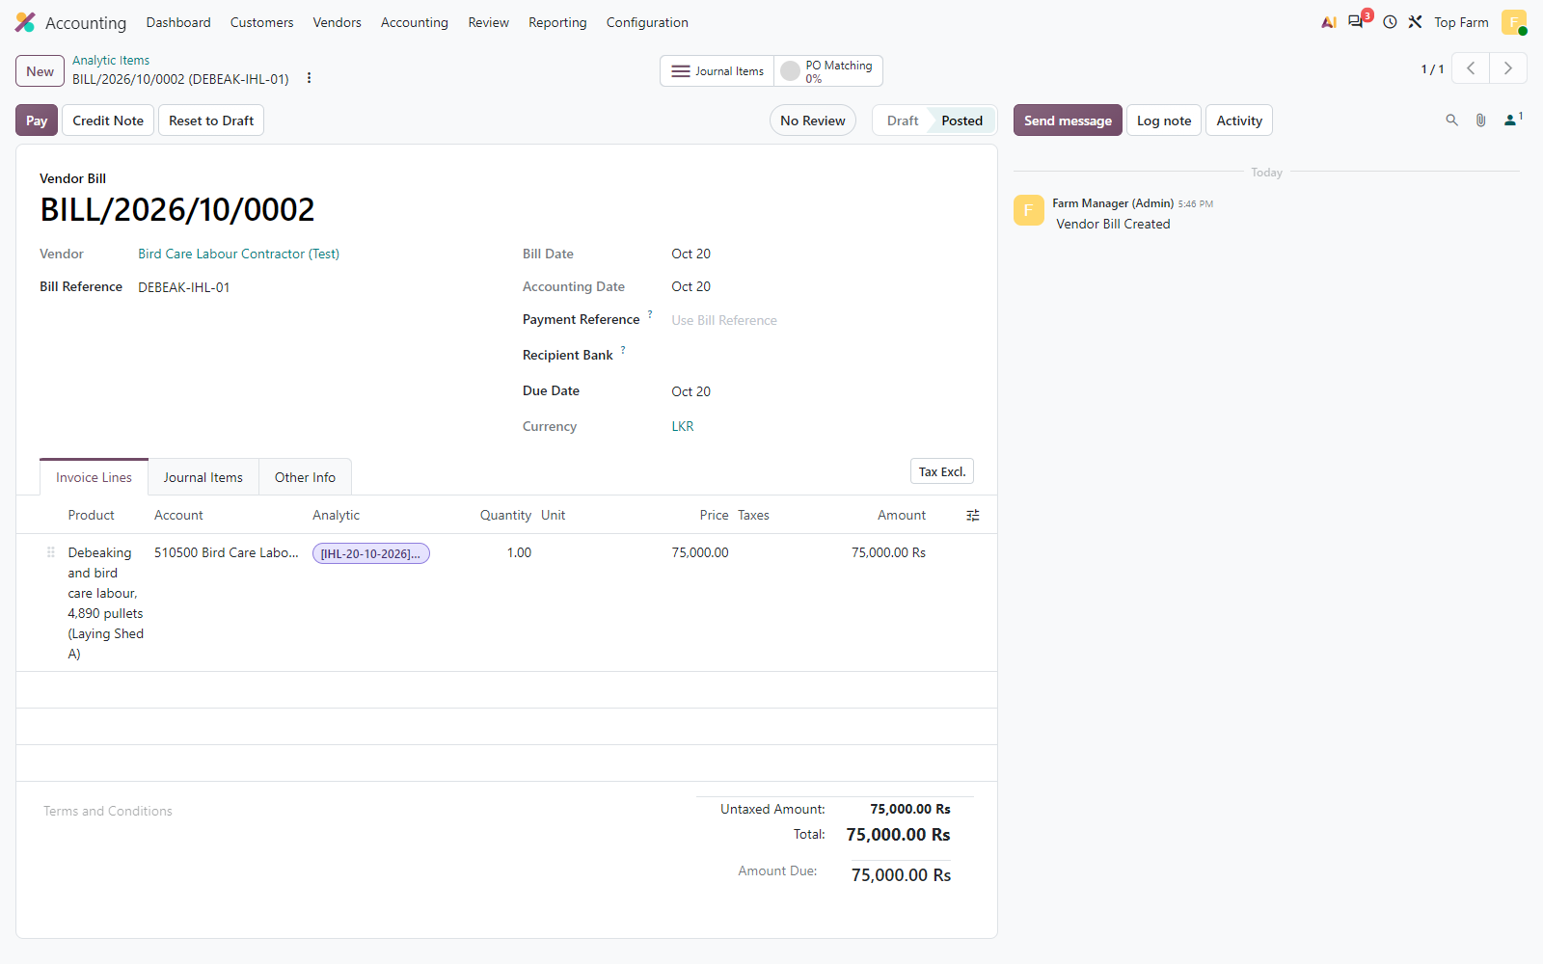
Figure 58. Debeaking & bird care labour bill (LKR 75,000 on 510500 Bird Care Labour), charged to the flock analytic account IHL-20-10-2026.

Figure 59: Analytic items of the rearing costs in the cages (12 lines)
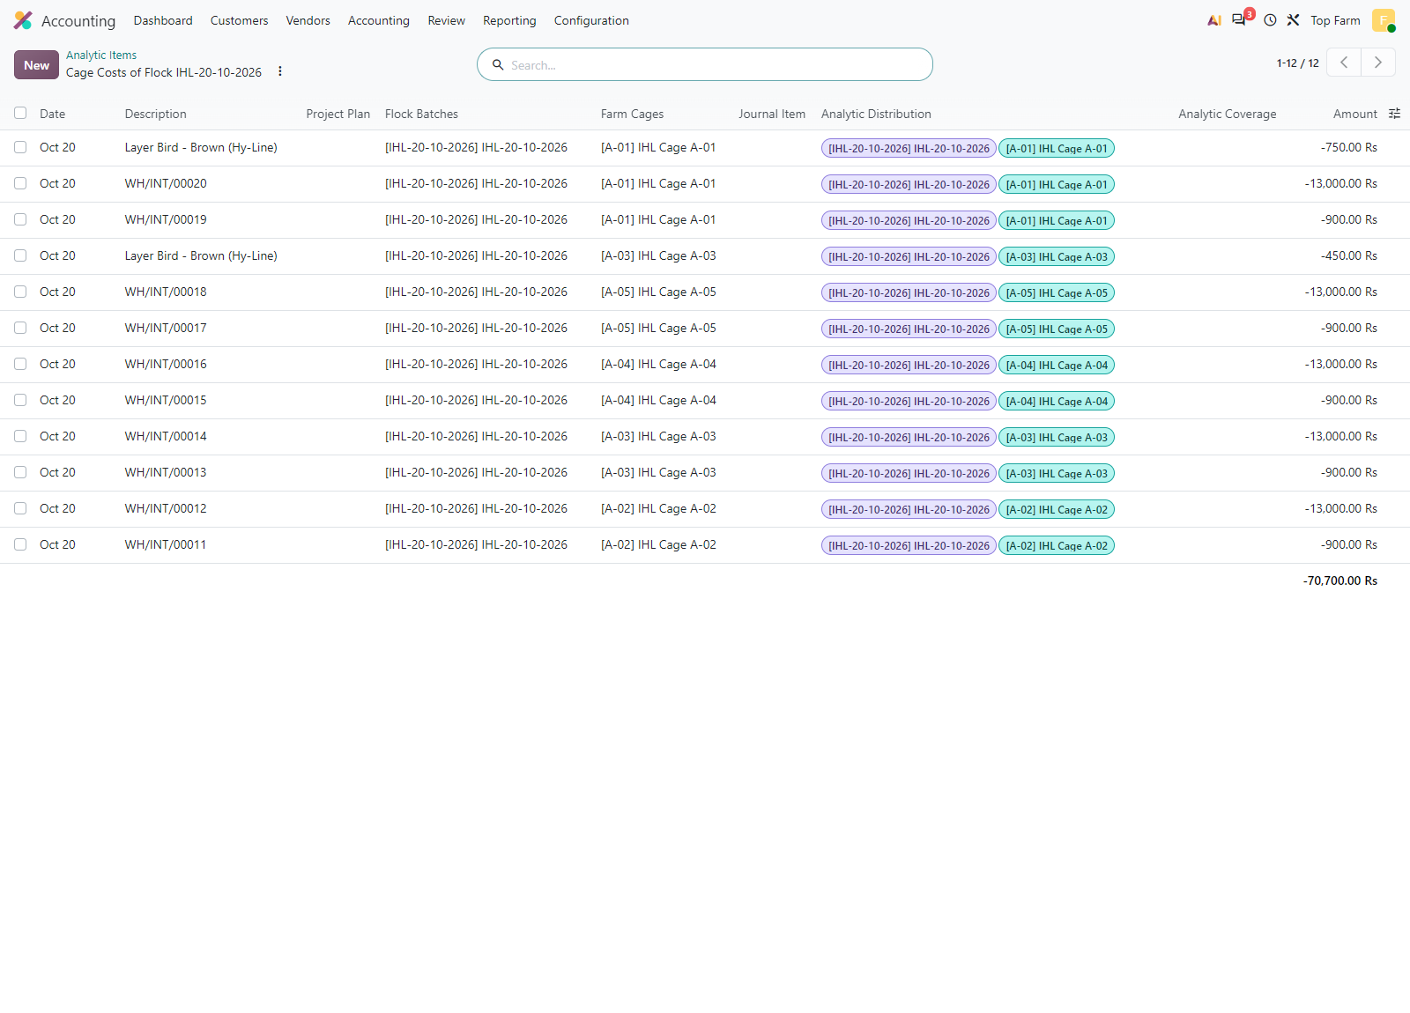
Figure 59. Analytic items of the rearing costs in the cages (12 lines): each line carries BOTH the flock account (Flock Batches) and the cage account (Farm Cages), so the cost is counted once and reported per flock and per cage.

Figure 60: Analytic costs of the flock so far by cage (LKR 747,200; the LKR 750
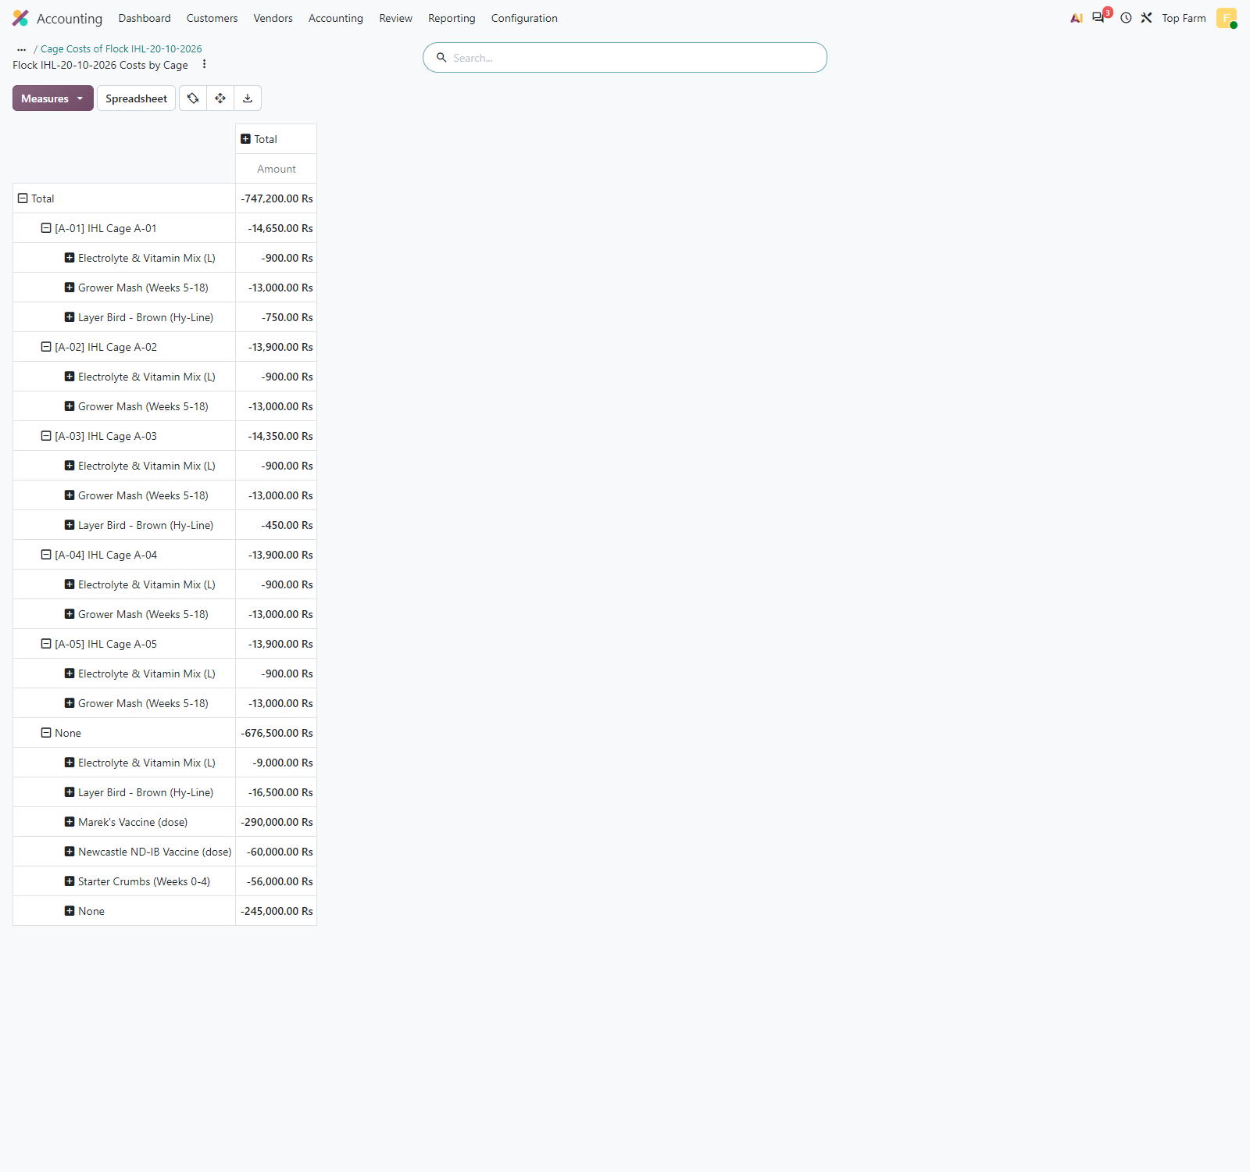
Figure 60. Analytic costs of the flock so far by cage (LKR 747,200; the LKR 750,000 chick purchase is in the bird stock value, not in analytic items). "None" = brooding and flock-level costs (LKR 676,500: vaccines, electrolytes, brooding mortality, starter feed, LPG heating, debeaking labour); one row per cage for the rearing grower feed, vitamins and cage mortality (LKR 70,700).

Figure 61: Pre-Laying Flock Investment during rearing
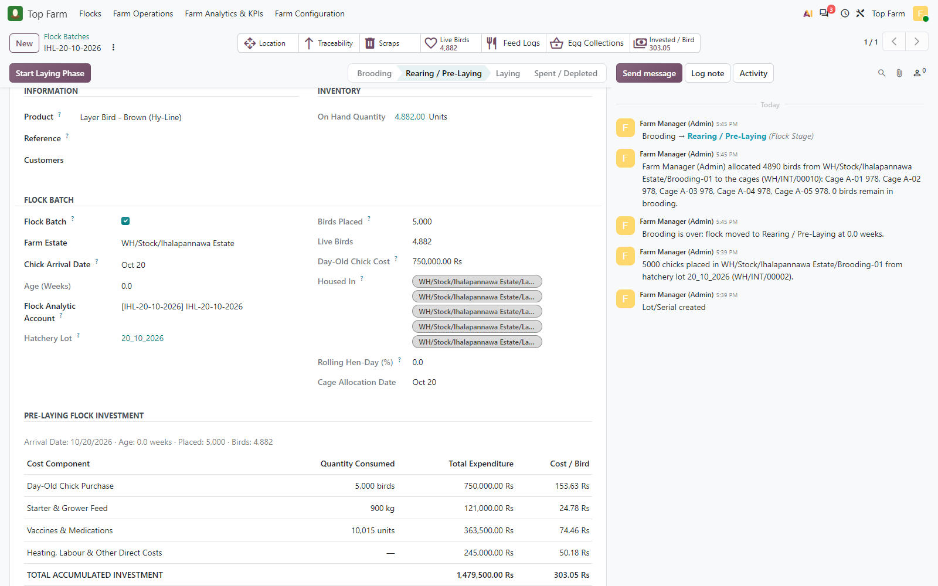
Figure 61. Pre-Laying Flock Investment during rearing: chicks, starter and grower feed, vaccines and vitamins, LPG heating and debeaking labour = LKR 1,479,500, i.e. LKR 303.05 per live bird (4,882), against the LKR 1,200-1,300 per bird benchmark. (Still dated on the test day, before the flock age is simulated.)

Figure 62: Pre-Laying Flock Investment report
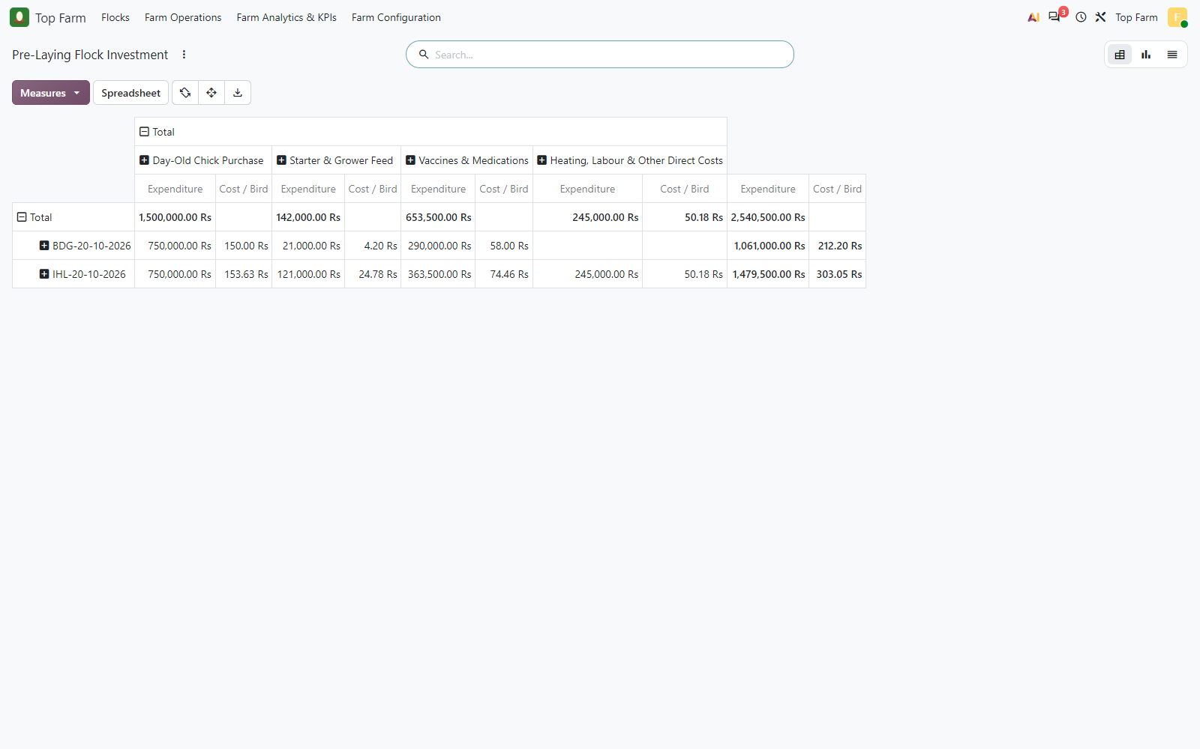
Figure 62. Pre-Laying Flock Investment report: expenditure and cost per bird by flock and cost component. Cost / Bird is meaningful on the flock rows; in the Total row it is only shown where a single flock has that cost.

9. Point of lay: the 50 % hen-day transition
The Laying Phase is never forced by the calendar. Each egg collection of a rearing flock older than 17 weeks recomputes its rolling 7-day hen-day rate (eggs over live bird days of its cages; a cage-day without a harvest counts its birds with no eggs). When the rate reaches 50 % the Farm Managers get a chatter alert and a To-Do; in manual mode a manager confirms with Start Laying Phase, which locks the pre-laying investment.
Date | Eggs | Bird snapshot | Daily hen-day % | Feed in MOs (kg) | Rolling 7-day %
2026-10-13 | 1,500 | 4,882 | 30.73 | 0.00 | 4.39
2026-10-14 | 1,500 | 4,882 | 30.73 | 0.00 | 8.78
2026-10-15 | 1,500 | 4,882 | 30.73 | 0.00 | 13.17
2026-10-16 | 4,000 | 4,882 | 81.93 | 0.00 | 24.87
2026-10-17 | 4,000 | 4,882 | 81.93 | 0.00 | 36.58
2026-10-18 | 4,000 | 4,882 | 81.93 | 0.00 | 48.28
2026-10-19 | 4,000 | 4,882 | 81.93 | 0.00 | 59.99
2026-10-20 | 4,390 | 4,882 | 89.92 | 550.00 | 68.44
13-19 October: pre-laying harvests (no staged feed, no feed component in the MOs). The rolling column is the rate at the end of each day, all cages harvested. On 19 October the alert was raised as soon as the Cage A-01 harvest was produced, at 50.6 % (the other four cages counted with no eggs yet); with all five cages the day ends at 59.99 %. 20 October: first laying day, the feed is consumed by the egg MOs.

Figure 63: Flock IHL-20-10-2026 at 18 weeks (simulated arrival 16 June)
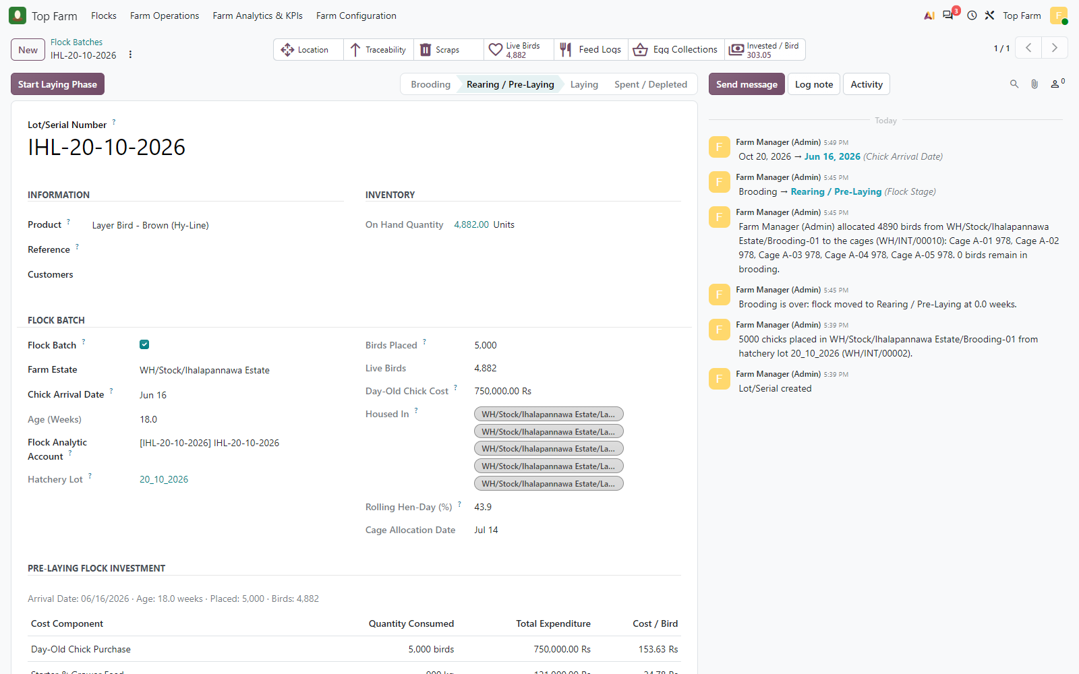
Figure 63. Flock IHL-20-10-2026 at 18 weeks (simulated arrival 16 June), still in Rearing / Pre-Laying. Its Rolling Hen-Day field counts the 7 days up to today, 20 October, with no harvest yet on 19-20 October; the 12-18 October rate is 48.28 %, below the 50 % benchmark. (The chatter's 'moved to Rearing / Pre-Laying at 0.0 weeks' was logged before the arrival date was moved back.)

Figure 64: First egg collections of the pre-laying flock
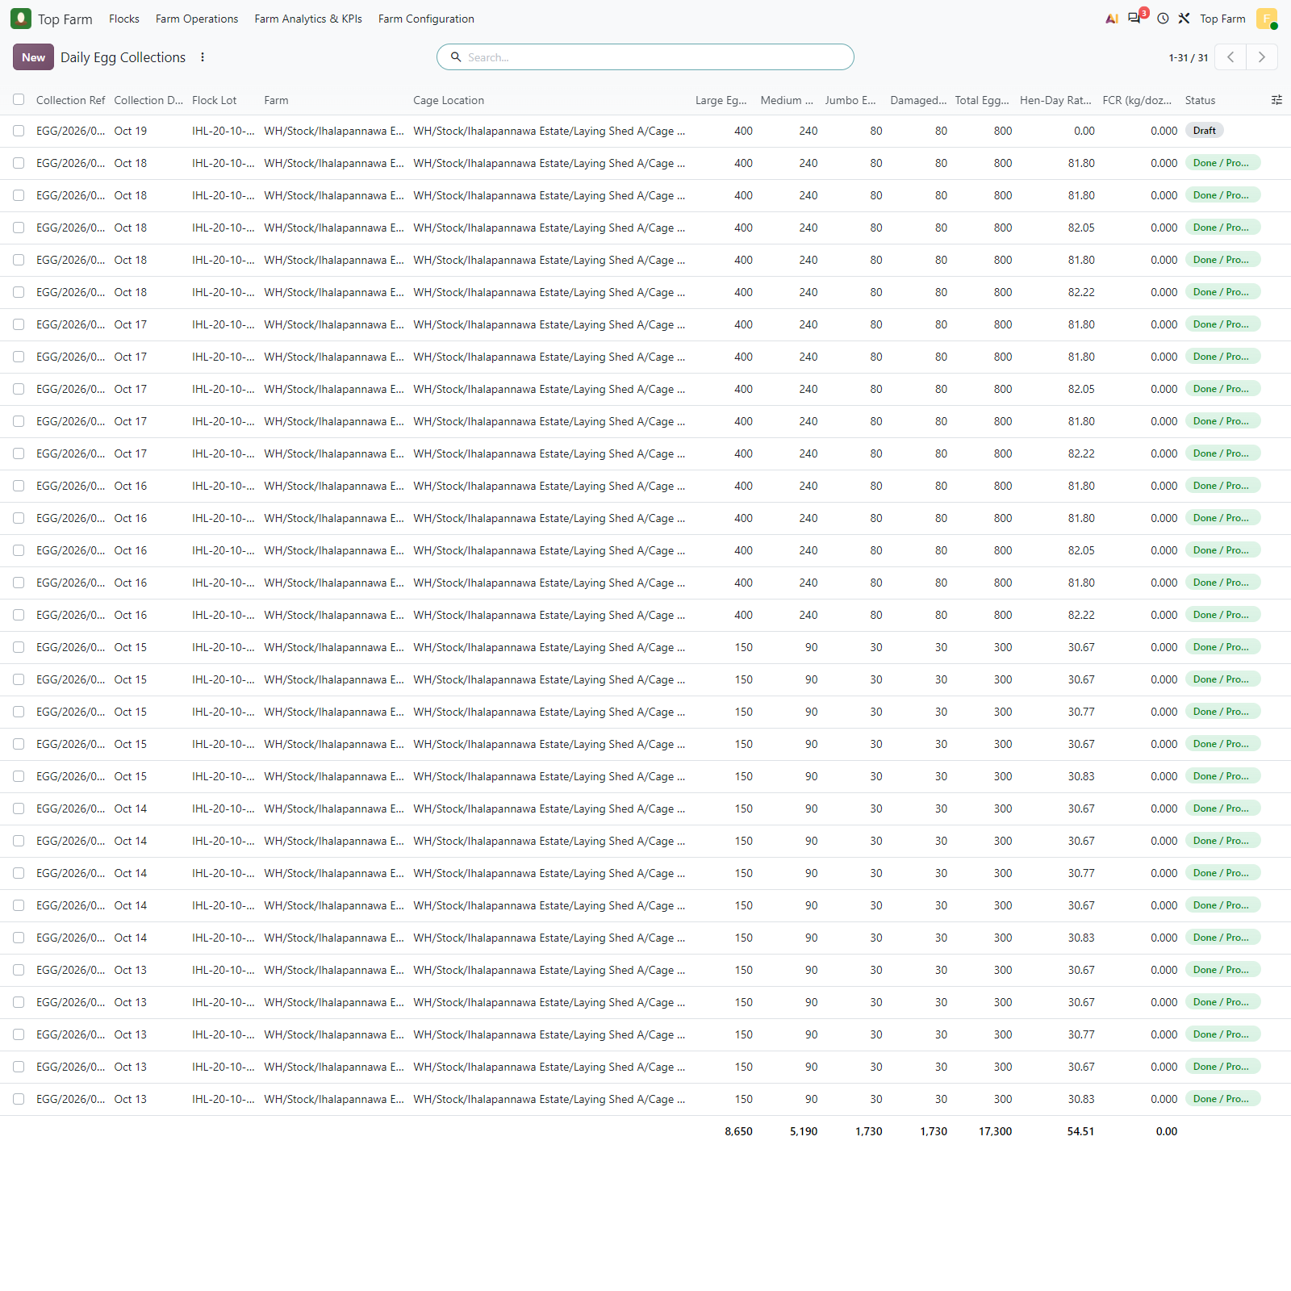
Figure 64. First egg collections of the pre-laying flock, 13-18 October (5 cages a day): about 31 % per cage on 13-15 October, then about 82 % on 16-18 October. The 19 October collection of Cage A-01 (top row) is still a draft.

Figure 65: Egg collection of Cage A-01 on 19 October
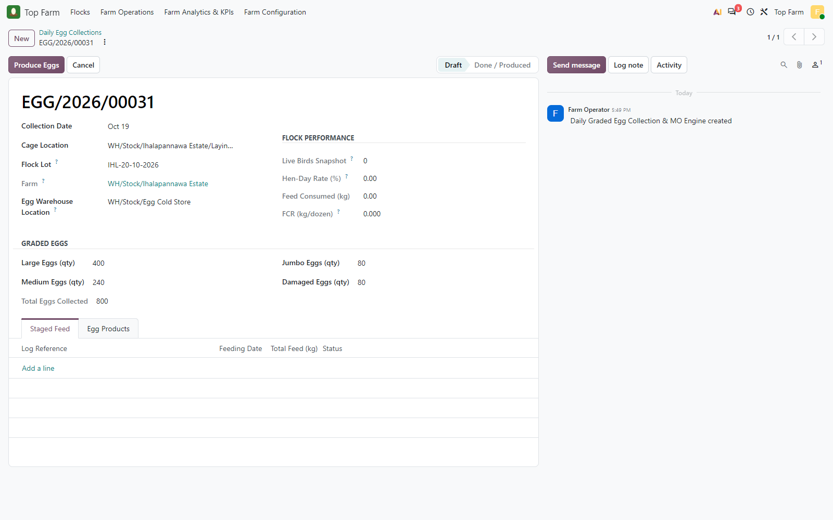
Figure 65. Egg collection of Cage A-01 on 19 October: 800 graded eggs (Large 400, Medium 240, Jumbo 80, Damaged 80). No staged feed: the flock is not laying yet, its feed is a direct expense.

Figure 66: Produced
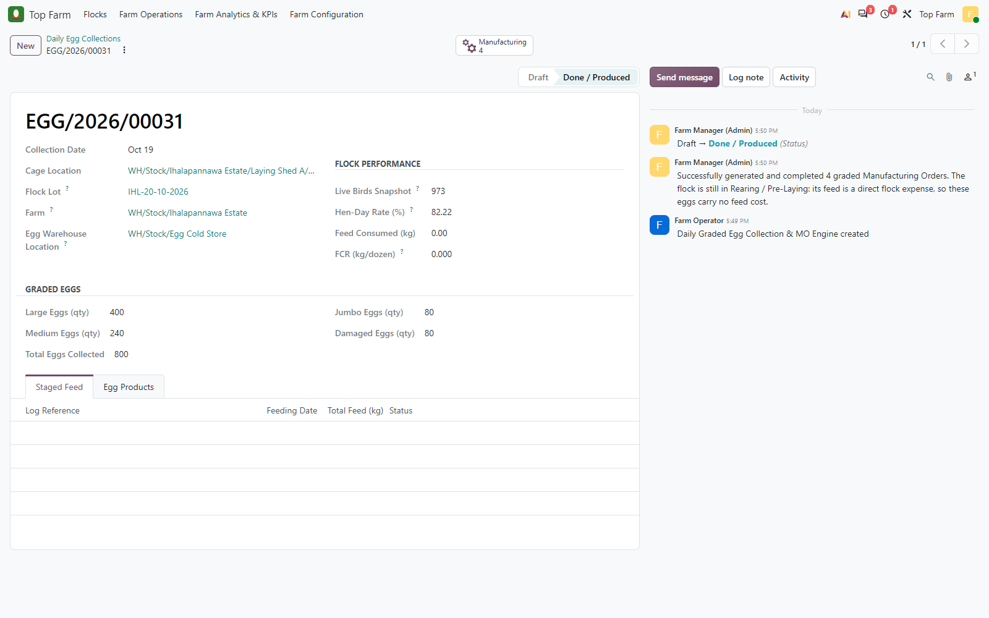
Figure 66. Produced: live birds snapshot 973 (Cage A-01), hen-day 82.22 %, one manufacturing order per egg grade lotted under the flock. The chatter notes that pre-laying eggs carry no feed cost.

Figure 67: The 4 graded manufacturing orders of the collection (Large 400, Medium 240
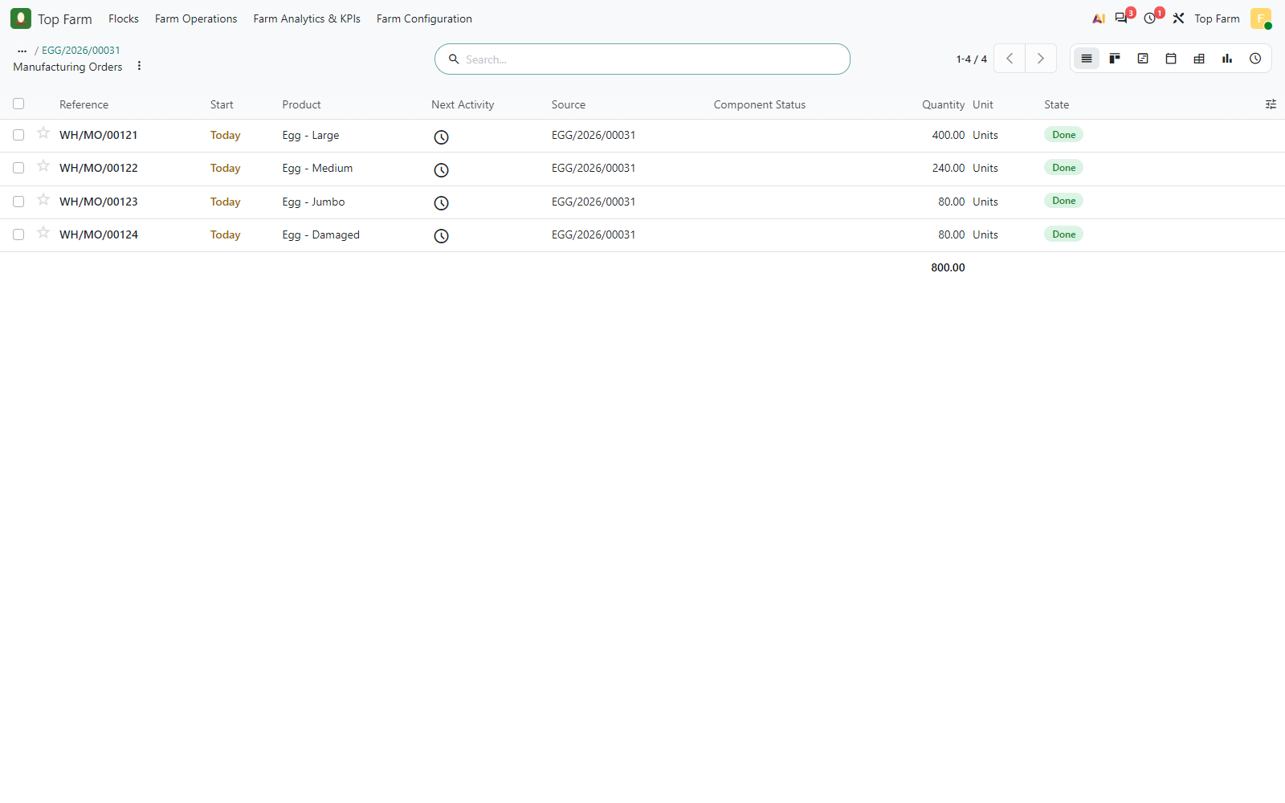
Figure 67. The 4 graded manufacturing orders of the collection (Large 400, Medium 240, Jumbo 80, Damaged 80).

Figure 68: Graded egg MO of a pre-laying flock
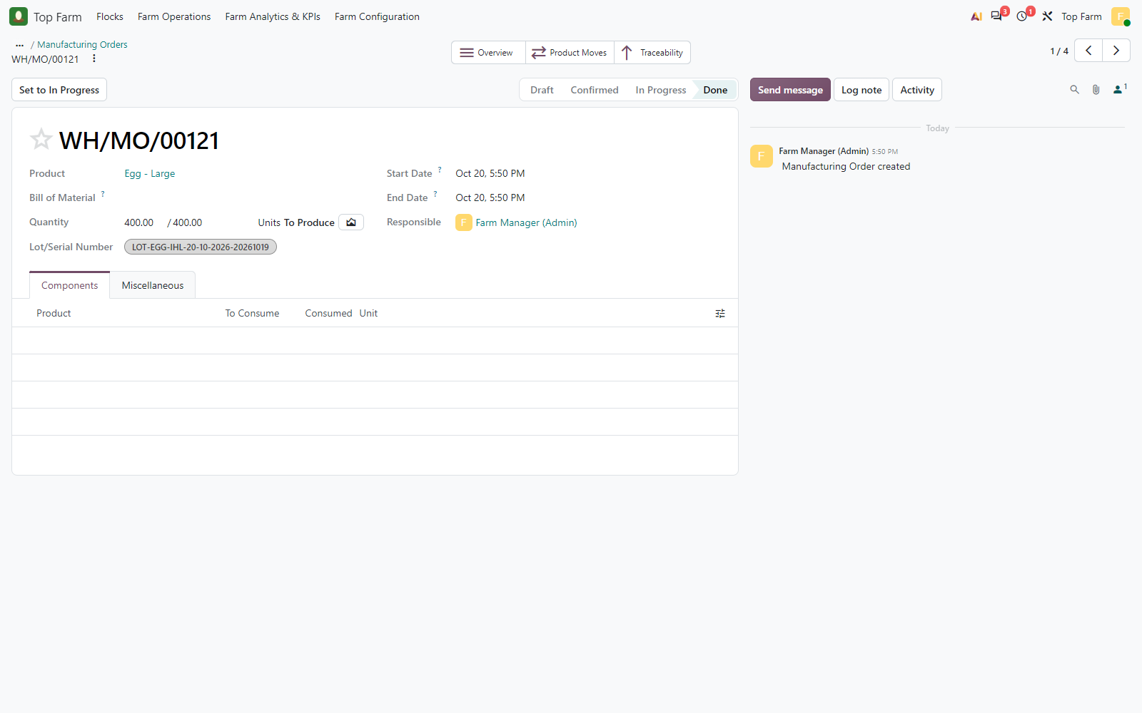
Figure 68. Graded egg MO of a pre-laying flock: no feed component; the eggs are produced under the egg lot LOT-EGG-IHL-20-10-2026-20261019. The MO dates show 20 October, the day the simulated collection was processed; the egg lot carries the collection date.

Figure 69: The Cage A-01 harvest of 19 October pushed the 7-day rolling hen-day ...
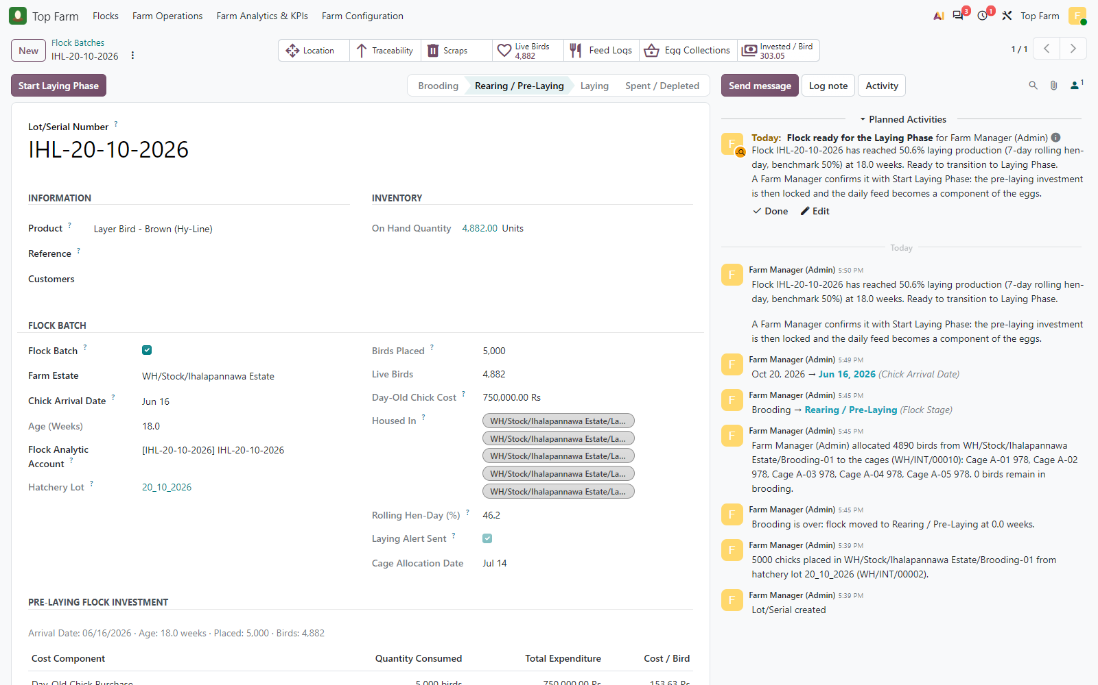
Figure 69. The Cage A-01 harvest of 19 October pushed the 7-day rolling hen-day rate of 13-19 October to 50.6 % (17,300 eggs / 34,174 live bird days, the other cages counted with no eggs yet): the Farm Manager gets the alert "Ready to transition to Laying Phase" and a To-Do. (The Rolling Hen-Day field counts up to today, 20 October.)

Figure 70: The Farm Manager clicks Start Laying Phase and confirms that the ...
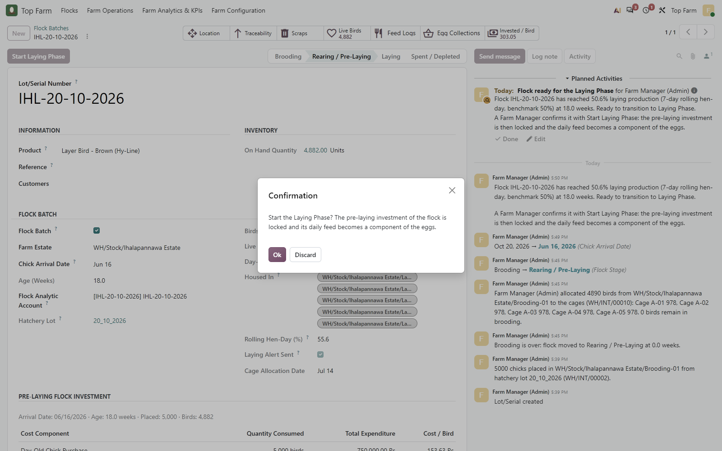
Figure 70. The Farm Manager clicks Start Laying Phase and confirms that the pre-laying investment will be locked. The 19 October collections of Cages A-02 to A-05 have been entered meanwhile (13-19 October: 59.99 % at the end of the day).

Figure 71: Flock IHL-20-10-2026 in Laying
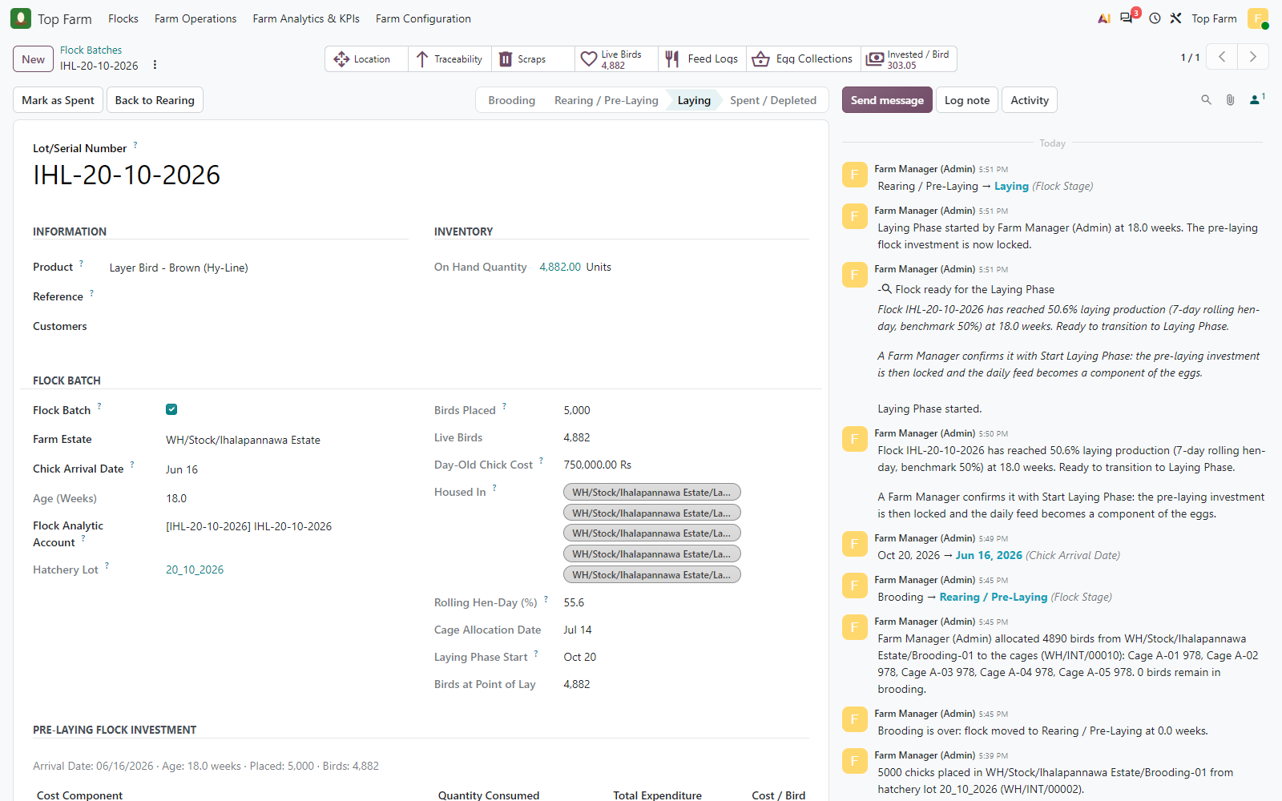
Figure 71. Flock IHL-20-10-2026 in Laying: Laying Phase start date and birds at point of lay recorded, the To-Do closed, the chatter logs the transition.

Figure 72: Pre-Laying Flock Investment locked at the start of the Laying Phase
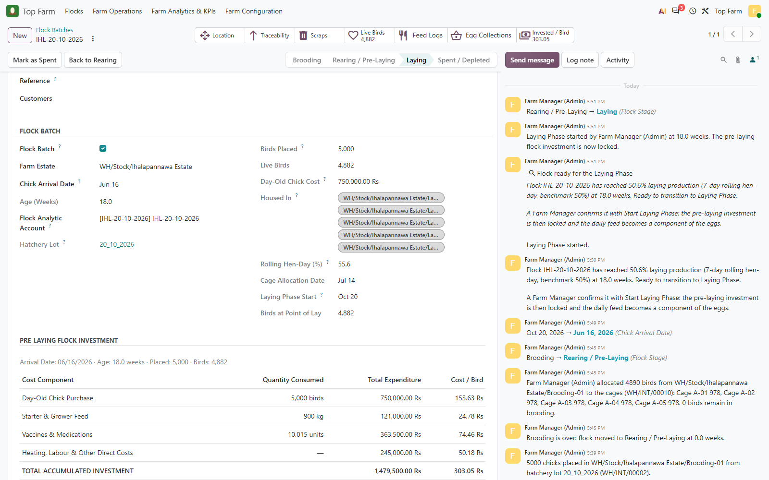
Figure 72. Pre-Laying Flock Investment locked at the start of the Laying Phase: LKR 1,479,500 over the 4,882 birds at point of lay = LKR 303.05 per bird.

10. Laying: staged feed, egg collection and manufacturing orders
Once the flock is Laying, the day's cage feed is staged (no stock move) until the egg collection of that cage and day. Producing the collection creates one manufacturing order per egg grade; the staged feed becomes their component in proportion to the eggs of each grade, and the eggs are received into the Egg Cold Store under the daily flock egg lot LOT-EGG-IHL-20-10-2026-<date>, linked to its parent flock.

10.1 Laying feed per cage (analytic accounting)
Cage | Layer Mash (kg) | Expected (LKR) | Analytic actual (LKR) | Accounts | Result
Cage A-01 | 110.00 | 13,200.00 | 13,200.00 | Flock + cage | PASS
Cage A-02 | 110.00 | 13,200.00 | 13,200.00 | Flock + cage | PASS
Cage A-03 | 110.00 | 13,200.00 | 13,200.00 | Flock + cage | PASS
Cage A-04 | 110.00 | 13,200.00 | 13,200.00 | Flock + cage | PASS
Cage A-05 | 110.00 | 13,200.00 | 13,200.00 | Flock + cage | PASS

10.2 Egg balance
Grade | Collected | Produced by MOs | Sold | On hand | Result
Large | 12,490 | 12,490 | 3,000 | 9,490 | PASS
Medium | 7,650 | 7,650 | 2,000 | 5,650 | PASS
Jumbo | 2,550 | 2,550 | 600 | 1,950 | PASS
Damaged | 2,200 | 2,200 | 200 | 2,000 | PASS

Figure 73: Laying feed log in Cage A-01 (20 October)
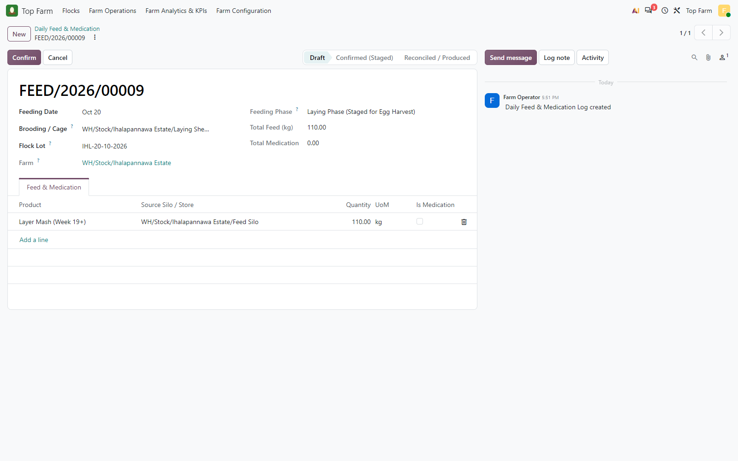
Figure 73. Laying feed log in Cage A-01 (20 October): Layer Mash 110 kg. The flock is Laying, so the Feeding Phase is "Laying Phase (Staged for Egg Harvest)".

Figure 74: Confirmed (Staged)
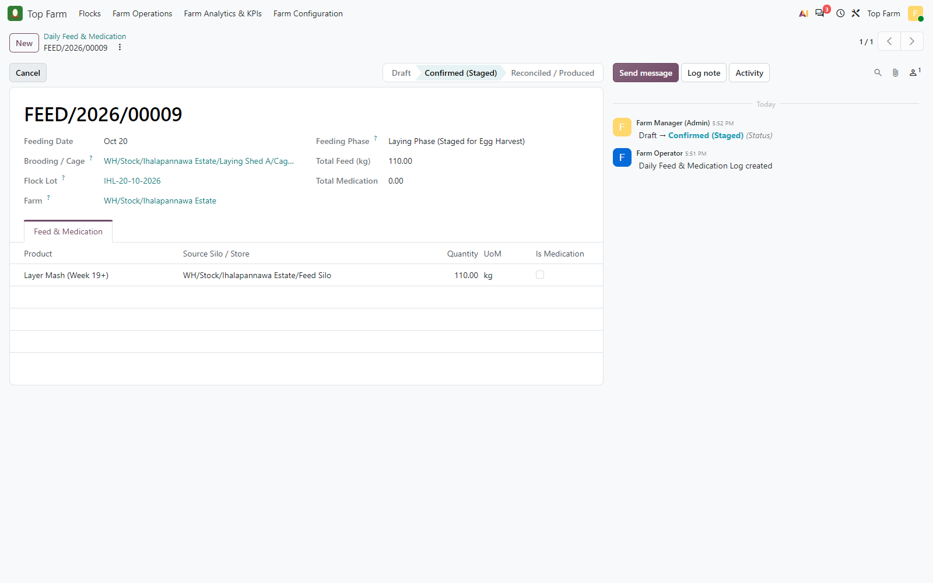
Figure 74. Confirmed (Staged): no stock moves yet. The feed waits for the day's egg collection, which consumes it in the egg MOs.

Figure 75: Egg collection of Cage A-01 on 20 October
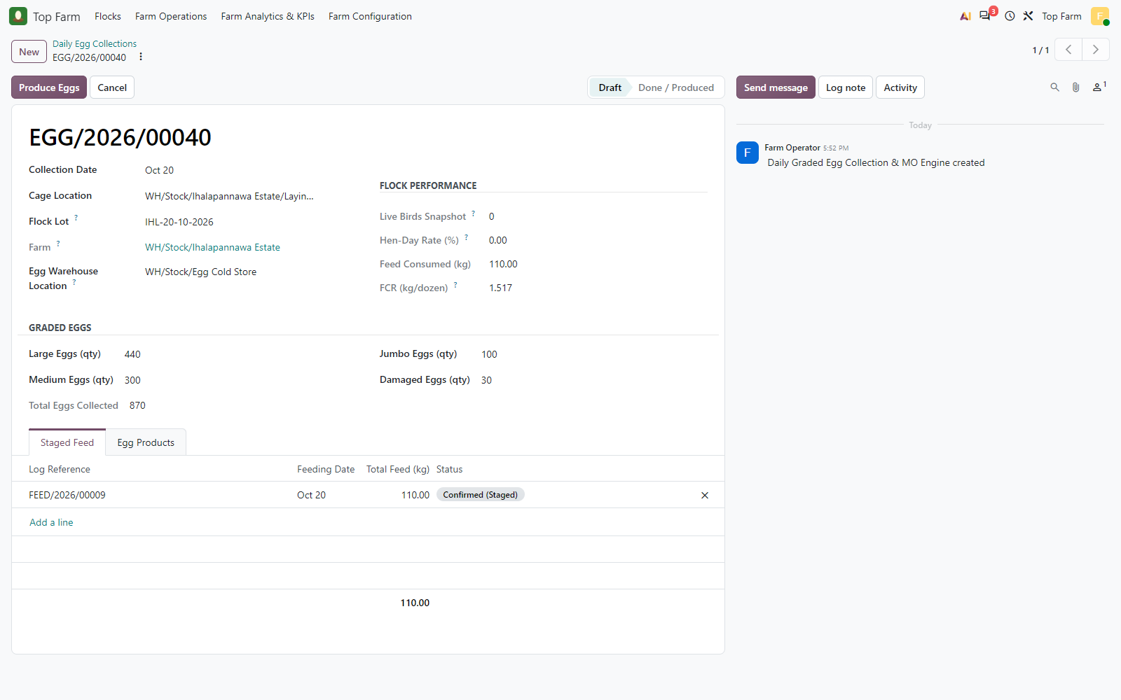
Figure 75. Egg collection of Cage A-01 on 20 October: 870 graded eggs (Large 440, Medium 300, Jumbo 100, Damaged 30); the Staged Feed tab holds the 110 kg Layer Mash log.

Figure 76: Produced
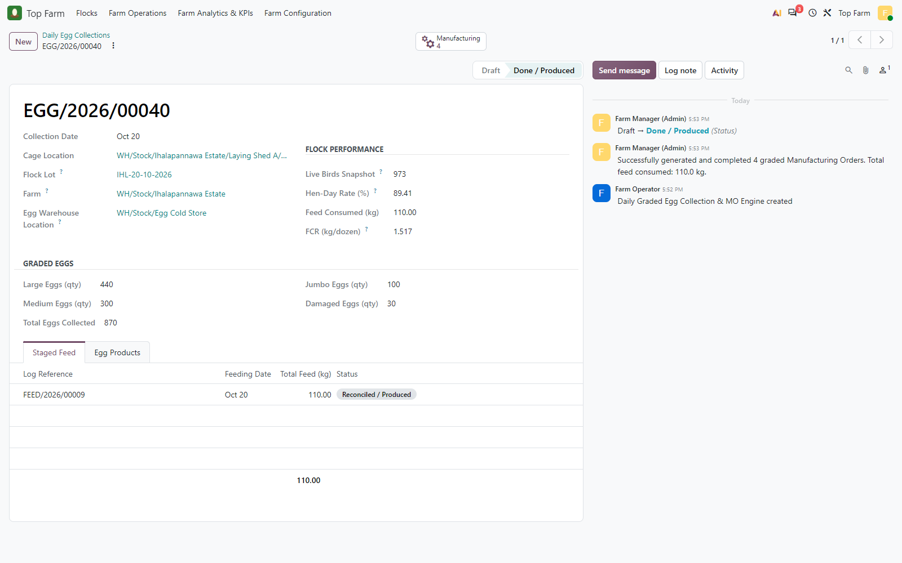
Figure 76. Produced: live birds snapshot, hen-day rate and FCR (kg feed per dozen eggs) recorded; 4 graded MOs consumed the 110 kg in proportion to the eggs.

Figure 77: The 4 graded MOs of the collection
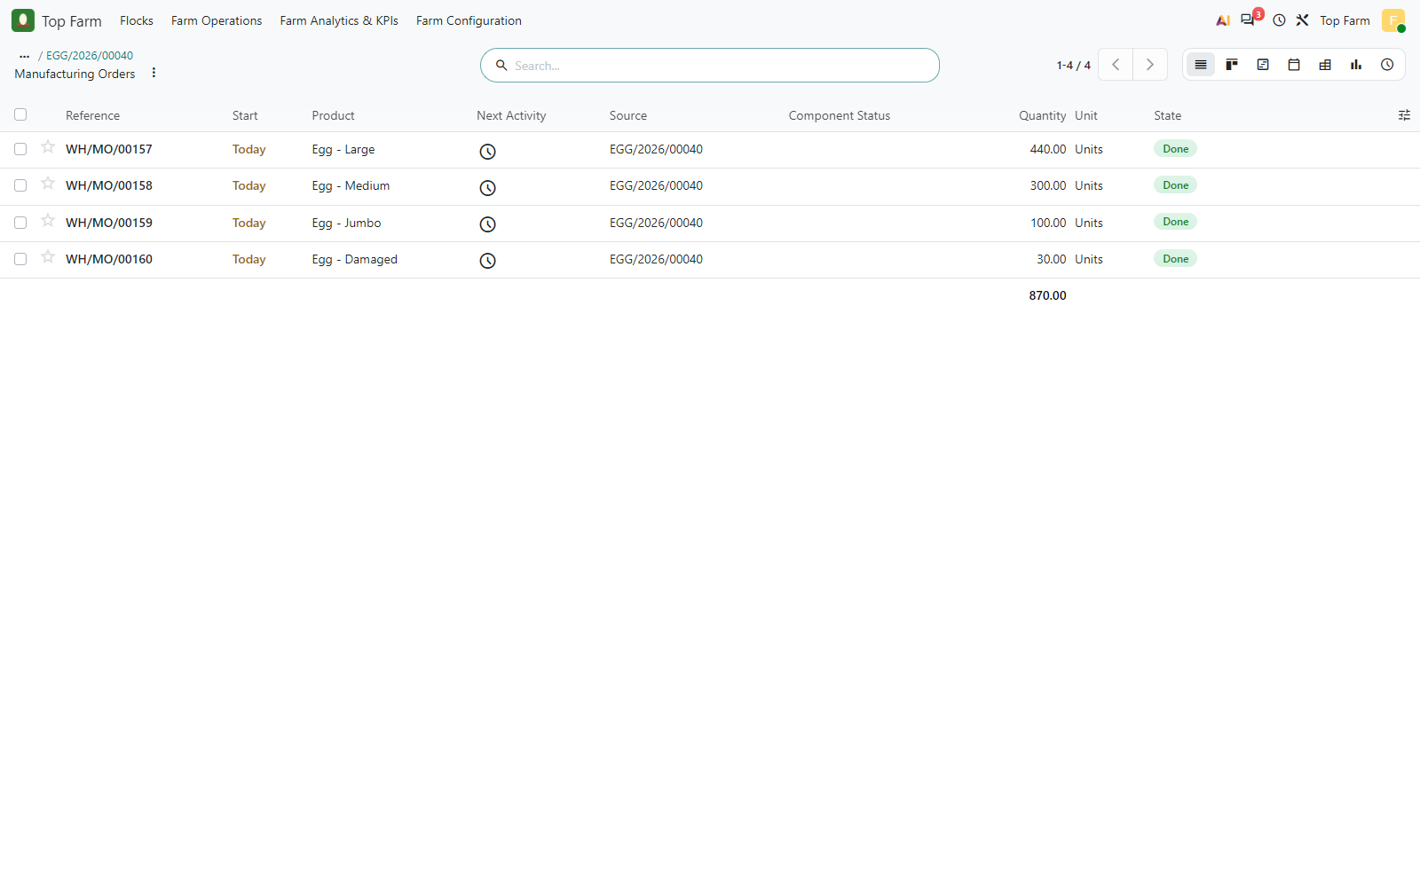
Figure 77. The 4 graded MOs of the collection.

Figure 78: Large-egg MO
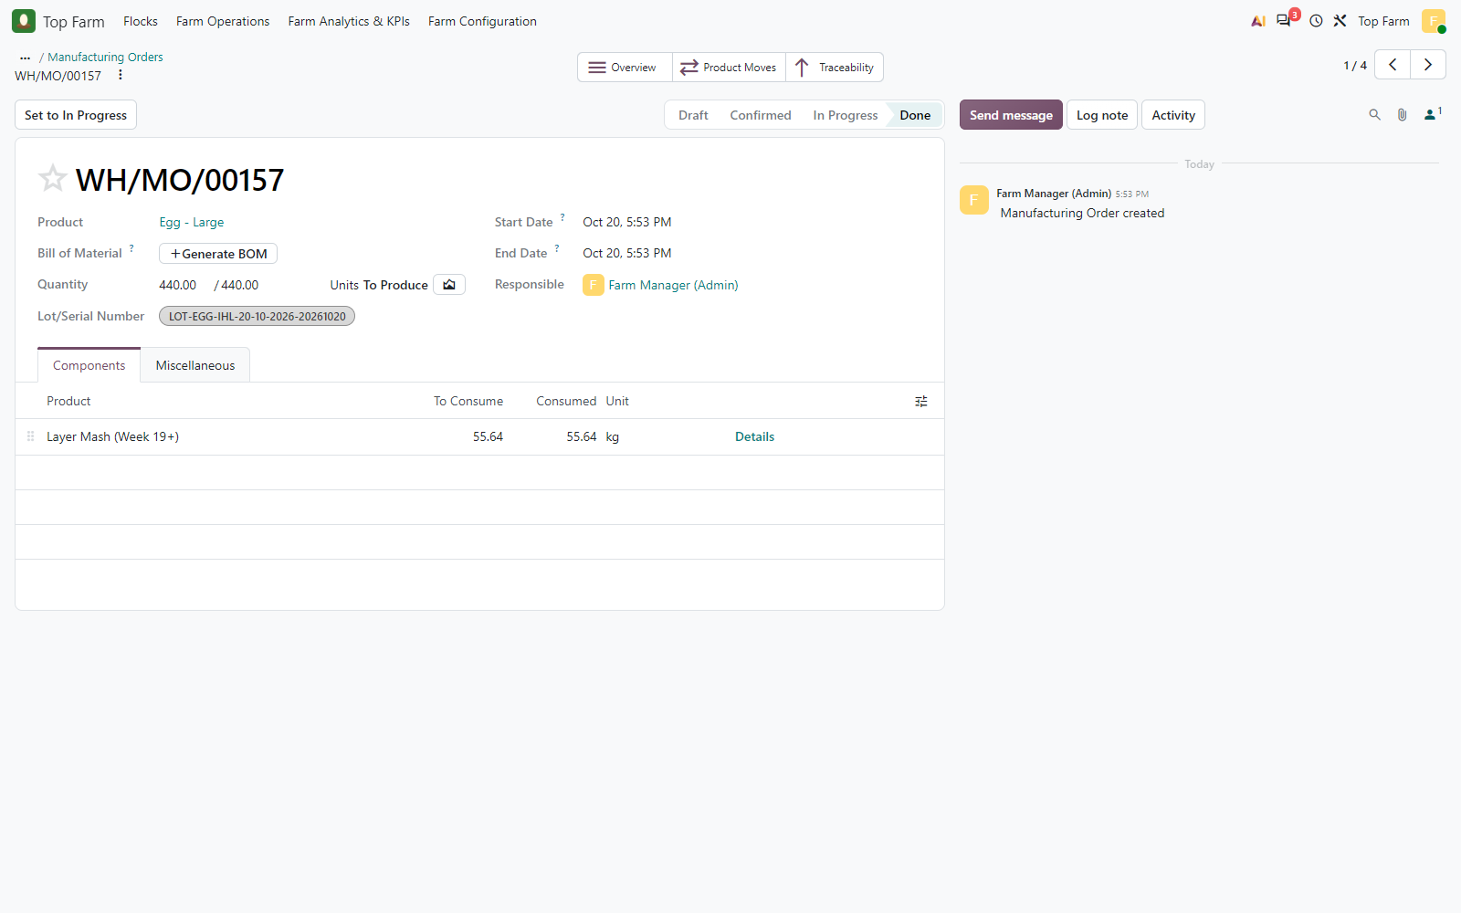
Figure 78. Large-egg MO: 55.64 kg of Layer Mash consumed as a component, in proportion to the large eggs (440 / 870 x 110 kg = 55.63 kg; the 0.01 kg rounding remainder goes to the largest grade so that the 4 MOs consume exactly 110 kg); finished eggs under lot LOT-EGG-IHL-20-10-2026-20261020.

Figure 79: Egg lot LOT-EGG-IHL-20-10-2026-20261020 (Large)
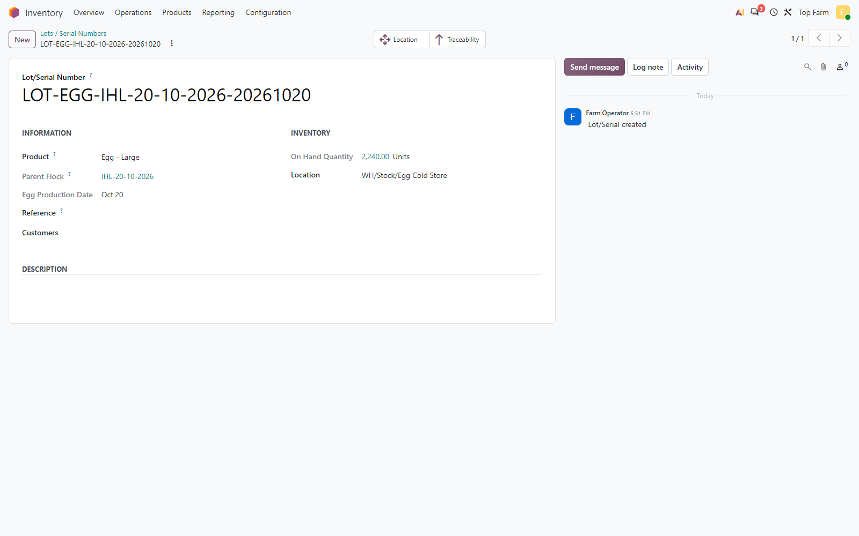
Figure 79. Egg lot LOT-EGG-IHL-20-10-2026-20261020 (Large): Parent Flock IHL-20-10-2026 and Egg Production Date, used to trace sales back to the flock.

Figure 80: Graded eggs in the Egg Cold Store by product and daily flock egg lot ...
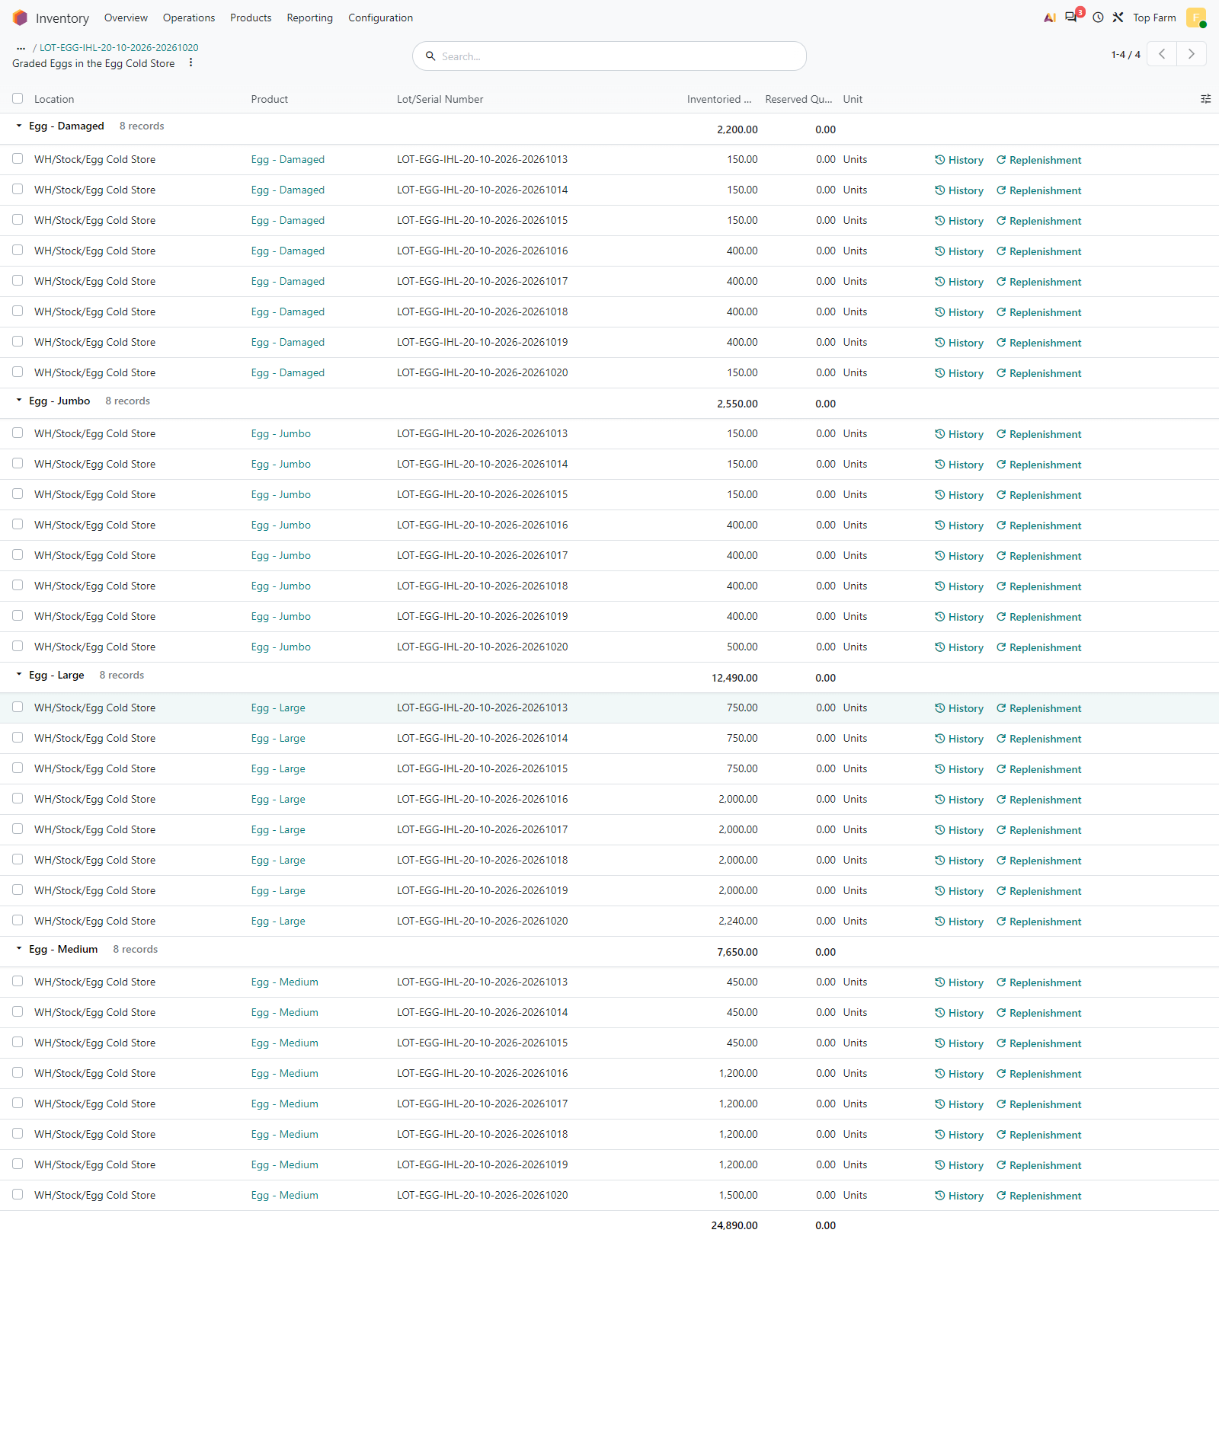
Figure 80. Graded eggs in the Egg Cold Store by product and daily flock egg lot (13-20 October): Damaged 2,200, Jumbo 2,550, Large 12,490, Medium 7,650 = 24,890 eggs.

Figure 81: Analytic items of the laying feed (Layer Mash
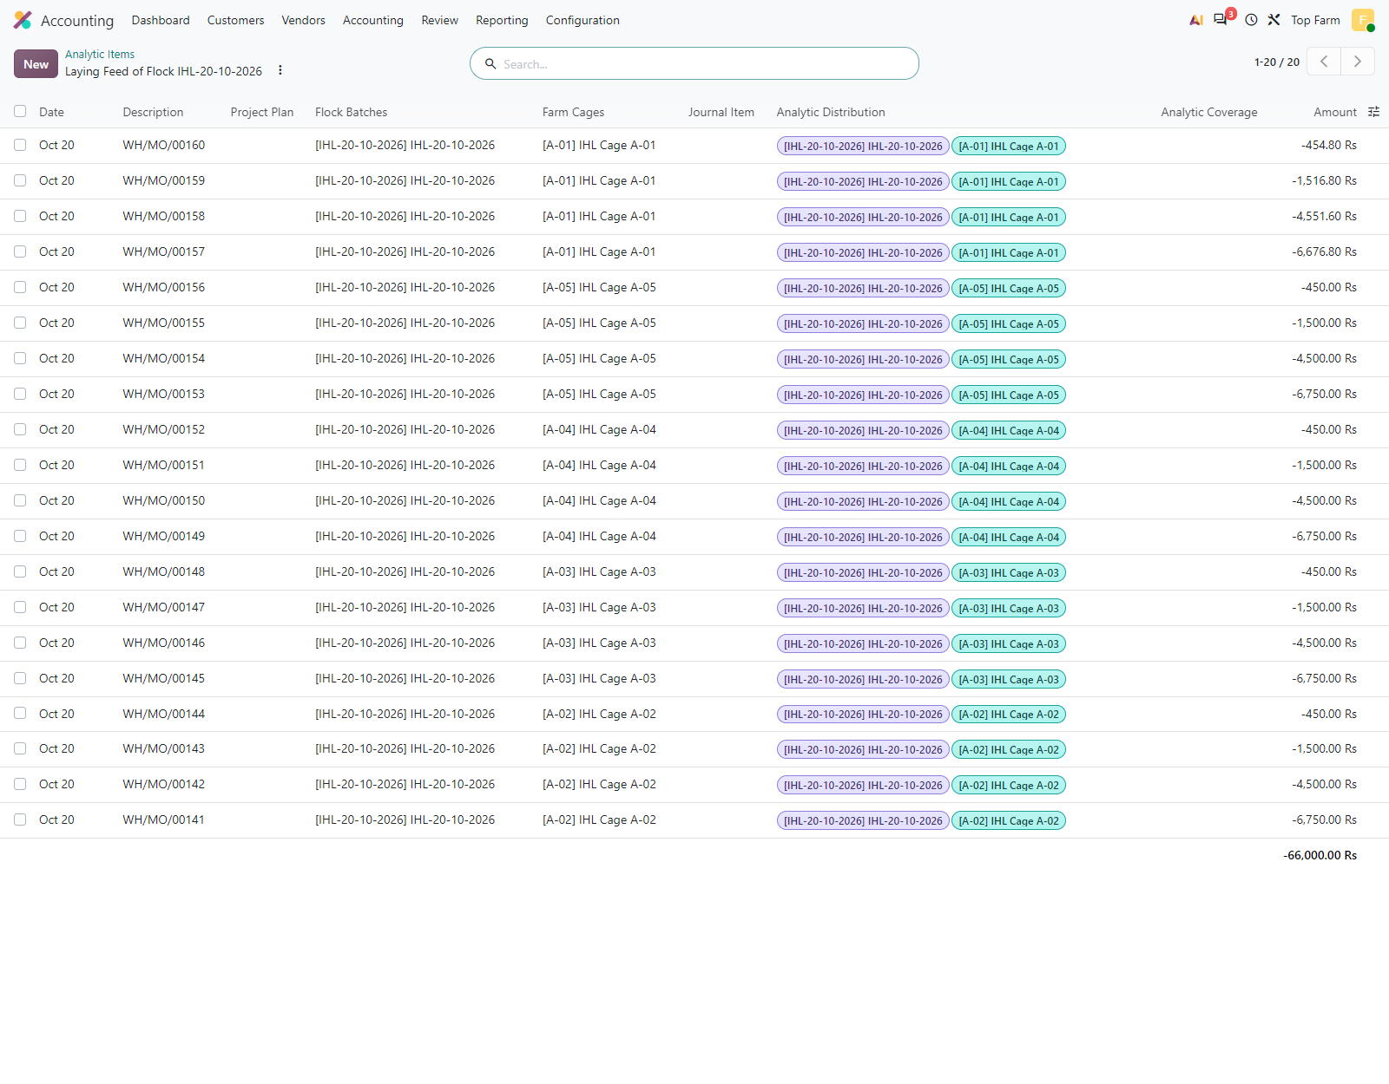
Figure 81. Analytic items of the laying feed (Layer Mash, LKR 120 / kg) consumed by the 20 egg MOs of 20 October: each line carries the flock account IHL-20-10-2026 and the cage account of the producing cage; LKR 13,200 (110 kg) per cage.

Figure 82: Egg Production Analysis by flock and cage, per grade
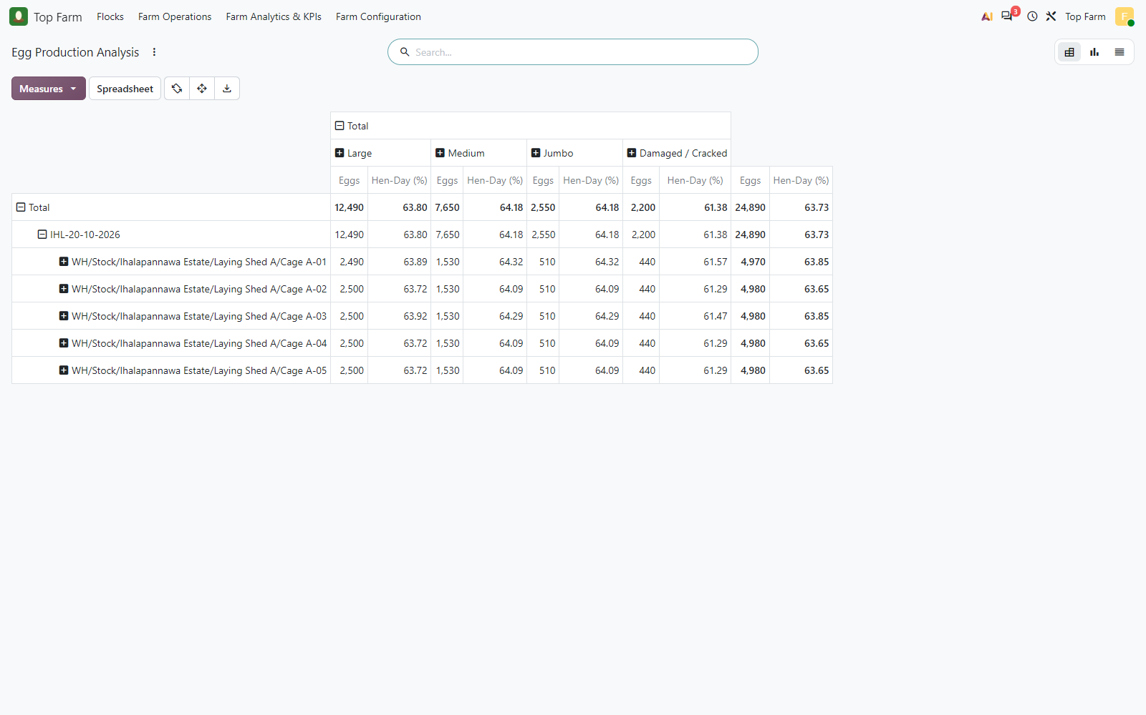
Figure 82. Egg Production Analysis by flock and cage, per grade: 24,890 eggs on 13-20 October. The Hen-Day (%) under a grade is the flock rate weighted by the share of the eggs of that grade, not a per-grade laying rate; the overall rate is 63.73 %.

11. Sales: eggs and spent hens
The eggs are sold from the Egg Cold Store; the delivery takes the oldest flock egg lots first. When the delivery is validated, each sale line receives the analytic distribution of the flock(s) of the delivered lots (here 100 % IHL-20-10-2026), and the invoice lines inherit it. At the end of the cycle (simulated) the spent hens are sold from the cages under the flock lot, the flock is marked Spent / Depleted and the permanent cages are free for the next flock.

Figure 83: Egg sale order confirmed
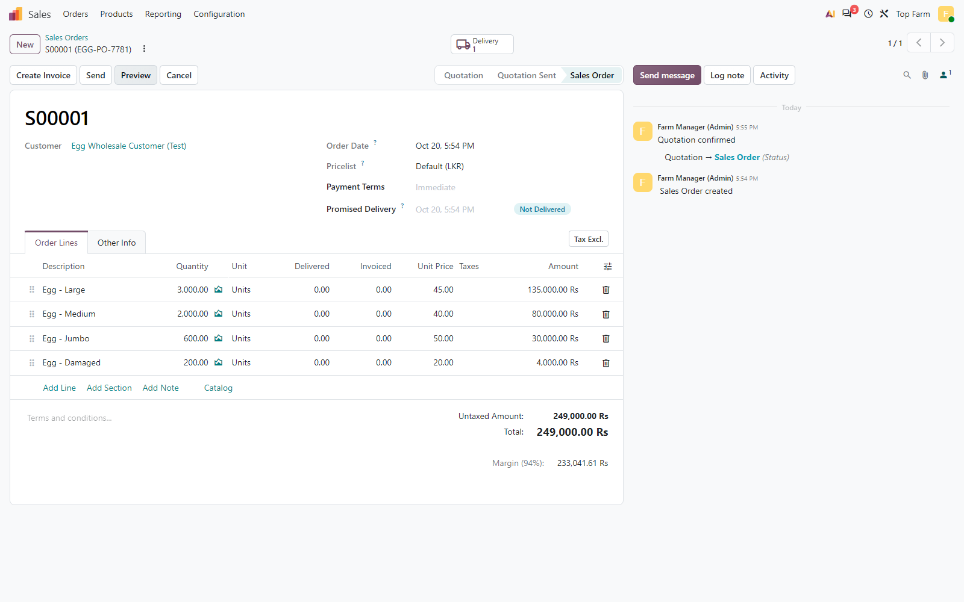
Figure 83. Egg sale order confirmed: Large 3,000 @ 45, Medium 2,000 @ 40, Jumbo 600 @ 50, Damaged 200 @ 20 (LKR 249,000).

Figure 84: Egg delivery validated from the Egg Cold Store
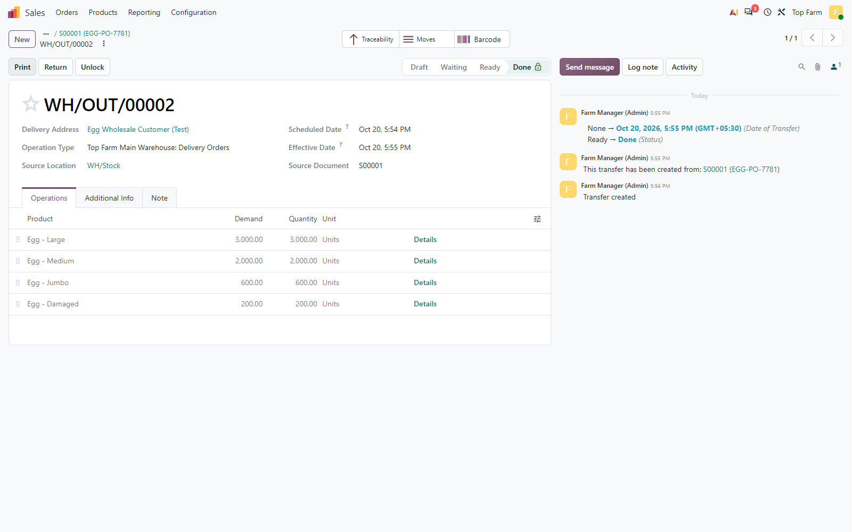
Figure 84. Egg delivery validated from the Egg Cold Store.

Figure 85: Delivered egg lots
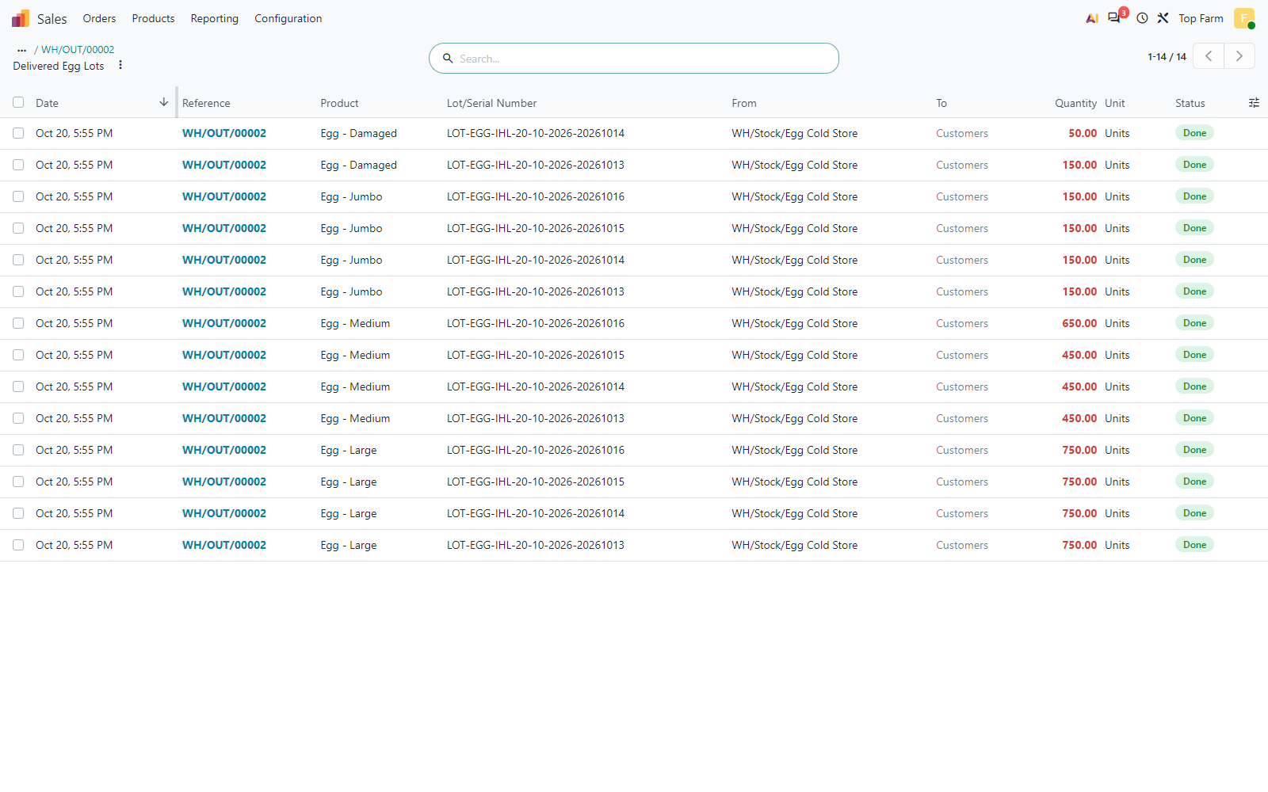
Figure 85. Delivered egg lots: the oldest flock egg lots (LOT-EGG-IHL-20-10-2026-<date>) are taken first; each lot links back to flock IHL-20-10-2026.

Figure 86: After the delivery the sale lines carry the analytic distribution of the ...
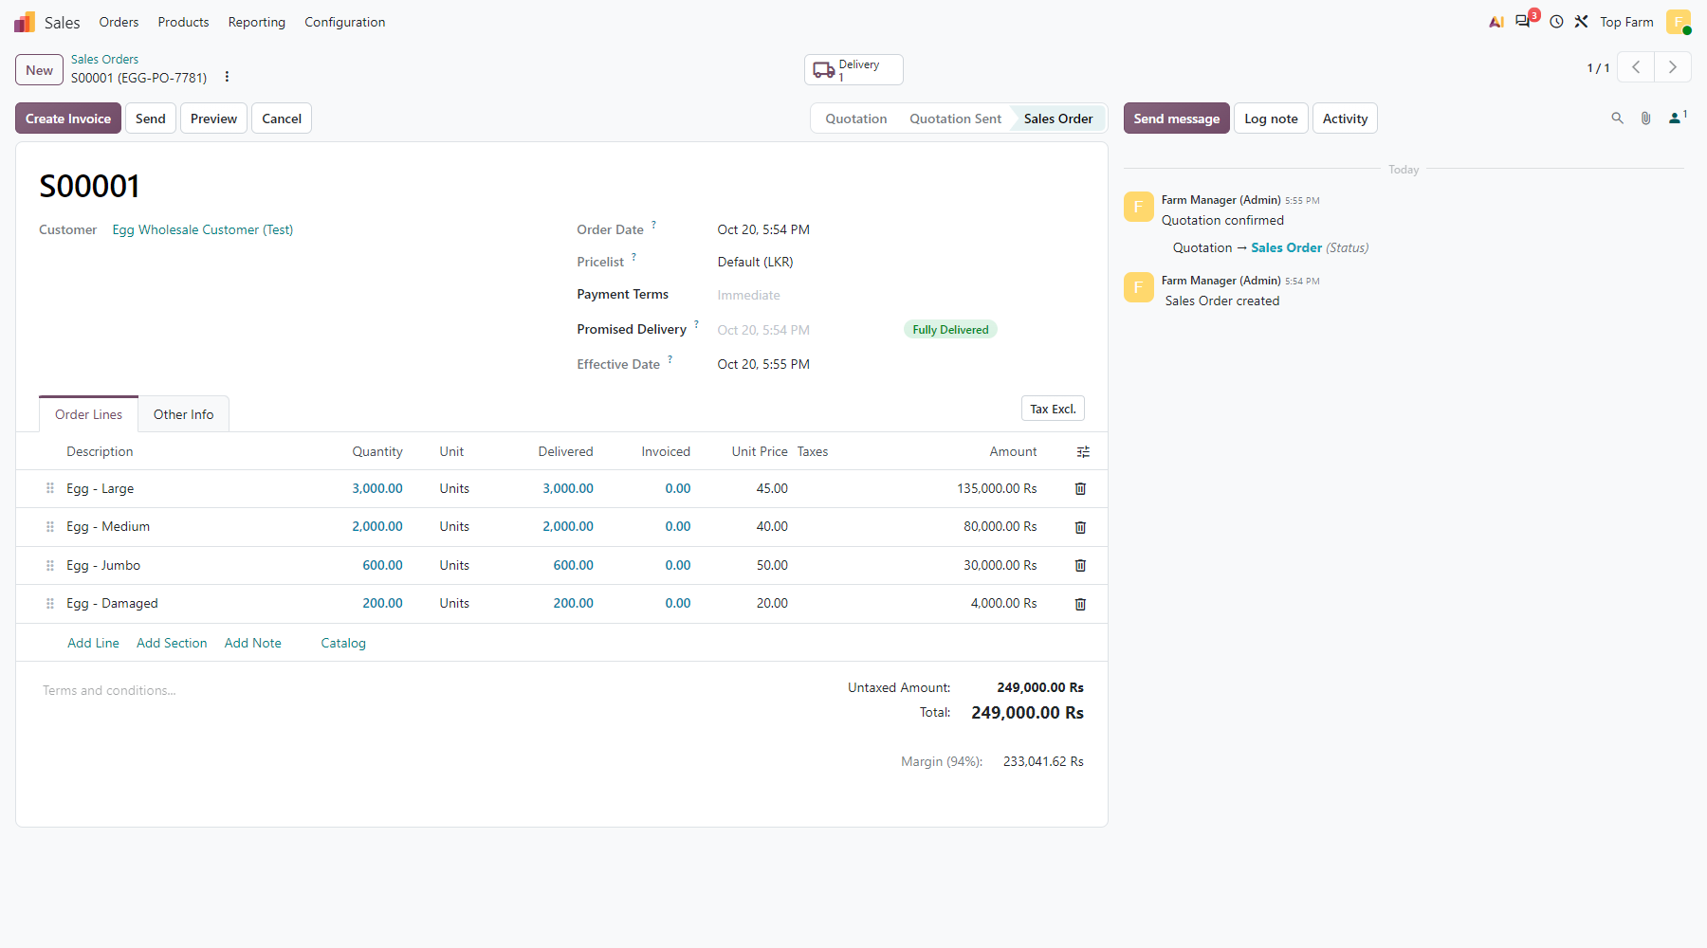
Figure 86. After the delivery the sale lines carry the analytic distribution of the delivered lots: 100 % flock IHL-20-10-2026.

Figure 87: End of cycle (simulated)
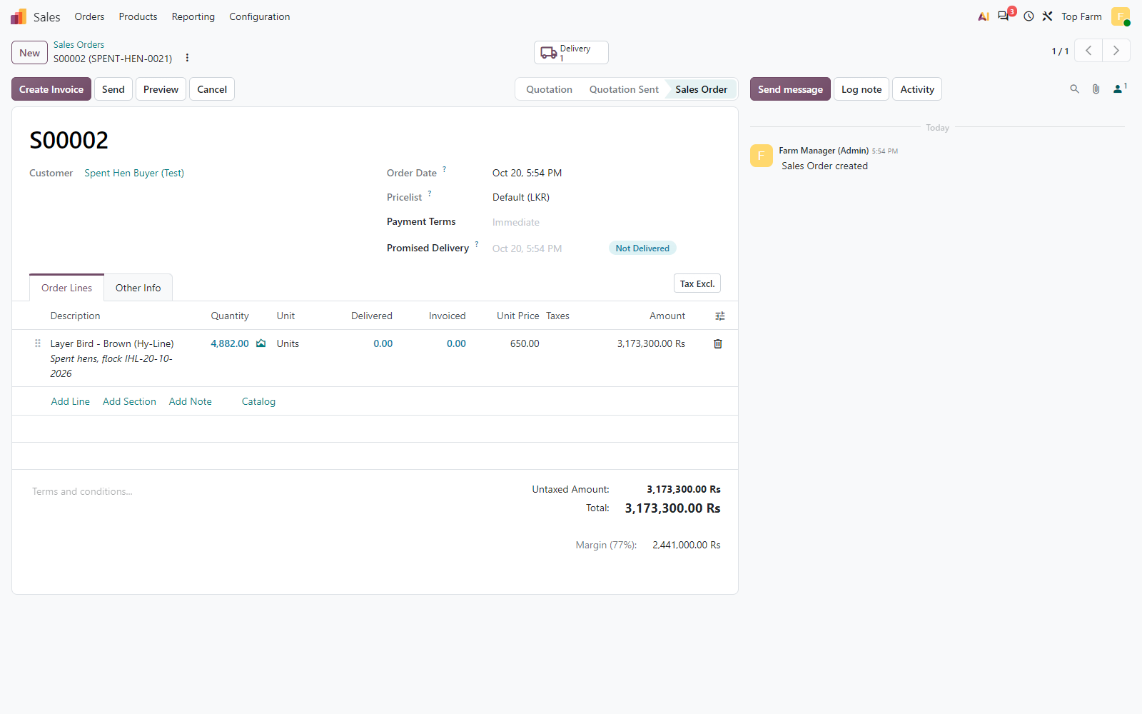
Figure 87. End of cycle (simulated): the spent hens of the flock are sold, all its live birds at LKR 650.

Figure 88: Spent hen delivery
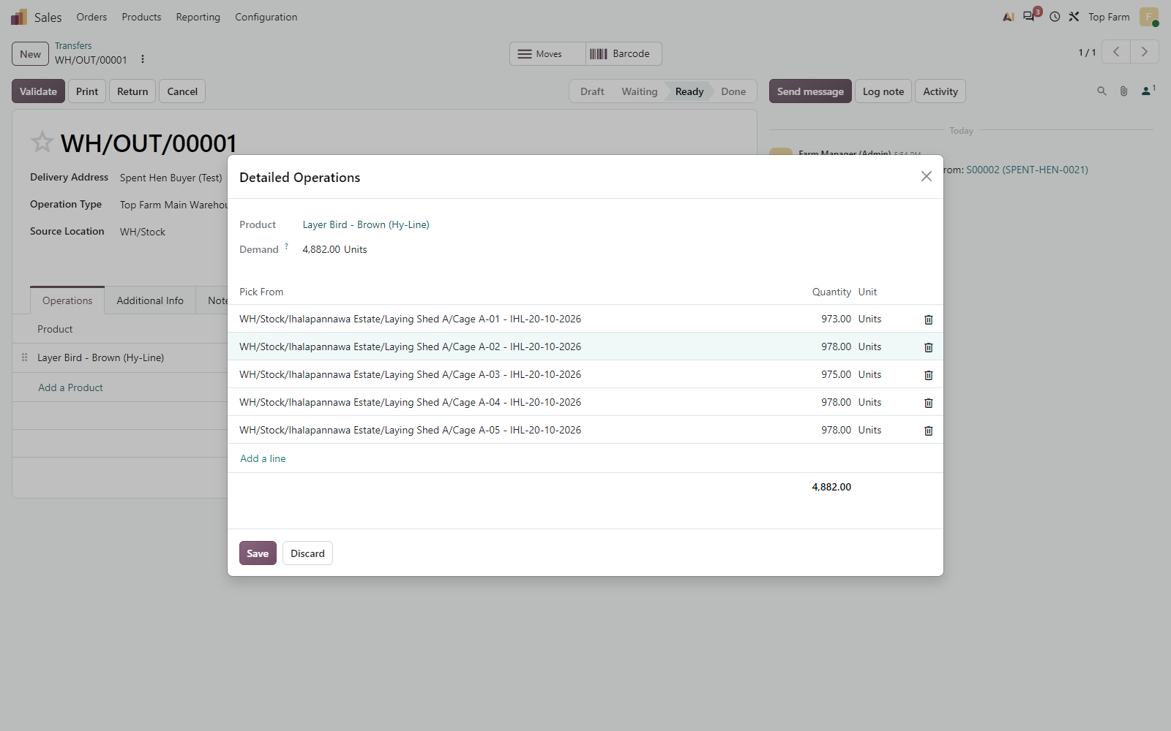
Figure 88. Spent hen delivery: the birds leave the 5 cages of Laying Shed A under flock lot IHL-20-10-2026.

Figure 89: Spent hen delivery validated
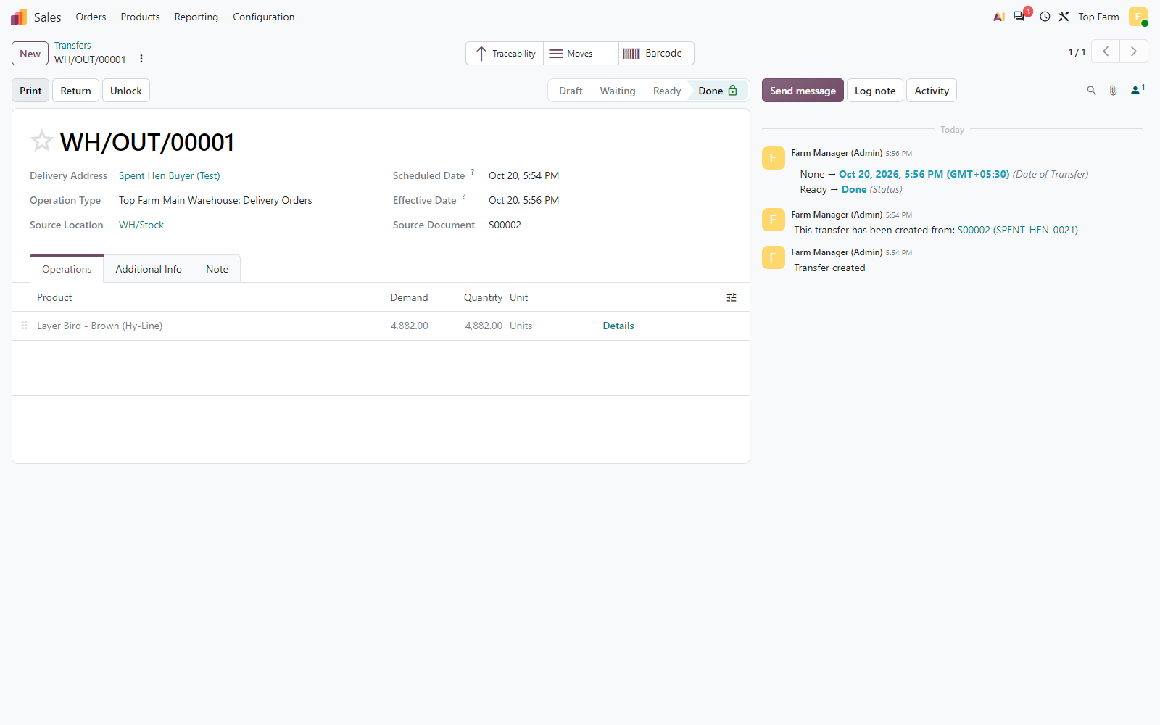
Figure 89. Spent hen delivery validated: the cages are empty.

Figure 90: Posted egg invoice (LKR 249,000)
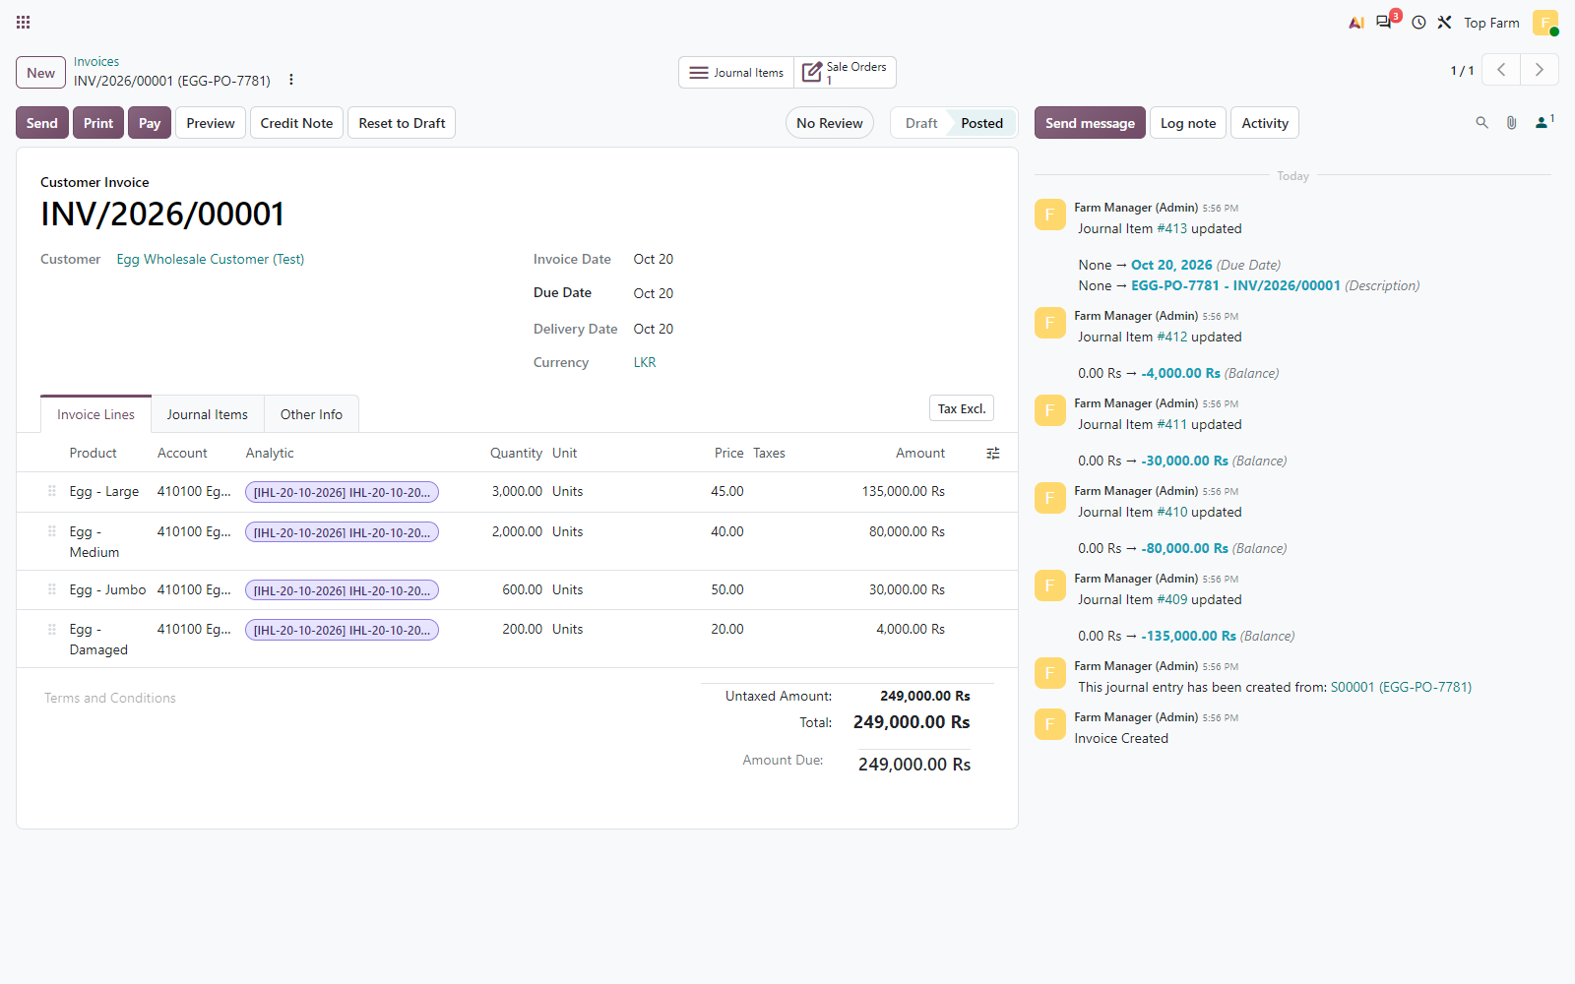
Figure 90. Posted egg invoice (LKR 249,000): every line carries the flock analytic account IHL-20-10-2026.

Figure 91: Posted spent hen invoice, tagged to the flock account
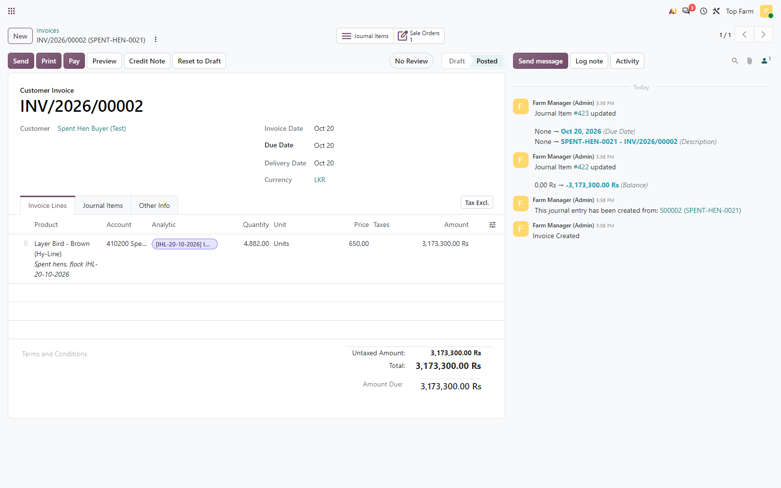
Figure 91. Posted spent hen invoice, tagged to the flock account.

Figure 92: The Farm Manager marks the flock Spent / Depleted
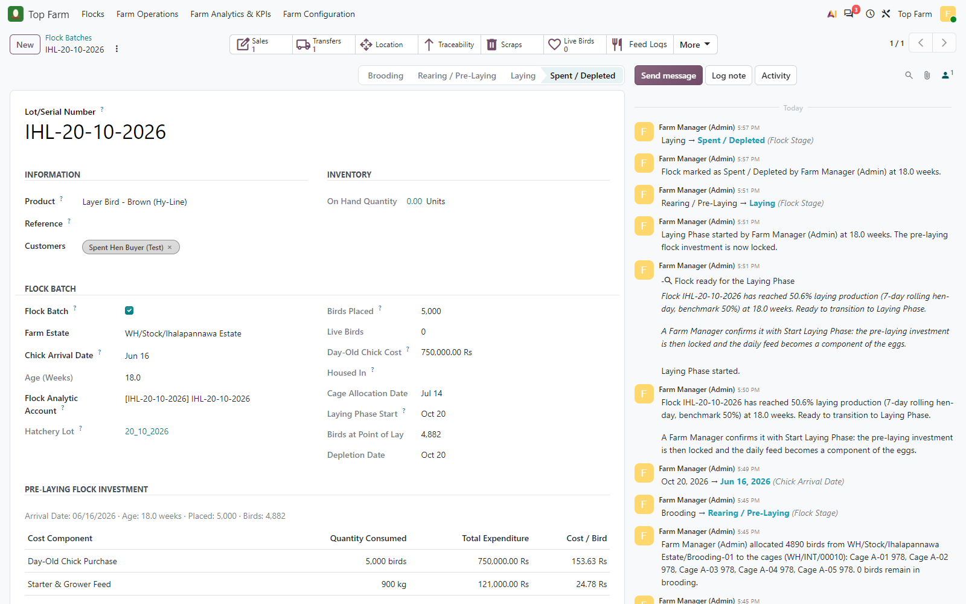
Figure 92. The Farm Manager marks the flock Spent / Depleted: depletion date recorded, no live birds left.

Figure 93: The permanent cages of Laying Shed A are empty
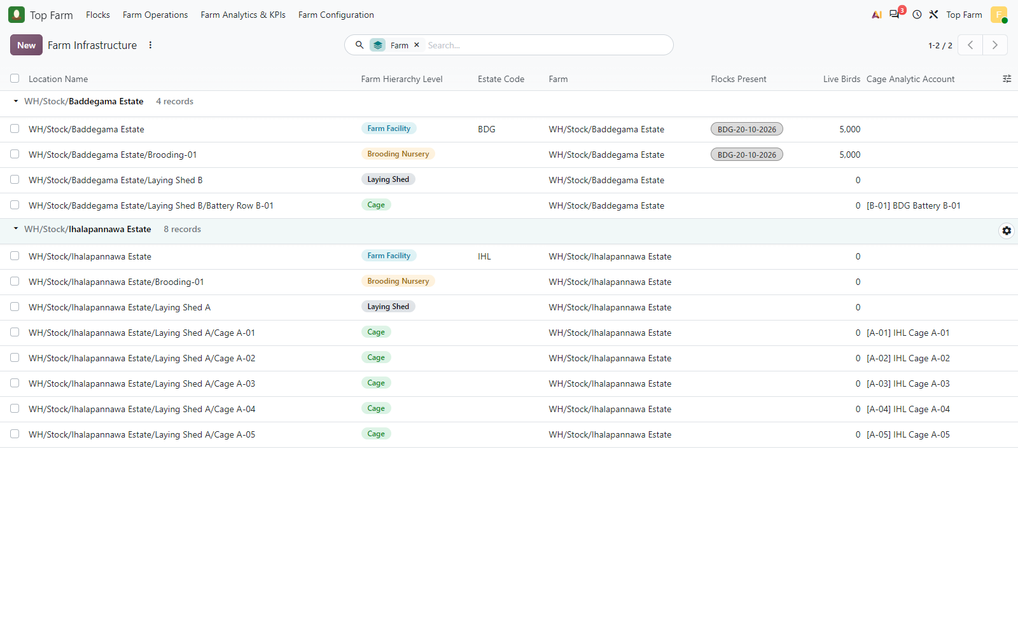
Figure 93. The permanent cages of Laying Shed A are empty, ready for cleaning and the next flock; BDG-20-10-2026 is still brooding in Baddegama.

12. Flock reports and financial reconciliation

12.1 Flock lifetime P&L
Line | Expected (LKR) | Flock Lifetime Profitability (LKR) | Result
Egg revenue | 249,000.00 | 249,000.00 | PASS
Spent hen revenue | 3,173,300.00 | 3,173,300.00 | PASS
Feed cost | 187,000.00 | 187,000.00 | PASS
Medication cost | 363,500.00 | 363,500.00 | PASS
Mortality loss | 17,700.00 | 17,700.00 | PASS
Bird cost of sales | 732,300.00 | 732,300.00 | PASS
Other direct cost | 245,000.00 | 245,000.00 | PASS
Total direct cost | 1,545,500.00 | 1,545,500.00 | PASS
Gross operating profit | 1,876,800.00 | 1,876,800.00 | PASS
Bird cost of sales is the standard cost of the spent hens delivered; with the mortality loss it adds up to the cost of every chick that left the flock.

12.2 General ledger
Account | What it holds | Expected (LKR) | Balance (LKR) | Result
510100 Feed Expense | Feed Expense (brooding + rearing, both estates) | 142,000.00 | 142,000.00 | PASS
510200 Vet & Medication Expense | Vet & Medication Expense | 653,500.00 | 653,500.00 | PASS
510300 Mortality Loss | Mortality Loss | 17,700.00 | 17,700.00 | PASS
510400 Brooding Heating (LPG / Electricity) | Brooding Heating (LPG / Electricity) | 170,000.00 | 170,000.00 | PASS
510500 Bird Care Labour (Debeaking) | Bird Care Labour (Debeaking) | 75,000.00 | 75,000.00 | PASS
410100 Egg Sales | Egg Sales (credit) | -249,000.00 | -249,000.00 | PASS
410200 Spent Hen Sales | Spent Hen Sales (credit) | -3,173,300.00 | -3,173,300.00 | PASS
Feed and medication expenses include the Baddegama flock (150 kg starter, 5,000 Marek's doses). The laying feed is not an expense: it passes through the production clearing account into the egg stock.

12.3 Dashboard figures (13-20 October, flock IHL-20-10-2026)
KPI | Value
Eggs harvested | 24,890
Hen-day rate | 63.73 %
FCR (kg feed per dozen eggs) | 0.265
Feed consumed by egg MOs (kg) | 550.00
Dead birds / mortality | 118 / 1.696 %

Figure 94: Flock Lifetime Profitability
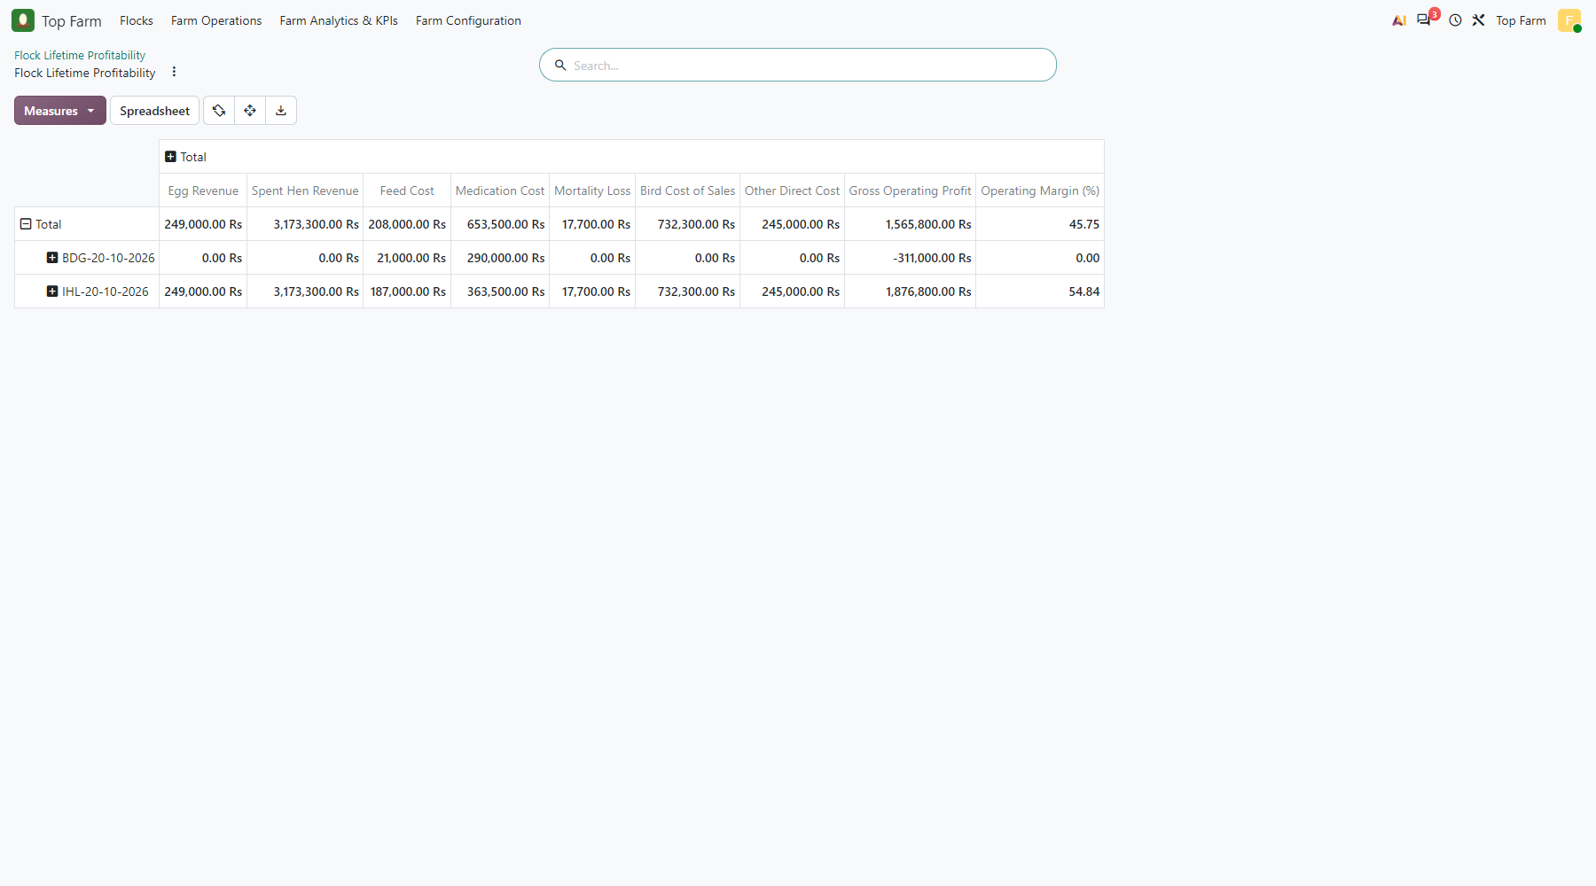
Figure 94. Flock Lifetime Profitability: egg and spent hen revenue less feed, medication, mortality loss, bird cost of sales and other direct costs, per flock.

Figure 95: The same P&L of flock IHL-20-10-2026 split by cage
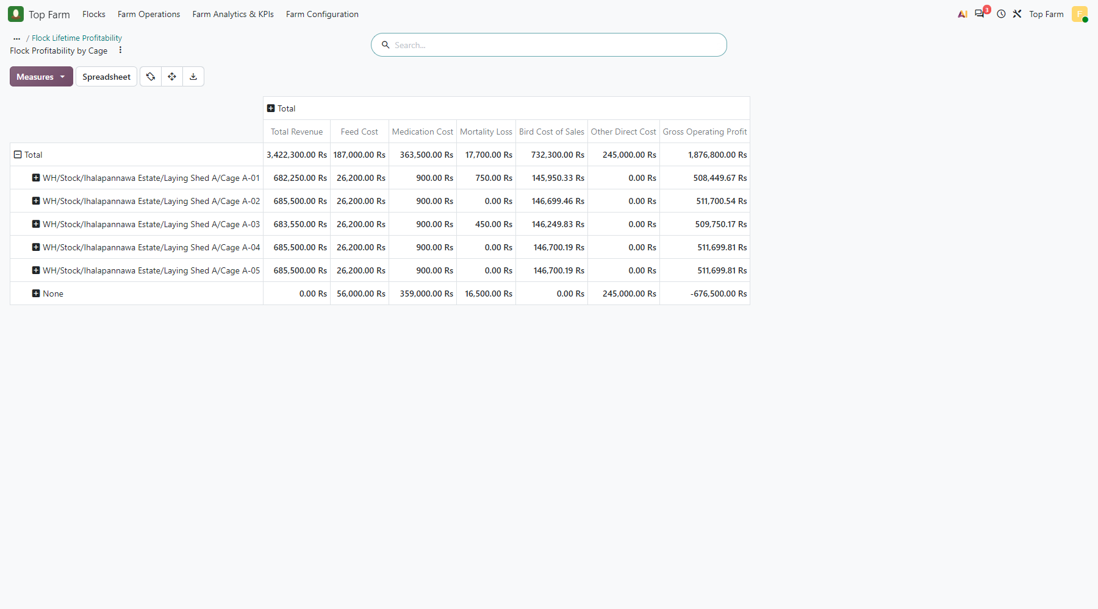
Figure 95. The same P&L of flock IHL-20-10-2026 split by cage: egg revenue by the eggs each cage laid, spent hen revenue and cost by the cage the hens left from, feed, medication and mortality of the cage. "None" = flock-level items: the brooding costs and the LPG and labour bills.

Figure 96: Flock Revenue Allocation
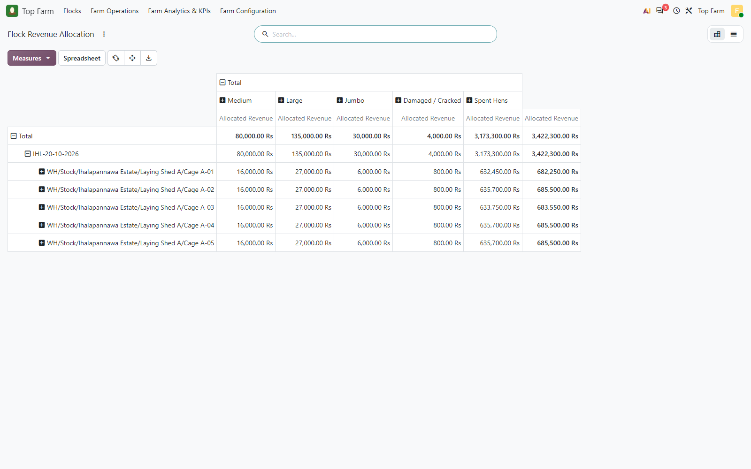
Figure 96. Flock Revenue Allocation: egg revenue of each delivered egg lot shared between the cages by their eggs of that grade and day; spent hen revenue on the cage the hens were delivered from.

Figure 97: Pre-Laying Flock Investment (final)
Figure 97. Pre-Laying Flock Investment (final): IHL-20-10-2026 locked at point of lay; BDG-20-10-2026 still accumulating in brooding.

Figure 98: Feed Consumption Analysis by flock and house type (brooding nursery / cage)
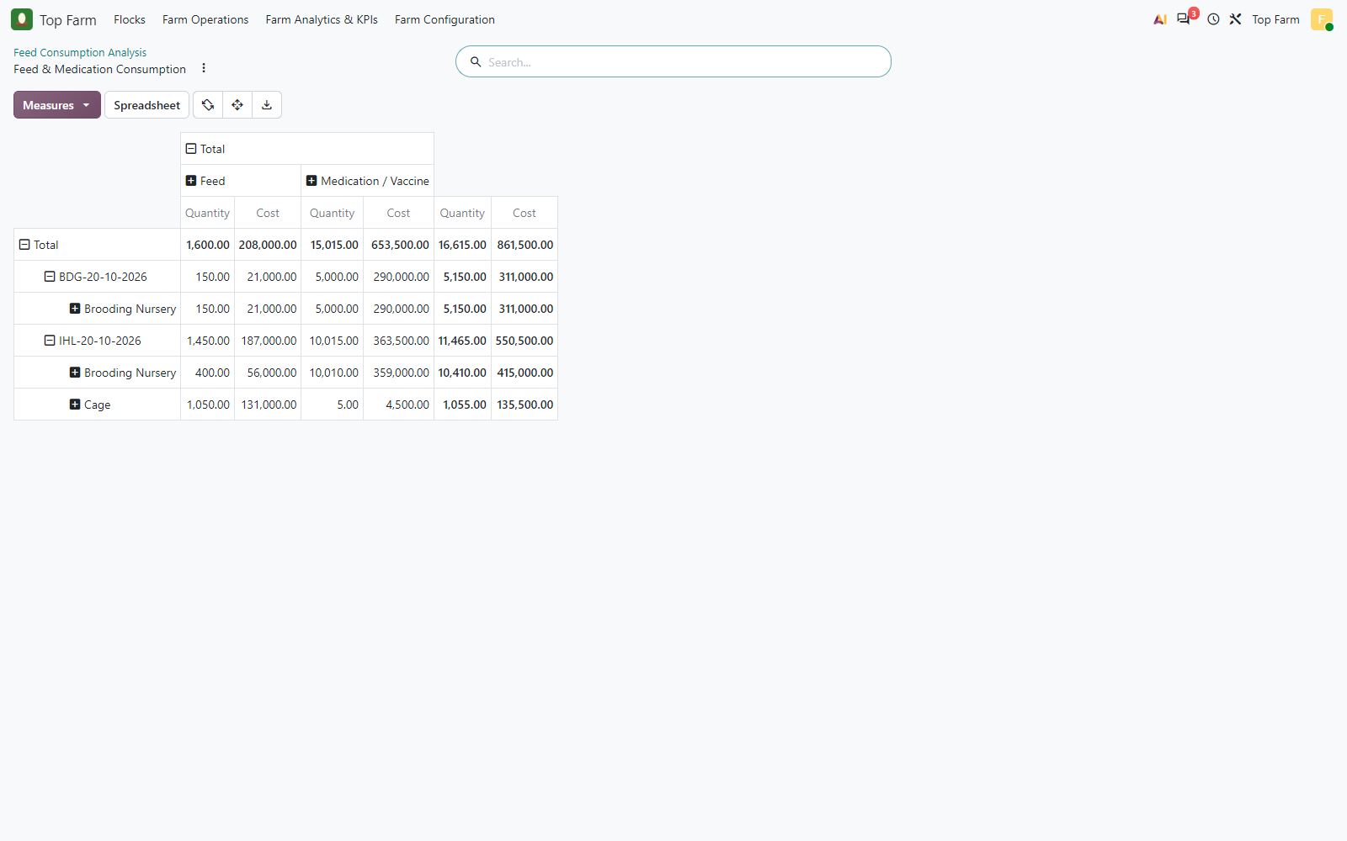
Figure 98. Feed Consumption Analysis by flock and house type (brooding nursery / cage), feed vs medication.

Figure 99: Mortality BI by flock and brooding nursery / cage, per cause of death
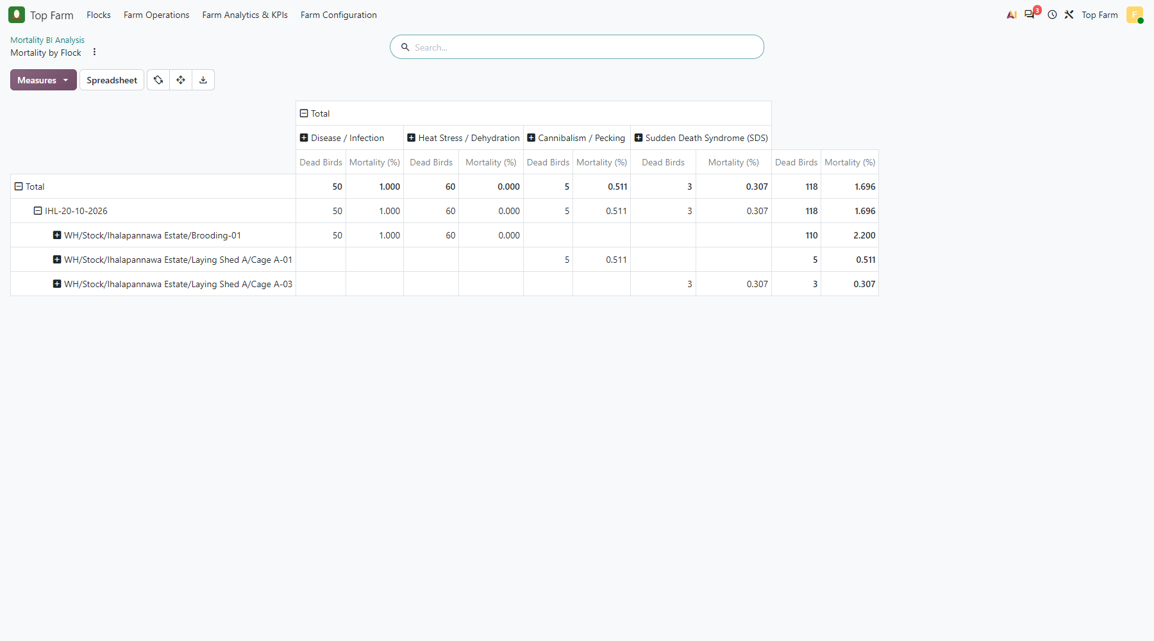
Figure 99. Mortality BI by flock and brooding nursery / cage, per cause of death.

Figure 100: All analytic items of flock IHL-20-10-2026 over its lifecycle
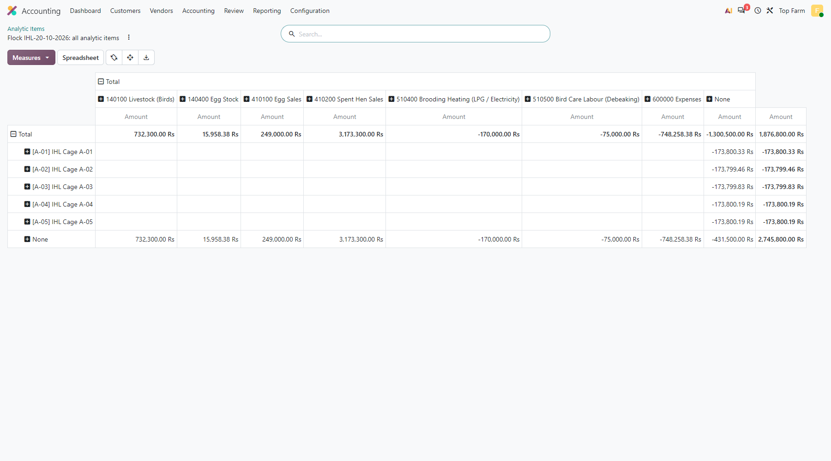
Figure 100. All analytic items of flock IHL-20-10-2026 over its lifecycle, by cage (rows; "None" = flock level) and general account (columns): sales income, the cost-of-goods-sold pairs of the invoices (Livestock / Egg Stock against 600000 Expenses, netting to zero), the bills, and the stock moves (no general account). The grand total, LKR 1,876,800, equals the gross operating profit of the flock P&L.

Figure 101: General ledger of the farm accounts
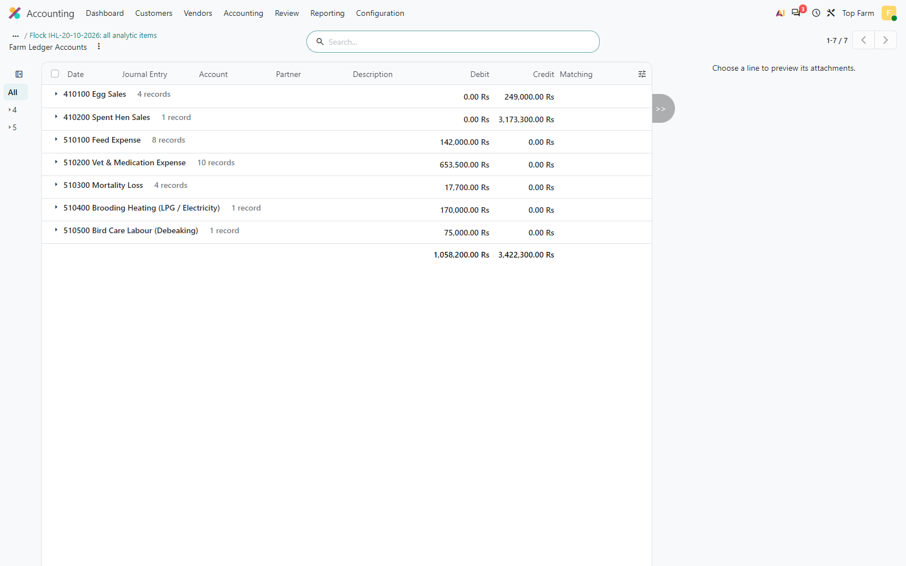
Figure 101. General ledger of the farm accounts: feed, medication, mortality, heating and labour expenses; egg and spent hen sales.

Figure 102: Flock Performance Dashboard, 13-20 October, all active flocks
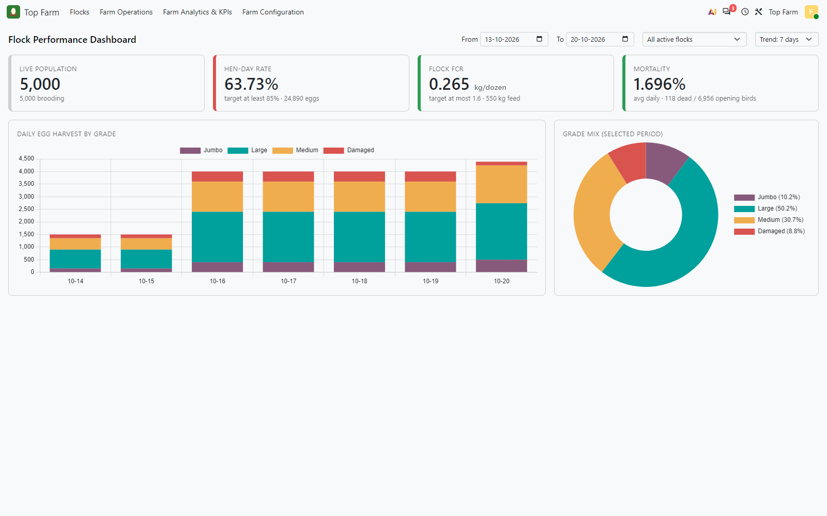
Figure 102. Flock Performance Dashboard, 13-20 October, all active flocks: live population by stage (the spent flock is no longer counted), hen-day rate, FCR, mortality, harvest by grade. The FCR is low because the period mixes pre-laying eggs, which carry no feed, with one laying day.

Figure 103: Flock Batches at the end of the test
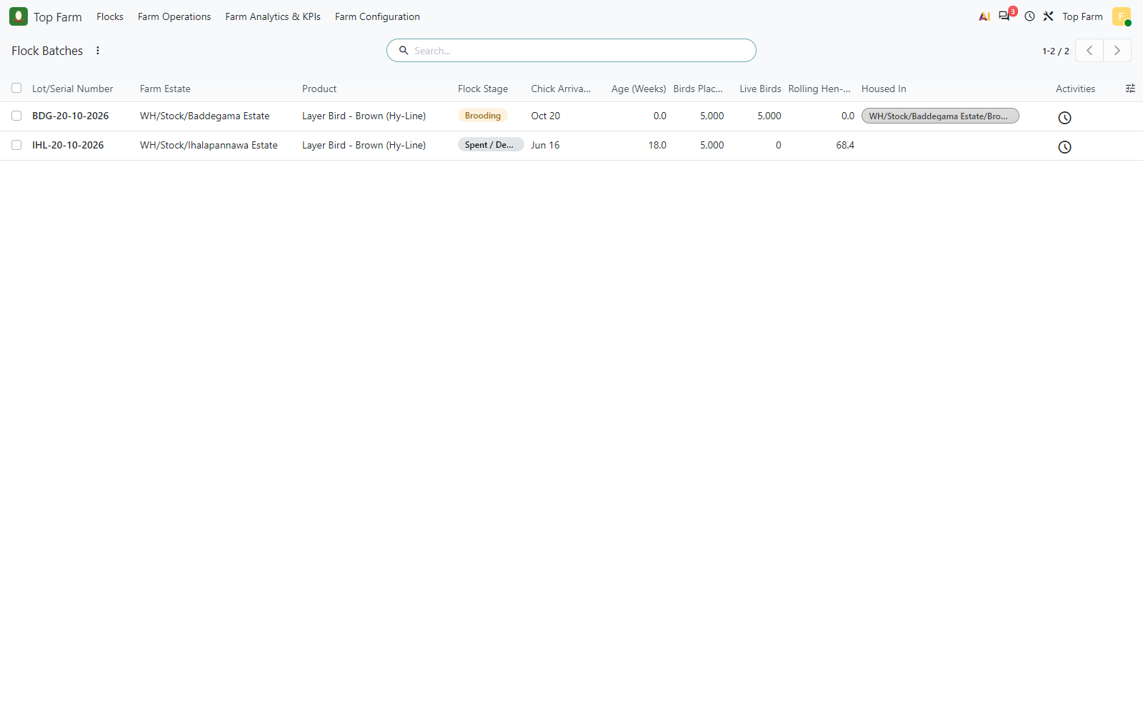
Figure 103. Flock Batches at the end of the test: IHL-20-10-2026 Spent / Depleted, BDG-20-10-2026 in Brooding.

13. Reusing the cages for the next flock
Cages and brooding nurseries are permanent: after a flock is depleted and the cages are cleaned, the next flock moves into the same cages. Each cage keeps its cage analytic account for ever (Farm Cages plan), while every flock gets a new flock analytic account (Flock Batches plan). Every cost line carries both, so a cage account accumulates the history of all its flocks, and the flock account on each line keeps them apart.
- Per flock: filter on the flock account: only that flock, whatever cages it used.
- Per cage, all flocks: filter on the cage account: the lifetime history of the cage.
- One cage for one flock: both accounts are on the same line; a pivot with the cages in rows and the flocks in columns splits them exactly.
- The allocation wizard only lets a flock into a cage that holds no other flock, so a cage never mixes two flocks at the same time.
In this test a second purchase of 4,000 chicks was dispatched to Ihalapannawa Brooding-01 and allocated into Cages A-01 to A-05 after the spent hens of IHL-20-10-2026 had left. Analytic items per cage, by flock (LKR, negative = net cost):
Cage | Cage account | IHL-20-10-2026 (before) | IHL-20-10-2026 (after) | IHL-20-10-2026-2 | Expected | Result
Cage A-01 | [A-01] IHL Cage A-01 | -173,800.33 | -173,800.33 | -11,600.00 | -11,600.00 | PASS
Cage A-02 | [A-02] IHL Cage A-02 | -173,799.46 | -173,799.46 | -11,300.00 | -11,300.00 | PASS
Cage A-03 | [A-03] IHL Cage A-03 | -173,799.83 | -173,799.83 | -11,300.00 | -11,300.00 | PASS
Cage A-04 | [A-04] IHL Cage A-04 | -173,800.19 | -173,800.19 | -11,300.00 | -11,300.00 | PASS
Cage A-05 | [A-05] IHL Cage A-05 | -173,800.19 | -173,800.19 | -11,300.00 | -11,300.00 | PASS
The first flock's figures per cage (its rearing and laying costs, mortality and the spent hens it sold) did not change; the next flock's grower feed, vitamins and mortality land on the same cage accounts under its own account [IHL-20-10-2026-2] IHL-20-10-2026-2. In this same-day test the next flock is named IHL-20-10-2026-2, because IHL-20-10-2026 already holds the estate-date name; in production the next flock arrives weeks later and carries its own date.

Figure 104: The next chick purchase (4,000 birds
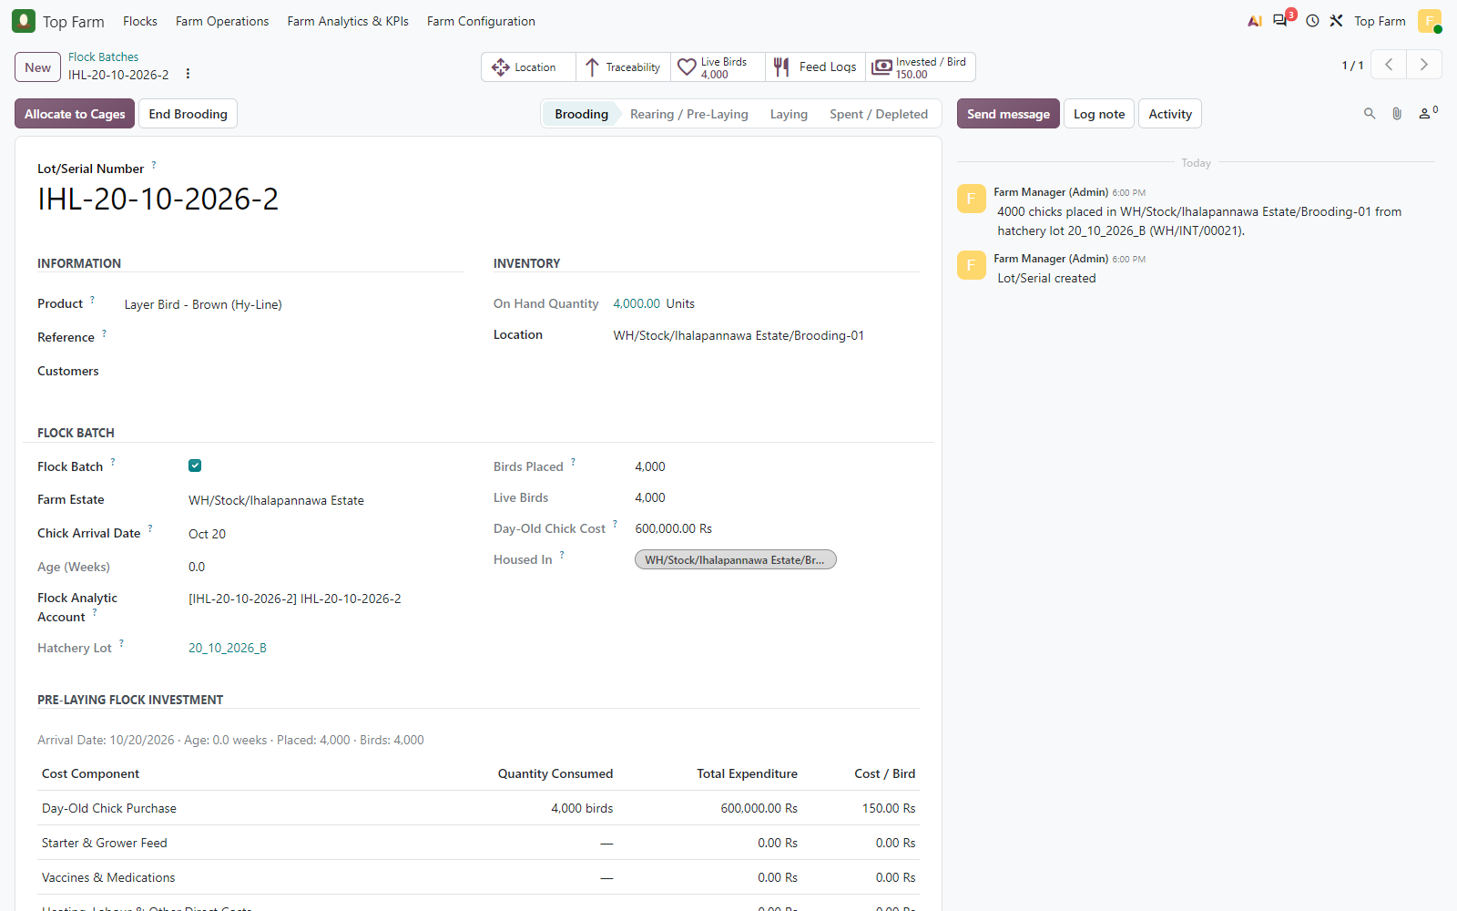
Figure 104. The next chick purchase (4,000 birds, hatchery lot 20_10_2026_B) dispatched to Ihalapannawa Brooding-01 becomes a new flock with its own analytic account. It is named IHL-20-10-2026-2 because the first flock already holds IHL-20-10-2026 (same estate, same date in this test); in production the next flock arrives weeks later and carries its own date.

Figure 105: Allocation wizard for the next flock
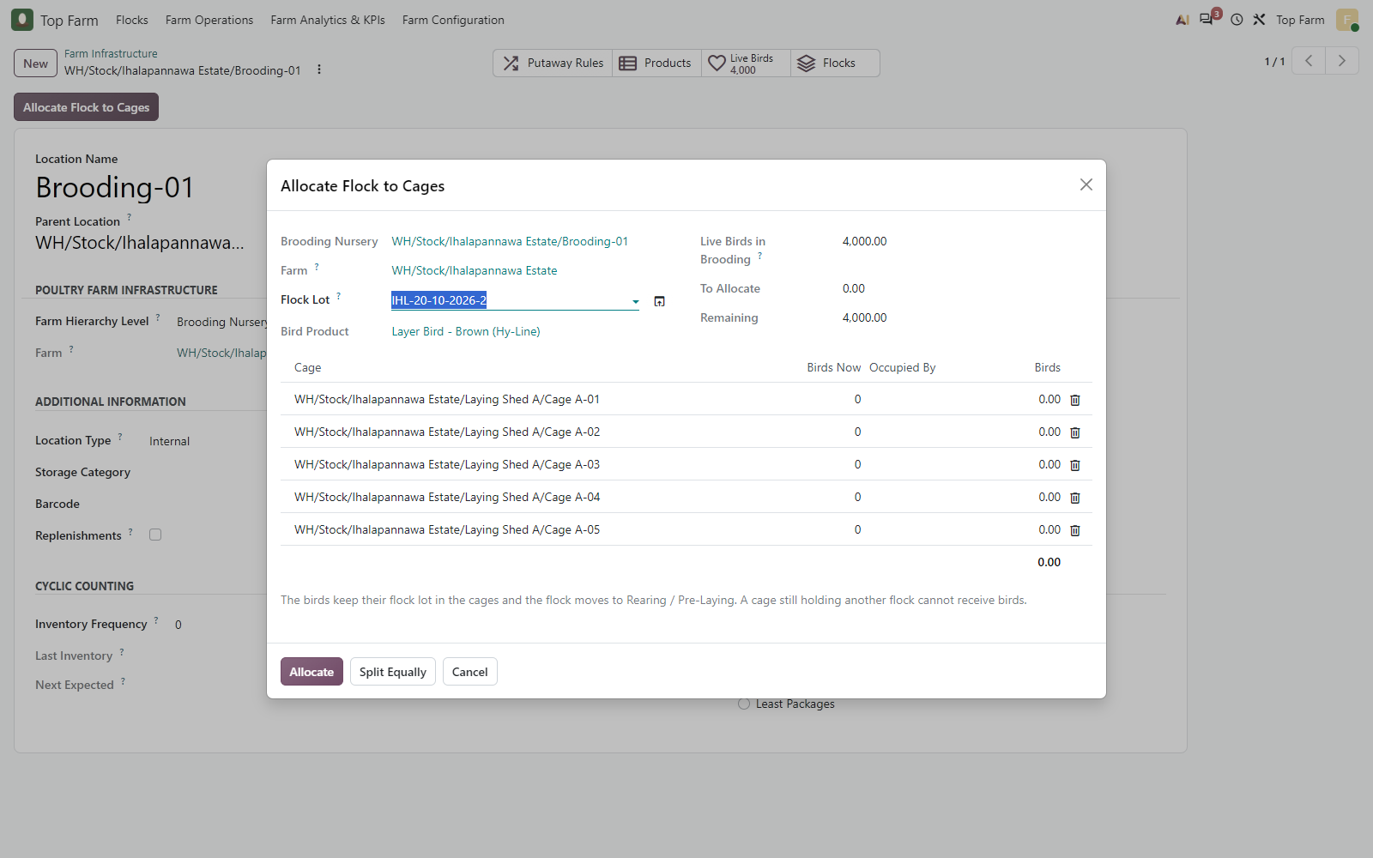
Figure 105. Allocation wizard for the next flock: the same 5 cages of Laying Shed A are listed; Birds Now 0 and no other flock in them, so they can receive the new flock. (A cage still holding another flock would be refused.)

Figure 106: Split Equally
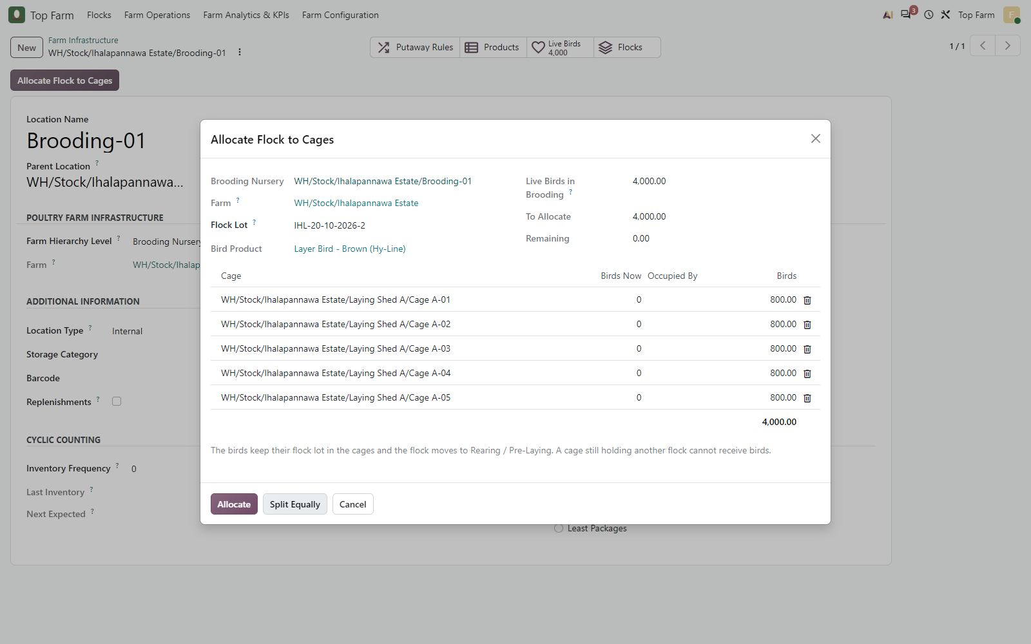
Figure 106. Split Equally: 800 birds of IHL-20-10-2026-2 per cage.

Figure 107: The permanent cages now hold the next flock IHL-20-10-2026-2; each cage ...
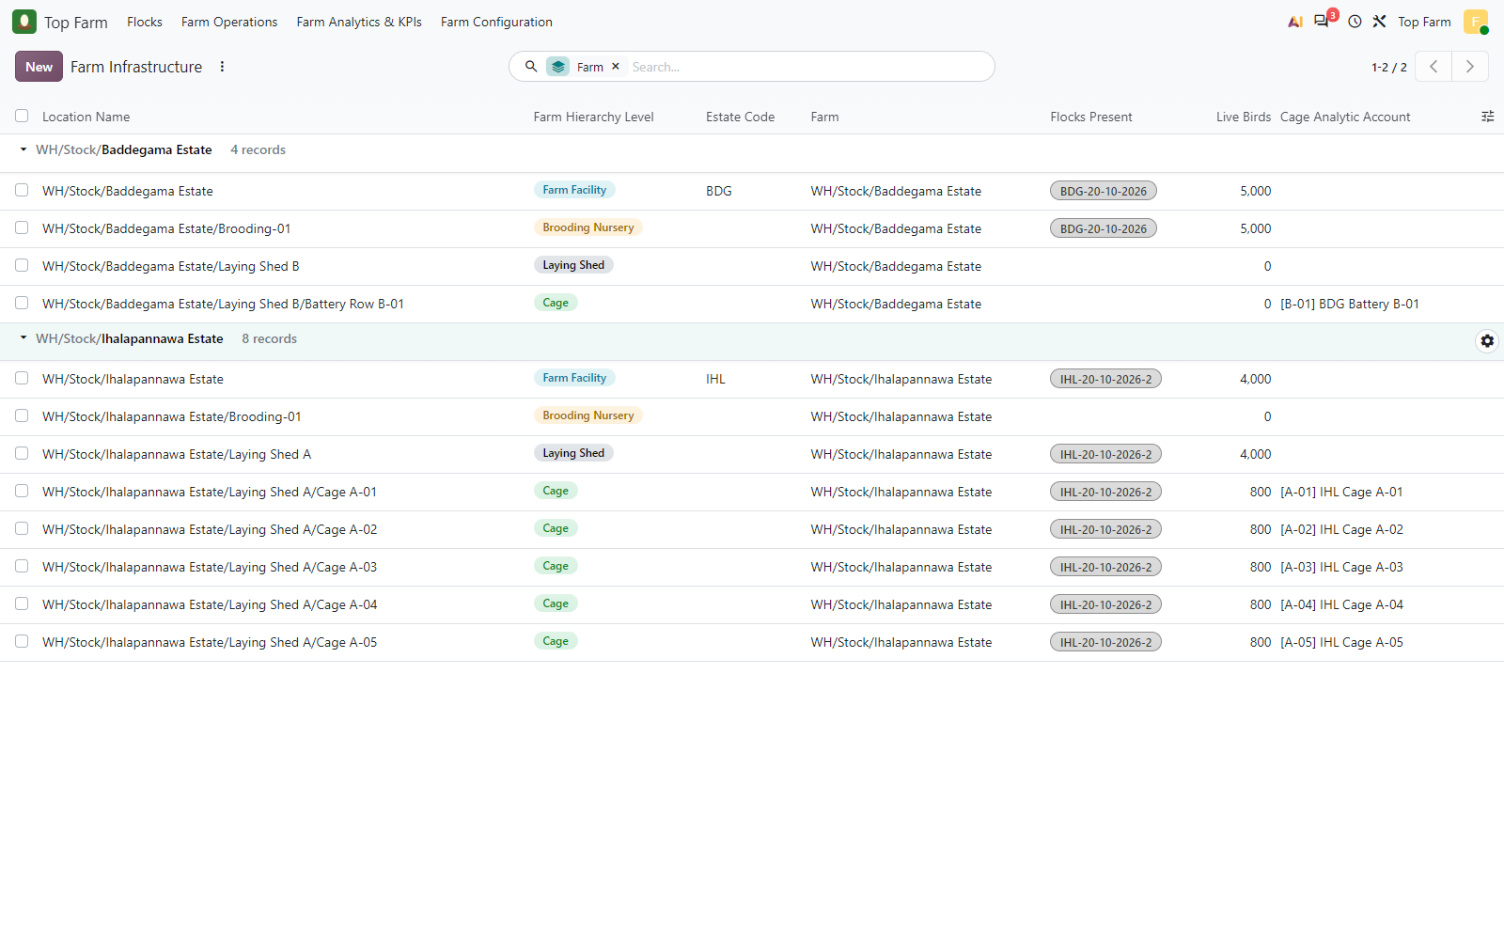
Figure 107. The permanent cages now hold the next flock IHL-20-10-2026-2; each cage keeps its own cage analytic account ([A-01] to [A-05]).

Figure 108: Cage A-01 with the next flock
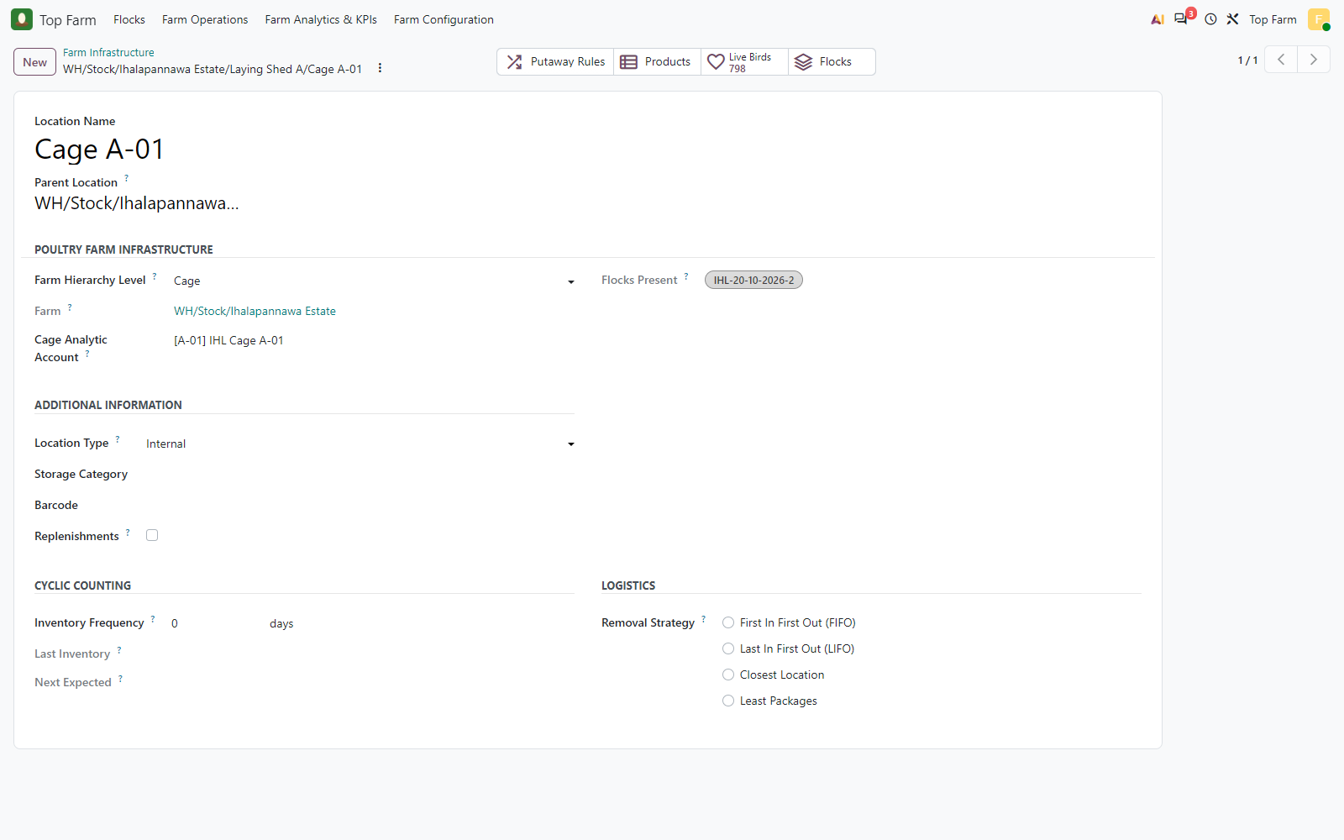
Figure 108. Cage A-01 with the next flock: Flocks Present IHL-20-10-2026-2, same cage analytic account [A-01] IHL Cage A-01 as for the first flock.

Figure 109: Analytic items of the cages by flock
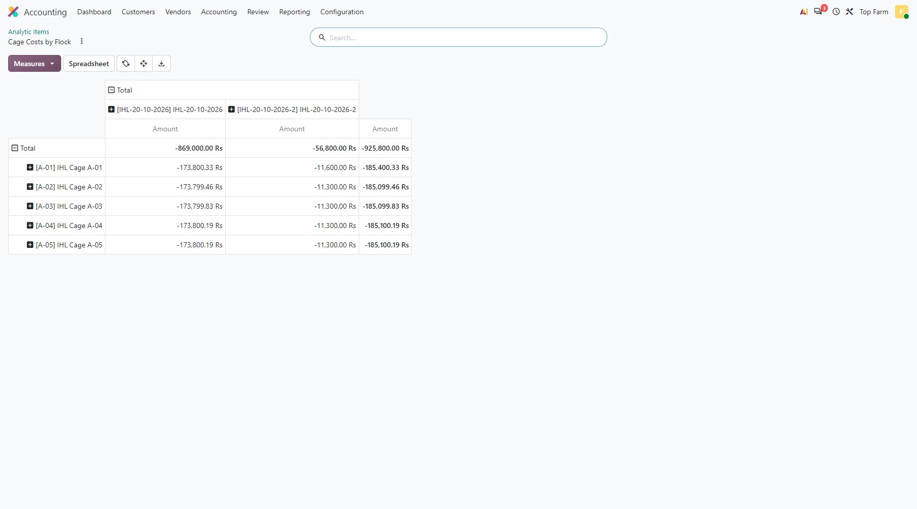
Figure 109. Analytic items of the cages by flock: each cage account (rows) holds the costs and revenue of the first flock IHL-20-10-2026 and the costs of the next flock IHL-20-10-2026-2 in separate columns. One cage, two flocks, nothing mixed.

Figure 110: Cage A-01 analytic items grouped by flock
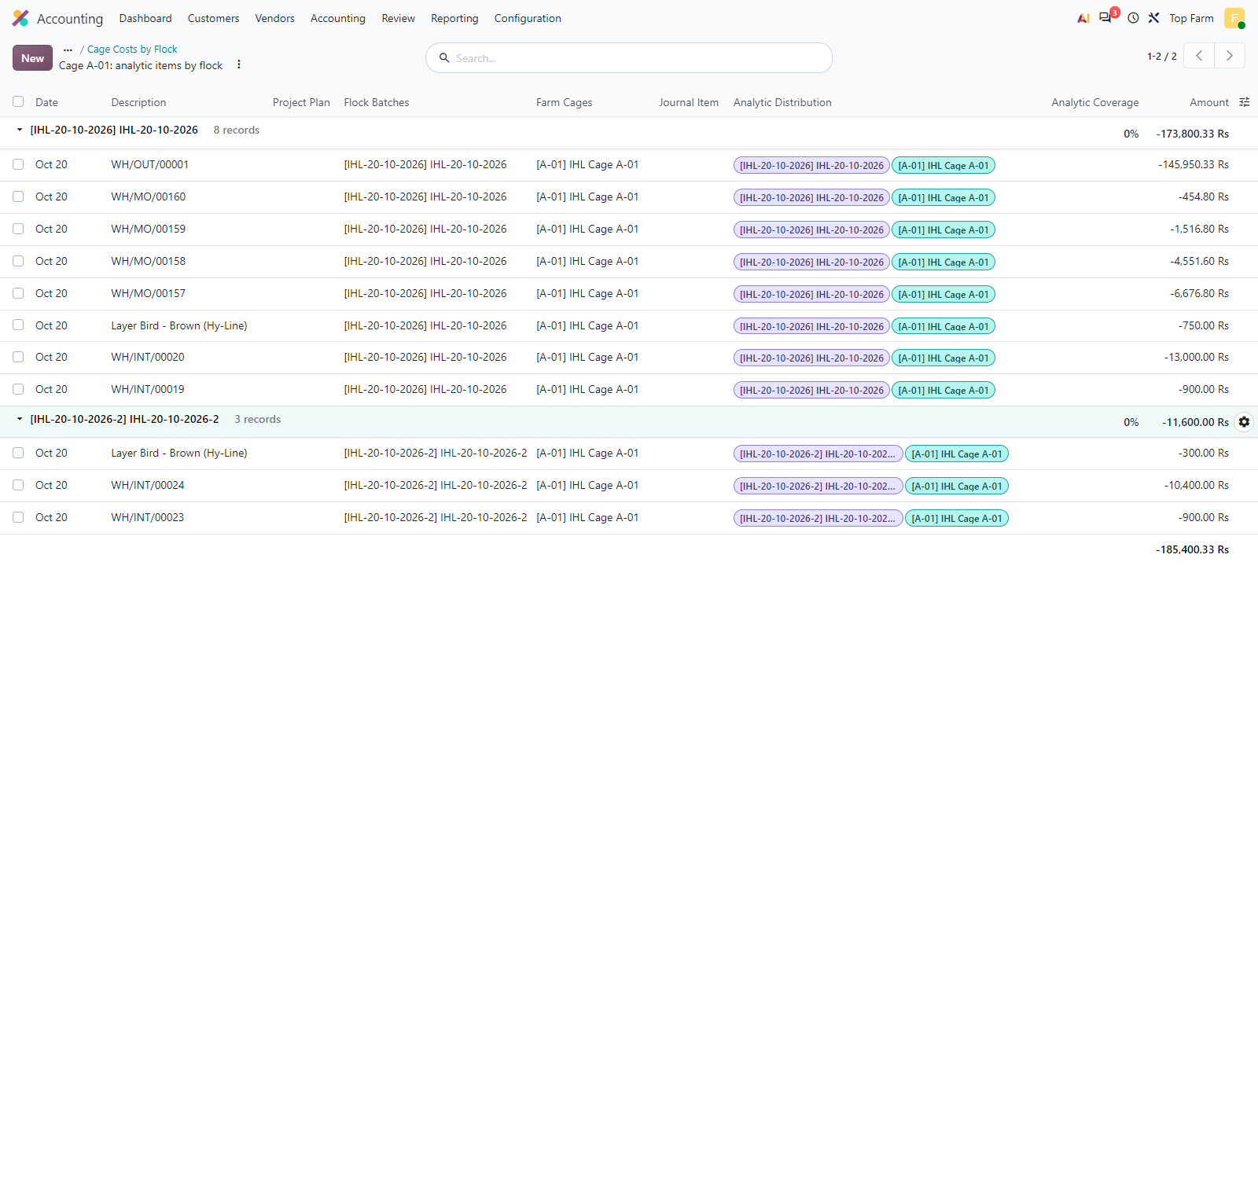
Figure 110. Cage A-01 analytic items grouped by flock: the first flock lines (rearing, laying feed, mortality, spent hens) and the next flock lines (grower feed, vitamins, 2 dead birds), all on the cage account [A-01].

Figure 111: Flock Batches
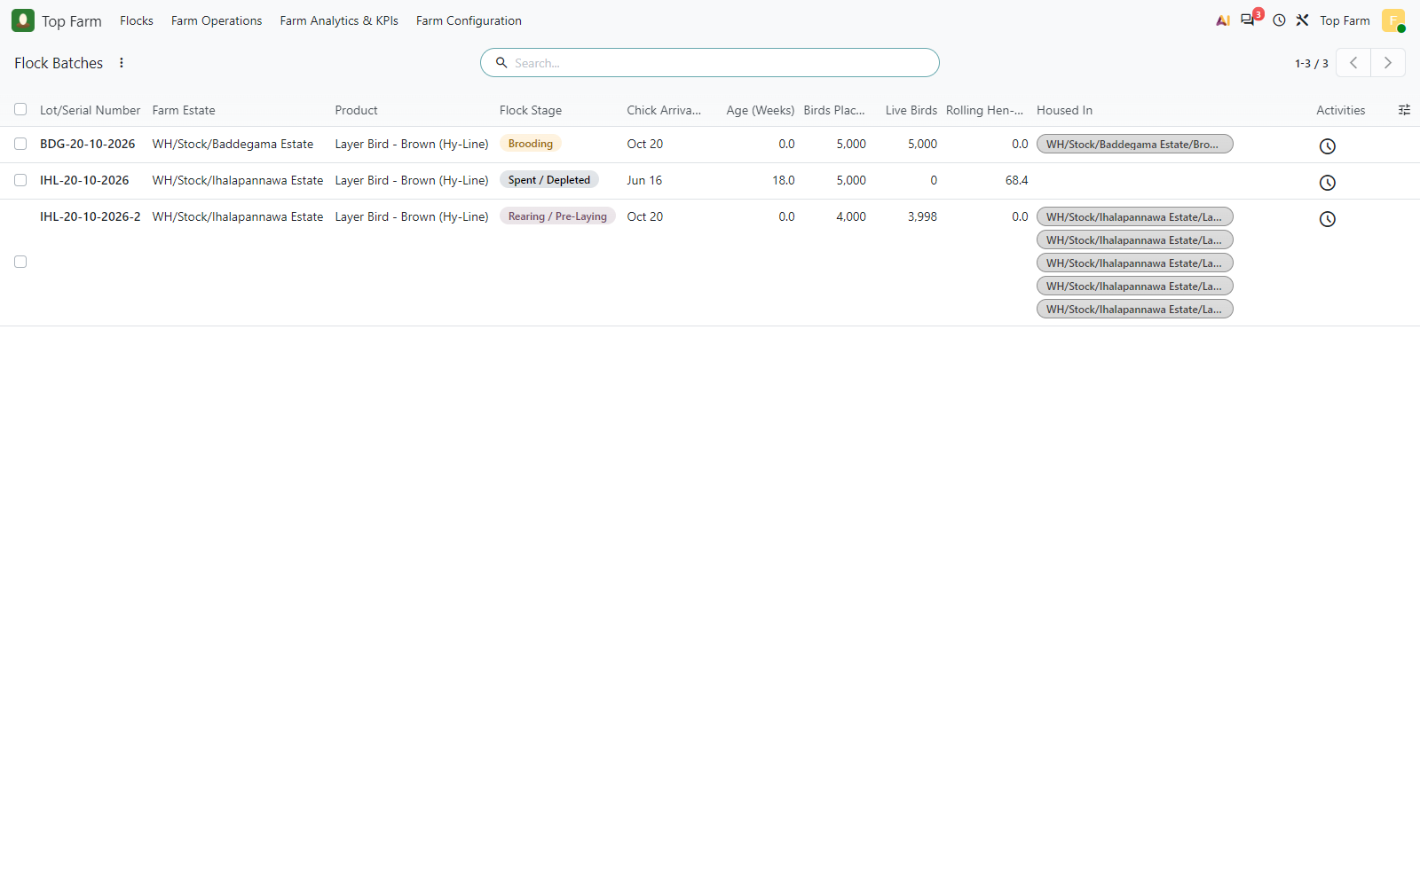
Figure 111. Flock Batches: IHL-20-10-2026 Spent, its successor IHL-20-10-2026-2 in Rearing in the same cages, BDG-20-10-2026 in Brooding at Baddegama.

14. All checks
124 passed, 0 failed. Negative cases (refused validations) ran in savepoints or in the browser and left no data.
Test case | Check | Expected | Actual | Result
TC-00-01 | company currency | LKR | LKR | PASS
TC-00-02 | bird product tracked by lots | lot | lot | PASS
TC-00-03 | cages resolve their estate through the shed | Ihalapannawa Estate | Ihalapannawa Estate | PASS
TC-00-04 | flock lot generation mode | auto | auto | PASS
TC-00-05 | laying benchmark (min age / hen-day / window) | 17, 50, 7 | 17, 50, 7 | PASS
TC-01-01 | chick purchase order confirmed | purchase | purchase | PASS
TC-01-02 | chick PO amount (10,000 x 150) | 1500000 | 1500000 | PASS
TC-01-03 | feed PO amount | 455000 | 455000 | PASS
TC-01-04 | medicine PO amount | 745000 | 745000 | PASS
TC-01-05 | chick receipt carries the hatchery batch number | 20_10_2026 | 20_10_2026 | PASS
TC-02-01 | dispatch reserves the hatchery lot | 20_10_2026 | 20_10_2026 | PASS
TC-02-02 | dispatch destination is a brooding nursery | brooding | brooding | PASS
TC-02-03 | transfer flagged as a dispatch to brooding (Flock Lot column shown) | true | true | PASS
TC-03-01 | flock lot generation switched to manual entry | manual | manual | PASS
TC-03-02 | dispatch to brooding without a flock lot is refused in manual mode | true | true | PASS
TC-03-03 | the refusal suggests the estate lot name | true | true | PASS
TC-03-04 | the refused dispatch is still Ready (nothing moved) | assigned | assigned | PASS
TC-03-05 | dispatch validated with the clerk-entered flock lot | done, BDG-20-10-2026 | done, BDG-20-10-2026 | PASS
TC-03-06 | clerk-entered lot completed as a flock at validation | true, brooding, Baddegama Estate, 2026-10-20, Flock Batches, 5000 | true, brooding, Baddegama Estate, 2026-10-20, Flock Batches, 5000 | PASS
TC-03-07 | chicks re-labelled in Baddegama Brooding-01 from the hatchery lot to the flock lot | (20_10_2026), (BDG-20-10-2026) | (20_10_2026), (BDG-20-10-2026) | PASS
TC-03-08 | Baddegama brooding holds the flock lot only | 5000, 0 | 5000, 0 | PASS
TC-04-01 | feed log picks the flock living in the brooding nursery | IHL-20-10-2026 | IHL-20-10-2026 | PASS
TC-04-02 | brooding feed phase is pre-laying (direct expense) | pre_laying | pre_laying | PASS
TC-04-03 | second brooding feed log expensed at once | reconciled | reconciled | PASS
TC-06-01 | flock in Rearing / Pre-Laying after the allocation | rearing | rearing | PASS
TC-06-02 | birds per cage after the allocation | 978, 978, 978, 978, 978 | 978, 978, 978, 978, 978 | PASS
TC-06-03 | cage feed log of a rearing flock is pre-laying | pre_laying | pre_laying | PASS
TC-06-04 | cage feed log fills the flock of the cage | IHL-20-10-2026 | IHL-20-10-2026 | PASS
TC-06-05 | cage A-02 costs: one analytic line per move with flock + cage accounts | (IHL-20-10-2026, IHL Cage A-02), (IHL-20-10-2026, IHL Cage A-02) | (IHL-20-10-2026, IHL Cage A-02), (IHL-20-10-2026, IHL Cage A-02) | PASS
TC-06-06 | cage A-03 mortality scrapped (0.31 %) | done | done | PASS
TC-07-01 | simulated flock age (weeks) | 18 | 18 | PASS
TC-07-02 | 7-day rolling hen-day on 18 October below the 50 % benchmark | true | true | PASS
TC-07-03 | no laying alert yet | false | false | PASS
TC-07-04 | pre-laying harvest: 4 graded MOs without feed components | 4, 0 | 4, 0 | PASS
TC-07-05 | egg lot linked to its parent flock | IHL-20-10-2026, true | IHL-20-10-2026, true | PASS
TC-07-06 | laying alert raised by the 19 October harvest | true | true | PASS
TC-07-07 | 7-day rolling hen-day on 19 October at or above 50 % | true | true | PASS
TC-07-08 | manual mode: the flock waits for the manager in Rearing | rearing | rearing | PASS
TC-07-09 | point-of-lay To-Do scheduled for the Farm Manager | true | true | PASS
TC-08-01 | flock in Laying | laying | laying | PASS
TC-08-02 | cage feed of a laying flock is staged, not expensed | laying, confirmed, 0 | laying, confirmed, 0 | PASS
TC-08-03 | cage A-02 MOs consume exactly the staged 110 kg of Layer Mash | 110 | 110 | PASS
TC-08-04 | laying feed of the MOs tagged to flock + cage on one analytic line | (IHL-20-10-2026, IHL Cage A-02), (IHL-20-10-2026, IHL Cage A-02), (IHL-20-10-2026, IHL Cage A-02), (IHL-20-10-2026, IHL Cage A-02) | (IHL-20-10-2026, IHL Cage A-02), (IHL-20-10-2026, IHL Cage A-02), (IHL-20-10-2026, IHL Cage A-02), (IHL-20-10-2026, IHL Cage A-02) | PASS
TC-08-05 | cage A-01 laying feed staged in the browser | confirmed | confirmed | PASS
TC-08-06 | collection finds the staged feed of the cage and day | 9 | 9 | PASS
TC-09-01 | spent hen delivery prepared from the 5 cages under the flock lot | IHL-20-10-2026, 4882 | IHL-20-10-2026, 4882 | PASS
TC-09-02 | egg sale lines tagged 100 % to the flock account | 7:100, 7:100, 7:100, 7:100 | 7:100, 7:100, 7:100, 7:100 | PASS
TC-09-03 | spent hen sale lines tagged 100 % to the flock account | 7:100 | 7:100 | PASS
TC-09-04 | egg invoice amount | 249000 | 249000 | PASS
TC-09-05 | spent hen invoice amount | 3173300 | 3173300 | PASS
TC-09-06 | egg invoice lines carry the flock analytic account | true | true | PASS
TC-09-07 | flock has no live birds left after the spent hen sale | 0 | 0 | PASS
TC-10-01 | purchase total (chicks + feed + medicine) | 2700000 | 2700000 | PASS
TC-10-02 | the 4 re-labelling moves post no journal entry | 0 | 0 | PASS
TC-10-03 | the re-labelling leaves the bird stock value unchanged (out = in) | 0 | 0 | PASS
TC-10-04 | brooding analytic cost: Starter Crumbs (Weeks 0-4) | 56000 | 56000 | PASS
TC-10-04 | brooding analytic cost: Marek's Vaccine (dose) | 290000 | 290000 | PASS
TC-10-04 | brooding analytic cost: Newcastle ND-IB Vaccine (dose) | 60000 | 60000 | PASS
TC-10-04 | brooding analytic cost: Electrolyte & Vitamin Mix (L) | 9000 | 9000 | PASS
TC-10-04 | brooding analytic cost: Layer Bird - Brown (Hy-Line) (mortality) | 16500 | 16500 | PASS
TC-10-04 | brooding analytic cost: LPG & electricity bill (brooding heat) | 170000 | 170000 | PASS
TC-10-05 | no brooding analytic item carries a cage account | 0 | 0 | PASS
TC-10-06 | rearing analytic cost of Cage A-01 (flock + cage) | 14650 | 14650 | PASS
TC-10-06 | rearing analytic cost of Cage A-02 (flock + cage) | 13900 | 13900 | PASS
TC-10-06 | rearing analytic cost of Cage A-03 (flock + cage) | 14350 | 14350 | PASS
TC-10-06 | rearing analytic cost of Cage A-04 (flock + cage) | 13900 | 13900 | PASS
TC-10-06 | rearing analytic cost of Cage A-05 (flock + cage) | 13900 | 13900 | PASS
TC-10-07 | debeaking labour on the flock account (no cage) | 75000 | 75000 | PASS
TC-10-08 | laying feed of the egg MOs on Cage A-01 (flock + cage) | 13200 | 13200 | PASS
TC-10-08 | laying feed of the egg MOs on Cage A-02 (flock + cage) | 13200 | 13200 | PASS
TC-10-08 | laying feed of the egg MOs on Cage A-03 (flock + cage) | 13200 | 13200 | PASS
TC-10-08 | laying feed of the egg MOs on Cage A-04 (flock + cage) | 13200 | 13200 | PASS
TC-10-08 | laying feed of the egg MOs on Cage A-05 (flock + cage) | 13200 | 13200 | PASS
TC-10-09 | spent hen cost of sales on the flock, split over the 5 cages | 5, 732300 | 5, 732300 | PASS
TC-10-10 | investment component: Day-Old Chick Purchase | 750000 | 750000 | PASS
TC-10-10 | investment component: Starter & Grower Feed | 121000 | 121000 | PASS
TC-10-10 | investment component: Vaccines & Medications | 363500 | 363500 | PASS
TC-10-10 | investment component: Heating, Labour & Other Direct Costs | 245000 | 245000 | PASS
TC-10-11 | investment per bird at point of lay | 303.05 | 303.05 | PASS
TC-10-12 | laying feed stays out of the locked investment | true | true | PASS
TC-10-13 | rolling hen-day below 50 % on 18 October, at or above 50 % on 19 October | true | true | PASS
TC-10-14 | large eggs: collected = produced by MOs = sold + on hand | 12490, 12490 | 12490, 12490 | PASS
TC-10-14 | medium eggs: collected = produced by MOs = sold + on hand | 7650, 7650 | 7650, 7650 | PASS
TC-10-14 | jumbo eggs: collected = produced by MOs = sold + on hand | 2550, 2550 | 2550, 2550 | PASS
TC-10-14 | damaged eggs: collected = produced by MOs = sold + on hand | 2200, 2200 | 2200, 2200 | PASS
TC-10-15 | flock lifetime P&L: Egg revenue | 249000 | 249000 | PASS
TC-10-15 | flock lifetime P&L: Spent hen revenue | 3173300 | 3173300 | PASS
TC-10-15 | flock lifetime P&L: Feed cost | 187000 | 187000 | PASS
TC-10-15 | flock lifetime P&L: Medication cost | 363500 | 363500 | PASS
TC-10-15 | flock lifetime P&L: Mortality loss | 17700 | 17700 | PASS
TC-10-15 | flock lifetime P&L: Bird cost of sales | 732300 | 732300 | PASS
TC-10-15 | flock lifetime P&L: Other direct cost | 245000 | 245000 | PASS
TC-10-15 | flock lifetime P&L: Total direct cost | 1545500 | 1545500 | PASS
TC-10-15 | flock lifetime P&L: Gross operating profit | 1876800 | 1876800 | PASS
TC-10-16 | general ledger: Feed Expense (brooding + rearing, both estates) | 142000 | 142000 | PASS
TC-10-16 | general ledger: Vet & Medication Expense | 653500 | 653500 | PASS
TC-10-16 | general ledger: Mortality Loss | 17700 | 17700 | PASS
TC-10-16 | general ledger: Brooding Heating (LPG / Electricity) | 170000 | 170000 | PASS
TC-10-16 | general ledger: Bird Care Labour (Debeaking) | 75000 | 75000 | PASS
TC-10-16 | general ledger: Egg Sales (credit) | -249000 | -249000 | PASS
TC-10-16 | general ledger: Spent Hen Sales (credit) | -3173300 | -3173300 | PASS
TC-10-17 | mortality logs of the flock (birds) | 118 | 118 | PASS
TC-11-01 | cages A-01 to A-05 empty after the spent hen sale | 0, 0, 0, 0, 0 | 0, 0, 0, 0, 0 | PASS
TC-11-02 | the next flock gets a new flock lot (suffix: the first flock already holds this estate-date name) | IHL-20-10-2026-2, true, brooding, 4000 | IHL-20-10-2026-2, true, brooding, 4000 | PASS
TC-11-03 | the next flock has its own analytic account in the Flock Batches plan | true, Flock Batches | true, Flock Batches | PASS
TC-11-04 | the spent first flock is untouched | spent, 0 | spent, 0 | PASS
TC-11-05 | the next flock was allocated into the same 5 cages | 800, 800, 800, 800, 800 | 800, 800, 800, 800, 800 | PASS
TC-11-06 | the feed log of a reused cage picks the new flock | IHL-20-10-2026-2 | IHL-20-10-2026-2 | PASS
TC-11-07 | mortality of a reused cage is charged to the new flock | done, IHL-20-10-2026-2 | done, IHL-20-10-2026-2 | PASS
TC-11-08 | Cage A-01: first flock totals unchanged by the next flock | -173800.33 | -173800.33 | PASS
TC-11-09 | Cage A-01: next flock costs on the same cage account, under the new flock account | -11600 | -11600 | PASS
TC-11-10 | Cage A-01: every cost line names its flock | 0 | 0 | PASS
TC-11-08 | Cage A-02: first flock totals unchanged by the next flock | -173799.46 | -173799.46 | PASS
TC-11-09 | Cage A-02: next flock costs on the same cage account, under the new flock account | -11300 | -11300 | PASS
TC-11-10 | Cage A-02: every cost line names its flock | 0 | 0 | PASS
TC-11-08 | Cage A-03: first flock totals unchanged by the next flock | -173799.83 | -173799.83 | PASS
TC-11-09 | Cage A-03: next flock costs on the same cage account, under the new flock account | -11300 | -11300 | PASS
TC-11-10 | Cage A-03: every cost line names its flock | 0 | 0 | PASS
TC-11-08 | Cage A-04: first flock totals unchanged by the next flock | -173800.19 | -173800.19 | PASS
TC-11-09 | Cage A-04: next flock costs on the same cage account, under the new flock account | -11300 | -11300 | PASS
TC-11-10 | Cage A-04: every cost line names its flock | 0 | 0 | PASS
TC-11-08 | Cage A-05: first flock totals unchanged by the next flock | -173800.19 | -173800.19 | PASS
TC-11-09 | Cage A-05: next flock costs on the same cage account, under the new flock account | -11300 | -11300 | PASS
TC-11-10 | Cage A-05: every cost line names its flock | 0 | 0 | PASS

15. Findings, fixes and notes
ID | Type | Finding | Resolution
F-1 | Fixed | The analytic cost of birds leaving in one move from several cages (spent hen delivery) was not charged to the flock: the hook only looked at the move's source location (WH/Stock). | The hook now weighs each delivered line on its flock and cage accounts (5 analytic lines for the 5 cages). Checked by TC-10-09.
F-2 | Fixed | The flock lifetime P&L counted egg revenue only, while the cost of the spent hens sold was a flock cost. | Spent hen sales are now flock revenue (Spent Hen Revenue) and the bird cost of sales has its own column. TC-10-15.
F-3 | Fixed | In Approach B the dispatch transfer did not show which flock lot was generated. | The generated flock lot is written on the transfer line (Flock Lot column, figure of section 5).
F-4 | Fixed | Unharvested laying feed expensed on the day of the transition counted in the locked pre-laying investment. | Laying-phase feed is excluded from the investment whatever its date. TC-10-12.
F-5 | Fixed | The Top Farm smart buttons used Font Awesome icon names, which Odoo 20 renders as a stray "-" next to the values. | Replaced by Odoo 20 icons (heart for Live Birds, grid for Cages, payments for Invested / Bird, ...).
F-6 | Fixed | The Approach A refusal message showed a fixed example lot (IHL-19-10-2026), also for other estates. | The example is built from the destination estate code and the arrival date (e.g. BDG-20-10-2026). TC-03-03.
F-7 | Fixed | A generated flock lot name already used by a flock that had left brooding would have put new chicks into that old flock. | Only a flock still in Brooding is topped up; otherwise the new flock gets a suffix (IHL-20-10-2026-2). TC-11-02.
F-8 | Fixed | Spent hen revenue was reported on the flock but not on the cages, while the cost of the hens was split per cage. | Spent hen revenue is attributed to the cage the hens were delivered from (P&L by cage, revenue allocation).
N-1 | Simulation | Flock age and first egg days simulated; spent hens sold right after the first laying day. | See section 1.4.
N-2 | Note | Approach A in the plan ("standard Odoo, use_create_lots") cannot re-label a lot during an internal transfer: Odoo moves a lot unchanged. | The clerk types the flock lot in the Flock Lot column; the system re-labels the chicks on validation (section 5.1).
N-3 | Note | The plan's GL codes 600000 / 610000 / 630000 collide with the generic chart; this test used 5101xx-5105xx. | Agree the final chart of accounts with Top Farm before go-live.
N-4 | Harness | Odoo 20 occasionally answered the headless browser with "Session Expired". | The browser scripts log in again and repeat the step; no business data is affected.
N-5 | Note | Totals of feed logs and quantity columns that mix vaccine doses and litres of electrolytes add different units. | Read them per product; the costs are always correct.
N-6 | Note | The report was reviewed by independent reviewers (screenshots against captions, figures against the database by read-only SQL, text against the request) before release. | Their findings were corrected in this version.

Appendix A: How to reproduce
- Create a database on Odoo 20.0 Enterprise with Top-Farm/top_farm_addons in the addons path and install top_farm_dashboard, purchase_stock, sale_management and accountant (database topfarm20_flock).
- Serve it on port 8021: test_scripts/run.sh serve.
- Point TF_NODE_MODULES to a folder holding the npm packages docx and playwright-core (Chrome must be installed), then run test_scripts/run_all.sh: it runs the data phases (p00-p10) and the browser phases (s00-s10) in order.
- Build this document: node test_scripts/report/gen_report.js, then python test_scripts/report/word_export.py Top_Farm_Flock_Workflow_Test_Report.docx to refresh the table of contents and export the PDF.
Files: screenshots/ (111 PNG files, numbered by section), test_scripts/ (data, browser and report scripts, results/ with the checks, captions and verification tables) and the PDF version of this document.

