TOP FARM ERP
Module 1: Top Farm Core
Functional Guide with Screenshots and Test Report
Farm / Batch / Cage hierarchy, live bird tracking, flock lifecycle with point-of-lay alerts and manual or automatic Laying Phase, Batch + Cage analytic costing and farm security roles, tested on Odoo 19 Enterprise.

Item | Detail
Module | top_farm_core version 19.0.1.1.0 (LGPL-3)
Platform | Odoo 19.0 Enterprise (also tested on Community)
Test database | topfarm_enterprise (new database, no Odoo demo data)
Report date | 30 September 2026 (update 2: flock lifecycle configuration and alerts)
Result | 27 / 27 automated tests passed; 12 / 12 acceptance checks passed

Automated tests | Acceptance checks | Screens verified | Defects found
27 passed, 0 failed, 0 errors | 12 of 12 passed | 32 screens, no client errors | 2 code + 1 configuration, all fixed and re-tested
Contents
1. Summary 3
Results at a glance 3
2. Test environment and test data 4
2.1 Environment 4
2.2 Test users 4
2.3 Farm data set used for testing 4
3. What the module adds 6
3.1 Menus and buttons 6
3.2 Fields and settings added 6
3.3 How the daily flock check works 7
3.4 How costs reach the Batch and Cage 7
4. Screen-by-screen guide 8
4.1 Navigation 8
4.2 Farm, batch and cage hierarchy 10
4.3 Flock lifecycle: settings, alerts and the Laying Phase 15
4.4 Validation guards 21
4.5 Product set-up 23
4.6 Analytic accounting 24
4.7 Security roles 28
5. Test results 33
5.1 Automated tests 33
5.2 Acceptance checklist: Module 1 plan (section 7) 35
5.3 Acceptance checklist: flock lifecycle plan (section 4) 35
6. Defects found and fixed 37
7. Open items and recommendations 38
Appendix A: Corrections to the Module 1 plan 39
Appendix B: Corrections to the flock lifecycle plan 40

1. Summary
This document walks through every screen that Module 1 (top_farm_core) adds to Odoo 19 Enterprise, explains what each one is for, and records the automated and acceptance test results.
What is new in this update (version 19.0.1.1.0): clean stage names without week ranges, a Top Farm Settings page, a daily flock check that sends a point-of-lay inspection alert and To-Do to the Farm Managers, and a choice between a manual (manager button) and an automatic Laying Phase start. Batch and cage forms now have a chatter that records every stage change.
Module 1 is the foundation for the other three Top Farm modules (Operations, Mortality, Dashboard). It provides:
- A 3-level location hierarchy: Farm Facility, then Batch / Flock, then Cage Sublocation. Each cage finds its batch automatically.
- Flock lifecycle: Pre-Laying, Laying Phase and Spent Hen / Depleted, held on the batch and followed by its cages, with flock age in weeks.
- Point-of-lay alerts: one week (configurable) before the target laying age, every Farm Manager gets an inspection To-Do and the batch chatter gets an alert.
- Manual or automatic Laying Phase: a Farm Manager clicks Start Laying Phase, or the daily check starts it at the target age. The button stays available in both modes for an early start.
- Live bird counts read directly from on-hand stock (with hatchery lots) at cage, batch and farm level.
- Batch + Cage analytic costing: every cost-bearing stock move out of a cage creates ONE analytic line carrying both the Batch and the Cage account.
- Two security roles: Farm Operator / User and Farm Manager / Supervisor.

Results at a glance
Area | Result | Notes
Automated tests (Odoo test runner) | PASS | 27 of 27 passed on Enterprise and on Community (16 core tests + 11 lifecycle tests).
Acceptance checks | PASS | 7 of 7 from the Module 1 plan and 5 of 5 from the lifecycle plan; see section 5.
Screens (32 screenshots) | PASS | Every screen loaded without a client error for admin, Farm Manager, operator and a plain inventory user.
Defects | FIXED | Two code defects and one configuration issue were found, fixed and re-tested; see section 6.

2. Test environment and test data

2.1 Environment
Item | Value
Odoo edition / version | Odoo 19.0 Enterprise (Enterprise addons 19.02); suite also run on Community
Database | topfarm_enterprise, created for this test, without Odoo demo data
Installed apps | Top Farm Core, Inventory, Accounting (accountant), plus modules Odoo installs automatically
Chart of accounts | Odoo generic chart (generic_coa)
Inventory valuation | Perpetual (real time), standard cost, on the four farm product categories
Settings enabled | Storage Locations, Lots & Serial Numbers, Analytic Accounting
Top Farm settings | Laying Phase start age 19.0 weeks, advance warning 1.0 week; Manual mode, switched to Automatic during the test
Browser checks | Chrome (headless), 1440 x 900, as admin, Farm Manager, Farm Operator and Warehouse Clerk

2.2 Test users
User (login / password) | Role | Purpose in the test
Administrator (admin / admin) | Farm Manager + Settings | Configuration, the daily check and the Settings page
Farm Manager (manager / manager123) | Farm Manager / Supervisor | Receives the inspection To-Do and starts the Laying Phase
Farm Operator (operator / operator123) | Farm Operator / User | Checks that operators cannot start the laying phase or delete locations
Warehouse Clerk (clerk / clerk123) | Inventory User only | Checks that non-farm users do not see the farm app or farm fields

2.3 Farm data set used for testing
Location | Level | Arrival / age | Live birds | Analytic account
WH/Stock/Farm 1 | Farm | - | 6,428 | -
Batch C-01 | Batch | 12 May, 20.0 wk | 2,978 | Batch C-01 (Flock Batch Plan)
Cage A-01 | Cage | inherits 20.0 wk | 988 | Cage A-01 (Cage Row Plan)
Cage A-02 | Cage | inherits 20.0 wk | 980 | Cage A-02 (Cage Row Plan)
Cage A-03 | Cage | inherits 20.0 wk | 1,010 | Cage A-03 (Cage Row Plan)
Batch C-02 | Batch | 21 Jul, 10.0 wk | 2,350 | Batch C-02 (Flock Batch Plan)
Cage B-01 | Cage | inherits 10.0 wk | 1,200 | Cage B-01 (Cage Row Plan)
Cage B-02 | Cage | inherits 10.0 wk | 1,150 | Cage B-02 (Cage Row Plan)
Batch C-03 | Batch | 19 May, 19.0 wk | 1,100 | Batch C-03 (Flock Batch Plan)
Cage D-01 | Cage | inherits 19.0 wk | 1,100 | Cage D-01 (Cage Row Plan)
Feed Silo 1 | (none) | - | - | -

Transactions recorded on this data:
- Hatchery receipts from "Golden Hatchery Co.": 2,990 birds into the C-01 cages (lot LOT-2026-01), 2,350 into the C-02 cages (LOT-2026-02) and 1,100 into Cage D-01 (LOT-2026-03). Product: Layer Hen - Lohmann Brown, cost 2.50.
- Feed receipt of 5,000 kg Layer Mash Feed (cost 0.50/kg) into Feed Silo 1.
- Mortality scrap SP/00002: 12 birds from Cage A-01 to the Mortality Loss location.
- Feed issue WH/INT/00003: 50 kg for Cage A-02 and 40 kg for Cage B-01 (the same issue as WH/INT/00001, re-done after defect D-02 was fixed).
- Lifecycle: daily check in Manual mode (alerts on C-01 and C-03), Farm Manager starts laying on C-01, settings switched to Automatic, next daily check starts C-03 automatically. C-02 (10 weeks) stays untouched throughout.

3. What the module adds

3.1 Menus and buttons
Where | What it opens / does | Who sees it
Top Farm (app on the home screen) | The Top Farm application | Farm Operators and Farm Managers
Top Farm > Farm Configuration > Farm, Batch & Cage Hierarchy | List of all farm, batch and cage locations, grouped by parent batch | Operators (read and edit), Managers (full)
Top Farm > Farm Configuration > Settings | Top Farm tab of Settings: transition mode, start age, advance warning | Settings administrators
Location form > Cages / Live Birds (smart buttons) | The cages under a farm or batch / on-hand live birds per cage and lot | Farm users
Batch form > Start Laying Phase | Moves the flock from Pre-Laying to Laying; its cages follow; closes open inspection To-Dos | Farm Managers only, in both modes
Batch and cage forms > chatter | Stage history, inspection alerts, To-Do activities, notes | Farm users
Settings > Technical > Scheduled Actions > Top Farm: Flock Age & Laying Phase Transition Check | The daily check (runs 00:05 server time; "Run Manually" for testing) | Settings administrators (debug mode)
Product form > Is Live Farm Bird | Marks the products counted as live birds | Anyone who can edit products
Settings > Users > Access Rights > Poultry Farm | Assigns Farm Operator or Farm Manager | Administrators

3.2 Fields and settings added
Field | Where | Meaning
Farm Hierarchy Level | Location | Farm Facility, Batch / Flock or Cage Sublocation
Parent Batch Location | Location | Filled automatically: the batch a cage belongs to (a batch points to itself)
Flock Lifecycle Stage | Location | Pre-Laying, Laying Phase or Spent Hen / Depleted. Set on the batch; cages follow it; changes are logged in the chatter
Chick Arrival Date | Location (batch) | Date the chicks or pullets arrived; entered on the batch
Flock Age (Weeks) | Location | Weeks since arrival, recalculated every day; cages show their batch age
Laying Advance Warning Sent | Location (batch) | Ticked once the point-of-lay alert has been sent; cleared automatically when a new arrival date is entered
Farm Analytic Account | Location | Batch account (Flock Batch Plan) or cage account (Cage Row Plan)
Live Birds / Cages | Location | Birds on hand (from stock) and number of cages below the location
Laying Transition Mode | Company (Settings) | Manual (Manager Button Only) or Automatic by Flock Age. Default: Manual
Laying Phase Start Age (Weeks) | Company (Settings) | Target age for the Laying Phase. Default: 19.0
Advance Warning (Weeks Before Laying) | Company (Settings) | How early the inspection alert is sent. Default: 1.0 (must be less than the start age)
Is Live Farm Bird | Product | Only flagged products are counted as live birds
Farm Cage Location | Stock move (technical) | Cage to charge a move to; set by the feed log / cron in Module 2

3.3 How the daily flock check works
Every day the check looks at every batch that is Pre-Laying and has a chick arrival date:
- Automatic mode, flock at or past the start age: the Laying Phase starts automatically. The cages follow, open inspection To-Dos are marked done, and the chatter records "Laying Phase started automatically".
- Otherwise, flock inside the warning window (age at least start age minus advance warning) and not yet alerted: the batch chatter gets the inspection alert and each Farm Manager of the company gets a "Point-of-Lay Inspection" To-Do, due on the date the flock reaches the start age (or today if that date has passed). The alert is sent only once per flock.
- Manual mode never starts the Laying Phase by itself, even past the target age; a Farm Manager decides.
- The Start Laying Phase button works at any age in both modes, so a manager can start early when egg production has begun.

3.4 How costs reach the Batch and Cage
When a stock move leaves stock towards a consumption, scrap or production location, the module looks for the cage responsible, in this order: (1) the cage stamped on the move by Module 2 or Module 3, (2) the source location when it is a cage, (3) the cage of the egg-collection manufacturing order (Module 2). It then writes one analytic line with the batch account in the Flock Batch Plan column and the cage account in the Cage Row Plan column. Incoming moves (birds or eggs arriving) are never tagged, so no cost is counted twice.

4. Screen-by-screen guide

4.1 Navigation

Figure 1: Home screen with the Top Farm app
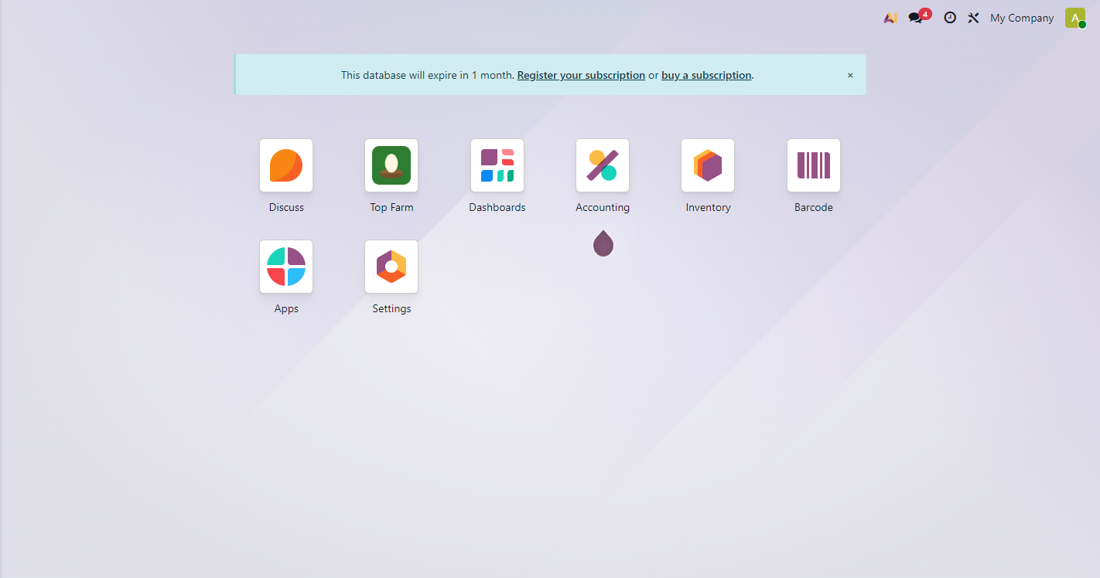
Figure 1. Home screen with the Top Farm app
After installation, Top Farm appears as its own application (green egg icon). Only users with a Poultry Farm role see it (compare Figure 31).
The blue banner is the standard Odoo Enterprise notice for an unregistered test database. It has nothing to do with the module.

Figure 2: Top Farm Core in the Apps list
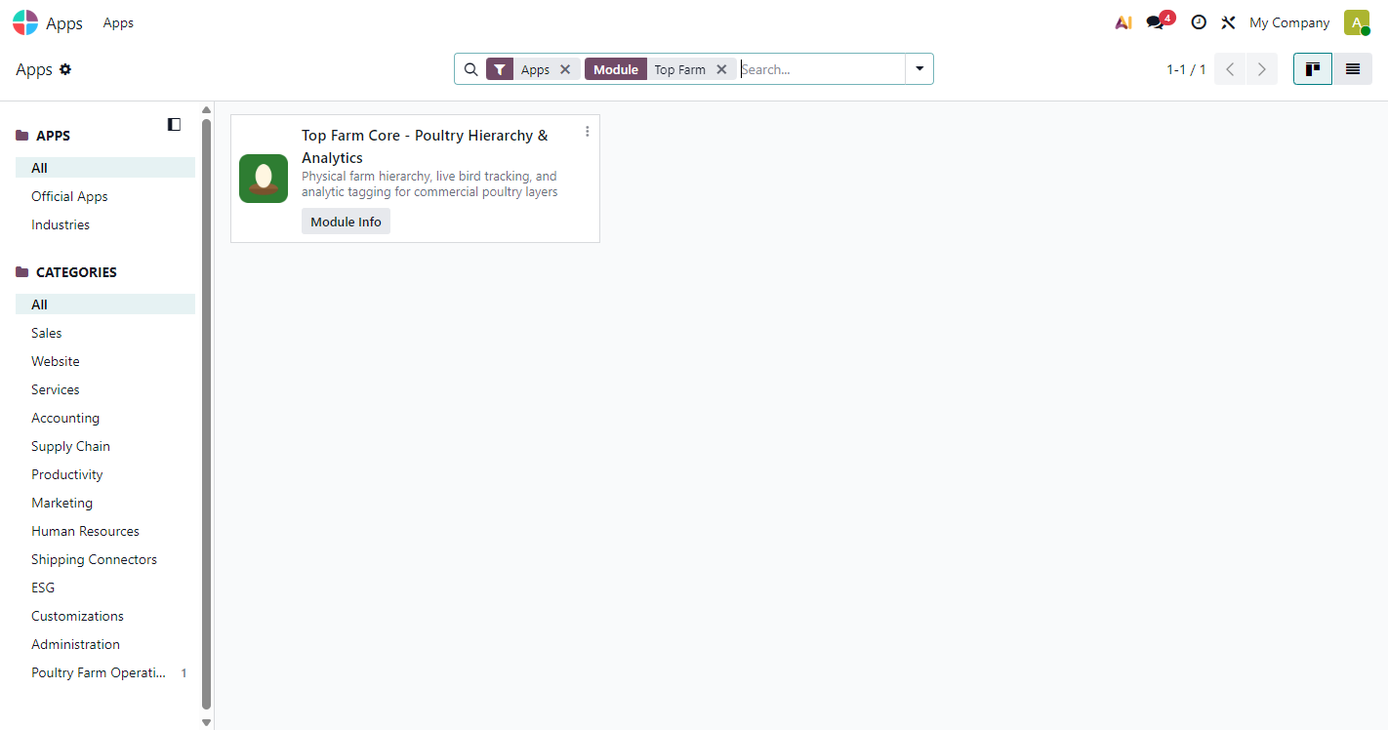
Figure 2. Top Farm Core in the Apps list
Apps > search "Top Farm". The module Top Farm Core - Poultry Hierarchy & Analytics is installed and has its own category, Poultry Farm Operations. It depends on Discuss (mail), Inventory, Stock Accounting and Analytic.

Figure 3: Top Farm menu structure
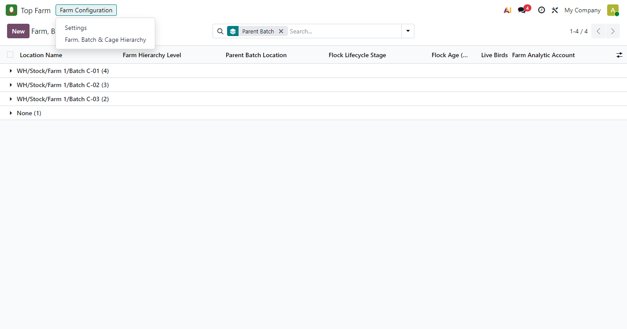
Figure 3. Top Farm menu structure
Top Farm > Farm Configuration now holds two entries: Settings (only for Settings administrators) and Farm, Batch & Cage Hierarchy. Modules 2 to 4 will add their own menus inside the same app.

4.2 Farm, batch and cage hierarchy

Figure 4: Hierarchy list grouped by parent batch
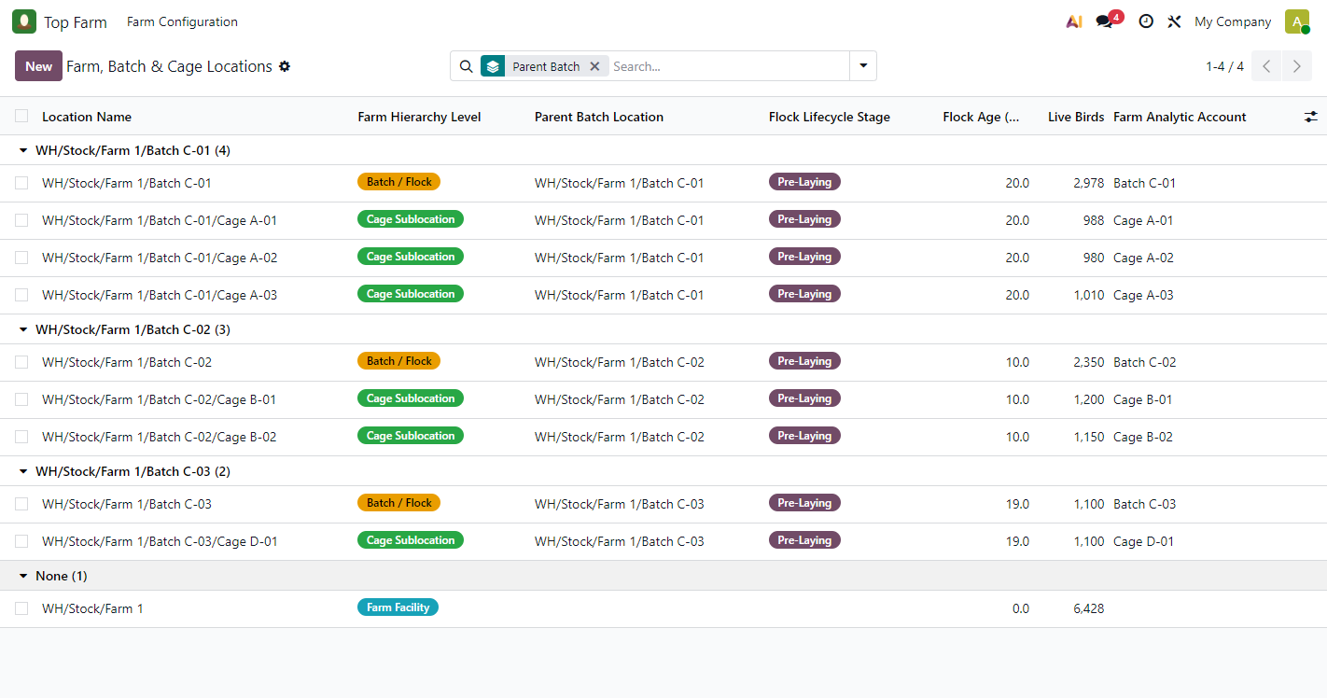
Figure 4. Hierarchy list grouped by parent batch
The main working list, grouped by Parent Batch. Stages now show the plain names Pre-Laying, Laying Phase and Spent Hen / Depleted; the live age is in the Flock Age column.
What to check
- Batch C-01 shows 2,978 birds = 988 + 980 + 1,010 (its three cages).
- Farm 1 shows 6,428 = all three batches together.
- All three flocks start as Pre-Laying: C-01 at 20.0 weeks, C-02 at 10.0 weeks, C-03 at 19.0 weeks.

Figure 5: Farm Facility form (Farm 1)
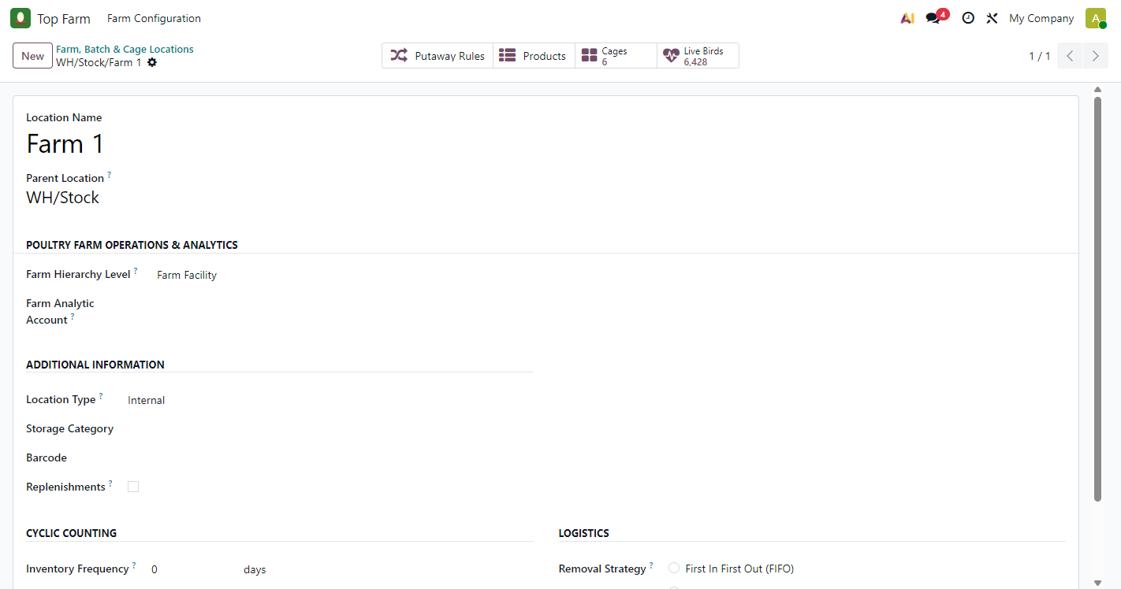
Figure 5. Farm Facility form (Farm 1)
For a farm only the level and an optional analytic account apply; stage, arrival date and chatter are hidden. Smart buttons: Cages 6 and Live Birds 6,428.

Figure 6: Batch / Flock form before the daily check
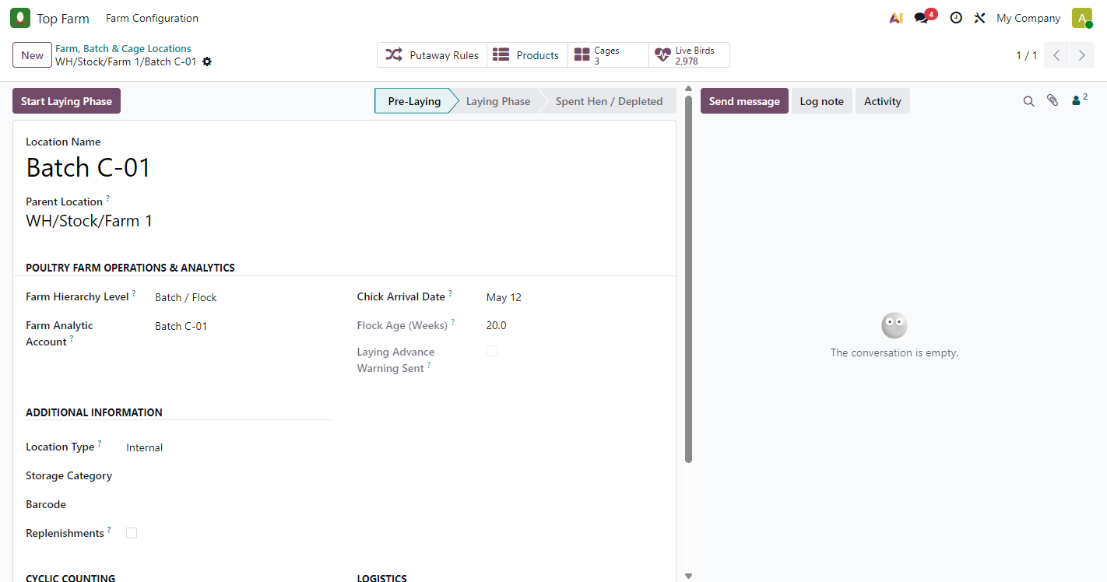
Figure 6. Batch / Flock form before the daily check
The batch form has the Start Laying Phase button (managers only), the status bar Pre-Laying > Laying Phase > Spent Hen / Depleted and, on the right, the chatter.
Chick Arrival Date 12 May gives a Flock Age of 20.0 weeks. Laying Advance Warning Sent is still unticked: the daily check has not run yet, so the conversation is empty.

Figure 7: Cage Sublocation form (Cage A-01)
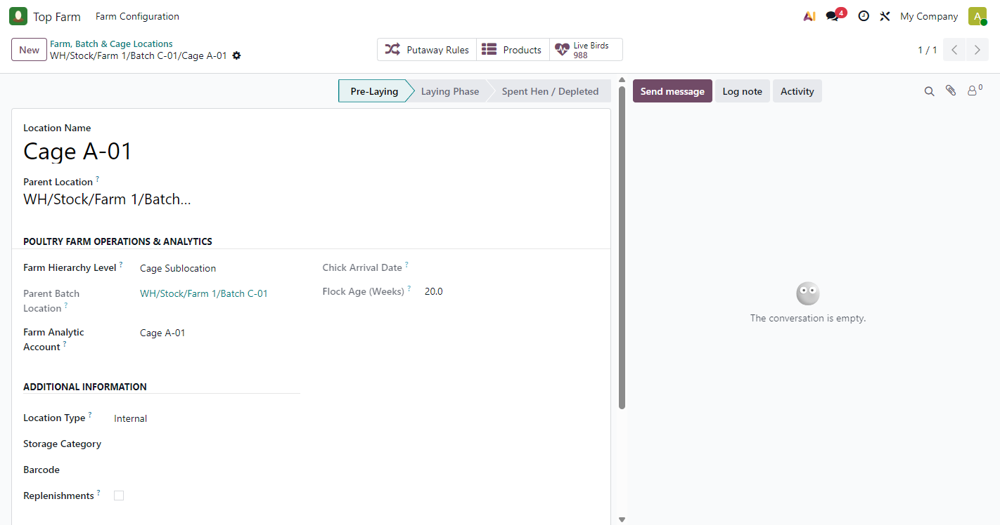
Figure 7. Cage Sublocation form (Cage A-01)
Parent Batch Location is filled in automatically and cannot be edited. The cage takes its stage and age (20.0 weeks) from Batch C-01 and has its own analytic account, Cage A-01. Live Birds 988 = 1,000 received minus 12 recorded as mortality (Figure 24).

Figure 8: Cages smart button
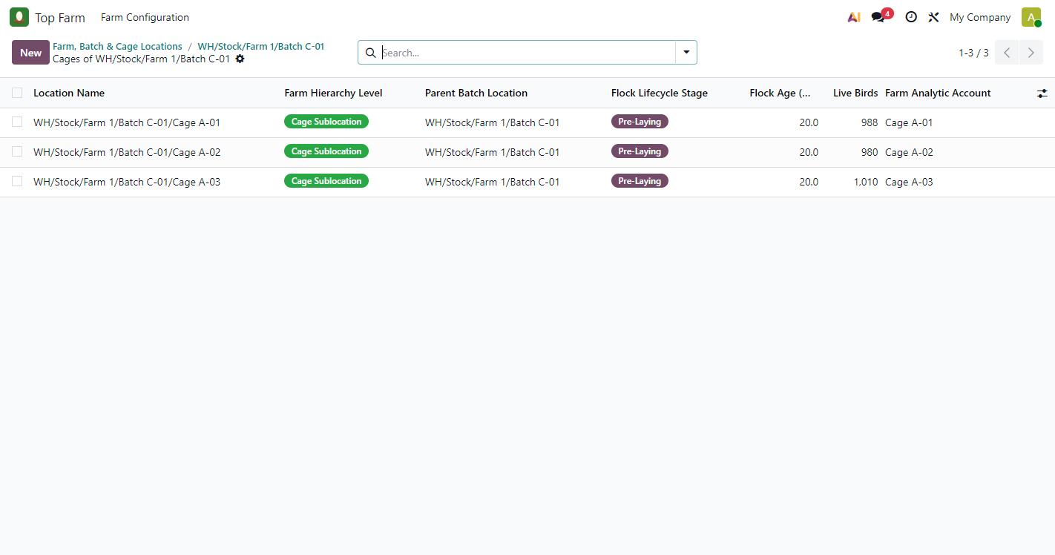
Figure 8. Cages smart button
Clicking Cages on Batch C-01 lists its three cages. Creating a new record from this list pre-fills the parent (the batch) and the level (Cage).

Figure 9: Live Birds smart button: on-hand birds with their hatchery lot
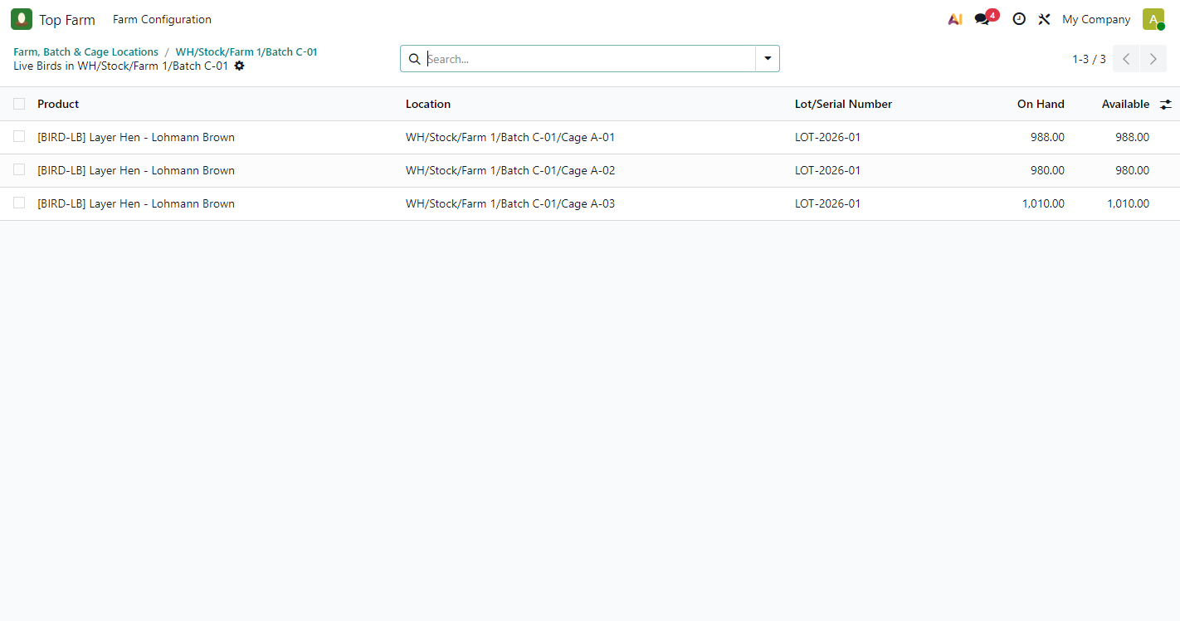
Figure 9. Live Birds smart button: on-hand birds with their hatchery lot
Clicking Live Birds opens the on-hand stock of products flagged "Is Live Farm Bird" in the batch and its cages, with the hatchery lot LOT-2026-01 on every cage. The numbers come straight from stock, so there are no manual counters to keep in step.

Figure 10: Search filters and group-by options
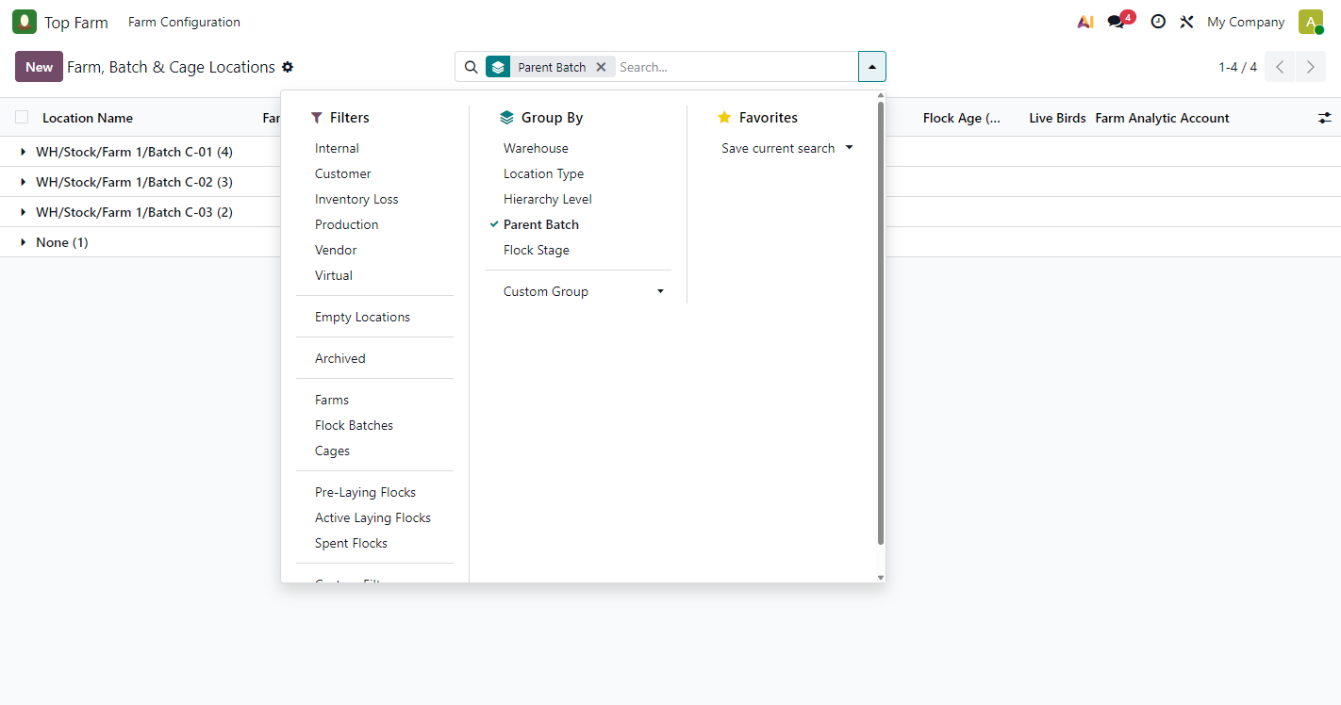
Figure 10. Search filters and group-by options
Filters: Farms, Flock Batches, Cages and Pre-Laying Flocks, Active Laying Flocks, Spent Flocks. Group by: Hierarchy Level, Parent Batch, Flock Stage. The same options appear in Inventory > Configuration > Locations.

4.3 Flock lifecycle: settings, alerts and the Laying Phase

Figure 11: Top Farm Settings (Manual mode)
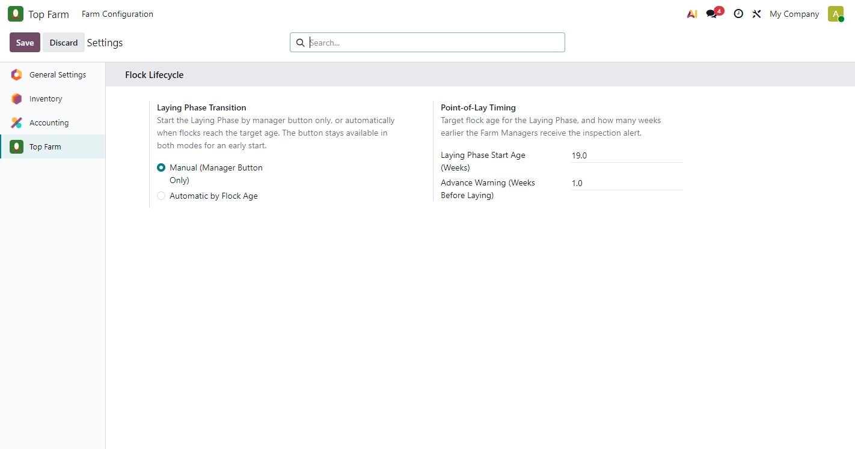
Figure 11. Top Farm Settings (Manual mode)
Top Farm > Farm Configuration > Settings opens the Top Farm tab of Odoo Settings. Laying Phase Transition chooses Manual (Manager Button Only) or Automatic by Flock Age. Point-of-Lay Timing sets the start age (19.0 weeks) and how many weeks earlier the alert is sent (1.0).
The settings are per company. An advance warning that is not smaller than the start age, or a start age of 0, is refused.

Figure 12: The daily flock check (scheduled action)
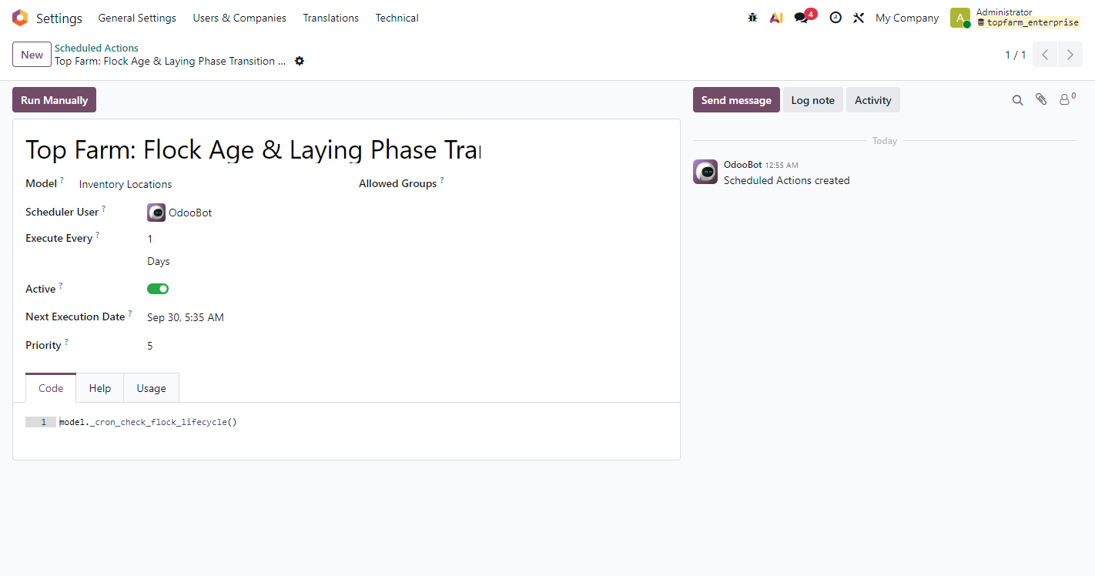
Figure 12. The daily flock check (scheduled action)
Settings > Technical > Scheduled Actions (debug mode). Top Farm: Flock Age & Laying Phase Transition Check runs every day at 00:05 server time (UTC), shown here in the viewer's local time. For this test it was started with Run Manually instead of waiting for the night run.

Figure 13: Point-of-lay alert and inspection To-Dos (Manual mode)
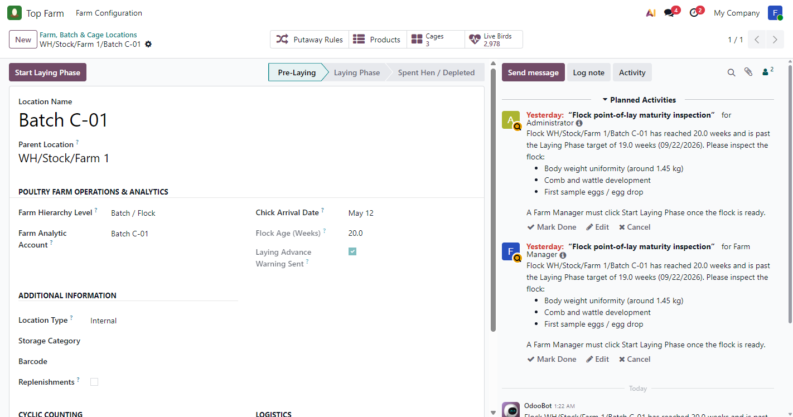
Figure 13. Point-of-lay alert and inspection To-Dos (Manual mode)
After the daily check, Batch C-01 has an inspection alert in its chatter and a Point-of-Lay Inspection To-Do for each Farm Manager (Administrator and Farm Manager), with the checklist: body weight uniformity (about 1.45 kg), comb and wattle development, first sample eggs. Laying Advance Warning Sent is now ticked, so the alert is never repeated for this flock.
C-01 was already 20.0 weeks old when first checked, so the alert says it is past the Laying Phase target and the To-Dos are due immediately (shown as overdue). In Manual mode the stage stays Pre-Laying. The same run also alerted C-03 (19.0 weeks); C-02 (10 weeks) was left alone.

Figure 14: Farm Manager starts the Laying Phase
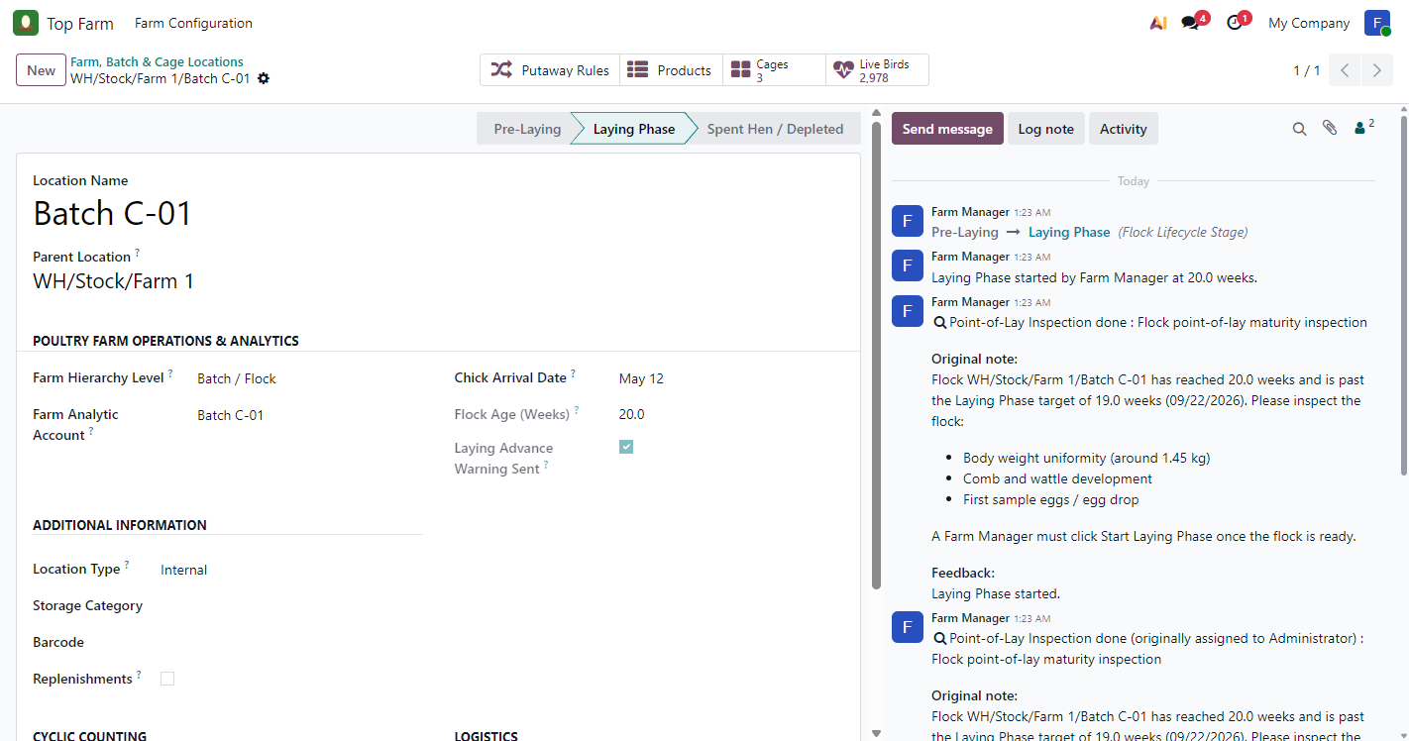
Figure 14. Farm Manager starts the Laying Phase
Logged in as Farm Manager, the manager clicked Start Laying Phase. The chatter shows the stage change Pre-Laying > Laying Phase, the note "Laying Phase started by Farm Manager at 20.0 weeks", and both inspection To-Dos marked done with the feedback "Laying Phase started." The button is gone because it is only offered while the flock is Pre-Laying.

Figure 15: Settings switched to Automatic
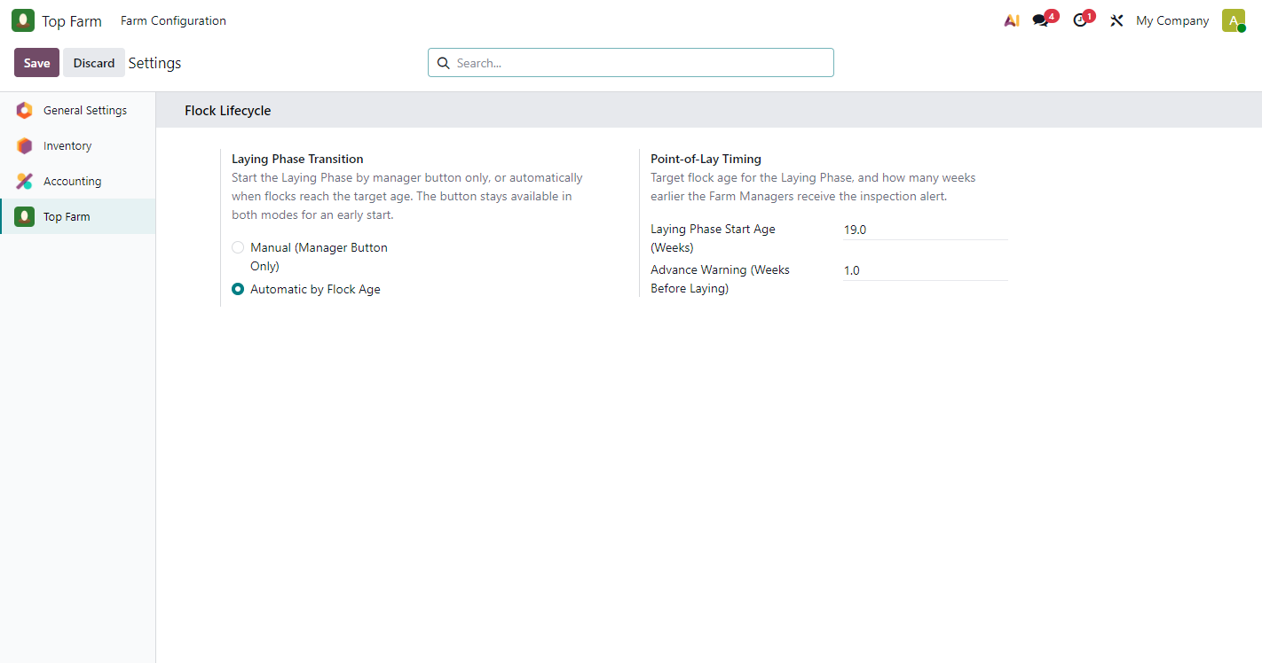
Figure 15. Settings switched to Automatic
The administrator switched Laying Phase Transition to Automatic by Flock Age and saved. From now on the daily check starts the Laying Phase itself when a flock reaches 19.0 weeks.

Figure 16: Automatic Laying Phase at the target age (Batch C-03)
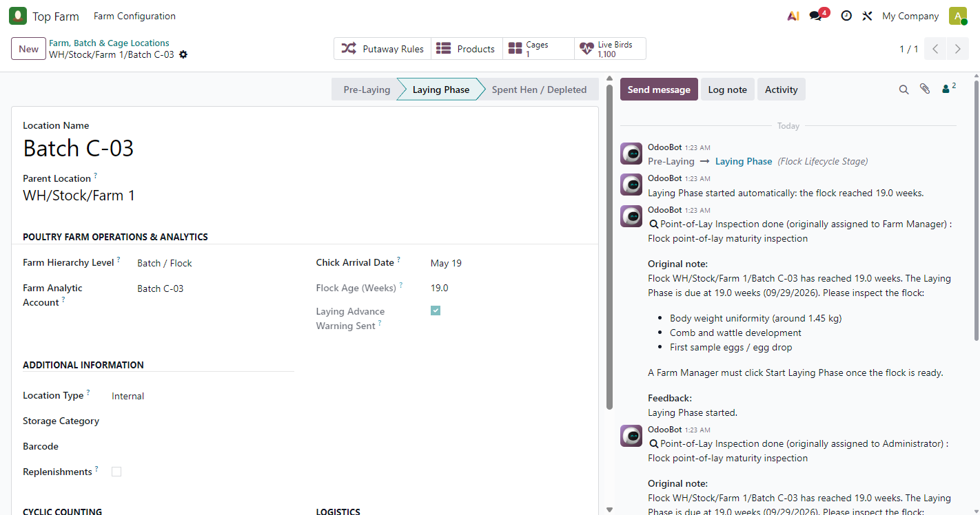
Figure 16. Automatic Laying Phase at the target age (Batch C-03)
The next daily check found Batch C-03 at 19.0 weeks and started its Laying Phase automatically. The chatter shows the stage change by OdooBot (the scheduler user), "Laying Phase started automatically: the flock reached 19.0 weeks.", and the inspection To-Dos from the earlier alert closed automatically.

Figure 17: Hierarchy after the transitions
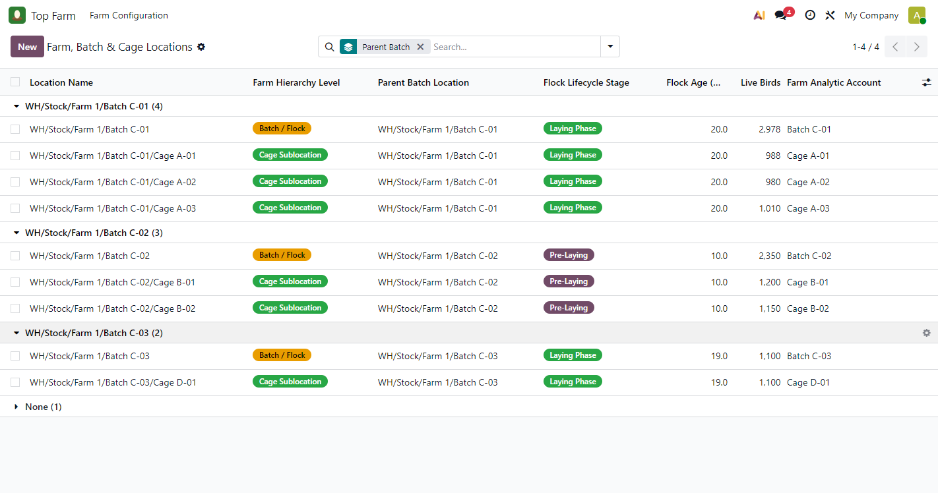
Figure 17. Hierarchy after the transitions
Batch C-01 (manager button) and Batch C-03 (automatic) are in Laying Phase together with their cages. Batch C-02, at 10 weeks, is still Pre-Laying and received no alert.

Figure 18: Cages grouped by flock stage
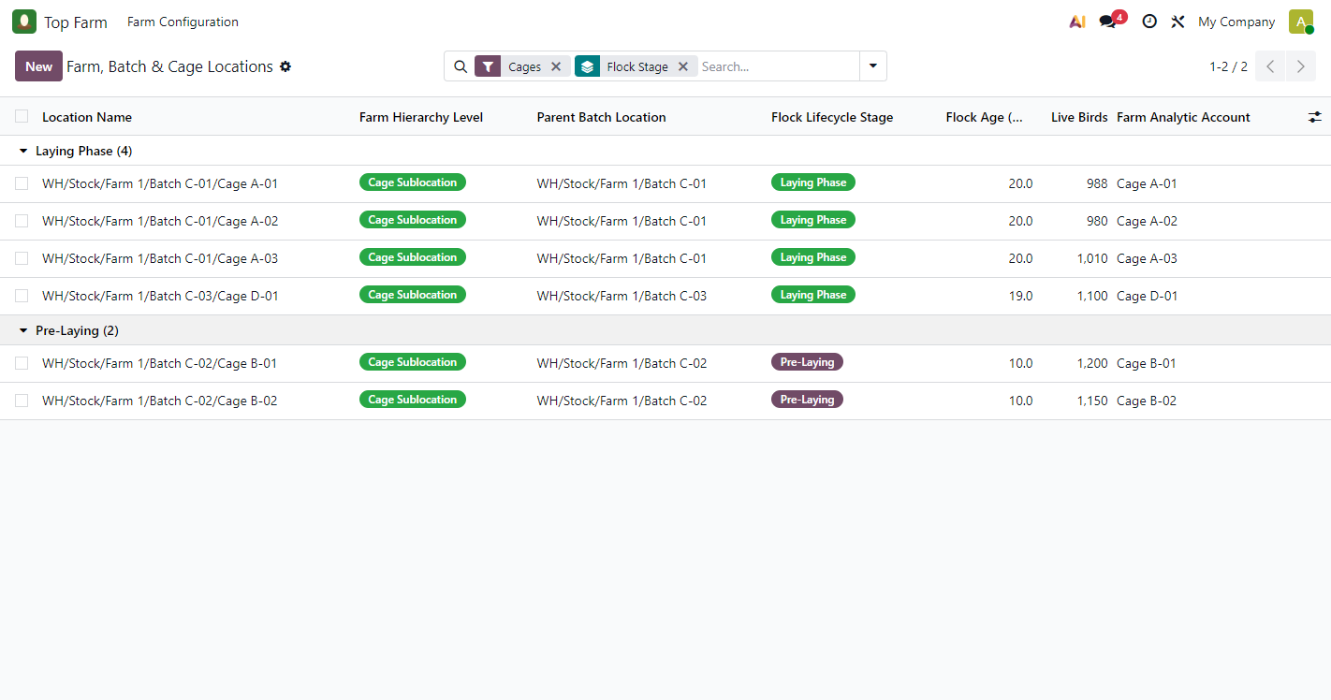
Figure 18. Cages grouped by flock stage
Filter "Cages" with group-by "Flock Stage": Laying Phase (4), the C-01 cages and D-01, and Pre-Laying (2), the C-02 cages. Cages always follow their batch; their stage cannot be set by hand.

4.4 Validation guards

Figure 19: Guard: a cage must sit under a batch
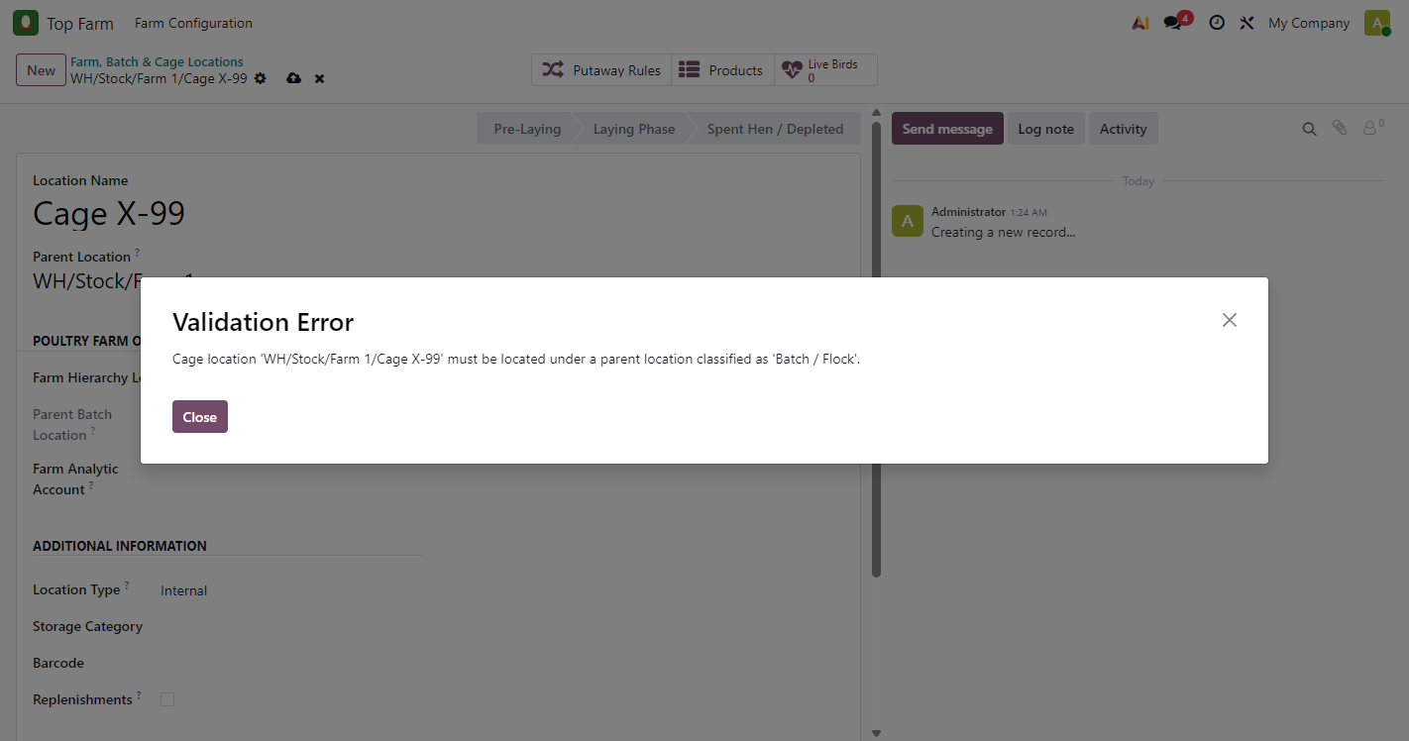
Figure 19. Guard: a cage must sit under a batch
We tried to create "Cage X-99" directly under Farm 1. Odoo refused to save it with a Validation Error. The same guard stops a batch from being unclassified while cages are still under it.

Figure 20: Guard: batch and cage accounts must come from different analytic plans
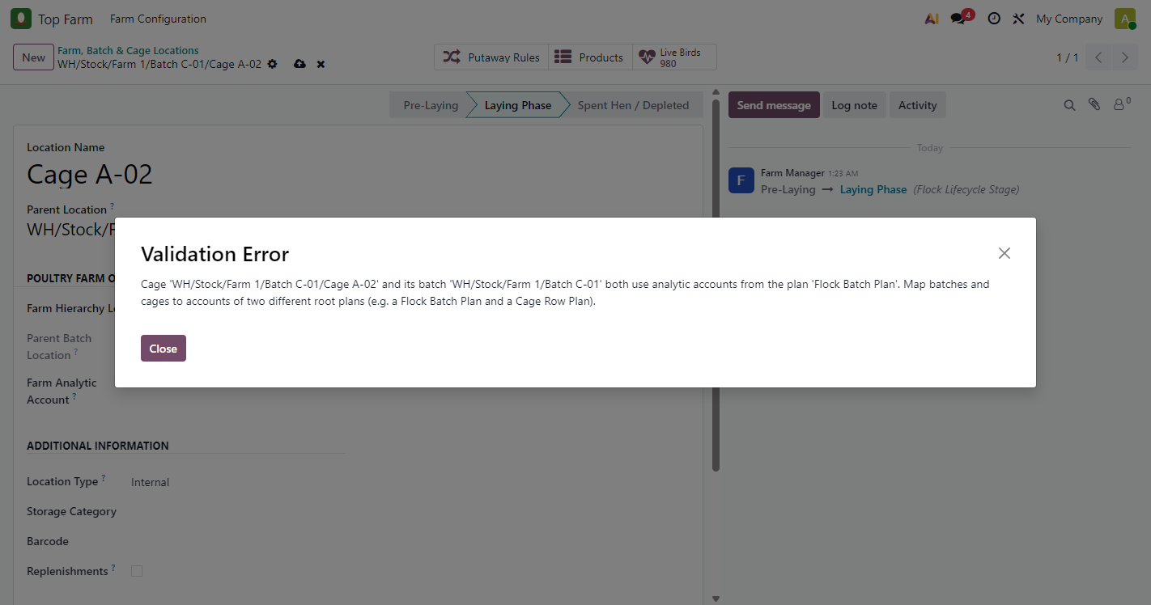
Figure 20. Guard: batch and cage accounts must come from different analytic plans
We tried to give Cage A-02 the account "Batch C-02" (Flock Batch Plan, like its own batch). Odoo refused: each cost is one analytic line with one column per plan, so two accounts from the same plan would collide and one would be silently lost.

4.5 Product set-up

Figure 21: The "Is Live Farm Bird" flag on the product
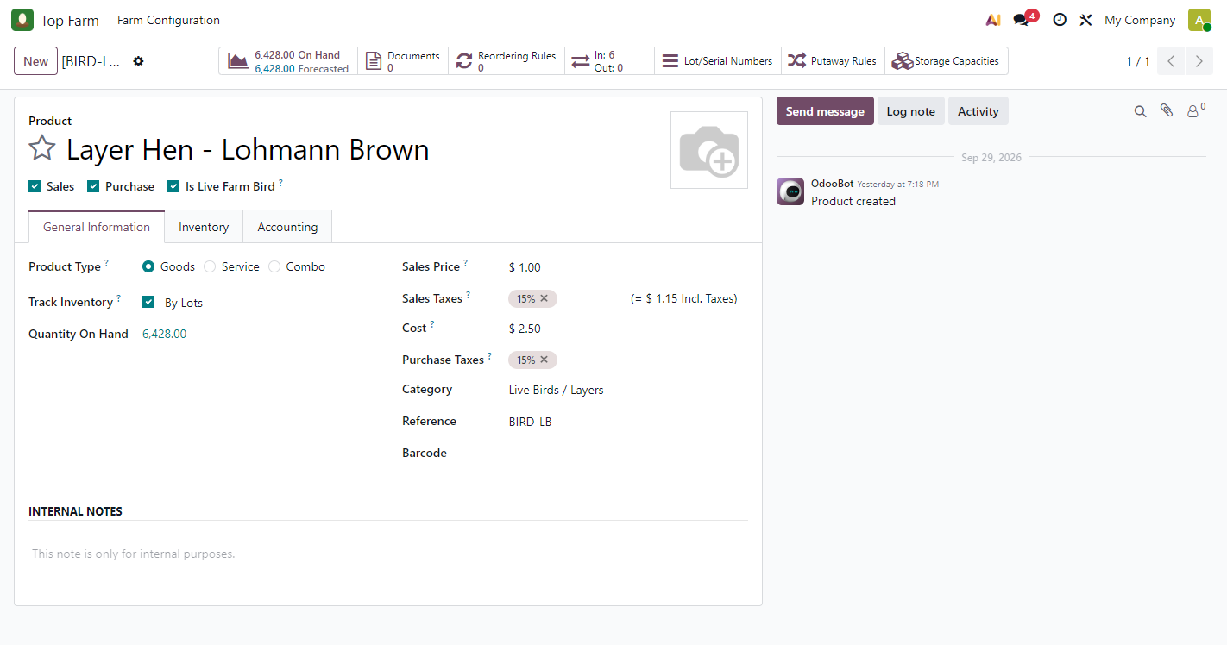
Figure 21. The "Is Live Farm Bird" flag on the product
A new checkbox, Is Live Farm Bird, sits next to Sales / Purchase. Only flagged products are counted as live birds, so feed, medicine and eggs never are. The layer hen product is tracked by lots, category "Live Birds / Layers", cost 2.50.

4.6 Analytic accounting

Figure 22: Analytic plans
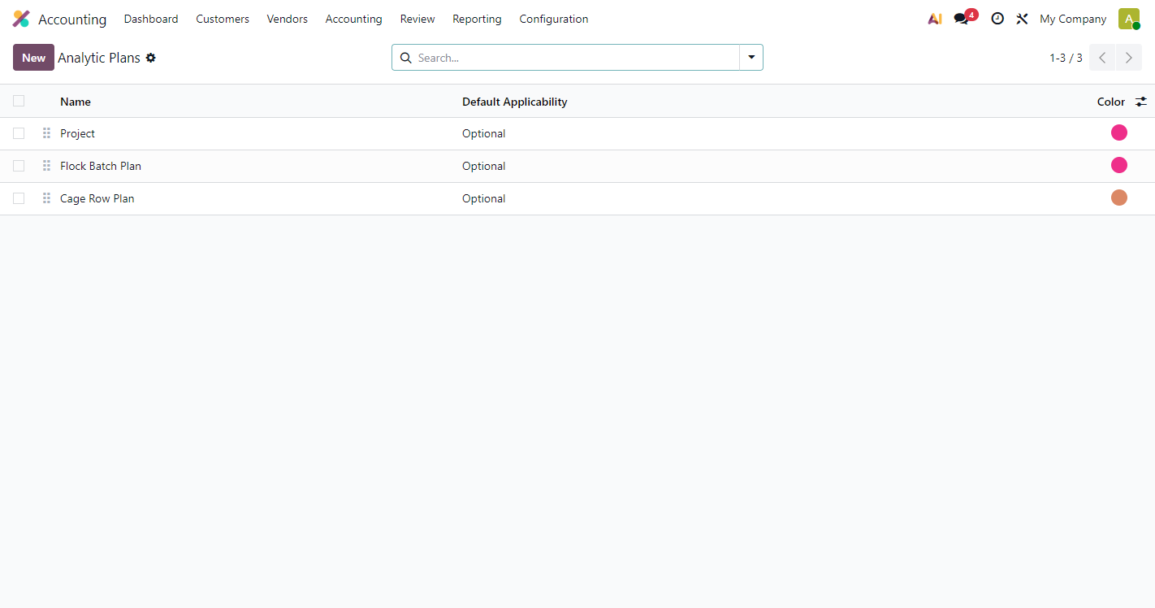
Figure 22. Analytic plans
Accounting > Configuration > Analytic Plans. Flock Batch Plan and Cage Row Plan are separate root plans, so each has its own column on analytic items. "Project" is Odoo's default plan and is not used by the farm.

Figure 23: Analytic items created by the stock-move hook
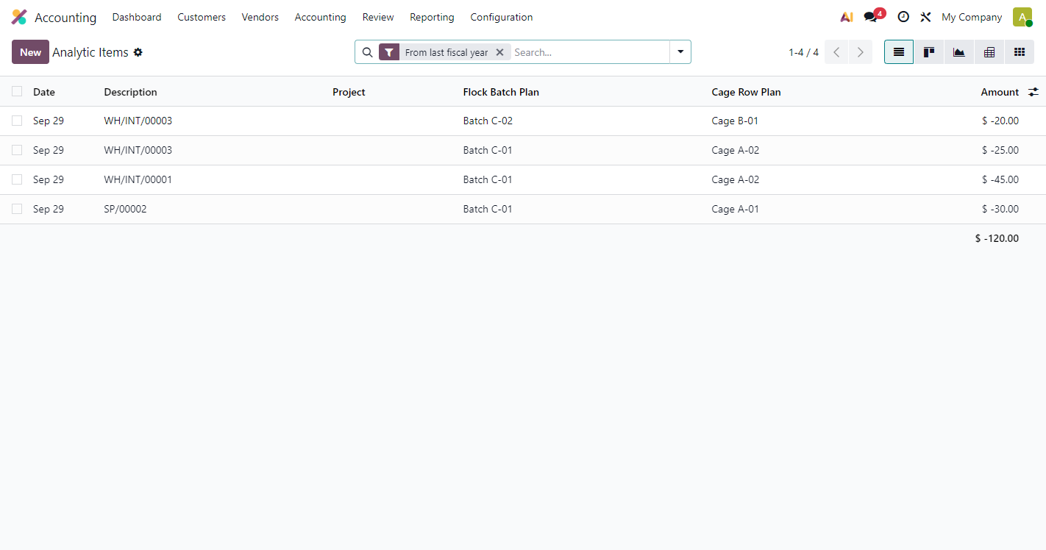
Figure 23. Analytic items created by the stock-move hook
Each cost-bearing stock move produced one analytic line with both the Flock Batch Plan and Cage Row Plan columns filled, so no cost is duplicated.
What to check
- SP/00002 (mortality): -30.00 = 12 birds x 2.50, charged to Batch C-01 / Cage A-01.
- WH/INT/00003 (feed, after the fix): -25.00 (50 kg) to Batch C-01 / Cage A-02 and -20.00 (40 kg) to Batch C-02 / Cage B-01.
- WH/INT/00001 is the same feed issue recorded before defect D-02 was fixed (all -45.00 on Cage A-02). It is kept as evidence (section 6).

Figure 24: Mortality scrap from a cage
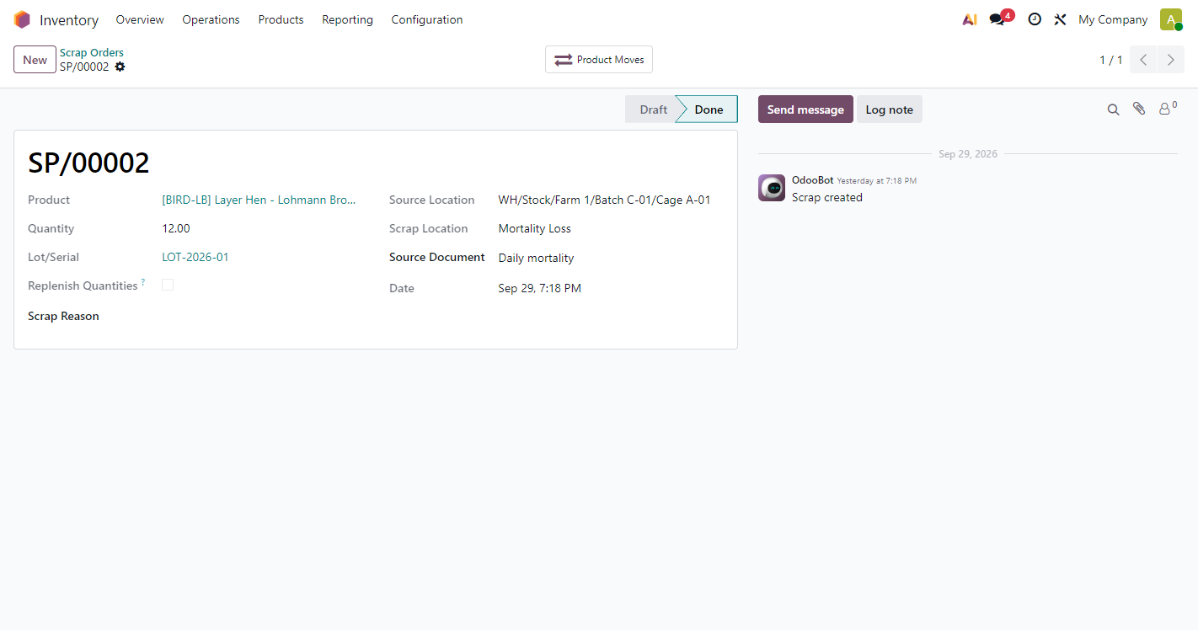
Figure 24. Mortality scrap from a cage
Inventory > Operations > Scrap. 12 birds of lot LOT-2026-01 scrapped from Cage A-01 to Mortality Loss. The source is a cage, so the cost was charged to Batch C-01 / Cage A-01 automatically. Module 3 will create these scraps from the daily mortality log.

Figure 25: Journal entry of the mortality scrap
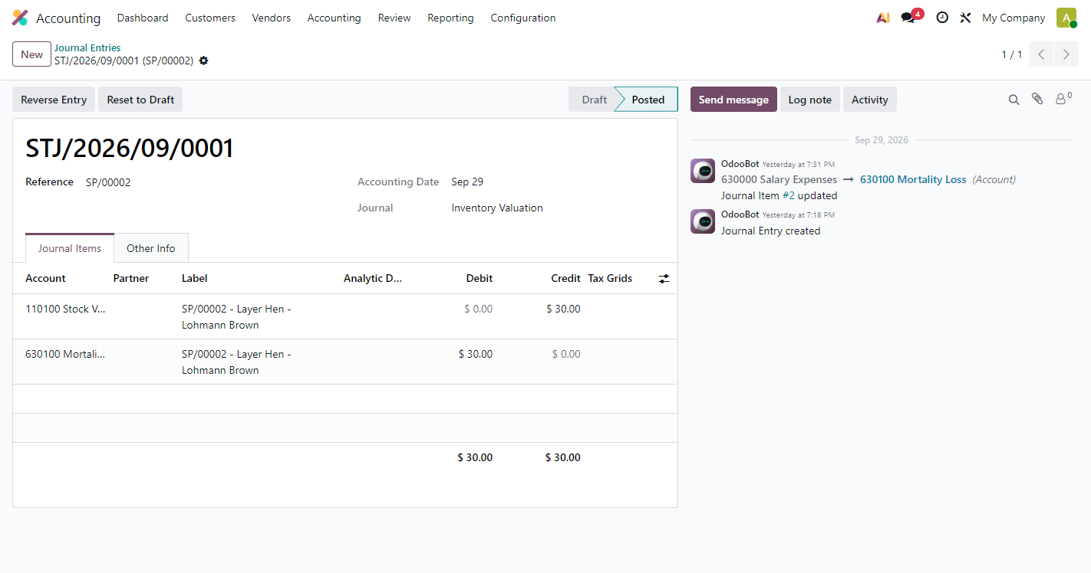
Figure 25. Journal entry of the mortality scrap
Perpetual valuation posts Debit 630100 Mortality Loss 30.00 / Credit 110100 Stock Valuation 30.00. The Batch / Cage split lives on the analytic items (Figure 23), so the cost is not counted twice. The chatter shows the account correction from 630000 to 630100 (finding D-03).

Figure 26: Feed issue transfer with two cage lines
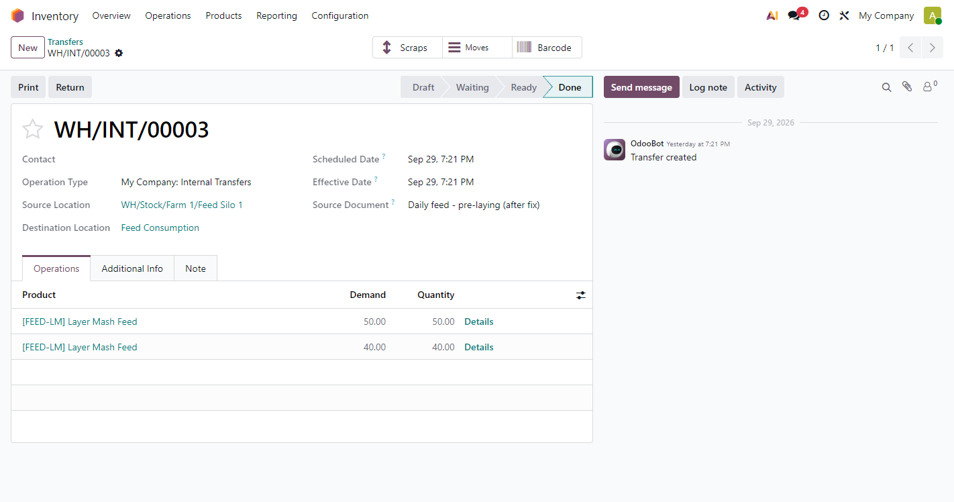
Figure 26. Feed issue transfer with two cage lines
WH/INT/00003 moves feed from Feed Silo 1 to Feed Consumption: 50 kg and 40 kg, each charged to a different cage (set by Module 2's feed log; not shown on this screen). After the D-02 fix the two lines stay separate when the transfer is confirmed.

4.7 Security roles

Figure 27: Poultry Farm access rights on the user form
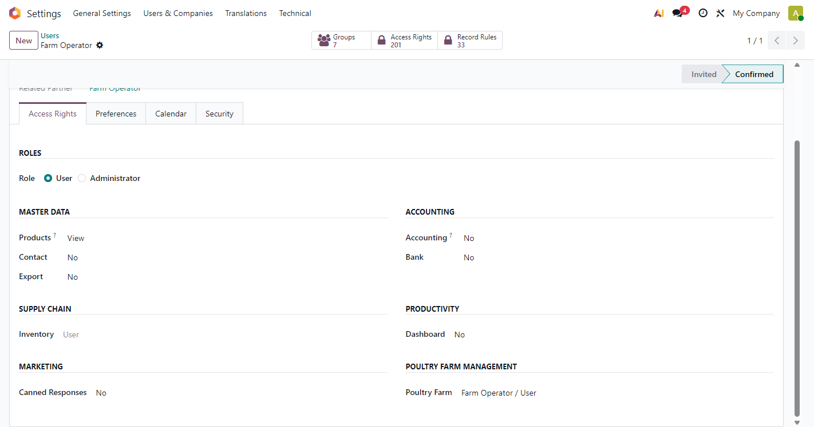
Figure 27. Poultry Farm access rights on the user form
Settings > Users > Farm Operator > Access Rights: section Poultry Farm Management, role Farm Operator / User or Farm Manager / Supervisor. Farm Operator includes Inventory User; Farm Manager includes Inventory Administrator.

Figure 28: Home screen as Farm Operator
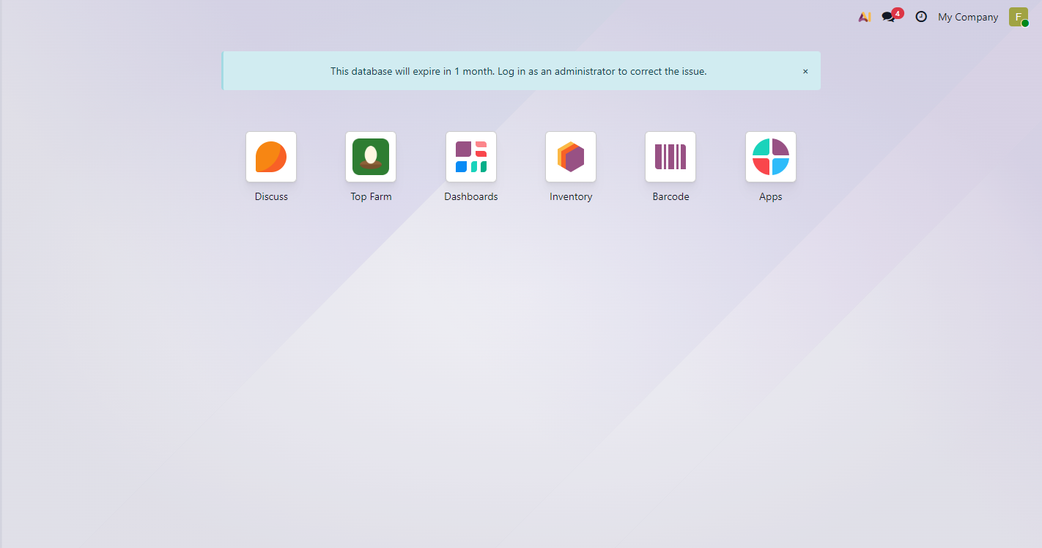
Figure 28. Home screen as Farm Operator
The operator sees Top Farm and Inventory, but not Accounting or Settings.

Figure 29: Batch form as Farm Operator
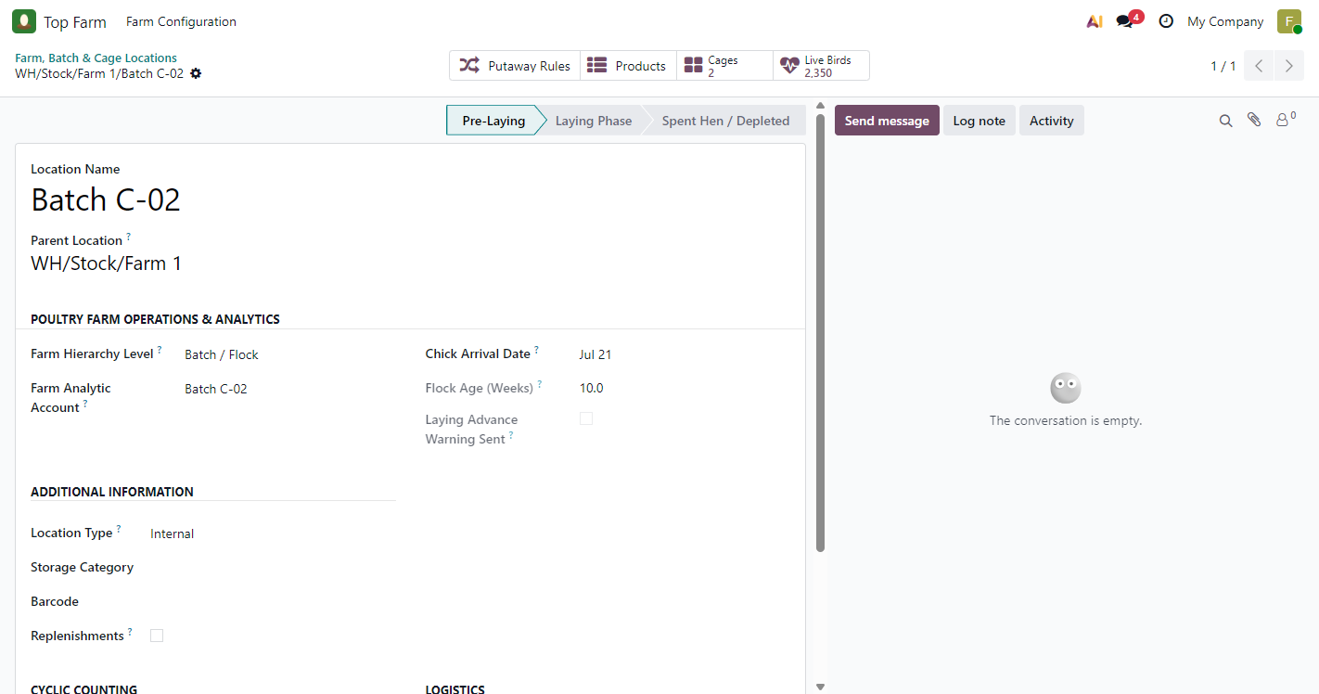
Figure 29. Batch form as Farm Operator
The operator sees the flock information, status bar and chatter, but no Start Laying Phase button: the transition is reserved for managers, and the server enforces it too (tests 08 and 27).

Figure 30: Operator actions menu: no Delete or Duplicate
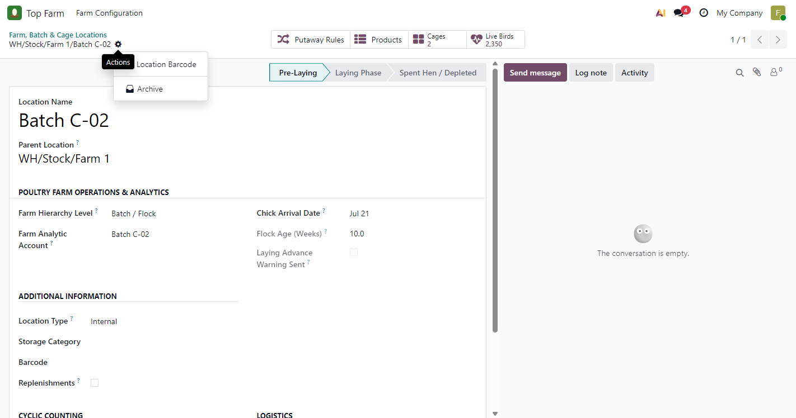
Figure 30. Operator actions menu: no Delete or Duplicate
Operators can view and edit farm locations but cannot create or delete them, so the actions menu offers only Location Barcode and Archive. A delete attempted through the API is refused (test 08).

Figure 31: Home screen as a plain inventory user
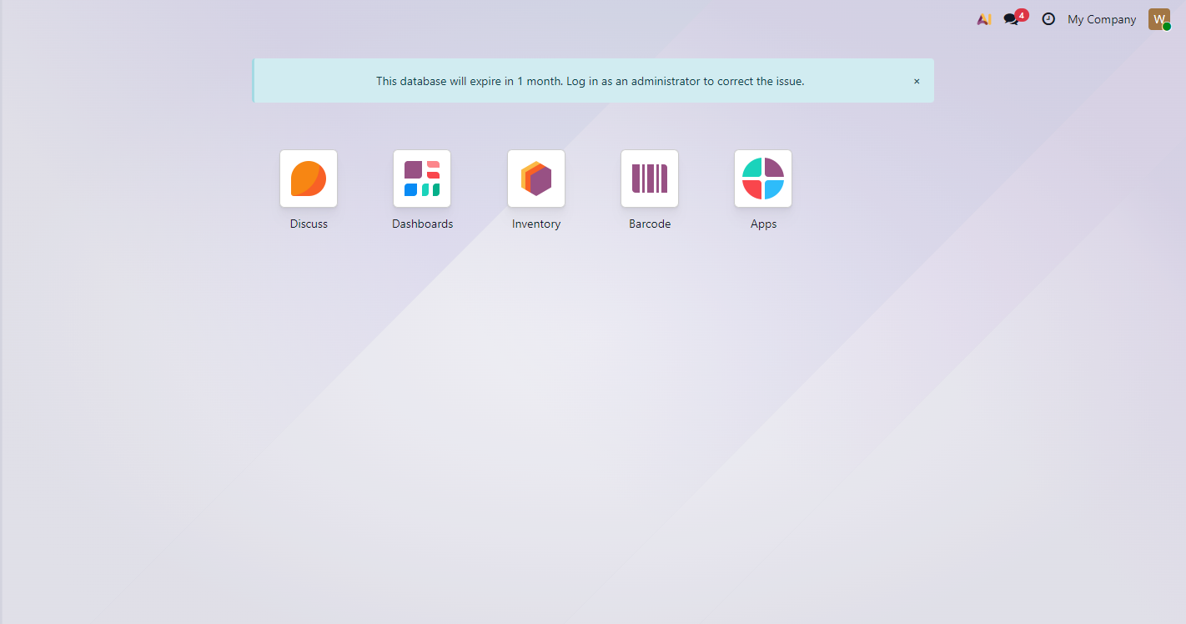
Figure 31. Home screen as a plain inventory user
"Warehouse Clerk" has Inventory access but no Poultry Farm role, so the Top Farm app is not shown.

Figure 32: Location form as a plain inventory user
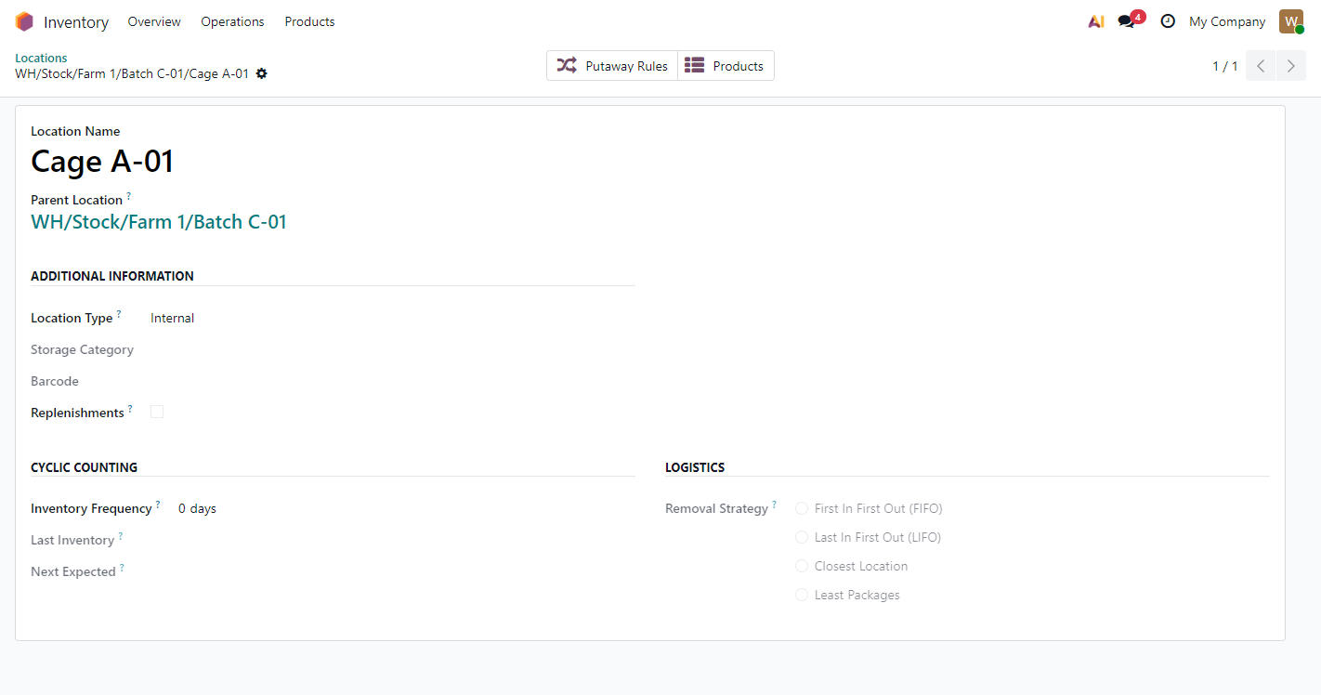
Figure 32. Location form as a plain inventory user
The same Cage A-01 from Inventory > Configuration > Locations shows no farm section, no status bar, no farm smart buttons and no chatter: all farm fields are limited to the Poultry Farm roles.

5. Test results

5.1 Automated tests
Command: odoo-bin -d topfarm_enterprise -u top_farm_core --test-enable --test-tags=/top_farm_core. Runner result: "0 failed, 0 error(s) of 27 tests" on Enterprise, and the same on the Community database topfarm_core_t1. Tests 01 to 08 cover the core module; tests 20 to 29 cover the flock lifecycle update.
# | Test | What it checks | Result | Time (s)
1 | test_01_parent_batch_auto_resolution | A cage resolves its batch; a batch resolves to itself; a farm has none. | PASS | 0.01
2 | test_01b_parent_batch_through_unclassified_row | A cage under an unclassified row still finds the batch above the row. | PASS | 0.04
3 | test_01c_moving_a_cage_follows_the_new_batch | Moving a cage to another batch updates its batch and its stage. | PASS | 0.05
4 | test_02_orphan_cage_raises_validation_error | A cage directly under a farm is refused. | PASS | 0.02
5 | test_02b_unclassifying_a_batch_orphans_its_cages | A batch cannot stop being a batch while cages are under it. | PASS | 0.02
6 | test_03_flock_age_calculation | Arrival 140 days ago gives 20.0 weeks on the batch and its cages. | PASS | 0.01
7 | test_04_analytic_distribution_format | Cage distribution is {"batch,cage": 100}; the batch alone uses only its own account. | PASS | 0.01
8 | test_04b_same_plan_accounts_rejected | Batch and cage accounts from the same plan are refused. | PASS | 0.04
9 | test_05_stage_transition_propagation | Manager starts laying; cages follow; a new cage joins at Laying; non-farm locations have no stage; a second start is refused. | PASS | 0.12
10 | test_06_live_bird_count | 1,000 birds in a cage count on cage, batch and farm; feed in the same cage is not counted. | PASS | 0.04
11 | test_07_analytic_hook_scrap_from_cage | An outgoing move from a cage creates one line with both plan columns (-25.00); a move without a reference still gets a line name (fix D-01). | PASS | 0.13
12 | test_07a_analytic_hook_mortality_scrap | A real stock.scrap of 4 birds: one line, both columns, -10.00; live count drops to 96. | PASS | 0.14
13 | test_07b_analytic_hook_explicit_cage_on_feed_move | Feed issued from the silo is charged to the cage stamped on the move. | PASS | 0.12
14 | test_07b2_feed_for_two_cages_in_one_picking | Two cage lines in one transfer are not merged: -25.00 and -20.00 on their own cages (fix D-02). | PASS | 0.36
15 | test_07c_incoming_moves_stay_untagged | Birds arriving into a cage create no analytic cost. | PASS | 0.08
16 | test_08_security_access_rights | An operator can read the counts, but starting the laying phase and deleting a cage both raise Access Denied. | PASS | 2.32
17 | test_20_stage_labels_have_no_week_ranges | Stage labels are exactly Pre-Laying, Laying Phase, Spent Hen / Depleted. | PASS | 0.00
18 | test_21_manual_mode_warns_once_and_waits | Week 18.0, Manual: one To-Do per manager (none for operators), due on the target date, chatter alert; a second run adds nothing; no transition even past the target. | PASS | 0.46
19 | test_21b_overdue_flock_warning_says_past_target | A flock first checked at 20.0 weeks gets a "past the target" alert and To-Dos due today. | PASS | 0.27
20 | test_22_manager_button_closes_the_inspection | Manager button: Laying, cages follow, inspection To-Dos marked done, "started by" note. | PASS | 0.37
21 | test_23_automatic_mode_transitions_at_target_age | Automatic, 19.0 weeks: the check starts Laying, cages follow, no To-Do left open, "started automatically" note. | PASS | 0.07
22 | test_24_automatic_mode_warns_before_target | Automatic, 18.3 weeks: alert sent, flock stays Pre-Laying. | PASS | 0.26
23 | test_25_early_button_in_automatic_mode | Automatic, 18.3 weeks: the manager starts laying early; the next check leaves the flock alone. | PASS | 0.09
24 | test_26_young_flock_is_left_alone | 10 weeks: no alert, no To-Do, no transition. | PASS | 0.03
25 | test_27_context_cannot_bypass_the_manager_check | An operator sending the plan's auto_transition context is still refused (Access Denied). | PASS | 0.02
26 | test_28_new_arrival_date_rearms_the_warning | Entering a new arrival date clears "Laying Advance Warning Sent" for the next flock. | PASS | 0.26
27 | test_29_invalid_settings_rejected | An advance warning equal to the start age, or a start age of 0, is refused. | PASS | 0.38

5.2 Acceptance checklist: Module 1 plan (section 7)
# | Scenario | Expected | Actual | Status | Evidence
1 | Hierarchy creation | Cage A-01 resolves Parent Batch = Batch C-01 | Resolved automatically, read-only on the cage | PASS | Fig. 4, 7; test 01
2 | Orphan cage guard | A cage under a farm is blocked | Validation Error; record not saved | PASS | Fig. 19; test 02
3 | Flock age | Arrival 140 days ago shows 20.0 weeks on batch and cages | 20.0 on Batch C-01 and all its cages | PASS | Fig. 6, 7; test 03
4 | Lifecycle transition | Manager starts laying; stage passes to the cages | C-01 and its 3 cages Laying; C-02 unchanged | PASS | Fig. 14, 17; tests 05, 22
5 | Live bird counter | 1,000 birds into Cage A-01 show on the cage and the batch | 1,000 received, 12 dead: cage 988; batch 2,978 | PASS | Fig. 4, 9; test 06
6 | Analytic hook | Move out of a cage gives one line with batch + cage columns | SP/00002: one line -30.00, C-01 / A-01 | PASS | Fig. 23; tests 07, 07a
7 | Security | Operator cannot delete or start laying | No button, no Delete; server refuses both | PASS | Fig. 29, 30; tests 08, 27

5.3 Acceptance checklist: flock lifecycle plan (section 4)
# | Scenario | Expected | Actual | Status | Evidence
1 | Clean stage display | Pre-Laying, Laying Phase, Spent Hen / Depleted without week ranges | Plain names on forms, lists and filters; age shown separately | PASS | Fig. 4, 6, 17; test 20
2 | Advance activity (Manual) | Week 18.0: manager gets an inspection To-Do; batch stays Pre-Laying | To-Do per manager with checklist; stage unchanged; sent once | PASS | Fig. 13; tests 21, 21b
3 | Manual button | Manager clicks Start Laying Phase; cages follow; To-Do done | C-01 and cages Laying; both To-Dos done | PASS | Fig. 14, 17; test 22
4 | Automatic transition | Automatic, 19.0 weeks: check sets Laying, cages follow, chatter note | C-03 and D-01 Laying by OdooBot; note posted | PASS | Fig. 15, 16; test 23
5 | Early button (Automatic) | Week 18.2: manager can start at once; the check does not re-trigger | Started at 18.3 weeks; the next check leaves it Laying | PASS | Test 25

6. Defects found and fixed
Testing on real transactions found three problems. All three are fixed and re-tested.
ID | Found in | Problem | Fix | Re-test
D-01 | Automated tests | A cost-bearing move with no picking, scrap or inventory reference crashed on validation: Odoo named the analytic line after the empty reference, and the name is mandatory. Module 2's nightly feed write-off would create exactly such moves. | The analytic line falls back to the product name when the move has no reference. | test 07 PASS
D-02 | Enterprise test data (WH/INT/00001) | Two feed lines for different cages in one transfer were merged by Odoo when the transfer was confirmed, so the whole 90 kg (-45.00) was charged to the first cage. | The cage now keeps moves apart, so lines for different cages are never merged. | test 07b2 PASS; WH/INT/00003 correct (Fig. 23)
D-03 | Configuration (plan section 6.3) | The plan's account codes already exist in Odoo's standard chart with other meanings: 600000 Expenses, 610000 Stock Variation (used by Odoo's own valuation), 630000 Salary Expenses. Mortality was first posted to Salary Expenses. | Test database uses dedicated accounts 600100 Feed Expense, 610100 Vet & Medication Expense and 630100 Mortality Loss; entries re-posted. | Fig. 25; confirm codes with the client's chart

7. Open items and recommendations
- Spent stage: nothing in Module 1 moves a flock to "Spent Hen / Depleted"; it belongs naturally to Module 3, since it usually goes with moving the birds out.
- Who receives the inspection To-Do: currently every active Farm Manager of the company gets one. If each farm has a single responsible supervisor, a "Flock Supervisor" field on the batch would target the To-Do better.
- Daily check time: the check runs at 00:05 server time (UTC) and uses the server date. For a farm in the Gulf that is 03:05 or 04:05 local time on the same day; adjust the schedule if a different time is wanted.
- Operator edit rights: as specified in the plan, operators can edit every location, including analytic accounts and hierarchy levels; only delete and the laying transition are blocked. Decide whether operators should be read-only on configuration.
- Account codes: agree the expense account codes with the client before go-live, avoiding codes already in their chart (D-03).
- Reporting source for Module 4: the Batch / Cage split is held on analytic items, so the dashboard's cage and batch P&L must read analytic items, not journal items.
- Module 2 contract: Module 2 must create mrp.production.farm_collection_id with exactly that name and should stamp farm_cage_location_id on feed moves; the core hook already listens for both.

Appendix A: Corrections to the Module 1 plan
The plan's code samples were checked against the Odoo 19 source before building. These items were changed so the module installs and behaves correctly on Odoo 19:
Plan item | Problem on Odoo 19 | What the module does instead
Security groups with category_id | Field removed in Odoo 19; the install would abort | Groups hang off a res.groups.privilege (Poultry Farm)
Live Birds button uses stock.quantsact | Action no longer exists; the button would crash | Uses Odoo's standard quant action with a farm-bird filter
Live birds matched by category name "Bird" | A "Bird Feed" category would count kilos of feed as birds | Only the Is Live Farm Bird flag counts
batch_stage default "Pre-Laying" on every location | Every warehouse location would show as a Pre-Laying flock | Only batches carry a stage; cages follow their batch
Hook reads MO fields directly | Crashes every move when Manufacturing is not installed | MO lookup is guarded; works with or without Module 2
Search view <group expand string> | Rejected by the Odoo 19 view validator | Group-by options added to the standard group
"Total Live Birds" sum in the list | Farm, batch and cage rows would be added together (triple count) | Sum removed
Test 05 run as the system bot | The bot is not a Farm Manager, so the test would fail | Tests use real manager and operator users

Appendix B: Corrections to the flock lifecycle plan
The same check was applied to the lifecycle plan before building version 19.0.1.1.0:
Plan item | Problem on Odoo 19 | What the module does instead
Adds mail but never makes locations chatter models | Every hasattr(self, 'activity_schedule') guard is False: no alert, no To-Do, silently | Locations inherit the chatter and activity mixins; batch and cage forms show the chatter
auto_transition=True in the context skips the manager check | Any user can send that context through the web API and start the Laying Phase | The check lives in the button; the daily check calls a private method (test 27)
manager_group.users | Field renamed in Odoo 19; the check would crash | Uses all_user_ids, active internal managers of the company
One To-Do for the "first" manager | Arbitrary person; others never see it | One To-Do per Farm Manager; all closed when the phase starts
To-Dos found by their translated summary | Breaks as soon as the interface language changes | Dedicated activity type "Point-of-Lay Inspection"
numbercall on the scheduled action | Field removed in Odoo 19; the install would abort | Removed; daily schedule from 00:05
Settings under the Inventory page | Hard to find; not under Top Farm | Own Top Farm tab, opened from Top Farm > Farm Configuration > Settings
"Warning sent" flag never reset | A batch house reused for a new flock would never be warned again | Cleared automatically when a new arrival date is entered (test 28)
<div class="oe_chatter"> form markup | Old syntax; Odoo 19 uses <chatter/> | <chatter/> shown on batches and cages only

