ISYE 6740 – Computational Data Analysis – Spring 2026
Final Report

Team: Karn Patel

Title: Identifying Pit Stop Strategy Patterns in Formula One

Problem Statement
Formula 1 is a highly strategic sport where race outcomes depend not only on driver skill and vehicle performance, but also on tactical decisions such as pit stop timing and frequency. Pit stop strategy in particular plays a critical role, as teams must continuously balance tire degradation, track position, traffic, and race pace. A poorly timed stop can result in significant position loss, while an optimal strategy can create a competitive advantage.

Although historical race data provides detailed information on pit stops and race outcomes, it remains difficult to formally quantify and evaluate the effectiveness of different pit stop strategies. In particular, it is unclear whether distinct “types” of strategies naturally exist in real race data, and if so, whether these strategies consistently lead to different performance outcomes.

This project addresses this problem by developing a two-stage machine learning framework applied to historical Formula 1 race data. First, unsupervised learning methods (K-Means and DBSCAN clustering) are used to explore whether natural groupings of pit stop strategies exist based on features such as pit stop frequency, timing, and duration. Second, supervised learning models (Logistic Regression and Support Vector Machines) are used to predict whether a driver improves their race position relative to their starting grid position based on pit stop behavior. Finally, the relationship between strategy clusters and race outcomes is evaluated to determine whether certain strategy types are associated with better or worse performance.

In summary, the project aims to answer the following question:
- Can pit stop behavior be used to predict whether a driver improves their finishing position using classification models?
- Do distinct pit stop strategy patterns emerge naturally from historical race data through clustering?
- Do the discovered strategy types meaningfully correspond to differences in race performance outcomes?

Data Source
The dataset used for this project is the Formula 1 World Championship (1950–2024) dataset obtained from Kaggle. It contains historical race information from multiple Formula 1 seasons, including data on races, drivers, pit stops, and final race results. The project focuses on three main tables: pit_stops.csv, results.csv, and races.csv. These tables provide the key information needed to analyze pit stop behavior, race outcomes, and seasonal context. All datasets are linked using shared identifiers such as raceId and driverId, allowing them to be unified for analysis.

To prepare the data for modeling, a custom data cleaning pipeline was implemented in data_cleaning.py. This script processes and merges the raw tables into a single dataset at the driver-race level. Pit stop data is aggregated to create strategy features such as number of pit stops, first pit stop lap, average pit stop time, and total pit stop time. Race results are cleaned by removing invalid or missing entries and are used to compute outcome variables such as finishing position and whether a driver improved position relative to their starting grid.

The final step in the cleaning process merges all processed tables and constructs the target variable position_improved, which indicates whether a driver finished higher than their starting position. Additional features such as position_change are also created to quantify race performance. The resulting dataset is saved as data/processed/features.csv, which serves as the input for both the clustering and classification models. This structured dataset is essential for the remainder of the pipeline, as it transforms raw event-level data into a format suitable for machine learning analysis.

Methodology
Clustering Pit Stop Strategies
The first part of the project was to use unsupervised learning to identify underlying pit stop strategies from the cleaned data. Clustering is the appropriate method because there are no predefined labels for strategy types, and the goal is to discover natural groupings based on observed race behavior. Each race instance is represented using numerical features that capture pit stop decisions and race context, including the number of pit stops, timing of the first stop relative to race length, average time per stop, position change, and starting grid position. Since these variables exist on different scales, all features are standardized prior to clustering to ensure that no single variable dominates the distance calculations.

To improve robustness, the clustering pipeline incorporates both density-based and partition-based methods. First, DBSCAN is used to identify and remove outliers. DBSCAN groups observations based on density and classifies points as noise if they do not belong to a sufficiently dense region. Formally, given a neighborhood radius $ε$and minimum number of points $minPts$, a point is considered a core metric if at least $minPts$ observations fall within its $ε$-neighborhood. This step is important because extreme race outcomes, such as DNFs or unusual pit strategies, can distort cluster formation.
After removing outliers, K-means clustering is applied to the remaining data. K-means partitions the dataset into $K$clusters by minimizing the within-cluster sum of squared distances between observations and their assigned cluster centroids. The objective function is given by:
$$\underset{C_{1},...,C_{K}}{min⁡}\sum_{i=1}^{K}{\sum_{x∈C_{i}}{∥x-}}μ_{i}∥^{2}$$
where $C_{i}$represents cluster $i$and $μ_{i}$is its centroid. The optimal number of clusters is selected using the silhouette score, which measures how well each observation fits within its assigned cluster compared to other clusters. The silhouette score for a single observation is defined as:
$$s=\frac{b-a}{max⁡(a,b)}$$
where $a$ is the average distance to points within the same cluster and $b$ is the average distance to points in the nearest neighboring cluster. Values closer to 1 indicate well-separated clusters, while values near 0 indicate overlapping clusters.

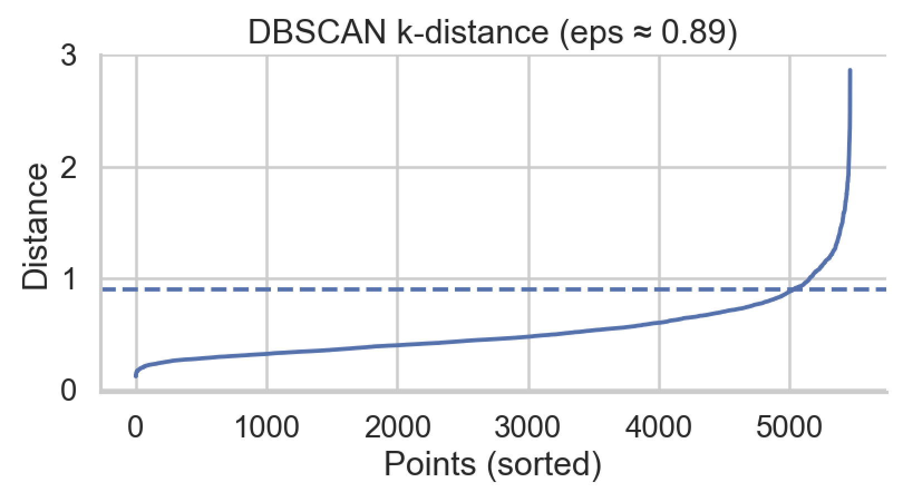
Figure 1: k-distance graph used to determine DBSCAN neighborhood radius

The clustering pipeline successfully identifies broad patterns in pit stop behavior, but the resulting silhouette score of approximately 0.21 indicates weak separation between clusters. This suggests that pit stop strategies in Formula One do not form clearly distinct groups but instead exist along a continuum influenced by race conditions, team decisions, and external factors such as safety cars or weather. Rather than indicating a failure of the method, the result provides insight into the structure of the problem itself that strategy variation is gradual rather than discrete.
Despite the low separation, the clustering results consistently reveal two dominant strategic profiles. The first corresponds to aggressive multi-stop strategies, characterized by a higher number of pit stops and greater flexibility in race management. The second reflects early or conservative strategies, where drivers pit earlier in the race and tend to make fewer adjustments afterward. Additional categories, including anomalous races and DNFs, are captured through the DBSCAN outlier detection step. These findings demonstrate that clustering can still extract meaningful high-level structure, even when fine-grained segmentation is not strongly supported by the data.

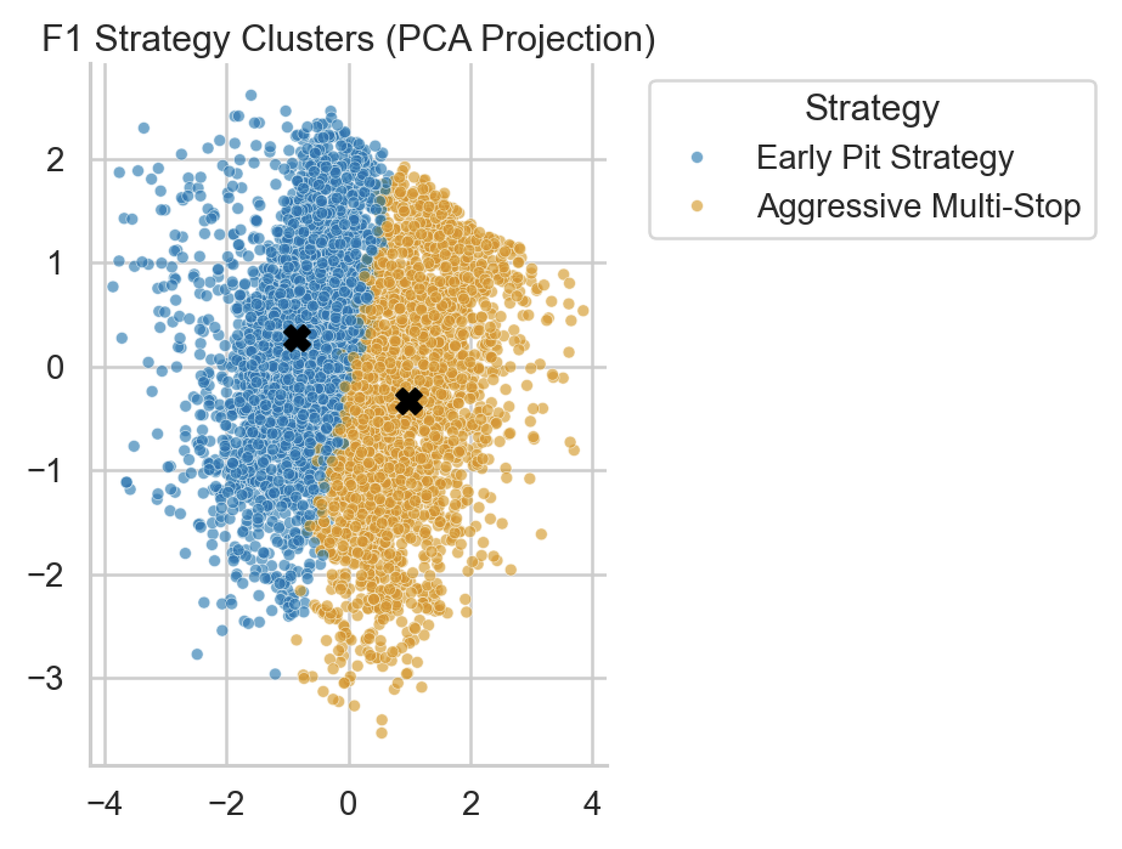
Figure 2: PCA projection of clustered strategies showing overlap between groups

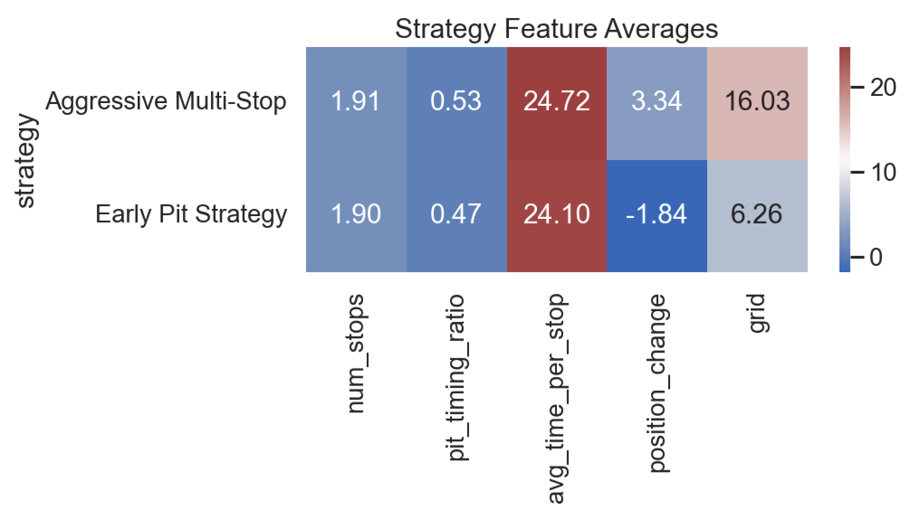
Figure 3: Average feature values by identified strategy

This limitation motivates the second stage of the analysis. Since unsupervised learning alone cannot fully separate strategies into clearly defined groups, classification models are introduced to impose decision boundaries and directly evaluate how pit stop behavior relates to race outcomes.

Predicting Position Improvement
The clustering analysis showed that pit stop strategies do not form clearly separated groups but instead exist along a continuum. While clustering was useful for identifying broad strategic patterns, it does not directly evaluate how those strategies impact race outcomes. To address this limitation, the second stage of the analysis applies classification models to predict whether a driver improves their finishing position based on pit stop behavior. This step shifts the focus from discovering structure in the data to quantifying how strategy-related features influence performance.

The classification problem is formulated as a binary outcome. For each race instance, a driver is labeled as 1 if they finish in a better position than their starting grid position, and 0 otherwise. The input features are designed to capture both pit stop decisions and race context, including the number of pit stops, pit stop timing relative to race length, average time per stop, total pit stop time, and starting grid position. These variables provide a structured representation of race strategy. As in the clustering stage, all features are standardized to ensure that differences in scale do not affect model performance.

Two classification models are used: logistic regression and support vector machines (SVM). Logistic regression models the probability of improvement as a function of the input features using a linear relationship in the log-odds space:
$$P(Y=1∣X)=\frac{1}{1+e^{-(β_{0}+β^{T}X)}}$$
This formulation allows for direct interpretation of model coefficients, making it possible to understand how each feature contributes to the likelihood of improving race position. In contrast, the SVM model identifies a decision boundary that maximizes the margin between the two outcome classes. For the linear case, this is defined as:
$$\underset{w,b}{min⁡}\frac{1}{2}∥w∥^{2}\text{subject to }y_{i}(w^{T}x_{i}+b)≥1$$
This approach allows the model to capture more complex relationships in the data, particularly when the separation between classes is not perfectly linear. Using both models provides a balance between interpretability and predictive flexibility.

The dataset is split into training and testing sets using an 80/20 split, with stratification to preserve the proportion of positive and negative outcomes. Model performance is evaluated using accuracy, F1-score, and ROC-AUC, along with 5-fold cross-validation to assess stability. After evaluation, both models are retrained on the full dataset to generate predictions for all observations, which are later used in the evaluation stage.

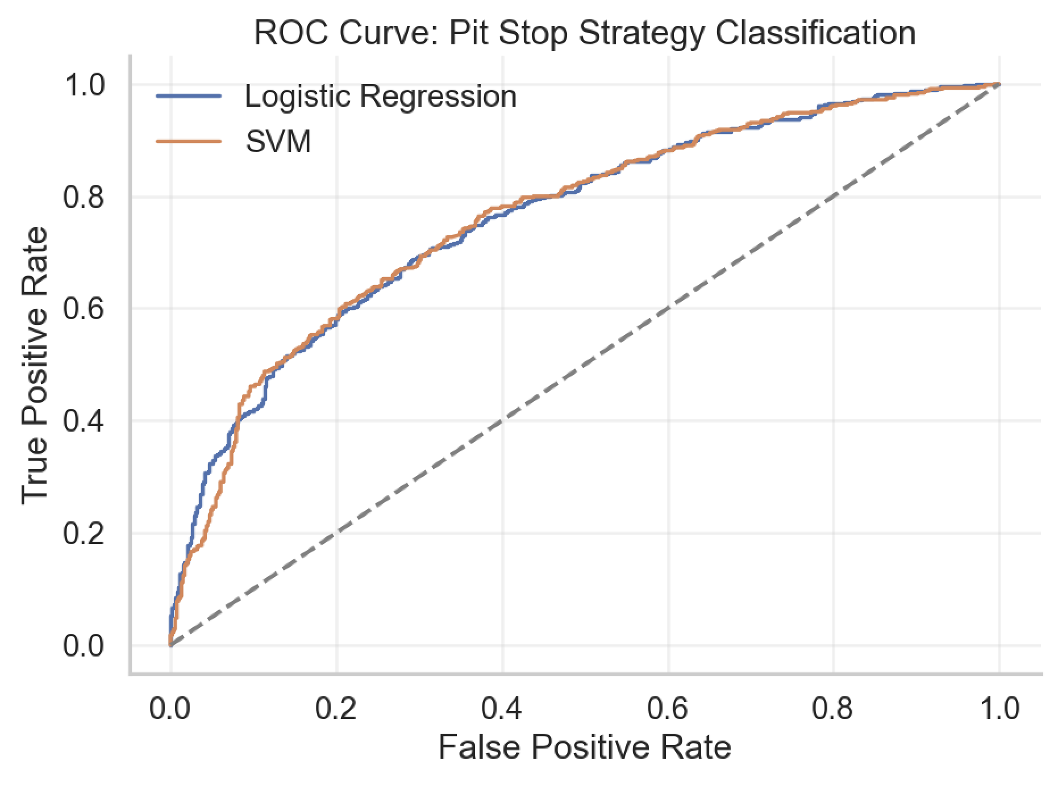
Figure 4: ROC curve comparing logistic regression and SVM performance

The results show that both models achieve consistent performance, with F1-scores around 0.70 and ROC-AUC values near 0.76. These results indicate that pit stop behavior provides meaningful predictive signal but does not fully determine race outcomes. This is expected, as race performance is influenced by additional factors such as driver skill, car performance, and race conditions that are not included in the dataset. The similar performance of logistic regression and SVM suggests that the relationship between strategy features and race outcomes is moderately complex but does not require highly nonlinear modeling.

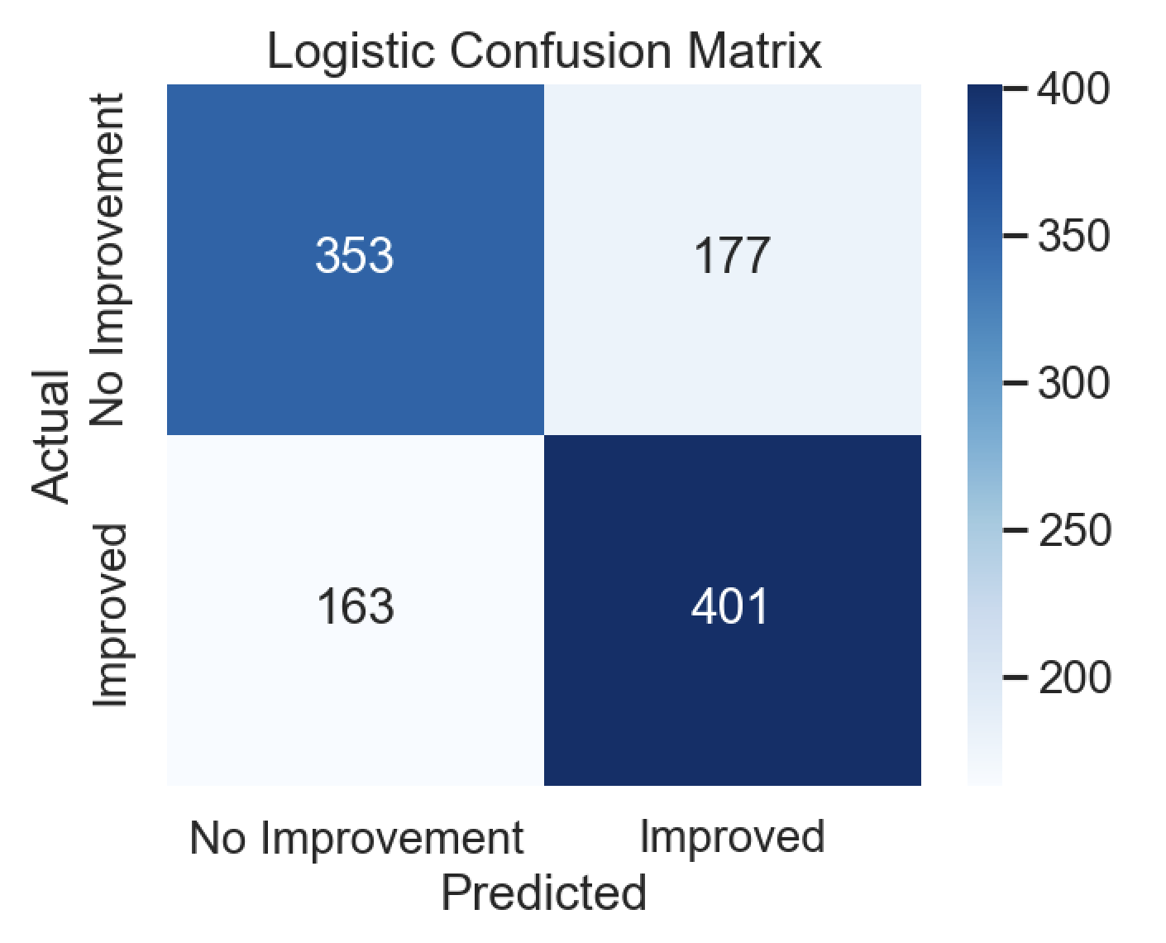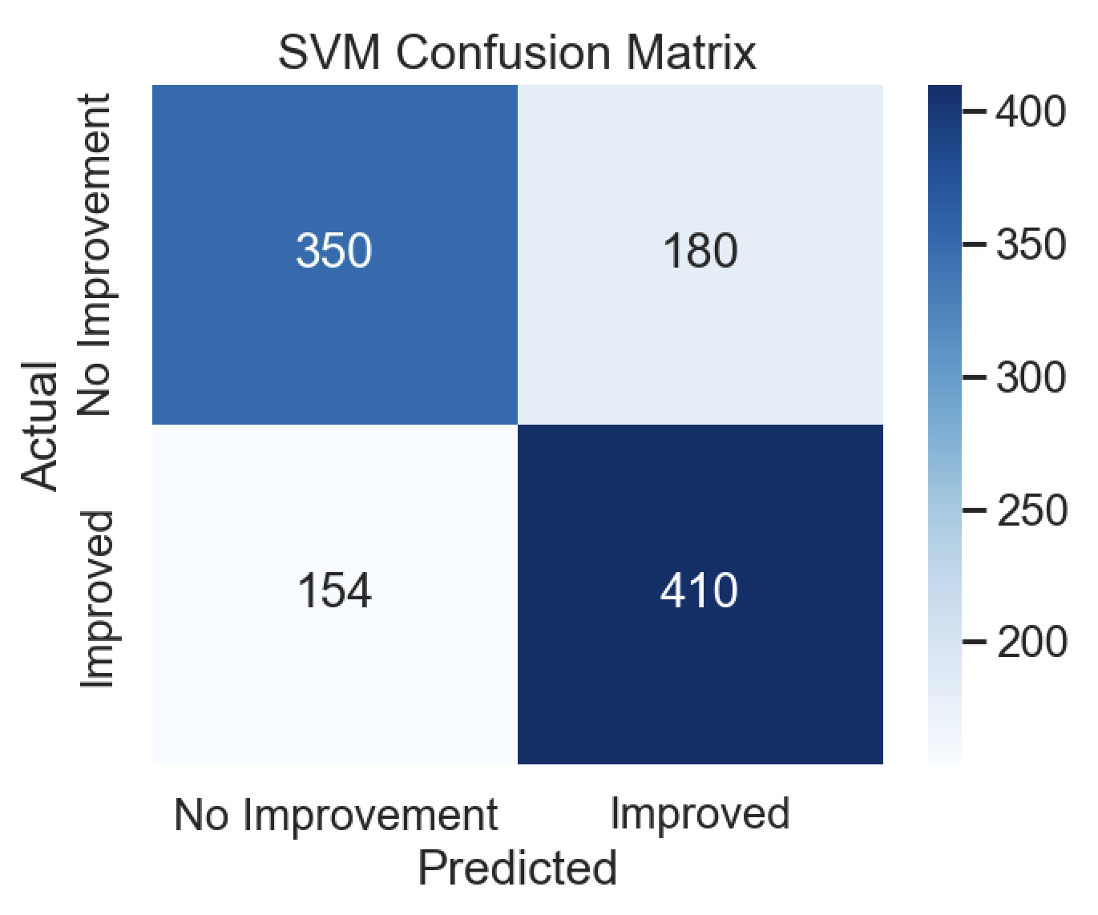
Figure 5 & 6: Confusion matrices showing classification performance

The logistic regression model also provides insight into feature importance through its coefficients. Features related to pit stop frequency and timing contribute positively to the probability of improvement, supporting the idea that more flexible strategies can create opportunities to gain positions. However, no single variable dominates the prediction, reinforcing the conclusion that race outcomes are driven by a combination of factors rather than a single strategic decision.
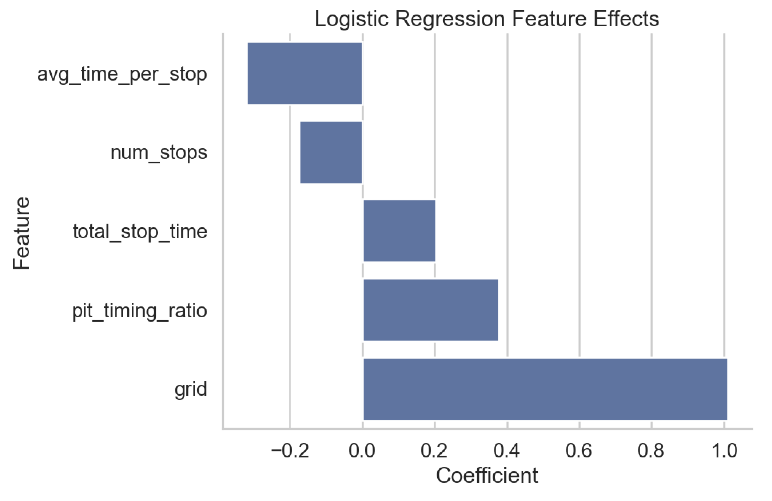
Figure 7: Logistic regression coefficients showing feature effects

Evaluation & Final Results
The final stage of the project focuses on evaluating how pit stop strategies relate to race outcomes by combining the results of both clustering and classification. While clustering identifies underlying strategy types and classification predicts performance outcomes, these methods operate independently. To bridge this gap, the evaluation step integrates both outputs into a single dataset, allowing for a direct comparison between discovered strategies and their observed effectiveness. This integration is implemented in the evaluation_visuals.py script, which merges the clustering results with classification predictions using shared race and driver identifiers. This step is critical because it transforms the analysis from separate modeling tasks into a unified framework that connects strategy behavior to measurable outcomes.

Once merged, the evaluation focuses on several key metrics that capture both actual performance and model-based predictions. The first metric is the strategy success rate, defined as the proportion of drivers within each strategy who improved their finishing position relative to their starting grid position. This provides a direct measure of how effective each strategy is in practice. The second metric is the average position change, which quantifies the magnitude of improvement or decline associated with each strategy. In addition to these outcome-based measures, the evaluation also incorporates model-derived probabilities from both Logistic Regression and Support Vector Machine models. These probabilities represent the predicted likelihood of position improvement and allow for a comparison between observed outcomes and model expectations.

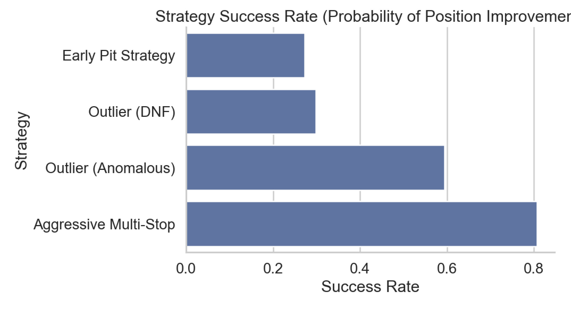
Figure 8: Success rate for each strategy

The results reveal clear and interpretable patterns across strategy types. Aggressive multi-stop strategies show the highest success rates and positive average position changes, suggesting that more frequent pit stops provide strategic flexibility and enable undercut opportunities. In contrast, early pit strategies are associated with lower success rates and negative position changes, indicating that early stops are often reactive decisions made under unfavorable conditions. Outlier strategies corresponding to drivers who did not finish (DNF) show consistently poor performance, which serves as a useful validation check for the analysis. Interestingly, anomalous strategies—those not captured by standard clusters—exhibit mixed but occasionally strong performance, highlighting the presence of edge cases where unconventional strategies may succeed under specific race conditions.

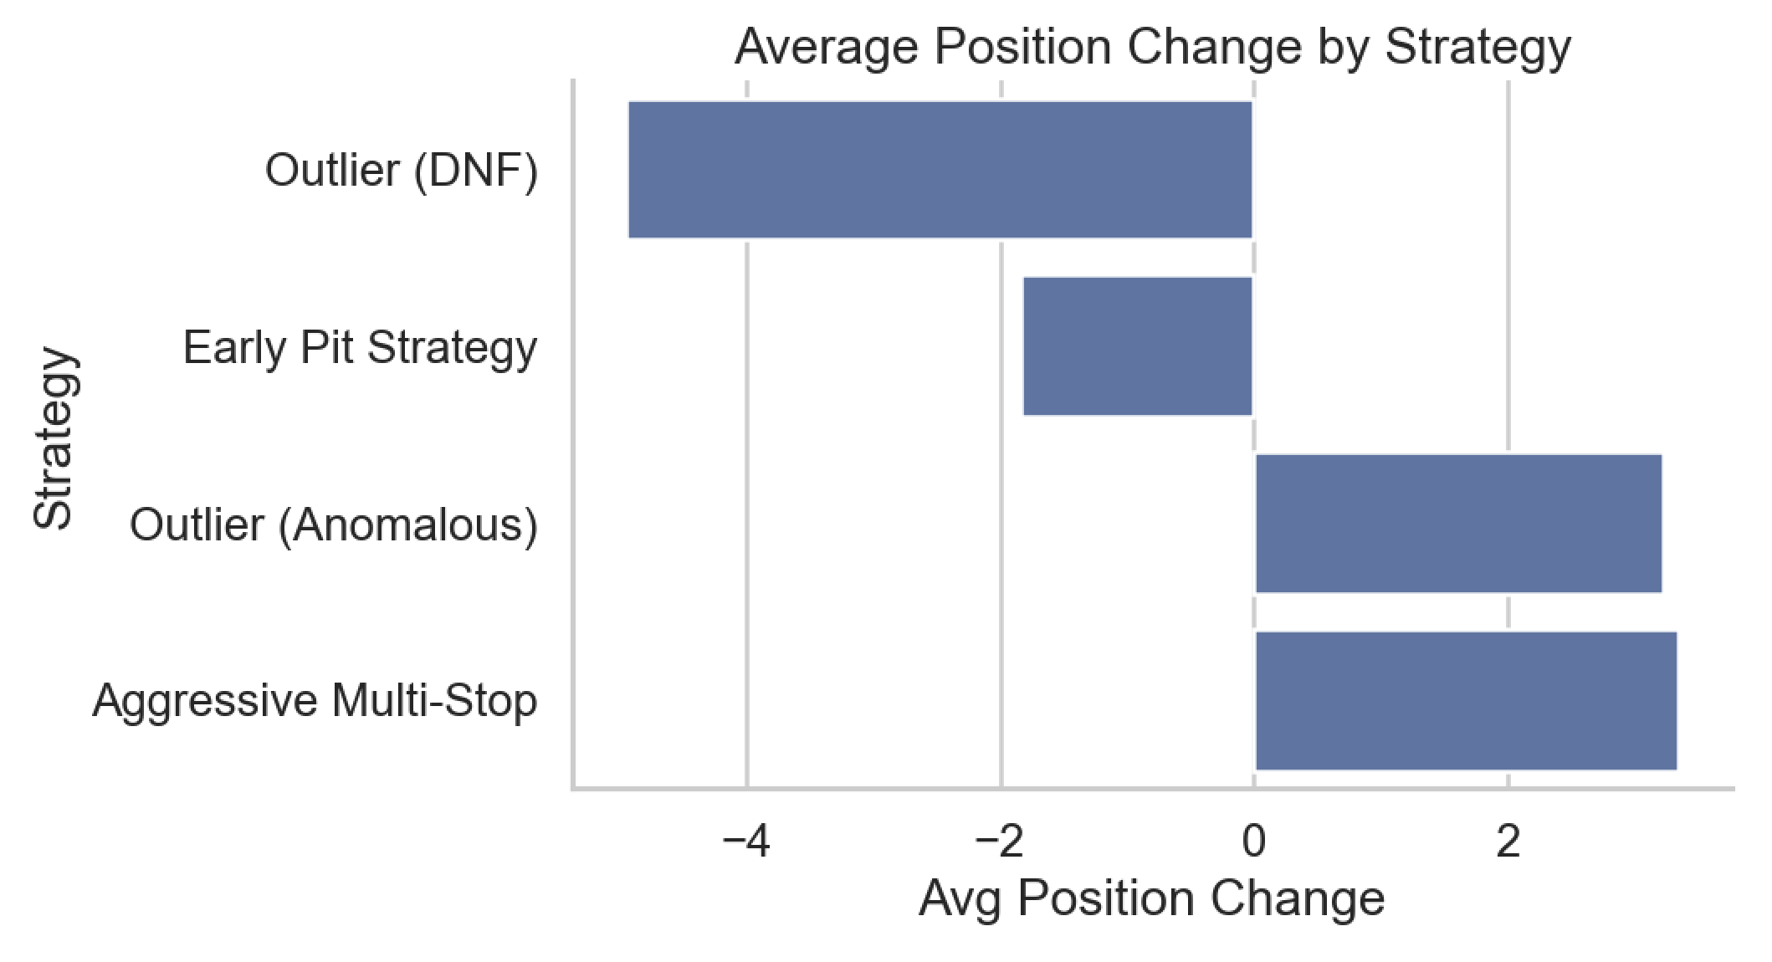
Figure 9: Average position change by strategy

To further evaluate model performance, the analysis examines classification accuracy across different strategy groups. By comparing predicted outcomes with actual results, it is possible to assess whether the models perform consistently across strategy types or if certain strategies are more difficult to predict. The results show that model accuracy varies slightly by strategy, but remains relatively stable overall, indicating that the classification models generalize well across different racing scenarios. This reinforces the idea that, even though clustering revealed weak natural group separation, classification models are still able to learn meaningful relationships between pit stop behavior and race outcomes.

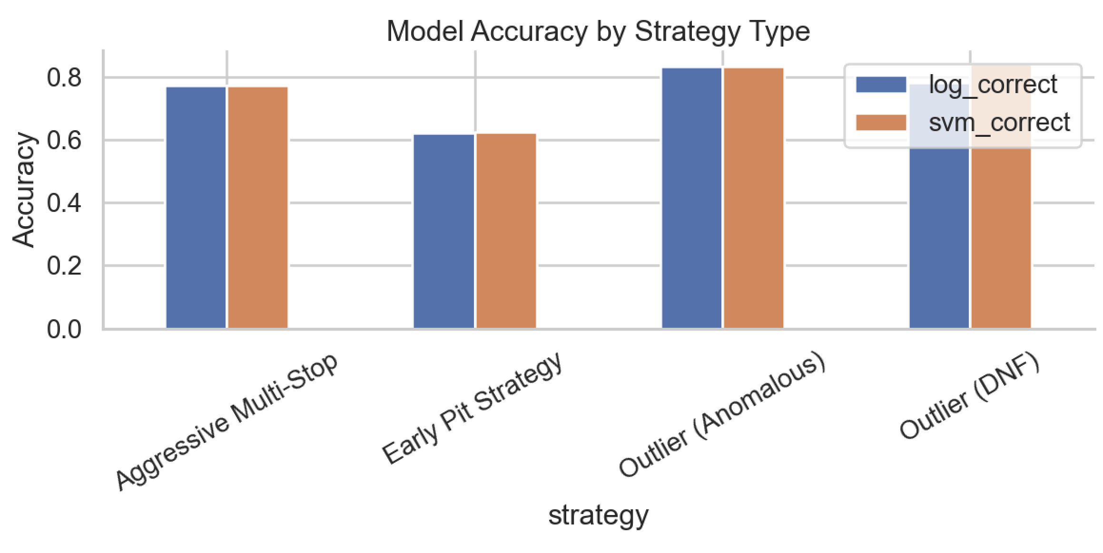
Figure 10: Accuracy of classification methods across strategy groups

A final summary table consolidates all key metrics, including success rate, average position change, and average predicted probabilities for each strategy. This table provides a concise and interpretable overview of the entire analysis and serves as the primary result of the project. It clearly demonstrates how different pit stop strategies translate into measurable performance outcomes, while also validating the consistency between observed data and model predictions.

Strategy | Success Rate | Avg Position Change | Log Probability | SVM Probability
Aggressive Multi-Stop | 0.8067 | 3.3 | 0.7148 | 0.7082
Early Pit Strategy | 0.2729 | -1.8 | 0.3474 | 0.3519
Outlier (Anomalous) | 0.5937 | 3.2 | 0.4667 | 0.4943
Outlier (DNF) | 0.2980 | -4.9 | 0.4643 | 0.4579

Overall, this combined evaluation highlights the complementary roles of clustering and classification within the pipeline. Clustering provides an interpretable structure for understanding strategy types, while classification imposes predictive structure in situations where natural group boundaries are weak. By linking these approaches, the analysis provides both descriptive insight and predictive capability, offering a more complete understanding of how pit stop strategies influence race performance. Finally, to streamline the execution of this full workflow, an automated pipeline script is provided to run all stages sequentially.

From a practical perspective, these results can be valuable for Formula 1 teams and analysts. The findings suggest that aggressive and flexible strategies tend to yield better outcomes, while early pit decisions may signal underlying race issues. Teams can use these insights to inform strategic decision-making, particularly in identifying when to adopt more aggressive pit strategies versus maintaining track position. Additionally, the modeling framework developed in this project can be extended to incorporate real-time data, allowing for dynamic strategy optimization during races.

References
Bishop, C. M. (2006). Pattern recognition and machine learning. Springer.
Hastie, T., Tibshirani, R., & Friedman, J. (2009). The elements of statistical learning: Data mining, inference, and prediction (2nd ed.). Springer.
James, G., Witten, D., Hastie, T., & Tibshirani, R. (2013). An introduction to statistical learning: With applications in R. Springer.
Jolliffe, I. T. (2002). Principal component analysis (2nd ed.). Springer.
Formula 1 World Championship (1950–2024) [Data set]. Kaggle. https://www.kaggle.com/datasets/rohanrao/formula-1-world-championship-1950-2020
Patel, K. (n.d.). F1 Pit Stop Strategy Analysis [Source code]. GitHub. https://github.com/karnp-27/F1-Pit-Stop-Strategy-Analysis

