SCREENSHOTS

Name – Vaibhav Karn

# Question 1. Which Store has Maximum Sales?

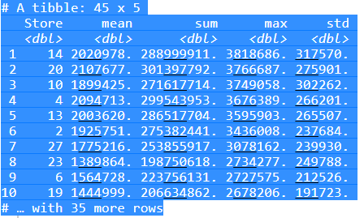

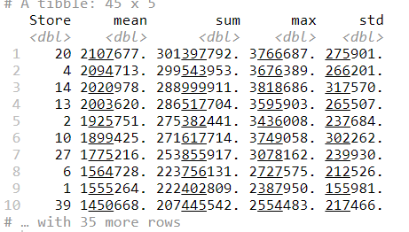

# Question 2 . Which store has maximum standard deviation i.e., the sales vary a lot. Also, find out the coefficient of mean to standard deviation

2a.

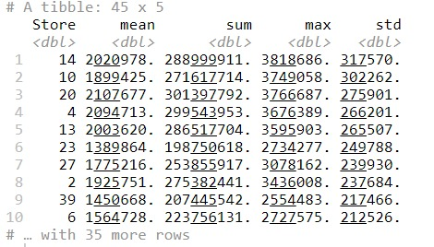

2b.

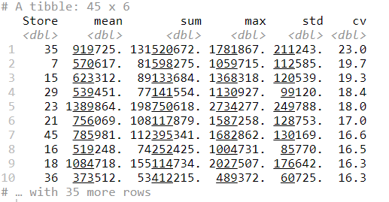

# Question 3. Which store/s has good quarterly growth rate in Q3’2012

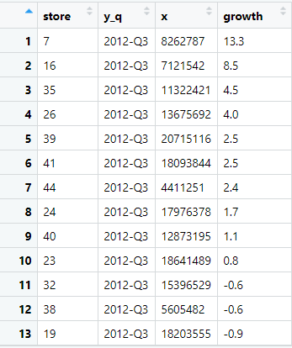

# Question 4.) Some holidays have a negative impact on sales. Find out holidays which have higher sales than the mean sales in non-holiday season for all stores together.

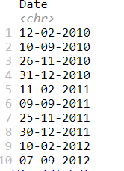

# Question 5. Provide a monthly and semester view of sales in units and give insights

### # Sales By Month

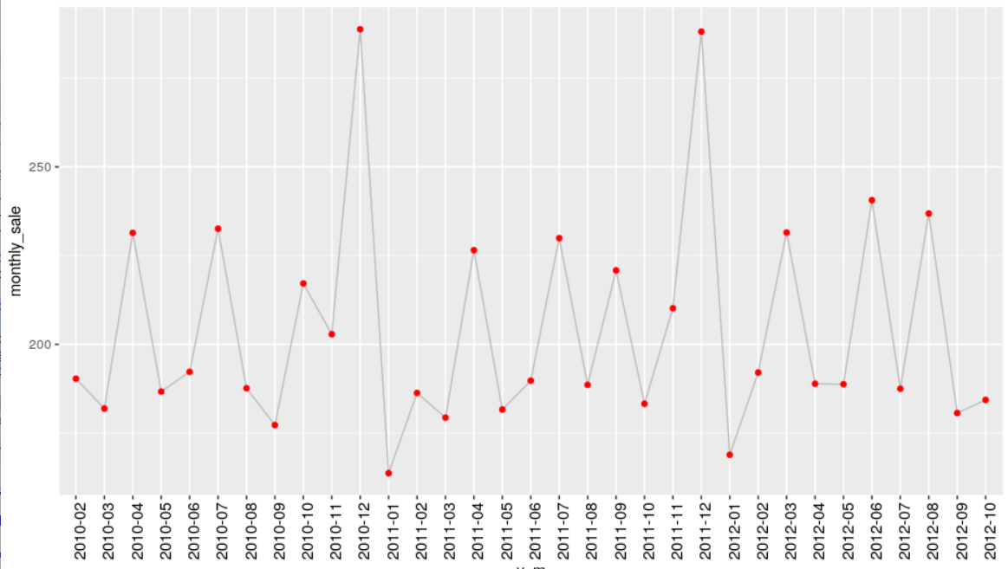

### #Sales by Semester

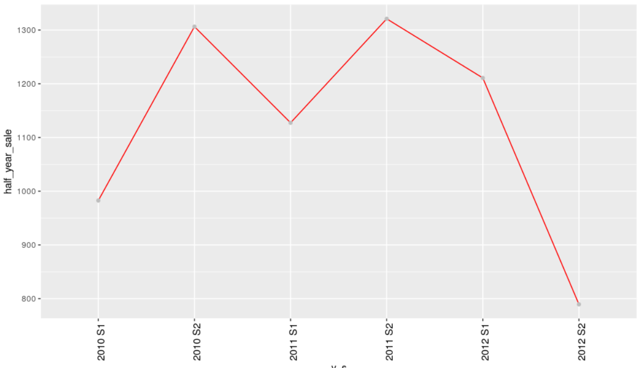

## Question 6) STATISTICAL MODEL

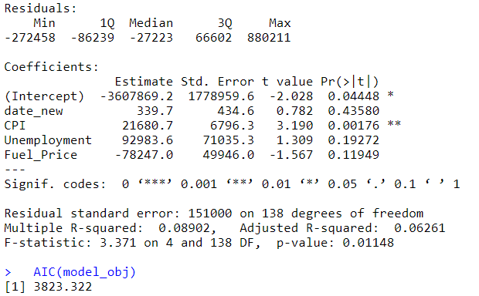

# ##Model-2)

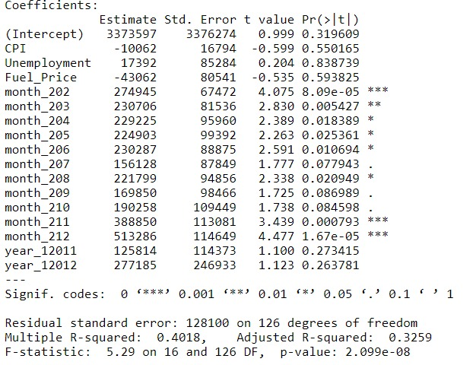

# (AIC model obj 2)

