

Practices for Secure Software Report

Table of Contents
Practices for Secure Software Report 1
Document Revision History 3
Client 3
1. Algorithm Cipher 3
2. Certificate Generation 4
3. Deploy Cipher 4
4. Secure Communications 5
5. Secondary Testing 5
6. Functional Testing 6
7. Summary 7
8. Industry Standard Best Practices 7

Document Revision History

Version | Date | Author | Comments
1.0 | October 17, 2026 | Leslie Sawyer | Initial project report

Client



Developer
Leslie Sawyer

Algorithm Cipher

For Artemis Financial, I recommend AES-256-GCM for encrypting sensitive data because it provides confidentiality and checks whether encrypted information has been modified. AES is a symmetric algorithm, meaning the same secret key is used for encryption and decryption. A 256-bit key provides a strong security margin, while GCM adds authenticated encryption. The system must generate a unique nonce for each encryption operation and protect its secret keys. For secure communication over the web, I would use modern TLS rather than creating a custom encryption protocol. TLS uses asymmetric cryptography during authentication and key agreement, then efficient symmetric encryption for the session. Random values are important for keys, nonces, and session establishment; predictable values would weaken security. Earlier algorithms such as DES and 3DES are outdated, and modern applications generally use AES and established TLS configurations. In this project, I implemented SHA-256 hashing for checksum verification; hashing is not encryption and cannot be decrypted.

Certificate Generation
I generated a self-signed X.509 certificate using Java Keytool, stored the private key in a PKCS12 keystore, and exported a CER file. The certificate identifies localhost and is valid from October 17, 2026, through October 17, 2027. The certificate is suitable for demonstrating local HTTPS, but it is not trusted by the browser because it is self-signed. A production website would require a certificate issued by a trusted certificate authority.

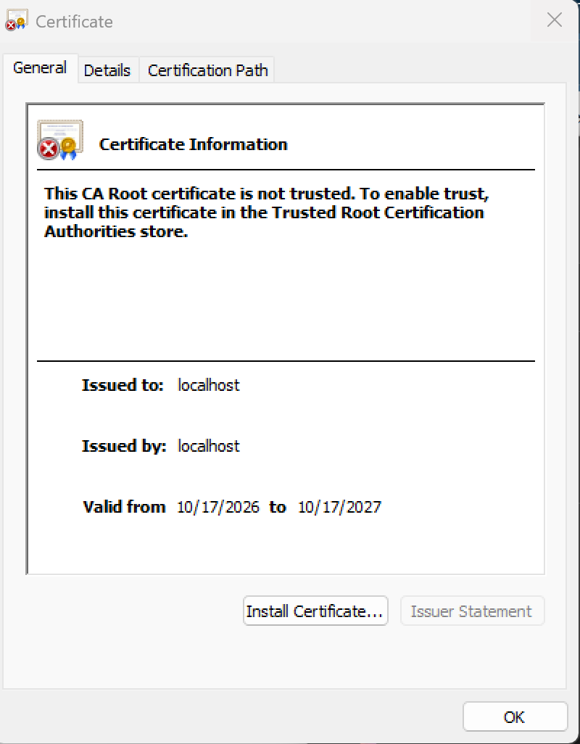

Deploy Cipher

I added a /hash endpoint that creates a SHA-256 digest for the text “Leslie Sawyer - Artemis Financial.” The browser displays the original text and the hexadecimal checksum. This verifies that the application can calculate a repeatable hash for the selected input. A checksum alone does not authenticate a sender or replace TLS encryption.

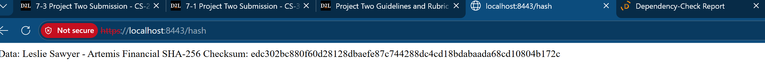

Secure Communications

I configured the Spring Boot application to serve HTTPS on port 8443 using the local PKCS12 keystore. I tested https://localhost:8443/hash in Microsoft Edge and confirmed that the endpoint returned the checksum over an HTTPS URL. The browser displayed “Not secure” because the self-signed certificate is not trusted. This confirms local TLS configuration and endpoint functionality, but it does not demonstrate a publicly trusted production certificate.

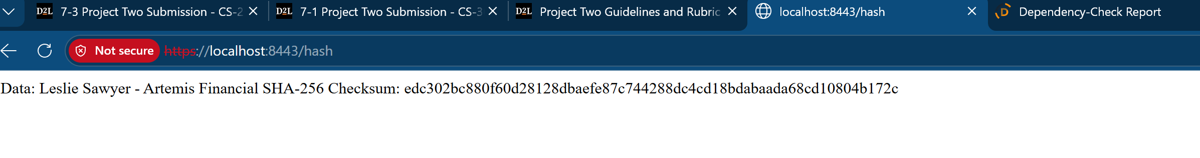

Secondary Testing

I ran Maven clean verify with OWASP Dependency-Check 12.1.0. Maven completed with BUILD SUCCESS, which shows that the build and scan ran to completion; it does not mean the dependencies are free of security issues. The scan reviewed 49 dependencies (31 unique), identified 16 vulnerable dependencies and 295 potential vulnerability findings, and reported zero suppressed findings. Examples include older Spring Boot, Spring Framework, SnakeYAML, and Jackson libraries. These findings require review for applicability and remediation. I did not verify that all findings were resolved. Before production release, I would update supported dependencies, review compatibility, rerun the scan, and retest the application. The OSS Index analyzer was disabled after an authentication error, so this run did not include that analyzer.

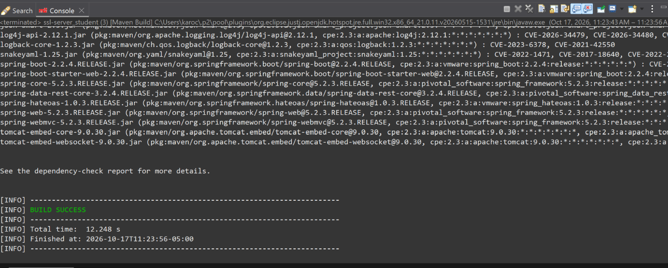

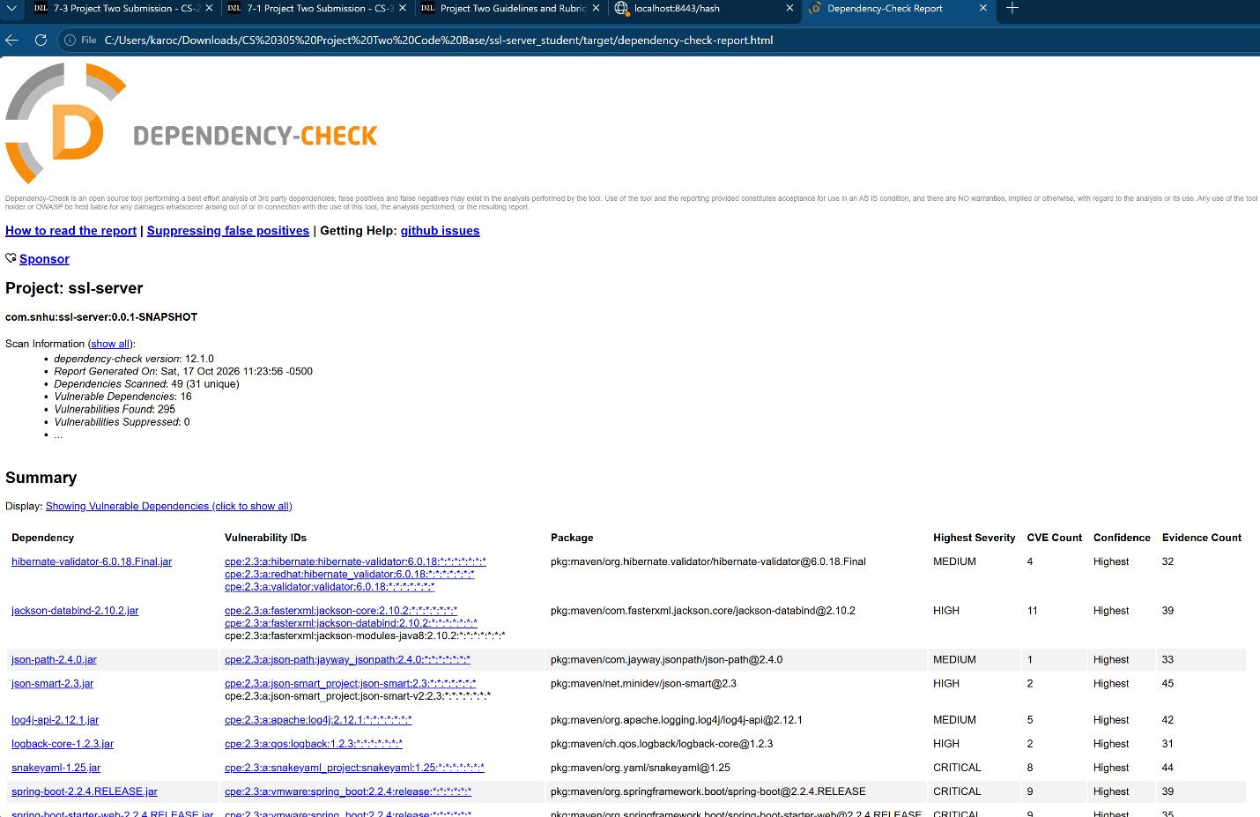

Functional Testing

I manually reviewed the changes for the SHA-256 endpoint, the application properties for HTTPS, and the keystore settings. I confirmed that the application responded at the /hash URL and that the Maven build completed without build errors. These checks support basic functionality, but they are not a complete security assessment. The dependency scan still identifies issues that need further remediation and retesting.
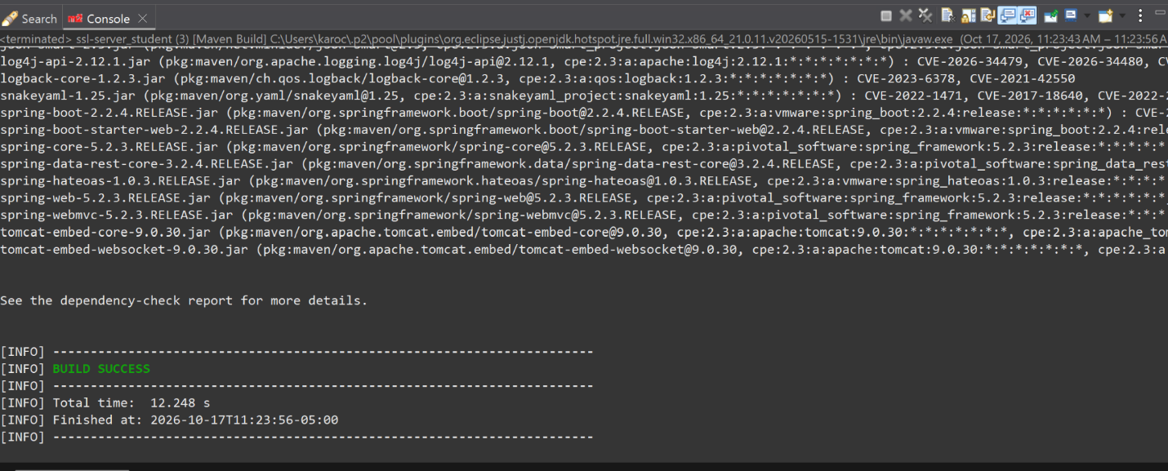

Summary

I improved the original application by adding a SHA-256 checksum endpoint, generating a local certificate, configuring HTTPS on port 8443, and running Maven with OWASP Dependency-Check. My review followed a basic vulnerability assessment process: identify security needs, inspect the code and dependencies, implement controls, test the application, examine scan results, and plan remediation and retesting. The work addresses data integrity demonstration and encrypted transport in a local development environment. It is not ready to be described as fully secure: the browser does not trust the self-signed certificate, and the dependency scan found 295 potential vulnerabilities across 16 dependencies. Those findings should be triaged, the affected libraries updated or otherwise remediated, and the tests repeated before deployment.

Industry Standard Best Practices

I used standard Java security libraries for SHA-256 rather than implementing my own hash function, Java Keytool to generate a certificate, a PKCS12 keystore to hold key material, HTTPS for transport encryption, and OWASP Dependency-Check to identify known issues in third-party components. Using maintained cryptographic libraries and standard protocols helps reduce avoidable implementation mistakes. Dependency scanning is useful because vulnerabilities can exist in libraries even when my own code compiles and runs. To protect Artemis Financial and its customers, I would also maintain supported library versions, safeguard keystore passwords and private keys, use trusted certificates in production, apply least privilege, and regularly repeat security and functional tests. These practices help protect sensitive financial information and reduce the risk of service disruption or data exposure.

