**Sam pressure/flow/shear:**

- wystarczy odkomentować wszystkie linie z Ox i Vegf (oraz w draw ustawić oxresult=[])

Wyniki dla 300 iteracji siatki triangular 100x100 z length wiggle 1 i diameter wiggle 3 oraz

F0 = 0.2  
F1 = 1  
z0 = 0  
z1 = 1  
F_mult = 10000  
dt = 0.8

**Rect**

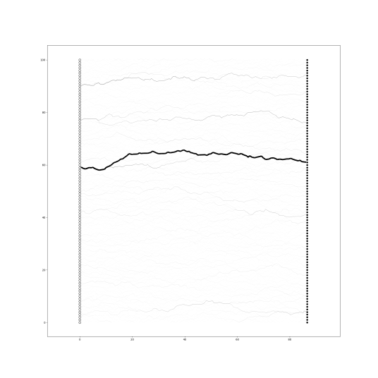

Czasy: update mat 0.07775449752807617, solve eq 0.20544958114624023, update graph 0.09574389457702637

**Donut**

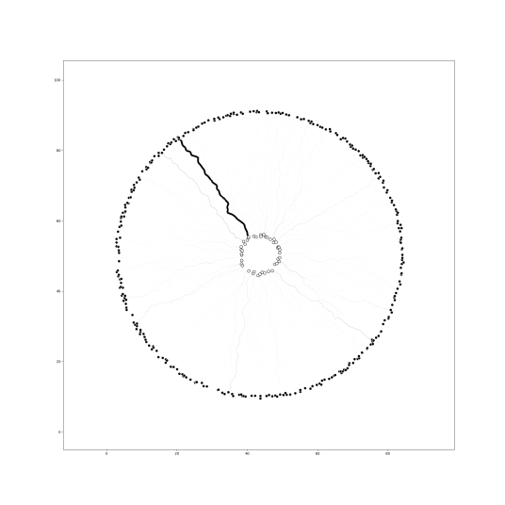

Czasy: update mat 0.07679486274719238, solve eq 0.13563799858093262, update graph 0.10571670532226562

**Cylindrical**

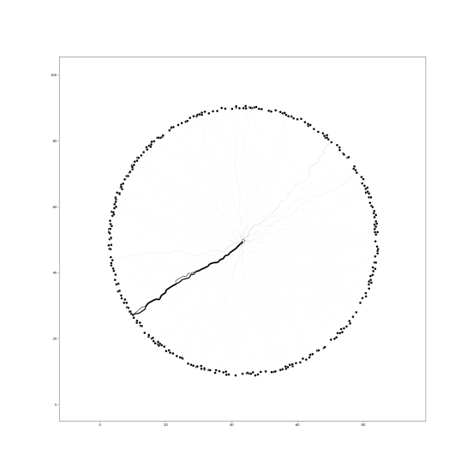

Czasy: update mat 0.07602882385253906, solve eq 0.14559602737426758, update graph 0.08712387084960938

**Equidistant**

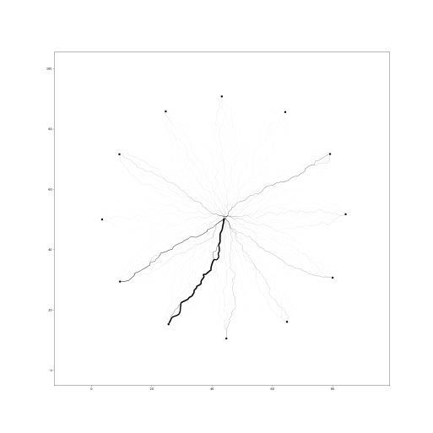

Czasy: update mat 0.07074642181396484, solve eq 0.16655445098876953, update graph 0.0877985954284668

Wyniki dla Delaunaya z tymi samymi parametrami:

**Rect**

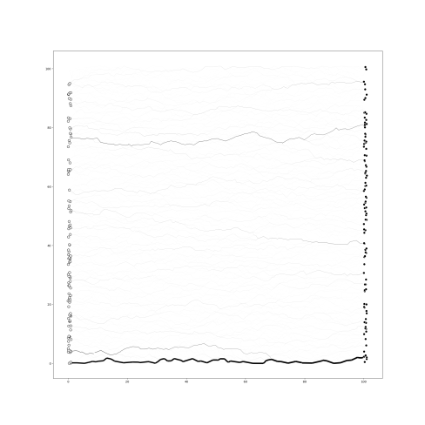

Czasy: update mat 0.0847313404083252, solve eq 0.1316826343536377, update graph 0.11768484115600586

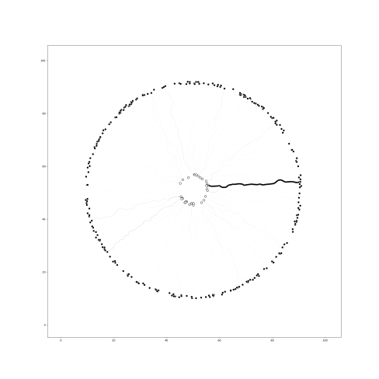

Czasy: update mat 0.07978677749633789, solve eq 0.05186128616333008, update graph 0.09574365615844727

**Cylindrical**

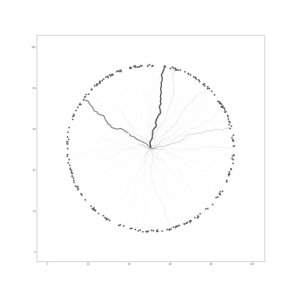

Czasy: update mat 0.08776473999023438, solve eq 0.06283116340637207, update graph 0.08676910400390625

**Equidistant**

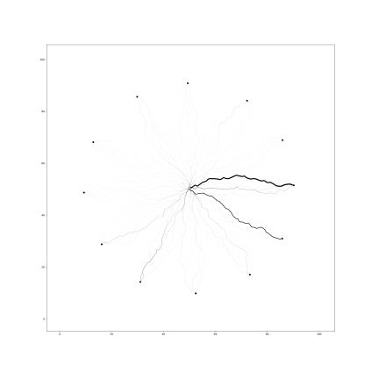

update mat 0.07598233222961426, solve eq 0.0668787956237793, update graph 0.09083414077758789

**Dodanie tlenu**

* Odkomentowanie linijek z ox, ale nie z vegf, czyli na razie brak updejtu krawedzi tlenem
* D = 1 *# współczynnik dyfuzji*k = 0.1 *# stała reakcji*dth = 8 *# graniczna grubosć*

**Rect**

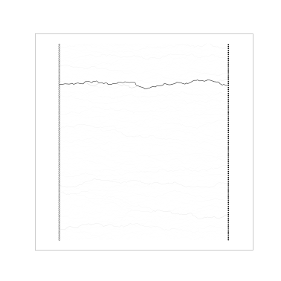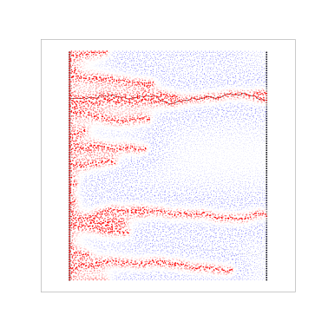

update mat press 0.07679486274719238, update mat ox 0.08377647399902344, solve pres eq 0.2044532299041748, solve ox eq 0.17553210258483887, update graph 0.12669801712036133

**Donut**

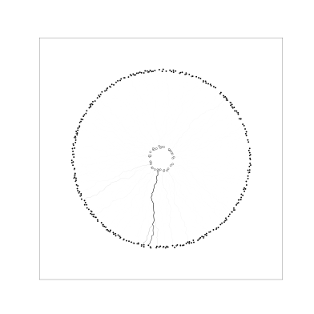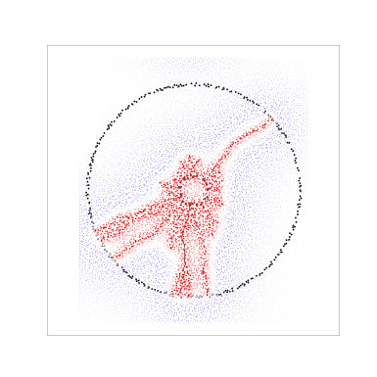

update mat press 0.07679510116577148, update mat ox 0.09075713157653809, solve pres eq 0.16755080223083496, solve ox eq 0.1655573844909668, update graph 0.09281802177429199

Cylindrical

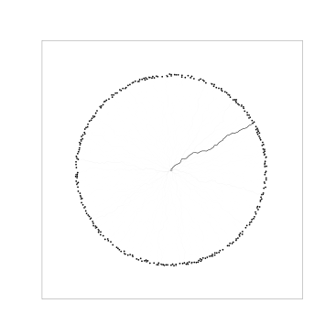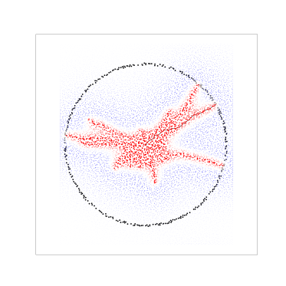update mat press 0.06781864166259766, update mat ox 0.0827789306640625, solve pres eq 0.13364386558532715, solve ox eq 0.16655516624450684, update graph 0.11269855499267578

**Equidistant**

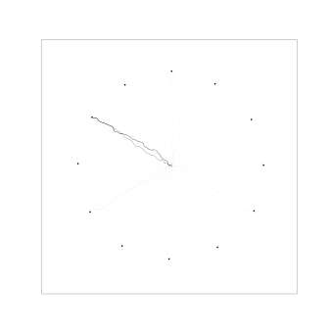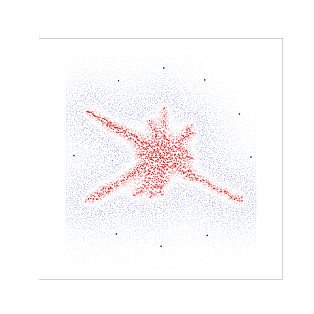

update mat press 0.08477568626403809, update mat ox 0.11569070816040039, solve pres eq 0.182511568069458, solve ox eq 0.23935890197753906, update graph 0.1266615390777588

**Delaunay**

**Rect**

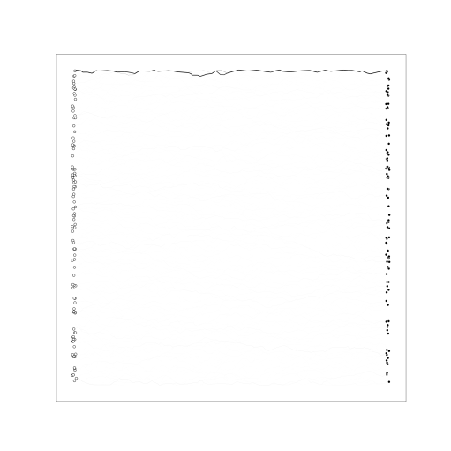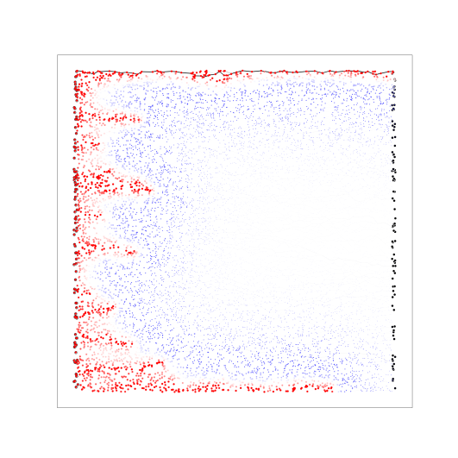

update mat press 0.11170196533203125, update mat ox 0.11998343467712402, solve pres eq 0.13663434982299805, solve ox eq 0.118682861328125, update graph 0.14960074424743652

**Donut**

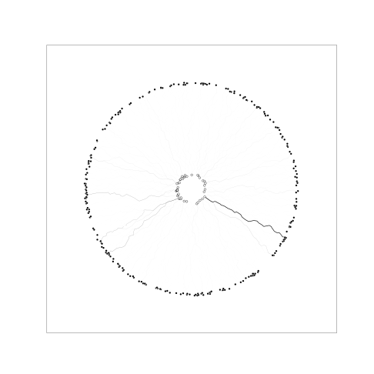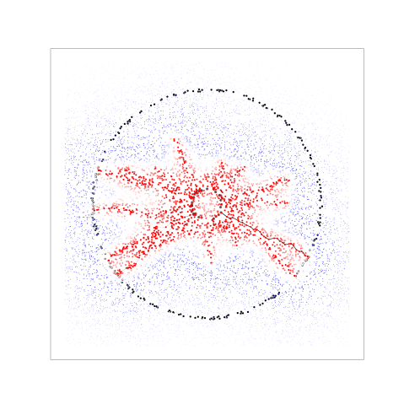

update mat press 0.10172867774963379, update mat ox 0.12312436103820801, solve pres eq 0.0967414379119873, solve ox eq 0.09877133369445801, update graph 0.12463951110839844

**Cylindrical**

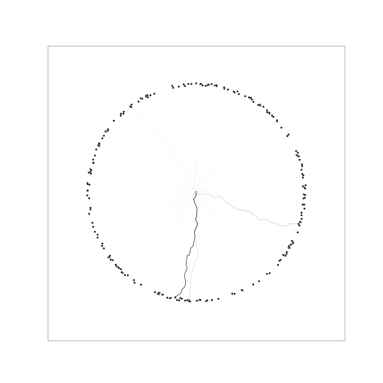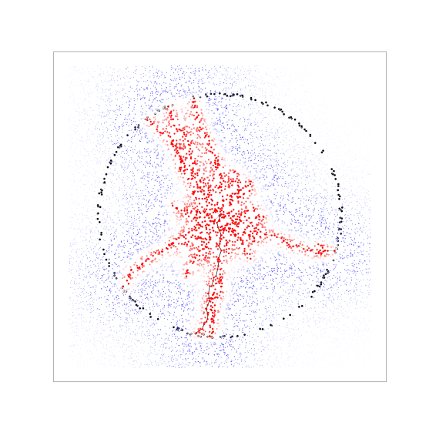

update mat press 0.09573602676391602, update mat ox 0.1216742992401123, solve pres eq 0.09208965301513672, solve ox eq 0.08628177642822266, update graph 0.13065075874328613

**Equidistant**

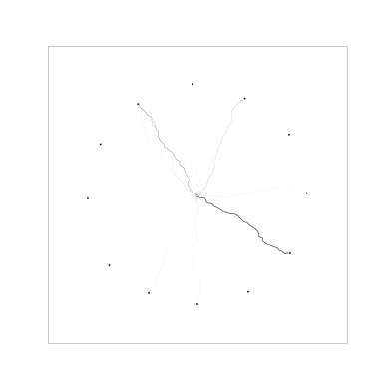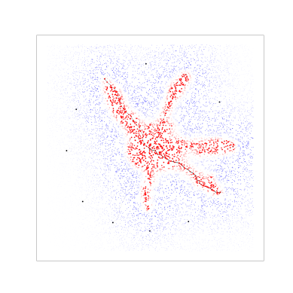

update mat press 0.07280731201171875, update mat ox 0.08676576614379883, solve pres eq 0.0658266544342041, solve ox eq 0.07077479362487793, update graph 0.11369657516479492

**Dodanie VEGF**

D = 1 *# współczynnik dyfuzji*k = 0.1 *# stała reakcji*dth = 8 *# graniczna grubosć*Dv = 1 *# współczynnik dyfuzji VEGF*F0_ox = 0.1  
F1_ox = 1  
z0_ox = 0  
z1_ox = 1  
F_mult_ox = 0.01  
dt_ox = 3

Rect

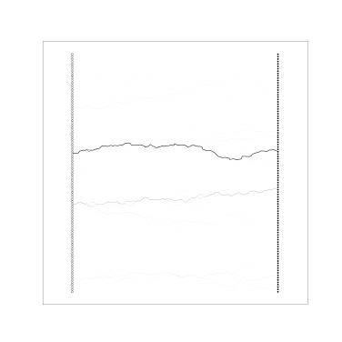 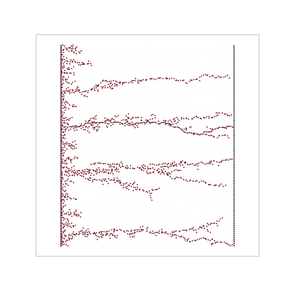 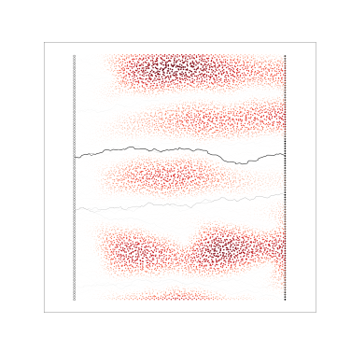

update mat press 0.08377599716186523, update mat ox 0.08876276016235352, solve pres eq 0.20644831657409668, solve ox eq 0.16256380081176758, vresult = 0.0, vmatrix = 0.0827786922454834, vnow = 0.16159439086914062, update graph 0.10376715660095215, update graph ox 0.025926828384399414

Cylindrical

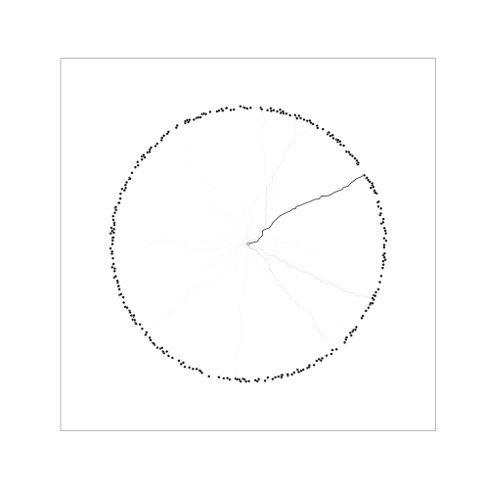 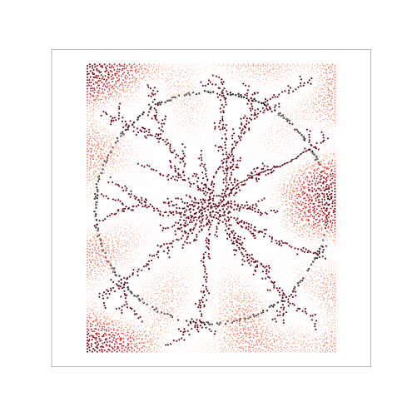

update mat press 0.06984543800354004, update mat ox 0.0827779769897461, solve pres eq 0.1475391387939453, solve ox eq 0.16954660415649414, vresult = 0.0, vmatrix = 0.08480715751647949, vnow = 0.15954065322875977, update graph 0.10970592498779297, update graph ox 0.03091740608215332

Donut

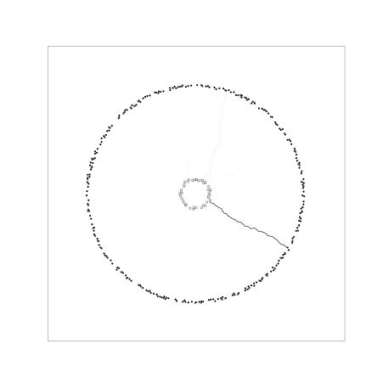 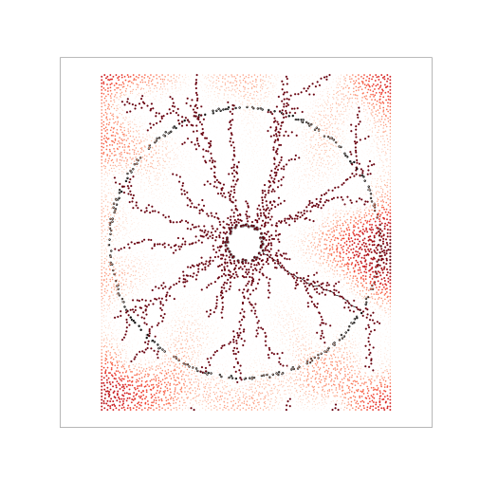

update mat press 0.06981348991394043, update mat ox 0.08477330207824707, solve pres eq 0.14162158966064453, solve ox eq 0.13863086700439453, vresult = 0.0, vmatrix = 0.08979320526123047, vnow = 0.11565613746643066, update graph 0.09079456329345703, update graph ox 0.02593207359313965

Equidistant

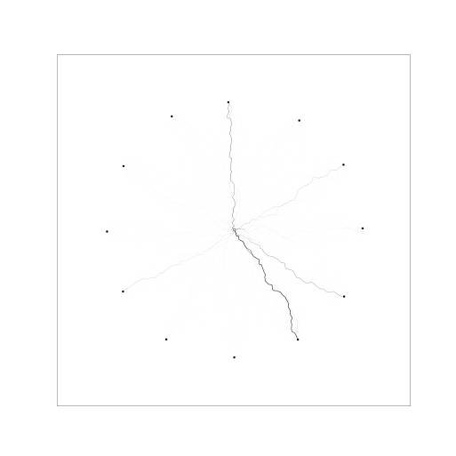 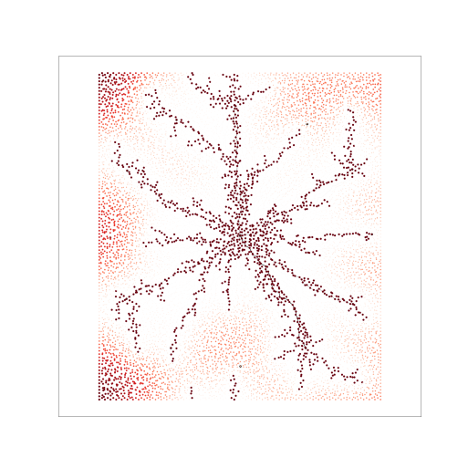

update mat press 0.06881165504455566, update mat ox 0.08477091789245605, solve pres eq 0.17849206924438477, solve ox eq 0.1825120449066162, vresult = 0.0, vmatrix = 0.09574437141418457, vnow = 0.17852306365966797, update graph 0.11269783973693848, update graph ox 0.029920339584350586

Delaunay

Rect

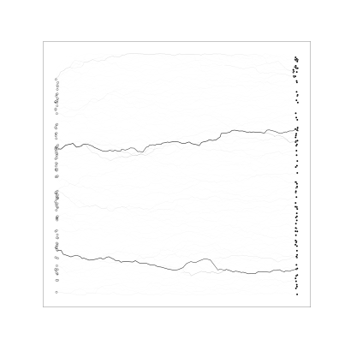 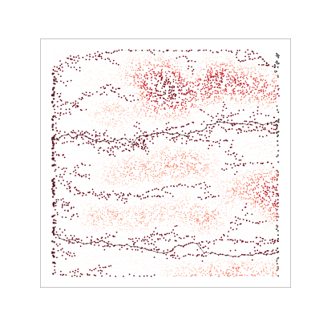

update mat press 0.07679462432861328, update mat ox 0.08577084541320801, solve pres eq 0.09675931930541992, solve ox eq 0.048853158950805664, vresult = 0.0, vmatrix = 0.09873795509338379, vnow = 0.057845115661621094, update graph 0.13563823699951172, update graph ox 0.025969266891479492

Equidistant

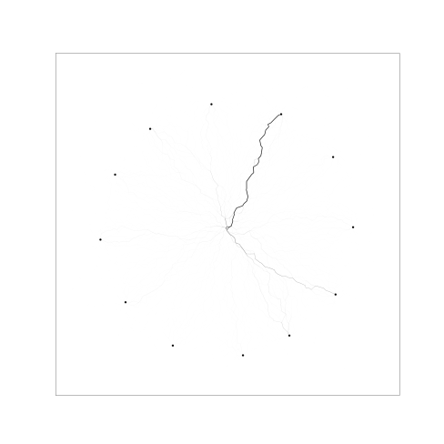 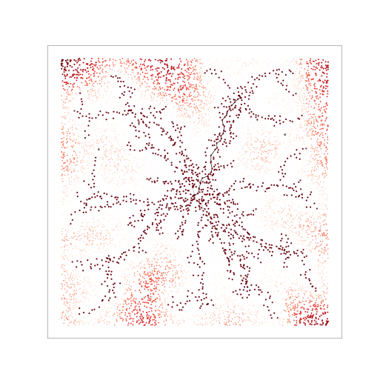

update mat press 0.07283902168273926, update mat ox 0.08673501014709473, solve pres eq 0.06183457374572754, solve ox eq 0.05684804916381836, vresult = 0.0, vmatrix = 0.09574389457702637, vnow = 0.058843135833740234, update graph 0.10471868515014648, update graph ox 0.025930166244506836

Cylindrical

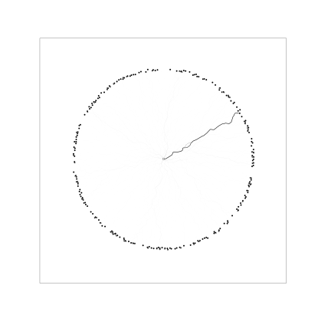 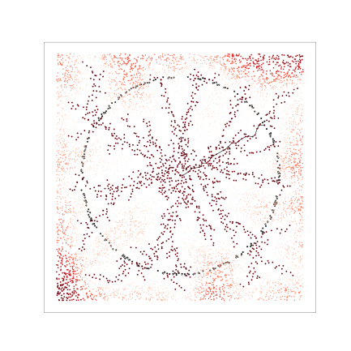

update mat press 0.0718080997467041, update mat ox 0.09075689315795898, solve pres eq 0.06582355499267578, solve ox eq 0.05684781074523926, vresult = 0.0009975433349609375, vmatrix = 0.08680343627929688, vnow = 0.05681252479553223, update graph 0.09275197982788086, update graph ox 0.023936033248901367

Donut

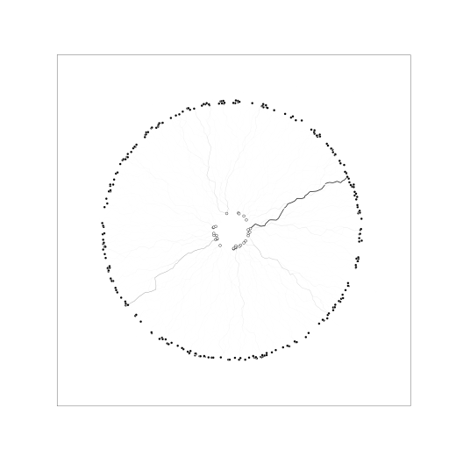 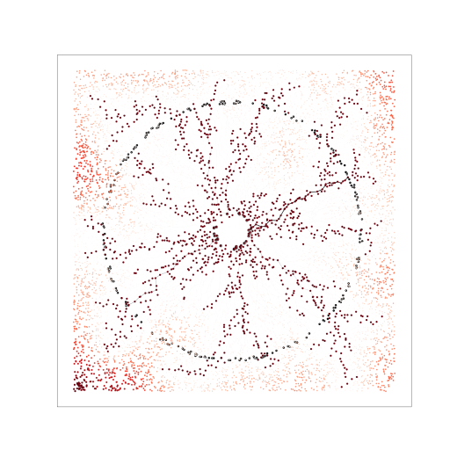

update mat press 0.07176899909973145, update mat ox 0.08580851554870605, solve pres eq 0.06578683853149414, solve ox eq 0.05585145950317383, vresult = 0.0, vmatrix = 0.08683300018310547, vnow = 0.0478060245513916, update graph 0.0907583236694336, update graph ox 0.025930404663085938