Work Division Report
CP317 Fall 2014
Prepared by: Carolyn Marshall, Jack Cohen, Jordan Saadon
Prof. Chính Hoàng
October 23, 2014

Requirements Document

Use Cases

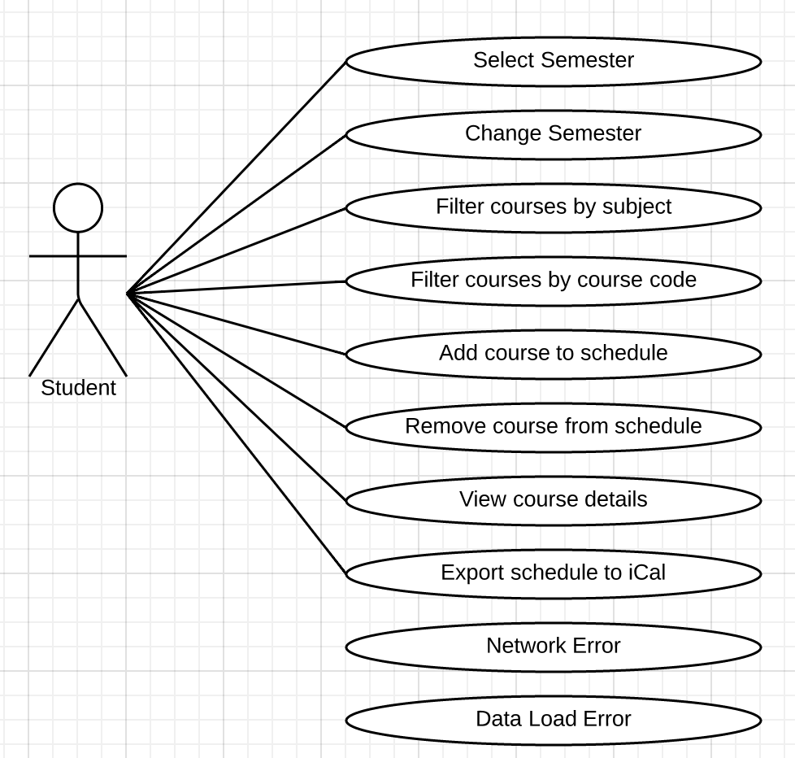

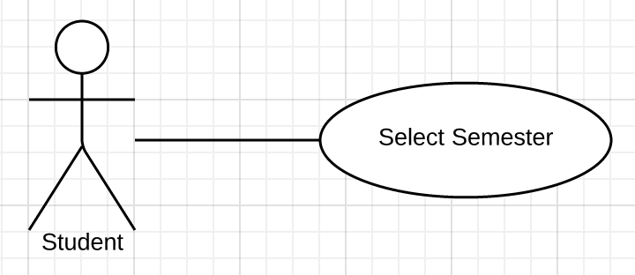
Use Case Name SelectSemester
Participating actor Student
Entry Condition 1. The Student opens the application to the SelectSemesterPage
Flow of Events 2. The Student clicks on the SelectSemester dropdown list
3. The Student selects the term they want to interact with.
Exit Condition 4. The SchedulePage for that term is displayed containing the ScheduleCalendar, ScheduleList, and CourseList
Special Requirements If the course server (LORIS) cannot be reached, an ErrorDialog is displayed.

Scenario: SelectWinter2015Term
Participating Actor Instances: Bob: Student
Flow of Events: 1. Bob wants to view his schedule for the 2015 Winter term.
2. He connects to the cours scheduling app and clicks on his schedule.
3. He select the 2015 Winter semester from the drop down list.
4. The schedule changes to show his Winter 2015 courses and all available courses.

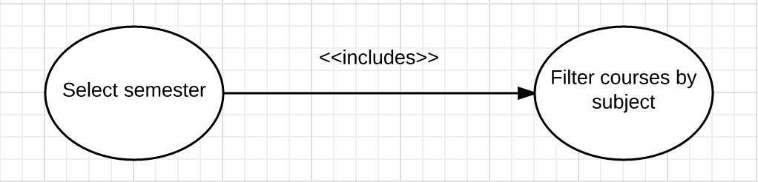

Use Case Name FilterCoursesBySubject
Participating actor Student
Entry Condition 1. This use case includes the SelectSemester use case which displays the Schedule and CourseList for the selected semester.
Flow of Events 2. The Student selects the SubjectName from the CourseSubjects drop down list
Exit Condition 3. The CourseList displays only Courses from the selected Semester that are categorized as the selected CourseSubject.
Special Requirements If the SelectSemester use case cannot be completed, the user receives an error.
If no Course matching the filter is on the CourseList, no Courses are shown.

FilterCourses Scenario: FilterCoursesByPhysicsFall2014
Participating Actor Instances: Bob: Student
Flow of Events: 1. Bob wants to view the Physics courses listed for 2014 Fall.
2. He opens the course scheduling app and selects the 2014 Fall term.
2. He selects Physics (PC) from the Subject dropdown menu
4. The list of courses in the course list displays only Physics courses for the Fall 2014 term.

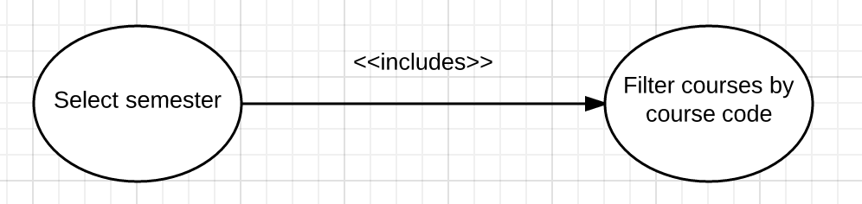
Use Case Name FilterCoursesByCourseCode
Participating actor Student
Entry Condition 1. This use case includes the SelectSemester use case which displays the SchedulePage for the selected semester.
Flow of Events 2. The Student types the entire or partial CourseCode into the search bar of the application above the CourseList.
3. The Student types the CourseId into the FilterField
4. The application displays a CourseList of Courses matching the provided Filter.
Exit Condition 5. The Student locates the desired Course on the CourseList
Special Requirements If the SelectSemester use case cannot be completed, the user receives an error.
If no Course matching the filter is on the CourseList, no Courses are shown.

ScenarioName SearchForCP317
Participating Actor Instances Bob: Student
Flow of Events 1. Bob wants to add CP317 to his course schedule.
2. He opens the scheduling application and selects the semester during which he wants to take the course.
3. The application displays the list of all courses available during the selected
semester.
4. He filters the list by typing CP317 into the filter box
5. The application removes all courses that do not match the given course code leaving CP317 in the Course list
6. The user locates the desired course

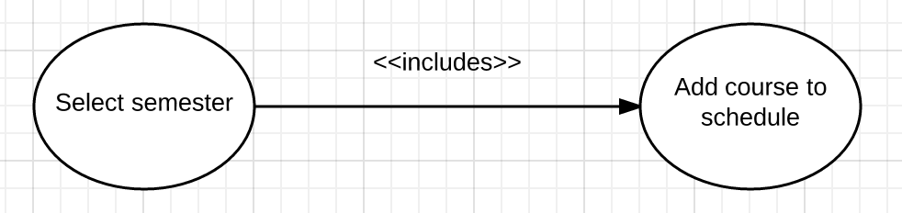
Use Case Name AddCourseToSchedule
Participating actor Student
Entry Condition 1. This use case includes the SelectSemester use case which displays the SchedulePage for the selected semester.
Flow of Events 2. The Student selects a Course from the CourseList and adds it to the
selected ScheduleList by clicking the AddToSchedule button.
Exit Condition 3. The application updates the ScheduleList and ScheduleCalendar so it includes the Course.
Special Requirements If the Course conflicts with an existing Course on the ScheduleList, the Course is not added and an ErrorMessage is displayed.

ScenarioName: AddCP317ToSchedule
Participating Actor Instances: Bob: Student
Flow of Events: 1. Bob locates CP317 on the course list for the current semester
2. He selects the course and adds it to the schedule
3. The course is added to the schedule list and is displayed in on the course schedule

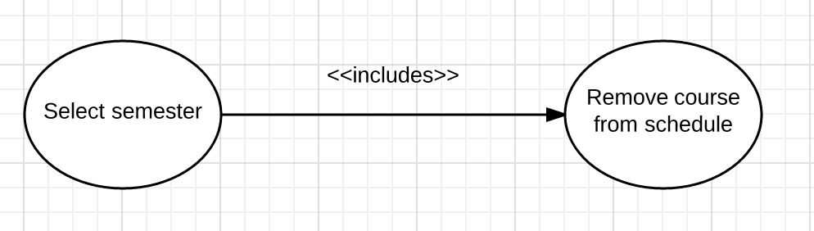
Use Case Name RemoveCourseFromSchedule
Participating actor Student
Entry Condition 1. This use case includes the SelectSemester use case which displays the Schedule and CourseList for the selected semester.
Flow of Events 2. The student selects the Course they wish to remove from either the ScheduleList or the ScheduleCalendar
4. The student clicks the DeleteButton on the selected Course
5. The student chooses the option to remove this Course from their schedule.
Exit Condition 6. The Course is removed and the ScheduleList and ScheduleCalendar are displayed without the Course.
Special Requirements None

RemoveCourse Scenario: RemoveCourseCP317FromWinter2015Schedule
Participating Actor Instances: Bob: Student
Flow of Events: 1. Bob wants to remove the CP317 2015 Winter course from his schedule.
2. He connects to the scheduling app and clicks on his schedule to display his added ccourses.
3. He clicks on the Winter 2015 semester.
4. He locates the CP317 course on the schedule calendar.
5. He clicks on the delete option on the course element
6. The course is removed and the schedule is displayed without CP317.

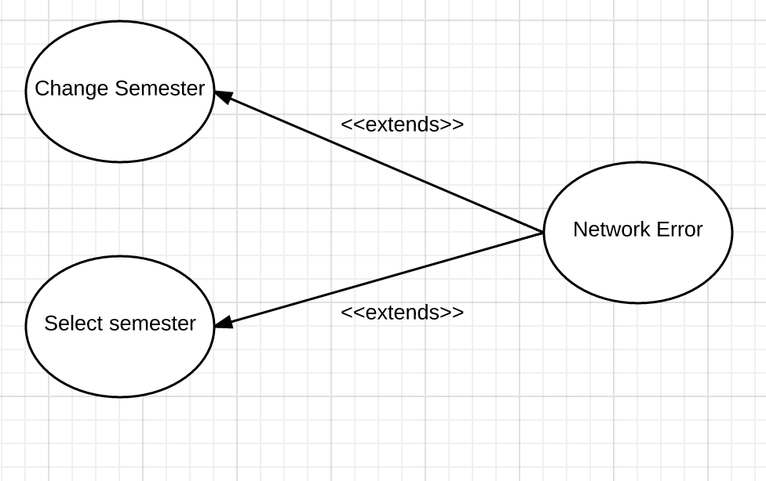
Use Case Name NetworkError
Participating actor Application Error invoked by Student
Entry Condition 1. This use case extends the SelectSemester and ChangeSemester. It is indicated by a Network Communication failure between the scheduling app and the course server (LORIS)
Flow of Events 2. The student invokes the SelectSemester or ChangeSemester use case by selecting a new semester on the SelectSemesterPage.
3. The network connection fails to retrieve Course data.
Exit Condition 4. An ErrorDialog is displayed to the Student.
Special Requirements None

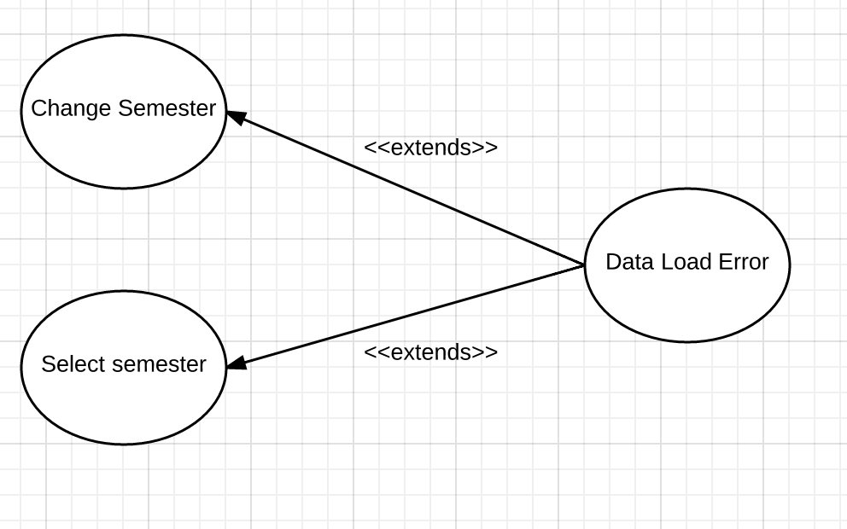
Use Case Name DataLoadError
Participating actor Application Error invoked by Student
Entry Condition 1. This use case extends the SelectSemester and ChangeSemester. It is indicated by a failure to process the returned course data from the course server (LORIS)
Flow of Events 2. The student invokes the SelectSemester or ChangeSemester use case by selecting a new semester on the SelectSemesterPage.
3. The returned data cannot be parsed into Course data.
Exit Condition 4. An ErrorDialog is displayed to the Student.
Special Requirements None

