**GENERAL ETHOS BEHIND OUR DESIGN:**  
Since the website is about the building, we think that the best approach to this is to focus on the building itself - the architecture. That’s why the colour of the background is meant to remind the colour of a Pergamon. Other colours are in a similar range. In addition, we chose a monospace font that is encountered in numerous old, technical documents. By that choice, we also wanted to point out that the Students’ Union Building isn’t a new, modern architecture that most people think (the original Graves Building was built in the 1930's).

Pictures on our pages should look like sketches and shouldn’t show everything so that the user could use their imagination. By doing so, we hope to grab their attention and, therefore, the website might encourage some to check the building out. On the architecture page, we use faded pictures. On the other pages, we use a similar effect, but in a higher contrast (due to accessibility reasons). Finally, all things considered, we believe that choosing that font, these colours and pictures stylized in the same style, the website is readable and neat.

Also, we chose not to use a universal banner throughout our website, since we feel that it does not fit our design. Instead, the unifying art style throughout every page and the consistent font is what unifies our webpage.

**OUR SITE MAP:**

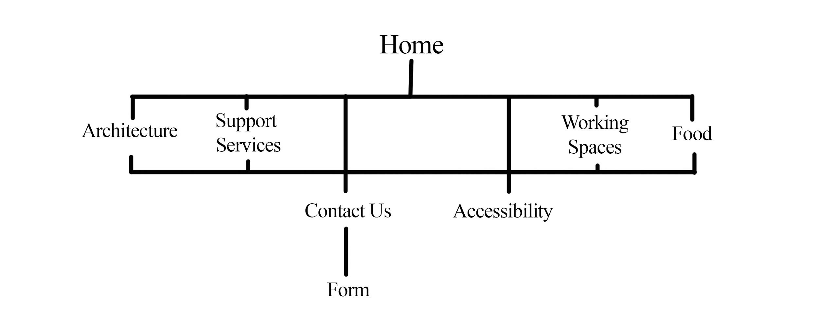

Diagram 1. The Site Map for our website

The Site Map is simplistic and easy to navigate. Users will never have to use more than 3 clicks to get to a webpage. Our two most important pages, Contact Us and Accessibility, are located in the footer of every page so that users may always have their links nearby.

**ACCESSIBILITY:**

To increase accessibility we would like to follow W3C Web Content Accessibility Guidelines (World Wide Web Consortium 2008) such as providing text alternatives for non-text content. However, we agree with the point of view of the Royal National Institute of Blind People (2018) that “where an image is purely decorative we don't use alt text as this is superfluous information, and extra 'noise'”.

These are the text alternatives we decided to provide:

the photo of the building on the homepage-”Find out more about the architecture”

the working spaces page-”You can find there: Wi-Fi, PCs, many sockets, meeting rooms, 3 bookable music suites, print/copy/scan service, plenty of desks, comfortable sofas and beyond”

images of support services-”...’s logo”

on the architecture/blog/food page- we find images decorative because they don’t give anything new to the content

We also would like to make all functionality available from a keyboard, using acceskeys:

Food -F

Blog- B

Workspaces- W

Architecture- A

Support Services- S

Contact- C

Accessibility- D

Home- I

By increasing clickable space (adding extra padding to anchors), creating sort of buttons in ‘the Inside Menu’ and following the rule of 3 clicks, we want our website to be easier to navigate and therefore, more convenient to use.

While thinking about the readability, we focused on the right font (monospace), spacing, padding, margins. Additionally, we want our website to be consistent in design and the structure, so that user will not be distracted by constant alterations.

We do not plan to use elements that are not compatible with older browsers, therefore, we should not have an issue. However, we will test our website in older browser versions to ensure that it functions properly.

**LEGAL ISSUES:**

We are the authors of the majority of the pictures on the website. However, we use copyright free icons from one website that insist on giving attribution to the authors of them. Bitlaw (2018) seems to support this practice when it comes to the use of ‘Free Images Off the Internet’. This website provides detailed instruction how we are supposed to credit them, as we’re going to follow.

We gathered nearly all of our information from visiting the Students’ Union in person and describe services as we see them, however, we will reference the appropriate sources when using other research. Other than our form and css reset, all of the code was written by us.

**DESIGN MOCKUPS:**

Our decision is to use 2 breakpoints, as the version for devices such as a tablet can look like the one made on mobile devices. Considering larger screens, we plan to surround the body by a wrapper so that the website will be steady (having a min/max width). Additionally, we don’t except any of our pages to ‘break’. We consider a 640px breakpoint, but final position might change.

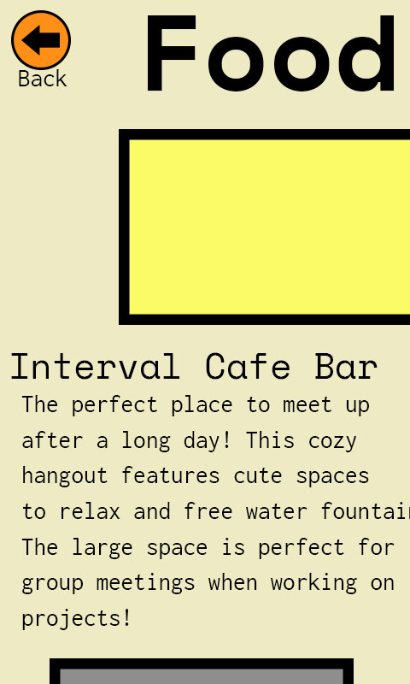Diagram 2. The mock up of food/ support services/blog page on mobile devices

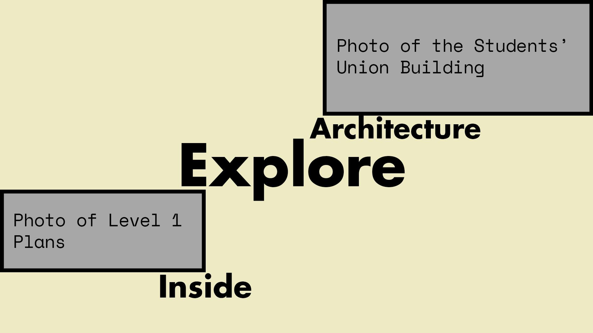Diagram 3. The mock up of homepage on desktops

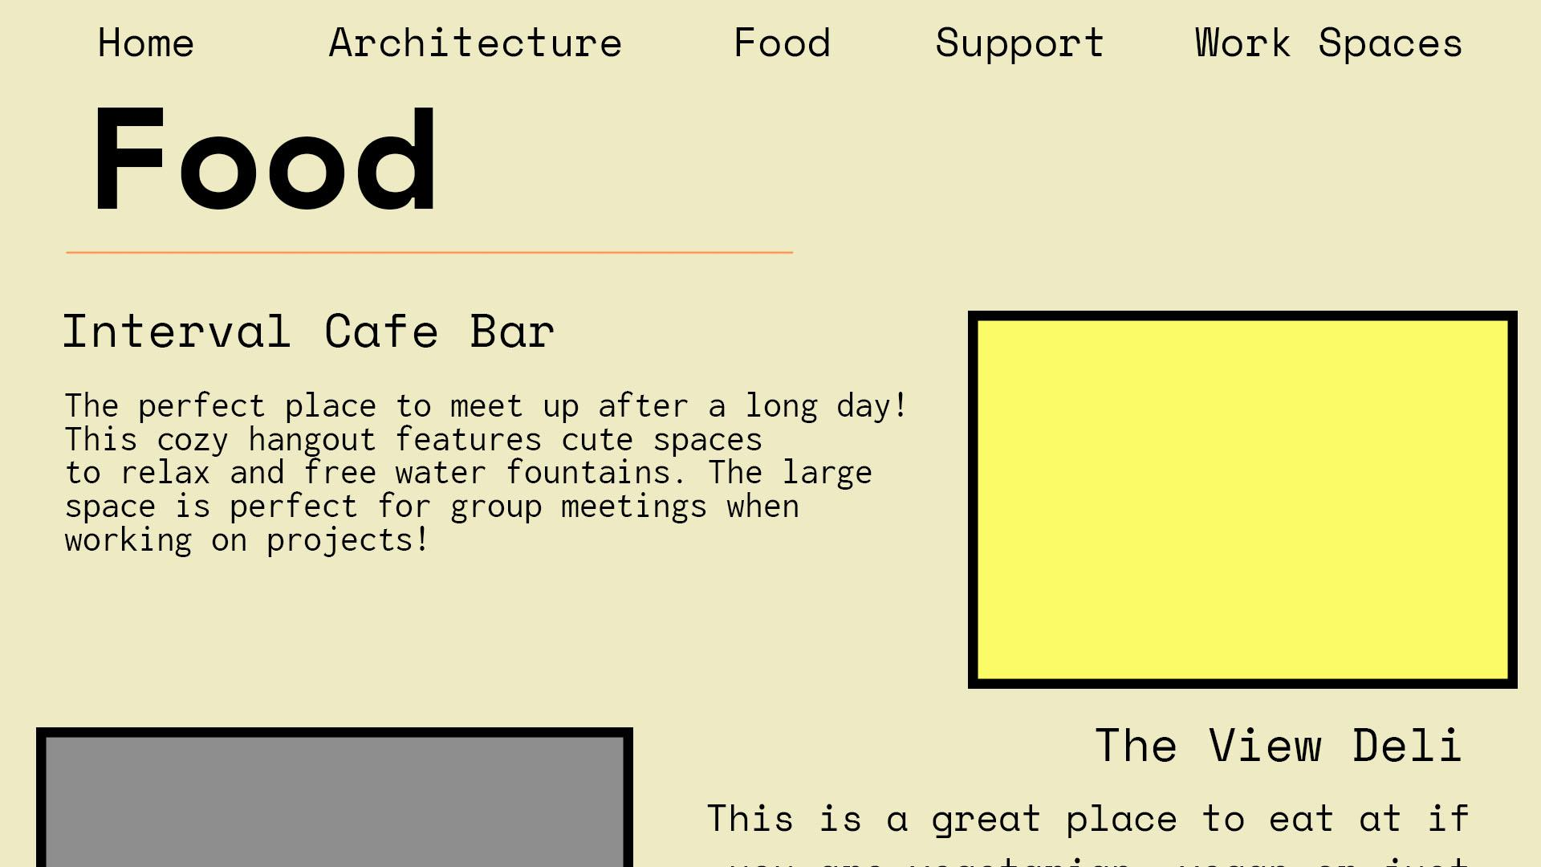

Diagram 4.. The mock up of food/ support services/blog page on desktops

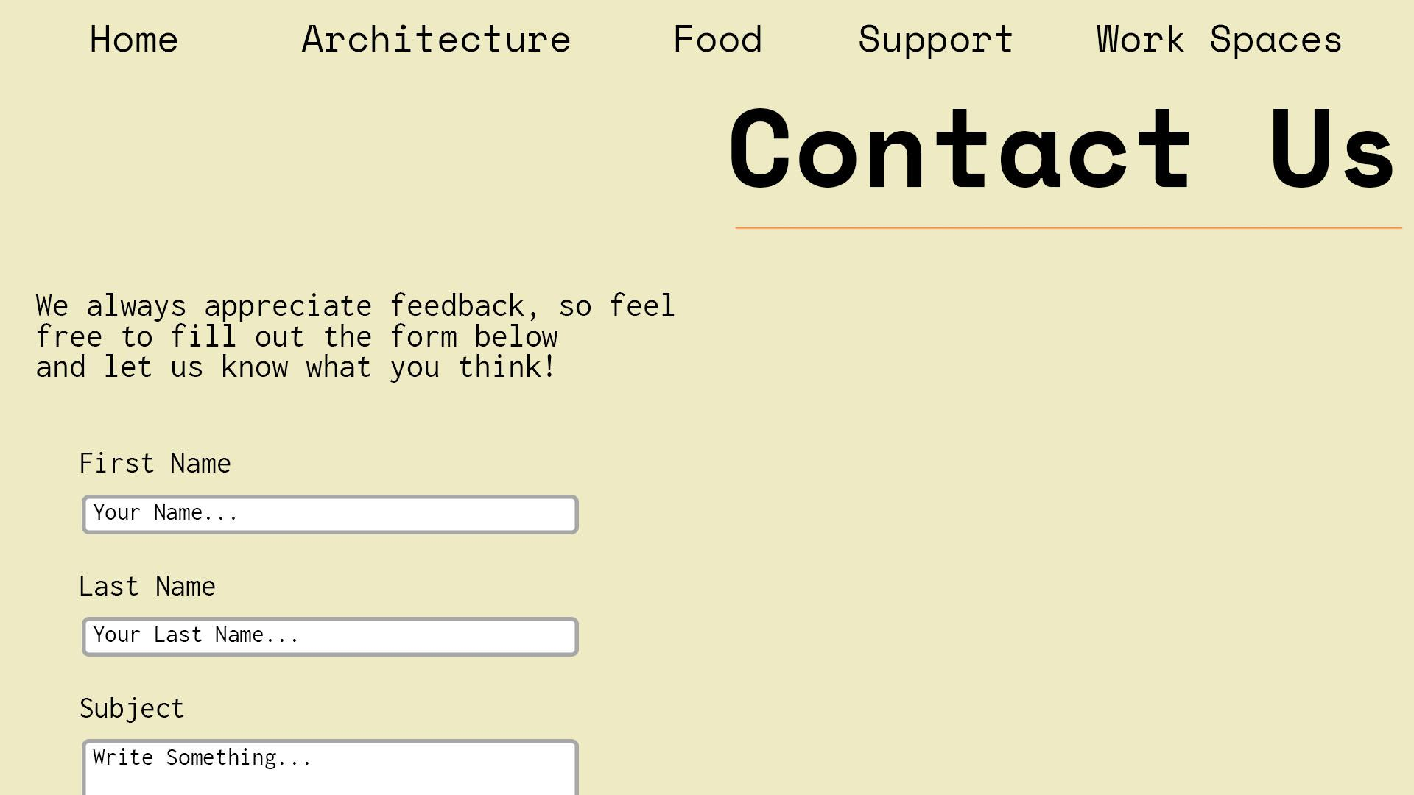

Diagram 5. the mock up of a contact/ accessibility page on desktops

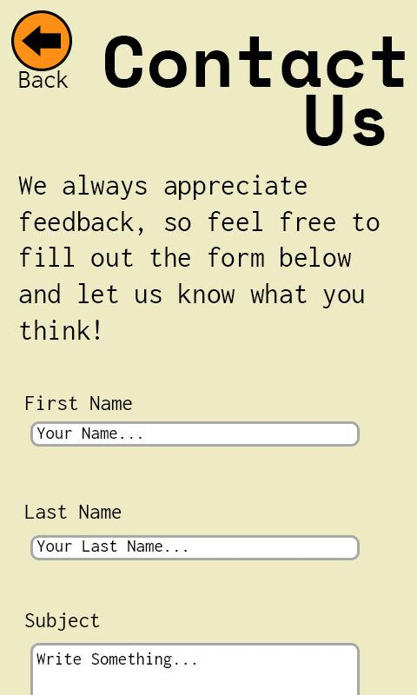Diagram 6. the mock up of a contact/ accessibility page on a

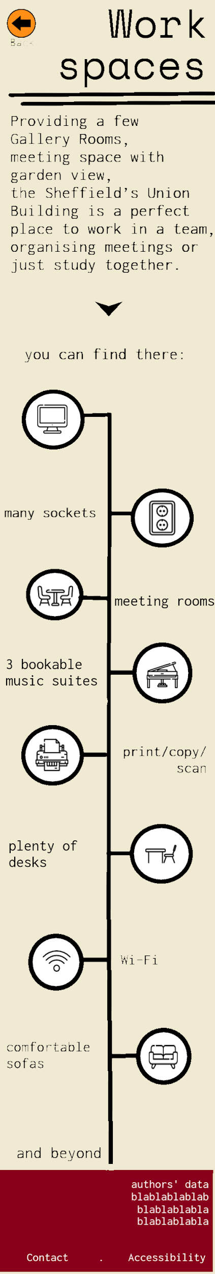

Diagram 7. the mock up of workspace page on mobile devices

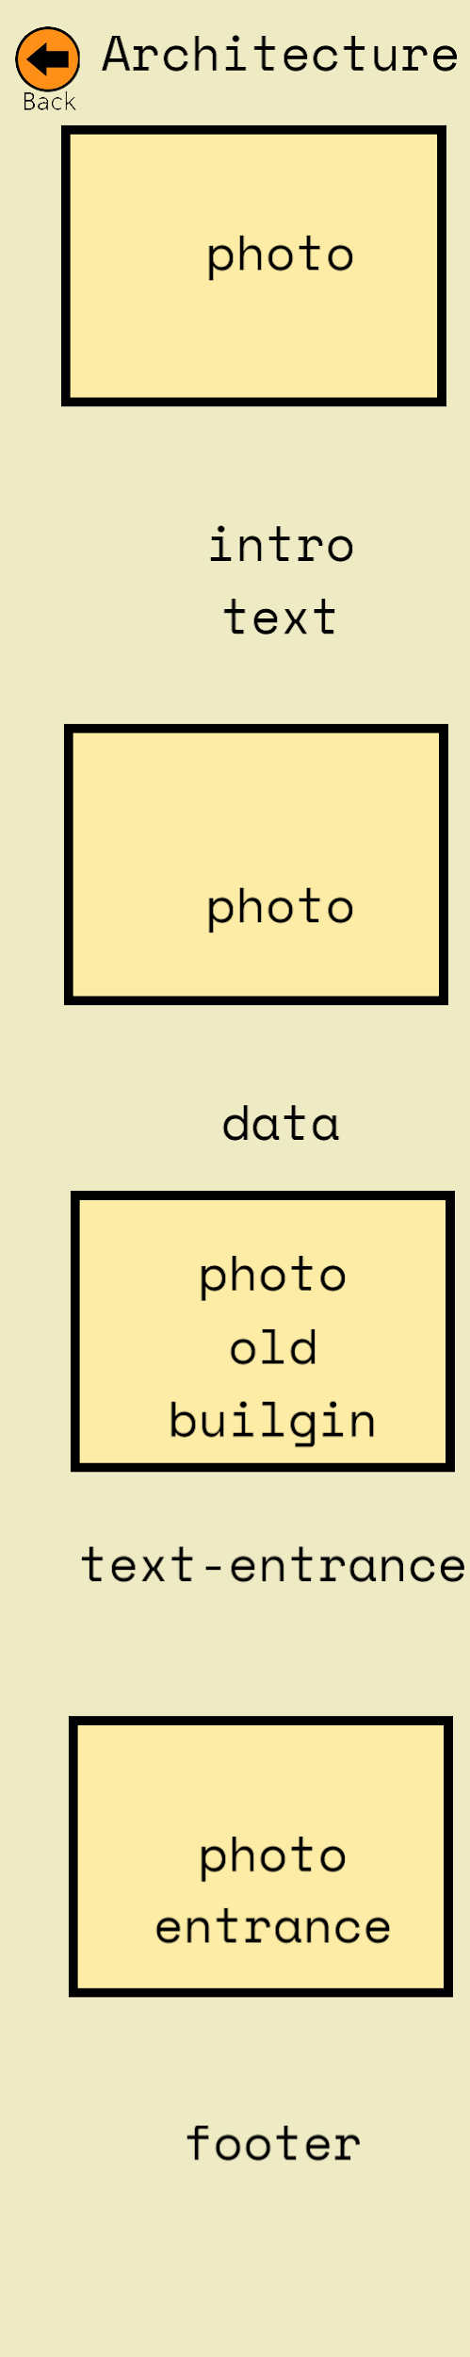

Diagram 8. The mock up of architecture page on mobile devices

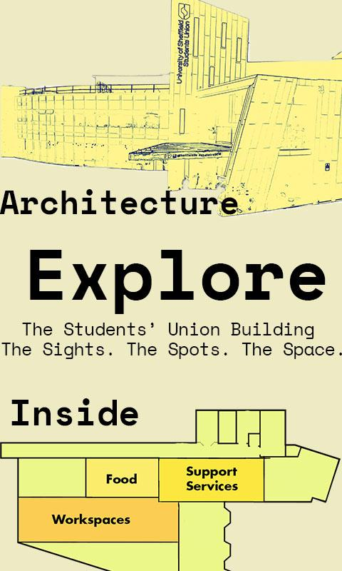

Diagram 9. The mock up of our mobile

homepage.

**MENU SYSTEM:**

The menu will be located on a homepage. Since we are using responsive web design, outlined by the Google Developers (2018), our navigation will have a different look on mobile and desktop devices. On mobile devices, users will be able to touch back arrows at the top of the page to navigate back to the homepage. The arrows will have an alternative text to increase accessibility. On desktop devices, pages that are not the homepage will have a grid-based navigation bar, in the style that [Erick Arbé](https://twitter.com/erickarbe) (2018) describes, at the top of the screen that can guide them to the different web pages within our site, including a link to the homepage.

To achieve an artistic style, our home navigation is based on images. The first is an image of the outside of the Students’ Union. This picture will serve as a button to lead to our “Architecture” page, with a label nearby it. The second will be of a indoor plan of Level 1 of the Students’ Union. This plan has been separated into rooms, labelled with html. Anastasios Karafillis (2012) mentions Fitts’s Law, stating that clickable places should be larger and closer to increase ease of access, therefore, the html labels will have significant padding around them that will be the size of the room they are placed in. In between the pictures, there will be a statement inviting users to explore the building. To clarify that the images are clickable, we will change the look of the linked areas when they are hovered over.

**A CONTACT FORM:**

On our contact page, we’ll attempt to create a similar form, without ‘the country box’ (W3schools 2018).

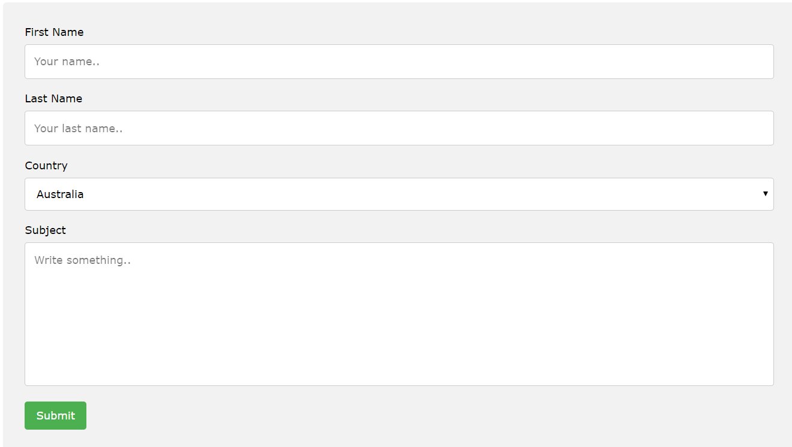

10. A contact form (W3schools 2018)

**REFERENCES:**

[Arbé](https://twitter.com/erickarbe). E., (2018). Responsive Navigation[online]. *Adventures in Responsive Navigation* [Viewed 02/11/2018]. Available from: http://responsivenavigation.net/

Bitlaw., (2018). Web Site legal issues[online]. *Bitlaw.* [Viewed 31/10/2018]. Available from: https://www.bitlaw.com/internet/webpage.html

Google Developers.,(2018). Responsive Web Design[online]. *Google Developers* [Viewed 02/11/2018]. Available from: https://developers.google.com/search/mobile-sites/

Karafillis. A., (2012). When You Shouldn’t Use Fitts Law to Measure User Experience[online]. *Smashing Magazine* [Viewed 02/11/2018]. Available from: https://www.smashingmagazine.com/2012/12/fittss-law-and-user-experience/

The Royal National Institute of Blind People,. (2018). Web accessibility statement [online]*.The Royal National Institute of Blind People*.[Viewed 31/10/2018]. Available from:https://www.rnib.org.uk/about-rnib/web-accessibility-statement

Sheffield Students’ Union., (2018).Sheffield Students’ Union [online]. *Sheffield Students’ Union*. [Viewed 08/11/2018]. Available from: https://su.sheffield.ac.uk/

W3schools., (2018). How TO-Contact Form [online]. *W3schools.* [Viewed 31/10/2018]. Available from:

https://www.w3schools.com/howto/howto_css_contact_form.asp

World Wide Web Consortium., (2008). WCAG 2.1 at a Glance [online]. *W3C*. [Viewed 31/10/2018]. Available from:https://www.w3.org/WAI/standards-guidelines/wcag/glance/