**CHANGES IN DESIGN OF OUR WEBSITE:**

Overall design of the website didn't change, mainly because of the good preparation to this task and numerous discussion about project. In addition, decisions about our website were made before the start of the assignment. However, there are some things that have been changed.

Firstly, our breakpoint is set up to 600px. It is because the website breaks in the other point that we expected at the beginning. While testing the website on bigger screens, we decided to add 2 tweak points (1200px, 1500px) in order to adjust same features that didn't look well in larger screens or to avoid breaking. The min-width of a body is 320px while max-width of a body is 1400px. Once the website reaches 1400px, the body is surrounded by a wrapper.

Secondly, we decided to reset css instead of normalizing it. We copied the reset css code from a legal source (Meyer 2018).

Thirdly, I added in some places an orange border due to aesthetic reasons.

Finally, we added an initial comment in css with the names of the authors (Web Designer Notebook 2009).

**ORGANISATION:**

We didn't create templates because they were not needed for our project.

We used reset because we wanted to start from scratch without any properties set up before. We thought that it's easier to create a website when all properties are adjusted to 0.

We organized our file structure for the website in a standard way, opting to put images and CSS files into their own separate folders. Our HTML files are kept in the main Website folder, rather into their own separate ones. We felt this was ok since each HTML file is labelled clearly.

Once we finished, we validated CSS code by using W3C CSS Validation Service (W3C 2009). The result was ”Congratulations! No error found!”. In order to check html code, we used W3C HTML Validation Service (W3C 2013). During the project, we've been using Google Developer Tools, which helped us to spot some mistakes.

The design of our menu didn't change. However, we added a hover effect (background-color:white) in the nav bar on desktops' version.

We didn't use JavaScript to keep our website simple.

Also, all of our code was written by us, except for the css reset and form in which case we referenced our source within a comment.

**ACCESSIBILITY:**

In accessibility statement we followed guidelines from Nomensa (2018).

As we mentioned previously in the first document, we didn't want to add alt text if it is purely decorative. However, as the alt text of the back arrow image, we decided to put an arrow (unicode in html) so that the user will see the back arrow even though the images aren't displayed.

**OPTIMISATION:**

We compressed images (to 100-400KB) to decrease the image loading times, but at the same time, we wanted to sustain the quality. As a result, some images that are displayed as large had to keep their size so that our website could be in a good quality.

**SECURITY:**

Although cross-site scripting is not ideal when working with forms, there should not be a large issue since the form is only copying data to an email message. The form does not ask for any sensitive data, so even if there was a security breach, it would not be urgent (Degges 2017). Also, http/https is a server-side choice, and we would use https because it is generally considered to be better security-wise.

**TESTING:**

We tested our website across different browsers such as Internet Explorer, Microsoft Edge, Google Chrome and Mozilla Firefox with a positive result. The website was also tested on different devices with different resolutions (a small laptop, a large screen of a computer and a mobile phone). During testing, we often used google chrome Web Developer Tools to check how our website behaves on different devices, which was very useful tool.

When it comes to accessibility issues, we tested our Website in case images aren't displayed and then, we had to adjust some content. During testing, we encountered some difficulties -words on the main page were displayed on top of one another. The reason was that they are positioned to the image relatively (image's position is relative, but words' one is absolute). When the image (ancestors) disappeared, words couldn't adjust their position. We solved this problem by adding padding-bottom to the div 'inside'. Also to increase accessibility and convenience while using the website we increase the padding of these words (to expand the clickable space of buttons).

While testing the website without a stylesheet, we noticed that our images were too big, so then they had to be compressed again to get a right size in case of CSS doesn't work.

We also tried to account for colour-blindness while making our website. We attempted to use online sources that emulate how our website would look with different types of colour-blindness, however, a URL for the website would be required to do that. Therefore, we used a website, called Contrast Ratio, to test the contrast between the major colours within our web pages (Verou no date), making sure that everything is distinguishable. When testing, the contrast between our black text and our lighter background was good as well as the outlines within all of our pictures. The fill of our stylized images does not contrast well with the background, so it might be difficult for some to tell that they are different colours, however, since every image has the high contrast outlines that detail it, the issue is very minor. The orange we used as accents does not contrast well either, but since the colour is not important to navigating the website, the problem is also very minor.

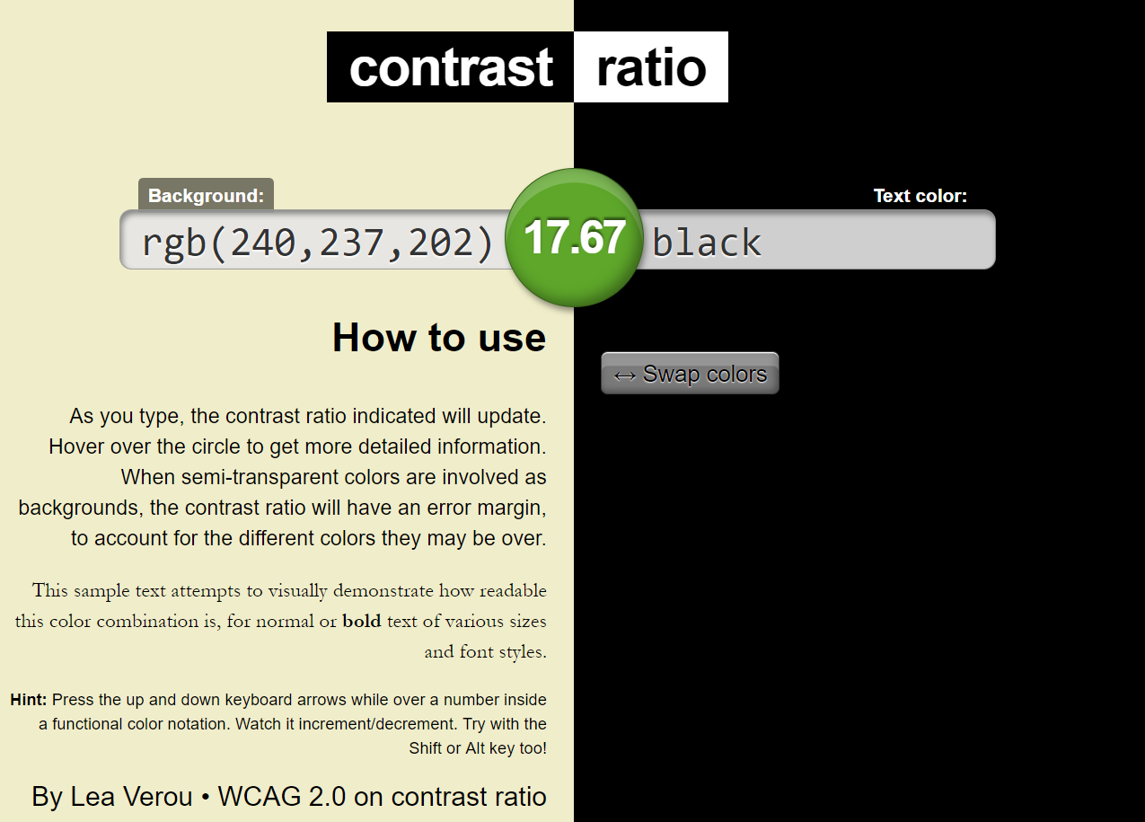

*Diagram 1. The Contrast between*

*Our text colour and the background*

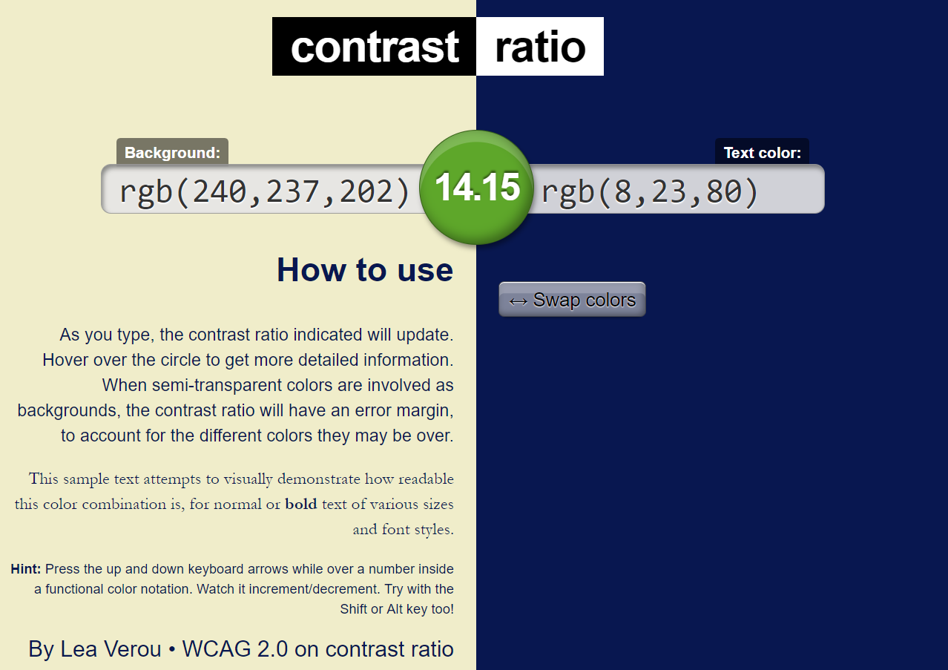

*Diagram 2. The Contrast between*

*Our image outline and the background*

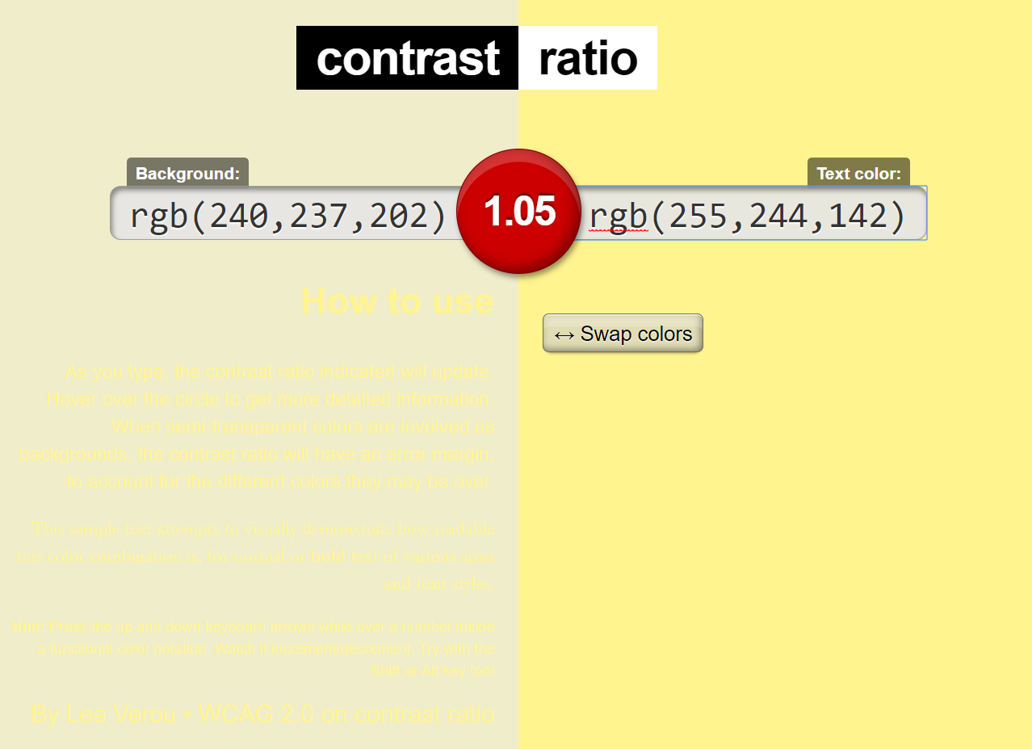

*Diagram 3. The Contrast between the image fill colour and the background*

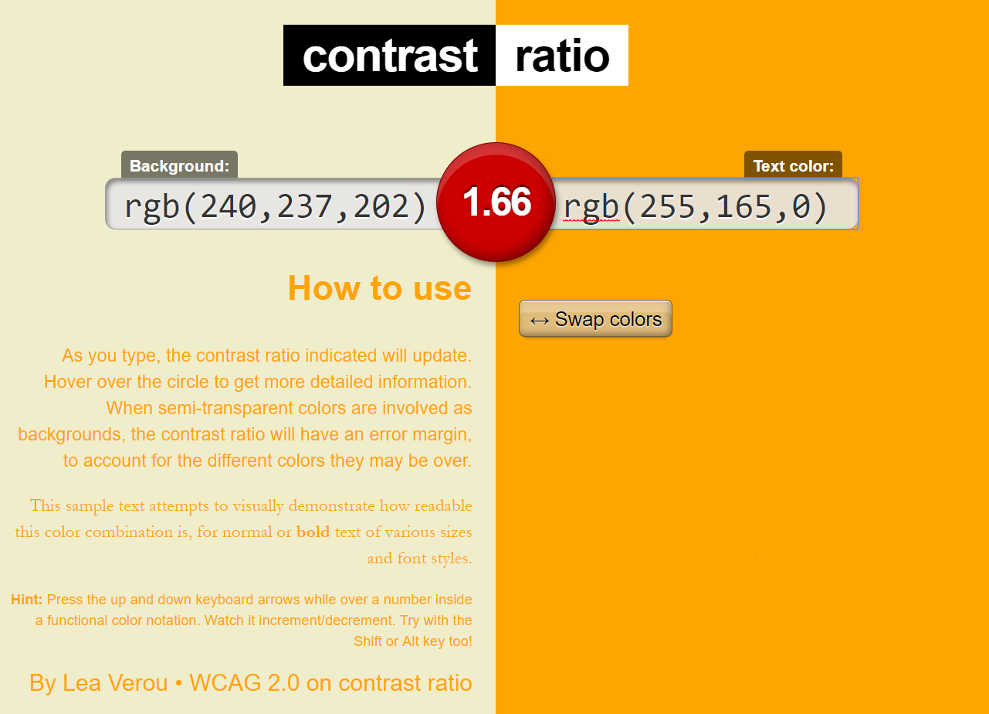

*Diagram 4. The Contrast between the accent orange colour and the background*

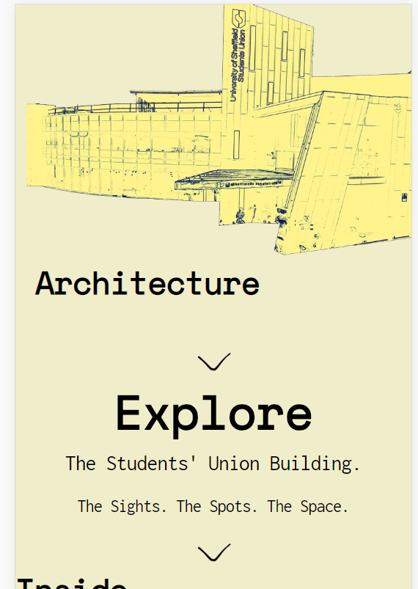

*Diagram 5: a homepage on mobiles*

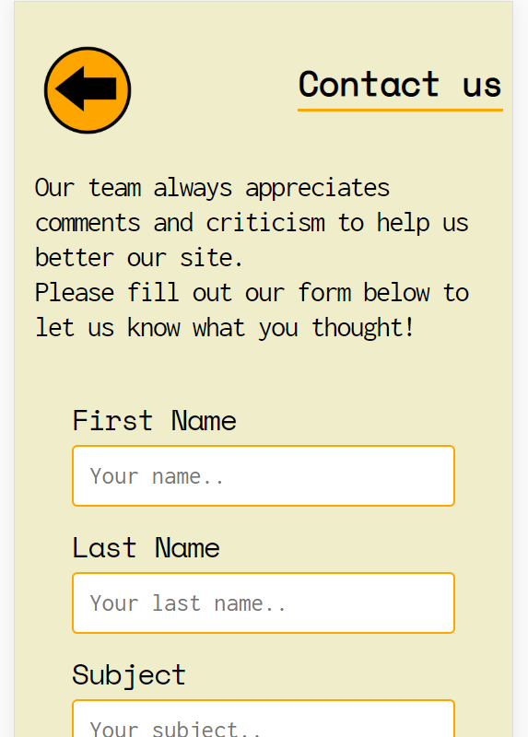

*Diagram 6: a contact page on mobiles*

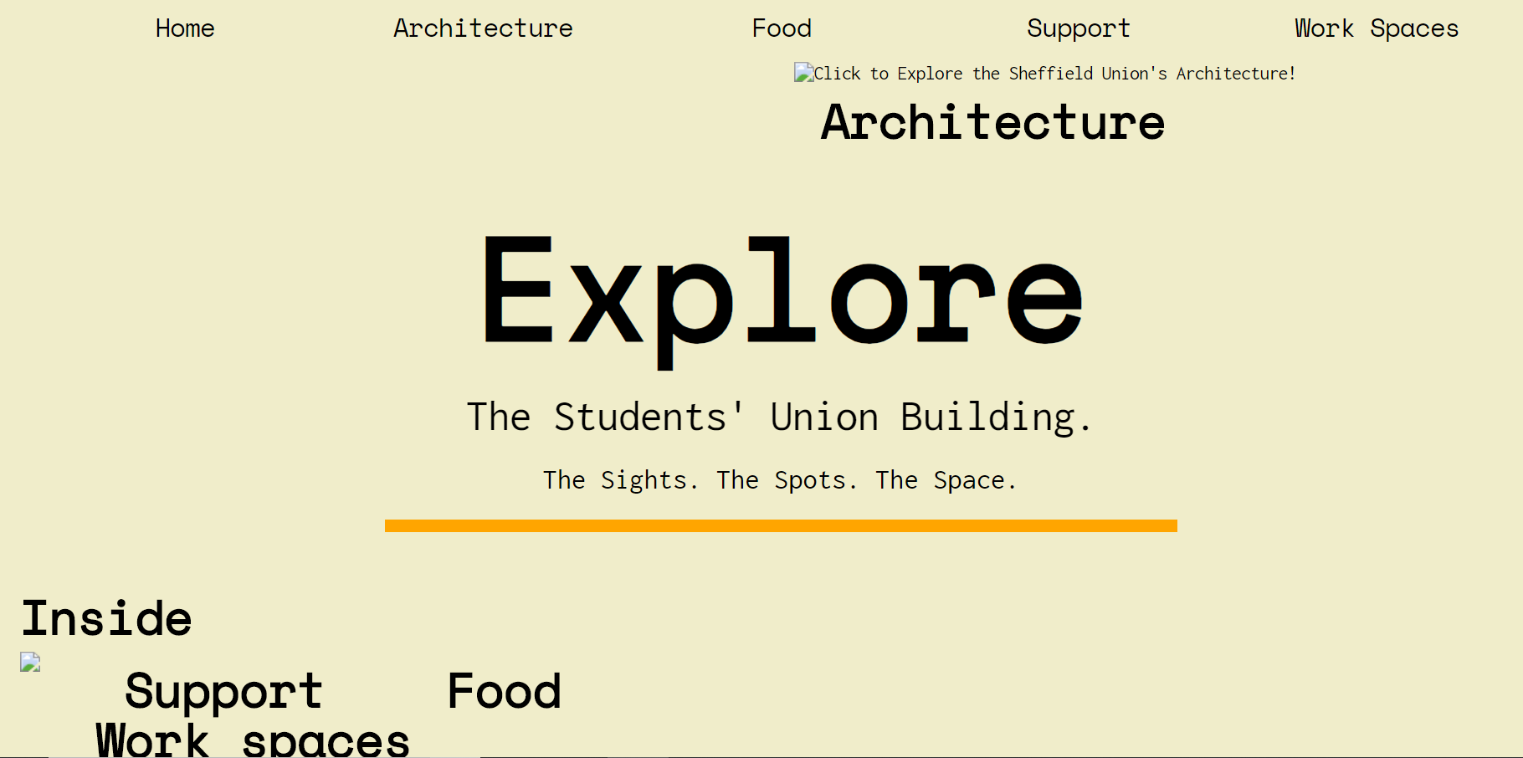

*Diagram 7: a homepage on desktops/tablets without images*

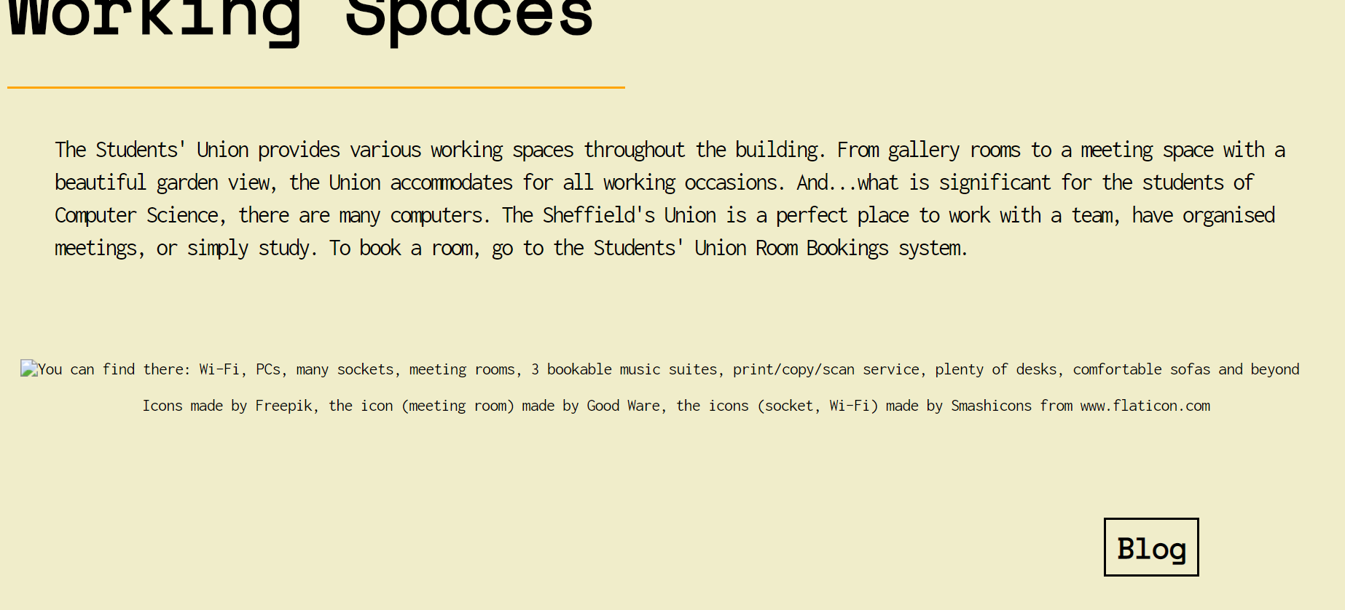

*Diagram 8: the alt text of the working spaces’ diagram*

**REFERENCES:**

Degges, R., (2017). Everything You Ever Wanted To Know About Secure HTML Forms [online]. *Twilio Blog*. [Viewed 25 November 2018]. Available from: https://www.twilio.com/blog/2017/09/everything-you-ever-wanted-to-know-about-secure-html-forms.html

Meyer, E. A., (2018). CSS Tools: Reset CSS[online]. *Meyerweb.* [Viewed 25 November 2018]. Available from: https://meyerweb.com/eric/tools/css/reset/index.html

Nomensa., (2018). How to write an accessibility statement [online]. *Nomensa*. [Viewed 25 November 2018]. Available from: https://www.nomensa.com/blog/2009/writing-an-accessibility-statement

Verou, L., (no date). Contrast Ratio [online]. *Contrast Ratio*. [Viewed 25 November 2018]. Available from: https://contrast-ratio.com/

W3C., (2009). CSS Validation Service. [online]. *W3C.* [Viewed 25 November 2018]. Available from: https://jigsaw.w3.org/css-validator/

W3C., (2013). Markup Validation Service*.* [online]. *W3C.* [Viewed 25 November 2018]. Available from: https://validator.w3.org/

Web Designer Notebook., (2009). How to start a css file [online]. *Web Designer Notebook*. [Viewed 25 November 2018]. Available from: http://webdesignernotebook.com/css/how-to-start-a-css-file/