## 4.1 MySQL

Import the **world** database from **world.sql** to MySQL

* **MySQL Workbench**

To import the *world* database from *world.sql* to MySQL I am using MySQL Workbench.

Open MySQL Workbench => Server => Data Import => Import from self-Contained File =>

Click and find the location where it is on my computer => start import => open new SQL query tab and type “SHOW DATABASES;” (When I run it I can see what databases are in world.sql).

* **Command prompt (cmder)**

Type commands in cmder prompt:

1. cd “\Program Files”
2. cd MySQL
3. cd MySQL Server 8.0
4. cd bin

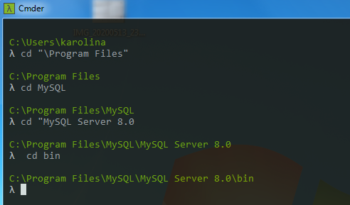

1. Then type commad as follows:

mysql -u (here is my root name) -p(here is my password to my root) < "C:\Users\karolina\Desktop\AD_project_2020\world.sql" (enter)

I give the whole path to the file here

1. I can go back to MySQL Workbench and I can run “SHOW DATABASES;” and world database is there.

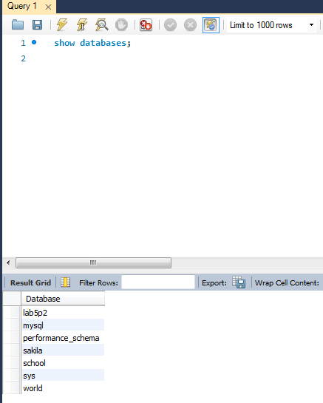

The ***world*** database is imported.

I can see what tables are in the ***world*** database by typing:

1. use world; (ctrl + enter)
2. show tables; (ctrl + enter)

The same commands I can type in MySQL 8.0 Command Line Client.

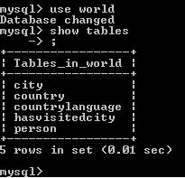

### 4.1.1 Alan’s travel details

Give the MySQL command that shows;

- the name of the cities,

- the arrival date in the cities,

- the name of the country the city is in.

For all cities and countries visited by Alan in alphabetical order by city name.

