Customer Retention & Revenue Optimization Report
July 2025
Report produced by Karolina Varkulevičiūtė

1. Executive Summary
This report presents an analysis of customer behavior and revenue performance using RFM segmentation, cohort analysis, and regional revenue analysis to identify opportunities for improving customer retention and driving revenue growth.
The analysis reveals a significant decline in customer activity over time, with transactions decreasing from 9.5K to 2.2K and active customers dropping from 100 to 49 over a six-month period. Revenue followed this trend, falling from 23.5bn MMK to 5.7bn MMK, indicating that performance is primarily driven by declining engagement rather than reduced spending per order.
Customer segmentation highlights a large base of Potential Loyalists (26%), representing a key growth opportunity, while At Risk (16%) and Hibernating (17%) customers indicate substantial churn risk.
The findings suggest that targeted retention strategies and early intervention mechanisms could significantly improve revenue performance. Even modest improvements in retention across key segments could result in meaningful short-term revenue uplift.

2. Business Problem
Customer retention is a critical driver of long-term business performance. Retaining existing customers is generally more cost-effective than acquiring new ones, yet many businesses lack visibility into:
- Which customers generate the most value
- Which customers are at risk of churn
- How customer engagement evolves over time
- Where to prioritize retention and growth efforts
This project addresses these challenges by developing a customer analytics framework that transforms transactional data into actionable insights using behavioral segmentation and lifecycle analysis.

3. Data & Methodology
3.1 Dataset
The analysis is based on a transactional sales dataset containing:
- Customer ID
- Transaction dates
- Revenue per transaction
- Geographic region
From this data, customer-level metrics were derived:
- Recency – time since last purchase
- Frequency – number of transactions
- Monetary – total revenue per customer
3.2 Analytical Approach
The analysis combines three key methods:
RFM Segmentation
Customers were grouped based on purchasing behavior into segments such as:
- Champions
- Loyal
- Potential Loyalists
- Active / Active Low-Value
- At Risk
- Can’t Lose Them
- Hibernating
This allows identification of high-value customers, growth opportunities, and churn risks.
Cohort Analysis
Customers were grouped by their initial segment (January baseline) and tracked over time to analyze:
- Changes in engagement
- Migration between segments
- Early indicators of churn
Revenue & Regional Analysis
Revenue performance was analyzed across:
- Time (monthly trends)
- Customer segments
- Geographic regions
This helps identify key revenue drivers and regional growth opportunities.
4. Analysis & Findings
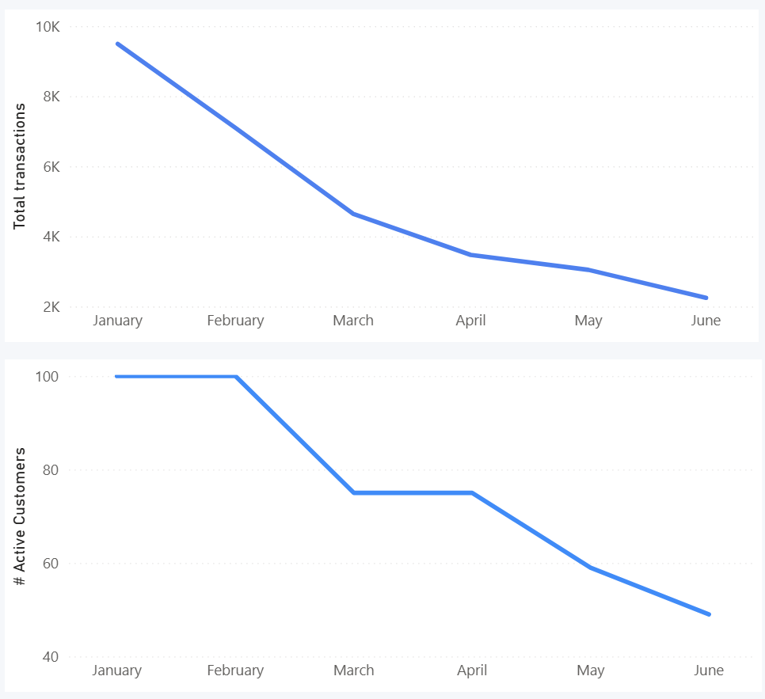
4.1 Declining Customer Activity
9.5K
2.2K

Figure 1 Monthly transaction trends.
49
100
Figure 2 Number of active customers by month.
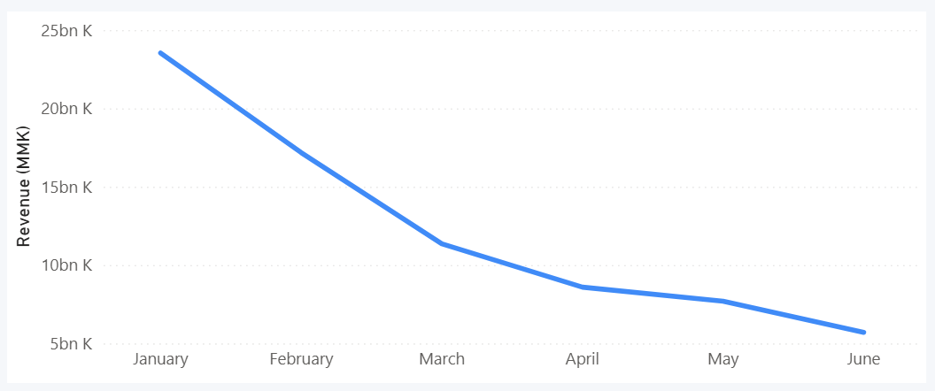
Figure 3 Monthly revenue trends.
5.7 bn K
23.5bn K
Customer activity shows a clear downward trend:
- Transactions decreased from 9.5K → 2.2K
- Active customers dropped from 100 → 49
- Revenue declined from 23.5bn → 5.7bn MMK
This indicates that revenue loss is primarily driven by reduced engagement, not reduced spending per transaction.
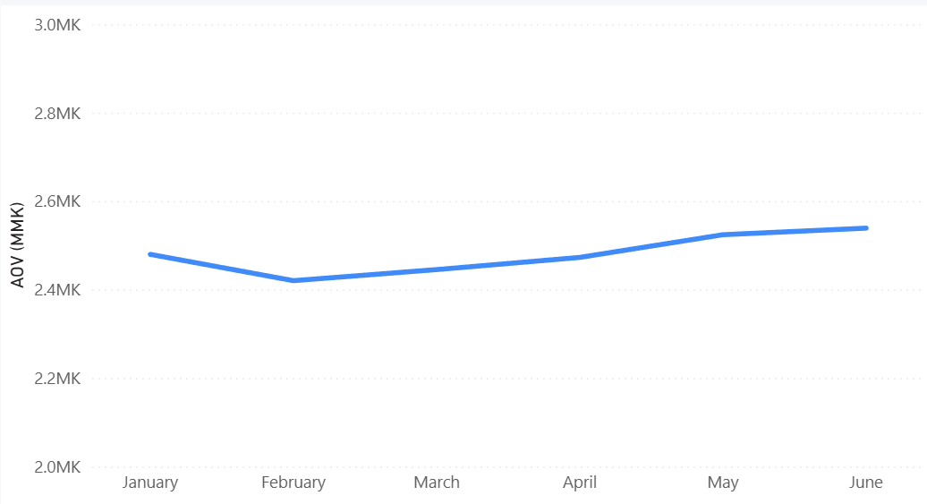
4.2 Stable Customer Spending
2.48 MK
2.54 MK
2.42 MK
Figure 4 Monthly average order value (AOV).

Despite declining activity:
- Average Order Value remained stable (~2.4M–2.5M MMK)
This suggests that customers who remain active continue to spend at similar levels, reinforcing that retention is the key issue.
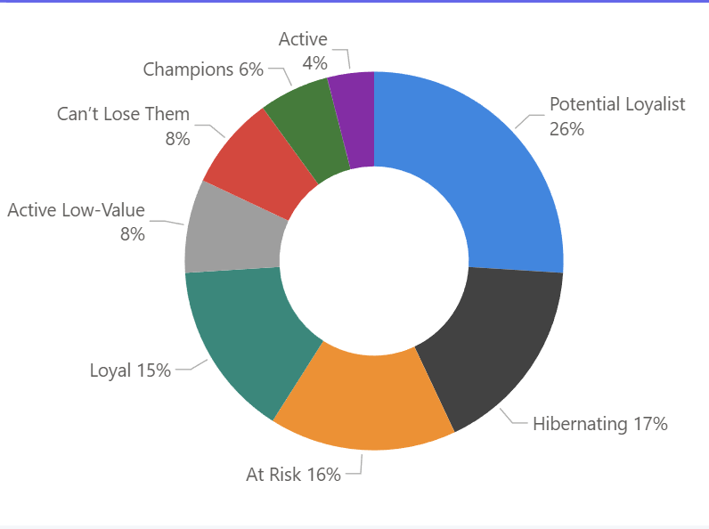
4.3 Customer Segmentation Insights
Figure 5 Customer segmentation make-up.
- Potential Loyalists (26%) represent the largest segment and strongest growth opportunity
- Hibernating (17%) + At Risk (16%) = ~33% of customers, indicating high churn exposure
- Champions (6%) generate the highest value despite small size
- Can’t Lose Them customers show high historical value but declining engagement
Overall, customer value is highly concentrated in a small number of customers, making retention critical.

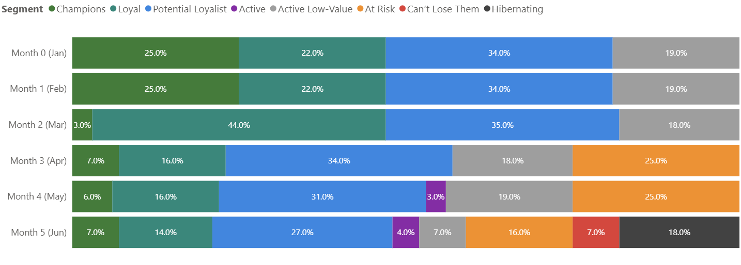
4.4 Customer Lifecycle Trends
Figure 6 Customer Segment migration over six-month period.
Cohort analysis shows:
- Customers tend to move from Potential Loyalist → Loyal → At Risk → Hibernating
- Engagement declines over time without intervention
- Some Active Low-Value customers can transition upward, indicating growth potential
This highlights the importance of early engagement and lifecycle management.
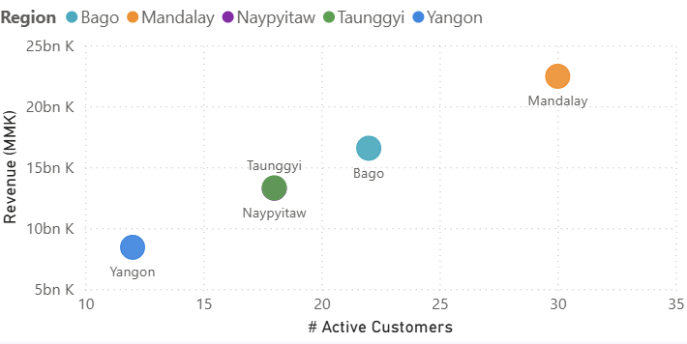
4.5 Regional Performance Insights
Figure 7 Regional customer value distribution by revenue and number of active customers.
- Mandalay is the strongest region (highest revenue and customer count)
- Yangon underperforms despite having a moderate customer base
- AOV is consistent across regions (~2.4M–2.5M MMK), meaning:
Revenue differences are driven by customer volume, not spending behavior
This suggests opportunities for regional customer acquisition and engagement strategies.
5. Business Recommendations
5.1 Retain High-Value Customers
Focus on Champions and Loyal customers:
- Loyalty programs
- Exclusive offers
- Personalized engagement
5.2 Recover At-Risk Customers
Target At Risk and Can’t Lose Them segments:
- Win-back campaigns
- Time-limited incentives
- Personalized outreach
These customers represent high-probability revenue recovery.
5.3 Develop Growth Segments
Invest in Potential Loyalists:
- Targeted promotions
- Onboarding campaigns
- Cross-selling strategies
This segment offers the highest ROI for long-term growth.
5.4 Reactivate Hibernating Customers
Use low-cost strategies:
- Email campaigns
- Discounts or reminders
- Automated re-engagement flows
5.5 Optimize Regional Strategy
- Use Mandalay as a growth benchmark
- Investigate lower performance in Yangon
- Focus on increasing customer volume in weaker regions
5.6 Implement Early Churn Detection
Use cohort and RFM monitoring to:
- Identify declining engagement early
- Trigger automated interventions
- Prevent customers from entering At Risk / Hibernating stages
6. Conclusion
This analysis demonstrates that customer retention is the primary driver of revenue performance in this dataset.
While spending per transaction remains stable, the decline in active customers has led to significant revenue loss. However, the presence of strong segments such as Potential Loyalists and At Risk customers presents a clear opportunity for recovery and growth.
By implementing targeted retention strategies and improving lifecycle management, the business can:
- Reduce churn
- Increase customer lifetime value
- Drive sustainable revenue growth
Even modest improvements in retention rates could lead to measurable revenue uplift in the short term, making customer retention a high-impact strategic priority.

