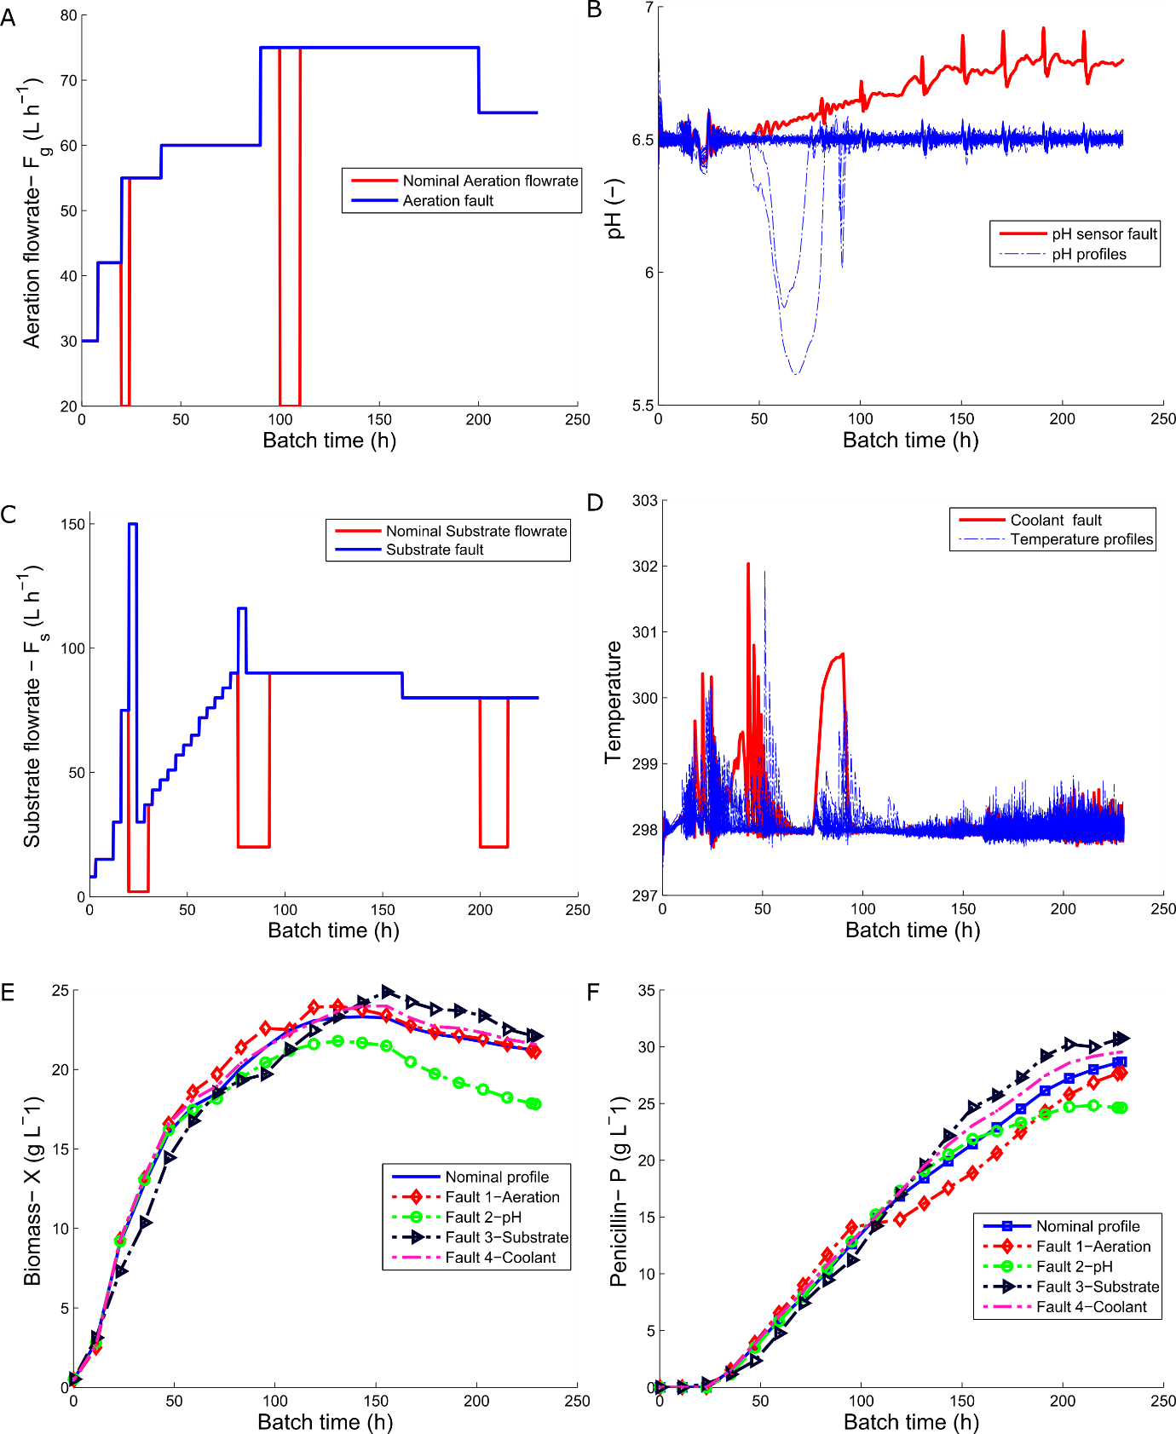

**Figure 1:** Outline of nominal trajectories of good batches represented by Batches 1-30 and with 4 “Bad” batches with faults, **A:** Aeration fault (Batch 31), **B:** pH sensor drift fault (Batch 32), **C**: Substrate fault (Batch 33) and **D**: Coolant fault (Batch 34). The nominal Biomass (*X*) and Penicillin (*P*) profiles are shown in **E** and **D**, respectively with the profiles shown for each of the 4 “Bad” batches with faults.

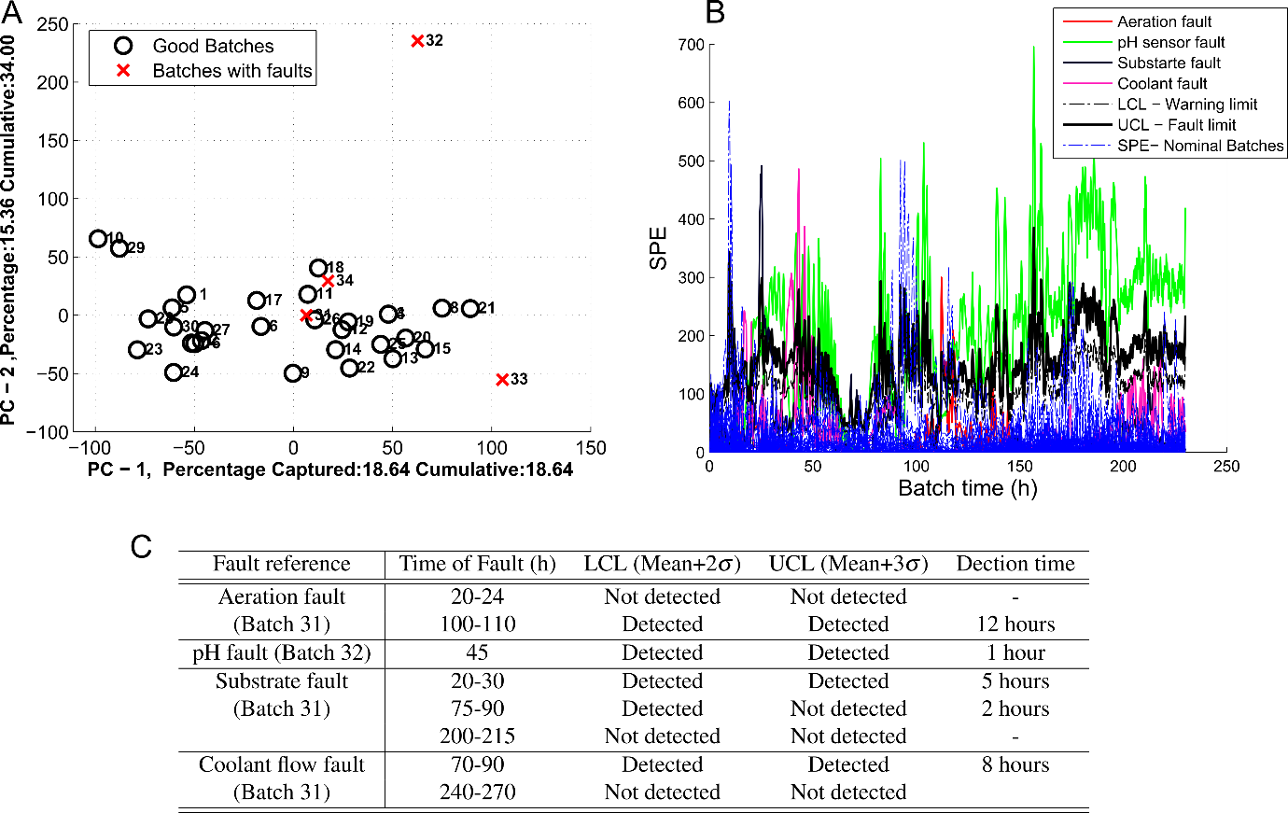

**Figure 2: A** Plot of T1 vs T2 for each of the 34 batches with the good batches represented by circles and the bad batches represented by crosses **B** A summary of the SPE recorded for each of the 30 nominal batches and the 4 batches with faults. **C** A summary of the faults and of the 4 batches and the time it takes until detection by the Lower Control Limit (LCL) and Upper Control Limit (UCL).