LESSON PLAN TEMPLATE
STUDENT- TEACHER: Karol Paulina Rentería Carreño | SCHOOL: IE INEM Lorenzo María Lleras sede Nuevo Bosque. | GRADE: 4°
LESSON TOPIC: | TIME: 2 hours | LESSON DATE: 23/03/2026

STAGE 1 – RESULTS
STANDARD/LEARNING OUTCOME  By the end of the lesson, students will be able to:  - Write short sentences giving advice of health.  - Express advice about health.  - Identify basic health problems and appropriate advice. | GUIDING QUESTION/ INQUIRY QUESTION  What should I do to stay healthy?
TEACHING POINTS

Vocabulary:
Diseases
Cold
Flu
Fever
Cough
Headache
Stomachache

Structure:
I + should + Verb + Complement.
I should rest at home.

STAGE 2 – ACCEPTABLE EVIDENCE
PERFORMANCE TASK(S):
Worksheet where they identify common diseases and write appropriate advice using the modal “should / shouldn’t.”
OTHER EVIDENCE:

STAGE 3 – LEARNING PLAN
LEARNING ACTIVITIES  WARM UP (5min): At the beginning of the class, the teacher leads students in a short action song to activate their energy and attention. Students sing and follow the teacher using hand gestures for each number.  Song:  Five fingers, five fingers, clap clap clap 👏  Four fingers, four fingers butterfly, butterfly 🦋  Three fingers, three fingers, OK, OK 👌  Two fingers, two fingers, peace, peace ✌️  One finger, one finger, silence please ☝️🤫  The teacher models the gestures and students repeat the actions while singing together. This activity helps students focus, practice numbers, follow instructions, and create a positive classroom environment before starting the lesson.  Vocabulary presentation (15 minutes):  The teacher introduces key vocabulary related to common diseases using flashcards, images, or realia.  Target vocabulary:  Headache  Fever  Cold  Cough  Toothache  Stomachache  The teacher models pronunciation and meaning through repetition and simple questions such as:  What’s this?  Is it a headache or a fever?  Students repeat the words and associate them with images to ensure comprehension.  Grammar presentation (20 minutes):  The teacher introduces the modal “should / shouldn’t” to give advice.  Structure:  You should + base verb → advice  You shouldn’t + base verb → negative advice  Examples presented on the board:  You should drink water.  You should rest.  You shouldn’t eat junk food.  The teacher explains that “should” is used to say what is good or correct to do, especially when someone is sick.  Students practice orally by repeating model sentences and completing simple prompts given by the teacher, such as:  If you have a headache, you should…  Main activity (70 minutes):  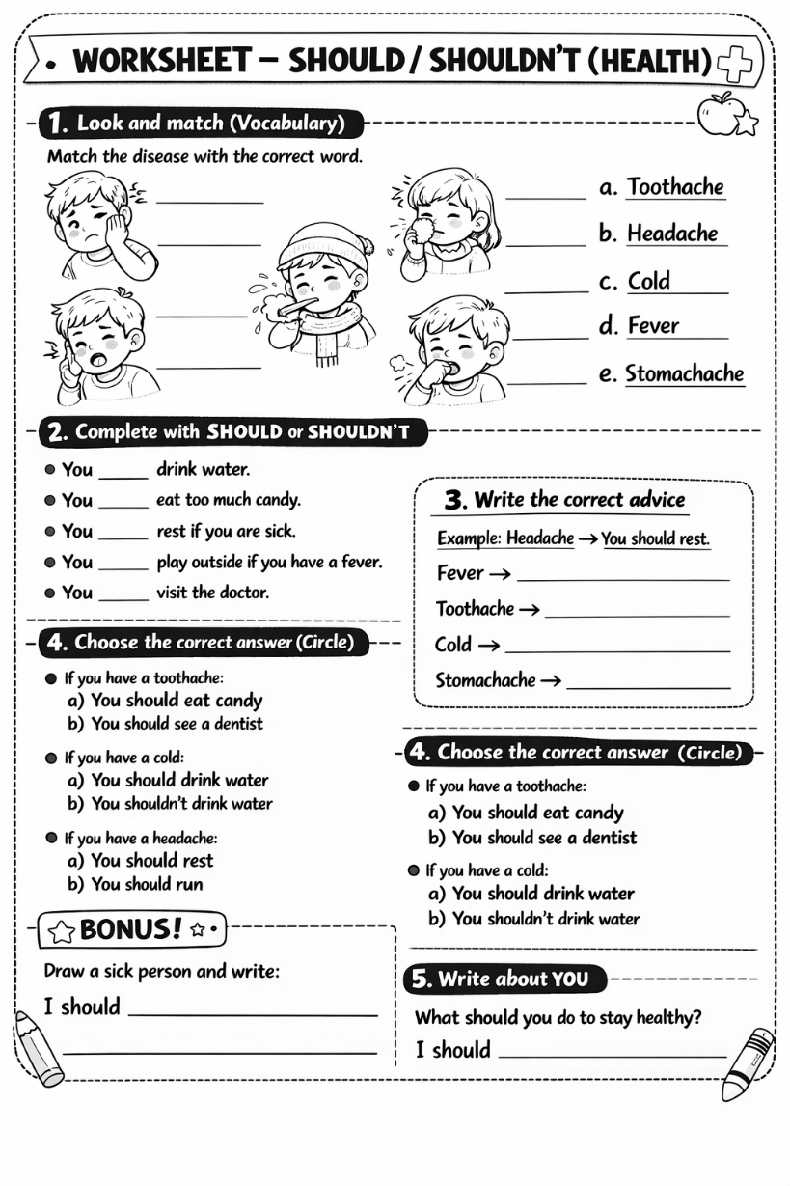 | DIFFERENT CONSIDERATIONS  Additional considerations to be made for diversity
ASSESSMENT
The assessment will be summative and will be based on the completion of the worksheet.
REFLECTION
What happened during my lesson? What did my students learn? How do I know?
What did I learn? How will I improve my lesson next time?
_________________________ _____________________________
Formative Supervisor’s Signature Advisor’s Signature

