HOMEWORK #1 – Karol Consoldane

1. What are three conclusions we can make about Kickstarter campaigns given the provided data?

* From May 2009 to March 2017, more than half of the projects (54%) presented in Kickstarter have been successful and about a third of them (38%) failed.



* The categories of “Theater” and “Music” have the highest numbers of projects (2093 projects all together) equivalent to 50% of the total of projects. These categories also have the highest percentage of successful projects: Theater, 60% successful projects out of 1393 projects presented; and Music, 77% successful projects out of 700 projects.

On the other hand, the Categories of “Food” and “Journalism” have the lowest numbers of projects on Kickstarter (200 and 24 projects each correspondingly), also these categories have the highest percentages of failed and canceled: food, 80% failed and canceled; journalism, 100% failed and canceled.



50% of all the projects

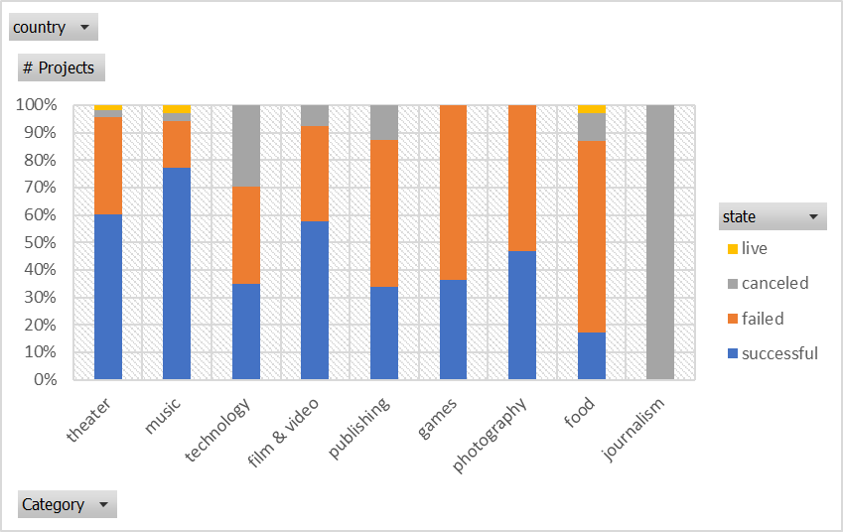

* According to the data provided, the percentage of successful projects are greater when the goal is lower. In that case, if we want to have better chances for our project to be successful or funded we got to keep the goal as low as it can be.

Additionally, observing the following graphic, we can notice there is a breach in percentage of success (10% difference) between the projects whose goals are lower than 45 000 and those who are greater than that.



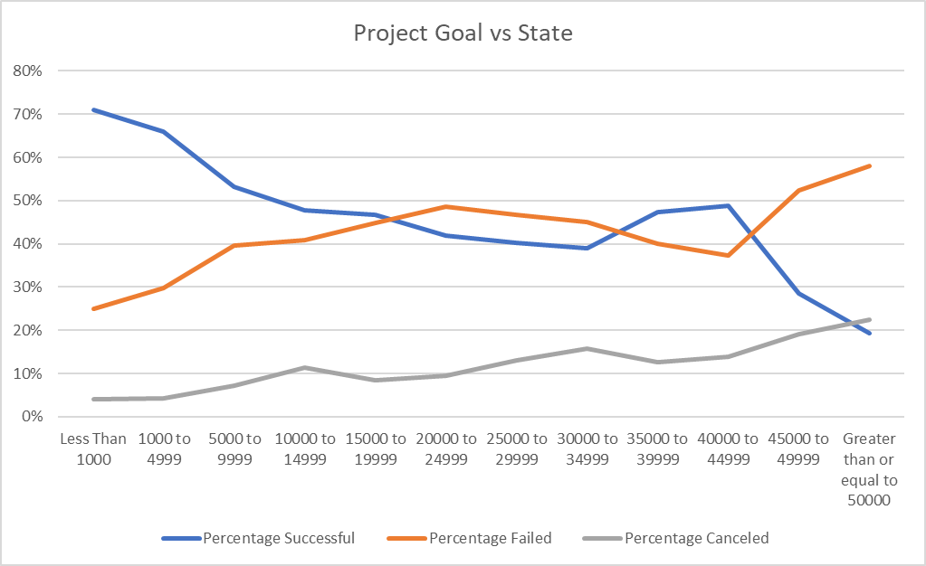

1. What are some of the limitations of this dataset?

Although the data provided represent an important contribution about the Kickstarter projects, there are some limitations of the data that can be recognized.

* The previous successful or failed projects from Kickstarter do not represent all future projects that can be presented. Two or more categories of projects are likely to be underrepresented among all the projects in Kickstarter specially the category of “Journalism” with 24 total projects on the history of Kickstarter.

1. What are some other possible tables/graphs that we could create?

From the data provided we can also obtain the following tables and graphs:

* Number of Backers per category



* Average Donation per category

