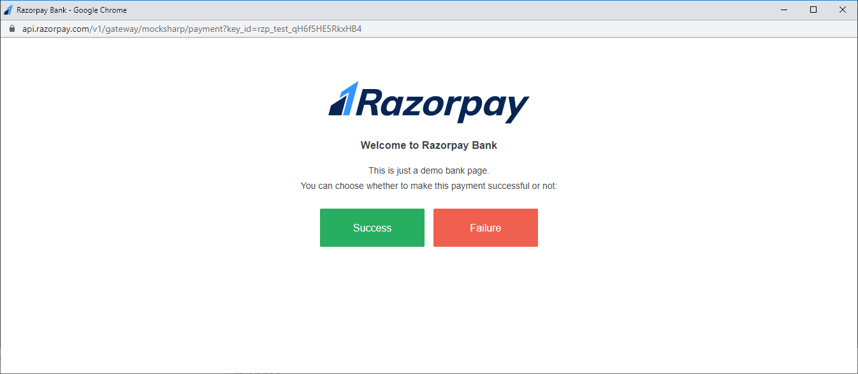

|  |  |  |
| --- | --- | --- |
| **Card Network** | **Domestic / International** | **Card Number** |
| Mastercard | Domestic | 5104 0155 5555 5558 5104 0600 0000 0008 |
| Visa | Domestic | 4111 1111 1111 1111 |
| Mastercard | International | 5555 5555 5555 4444 5105 1051 0510 5100 |
| Visa | International | 4012 8888 8888 1881 4000 1841 8621 8826 |