An Investigation of Fuel Type Viability for Scramjet Combustors

Karl Roush[1]

Ben T. Zinn Combustion Lab, Atlanta, GA, 30332

This paper serves as the culmination of the literary aspect of AE-2699 (research option), at the Ben T. Zinn Combustion Lab, for the spring term of 2018. This paper is an investigation of fuel types for scramjet combustors, specifically those of conventional fuels, solid fuels, and gelled propellants. The conventional fuels covered are: methane, ethylene, heptane, JP-10, hydrogen. Given the prevalence of these fuels, they will be compared on their ignition time delay. The solid fuel analysis references a combustor composed of poly-methyl-meth-acrylate (PMMA) and will focus on features specific to solid fuel, i.e. fuel regression rate. Gelled propellants will be examined, specifically atomization and related difficulties intrinsic to gelled propellants. As a result of this investigation, it was determined that conventional fuel selection should be the default selection, solid fuels should be selected in cases where the mission parameters are fixed (but additional research is needed in that area), and gelled propellants selection should be held off until atomization efficiency is increased.

# Introduction

O

perating at supersonic speeds, a scramjet utilizes shocks to slow down incoming airflow to a speed that allows for combustion1, 2. How and where these shocks are generated is largely dependent on the geometry of the combustor. Fuel is injected into the airstream via fuel injector producing rapid combustion and mixing in a reasonable length3. However, this length of injector must be optimized due to mechanical and thermal constraints. To improve combustion efficiency, we turn instead to fuel types. Most fuels that are used for this purpose are liquid due to their comparably large specific impulse, as well as the availability of storage and control systems. Solid fuels have seen use in rockets but require a pre-determined mission profile (fuel consumption changes combustion chamber geometry and must be accounted for).4 Gelled propellants have seen very little use, primarily since the gel has to be atomized before combustion can occur. 5

# Conventional Fuels

Conventional fuels were compared by looking at the ignition delays for each. This was defined as the onset of emission from hydroxyl radicals. As a reminder, ignition delays should be short, for efficient combustion in a practical length. The relative ignition delay times for different fuels were found to be methane>JP-10 $≅$ heptane>hydrocarbon mixture> ethylene>hydrogen.

## Methane

Methane (CH4) autoignition data6 was obtained from 25 previous investigations was correlated by Colket and Spadaccini.8 The correlation was derived from over 500 methane-oxygen ignition-delay measurements over a temperature range of 1250- 2500K. From five mixture rations, it was determined that the ignition rate of methane has a strong inverse dependence on oxygen concentration and a weak direct dependence on methane concentration. These results can be summarized with the following expression:

$$τ=2.21*{10}^{-14}\exp\left(\frac{45000}{RT}\right){\left[O_{2}\right]}^{-1.05}{\left[{CH}_{4}\right]}^{0.33}$$

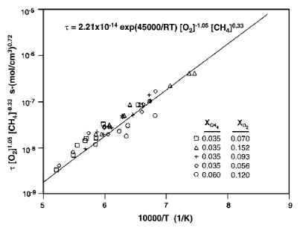

Fig. 1: Methane autoignition

## Ethylene

Ethylene (C2H4) was found to have a strong dependence on oxygen concentration (b<-1) and a weak dependence on fuel concentration (0<a<0.3). Mixtures of ethylene/oxygen/argon with equivalence ratios of 0.5, 0.75, and 1.0 were tested.8 The results can be summarized with the following expression:

$$τ=2.82*{10}^{-17}exp⁡(\frac{35000}{RT}){\left[O_{2}\right]}^{-1.2}$$

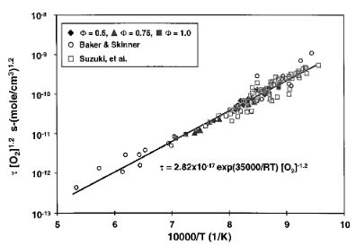

Fig. 2: Ethylene autoignition

## Heptane

Past research has shown that mixtures of heptane (H3C(CH2)5CH3)7 in argon has an ignition delay dependent on the concentration of argon. This expression is

$$τ=3.2*{10}^{-12}exp⁡(\frac{35300}{RT}){\left[C_{7}H_{16}\right]}^{0.2}{\left[O_{2}\right]}^{-1.1}{\left[Ar\right]}^{0.6}$$

Experimental data from Colket and Spadaccini8 shows a weak dependence on argon (-0.2). As such, the modified ignition-delay correlation for heptane was found to be

$$τ=6.76*{10}^{-15}exp⁡(\frac{40160}{RT}){\left[C_{7}H_{16}\right]}^{0.4}{\left[O_{2}\right]}^{-1.2}$$

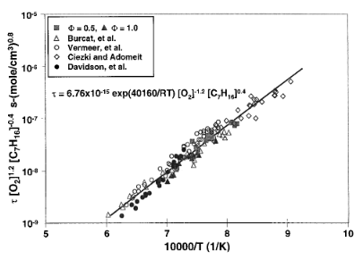

Fig. 3: Heptane autoignition

## JP-10

JP-10, a mixture of (in decreasing order) endo-tetrahydrodicyclopentadiene, exo-tetrahydrodicyclopentadiene, and adamantane, is primarily used in volume-limited applications due to its high density. JP-10 also has a very low vapor pressure, so without the aid of a heated shock tube and premixing system, only a few conditions could be tested. Tests were preformed with mixtures of JP-10 and oxygen in argon at equivalence ratios of 0.5, 0.75, 1.0, and 1.5.8 The expression for ignition time was similar to heptane and is defined as



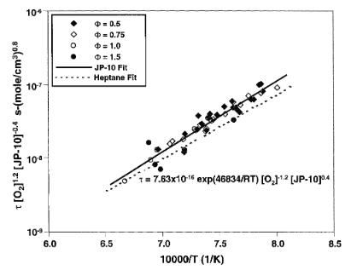

Fig. 4: JP-10 autoignition

## Hydrogen

There were no expirements testing the ignition delay times of hydrogen- the data was instead sourced from literature.8 The literature results show that the ignition time for hydrogen can be modeled by



However, at lower temperatures and relatively high pressures, the pressure dependence of the ignition delay becomes nonlinear and shifts from an inverse proportionality to a nearly direct proportionality. This can be explained by the removal of active hydrogen atoms through the formation of the HO2 radical which does not participate in chain propagation. Because this reaction is weakly dependent on temperature, it is kinetically favored at low temperatures where the other chain-carrying reactions are slower.8

## Hydrocarbon mixture

Consisting of 30/60/10 relative molar ratios of methane, ethylene, and heptane, this mixture sought to test the hypothesis that the addition of hydrocarbon contaminants significantly reduced ignition delay.8 No singular equation was derived, and the full data table is listed in the appendix. However, the results indicated that ignition delay times were ~50-70% of that of heptane. This time was not driven by the constituent with the lowest delay (i.e. ethylene), nor did small changes in constituent concentration drastically change the ignition time.

# Solid Fuels

## Prior Research and Experimental Setup

Previous research has shown that combustion of solid fuel at good combustion efficiencies is possible. Additionally, there is evidence of spontaneous ignition and stable supersonic combustion with no external aid.

The experiment used a combustor composed of translucent poly-methyl-methacrylate. Test conditions simulated the conditions at Mach 5.5, 1500K, and 50 atm. The purpose of the experiment was to examine features inherent to solid fuel, namely fuel regression rate.4

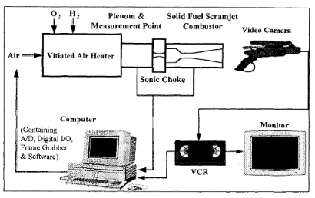

Fig. 5: Schematic of test facility

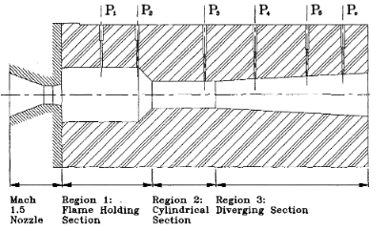

Fig. 6: Schematic of solid fuel combustor

## Results

The initial stage of operation had very little of evaporating fuel being burned, or in other words, the thermal efficiency started near zero. This transition period of inefficiency due to high velocities and insufficient mixing is negligibly short in realistic propulsion systems but would have to be considered for short operating times. Overall, there was a decrease in thermal efficiency if any of the parameters were to be increased. This could be addressed by increasing the ratio between bore circumference and cross-sectional area (multiple bores).

During testing, the shock boundary layer interaction developed surface roughness, adding in fuel mixing. Also, combustion initially took place outside the motor on the downstream end, but quickly was drawn back inside the motor. Diversion angles were also tested and indicated that larger diversion angles led to a decrease in fuel regression rate. The optimal diversion angle was found to be 3 degrees.

In summary, fuel regression rate, which was the critical feature, was calculated as a combination of inlet mass flow rate, inlet air temperature, and inlet air pressure. All of which when increased also increased fuel regression rate and therefore fuel mass flow rate. However, more fuel led to a limited change in burn rate and therefore a decrease in combustion efficiency.4

# Gelled Propellants

## Overview

Gelled propellants are a liquid fuel with additives to change the consistency. Sometimes an oxidizer is included as an additive, but this depends on the type of gel. A list of examples of gelled propellants can be found in the appendix.

The advantages of gelled propellants are that they have aspects of both solid and liquid fuels. They are solid when stored and liquify upon injection for combustion. Additionally, gels such as high-test hydrogen peroxide (HPE)/Boron carbide based - SiO2 induced gel and hydroxyl ammonium nitrate (HAN) also serve as more eco-friendly fuels. 5

## Atomization

Since the gels must be liquified for efficient combustion, a technique called atomization is used. An area of high pressure is generated in the small angle of the injection jet. This forces the gel into small droplets as it exits the injector. Prior research suggests gelled propellants are unable to form adequate jet and have significant variation in atomization characteristics.

Recently, a NASA study showed feasibility of a coaxial injector for gel injection.

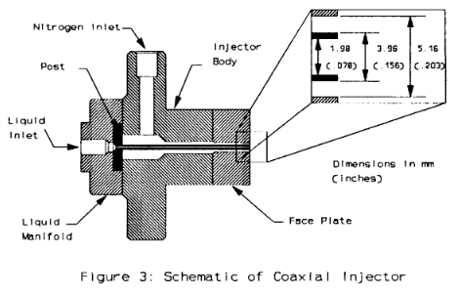

Fig. 7: Schematic of a coaxial injector

The NASA study showed that higher viscosity gel propellants can exhibit spray characteristics similar to that of water (which has a significantly lower viscosity). Furthermore, they concluded that atomization improves with liquid flow rate and overall flow rate.

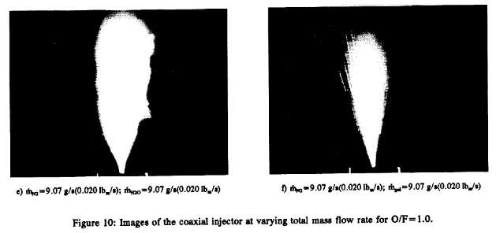

Fig. 8: Images of the coaxial injector at varying total mass flow rate for O/F=1.0

# Conclusion

The viability of conventional liquid/gaseous fuels has already been cemented. Previous research and testing have proven their application for general use. They are also the easiest to control and present the easiest interchangeability of fuels. Solid fuels have possible viability in specialized cases. Their usage requires that the flight profile and conditions be pre-determined but offer a higher density and simpler control systems (at the cost of a lower specific impulse). However, improvements to their efficiency needs to be made before solid fuel can see viability on the level of current conventional fuels. Gelled propellants seem to be primarily in the stages of testing and without improvements in atomization quality or injection scheme , they are simply too inefficient when compared to conventional or solid fuels.

# Appendix

The data regarding the ignition delay times for the hydrocarbon mixture are included due to the lack of an overarching correlation equation. For additional conventional fuel data, refer to Colket and Spadaccini.8

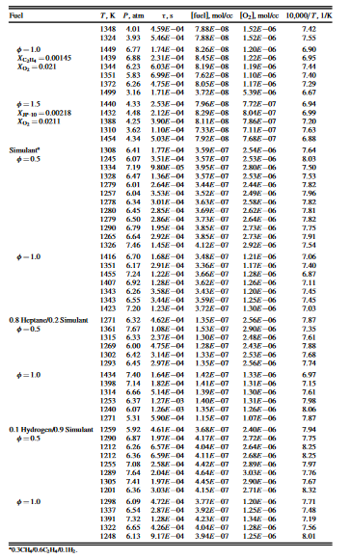

Table 1: Various gel propellants & gellants5

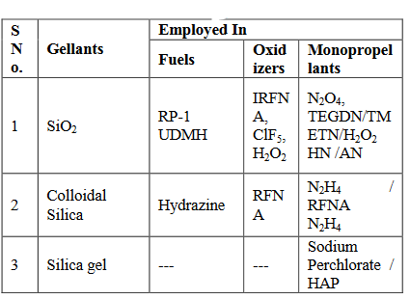

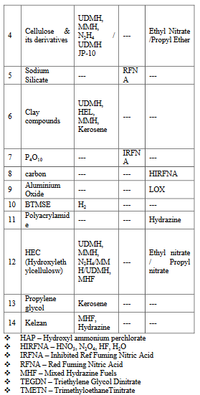

# Acknowledgments

Special thanks to the many graduate students of the Ben T. Zinn combustion lab for their guidance through some of the more advanced topics I came across while doing research. Additional thanks to Research Engineer, David Wu for additional guidance.

# References

[1] Drummond, J., Diskin, G. and Cutler, A. (2002). Fuel-Air Mixing and Combustion in Scramjets. *AIAA*, 2002(3878).

[2] Epstein, M. and Kutschenreuter, P. (1994). *Fuel Injection System for Scramjet Engines*. 5,280,705.

[3] Baurle, R., Fuller, R., White, J., Chen, T., Gruber, M. and Nejad, A. (1997). An Investigation of Advanced Fuel Injection Schemes for Scramjet Combustion. 36th AIAA Aerospace Sciences Meeting and Exhibit.

[4] Cohen-Zur, A. and Natan, B. (1998). Experimental Investigation of a Supersonic Combustion Solid Fuel Ramjet. Journal of Propulsion and Power, 14(6), pp.880-889.

[5] Aggarwal, R., Patel, I. and Sharma, P. (2015). A COMPREHENSIVE STUDY ON GELLED PROPELLANTS. International Journal of Research in Engineering and Technology, 04(09), pp.286-290.

[6] Molnar, M. and Marek, C. (2003). Reduced Equations for Calculating the Combustion Rates of Jet-A and Methane Fuel. NASA STI Program Office.

[7] Ye, J., Medwell, P., Evans, M. and Dally, B. (2017). Characteristics of turbulent n -heptane jet flames in a hot and diluted coflow. Combustion and Flame, 183, pp.330-342.

[8] Colket, M. and Spadaccini, L. (2001). Scramjet Fuels Autoignition Study. Journal of Propulsion and Power, 17(2), pp.315-323.

[9] Green, J., Rapp, D. and Roncace, J. (1991). Flow Visualization of a Rocket Injector Spray Using Gelled Propellant Simulants. AIAA, 2198.

1. Aerospace Engineering student, Georgia Tech Daniel Guggenheim School of Aerospace