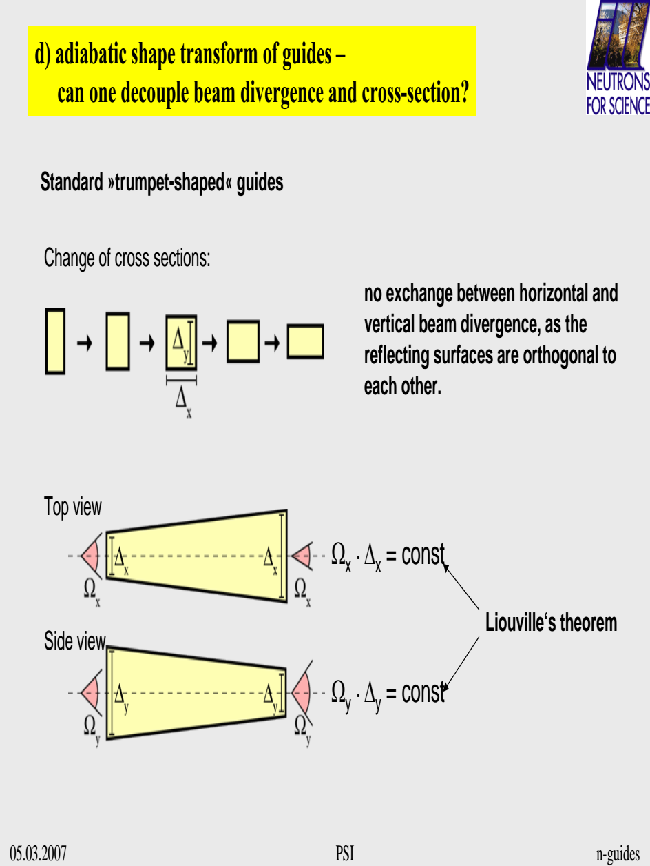

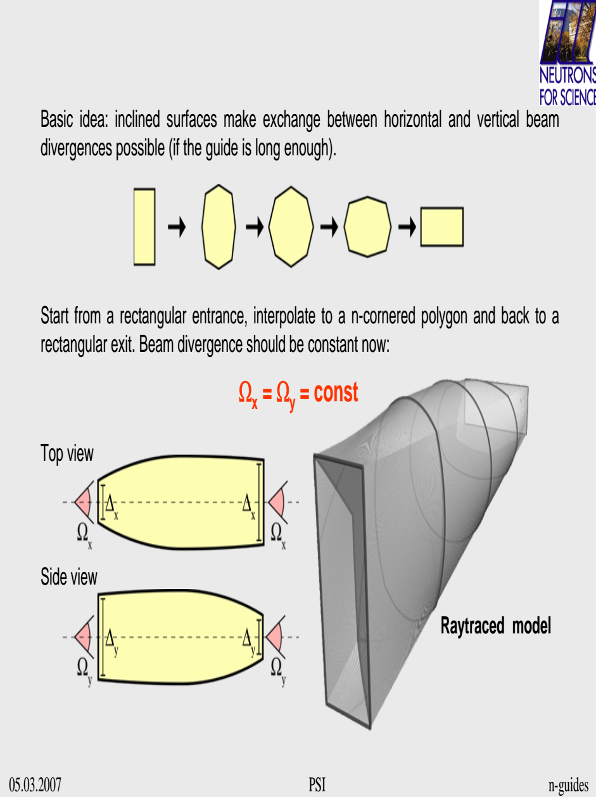

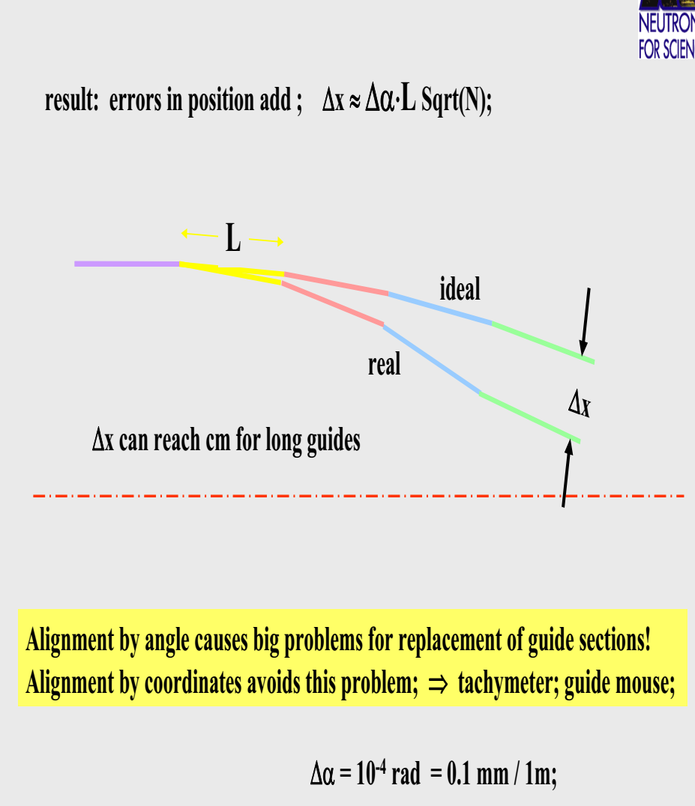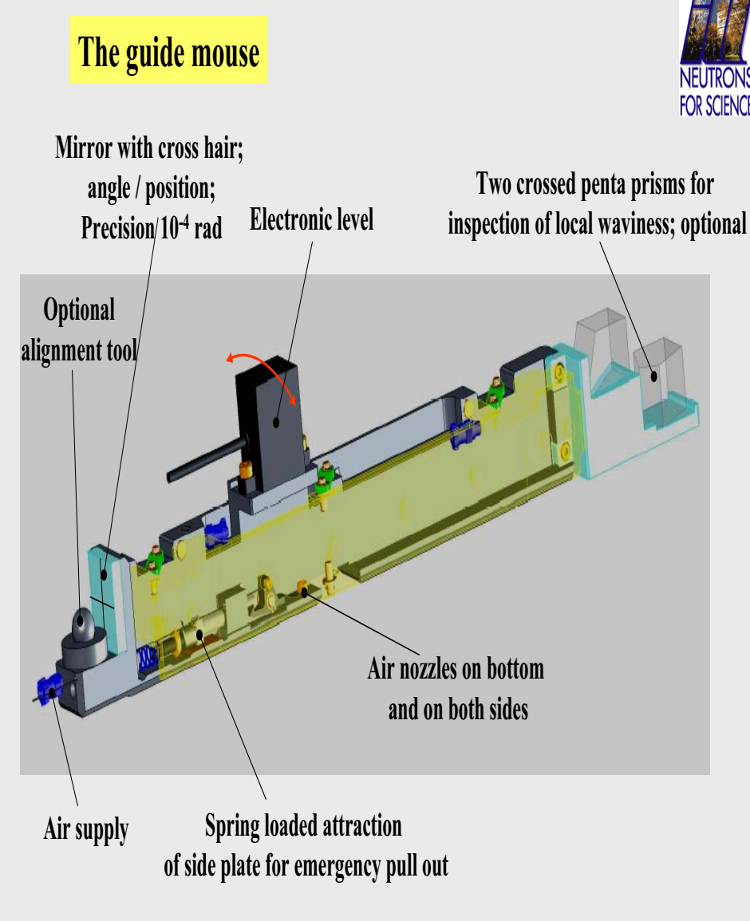



In view of the multibeam collimation it is beneficial to increase the beam cross section and decrease the divergence at the same time.

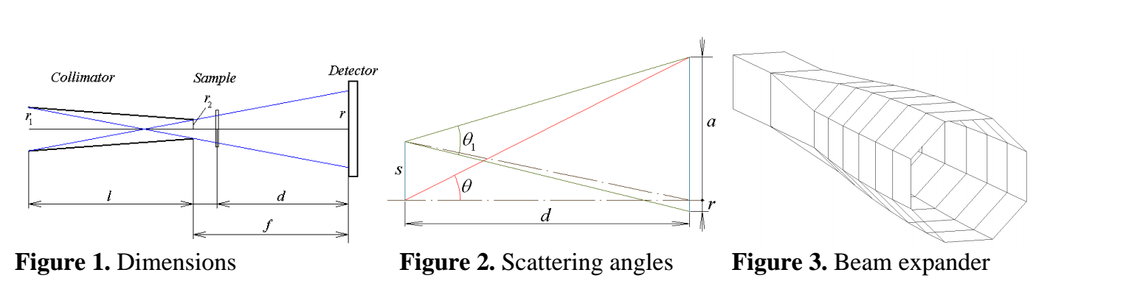

The use of multibeam collimation ensures the increase of the flux illuminating the sample by the

number of channels n. The collimator transmission parameter becomes:

In order to accommodate a larger number of channels, the beam cross section has to be increased at

the entrance of the collimator, especially when a relatively small cross-section beam feeds the

instrument. This can be done by means of a beam expander (Figure 3), on the expense of divergence

decrease (Figure 4), to the extent of fully illuminating all channels. The condition is that the reflection angles seen from the sample upstream through the collimator do not exceed the critical angle of the incoming guide supermirror. The expander shown in Figure 3 is 5.6 m long and transforms the beam cross section from a 25 mm square to a 56 mm high octagon. The collimator is 4 m long and one channel diagonal is 2.8 mm at the inlet and 1.4 mm at the exit. The direct beam spot diagonal on the detector is 5.6 mm.

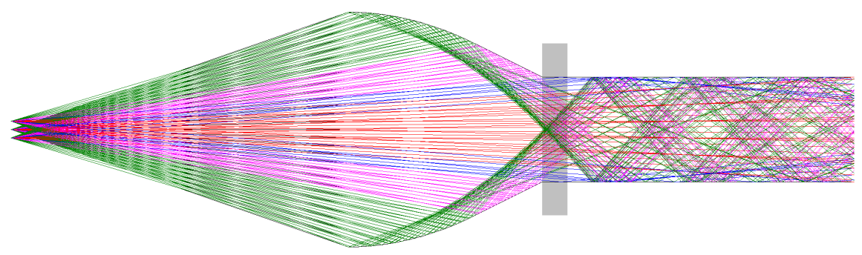

Multibeam focusing offers an appealing compromise between high resolution and

high incident flux configurations for SANS spectrometers. In fact so many “spectrometers”

operate in parallel as the number of channels in the collimator. Each channel provides high

resolution by small spot size on the detector and long sample-to-detector distance, involving

significant limitation of the transmitted beam phase space volume, thus reducing the flux. The

flux on the sample is increased by the large number of channels. In view of the multibeam

collimation it is beneficial to increase the beam cross section and decrease the divergence at the

same time. Two aspects related to the use of rotational velocity selectors are investigated.

Reflectometer LIRA

Reflectometer with a medium/low resolution, designed for experiments with

surfaces and interfaces of liquids.

LIRA = Liquid Interface Reflection Apparatus

Scattering plane: vertical (horizontal sample surface)

❖ Collimation geometry: slit geometry with focusing in the horizontal plane

❖ Modes: time-of-flight

❖ Options: non-polarized beam; polarized beam

❖ Specialization: surfaces and interfaces of liquids; ordering of nanoparticles at

interfaces of liquids; processes at interfaces and mass transport through interfaces

of liquid phases; magnetism of ferrofluids and magnetic nanoparticles in liquids

Diffractometer POWTEX

Nevertheless, with an increasing length, especially for

long wavelengths, the number of reflection increases, such that

the loss of neutron flux is significant even with high-reflectivity

neutron guides. To overcome these problems, it has been proposed

to change the neutron-guide geometry such that either the angle of

incidence or the number of reflections is reduced. Therefore, in a

first approach, the concept of a ballistic geometry was introduced

by Mezei [8]. A ballistic guide will open its initial cross section by a

linearly tapered section at the beginning, followed by a straight

guide and a reduction of the cross section by another linearly

tapering and such focusing section near the end. Meanwhile, other

and more sophisticated geometries, such as parabolic or elliptic

focusing guides, have been investigated [7,5].

For a diffractometer, a simple peak shape is desirable. It is

obvious that in solution (c) the small divergences are not transported well enough such that a double peak appears in y and z

direction, i.e., a fourfold peak in 2D. It seems reasonable that

the peak structure follows from the quadratic cross section of the

guide. A possible explanation could be that the small divergences

are not as well transported in the very corners as in the middle of

each guide plane because here the difference to the most ideal

shape, i.e., a circular cross section, is most pronounced.

To overcome this, a more circular cross section would be needed.

Since truly circular cross sections are not available due to

technical limitations, a hexagonal or octagonal guide cross section

seems a feasible choice.

A major improvement in the homogeneity of the divergence

profile is achieved by neutron guides with octagonal cross sections.

A first prototype was already presented by

SwissNeutronics [21]. Except for guides with truly circular cross

sections it is not expectable to gain much from cross sections of a

higher order polygonal shape because test simulations show an

increase in the number of garland reflections

