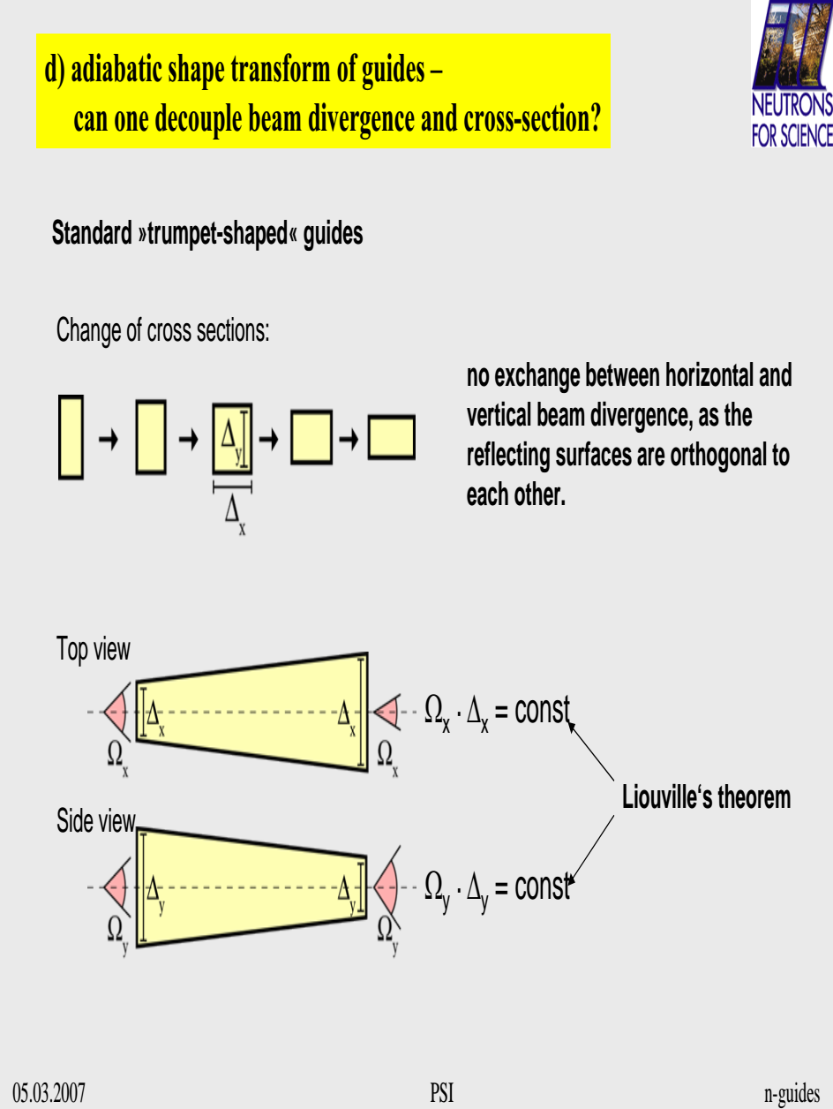

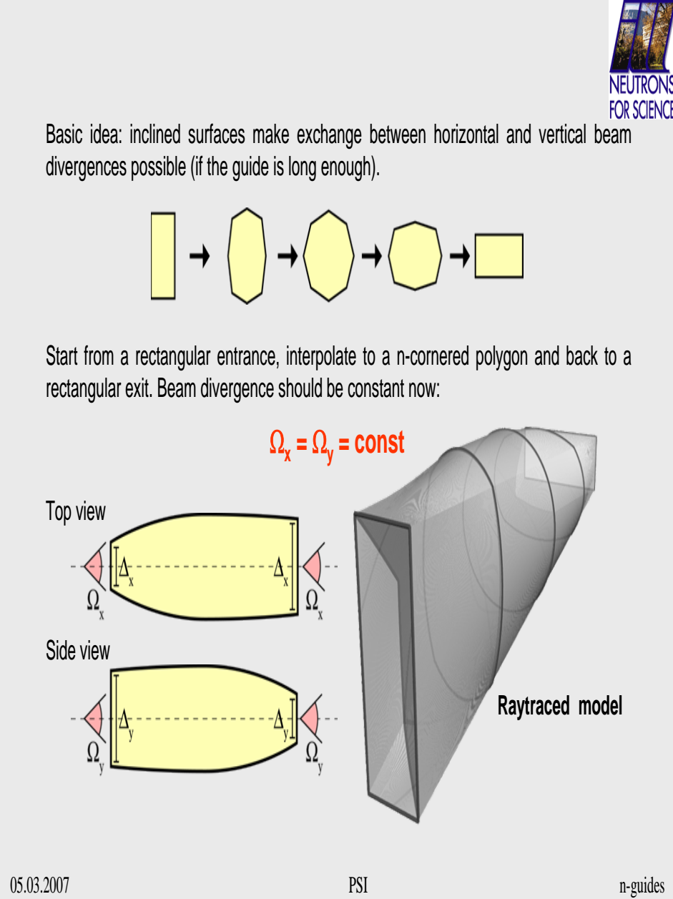

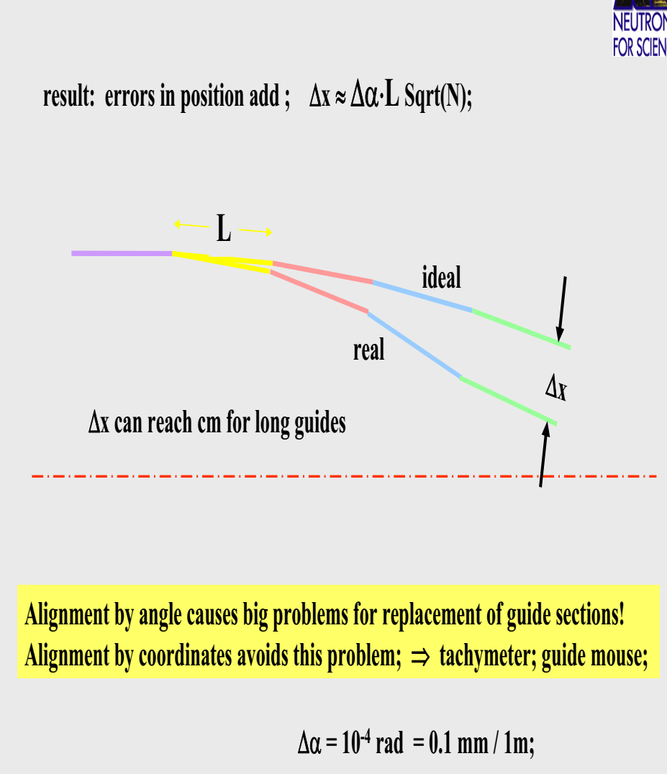
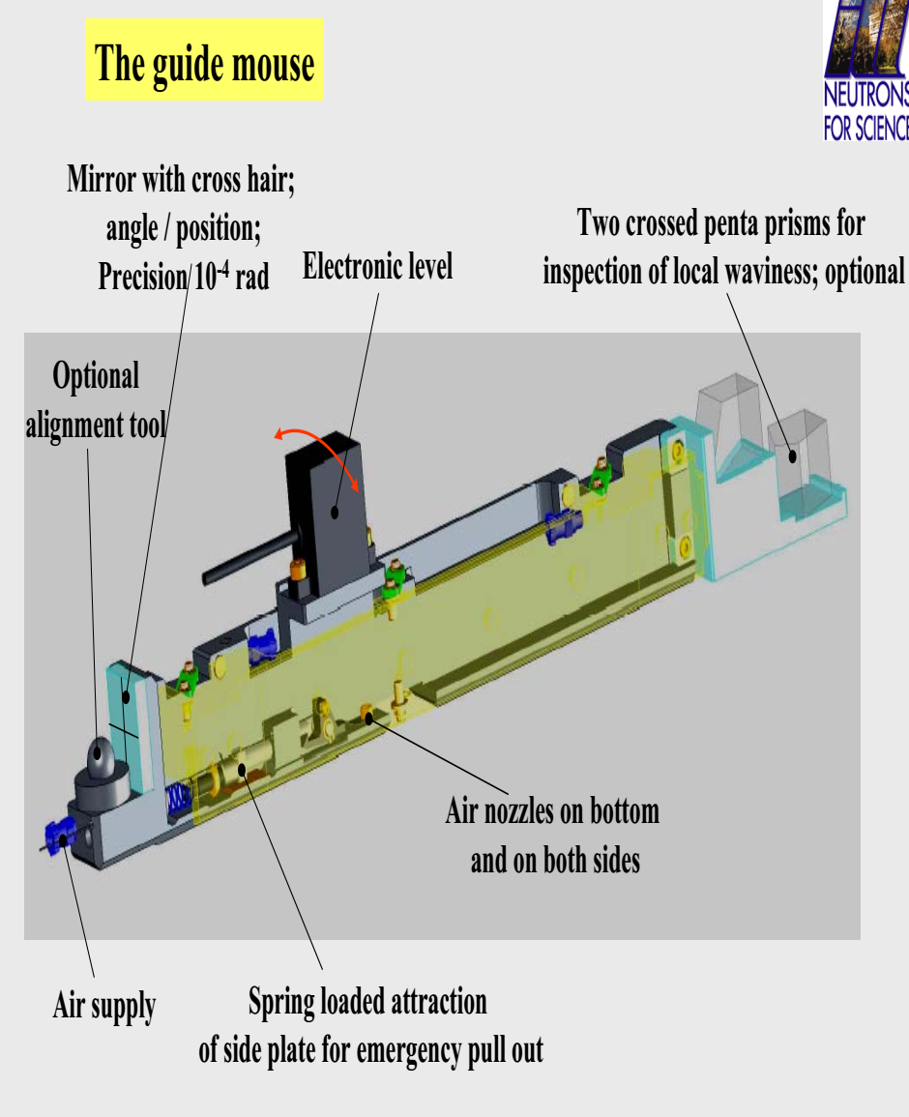

In view of the multibeam collimation it is beneficial to increase the beam cross section and decrease the divergence at the same time.

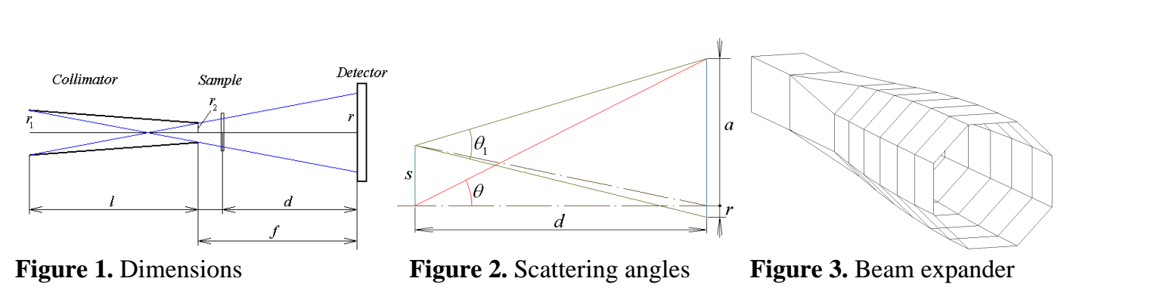
The use of multibeam collimation ensures the increase of the flux illuminating the sample by the
number of channels n. The collimator transmission parameter becomes:

In order to accommodate a larger number of channels, the beam cross section has to be increased at
the entrance of the collimator, especially when a relatively small cross-section beam feeds the
instrument. This can be done by means of a beam expander (Figure 3), on the expense of divergence
decrease (Figure 4), to the extent of fully illuminating all channels. The condition is that the reflection angles seen from the sample upstream through the collimator do not exceed the critical angle of the incoming guide supermirror. The expander shown in Figure 3 is 5.6 m long and transforms the beam cross section from a 25 mm square to a 56 mm high octagon. The collimator is 4 m long and one channel diagonal is 2.8 mm at the inlet and 1.4 mm at the exit. The direct beam spot diagonal on the detector is 5.6 mm.

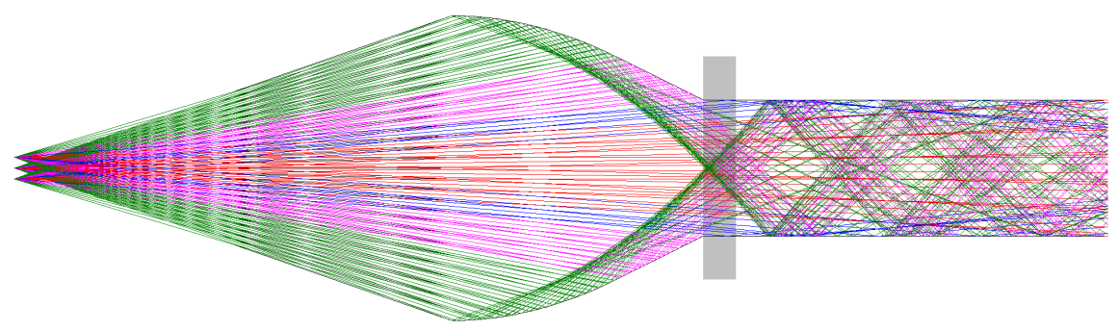
Multibeam focusing offers an appealing compromise between high resolution and
high incident flux configurations for SANS spectrometers. In fact so many “spectrometers”
operate in parallel as the number of channels in the collimator. Each channel provides high
resolution by small spot size on the detector and long sample-to-detector distance, involving
significant limitation of the transmitted beam phase space volume, thus reducing the flux. The
flux on the sample is increased by the large number of channels. In view of the multibeam
collimation it is beneficial to increase the beam cross section and decrease the divergence at the
same time. Two aspects related to the use of rotational velocity selectors are investigated.

Reflectometer LIRA
Reflectometer with a medium/low resolution, designed for experiments with
surfaces and interfaces of liquids.
LIRA = Liquid Interface Reflection Apparatus
Scattering plane: vertical (horizontal sample surface)
❖ Collimation geometry: slit geometry with focusing in the horizontal plane
❖ Modes: time-of-flight
❖ Options: non-polarized beam; polarized beam
❖ Specialization: surfaces and interfaces of liquids; ordering of nanoparticles at
interfaces of liquids; processes at interfaces and mass transport through interfaces
of liquid phases; magnetism of ferrofluids and magnetic nanoparticles in liquids

Diffractometer POWTEX
Nevertheless, with an increasing length, especially for
long wavelengths, the number of reflection increases, such that
the loss of neutron flux is significant even with high-reflectivity
neutron guides. To overcome these problems, it has been proposed
to change the neutron-guide geometry such that either the angle of
incidence or the number of reflections is reduced. Therefore, in a
first approach, the concept of a ballistic geometry was introduced
by Mezei [8]. A ballistic guide will open its initial cross section by a
linearly tapered section at the beginning, followed by a straight
guide and a reduction of the cross section by another linearly
tapering and such focusing section near the end. Meanwhile, other
and more sophisticated geometries, such as parabolic or elliptic
focusing guides, have been investigated [7,5].

For a diffractometer, a simple peak shape is desirable. It is
obvious that in solution (c) the small divergences are not transported well enough such that a double peak appears in y and z
direction, i.e., a fourfold peak in 2D. It seems reasonable that
the peak structure follows from the quadratic cross section of the
guide. A possible explanation could be that the small divergences
are not as well transported in the very corners as in the middle of
each guide plane because here the difference to the most ideal
shape, i.e., a circular cross section, is most pronounced.
To overcome this, a more circular cross section would be needed.
Since truly circular cross sections are not available due to
technical limitations, a hexagonal or octagonal guide cross section
seems a feasible choice.

A major improvement in the homogeneity of the divergence
profile is achieved by neutron guides with octagonal cross sections.

A first prototype was already presented by
SwissNeutronics [21]. Except for guides with truly circular cross
sections it is not expectable to gain much from cross sections of a
higher order polygonal shape because test simulations show an
increase in the number of garland reflections
