INTERVIEWPANEL

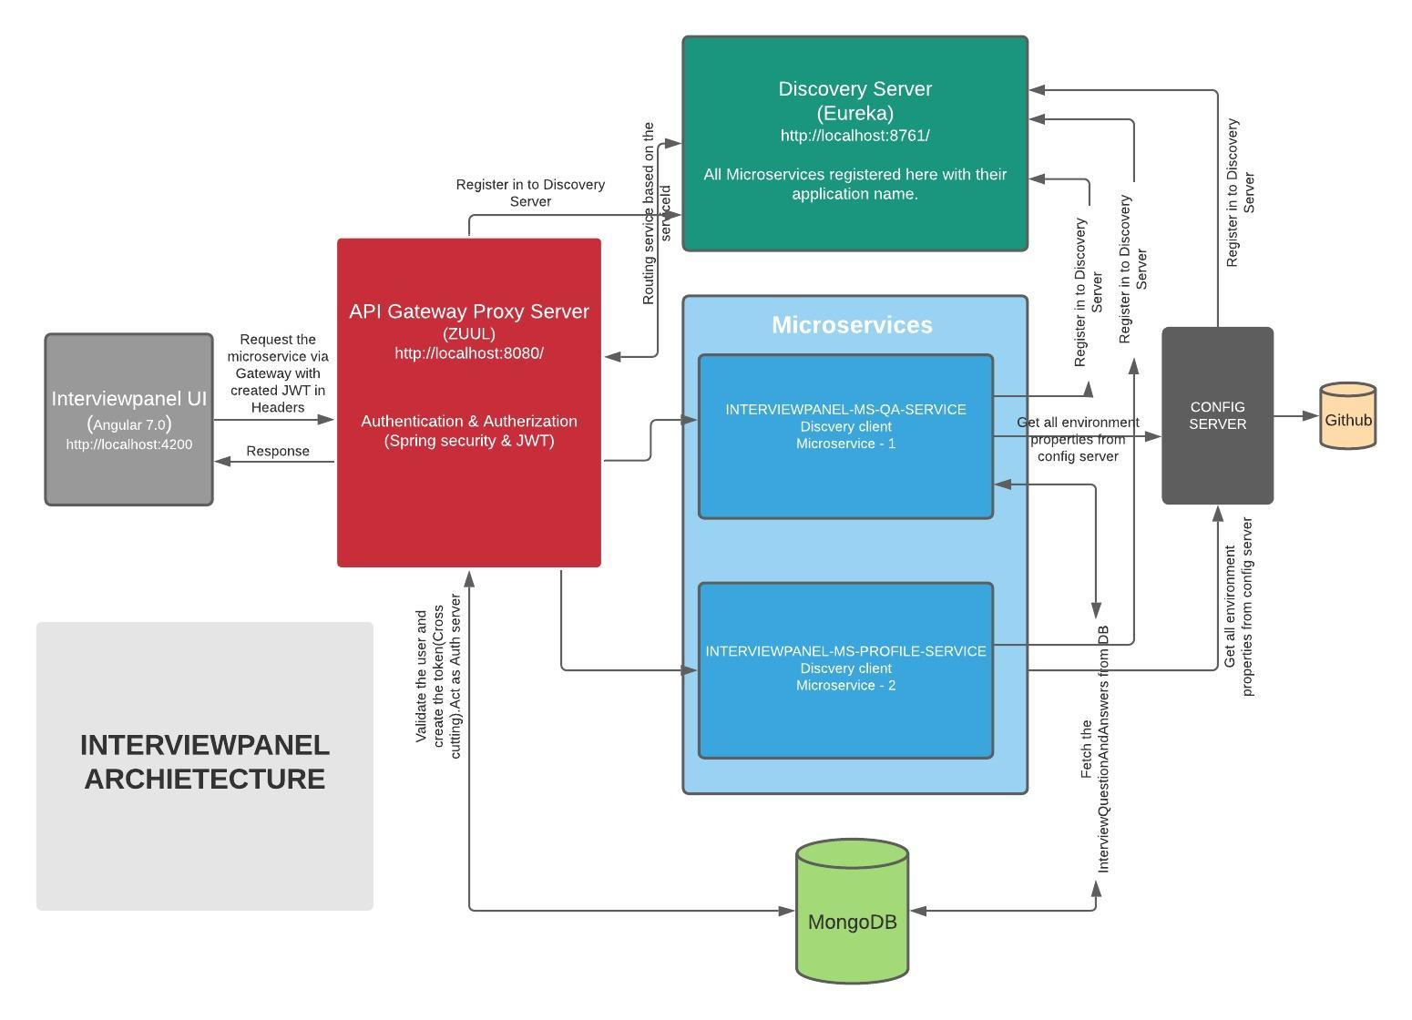
Fig: Interviewpanel - Architecture-Diagram

Project Local setup :

Frontend Development:

Git Repository:

> https://github.com/karpomkarpipom/interviewpanel-ui

Development Software and Tool:

> IDE - Visual Studio Code
> Angular 7.0, Node.js, Angular CLI, https://www.geeksforgeeks.org/angular-7-installation/

Backend Development:

Git Repository:

> Gateway-server : https://github.com/karpomkarpipom/interviewpanel-api-gateway-server
> Discovery-server : https://github.com/karpomkarpipom/interviewpanel-discovery-server
> Question and Answer Service: https://github.com/karpomkarpipom/interviewpanel-ms-questionandanswer-service

Development Software and Tool:

> IDE – STS or IDEA IntelliJ (I am using Version: 3.9.12.RELEASE)
> JDK 1.8
> Mongo db (Any latest version) installed and running in the port of 27017
> MongoDB Compass Community (GUI)
> Restclient: Postman or Insomnia

Backend set steps:

STEP 1 > File> import > Git > Projects from Git > Clone URI
> In URI Place https://github.com/karpomkarpipom/interviewpanel-discovery-server
> User:selvasharesource password: selvasharesource@789

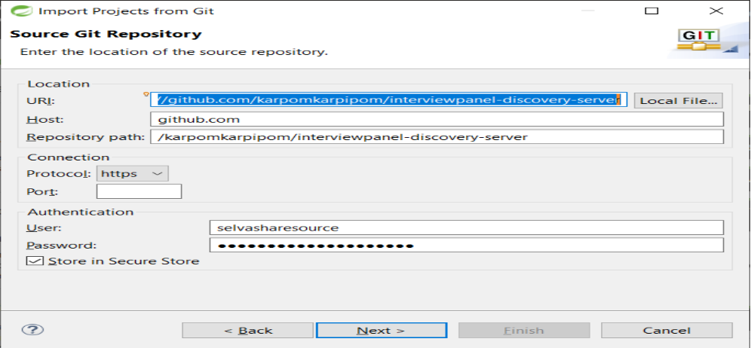

STEP 2 > select next

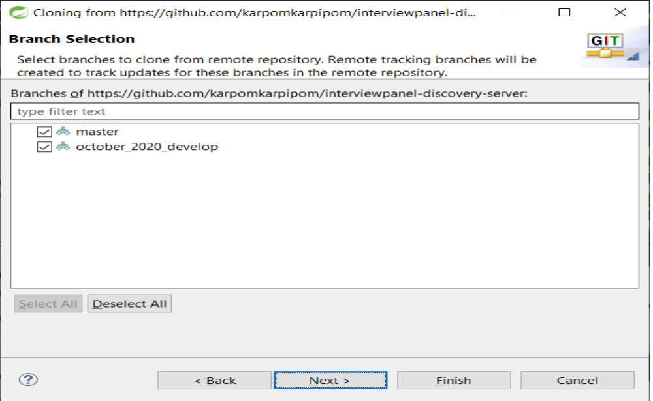

STEP 3 > Select your local directory and initial branch as october_2020_develop

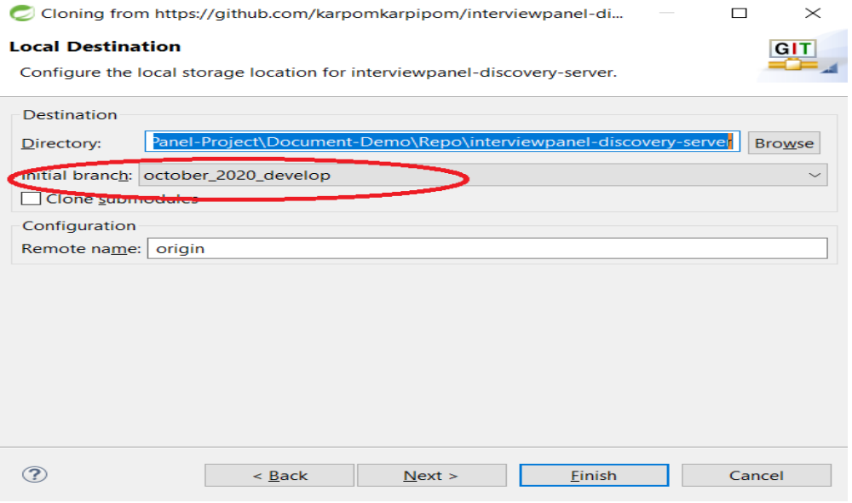

STEP 4> Select import as general project

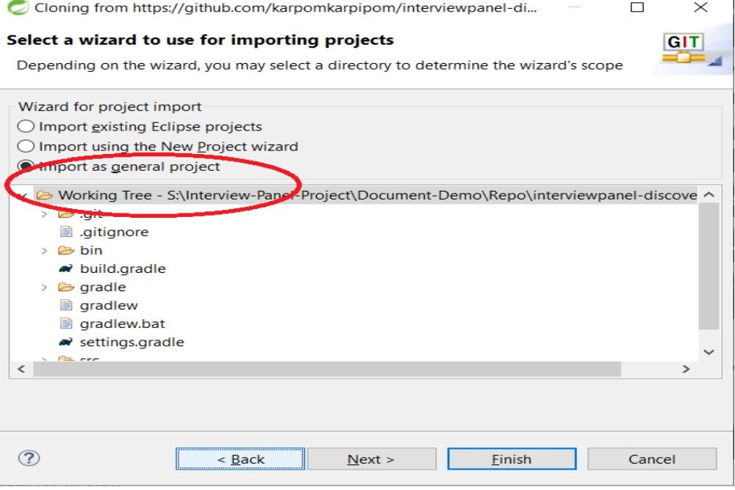

STEP 5 > Finish
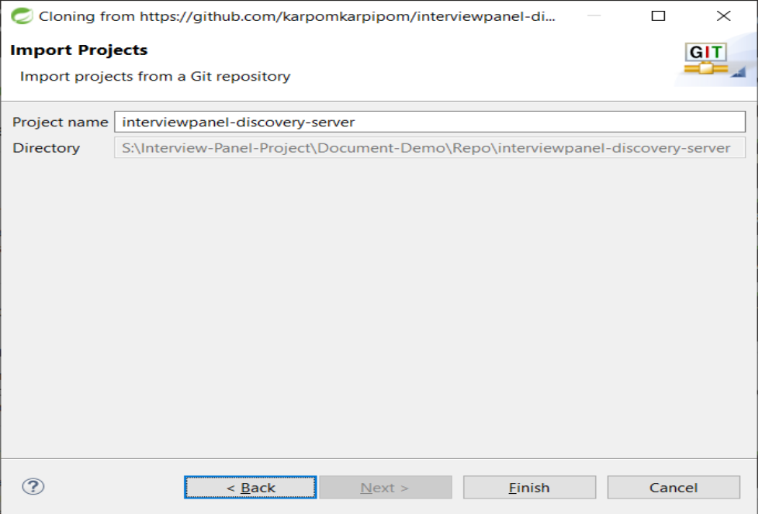

STEP 6 > Make sure remote branch october_2020_develop

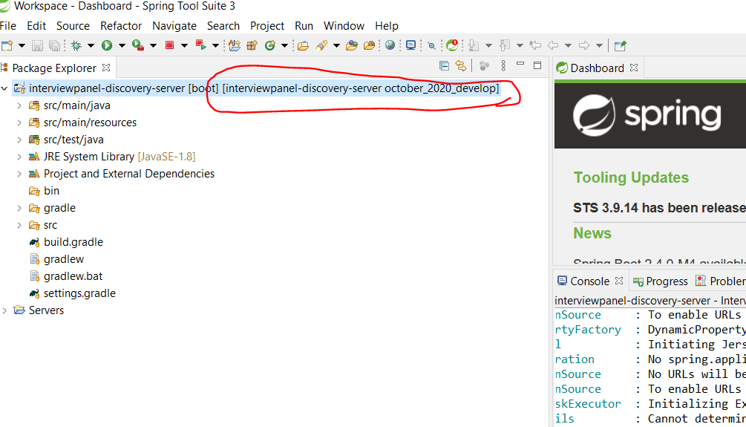

STEP 7> Right click > Configure > Add Gradle Nature

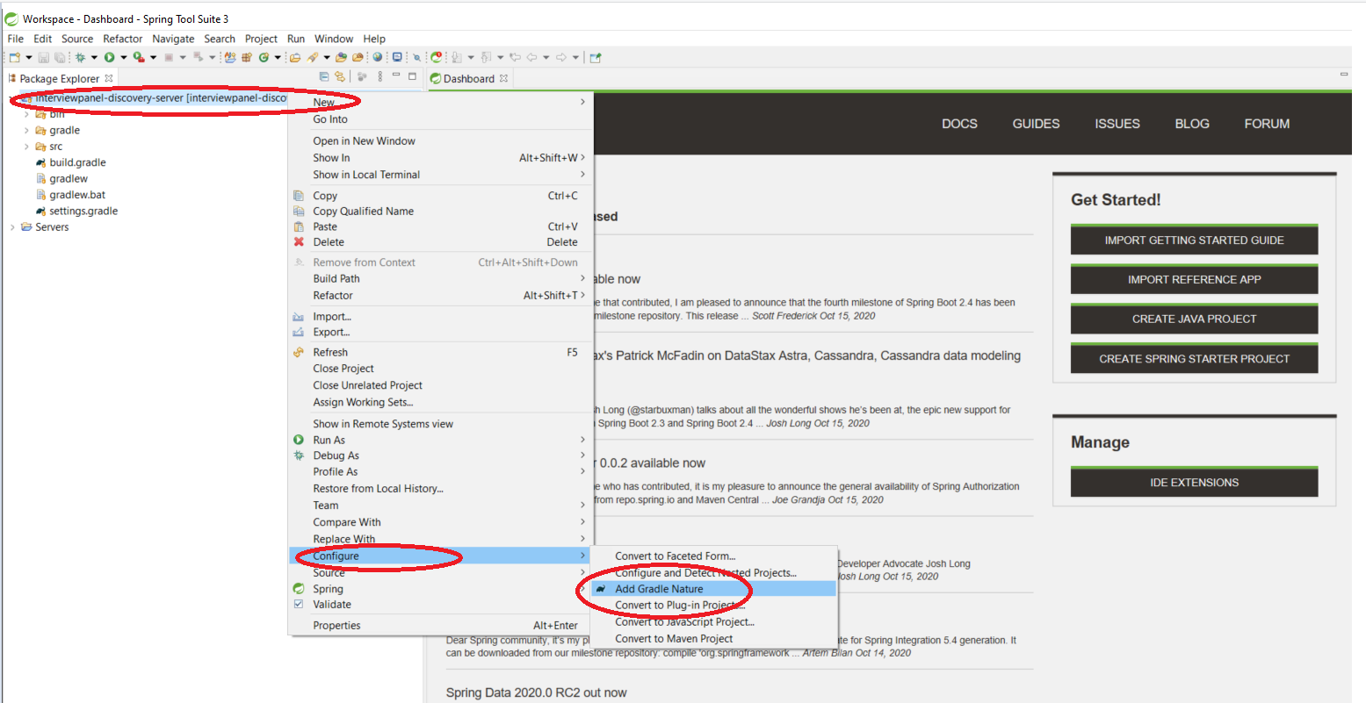

STEP 8 > After success build you will see the screen

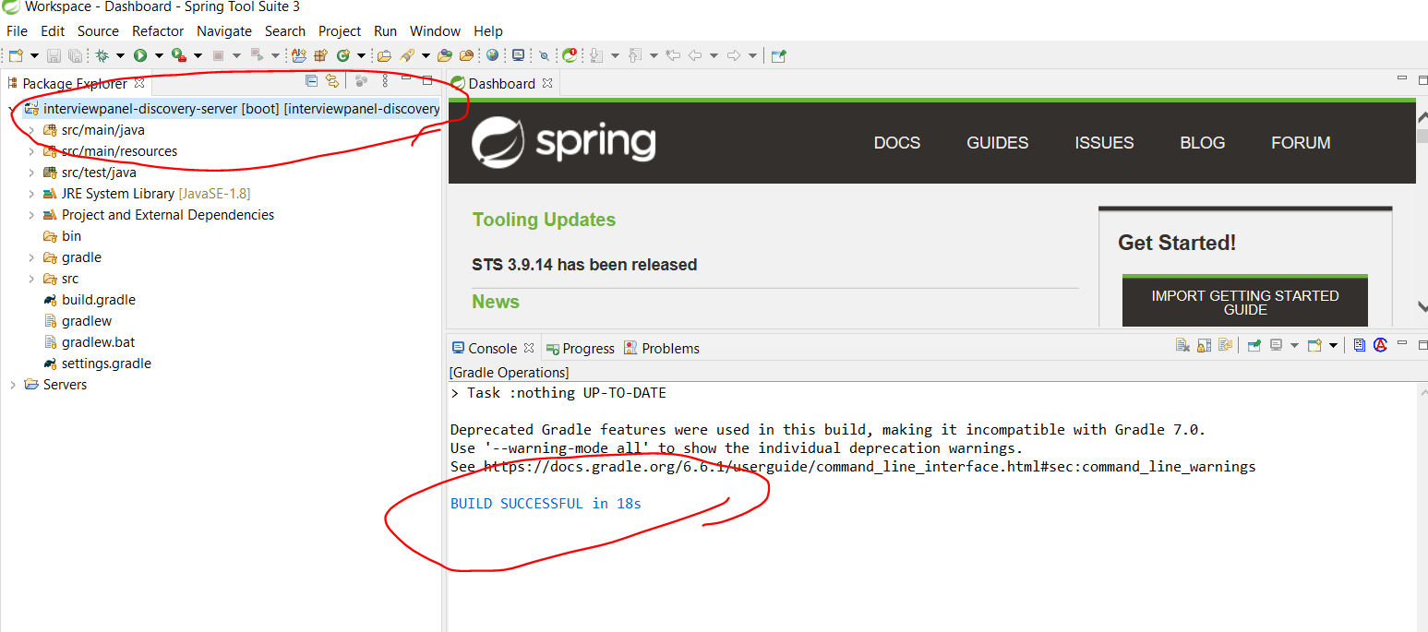

STEP 9 > Rightclick on the project> Run As > Spring Boot App

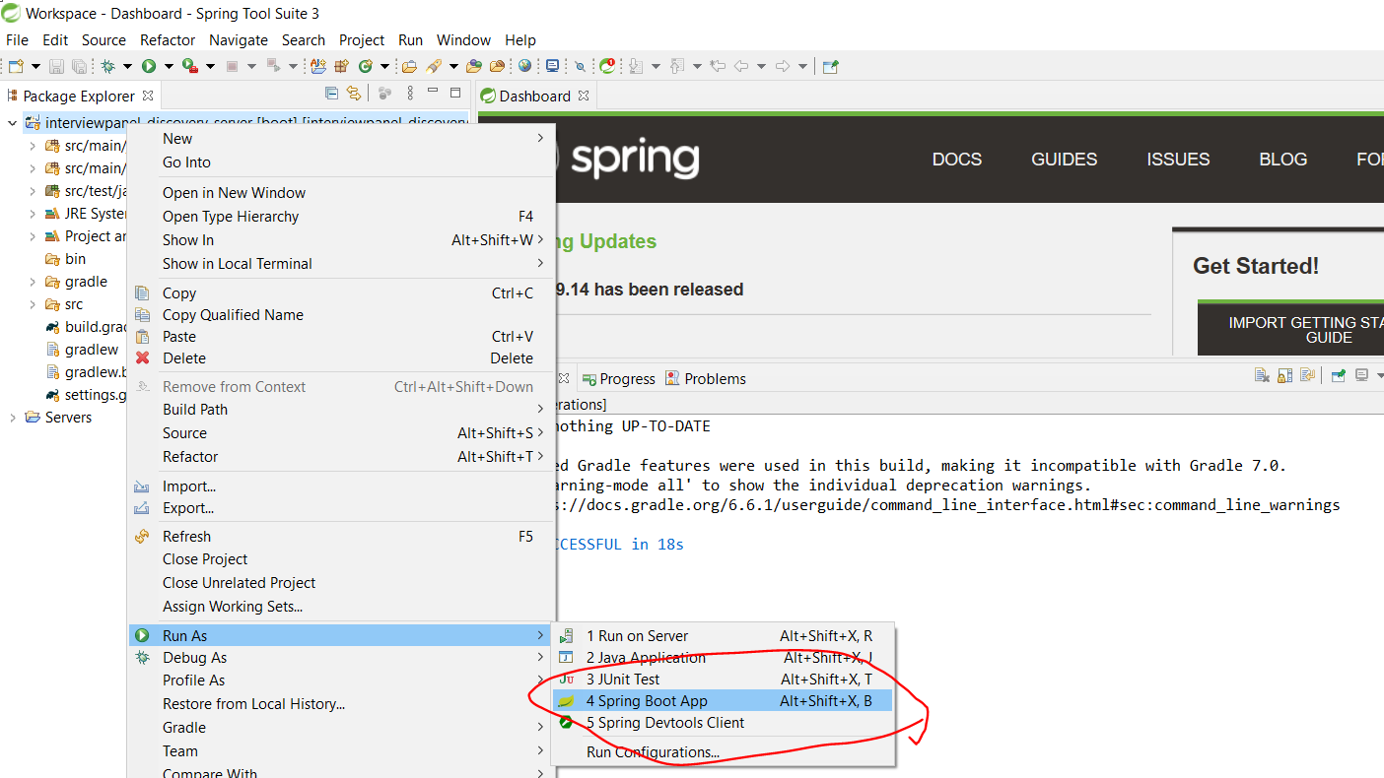

> Eureka Server started successfully!

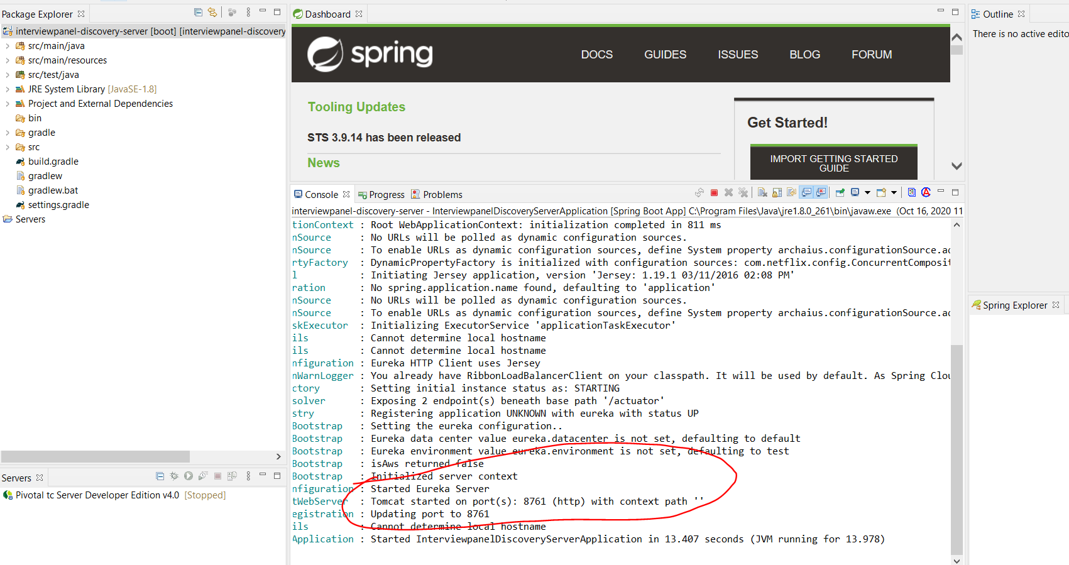
> Now you can access http://localhost:8761/

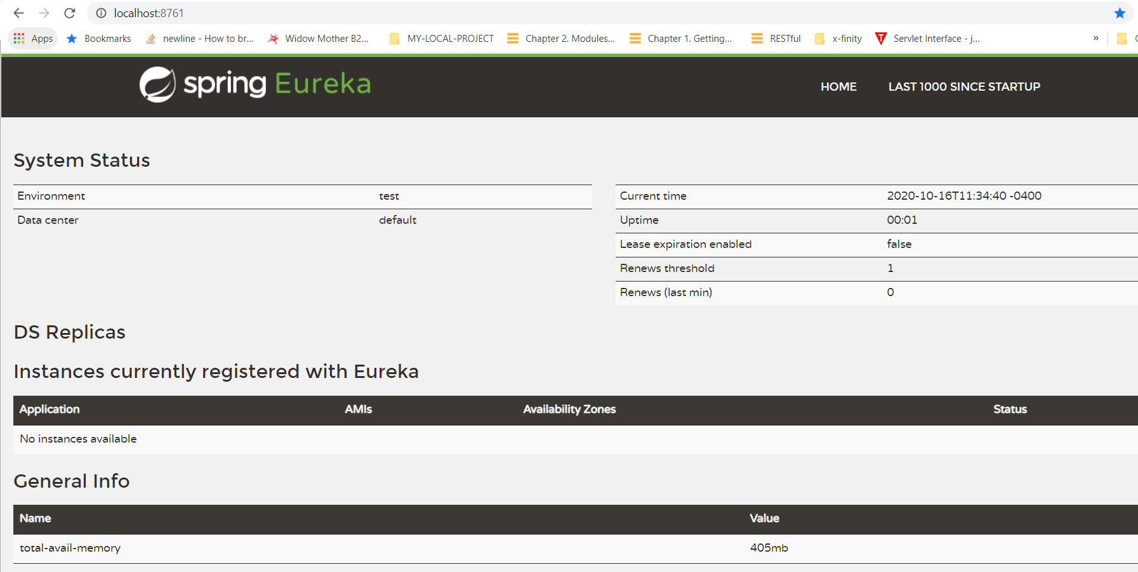

Follow the above 9 steps for other two services (Gateway and Microservice) till Run them successful

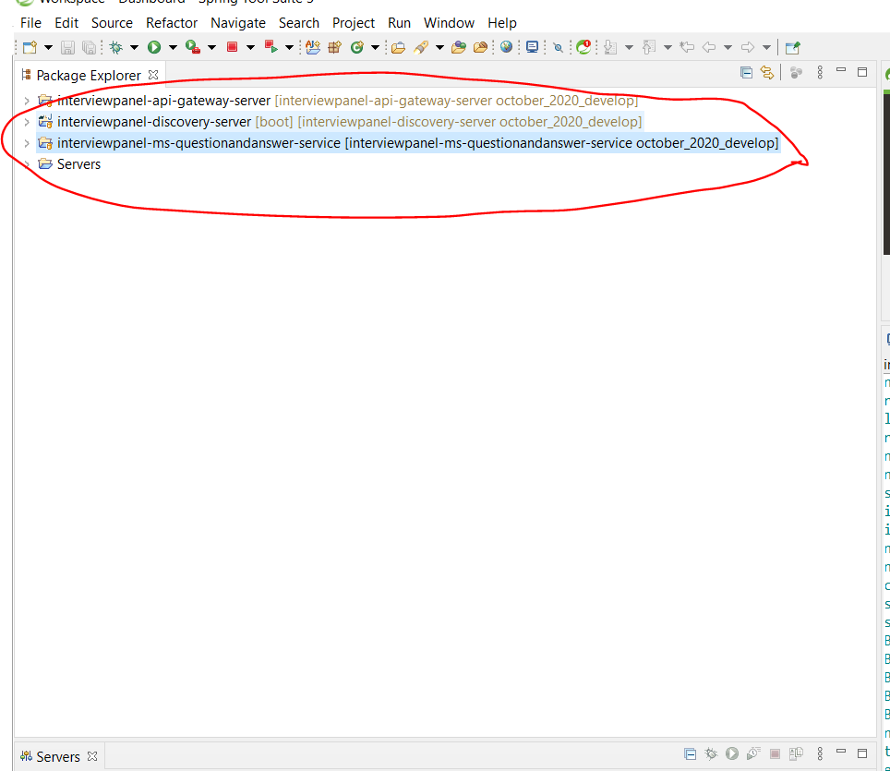

> If all services are up and running then you will see the below screen in http://localhost:8761/
Eureka server:

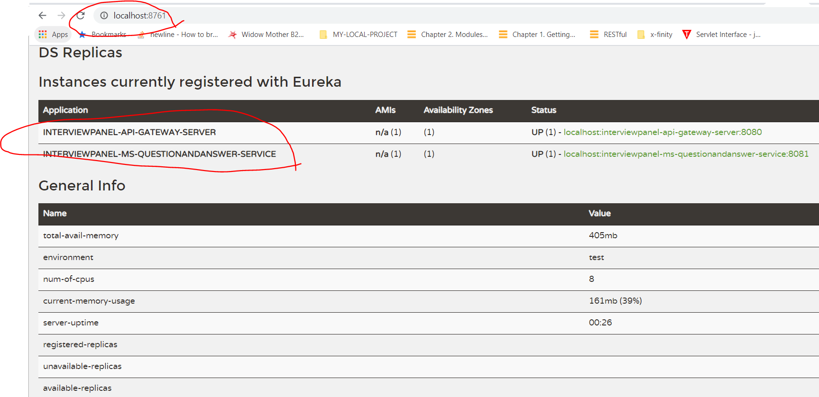

Checking Backend service working by Restclient - POSTMAN

API Gateway URL : http://localhost:8080/

First Signup the user : http://localhost:8080/api/signup

Below is the sample Payload, Create with your email and password

Payload:
{
"email": "selvasharesource@gmail.com",
"password": "seselvasharesource@789",
"firstName": "selva",
"lastName": "selvapandy",
"active": 1,
"isLoacked": false,
"isExpired": false,
"isEnabled": true,
"role": [ {
"id": 2,
"role": "USER",
"rank": 1
}]
}

Choose : raw and json – and pass above payload
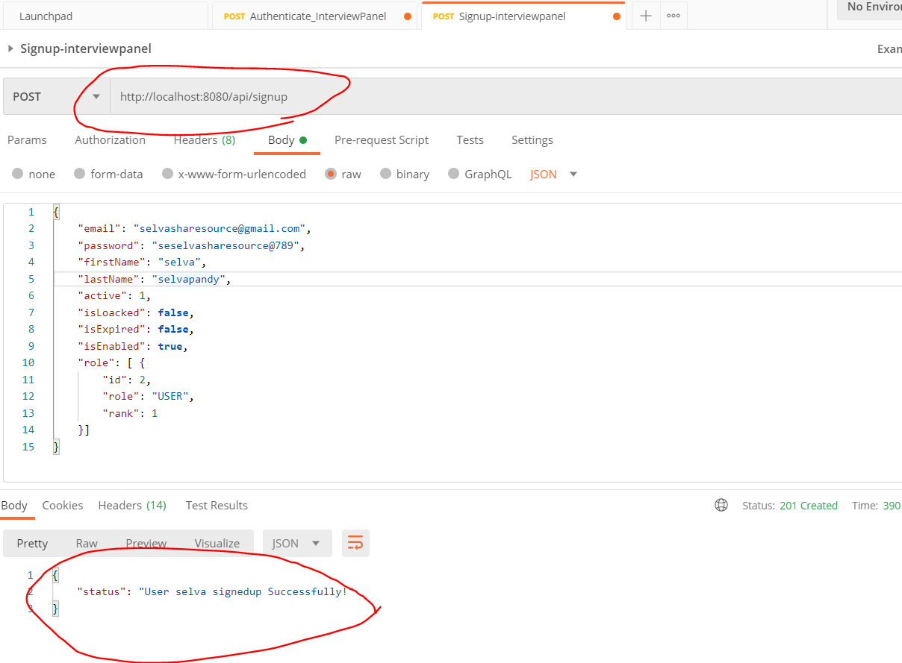

Step 2 : Call authenticate end point to get token: http://localhost:8080/api/authenticate with payload
to call the Microservice

{
"email": "selvasharesource@gmail.com",
"password": "seselvasharesource@789"
}

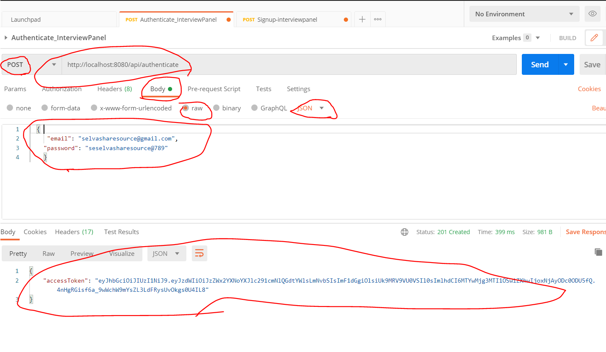
Step 3: Call qa service by passing the Bearer token http://localhost:8080/api/interviewpanel/v1/qalist

Select the Bearer token:
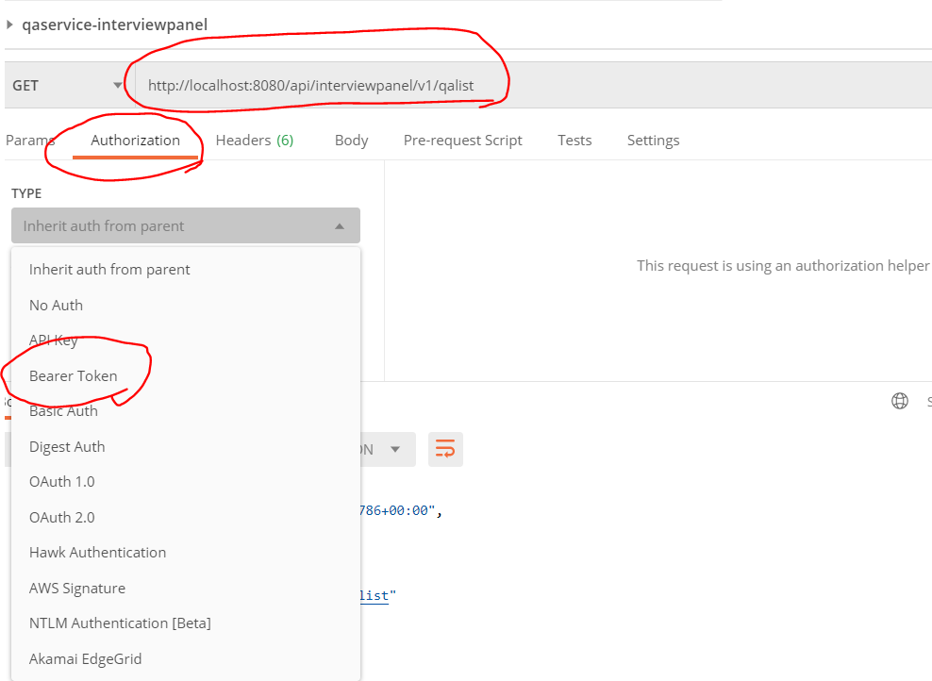

Successfully retrieved the data

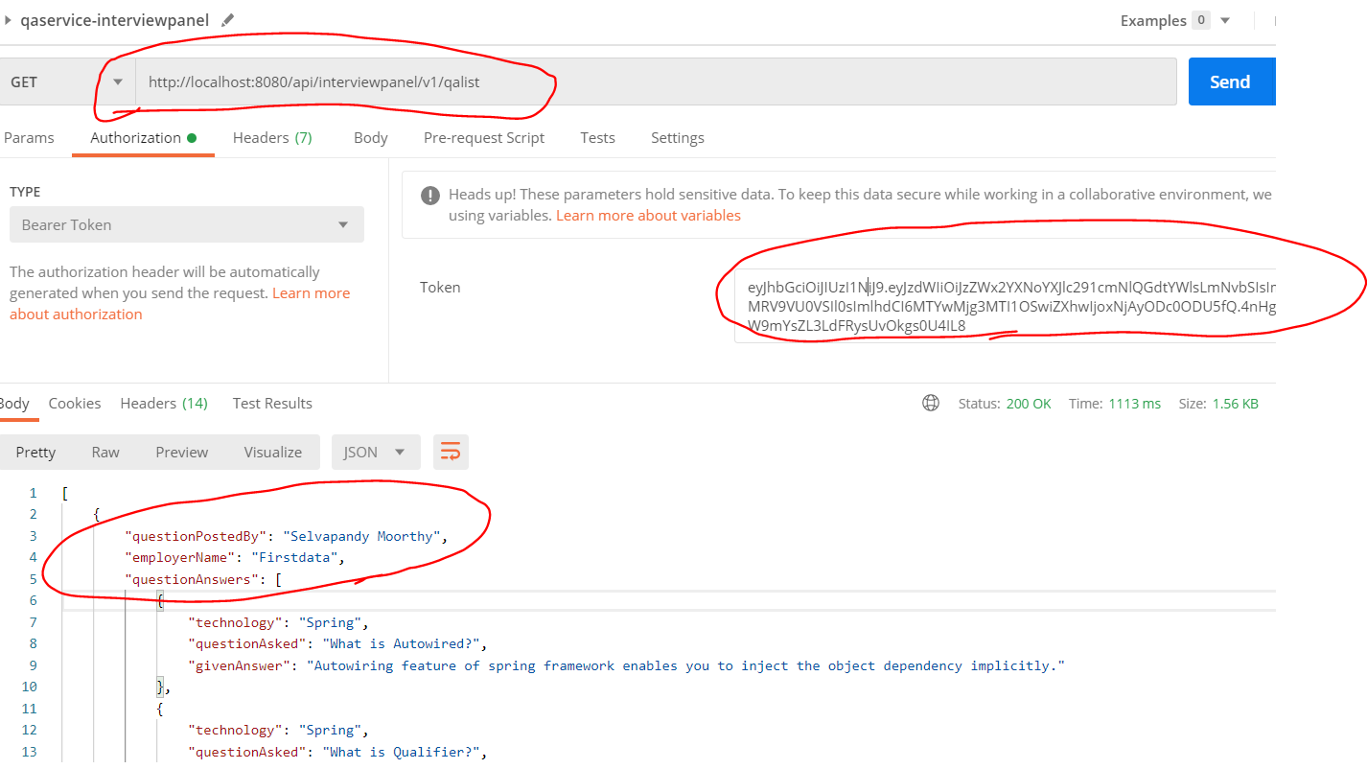

-------------------------------------------------Backend Successful done!-----------------------------------------

Frontend Setup :

Step 1> Visual Studio Code
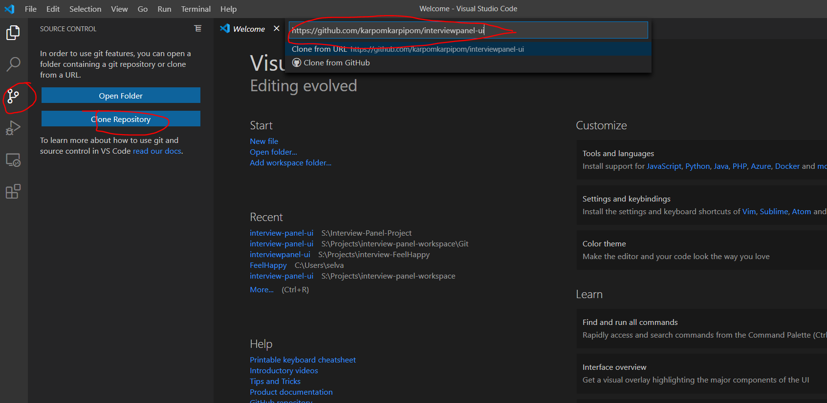
Step 2 > select some local folder

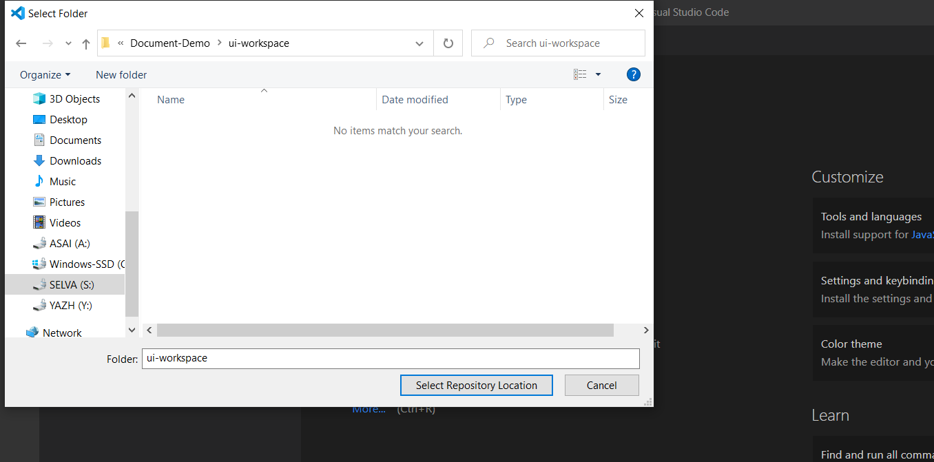

Step 3 > Open

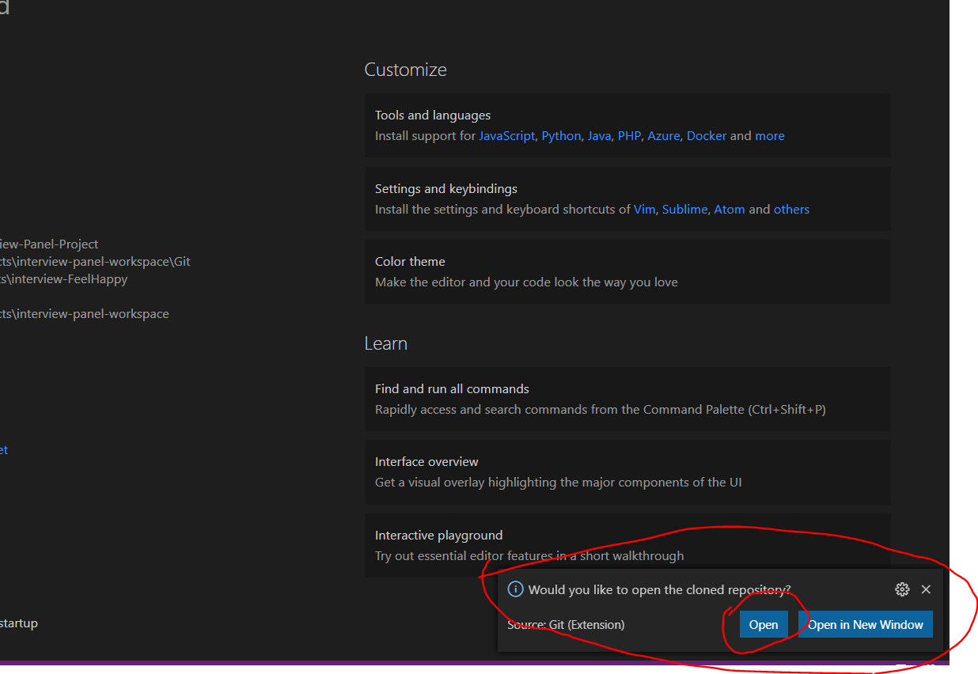

Step 3 > you can see the project structure
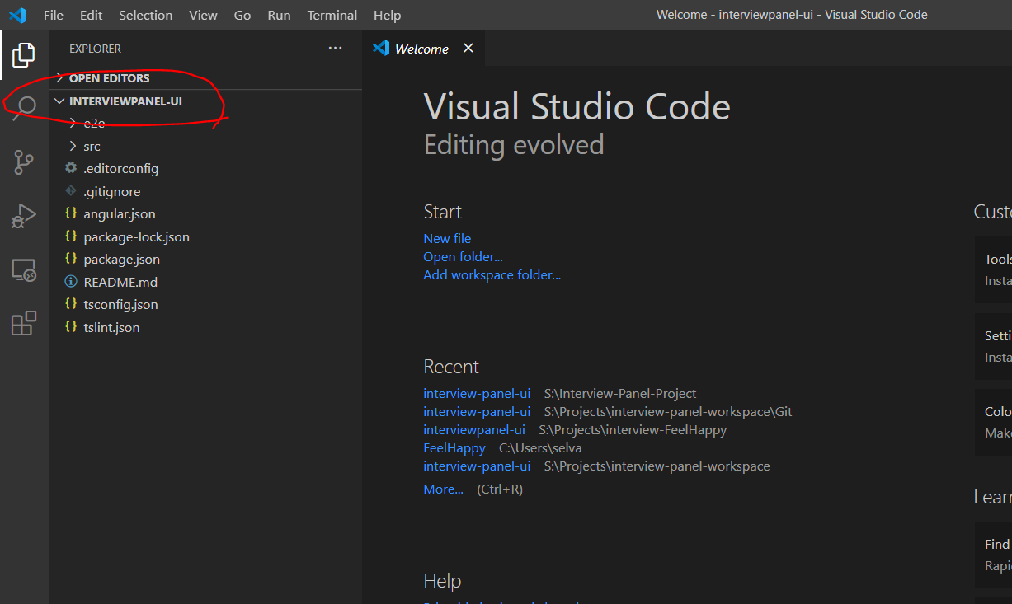

> Open new terminal
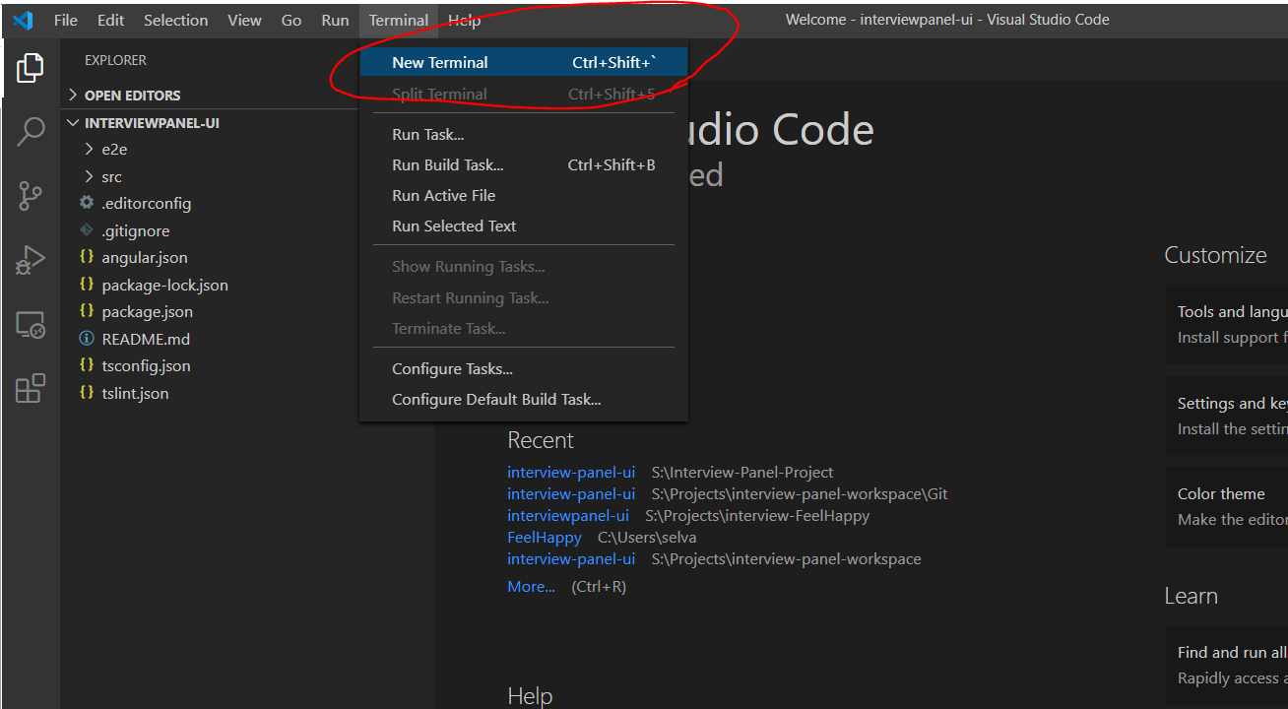

> Check all you have installed the version if not please follow the link Angular 7.0 setup

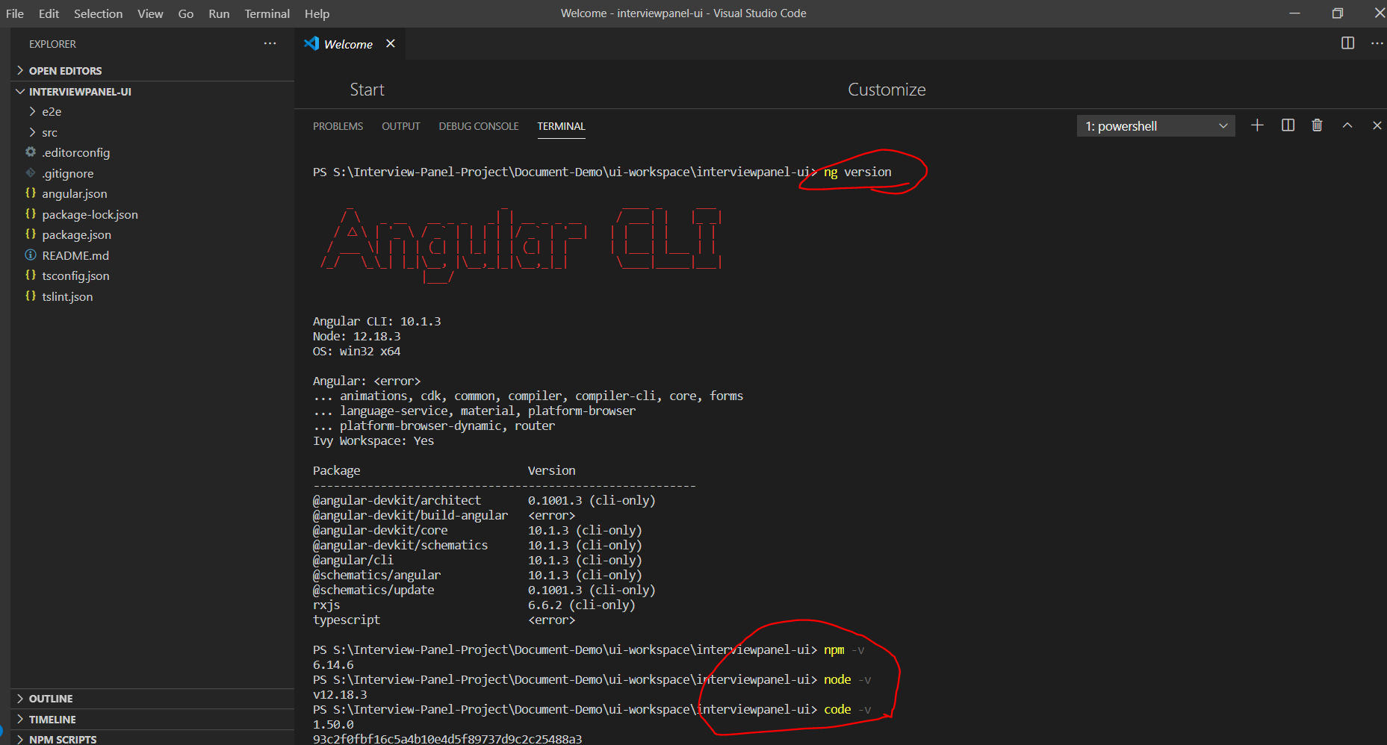
Must run this command: npm install --save-dev @angular-devkit/build-angular

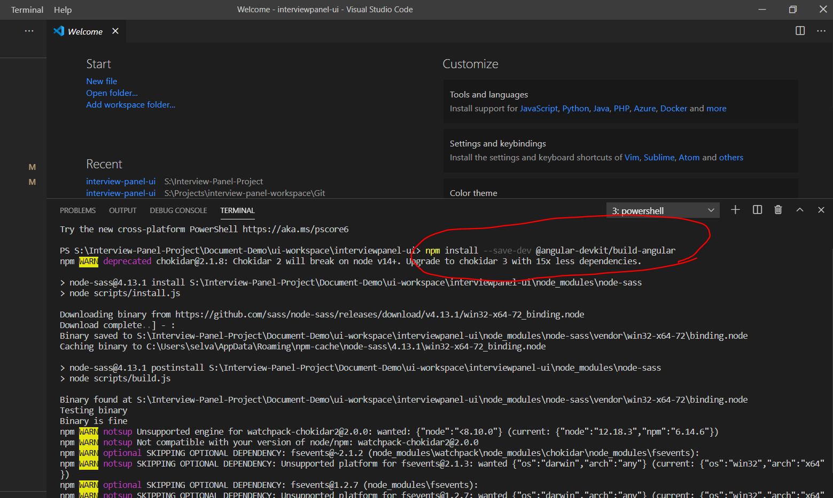

> Compiled and Run Successfully in 4200 port : http://localhost:4200/

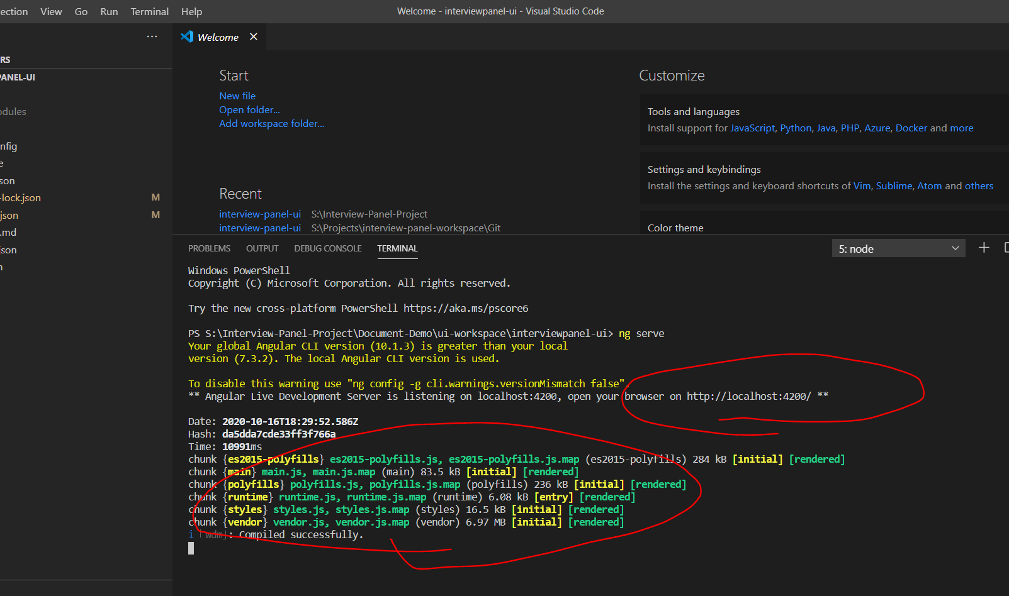

Application run successfully:

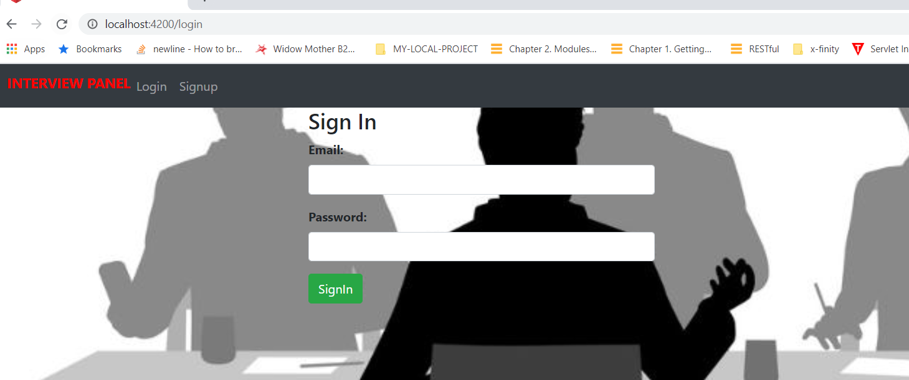

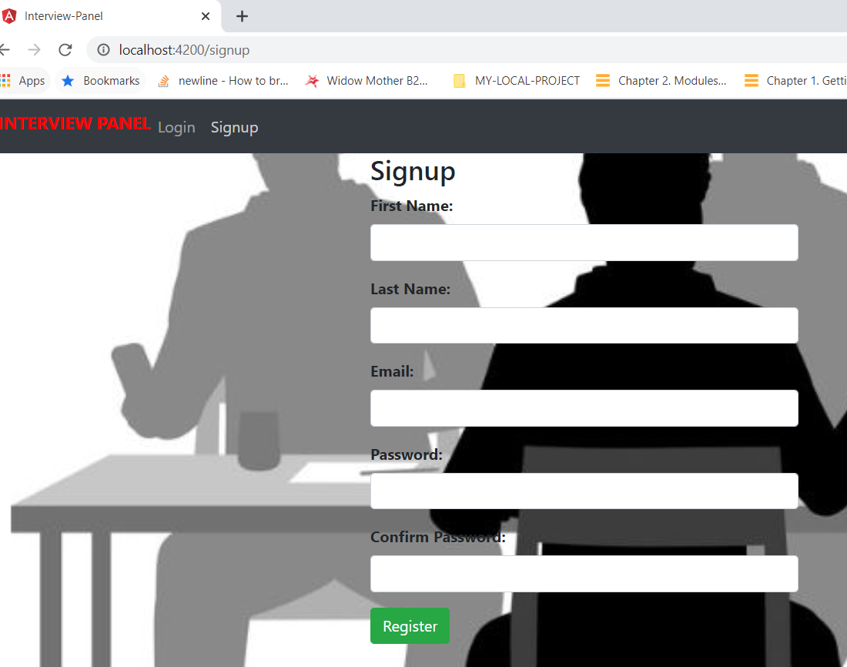
Signup : with new user

SignIn:

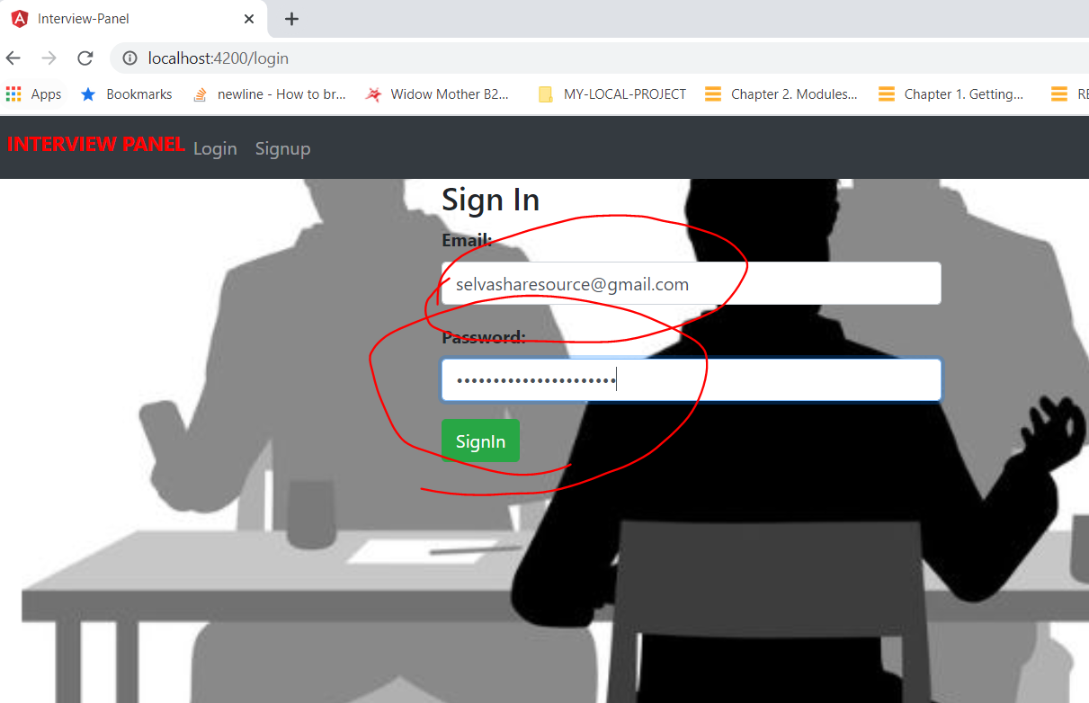

Successfull page:

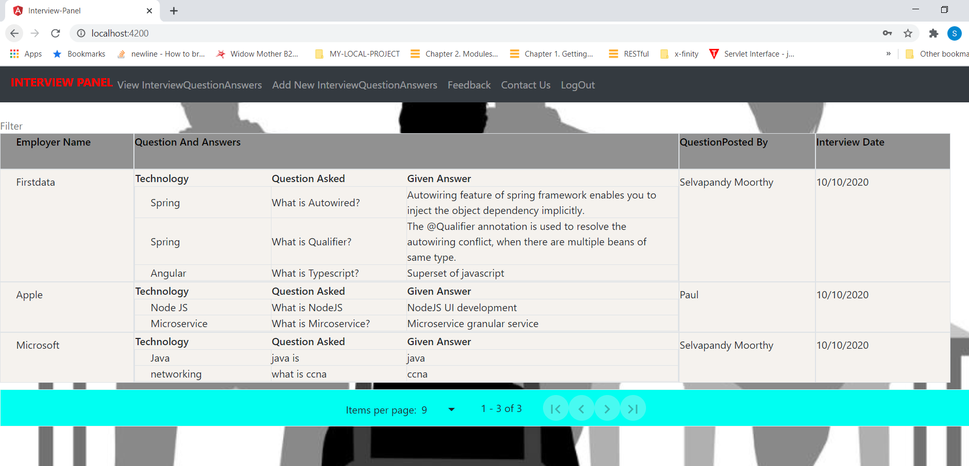

Add Interview Question and Answer Page:

