# Detail Document

# Use-case Diagram

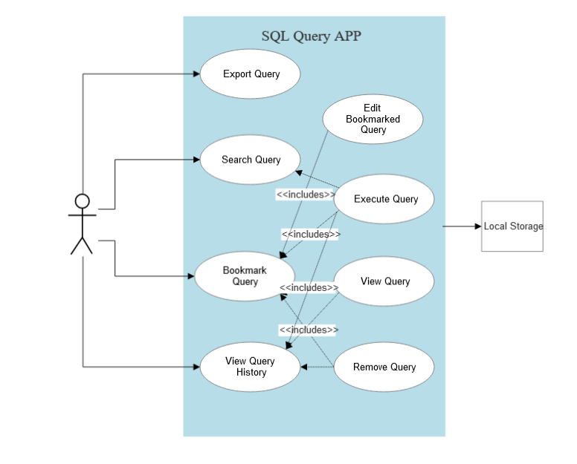

# Performance Measure:

## Google PageSpeed Insights

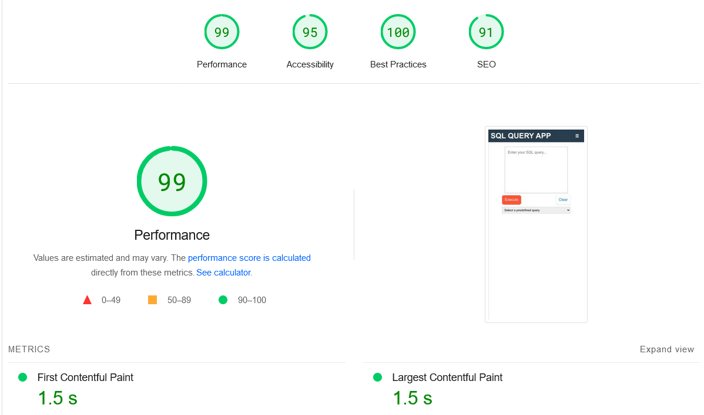

# Performance Optimization

* Utilized **react-window** for **virtualization** to efficiently handle large datasets, ensuring smooth scrolling and rendering of the table.
* Employed **React Profiler** to measure rendering performance, achieving an **impressive 2ms rendering time for the entire table**, with **each virtual row rendering in just 0.1-0.2ms**. This guarantees a highly performance, even with extensive data.

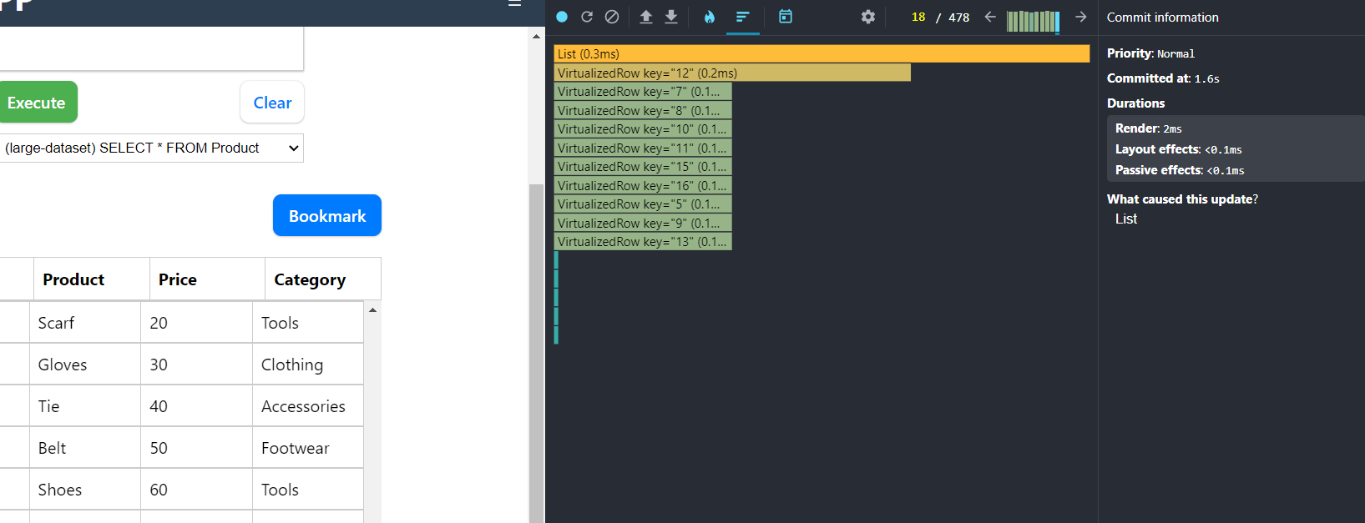

# Features:

## Virtualization of large Tables:

Test by selecting large-dataset in predefined queries

## Custom Field validations:

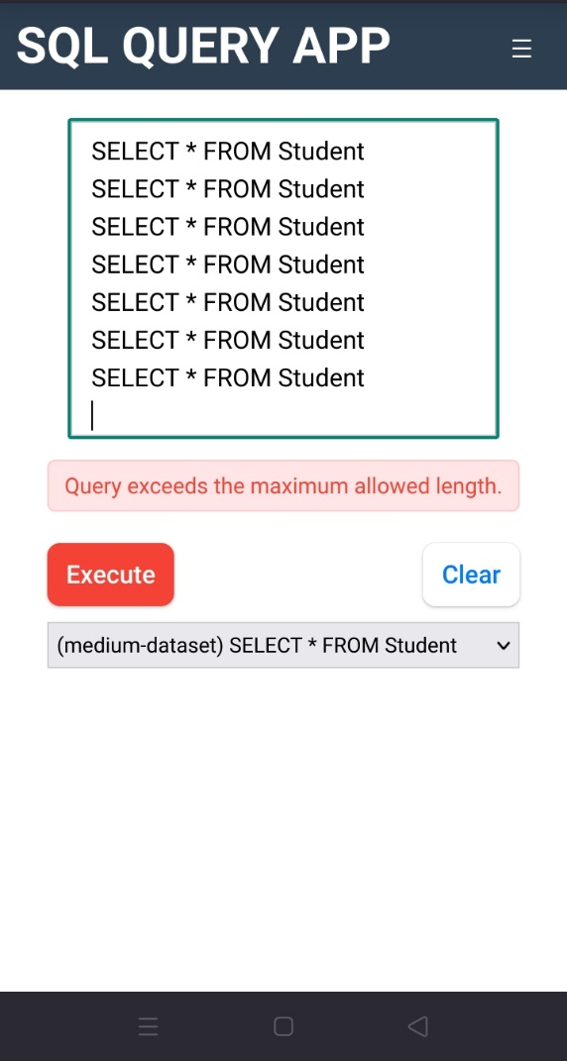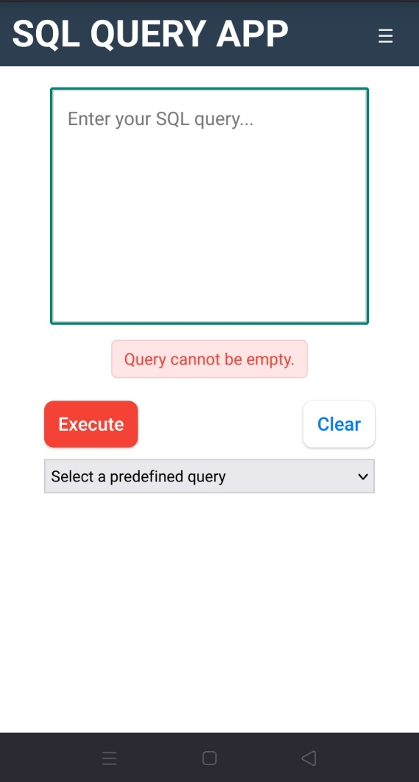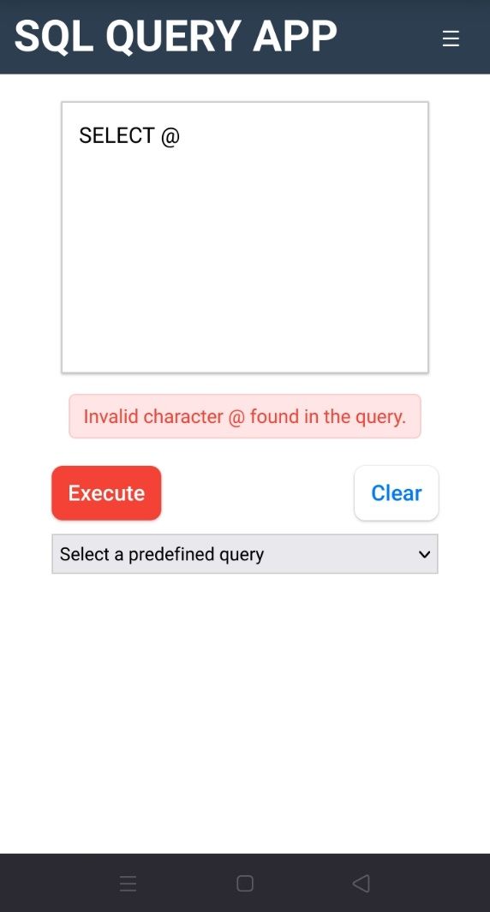

## Mobile Menu and Responsive interface

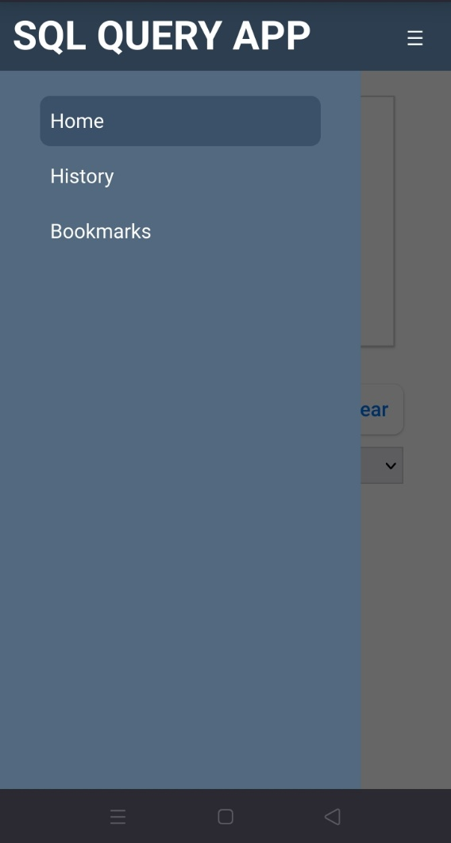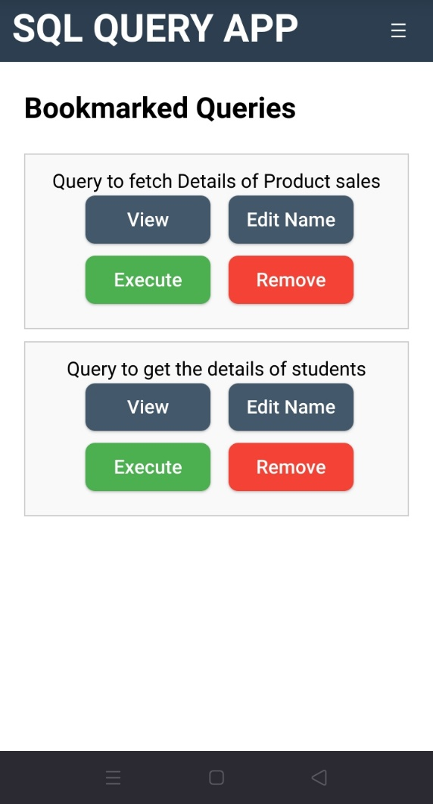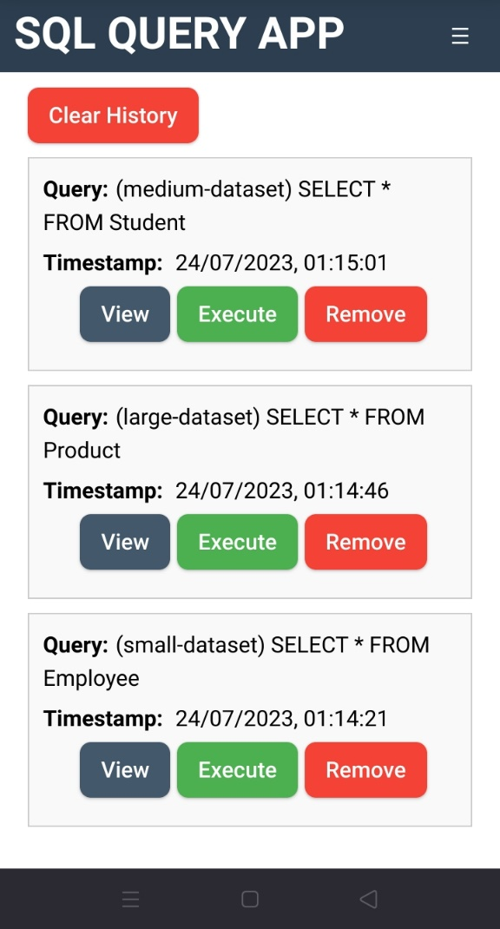

## Table Export:

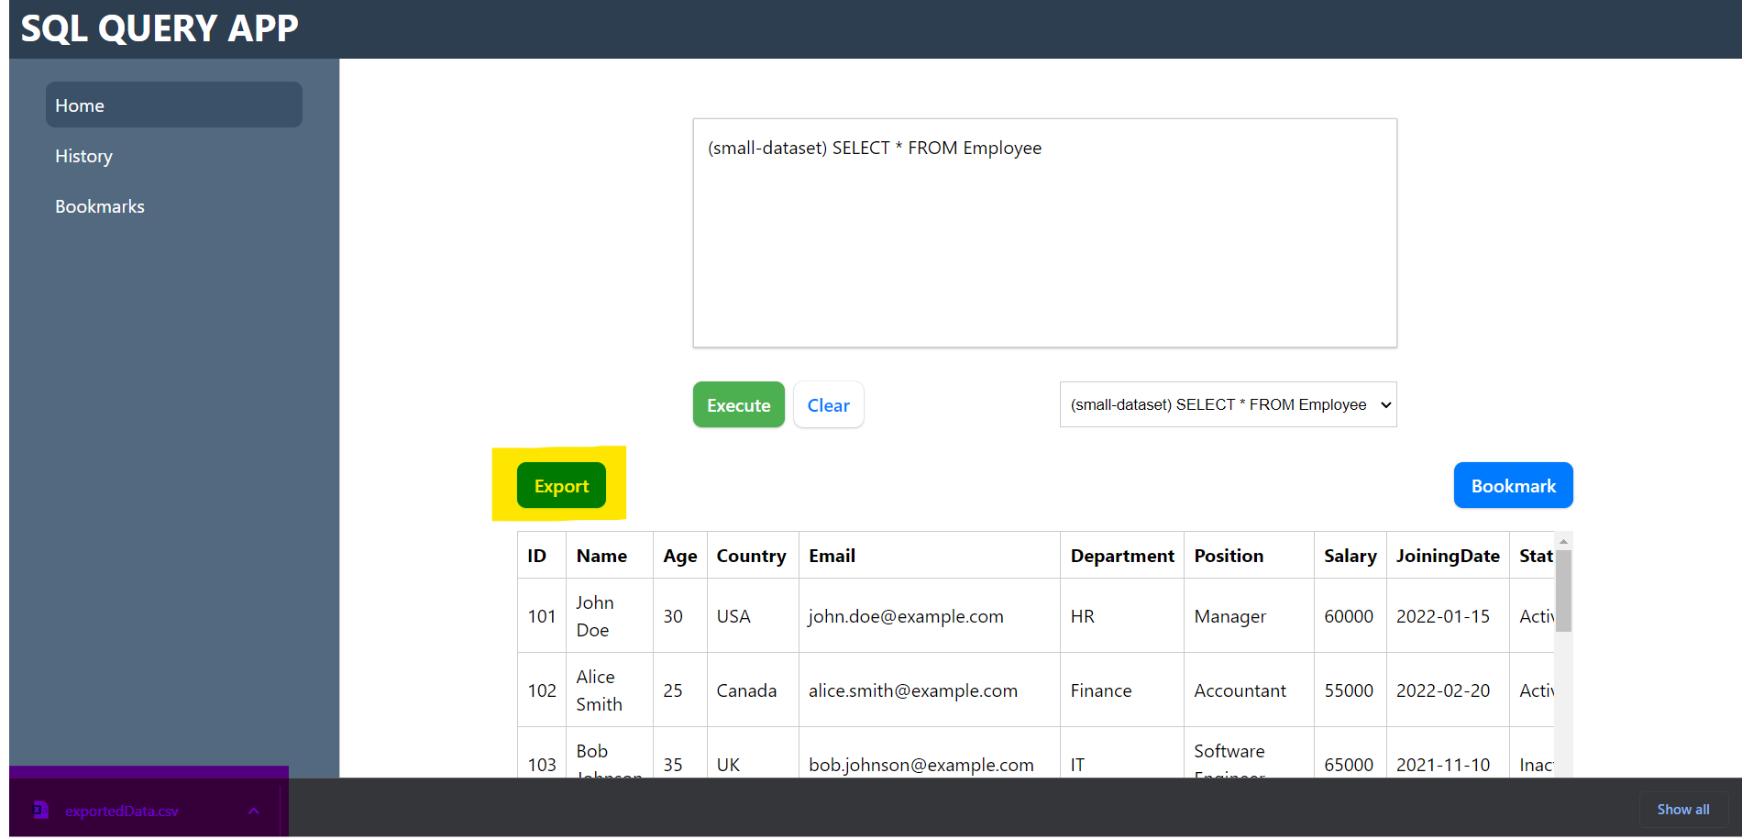

## Table Bookmark

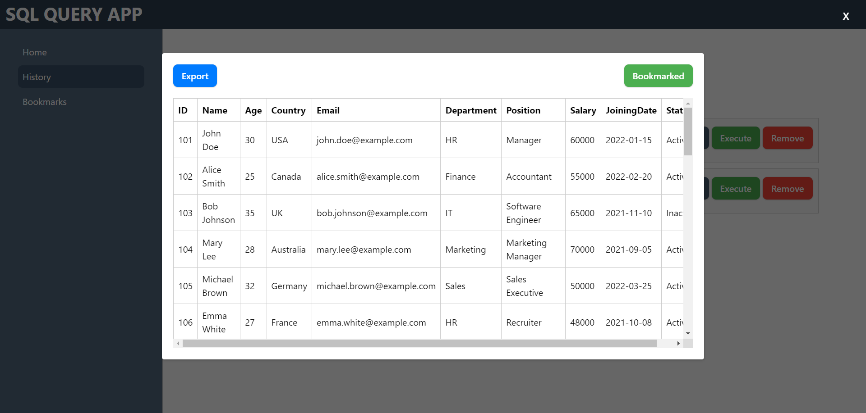

## View Queries in history and bookmarks

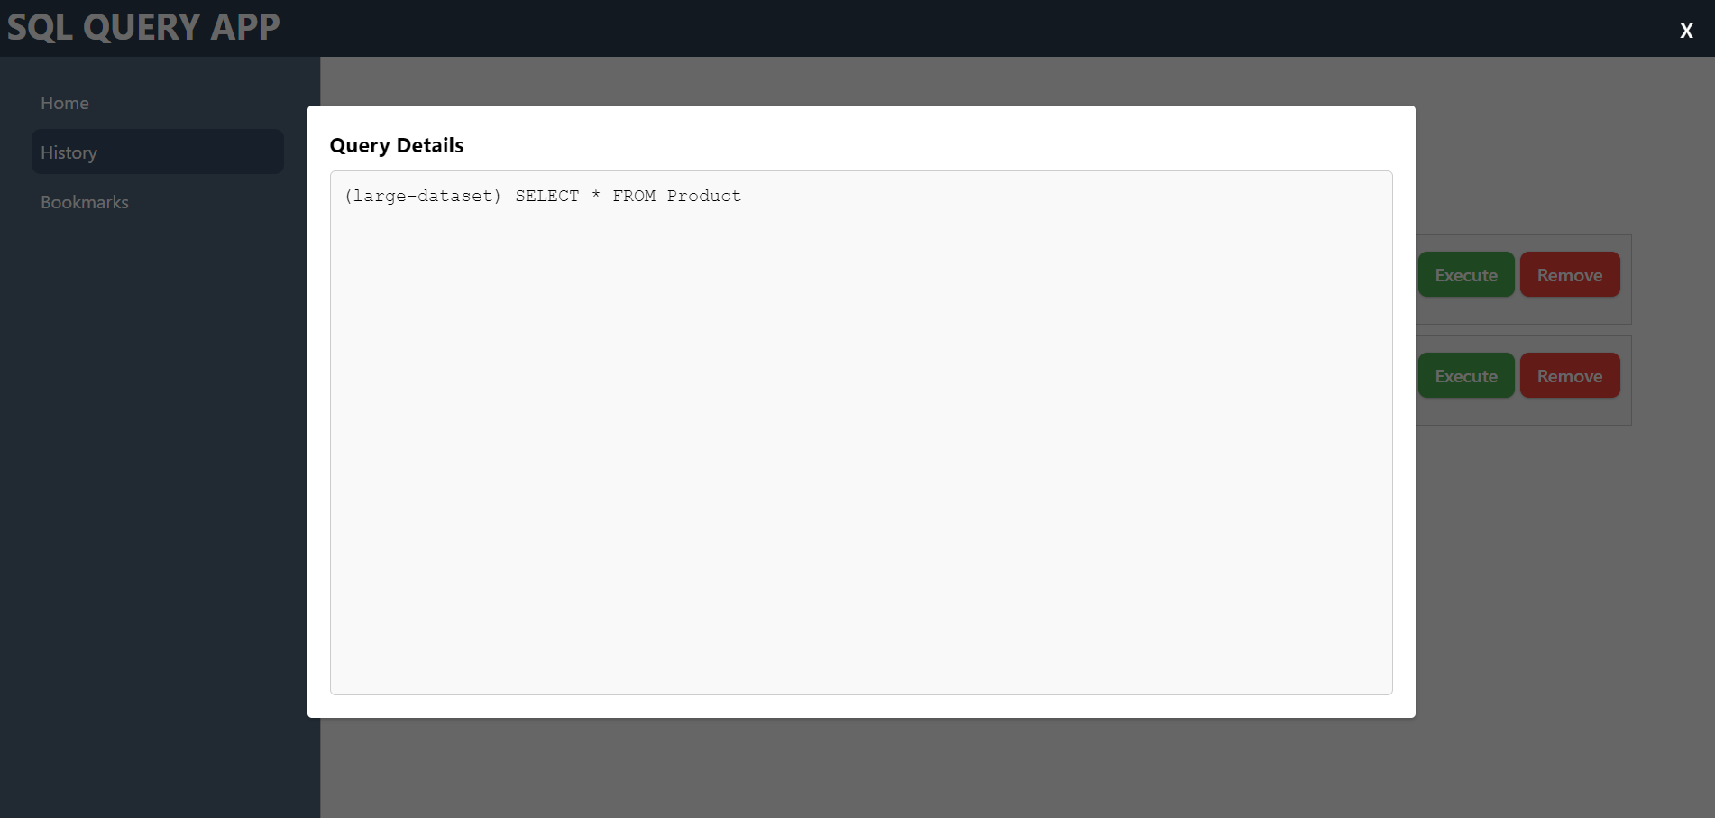

## Large Query Size Trim in History:

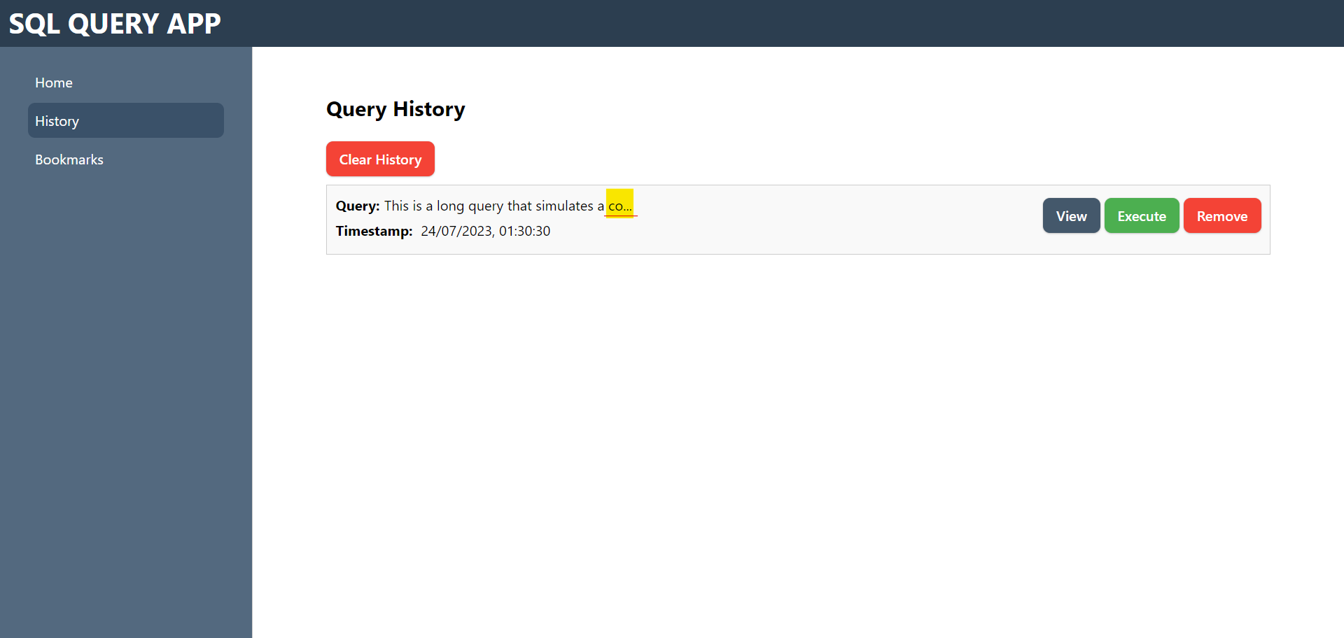

## Bookmark Rename

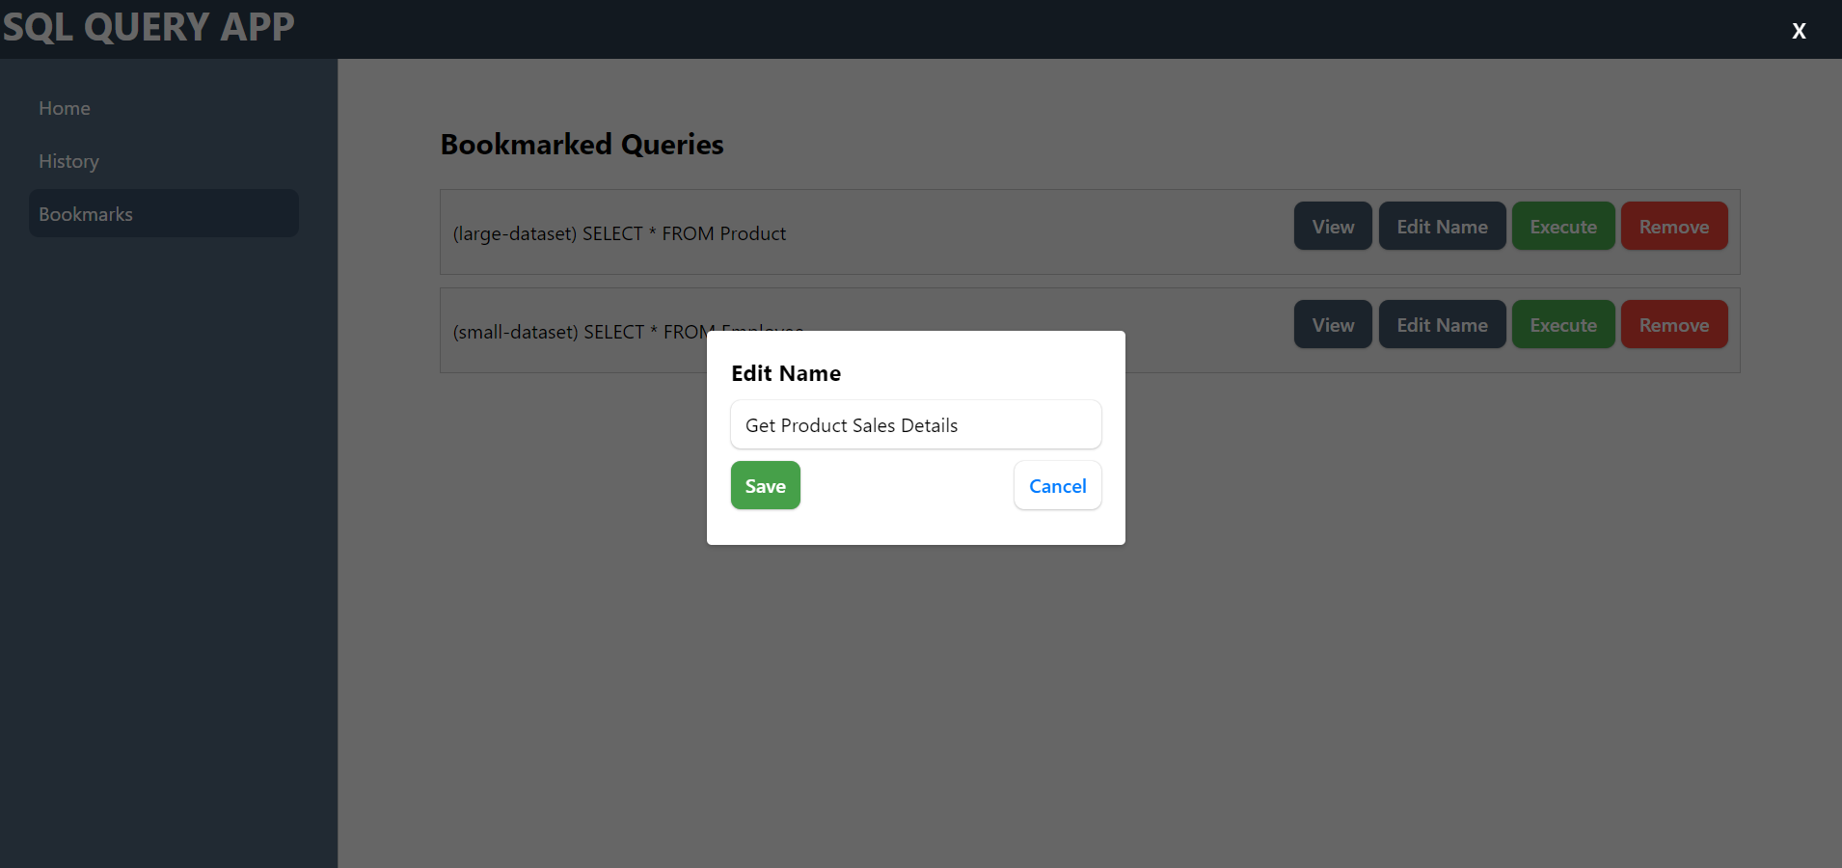

## Error Page

