

Research into optimised and future railway infrastructure

S2R-CFM-IP3-01-2020 Innovation Action

Appendix 4.1.1 Track information model

Confidentiality level: CO

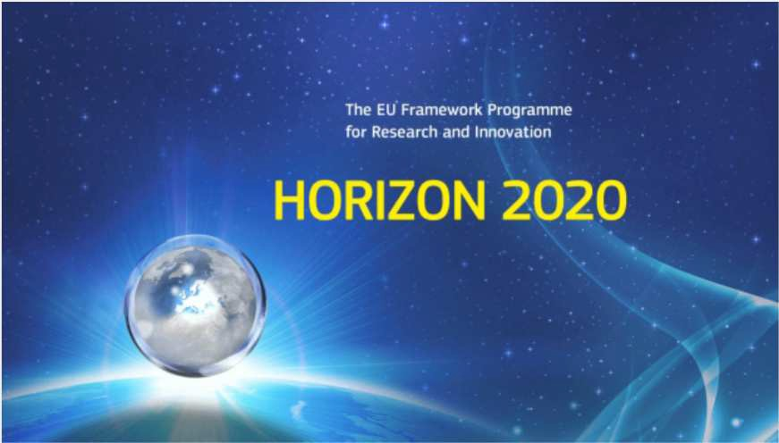Project information

DISCLAIMER AND ACKNOWLEDGEMENT

This project has received funding from the European Union's Horizon 2020 Programme Research and Innovation action under Grant Agreement No 101012456.

This document reflects the views of the author(s) and does not necessarily reflect the views or policy of the European Commission. Whilst efforts have been made to ensure the accuracy and completeness of this document, the In2Track3 consortium shall not be liable for any errors or omissions, however caused.

|  |  |  |
| --- | --- | --- |
| Document history | | |
| **Revision** | **Date** | **Description** |
| 1 | 2023-06-14 | Appendix |
|  |  |  |
|  |  |  |

**TABLE OF CONTENTS**

Appendix A- task approach and methodology 3

Phase 1: The development of a track based building Information Model (TIM) 3

1.1. Define model structure (systems and components) 3

1.2. Define a data structure (types and information structure) 3

1.3. Identify, collect or create 3D profiles and 3D objects needed to create the BIM model (Object Library) 4

1.4. Collect input data for the model (sample data) 4

1.5. Define appropriate tools for creating the artificial environment (BIM model / database) 4

1.6. Evaluation of the design concept (gap analyzes) 4

Phase 2: Incorporation of the infrastructure regulations (TRVINFRA) 5

2.1. Define the model's governing infrastructure regulations. 5

2.2. Develop IT concepts to link the regulations to BIM objects 5

Phase 3: The development of a virtual environment as a digital information carrier 6

3.1. Combine data and 3D objects to create BIM model 6

# Appendix A- task approach and methodology

The primary approach of the task is to identify technical challenges at an early stage and re-evaluate the methods or change working methods if necessary. This will ensure that the activities are executed efficiently to achieve the desired results. The task's objectives will be met using various methods, and the activities will be grouped into three distinct phases. The first phase aims to develop an artificial environment, namely a Building Information Model (BIM), to capture the necessary information regarding the Track superstructure. In the second phase, Trafikverket's relevant infrastructure regulations that govern Track structure will be defined and digitized using the “Semantic web” technology (W3C, 2015). Lastly, in phase three, a virtual environment will be created to serve as a digital information carrier. The proposed solutions aim to improve the management and maintenance of the Track superstructure by providing stakeholders with accurate and up-to-date information about the assets.

## Phase 1: The development of a track-based building Information Model (TIM)

### Define model structure (systems and components)

In this activity, an information model for the artificial environment (BIM model) of a Track superstructure will be established. Unified Modeling Language (UML) will be used to generate and configure the information model. The information model will be structured based on the following concepts:

* Using the standard "IFC-Rail 4x3" (and/or “IFC 4” the current official release schema) model structure developed by the "buildingSMART" group. (buildingSMART, 2022). The IFC conceptual model describe each railway object as a unique Concept inside the model, meaning it is described one time and for all inside the Model. However, the same object can be seen under multiple points of view. Three major modelling views (aspects) are adopted in the model, Structural (physical), Spatial and Functional. (IFC Rail Team, 2022)

Table Modelling views and their use (IFC Rail Team, 2022)

For the purpose of this task only the Structural (physical) and Spatial aspects will be used.

* Using the information model for "Reference facility" developed by Trafikverket in connection with the feasibility study "Virtual Master facility" (Svärdby-Bergman). This model will be used as a frame-work for creating an “Object type Library”, a data-catalog for the Structural (physical) objects and the Spatial objects.
* Using the information model for "Reference ID", Trafikverket's common hierarchy and reference designations system for assets in a facility. (~~reference~~)

The purpose of the information model is to identify the different systems and component types that exist in a Track Structure environment. The information model will describe a combination of spatial structure and a physical objects, displaying the relationships between objects and how they are (de)composed using “Aggregation” (i.e. part of, composed of) and “Generalization” type of relationships.

### Define a data structure (types and information structure)

In this activity, a definition will be established for the different properties that different types of facilities, systems or components have. The activity is performed in parallel with activity "Phase 1: 1" and will generate data for the UML model. In addition to the geometric properties, properties defined in the feasibility study "Virtual Master Plant" will be used. Information stored in Trafikverket's various IT systems can then (theoretically) be linked to the BIM model in the next phases of the task with the help of a unique "Object Key".

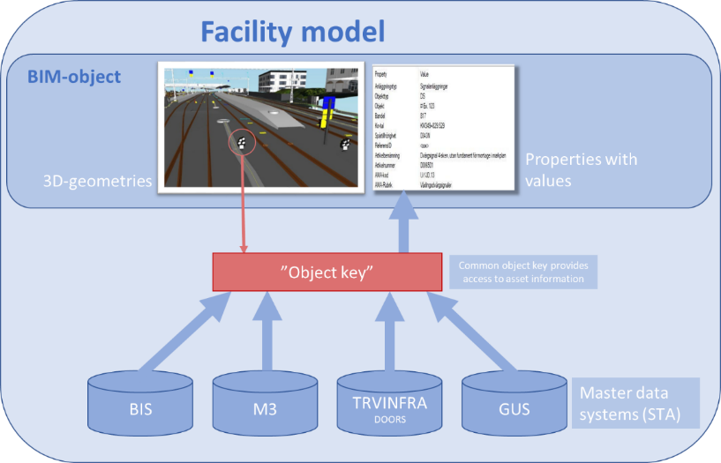

Figure An "object key" enables access to data.

### Identify, collect (or create) BIM-Objects (3D/2D-geometries) needed to create the BIM model (Object Type Library)

In this activity, BIM-objects (3D/2D-geometries) will be created or collected for all the components defined by the UML model in activity 1.1. The BIM objects must be parametric and contain the attributes corresponding to the properties defined in activity 1.2. Different types of CAD / BIM tools will be evaluated to perform this activity. For the purpose of this task, objects created in various Trafikverket’s early projects are collected and reused for the creation of the BIM model.

### Collect input data for the model (sample data)

In this activity, sample data is collected from the Trafikverket's various databases to use in the BIM model. The goal is that all the properties defined in the UML model will contain data. In the event that the information is missing from Trafikverket's databases, a fictitious but “reality-based” data will be created to ensure that all aspects of the UML model are tested in the BIM model to guarantee a high quality of our proof-of-concept.

### Define appropriate tools for creating the artificial environment (BIM model / database)

In this activity, different types of CAD / BIM tools will be evaluated to define the most suitable tool that can be used to create a BIM model for the entire Track superstructure part of a railway Track. The tools must meet the following criteria to qualify for use as a BIM design tool:

* Has tools for performing parametric design
* Has tools for performing graphical programming to maximize the efficiency of the design process.
* Can export the design to an IFC file format.

Finally, a BIM model of a limited area will be created to use as a basis for the artificial environment.

### Evaluation of the design concept (gap analysis)

In this activity, a gap analysis will be used to follow up the progress and success of the various above-mentioned activities in Phase 1 and activities in Phases 2 and 3. The analysis will describe the desired result at the end of the project (2023) compared to the start of the project. The analysis will also be used to identify future measures and recommendations for further work.

## Phase 2: Incorporation of the infrastructure regulations (TRVINFRA)

### Define the model's governing infrastructure regulations.

During the project, we will use the new regulations for New mainlines "Technical system requirements New mainlines" version 1.0 (TSK_NS_1.0). "Technical system requirements New mainlines" (TSK NS) is a Trafikverket’s document which together with existing regulations (TDOK / TRVINFRA) contains Trafikverket's technical requirements for planning, design, construction, operation and maintenance for the high-speed system on the Stockholm-Gothenburg / Malmö mainlines. TSK NS will be used for ballasted track system for speeds up to and including 250 km / h and ballast-free track system for speeds up to and including 320 km / h. (reference). Trafikverket’s infrastructure regulations “Track components” (TRVINFRA-00018) will be used for requirements about specific track components. During this phase an IT concept will be developed to link the regulation to the BIM model.

### Develop IT concepts to link the regulations to BIM objects.

The regulations and requirements from activity 2.1 will be converted into a digital format and stored in a database that can later be linked to objects in the BIM model. The purpose is to be able to refer via the BIM model to different requirements that govern the design of the systems or components in the track structure. The main digitalization method that will be used in this task will be based on the “Semantic web” technology (W3C, 2015).

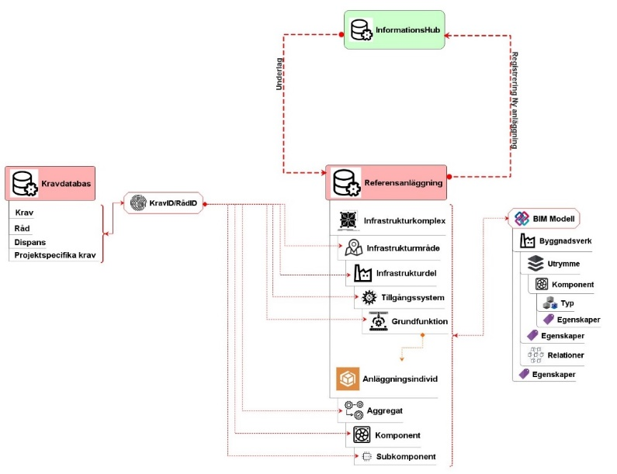

Figure Principle for linking regulations to different objects in the BIM model

## Phase 3: The development of a virtual environment as a digital information carrier

### Combine data and 3D objects to create BIM model

The last activity in the task is to put all the data together with a corresponding 3D object and create a complete BIM model according to the structure defined in Phase 1. In connection with this activity, different types of "Model Viewer" will also be tested to decide which is best for:

* Visualization of information and 3D
* Export of information in other formats for further analysis with other tools
* User friendliness

# Litteraturförteckning

buildingSMART. (2022). *IfcRailDomain*. Retrieved from IFC4.3.1.0 Documentation: https://ifc43-docs.standards.buildingsmart.org/

IFC Rail Team. (2022). *IFC Rail Phase 2 Final Report, WP4 – Conceptual Model Report.* buildingSMART International.

Svärdby-Bergman, A. &. (n.d.). Virtuell Masteranläggning : ökad förmåga att arbeta modellbaserat i Trafikverke. Trafikverket. Retrieved from http://urn.kb.se/resolve?urn=urn:nbn:se:trafikverket:diva-4502

W3C. (2015). *Semantic Web: W3C*. Hämtat från The World Wide Web Consortium (W3C): https://www.w3.org/standards/semanticweb/