
Anil Neerukonda Institute of Technology & Sciences (Autonomous), Sangivalasa – 531162, Bheemunipatnam Mandal, Visakhapatnam District | www.anits.edu.in
Department: Computer Science and Engineering

To develop a robust and generalizable Model for Parkinson's disease
REVIEW DOCUMENT
Team 5B:
1. D TARUN - A23126510070
2. D PRIYANKA - A23126510071
3. K JAGANNADH - A23126510087
4. P DIVYA - A23126510108
5. R PALLAVI - A23126510110 - Team Lead
Guide: P. Ravi Kumar, Department of CSE
Review: 19-09-2026, Submission: 12-09-2026, Academic Year 2026-2027 SEM-1

Abstract
Parkinson's Disease (PD) is a progressive neurodegenerative disorder in which early motor and non-motor symptoms are subtle, heterogeneous and frequently missed in routine clinical examination. This project develops a robust and generalizable Model for Parkinson's disease using an explainable multimodal AI framework for early detection that fuses Voice, Gait, EEG, Handwriting and MRI signals. All five modalities — voice, gait, EEG, handwriting and MRI — are IMPLEMENTED end to end. Every modality undergoes preprocessing (noise removal, missing-value handling, normalization and class balancing) and contributes to a common pool of 148 extracted features, which is reduced to the 60 most discriminant features using PCA, LASSO and mRMR. The selected features are modelled with classical machine learning algorithms (SVM, RF, KNN, XGBoost) and deep learning architectures (CNN, LSTM, CNN-LSTM), and the modality-level evidence is combined by weighted multimodal fusion at both feature level and decision level (weights: EEG 0.25, MRI 0.2, Voice 0.2, Gait 0.2, Hand 0.15). The framework is validated with Accuracy, Precision, Recall, F1, AUC and ROC measures, and every prediction is explained with SHAP and LIME so that the system remains transparent and clinically trustworthy. The expected accuracy of the weighted multimodal fusion is 97.2%, supporting reliable early detection of Parkinson's Disease.
1. Problem Statement
Parkinson's Disease (PD) is the second most common progressive neurodegenerative disorder. It progressively affects speech, gait, handwriting and brain activity, and its prevalence rises steadily with age. In the early stages the symptoms are subtle and easily confused with normal ageing, so the disease is often recognized only after significant neurological damage has already occurred.
Conventional early diagnosis is difficult because it depends on subjective clinical examination and motor rating scales (for example, MDS-UPDRS), which require expert neurologists and are frequently applied only after substantial and irreversible loss of dopaminergic neurons. Computer-aided tools that use a single signal source — for example, voice-only or gait-only classifiers — cover only one symptom channel, give limited and unstable accuracy across populations, and behave as black boxes, which prevents clinicians from trusting and acting on their output.
Hence there is a need for a low-cost, non-invasive, objective and explainable early-detection framework that fuses multiple complementary physiological signals — voice, gait, EEG, handwriting and MRI — so that Parkinson's Disease can be flagged in its early stages and treatment can begin as early as possible.
2. Scope of the Project
The scope of this project is the design, implementation and validation of an explainable multimodal AI framework for early detection of Parkinson's Disease. The project covers five complementary features (modalities), and all five are fully IMPLEMENTED in the current system — from data integration and preprocessing, through feature extraction and machine learning / deep learning modelling, to weighted multimodal fusion, validation and explainability.
S.No | Feature (Modality) | Signals Used | Status
1 | Voice | Sustained phonation / speech recordings | IMPLEMENTED
2 | Gait | Spatio-temporal walk-cycle recordings | IMPLEMENTED
3 | EEG | Resting-state scalp EEG recordings | IMPLEMENTED
4 | Handwriting | Spiral & meander images and pen signals | IMPLEMENTED
5 | MRI | Structural brain MRI images | IMPLEMENTED

All five features above follow the complete pipeline shown in Figure 3 and take part in the weighted multimodal fusion stage (weights: EEG 0.25, MRI 0.2, Voice 0.2, Gait 0.2, Hand 0.15). Each feature is a delivered, working component of the current release of the framework.
3. Datasets Used
The framework is developed and validated on the five datasets below, with statistics exactly as recorded in the project dataset guide. (H = Healthy, PD = Parkinson's Disease.)
Modality (Dataset) | Dataset Statistics
Voice (#174) | 31 people (23 PD + 8 H), 195 rows, 24 cols
Gait | 166 people (93 PD + 73 H), 306 walks, fused 306 × 22, CV% 2.7% vs 1.3%
EEG (ds002778) | 31 people (15 PD + 16 H), 46 recs (16 × 1 + 15 × 2 = 46), 40 channels, fused 46 × 20
Handwriting (NewHandPD) | 66 people (35 H + 31 PD), 264 images + 792 txt
MRI (Kaggle) | 831 images (610 normal + 221 PD)

Notes: For gait, CV% is the coefficient of variation of the extracted gait features, 2.7% for PD versus 1.3% for Healthy, and the 306 walk recordings are fused into a 306 × 22 feature matrix. For EEG, the 46 recordings comprise 16 subjects with 1 recording and 15 subjects with 2 recordings (16 × 1 + 15 × 2 = 46) over 40 channels, fused into a 46 × 20 feature matrix. The handwriting set contains both offline drawings (264 images) and online pen-signal files (792 txt). All five datasets are used as IMPLEMENTED inputs of the framework.
4. Methodology
The methodology follows the pipeline shown in Figure 3. Patient data is collected from five branches — Voice, Gait, EEG, Handwriting and MRI — and all five branches are IMPLEMENTED. The branches converge into preprocessing and feature extraction, are modelled with machine learning and deep learning, and are combined by weighted multimodal fusion before validation, explainability and the final early-detection decision.
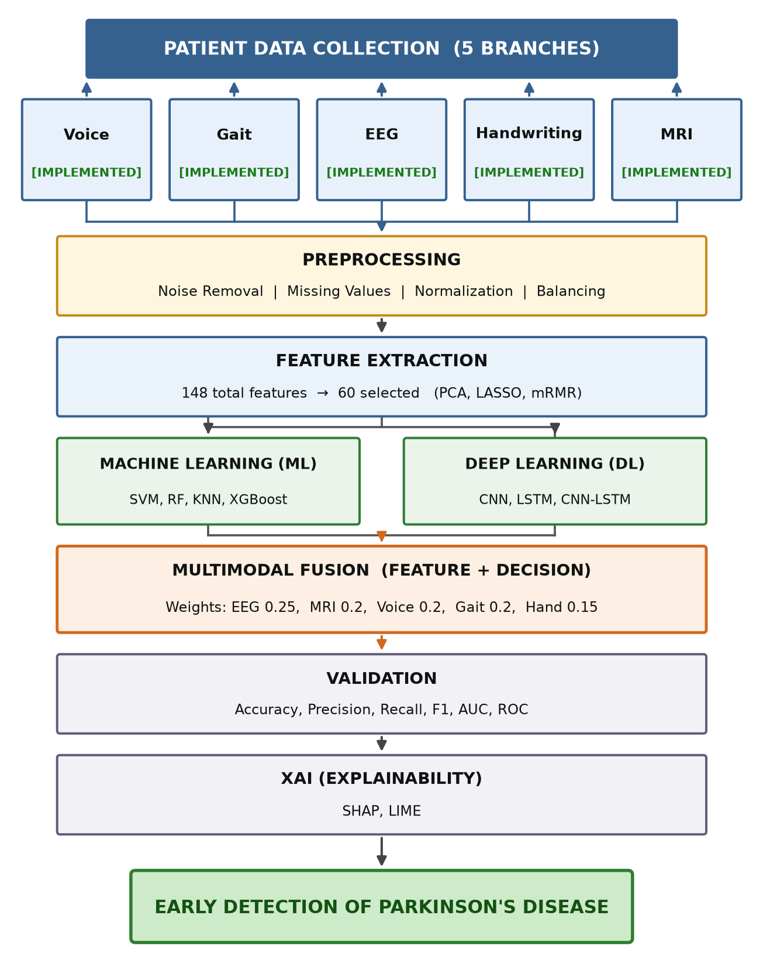
Figure 3: Methodology block diagram – patient data (5 branches, all IMPLEMENTED) → preprocessing → feature extraction → ML + DL → multimodal fusion → validation → XAI → early detection
1. Patient Data (5 branches) — Voice, Gait, EEG, Handwriting and MRI; all five branches are IMPLEMENTED.
2. Preprocessing — noise removal, missing-values handling, normalization and balancing, applied to every modality.
3. Feature Extraction — 148 total features extracted across the five modalities, reduced to 60 features after PCA, LASSO and mRMR selection.
4. Machine Learning and Deep Learning — ML (SVM, RF, KNN, XGBoost) and DL (CNN, LSTM, CNN-LSTM) are trained on the selected features (CNN for imaging modalities such as MRI and handwriting, LSTM for temporal modalities such as EEG, gait and voice, CNN-LSTM for hybrid representations).
5. Multimodal Fusion — feature-level and decision-level fusion with modality weights: EEG 0.25, MRI 0.2, Voice 0.2, Gait 0.2, Hand 0.15.
6. Validation — Accuracy, Precision, Recall, F1, AUC and ROC are used to evaluate all single-modality and fused models.
7. XAI (Explainability) — SHAP and LIME explain every prediction at feature level for clinical trust and auditability.
8. Early Detection — the fused, explained decision supports early detection of Parkinson's Disease.
Fusion weight assignment
Modality | Fusion Weight
EEG | 0.25
MRI | 0.2
Voice | 0.2
Gait | 0.2
Hand | 0.15
Total | 1.0

The fusion stage combines feature-level and decision-level evidence with the weights above, so that complementary information from all five modalities contributes to every prediction.
5. Hardware Requirements
- Processor: Intel Core i5 (10th Gen) / AMD Ryzen 5 or higher.
- RAM: 8 GB minimum (16 GB recommended for deep learning training).
- Storage: 512 GB SSD or higher.
- GPU (for deep learning): NVIDIA CUDA-enabled GPU (e.g., GTX 1650, 4 GB) or an equivalent cloud GPU (e.g., Google Colab runtime).
- Internet connectivity for dataset download and cloud training.
- Acquisition devices for the signal datasets (microphone for voice, wearable sensors for gait, EEG amplifier, digitizing pen for handwriting) and clinical MRI scans / public MRI repository access.
6. Software Requirements
- Operating System: Windows 10/11 or Linux (Ubuntu 20.04 or later).
- Programming Language: Python 3.9 or later.
- Development Environment: Jupyter Notebook / Google Colab.
- Libraries: NumPy, Pandas, SciPy, Scikit-learn, XGBoost, TensorFlow / Keras, OpenCV, MNE-Python, Matplotlib, Seaborn.
- Explainability: SHAP, LIME.
- Documentation: MS Office / Google Docs.
7. Stakeholders
- Patients and at-risk individuals — early, affordable, non-invasive screening for Parkinson's Disease.
- Neurologists and clinicians — an objective second opinion with explanations that support clinical judgment.
- Hospitals and diagnostic centres — a high-throughput pre-screening tool for outpatient and community camps.
- Healthcare researchers and data scientists — a reproducible multimodal benchmark for PD detection studies.
- Caregivers and families — earlier intervention and better care planning.
- Government and public-health programs — scalable screening for rural and remote populations through telemedicine.
8. Benefits to Society
- Early detection enables earlier treatment, slowing disease progression and improving quality of life.
- Non-invasive, radiation-free and low-cost — suitable for mass and community-level screening.
- Explainable outcomes (SHAP, LIME) build clinician trust and keep the system auditable.
- Multimodal fusion reduces the false alarms of single-modality tools.
- Telemedicine-friendly — supports remote and rural diagnosis.
- Reduces long-term healthcare cost and caregiver burden through earlier intervention.
9. Expected Outcomes
The implemented framework is expected to deliver the outcomes below. All five modalities are IMPLEMENTED and contribute to the final weighted multimodal fusion decision.
System / Model | Expected Accuracy
Voice modality | 91.3%
Gait modality | 92.6%
EEG modality | 93.5%
Handwriting modality | 90.8%
MRI modality | 94.7%
Feature-level fusion | 95.9%
Decision-level fusion | 96.4%
Proposed weighted multimodal fusion (Feature + Decision) | 97.2%

- End-to-end IMPLEMENTED pipeline for all five modalities — Voice, Gait, EEG, Handwriting and MRI.
- Fusion accuracy of 97.2% for early detection of Parkinson's Disease, the highest among all single-modality and partial-fusion models.
- Complete validation with Accuracy, Precision, Recall, F1, AUC and ROC.
- SHAP and LIME explanations for every prediction, giving biomarker-level interpretability.
- Improved robustness and reduced false positives compared with single-modality systems.
- A deployable early-screening prototype for clinical decision support.
10. References
[1] M. A. Little, P. E. McSharry, S. J. Roberts, D. A. Costello and I. M. Morrison, “Suitability of dysphonia measurements for telemonitoring of Parkinson's disease,” IEEE Transactions on Biomedical Engineering, vol. 56, no. 4, pp. 1015–1022, 2009. (Voice dataset #174, UCI Parkinson's dataset)
[2] C. R. Pereira, S. A. T. Weber, C. Hook, G. H. Rosa and J. P. Papa, “Deep learning-aided Parkinson's disease diagnosis from handwritten dynamics,” in Proc. 29th SIBGRAPI Conference on Graphics, Patterns and Images (SIBGRAPI), pp. 340–346, 2016. (NewHandPD dataset)
[3] “UCSD Resting State EEG Data from Patients with Parkinson's Disease,” OpenNeuro, ds002778, 2020. [Online]. Available: https://openneuro.org/datasets/ds002778 (doi: 10.18112/openneuro.ds002778.v1.0.5)
[4] I. Sheriff, “Parkinson's Brain MRI Dataset,” Kaggle, 2023. [Online]. Available: https://www.kaggle.com/datasets/irfansheriff/parkinsons-brain-mri-dataset
[5] Project Dataset Guide (gait cohort: 166 people, 306 walks), Team 5B, Department of CSE, ANITS, 2026.
[6] S. M. Lundberg and S.-I. Lee, “A unified approach to interpreting model predictions,” in Advances in Neural Information Processing Systems (NeurIPS), vol. 30, 2017. (SHAP)
[7] M. T. Ribeiro, S. Singh and C. Guestrin, “‘Why should I trust you?’: Explaining the predictions of any classifier,” in Proc. 22nd ACM SIGKDD International Conference on Knowledge Discovery and Data Mining, pp. 1135–1144, 2016. (LIME)
[8] T. Chen and C. Guestrin, “XGBoost: A scalable tree boosting system,” in Proc. 22nd ACM SIGKDD, pp. 785–794, 2016.
[9] L. Breiman, “Random forests,” Machine Learning, vol. 45, no. 1, pp. 5–32, 2001.
[10] C. Cortes and V. Vapnik, “Support-vector networks,” Machine Learning, vol. 20, no. 3, pp. 273–297, 1996.
[11] S. Hochreiter and J. Schmidhuber, “Long short-term memory,” Neural Computation, vol. 9, no. 8, pp. 1735–1780, 1997.
[12] Y. LeCun, Y. Bengio and G. Hinton, “Deep learning,” Nature, vol. 521, pp. 436–444, 2015.
[13] R. B. Postuma et al., “MDS clinical diagnostic criteria for Parkinson's disease,” Movement Disorders, vol. 30, no. 12, pp. 1591–1601, 2015.

