Beyond the Alert
  - SOC Automation Lab
  - Connecting detection evidence to analyst investigation
Implementation whitepaper
Jayanth · October 2026
Version 1.0.0
This paper explains the problem, the implemented workflow, an investigation example, and the evidence supporting the release. It is written for cybersecurity beginners, SOC analysts and incident-response interviewers.
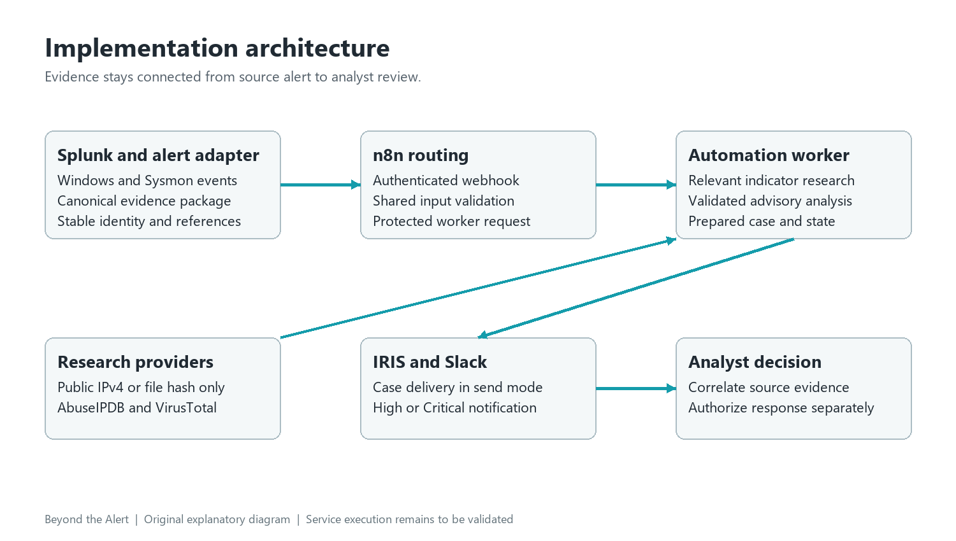
Architecture illustration showing the implemented component roles and investigation handoff. Service-connected validation is the next milestone.
Implementation and verification by Jayanth. Recorded checks cover processing logic, five reproducible synthetic examples, local authenticated HTTP behavior and generated workflow structure. Service-connected integration and deployment tuning form the next milestone.
Repository and reproducible evidence

The investigation problem
A security alert is the beginning of an investigation. An analyst still has to confirm which host and account are involved, inspect the source events, research suitable indicators, and record the reasons for escalation. When those tasks require repeated copying between tools, context can be lost and uncertain findings can appear more definite than the evidence supports.

What the project changes
Beyond the Alert prepares a consistent investigation package. It accepts a defined alert format, preserves source identities and references, performs relevant indicator research, checks an advisory summary, and prepares case fields. The same package carries the evidence into the next step so the analyst can review its reasoning instead of reconstructing it from disconnected messages.
The workflow connects Splunk detection, authenticated n8n routing, worker validation, relevant enrichment, structured analysis, IRIS case preparation and analyst notification. A priority label directs review; the analyst correlates source evidence and checks authorization before deciding the response.

Recorded implementation capabilities
The implementation contains five scenario contracts, provider adapters, a persistent duplicate record, bounded network handling and visible failure states. Ninety-four automated checks pass in the recorded validation run. Five synthetic examples reproduce their generated investigation packages. The n8n workflow is generated from maintained validation source and remains inactive until configured.
Reader | What to inspect
Beginner | Follow the account-change example and distinguish observation from interpretation.
SOC analyst | Check identities, event references, enrichment relevance and escalation reasoning.
Manager or interviewer | Review reproducibility, failure behavior, security boundaries and integration work.

Recorded verification covers processing logic, local authenticated HTTP behavior and reproducible synthetic examples. The next milestone is service-connected execution and deployment tuning. Performance measurement follows that validation.

Architecture and component roles
Splunk provides the detection context. A controlled adapter maps the search results into canonical JSON. n8n authenticates and routes that package to the automation worker. The worker owns the processing logic, preserving one maintained implementation that can be checked with the Node.js test runner. [1–3]
Figure 1. Original component diagram. Research feeds the worker; prepared cases and notifications support analyst review. Editable source: assets/architecture.svg.
The research adapters query AbuseIPDB for public IPv4 reputation and VirusTotal for SHA-256 file reports. A language model proposes a structured interpretation using the supplied evidence. Deterministic validation checks the response before a policy floor sets the minimum investigation priority.
IRIS receives an alert and escalation request in send mode. Slack receives High or Critical notifications after case creation. The implementation supports investigation preparation and handoff; the analyst correlates evidence and authorizes response through separate tooling. [9–12]

Service configuration milestone
The generated n8n route includes connected success, rejection and processing-failure branches. Configure credentials and replace the worker URL placeholder in a pinned test instance, then capture import and execution results before activation. The recorded suite verifies the graph and generated validation logic locally.

Telemetry and detection candidates
Telemetry is the recorded activity used to answer an investigation question. Windows Security events describe authentication and account administration. Sysmon process-creation events add execution context such as command lines and hashes when configured to collect them. Missing collection cannot be repaired by a better summary. [4–8]
Scenario | Required evidence | Question to investigate
Failed logins | 4625 and count at least 3 | Is this user error, a stale password or abuse?
Account changes | 4720 or 4732 with subject and actor | Was account creation or group membership approved?
File hash | Sysmon 1 and valid SHA-256 | Does the reputation apply to this file and execution?
PowerShell | Sysmon 1 or 4688 and command context | What launched the command and is it expected?
Scan candidate | 5157 and at least 3 ports or 5 drops | Is the source an approved scanner?

Thresholds identify candidates
The searches use a five-minute starting window. The canonical worker checks reported counts, not the underlying Splunk aggregation. A detector or adapter must preserve the observation window, actual source record IDs and a stable alert identity. Three failures do not prove brute force; blocked connections do not prove a successful scan.

Map identities carefully
For account changes, the initiating identity is the actor and the changed identity is the subject. A membership event can identify a member by SID rather than a readable name. Correlate the member SID with account records; do not mistake the group name for the target account. Preserve the source timezone and investigation link.
The SPL templates under detections/ cover five scenario families. Validate indexes, source types, fields, audit categories and command-line collection in the lab. Map the stock Splunk webhook envelope into the canonical input contract through a controlled adapter, then retain search results and source references as service-validation evidence.

Authenticated processing and state
An alert crosses two authenticated boundaries: the n8n intake and the worker request. Use different secrets for them. The worker listens on loopback and must sit behind trusted HTTPS before n8n connects. Certificate validation remains enabled; source links are stored but never fetched.
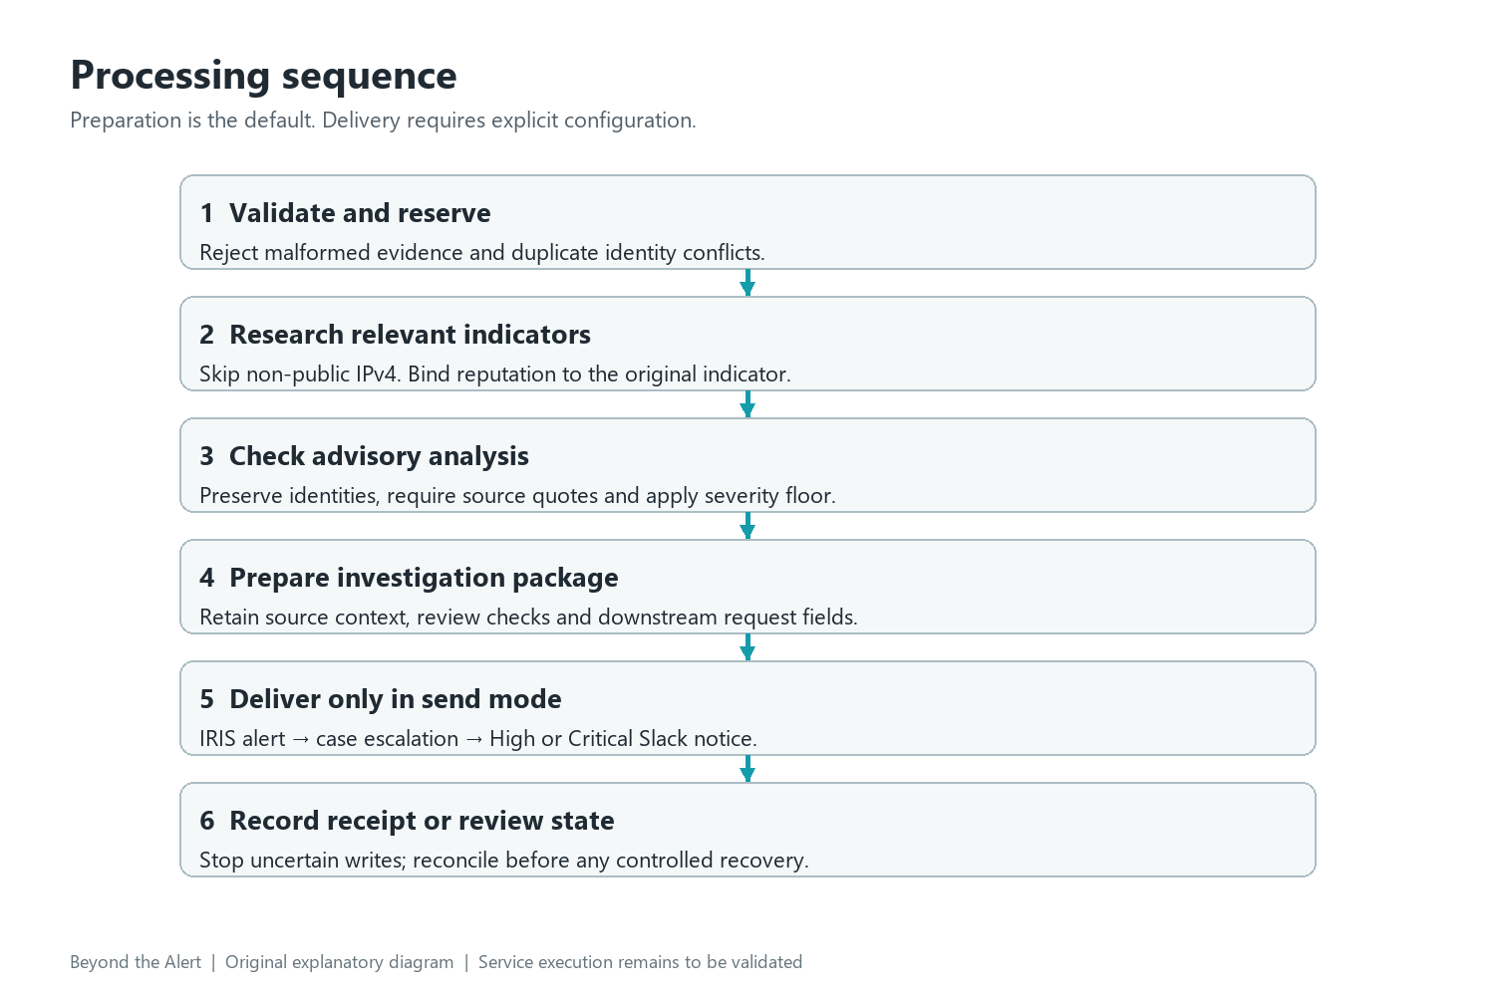
Figure 2. Processing order generated from the implemented design. Each attempt is recorded before a downstream write. Editable source: assets/sequence.svg.
The worker reserves a source and alert ID before enrichment. An identical repeat returns the saved result. Different content under the same ID becomes a conflict. The file store persists across restarts on one host; it is not a distributed queue or an exactly-once delivery guarantee.
GET lookups have bounded retry behavior. POST writes are attempted once because a timeout can occur after the receiver accepted a request. An uncertain stage remains visible for operator reconciliation rather than being silently replayed.

Research and advisory interpretation

Research the right indicator
A private address identifies a local network asset, not a globally unique internet owner. The workflow records a skipped result for non-public IPv4 instead of sending it to a reputation service. Public IPv4 lookups are bound to the original address; file reports are bound to the exact SHA-256. Provider scores provide context and require interpretation. [9–10]
The current adapter supports IPv4 and SHA-256. IPv6 input is rejected rather than silently treated as a public address. An unknown hash, quota problem or malformed provider response remains an investigation dependency failure. Do not replace private addresses with public examples to create the appearance of a successful lookup.

Check the analysis before using it
The model receives a fixed system contract and serialized evidence as untrusted user content. It has no tools. The response must contain exactly the documented fields, preserve alert and identity values, and quote text that occurs within the referenced evidence. Recommended checks come from an allowlist. Truncated responses and unsupported response-outcome wording are rejected. [13]
Schema, identity and exact-quote controls constrain advisory output. Analysts compare each summary with source events and business context, including unsupported interpretations or prompt-injection attempts. The model drafts investigation context; the analyst determines findings and authorizes actions.
Policy input | Minimum priority
Administrators group SID | High
Encoded PowerShell indicator | High
Abuse score at least 75 or at least 5 malicious hash detections | High
Other accepted scenario | Medium

The policy floor is a transparent lab rule, not a measured detection model. A suggested priority can increase the floor but cannot lower it. Review thresholds and false positives using representative telemetry before operational deployment.

Worked example from account evidence
The synthetic example records account creation and a later Administrators membership change on JAYANTH-LAB-01. The subject is lab-user; the initiating identity is lab-operator. Confirm the actual JSON references before accepting an interpretation.
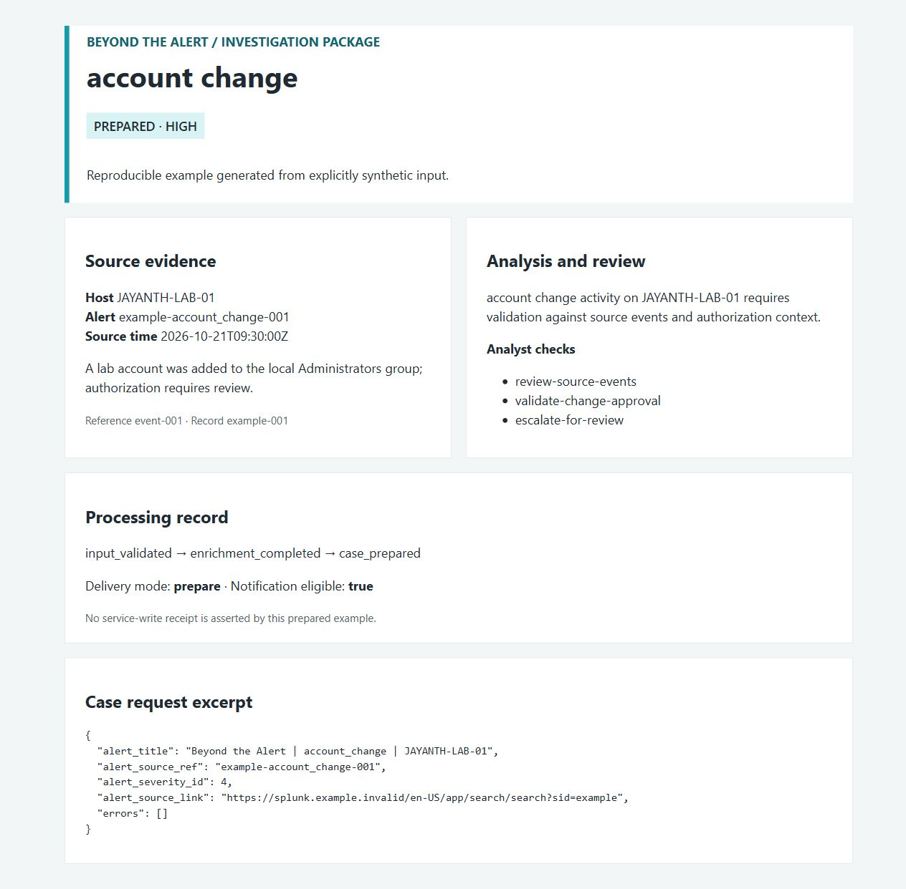
Figure 3. Browser capture of the generated account-change package using a reproducible synthetic input and deterministic provider substitutes. This example finishes in prepare mode.
The private source address is skipped for reputation. The Administrators SID raises the priority floor to High. The displayed source record and review checks remain linked to the complete JSON package in examples/outputs/account_change.json. Two source events are present in the input; the view displays the primary membership event.

From findings to a prepared case
A useful case retains enough information for another analyst to continue. The workflow carries the original observation time, host, subject, initiating identity, event references, enrichment and assessment into IRIS context and notes. The prepared title identifies the scenario and host without asserting a confirmed incident.
Prepared field | Purpose
Source reference and HTTPS link | Return to the alert and underlying search.
Observation time and identities | Preserve chronology and actor versus subject.
Evidence and exact quotations | Explain the basis for interpretation.
Priority and review checks | Direct attention without authorizing response.
Processing stages and errors | Show whether preparation or delivery stopped.

Prepared packages and delivery receipts
The published examples finish as prepared: inspectable request fields are ready for review. In configured send mode, the worker validates an IRIS alert ID, attempts escalation, validates a case ID and sends an eligible Slack notification. A downstream error produces needs_review and preserves earlier receipts. [11–12]
This version retains indicators in case context and notes. Structured IRIS IOC and asset arrays are empty; typed import is a future mapping milestone with its own contract and service checks.

Prioritize analyst attention
High and Critical findings are eligible for Slack; Medium findings still receive a case in send mode but no Slack notice. The message includes host, summary, source time, review checks and investigation link. It escapes untrusted markup and disables link previews. The analyst must validate the source, authorization and likely impact before deciding the next action.
A validated case receipt records an accepted API operation. The analyst separately checks case completeness, investigation conclusions and response outcomes. Capture the linked service trace to verify the delivery path before reporting it as an executed lab result.

Investigation and response decisions
For the account-change example, the central question is authorization. Check the account owner and approved change record, identify the initiating logon, and correlate later privilege use or process execution. A suspicious combination matters more than an isolated priority label.
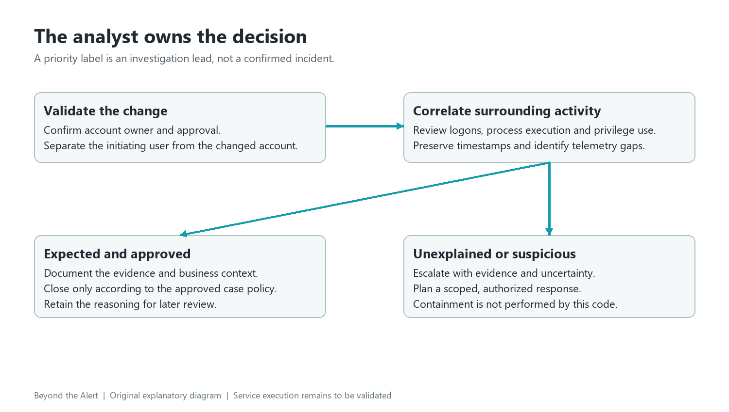
Figure 4. Analyst decision path. Both closure and escalation require documented reasoning. Editable source: assets/analyst-decision.svg.

Preserve uncertainty and scope
If the change is expected and follow-on activity matches the approved purpose, document that evidence and close according to policy. If the change is unexplained or followed by suspicious execution, preserve relevant records and escalate with the affected identities, host scope and remaining questions.
Response planning identifies business impact, evidence locations, approvals and recovery checks. Endpoint isolation, account restriction and credential rotation require authorized runbooks and separate response tooling. This implementation supplies investigation context for that decision.
This is the practical Incident Responder and L2 value: separate actor from subject, correlate multiple records, interpret research in context, explain prioritization, preserve evidence and propose a justified response. The repository supports demonstrating those decisions without relying on a presenter to fill gaps.

Implementation verification and integration status
The recorded Node.js 24.19.0 run passes 94 behavioral checks covering input handling, protected identities, bounded transport, duplicate handling and visible failures. Five synthetic scenarios use substituted external adapters. Full TAP results and source hashes are included in reports/. [14]
Area | Verified behavior
Input | Required fields, event IDs, thresholds, clocks, addresses and hashes.
Analysis | Schema, protected identities, exact quotations and allowed review actions.
Transport | Timeout, response bound, redirect rejection and bounded retry behavior.
Delivery | Duplicate suppression, identity conflicts and visible partial failures.
Worker | Real loopback HTTP authentication, minimal receipts and malformed JSON.
Workflow | Connected inactive graph and execution of generated validation code.
Examples | Five reproducible investigation inputs and packages.

Service integration checklist
Next, import the export into a pinned n8n service, execute SPL against a deployed index and validate actual model, reputation, IRIS and Slack contracts. Record trusted TLS configuration, provider quotas, live case receipts and end-to-end timing together. These service checks are pending; the current recorded suite uses provider substitutes.
The main README includes lab artifacts and reported evaluation with their source records. Those historical views complement the current implementation examples and local checks; their timing and quality scores retain the original study scope.

Collect the next evidence deliberately
Use one run ID to connect source records, mapped alert, n8n execution, worker stages, provider receipts, IRIS case ID and Slack timestamp. Preserve UTC times and versions; redact secrets transparently. Record successful operations, deliberate failures and recovery checks in the same validation record.

Setup priorities and practical value

Start with reproducible examples
From the repository root, run node scripts/build.mjs, node scripts/demo.mjs, node --test tests/core.test.mjs and node scripts/check.mjs. No runtime packages are required. Open the generated HTML views beside their JSON inputs and compare expected fields, priority and processing stages.

Configure services in a controlled lab
Copy .env.example to an untracked .env. Use approved secrets and least-privilege access. Keep delivery set to prepare. Start the worker with node --env-file=.env src/server.mjs, protect its persistent state, and configure a trusted HTTPS proxy. Prepare mode avoids case and message writes but still calls configured research and model services; the example command substitutes all of them.
Import the inactive workflow into a test n8n instance, bind distinct intake and worker Header Auth credentials, and replace the explicit worker URL placeholder. Validate the Splunk mapping step, provider contracts, IRIS severity/customer IDs and Slack bot membership. Restrict execution-history access and retention.
Priority | Next deliverable
1 | Pinned service versions and a correlated successful and failing integration trace.
2 | Representative telemetry for detection baselines, false-positive review and field mapping.
3 | Transactional shared state, explicit recovery and duplicate reconciliation.
4 | IPv6 support, structured IOC mapping and a defined analyst-usefulness evaluation.

The operational value is a repeatable investigation handoff with inspectable source context and visible uncertainty. That is valuable even before measuring speed. Measure any future improvement with defined start and end points, comparable cases and documented review quality; do not infer it from a shorter workflow diagram.
A technical walkthrough can reproduce one example, trace a failure path and identify the next service boundary to validate. This connects the implementation with investigation reasoning and operational tradeoffs.

Conclusion and references
Beyond the Alert implements a reviewable path from alert evidence to prepared investigation context. Its strongest release evidence is reproducible behavior, preserved identities and explicit failure handling. The next milestone is a correlated service-connected validation run. Analyst judgment remains central to authorization, escalation and response.

Essential glossary
Term | Meaning in this project
SOC and SIEM | Security Operations Center; a platform that collects and searches security events.
SOAR and n8n | Security orchestration and automation; n8n routes the authenticated workflow.
IRIS and IOC | DFIR-IRIS case management; an indicator of compromise such as an address or hash.
SPL and SHA-256 | Splunk search language; a fixed-length cryptographic file digest.
SID and TLS | Windows security identifier; encrypted, certificate-validated transport.

Evidence and technical references
Repository and current release evidence
[1–2] n8n webhook and workflow import
[3] Splunk alert actions
[4–7] Windows audit event documentation
[8] Sysmon documentation
[9] AbuseIPDB API
[10] VirusTotal file report API
[11] DFIR-IRIS alert API
[12] Slack message API
[13] Model request API
[14] Node.js test runner
Full event-specific links are in docs/references.md. Figures 1, 2 and 4 are original explanatory diagrams; Figure 3 is a browser capture of an actual generated synthetic output. The unchanged explanation video is conceptual. Documentation date: 21 October 2026.

