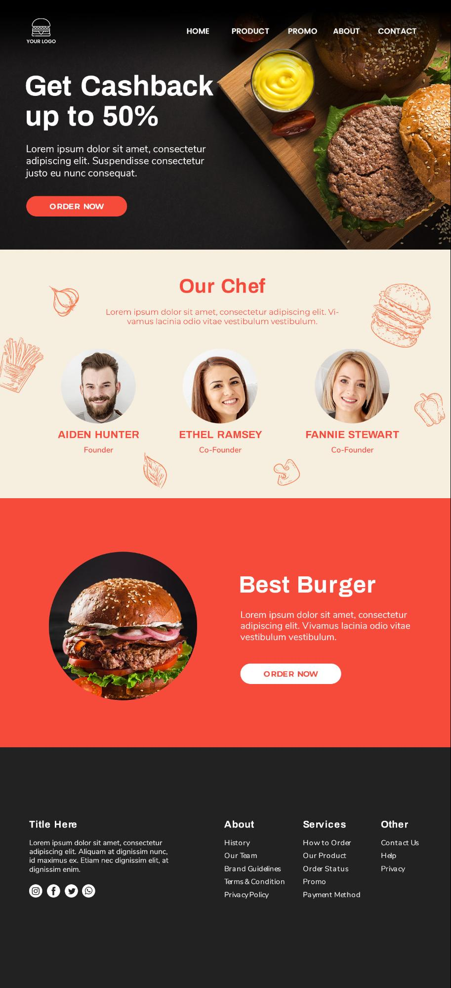

**HOME**

**PRODUCT**

**PROMO**

**ABOUT**

**CONTACT**

**YOUR LOGO**

**Get Cashback up to 50%**

Lorem ipsum dolor sit amet, consectetur adipiscing elit. Suspendisse consectetur justo eu nunc consequat.

ORDER NOW

Our Chef

Lorem ipsum dolor sit amet, consectetur adipiscing elit. Vi

vamus lacinia odio vitae vestibulum vestibulum.

AIDEN HUNTER

ETHEL RAMSEY

FANNIE STEWART

Co-Founder

Founder

Co-Founder

Best Burger

Lorem ipsum dolor sit amet, consectetur adipiscing elit. Vivamus lacinia odio vitae vestibulum vestibulum.

**ORDER NOW**

**Title Here**

**About**

**Services**

**Other**

How to Order

Lorem ipsum dolor sit amet, consectetur adipiscing elit. Aliquam at dignissim nunc, id maximus ex. Etiam nec dignissim elit, at dignissim enim.

History Our Team Brand Guidelines

Our Product

Contact Us Help Privacy

Order Status

Terms & Condition

Promo

Privacy Policy

Payment Method