TABLE OF CONTENTS
1. Cover Page 1
2. Certificate 2
3. Declaration 3
4. Acknowledgement 4
5. Abstract 6
6. List of Figures / List of Tables / Acronyms 7
7. Introduction 9
8. System Analysis 11
9. Database Design 13
10. ER Diagram 15
11. Relational Schema 16
12. Table Design 17
13. Normalization 21
14. SQL Implementation 23
15. SQL Queries & Screenshots 28
16. Conclusion & Future Enhancements 33
17. References 35

ABSTRACT
The Hospital Management System is a database-based system designed to organize and manage hospital information in a centralized relational database. The project stores information related to departments, patients, doctors, appointments, medical records, medicines, prescriptions, billing, rooms, and staff.
The system uses Primary Keys and Foreign Keys to connect related tables and constraints to maintain valid data. SQL implementation demonstrates DDL, DML, DQL, joins, aggregate functions, subqueries, views, indexes, transactions, and CRUD operations. Normalization up to 3NF is included to reduce redundancy and improve consistency.

LIST OF FIGURES
Figure 1. ER Diagram of the Hospital Management Database System

LIST OF TABLES
Table 1. Major Database Entities
Table 2. Entity Relationships and Cardinality
Table 3. Relational Schema Summary
Table 4. Department Table Structure
Table 5. Patient Table Structure
Table 6. Medicine Table Structure
Table 7. Rooms Table Structure
Table 8. Doctor Table Structure
Table 9. Appointment Table Structure
Table 10. Medical Records Table Structure
Table 11 .Staff Table Structure
Table 12. Prescription Table Structure
Table 13. Billing Table Structure
Table 14. Keys and Constraints Summary

ACRONYMS
- DBMS – Database Management System
- ER – Entity Relationship
- SQL – Structured Query Language
- DDL – Data Definition Language
- DML – Data Manipulation Language
- DQL – Data Query Language
- DCL – Data Control Language
- TCL – Transaction Control Language
- PK – Primary Key
- FK – Foreign Key
- 1NF – First Normal Form
- 2NF – Second Normal Form
- 3NF – Third Normal Form

1. INTRODUCTION
Hospitals handle large amounts of information related to patients, doctors, departments, appointments, medical records, medicines, prescriptions, billing, rooms, and staff. A relational database provides a structured way to store and manage these interconnected records.

1.1 Objectives
- Maintain patient and doctor information.
- Manage departments and department associations.
- Store patient-doctor appointments.
- Maintain diagnosis and treatment records.
- Manage medicines and prescriptions.
- Maintain billing information.
- Manage rooms and room availability.
- Store hospital staff information.
- Reduce data redundancy and maintain data integrity.
- Support fast retrieval through SQL queries.

1.2 Scope
The scope covers patient, doctor, department, appointment, medical record, medicine, prescription, billing, room, and staff management.

2. SYSTEM ANALYSIS

2.1 Existing System
- Manual or separate-file record keeping.
- Time-consuming searches.
- Duplicate or inconsistent information.
- Difficulty generating consolidated reports.

2.2 Proposed System
- Centralized relational database.
- Ten related entities with PK/FK relationships.
- NOT NULL, UNIQUE, CHECK, and DEFAULT constraints.
- SQL-based retrieval, reporting, joins, aggregation, and views.

2.3 Functional Requirements
Module | Requirement
Patient | Store and manage patient details.
Doctor | Store doctor details and specialization.
Department | Maintain department information.
Appointment | Maintain patient-doctor appointment details.
Medical Record | Store diagnosis, treatment, and record date.
Medicine | Store medicine details, quantity, and price.
Prescription | Store medicine dosage and duration.
Billing | Maintain patient billing information.
Room | Maintain room type, charge, and availability.
Staff | Store staff details and department association.

3. DATABASE DESIGN

3.1 Major Entities
Entity | Description
Department | Department details and hospital location.
Patient | Patient personal and contact details.
Doctor | Doctor profile and specialization.
Appointment | Patient-doctor appointment records.
Medical_Record | Patient diagnosis and treatment records.
Medicine | Medicine details, quantity, and price.
Prescription | Prescription and dosage records.
Billing | Patient billing information.
Room | Room details and availability.
Staff | Staff details and department association.

3.2 Relationships and Cardinality
Relationship | Cardinality | Meaning
Department–Doctor | 1:M | One department can have many doctors.
Department–Room | 1:M | One department can have many rooms.
Department–Staff | 1:M | One department can have many staff members.
Patient–Appointment | 1:M | One patient can have many appointments.
Doctor–Appointment | 1:M | One doctor can have many appointments.
Patient–Medical_Record | 1:M | One patient can have many medical records.
Doctor–Medical_Record | 1:M | One doctor can create many medical records.
Patient–Prescription | 1:M | One patient can have many prescriptions.
Doctor–Prescription | 1:M | One doctor can issue many prescriptions.
Medicine–Prescription | 1:M | One medicine can appear in many prescriptions.
Patient–Billing | 1:M | One patient can have many bills.

4. ER DIAGRAM
The ER diagram is intentionally left as an editable placeholder. Insert your final software-generated ER diagram in the box below. Keep this page for the final submission.
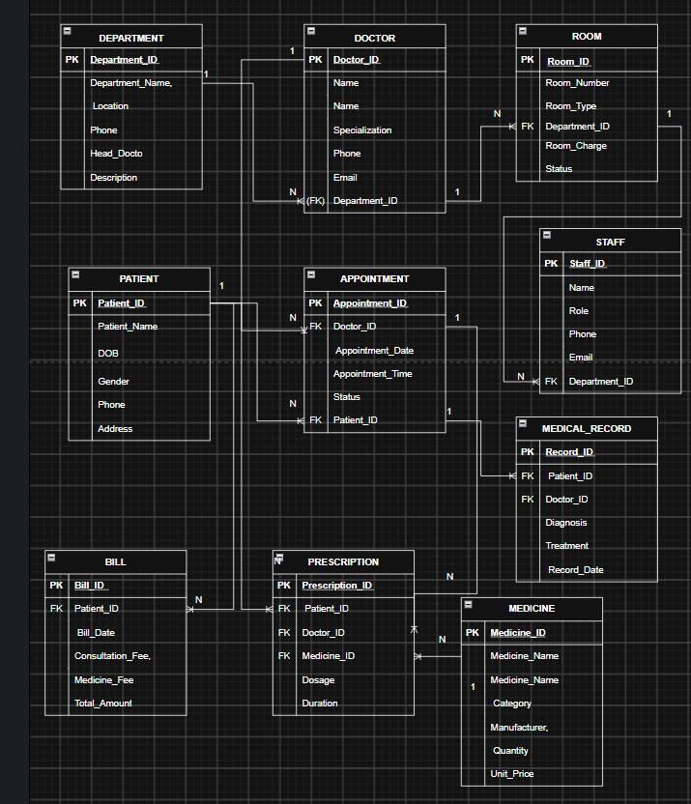
Suggested entities: Department, Patient, Doctor, Appointment, Medical_Record, Medicine, Prescription, Billing, Room, Staff. Show PK, FK and 1:M relationships.
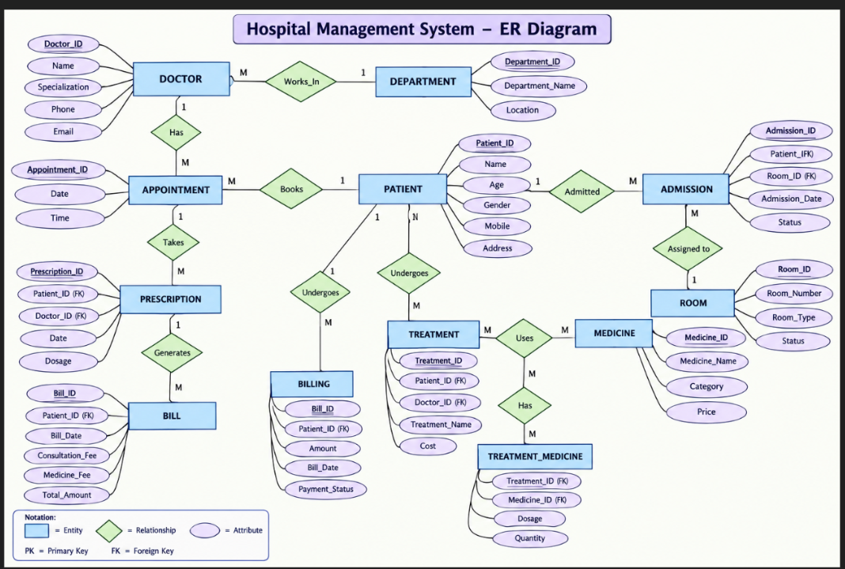

5. RELATIONAL SCHEMA
Relation | Schema | Keys
Department | Department(Department_ID, Department_Name, Location, Phone, Head_Doctor, Description) | PK: Department_ID
Patient | Patient(Patient_ID, Patient_Name, DOB, Gender, Phone, Address) | PK: Patient_ID
Doctor | Doctor(Doctor_ID, Doctor_Name, Specialization, Phone, Email, Department_ID) | PK: Doctor_ID; FK: Department_ID
Appointment | Appointment(Appointment_ID, Patient_ID, Doctor_ID, Appointment_Date, Appointment_Time, Status) | PK: Appointment_ID; FK: Patient_ID, Doctor_ID
Medical_Record | Medical_Record(Record_ID, Patient_ID, Doctor_ID, Diagnosis, Treatment, Record_Date) | PK: Record_ID; FK: Patient_ID, Doctor_ID
Medicine | Medicine(Medicine_ID, Medicine_Name, Category, Manufacturer, Quantity, Unit_Price) | PK: Medicine_ID
Prescription | Prescription(Prescription_ID, Patient_ID, Doctor_ID, Medicine_ID, Dosage, Duration) | PK: Prescription_ID; FK: Patient_ID, Doctor_ID, Medicine_ID
Billing | Billing(Bill_ID, Patient_ID, Bill_Date, Consultation_Fee, Medicine_Fee, Total_Amount) | PK: Bill_ID; FK: Patient_ID
Room | Room(Room_ID, Room_Number, Room_Type, Department_ID, Room_Charge, Status) | PK: Room_ID; FK: Department_ID
Staff | Staff(Staff_ID, Staff_Name, Role, Phone, Email, Department_ID) | PK: Staff_ID; FK: Department_ID

6. TABLE DESIGN

6.1 Department Table
Attribute | Data Type | Constraint
Department_ID | INT | PK
Department_Name | VARCHAR(100) | NOT NULL, UNIQUE
Location | VARCHAR(100)
Phone | VARCHAR(15)
Head_Doctor | VARCHAR(100)
Description | VARCHAR(255)

6.2 Patient Table
Attribute | Data Type | Constraint
Patient_ID | INT | PK
Patient_Name | VARCHAR(100) | NOT NULL
DOB | DATE | NOT NULL
Gender | VARCHAR(10) | CHECK
Phone | VARCHAR(15) | UNIQUE
Address | VARCHAR(255)

6.3 Doctor Table
Attribute | Data Type | Constraint
Doctor_ID | INT | PK
Doctor_Name | VARCHAR(100) | NOT NULL
Specialization | VARCHAR(100)
Phone | VARCHAR(15) | UNIQUE
Email | VARCHAR(100) | UNIQUE
Department_ID | INT | FK

6.4 Appointment Table
Attribute | Data Type | Constraint
Appointment_ID | INT | PK
Patient_ID | INT | FK
Doctor_ID | INT | FK
Appointment_Date | DATE | NOT NULL
Appointment_Time | TIME | NOT NULL
Status | VARCHAR(20) | DEFAULT

6.5 Medical_Record Table
Attribute | Data Type | Constraint
Record_ID | INT | PK
Patient_ID | INT | FK
Doctor_ID | INT | FK
Diagnosis | VARCHAR(255)
Treatment | VARCHAR(255)
Record_Date | DATE | NOT NULL

6.6 Medicine Table
Attribute | Data Type | Constraint
Medicine_ID | INT | PK
Medicine_Name | VARCHAR(100) | NOT NULL
Category | VARCHAR(100)
Manufacturer | VARCHAR(100)
Quantity | INT | CHECK >= 0
Unit_Price | DECIMAL(10,2) | CHECK >= 0

6.7 Prescription Table
Attribute | Data Type | Constraint
Prescription_ID | INT | PK
Patient_ID | INT | FK
Doctor_ID | INT | FK
Medicine_ID | INT | FK
Dosage | VARCHAR(100)
Duration | VARCHAR(50)

6.8 Billing Table
Attribute | Data Type | Constraint
Bill_ID | INT | PK
Patient_ID | INT | FK
Bill_Date | DATE | NOT NULL
Consultation_Fee | DECIMAL(10,2) | DEFAULT 0
Medicine_Fee | DECIMAL(10,2) | DEFAULT 0
Total_Amount | DECIMAL(10,2)

6.9 Room Table
Attribute | Data Type | Constraint
Room_ID | INT | PK
Room_Number | VARCHAR(20) | NOT NULL, UNIQUE
Room_Type | VARCHAR(50)
Department_ID | INT | FK
Room_Charge | DECIMAL(10,2)
Status | VARCHAR(20) | DEFAULT
Dosage | VARCHAR(100)
Duration | VARCHAR(50)

6.10 Staff Table
Attribute | Data Type | Constraint
Staff_ID | INT | PK
Staff_Name | VARCHAR(100)
Role | VARCHAR(50)
Phone | VARCHAR(15) | UNIQUE
Email | VARCHAR(100) | UNIQUE
Department_ID | INT | FK

7. NORMALIZATION
Normalization organizes data into related tables to reduce redundancy and update anomalies.
Form | Main Idea | Project Application
UNF | Combined/repeating information may exist. | Large combined hospital record.
1NF | Atomic values and no repeating groups. | Separate rows and atomic attributes.
2NF | Remove partial dependencies. | Separate entity-specific information.
3NF | Remove transitive dependencies. | Ten related normalized tables.

7.1 Project Result
The final design separates Department, Patient, Doctor, Appointment, Medical_Record, Medicine, Prescription, Billing, Room, and Staff so that entity-specific information is stored in the appropriate table.

8. SQL IMPLEMENTATION
The SQL implementation below is exactly as executed against the hospital_management_db database. Tables are created in an order that satisfies every Foreign Key dependency: DEPARTMENT, PATIENT, and MEDICINE first (no dependencies), followed by ROOM and DOCTOR (depend on DEPARTMENT), and finally APPOINTMENT, ADMISSION, TREATMENT, PRESCRIPTION, and BILLING, which depend on the tables created before them.

9.1 DDL – Data Definition Language
DDL defines database and table structures using commands such as CREATE and ALTER.
CREATE DATABASE Hospital_Management_System;
USE Hospital_Management_System;

CREATE TABLE Department (
Department_ID INT PRIMARY KEY,
Department_Name VARCHAR(100) NOT NULL UNIQUE,
Location VARCHAR(100),
Phone VARCHAR(15),
Head_Doctor VARCHAR(100),
Description VARCHAR(255)
);

CREATE TABLE Patient (
Patient_ID INT PRIMARY KEY,
Patient_Name VARCHAR(100) NOT NULL,
DOB DATE NOT NULL,
Gender VARCHAR(10) CHECK (Gender IN ('Male','Female','Other')),
Phone VARCHAR(15) UNIQUE,
Address VARCHAR(255)
);

CREATE TABLE Doctor (
Doctor_ID INT PRIMARY KEY,
Doctor_Name VARCHAR(100) NOT NULL,
Specialization VARCHAR(100),
Phone VARCHAR(15) UNIQUE,
Email VARCHAR(100) UNIQUE,
Department_ID INT,
FOREIGN KEY (Department_ID)
REFERENCES Department(Department_ID)
);

CREATE TABLE Appointment (
Appointment_ID INT PRIMARY KEY,
Patient_ID INT NOT NULL,
Doctor_ID INT NOT NULL,
Appointment_Date DATE NOT NULL,
Appointment_Time TIME NOT NULL,
Status VARCHAR(20) DEFAULT 'Scheduled',
FOREIGN KEY (Patient_ID)
REFERENCES Patient(Patient_ID),
FOREIGN KEY (Doctor_ID)
REFERENCES Doctor(Doctor_ID)
);

CREATE TABLE Medical_Record (
Record_ID INT PRIMARY KEY,
Patient_ID INT NOT NULL,
Doctor_ID INT NOT NULL,
Diagnosis VARCHAR(255),
Treatment VARCHAR(255),
Record_Date DATE NOT NULL,
FOREIGN KEY (Patient_ID)
REFERENCES Patient(Patient_ID),
FOREIGN KEY (Doctor_ID)
REFERENCES Doctor(Doctor_ID)
);

CREATE TABLE Medicine (
Medicine_ID INT PRIMARY KEY,
Medicine_Name VARCHAR(100) NOT NULL,
Category VARCHAR(100),
Manufacturer VARCHAR(100),
Quantity INT CHECK (Quantity >= 0),
Unit_Price DECIMAL(10,2) CHECK (Unit_Price >= 0)
);

CREATE TABLE Prescription (
Prescription_ID INT PRIMARY KEY,
Patient_ID INT NOT NULL,
Doctor_ID INT NOT NULL,
Medicine_ID INT NOT NULL,
Dosage VARCHAR(100),
Duration VARCHAR(50),
FOREIGN KEY (Patient_ID)
REFERENCES Patient(Patient_ID),

FOREIGN KEY (Doctor_ID)
REFERENCES Doctor(Doctor_ID),
FOREIGN KEY (Medicine_ID)
REFERENCES Medicine(Medicine_ID)
);

CREATE TABLE Billing (
Bill_ID INT PRIMARY KEY,
Patient_ID INT NOT NULL,
Bill_Date DATE NOT NULL,
Consultation_Fee DECIMAL(10,2) DEFAULT 0,
Medicine_Fee DECIMAL(10,2) DEFAULT 0,
Total_Amount DECIMAL(10,2),
FOREIGN KEY (Patient_ID)
REFERENCES Patient(Patient_ID)
);

CREATE TABLE Room (
Room_ID INT PRIMARY KEY,
Room_Number VARCHAR(20) NOT NULL UNIQUE,
Room_Type VARCHAR(50),
Department_ID INT,
Room_Charge DECIMAL(10,2),
Status VARCHAR(20) DEFAULT 'Available',
FOREIGN KEY (Department_ID)
REFERENCES Department(Department_ID)
);

CREATE TABLE Staff (
Staff_ID INT PRIMARY KEY,
Staff_Name VARCHAR(100) NOT NULL,
Role VARCHAR(50),
Phone VARCHAR(15) UNIQUE,
Email VARCHAR(100) UNIQUE,
Department_ID INT,
FOREIGN KEY (Department_ID)
REFERENCES Department(Department_ID)
);

ALTER TABLE Patient
ADD Email VARCHAR(100);

ALTER TABLE Patient
MODIFY Phone VARCHAR(20);

CREATE VIEW Patient_Appointment_View AS
SELECT
p.Patient_ID,
p.Patient_Name,
d.Doctor_Name,
a.Appointment_Date,
a.Appointment_Time,
a.Status
FROM Patient p
JOIN Appointment a
ON p.Patient_ID = a.Patient_ID
JOIN Doctor d
ON a.Doctor_ID = d.Doctor_ID;

CREATE INDEX idx_patient_name
ON Patient(Patient_Name);

CREATE INDEX idx_medicine_name
ON Medicine(Medicine_Name);

CREATE TABLE Patient_Hospital_UNF (
Patient_ID INT,
Patient_Name VARCHAR(100),
Doctor_ID INT,
Doctor_Name VARCHAR(100),
Department_ID INT,
Department_Name VARCHAR(100),
Medicine_ID INT,
Medicine_Name VARCHAR(100),
Dosage VARCHAR(100)
);

CREATE TABLE Patient_1NF (
Patient_ID INT,
Patient_Name VARCHAR(100),
Doctor_ID INT,
Doctor_Name VARCHAR(100),
Department_ID INT,
Department_Name VARCHAR(100),
Medicine_ID INT,
Medicine_Name VARCHAR(100),
Dosage VARCHAR(100),
PRIMARY KEY (Patient_ID, Medicine_ID)
);

CREATE TABLE Patient_2NF (
Patient_ID INT PRIMARY KEY,
Patient_Name VARCHAR(100)
);

CREATE TABLE Medicine_2NF (
Medicine_ID INT PRIMARY KEY,
Medicine_Name VARCHAR(100)
);

CREATE TABLE Prescription_2NF (
Patient_ID INT,
Medicine_ID INT,
Dosage VARCHAR(100),
PRIMARY KEY (Patient_ID, Medicine_ID),
FOREIGN KEY (Patient_ID)
REFERENCES Patient_2NF(Patient_ID),
FOREIGN KEY (Medicine_ID)
REFERENCES Medicine_2NF(Medicine_ID)
);

CREATE TABLE Department_3NF (
Department_ID INT PRIMARY KEY,
Department_Name VARCHAR(100)
);

CREATE TABLE Doctor_3NF (
Doctor_ID INT PRIMARY KEY,
Doctor_Name VARCHAR(100),
Department_ID INT,
FOREIGN KEY (Department_ID)
REFERENCES Department_3NF(Department_ID)
);

CREATE TABLE Patient_3NF (
Patient_ID INT PRIMARY KEY,
Patient_Name VARCHAR(100),
Doctor_ID INT,
FOREIGN KEY (Doctor_ID)
REFERENCES Doctor_3NF(Doctor_ID)
);

8.2 DML – Data Manipulation Language
DML is used to add, modify, and remove records using INSERT, UPDATE, and DELETE.
INSERT INTO Department VALUES
(1,'Cardiology','Block A','9876543210','Dr. Ravi','Heart related treatment'),
(2,'Neurology','Block B','9876543211','Dr. Kumar','Brain and nervous system'),
(3,'Orthopedics','Block C','9876543212','Dr. Priya','Bone and joint treatment'),
(4,'General Medicine','Block D','9876543213','Dr. Anil','General treatment');

INSERT INTO Patient VALUES
(101,'Rahul','2002-05-15','Male','9000000001','Kakinada'),
(102,'Sneha','2003-08-20','Female','9000000002','Rajahmundry'),
(103,'Arjun','2001-11-10','Male','9000000003','Amalapuram'),
(104,'Divya','2004-02-25','Female','9000000004','Vizag'),
(105,'Kiran','2000-06-18','Male','9000000005','Vijayawada');

INSERT INTO Doctor VALUES
(201,'Dr. Ravi','Cardiologist','9100000001','ravi@gmail.com',1),
(202,'Dr. Kumar','Neurologist','9100000002','kumar@gmail.com',2),
(203,'Dr. Priya','Orthopedic','9100000003','priya@gmail.com',3),
(204,'Dr. Anil','General Physician','9100000004','anil@gmail.com',4);

INSERT INTO Appointment VALUES
(301,101,201,'2026-09-15','10:00:00','Scheduled'),
(302,102,202,'2026-09-15','11:00:00','Scheduled'),
(303,103,203,'2026-09-16','10:30:00','Completed'),
(304,104,204,'2026-09-17','12:00:00','Scheduled'),
(305,105,201,'2026-09-18','09:30:00','Cancelled');

INSERT INTO Medical_Record VALUES
(401,101,201,'Chest Pain','ECG and Medication','2026-09-10'),
(402,102,202,'Headache','Medication and Rest','2026-09-11'),
(403,103,203,'Fracture','Plaster Treatment','2026-09-12'),
(404,104,204,'Fever','Medicines','2026-09-13');

INSERT INTO Medicine VALUES
(501,'Paracetamol','Tablet','ABC Pharma',100,5.00),
(502,'Amoxicillin','Capsule','XYZ Pharma',80,10.00),
(503,'Aspirin','Tablet','ABC Pharma',60,8.00),
(504,'Ibuprofen','Tablet','PQR Pharma',75,12.00);

INSERT INTO Prescription VALUES
(601,101,201,503,'1 tablet daily','5 days'),
(602,102,202,501,'1 tablet twice daily','3 days'),
(603,103,203,504,'1 tablet daily','7 days'),
(604,104,204,502,'1 capsule twice daily','5 days');

INSERT INTO Billing VALUES
(701,101,'2026-09-10',500,40,540),
(702,102,'2026-09-11',400,30,430),
(703,103,'2026-09-12',600,84,684),
(704,104,'2026-09-13',300,50,350);

INSERT INTO Room VALUES
(801,'A101','General',1,1000,'Occupied'),
(802,'B201','ICU',2,3000,'Available'),
(803,'C301','General',3,1200,'Occupied'),
(804,'D401','Private',4,2000,'Available');

INSERT INTO Staff VALUES
(901,'Ramesh','Nurse','9200000001','ramesh@gmail.com',1),
(902,'Sita','Receptionist','9200000002','sita@gmail.com',2),
(903,'Mohan','Nurse','9200000003','mohan@gmail.com',3),
(904,'Lakshmi','Pharmacist','9200000004','lakshmi@gmail.com',4);

UPDATE Patient
SET Address = 'Hyderabad'
WHERE Patient_ID = 101;

UPDATE Medicine
SET Unit_Price = 6.00
WHERE Medicine_ID = 501;

DELETE FROM Appointment
WHERE Appointment_ID = 305;

8.3 DQL – Data Query Language
DQL retrieves records using SELECT, WHERE, ORDER BY, DISTINCT, LIKE, BETWEEN, IN, GROUP BY, HAVING, joins, subqueries, and aggregate functions.
SELECT * FROM Patient;

SELECT * FROM Doctor;

SELECT * FROM Department;

SELECT * FROM Appointment;

SELECT * FROM Medical_Record;

SELECT * FROM Medicine;

SELECT * FROM Prescription;

SELECT * FROM Billing;

SELECT * FROM Room;

SELECT * FROM Staff;

SELECT *
FROM Patient
WHERE Gender = 'Female';

SELECT *
FROM Medicine
WHERE Unit_Price > 8;

SELECT *
FROM Doctor
WHERE Specialization = 'Cardiologist';

SELECT *
FROM Patient
ORDER BY Patient_Name ASC;

SELECT *
FROM Medicine
ORDER BY Unit_Price DESC;

SELECT DISTINCT Specialization
FROM Doctor;

SELECT DISTINCT Room_Type
FROM Room;

SELECT *
FROM Patient
WHERE Patient_Name LIKE 'A%';

SELECT *
FROM Doctor
WHERE Doctor_Name LIKE 'Dr.%';

SELECT *
FROM Medicine
WHERE Unit_Price BETWEEN 5 AND 10;

SELECT *
FROM Patient
WHERE Gender IN ('Male','Female');

SELECT COUNT(*) AS Total_Patients
FROM Patient;

SELECT COUNT(*) AS Total_Doctors
FROM Doctor;

SELECT AVG(Unit_Price) AS Average_Medicine_Price
FROM Medicine;

SELECT MAX(Unit_Price) AS Maximum_Price
FROM Medicine;

SELECT MIN(Unit_Price) AS Minimum_Price
FROM Medicine;

SELECT SUM(Total_Amount) AS Total_Hospital_Collection
FROM Billing;

SELECT Gender, COUNT(*) AS Number_Of_Patients
FROM Patient
GROUP BY Gender;

SELECT Status, COUNT(*) AS Number_Of_Appointments
FROM Appointment
GROUP BY Status;

SELECT Status, COUNT(*) AS Total
FROM Appointment
GROUP BY Status
HAVING COUNT(*) > 1;

SELECT
d.Doctor_ID,
d.Doctor_Name,
d.Specialization,
dp.Department_Name
FROM Doctor d
INNER JOIN Department dp
ON d.Department_ID = dp.Department_ID;

SELECT
p.Patient_Name,
d.Doctor_Name,
a.Appointment_Date,
a.Appointment_Time,
a.Status
FROM Appointment a
INNER JOIN Patient p
ON a.Patient_ID = p.Patient_ID
INNER JOIN Doctor d
ON a.Doctor_ID = d.Doctor_ID;

SELECT
p.Patient_Name,
d.Doctor_Name,
m.Diagnosis,
m.Treatment,
m.Record_Date
FROM Medical_Record m
JOIN Patient p
ON m.Patient_ID = p.Patient_ID
JOIN Doctor d
ON m.Doctor_ID = d.Doctor_ID;

SELECT
p.Patient_Name,
d.Doctor_Name,
me.Medicine_Name,
pr.Dosage,
pr.Duration
FROM Prescription pr
JOIN Patient p
ON pr.Patient_ID = p.Patient_ID
JOIN Doctor d
ON pr.Doctor_ID = d.Doctor_ID
JOIN Medicine me
ON pr.Medicine_ID = me.Medicine_ID;

SELECT
p.Patient_ID,
p.Patient_Name,
a.Appointment_ID,
a.Appointment_Date
FROM Patient p
LEFT JOIN Appointment a
ON p.Patient_ID = a.Patient_ID;

SELECT
d.Doctor_Name,
a.Appointment_ID,
a.Appointment_Date
FROM Appointment a
RIGHT JOIN Doctor d
ON a.Doctor_ID = d.Doctor_ID;

SELECT
p.Patient_Name,
d.Doctor_Name,
dp.Department_Name,
a.Appointment_Date,
a.Status
FROM Patient p
JOIN Appointment a
ON p.Patient_ID = a.Patient_ID
JOIN Doctor d
ON a.Doctor_ID = d.Doctor_ID
JOIN Department dp
ON d.Department_ID = dp.Department_ID;

SELECT *
FROM Medicine
WHERE Unit_Price >
(
SELECT AVG(Unit_Price)
FROM Medicine
);

SELECT Patient_Name
FROM Patient
WHERE Patient_ID IN
(
SELECT Patient_ID
FROM Appointment
);

SELECT p.Patient_Name
FROM Patient p
WHERE EXISTS
(
SELECT 1
FROM Appointment a
WHERE a.Patient_ID = p.Patient_ID
);

SELECT Patient_Name AS Name
FROM Patient
UNION
SELECT Staff_Name AS Name
FROM Staff;

SELECT *
FROM Patient_Appointment_View;

9. SQL QUERIES & SCREENSHOTS
The queries below are grouped by category — CRUD operations, joins, aggregation, a subquery, and a view — followed by additional retrieval queries built on the same schema. A screenshot is provided after each query for the actual MySQL output to be inserted before final submission.

9.1 CRUD Operations
Q1. CREATE — Insert Patient Data
The CREATE operation is used to add new records into the database. In this project, patient details are inserted into the Patient table.
INSERT INTO Patient VALUES
(101,'Rahul','Male','2000-05-10','9876543210','Hyderabad'),
(102,'Sneha','Female','1999-08-15','9876543211','Vizag'),
(103,'Arjun','Male','2001-01-20','9876543212','Vijayawada'),
(104,'Divya','Female','1998-12-05','9876543213','Guntur'),
(105,'Kiran','Male','2000-03-18','9876543214','Kakinada');
Output:
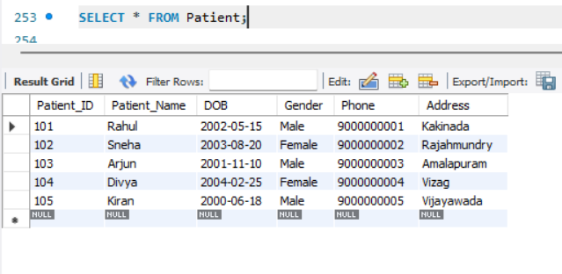

Q2. Read — Display Female Patients
Retrieve Female Patients
This query displays patients whose gender is Female.
SELECT *
FROM Patient
WHERE Gender = 'Female';
Output:
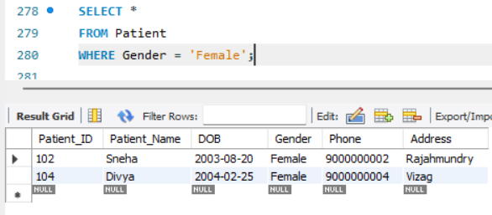
Q3. Update Patient Address
This query changes Rahul's address from Kakinada to Hyderabad.
UPDATE Patient
SET Address = 'Hyderabad'
WHERE Patient_ID = 101;
Output:
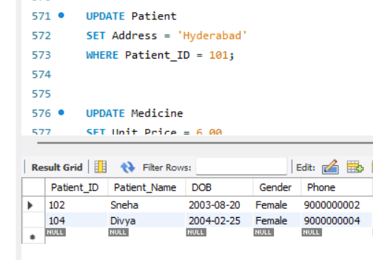

Q4 Delete Cancelled Appointment
This query removes appointment number 305, which has the status Cancelled.
DELETE FROM Appointment
WHERE Appointment_ID = 305;
Output:
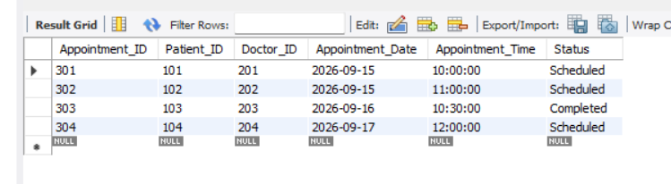

9.2 Joins
Q5. Doctor Details with Department
This query combines the Doctor and Department tables and displays each doctor's department.
SELECT
d.Doctor_ID,
d.Doctor_Name,
d.Specialization,
dp.Department_Name
FROM Doctor d
INNER JOIN Department dp
ON d.Department_ID = dp.Department_ID;
Output:
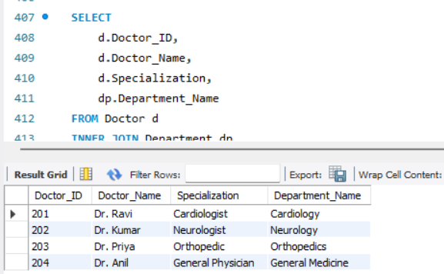

Q6. Patient, Appointment and Doctor Details
This query combines three tables to show which patient has an appointment with which doctor.
SELECT
p.Patient_Name,
d.Doctor_Name,
a.Appointment_Date,
a.Appointment_Time,
a.Status
FROM Appointment a
INNER JOIN Patient p
ON a.Patient_ID = p.Patient_ID
INNER JOIN Doctor d
ON a.Doctor_ID = d.Doctor_ID;
Output:
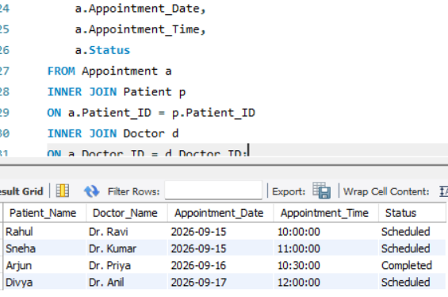

Q7. All Patients with Appointment Details
This query displays all patients and their appointment details. Even patients without appointments would be displayed.
SELECT
p.Patient_ID,
p.Patient_Name,
a.Appointment_ID,
a.Appointment_Date
FROM Patient p
LEFT JOIN Appointment a
ON p.Patient_ID = a.Patient_ID;
Output:
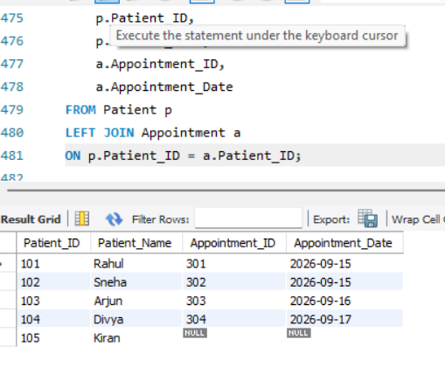

9.3 Aggregation & Grouping
Q8. Count Total Patients
This query counts the total number of patients in the hospital.
SELECT COUNT(*) AS Total_Patients
FROM Patient;
Output:
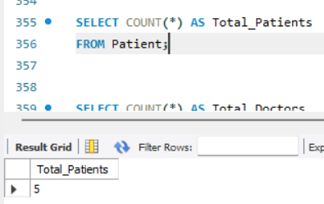
Q9. Appointment Count by Status
This query groups appointments according to their status and counts each group.
SELECT Status, COUNT(*) AS Number_Of_Appointments
FROM Appointment
GROUP BY Status;
Output:
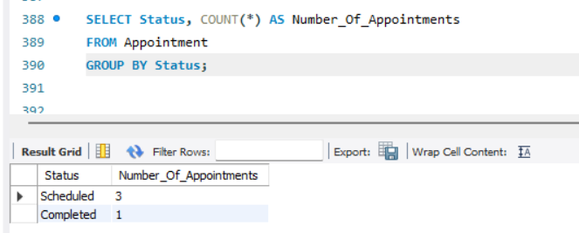

9.4 Subquery
Q10. Medicines Above Average Price
The inner query calculates the average medicine price. The outer query displays medicines whose price is greater than that average.
Average price:
(5 + 10 + 8 + 12) / 4 = 8.75
SELECT *
FROM Medicine
WHERE Unit_Price >
(
SELECT AVG(Unit_Price)
FROM Medicine
);
Output:
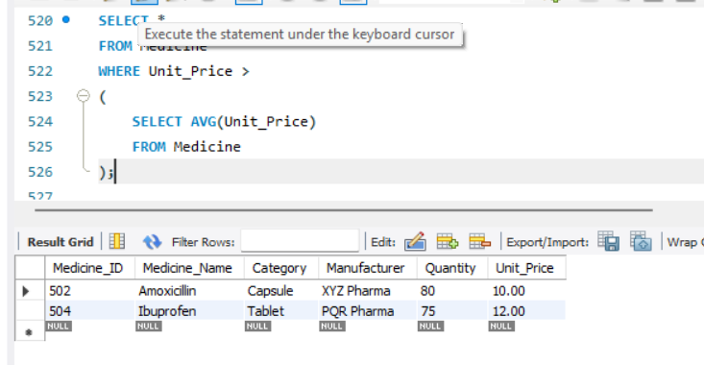

9.5 View
Q11. . Create Patient Appointment View
This query creates a virtual table containing patient, doctor and appointment information.
CREATE VIEW Patient_Appointment_View AS
SELECT
p.Patient_ID,
p.Patient_Name,
d.Doctor_Name,
a.Appointment_Date,
a.Appointment_Time,
a.Status
FROM Patient p
JOIN Appointment a
ON p.Patient_ID = a.Patient_ID
JOIN Doctor d
ON a.Doctor_ID = d.Doctor_ID;

SELECT *
FROM Patient_Appointment_View;
Output:
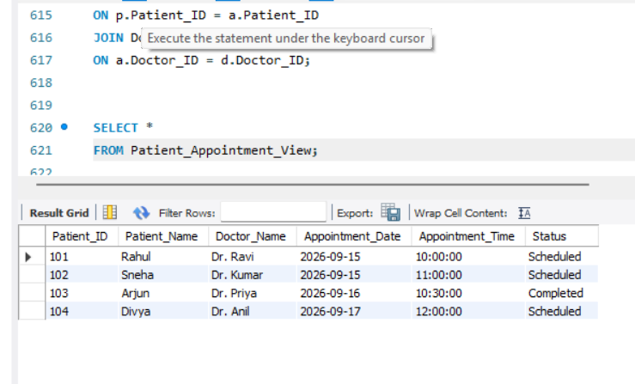

9.6 Additional Queries
Q12. Display All Departments
Displays all department records in the hospital.
SELECT * FROM Department;
Output:
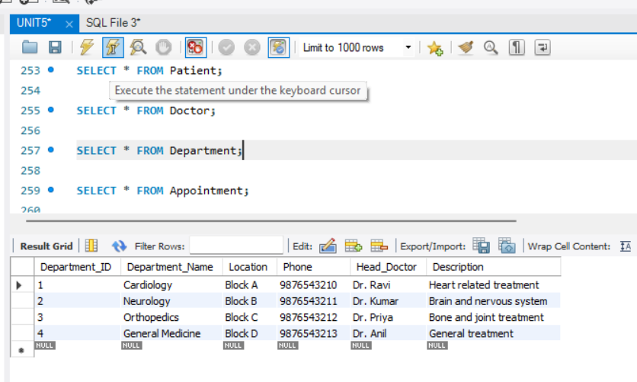
Q13. Doctors with Specialization
Displays doctors whose specialization is Cardiologist.
SELECT *
FROM Doctor
WHERE Specialization = 'Cardiologist';
Output
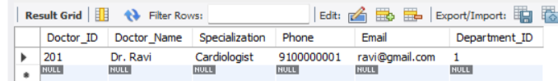

Q14. Available Rooms
Displays all rooms whose status is Available.
SELECT *
FROM Room
WHERE Status = 'Available';
Output:
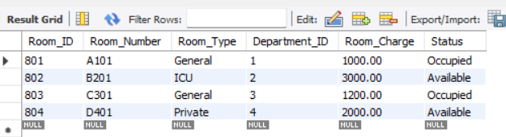
Q15. Who Have Appointments
The inner query finds patient IDs having appointments. The outer query displays their names.
SELECT Patient_Name
FROM Patient
WHERE Patient_ID IN
(
SELECT Patient_ID
FROM Appointment
);
Output:
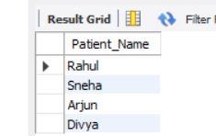

Q16. Total Appointments for Each Doctor
Counts the number of appointments handled by each doctor.
SELECT Doctor_ID, COUNT(*) AS Total_Appointments
FROM Appointment
GROUP BY Doctor_ID;
Q17 . Medicines Priced Above 8
Displays medicines whose unit price is greater than 8.
SELECT *
FROM Medicine
WHERE Unit_Price > 8;
Output:
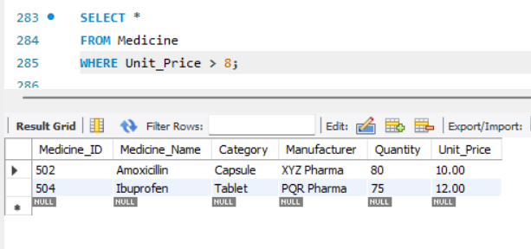
Q18. Patients Using EXISTS
Displays patients for whom at least one appointment exists.
SELECT p.Patient_Name
FROM Patient p
WHERE EXISTS
(
SELECT 1
FROM Appointment a
WHERE a.Patient_ID = p.Patient_ID
);
Output:
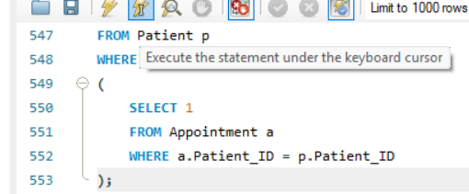
Q19. Combine Patient and Staff Names
SELECT Patient_Name AS Name
FROM Patient
UNION
SELECT Staff_Name AS Name
FROM Staf;Output:
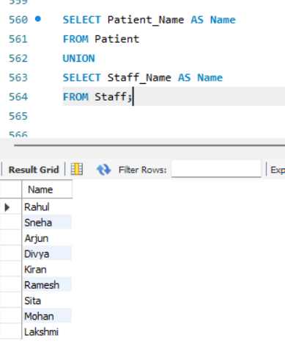

Q20. Total Hospital Collection
SELECT SUM(Total_Amount) AS Total_Hospital_Collection
FROM Billing;
Output:
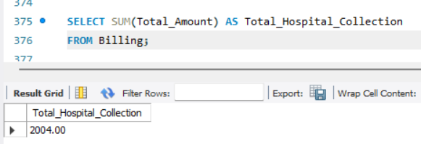

10. CONCLUSION

The Hospital Management System provides a structured relational database for managing core hospital information. Ten related entities are organized using Primary Keys, Foreign Keys, and integrity constraints. Normalization up to 3NF reduces redundancy. The SQL implementation demonstrates database creation, record management, retrieval, joins, aggregation, views, indexes, transactions, and CRUD operations.

12.1 Future Enhancements
- Online appointment scheduling.
- Role-based access.
- Medicine stock alerts and pharmacy inventory.
- Automated reports and dashboards.
- Laboratory and diagnostic records.
- Insurance processing.
- Backup, recovery, audit logging, and stronger security.
- Web or mobile application interface.

11. FUTURE ENHANCEMENTS

Online Appointment Booking – Patients can book appointments online based on doctor availability.

User Login and Security – Add separate login access for admin, doctors, staff, and patients.

Online Payment System – Allow patients to pay hospital bills through online payment methods.

Patient Medical History – Store and display complete medical history of patients.

Pharmacy Management – Add automatic medicine stock updates and low-stock alerts.

Room and Bed Management – Manage room availability, bed allocation, and patient admission/discharge.

Report Generation – Generate patient, billing, appointment, medicine, and staff reports automatically.

SMS/Email Notifications – Send appointment reminders, billing information, and other notifications.

Advanced Search – Provide search options based on patient name, doctor, department, appointment date, and medicine.

Backup and Recovery – Add automatic database backup and recovery facilities to protect hospital data.

12. REFERENCES
- Korth, H. F., Silberschatz, A., and Sudarshan, Database System Concepts, McGraw Hill.
- Elmasri, R. and Navathe, S. B., Fundamentals of Database Systems, Pearson.
- MySQL 8.0 Reference Manual, Oracle Corporation.



