X86截图：

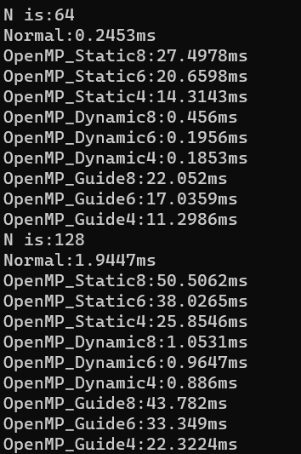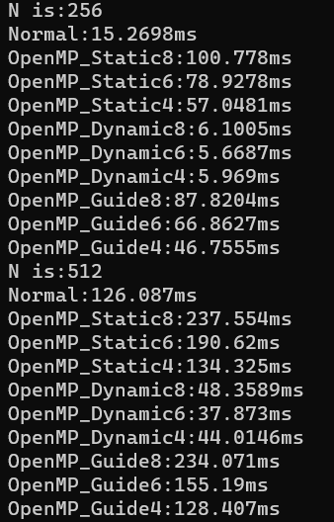

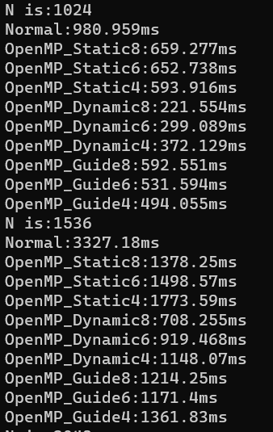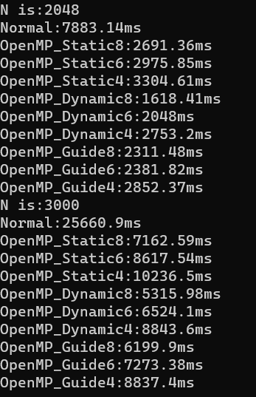

N is:64

Normal:0.2453ms

OpenMP_Static8:27.4978ms

OpenMP_Static6:20.6598ms

OpenMP_Static4:14.3143ms

OpenMP_Dynamic8:0.456ms

OpenMP_Dynamic6:0.1956ms

OpenMP_Dynamic4:0.1853ms

OpenMP_Guide8:22.052ms

OpenMP_Guide6:17.0359ms

OpenMP_Guide4:11.2986ms

N is:128

Normal:1.9447ms

OpenMP_Static8:50.5062ms

OpenMP_Static6:38.0265ms

OpenMP_Static4:25.8546ms

OpenMP_Dynamic8:1.0531ms

OpenMP_Dynamic6:0.9647ms

OpenMP_Dynamic4:0.886ms

OpenMP_Guide8:43.782ms

OpenMP_Guide6:33.349ms

OpenMP_Guide4:22.3224ms

N is:256

Normal:15.2698ms

OpenMP_Static8:100.778ms

OpenMP_Static6:78.9278ms

OpenMP_Static4:57.0481ms

OpenMP_Dynamic8:6.1005ms

OpenMP_Dynamic6:5.6687ms

OpenMP_Dynamic4:5.969ms

OpenMP_Guide8:87.8204ms

OpenMP_Guide6:66.8627ms

OpenMP_Guide4:46.7555ms

N is:512

Normal:126.087ms

OpenMP_Static8:237.554ms

OpenMP_Static6:190.62ms

OpenMP_Static4:134.325ms

OpenMP_Dynamic8:48.3589ms

OpenMP_Dynamic6:37.873ms

OpenMP_Dynamic4:44.0146ms

OpenMP_Guide8:234.071ms

OpenMP_Guide6:155.19ms

OpenMP_Guide4:128.407ms

N is:1024

Normal:980.959ms

OpenMP_Static8:659.277ms

OpenMP_Static6:652.738ms

OpenMP_Static4:593.916ms

OpenMP_Dynamic8:221.554ms

OpenMP_Dynamic6:299.089ms

OpenMP_Dynamic4:372.129ms

OpenMP_Guide8:592.551ms

OpenMP_Guide6:531.594ms

OpenMP_Guide4:494.055ms

N is:1536

Normal:3327.18ms

OpenMP_Static8:1378.25ms

OpenMP_Static6:1498.57ms

OpenMP_Static4:1773.59ms

OpenMP_Dynamic8:708.255ms

OpenMP_Dynamic6:919.468ms

OpenMP_Dynamic4:1148.07ms

OpenMP_Guide8:1214.25ms

OpenMP_Guide6:1171.4ms

OpenMP_Guide4:1361.83ms

N is:2048

Normal:7883.14ms

OpenMP_Static8:2691.36ms

OpenMP_Static6:2975.85ms

OpenMP_Static4:3304.61ms

OpenMP_Dynamic8:1618.41ms

OpenMP_Dynamic6:2048ms

OpenMP_Dynamic4:2753.2ms

OpenMP_Guide8:2311.48ms

OpenMP_Guide6:2381.82ms

OpenMP_Guide4:2852.37ms

N is:3000

Normal:25660.9ms

OpenMP_Static8:7162.59ms

OpenMP_Static6:8617.54ms

OpenMP_Static4:10236.5ms

OpenMP_Dynamic8:5315.98ms

OpenMP_Dynamic6:6524.1ms

OpenMP_Dynamic4:8843.6ms

OpenMP_Guide8:6199.9ms

OpenMP_Guide6:7273.38ms

OpenMP_Guide4:8837.4ms

arm平台实验结果：

