CampusInbox: An Evidence-Gated Agent for College Deadline Management, Evaluated on Public Enron Mail
Kareena Jahagirdar
Department of Computer Engineering, Pimpri Chinchwad College of Engineering, Pune, India
PRN 123B1B048, Division A kareena.jahagirdar23@pccoepune.org
Abstract-College students miss deadlines because dates arrive scattered across course mails. This paper presents CampusInbox, a local agent-style application that turns mail into reviewed deadlines, reminders, calendar entries and draft replies to faculty, under one rule: evidence before action. A prompted language model or a rule extractor may propose a deadline only with a verbatim quote from the mail, every date waits for one-tap human approval, and the application cannot send mail. The first version of this work was measured only on 65 synthetic mails written by the author. This revision adds an evaluation on public Enron mail: 300 sampled mails, of which 261 were labelled by two open-weight language models acting as annotators, with 237 agreed labels forming a "silver" reference (no human annotated it). On the 178 held-out test mails, a frozen rule extractor reaches precision 84.7% and recall 65.6%; a language-model extractor (gpt-oss-20b) with a quote check reaches 91.8% and 95.7%; a hybrid that auto-accepts a date only when model and rules agree reaches 98.3% precision at 63.4% recall and sends 24.2% of mails to a human. A 40-mail injection test is a negative result: an injected "the real deadline is X" sentence was accepted in 20/40 cases by the rules, 23/40 by the model and 12/40 by the hybrid gate. The gate therefore guards against invented dates, not against a hostile sender. We state the labelling method, the models used and all limits. No model was trained or fine-tuned in this work; the language models are used as prompted and the rest is rules and checks.
Keywords-deadline extraction, human-in-the-loop, LLM annotation, Enron corpus, prompt injection, evidence grounding, personal productivity agents

1. INTRODUCTION
1.1 Background and Motivation
A final-year engineering student receives deadline-bearing mail from several courses, a learning platform and ad-hoc announcements that quietly change earlier dates. The failure is ordinary and expensive: a report due "next Friday" is read once, forgotten, and found after the deadline. Existing tools do not close the loop. Google Classroom lists assigned and missing work but does not read mail [10]; Gmail nudges resurface whole messages [11]; commercial inbox assistants add snoozing but need ongoing third-party mailbox access [12].
Pointing a language model at the inbox is the obvious response, and it brings known failure modes: the model may invent a plausible date, or follow instructions hidden in mail text [8], [9]. For a deadline tracker, one invented date is worse than no extraction. CampusInbox is built around one rule: evidence before action. A proposed deadline must carry a verbatim quote, a human approves every date, and the application has no send path.
1.2 Contributions
The first version was evaluated only on 65 synthetic mails, which cannot show how the design behaves on real mail. This revision therefore asks three questions on public data: (RQ1) how do rule, language-model and hybrid extractors compare on real mail; (RQ2) what does the agreement gate between model and rules cost in review effort; (RQ3) does the gate resist deadline text injected by a mail sender. The contributions are modest and stated as such: (1) an open, reproducible evaluation harness and a 300-mail Enron sample with documented labelling; (2) measured trade-offs between precision, recall and review load for three extractors; (3) a negative injection result with an analysis of why it occurs; and (4) an error analysis with a list of threats to validity. We do not claim a new method; the components (temporal normalisation, evidence grounding, model-rule agreement, human escalation) are established, and the case study is the contribution.
1.3 Layout of the Paper
The rest of this paper is laid out as follows. Section 2 reviews related work, compares existing systems and states the research questions. Section 3 describes the datasets and the labelling method. Section 4 gives the methodology: the system design, the evaluation setup and the proposed algorithm with its flowchart. Section 5 presents results and discussion, including limitations and a real-world scenario. Section 6 concludes and lists future scope. Section 7 lists references.
2. LITERATURE REVIEW
Detecting actionable content in mail has a long history. The Enron corpus was introduced for mail classification research [13]. Later work detected action items in mail [14], emails containing requests for action [15] and commitments [16]. Temporal expression extraction and normalisation is a mature rule-and-model task [4], [5], and has been applied to mail directly [17]. These systems target tagging or classification of text spans. CampusInbox instead targets a single decision for a student: which date may become a reminder, and how a human verifies it.
LLM agents are surveyed in [2] and built from roles in [1], [3]. Modular neuro-symbolic designs pair models with external tools and reasoners [24]; tool-use agents include Toolformer [22], Gorilla [23] and HuggingGPT [27]; chain-of-thought prompting [26] and reflection [25] inform our retry step. Grounding an answer in quoted source text follows the retrieval-augmented idea [6]. Deferring uncertain model outputs to a human is studied as selective prediction and cascaded escalation, for example [18]; agreement between independent extractors as an acceptance test is a common pattern, and our hybrid gate is an instance of it rather than a new technique. Indirect prompt injection against LLM-integrated applications was described in [8], and benchmarked for tool-using agents in [19], [20]; [21] studies extraction with black-box models. Our injection set is small and specific to deadline mail, and is not comparable to those benchmarks.
We found no published evaluation of this exact combination (student deadline extraction from mail, a quote-grounded model, a model-rules agreement gate, and an injection test) on public Enron mail. This statement comes from a non-exhaustive search and is not a claim that none exists.
2.1 Comparative Analysis
Table I compares CampusInbox with the closest existing tools on the features a deadline assistant needs. Prior academic work (Section 2) studies single decisions - whether a mail contains a request, its date, its priority; the products below manage mail but none reads a deadline out of a mail, shows the evidence for it and waits for a human before reminding. CampusInbox is narrower than all of them and does that one loop.
TABLE I
FEATURE COMPARISON (FROM VENDOR HELP PAGES [10]-[12])
Capability | Class-room | Nudges | SaneBox | CampusInbox
Reads mail for deadlines | No | No | No | Yes, with quote
Shows proof for a date | n/a | No | No | Yes
Human approval before acting | n/a | n/a | No | Yes
Reminder bands | No | No | Snooze | Yes
Calendar export (approved) | Manual | No | No | Yes (.ics)
Draft reply, cannot send | No | No | No | Yes
Runs locally | No | No | No | Yes (offline mode)

The comparison is of features documented on the vendors' help pages, not a measured accuracy comparison; those products do not publish extraction accuracy, so none is claimed. CampusInbox is narrower than all three: it reads mail, shows evidence, waits for approval and reminds.
2.2 Research Questions
Three questions guide the evaluation. RQ1: on real mail, how do a frozen rule extractor, a prompted language-model extractor with a quote check, and a hybrid that accepts a date only when model and rules agree compare on precision, recall and review load? RQ2: what does the agreement gate cost in human review effort? RQ3: does the gate resist deadline text injected by a mail sender? Section 5 answers them: for RQ1 and RQ2, on 178 held-out mails the hybrid reaches 98.3% precision at 63.4% recall with 24.2% of mails sent to review (Section 5.1, 5.2); for RQ3, the gate does not resist a hostile sender - every automatic path accepts planted deadline text (Section 5.5).
3. DATASETS
3.1 Data
Enron mail is public and widely used [13]. We scanned the CMU distribution (204,499 mails) with a fixed seed (20261020) for mails with a deadline cue (such as "due", "by Friday", "deadline", "RSVP") and for mails without one. The pool held 389 cue and 232 no-cue mails. We sampled 200 cue and 100 no-cue mails. Each mail is assigned to a dev or test split by a hash of its ID. The sampling is stratified, so precision here is not an estimate for a real inbox, where most mail has no deadline. Enron mail is corporate, from 1999-2002, not college mail; this limits what the results say about students.
TABLE II
DATA AND SPLITS
Item | Count
Mails scanned (CMU Enron) | 204,499
Pool: deadline cue / no cue | 389 / 232
Sampled: cue / no cue | 200 / 100
Labelled by both AI labellers | 261
Agreed (silver reference) | 237
Dev split (rule tuning only) | 59
Test split (all reported results) | 178
Silver positives in test | 93
Injection test mails (synthetic) | 40

3.2 Labelling and what "gold" means here
No human annotated this data. Two open-weight language models, gpt-oss-120b and qwen3.8-27b, both hosted on the Groq free tier, each read every mail and returned a deadline date (or none) with a quote. We call the result silver labels. A mail enters the reference set only if both models give the same date or both give none (237 of 261 doubly labelled mails; the remaining 39 of the 300 did not finish labelling before the free daily token limits ended). Agreement on whether a deadline exists was 93.9% with Cohen's kappa 0.88 [28]; exact agreement on the date was 242 of 261. Disagreeing mails are excluded, which biases the reference toward easy mails and probably flatters every system. For labelling only, a returned date was kept when its quote matched the mail apart from whitespace (eight mails were kept despite an unmatched quote). The labellers are LLMs, so shared blind spots between them are possible and unmeasured. Only a 50-mail subset was reviewed, by the author, from AI-proposed answers (Section 5.8); no result here should be called independently human-verified or gold.
4. METHODOLOGY
Fig. 1 shows the architecture. Mail enters only through explicit imports (a JSON batch or a plain-text .eml file); the MVP has no live mailbox connection. An import layer enforces size limits, deduplicates message IDs and rejects conflicting content under a repeated ID. The EvidenceExtractor role proposes course, task and candidate deadline. Two engines exist. The rule engine (rules_v2) resolves absolute dates, weekday names and a few relative phrases against the mail's Date header and turns a date without a time into 23:59 IST. The optional model engine calls any OpenAI-compatible endpoint and must return JSON with a date and a quote; the quote must occur in the mail (ignoring line wrapping and case) otherwise the model output is discarded.
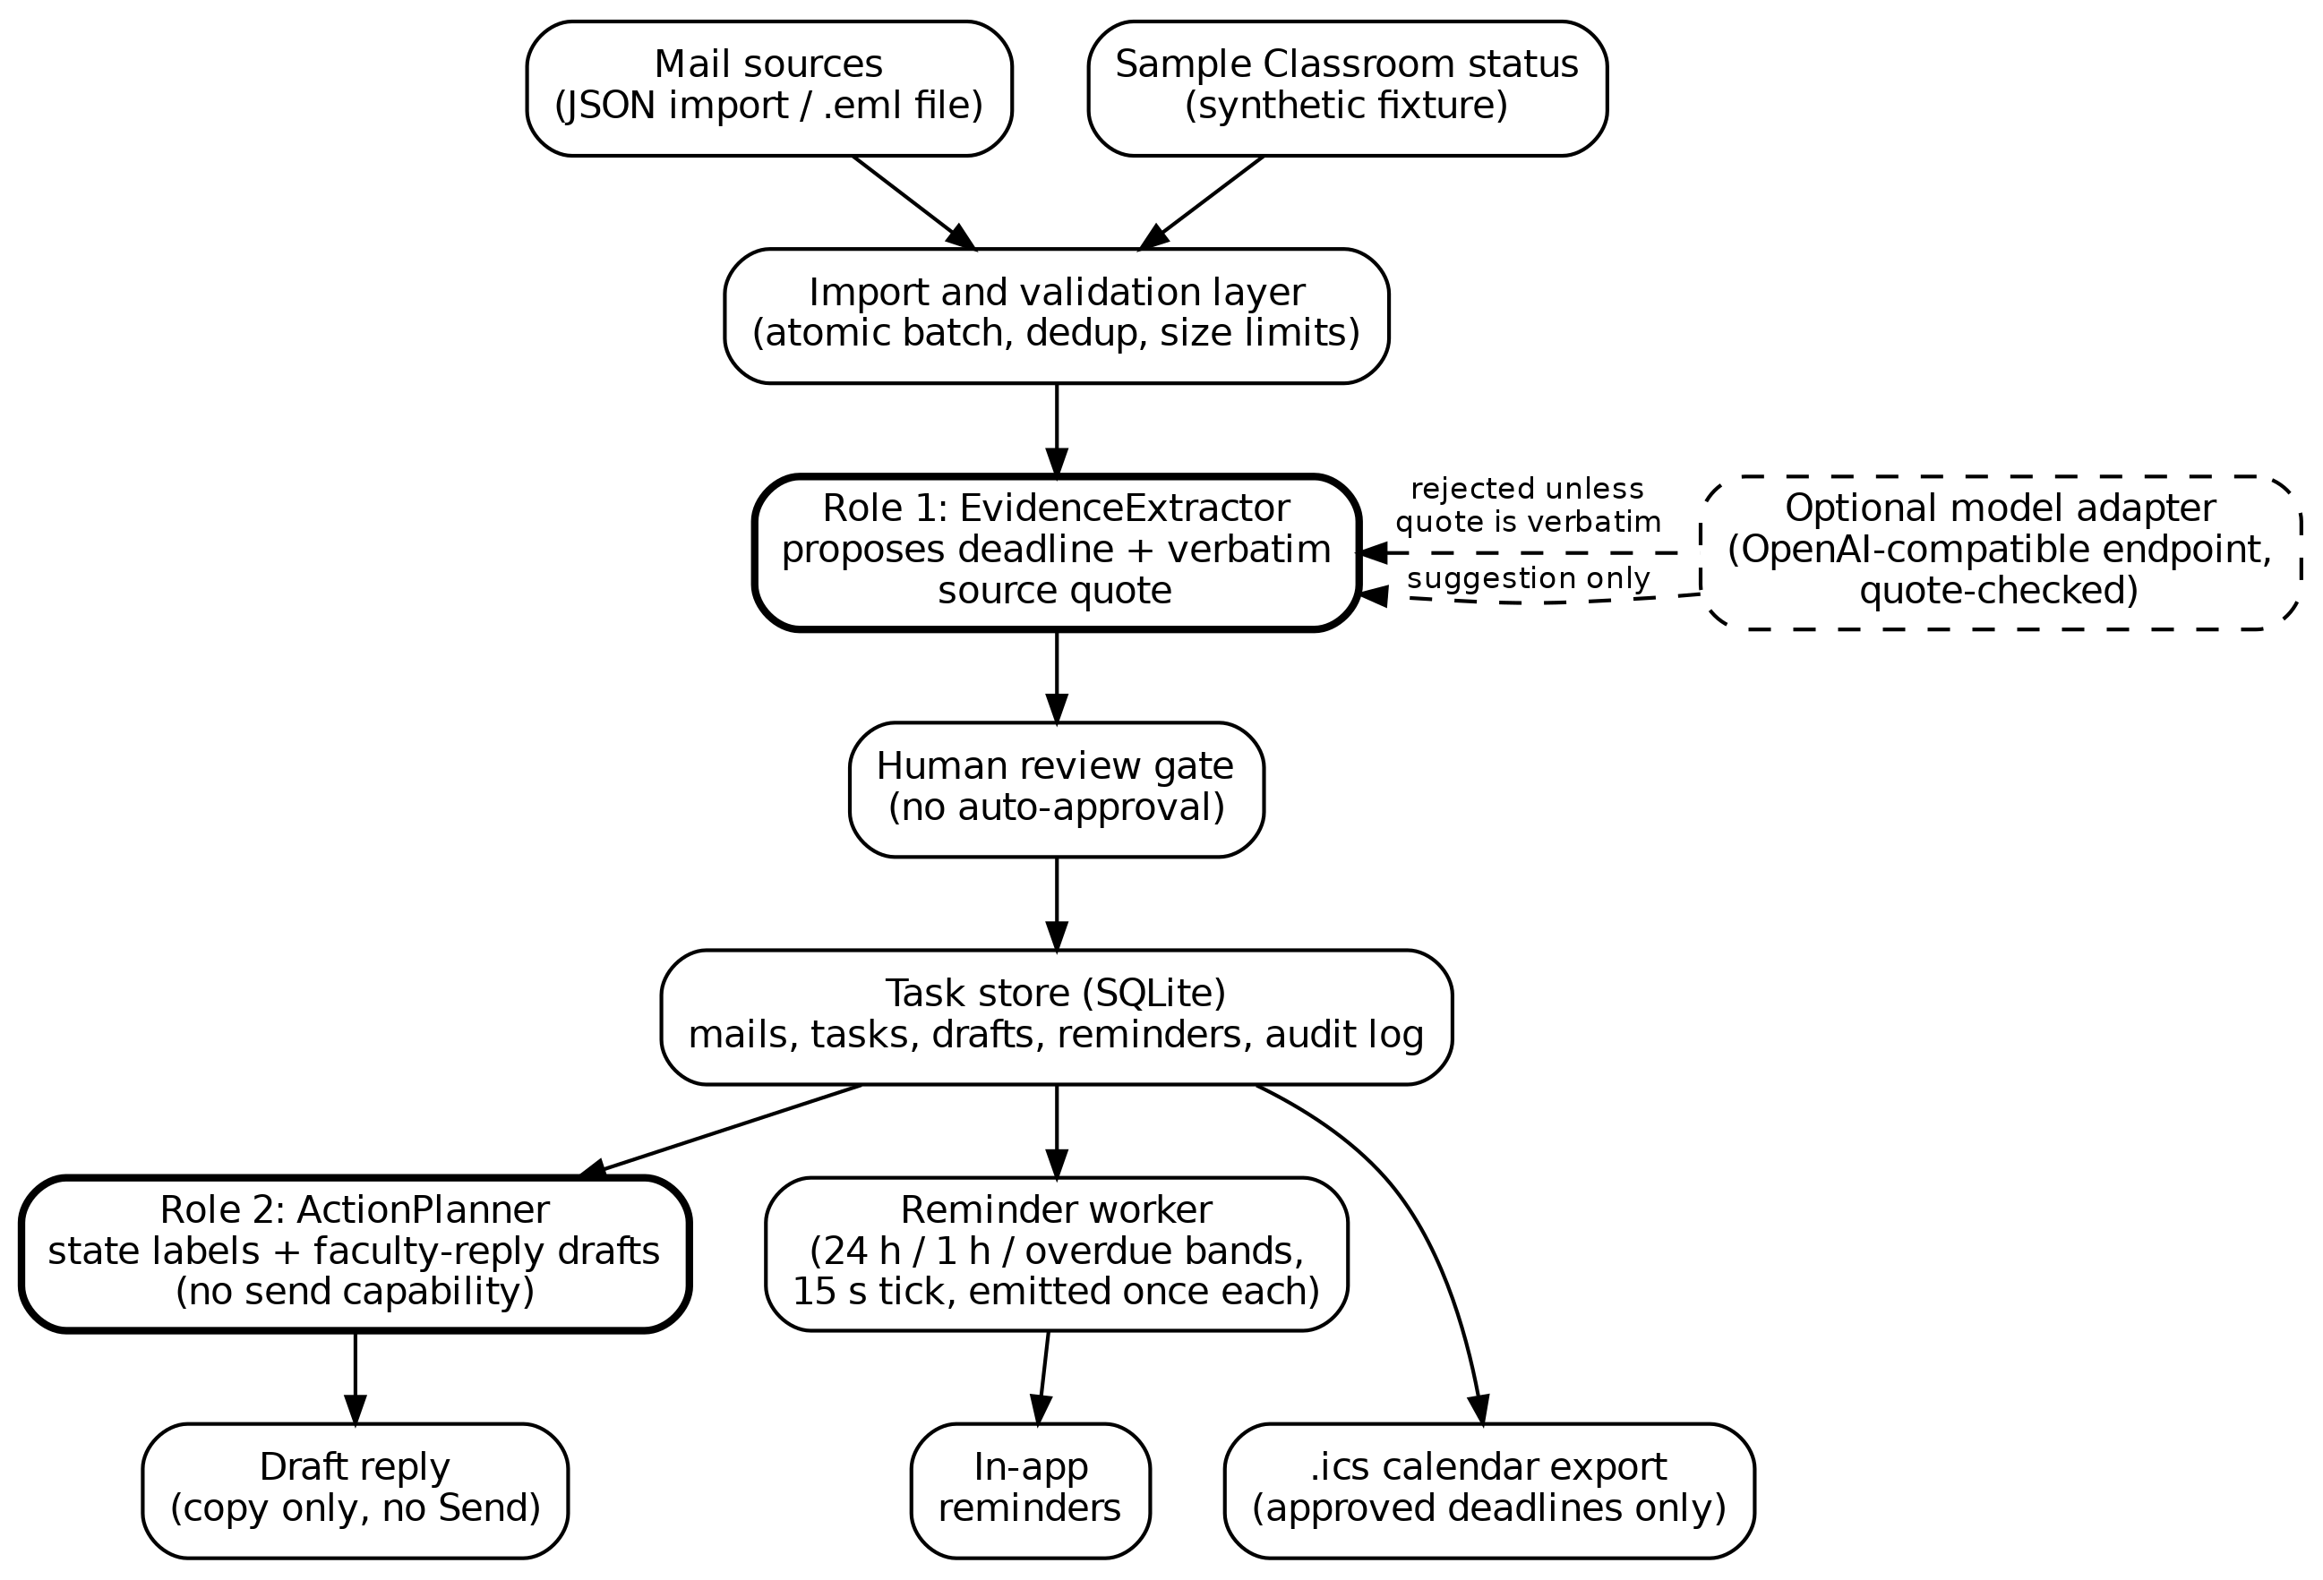
Fig. 1. CampusInbox architecture. Untrusted mail flows down the left; the model engine may only suggest, and its suggestion is rejected unless the quote is found in the mail.
The new agreement gate compares both engines. If model and rules give the same date, the task is marked "agree" and still waits for approval, with that stated in the review card. If they differ, or the rules abstain, the card says "DISAGREE or rules abstained, check the quote carefully". In the evaluation we treat "agree" as auto-accept to measure what such a policy would cost; the shipped app never auto-approves. A human review gate holds every date until the student approves it against the quote. Only approved tasks feed reminders (24 h, 1 h, overdue, once per task version), the .ics export and draft replies. The ActionPlanner writes draft replies that the application cannot send. State lives in a local SQLite database with an audit log. Fig. 3 shows the task lifecycle.
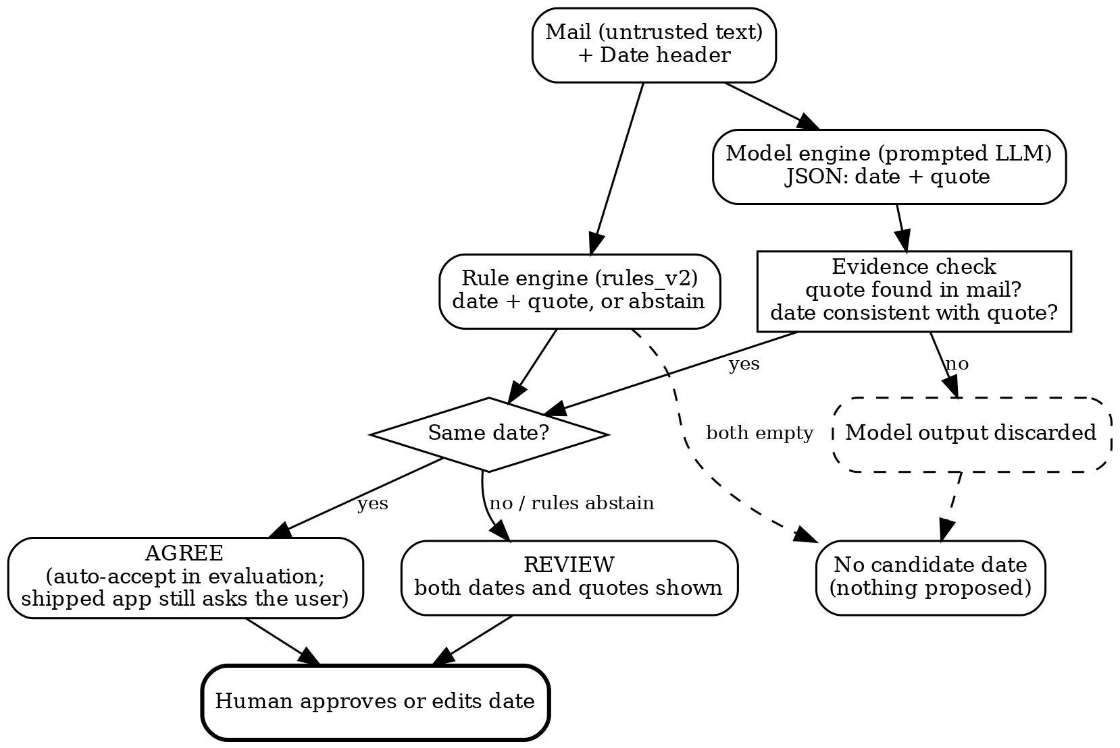
Fig. 2. Decision flow of the extraction and agreement gate. The shipped app always ends at a human decision; "auto-accept" exists only as a policy we score in the evaluation.
The gate procedure. Input: mail text, Date header. (1) The rule engine returns a date and quote or abstains. (2) The model engine returns a date and quote; the quote is checked to occur in the mail (whitespace and case ignored), and the model date is dropped if not. (3) If both engines return the same date, the mail is labelled "agree". (4) If they differ, or only one engine returns a date, the mail is labelled "review". (5) If neither returns a date the mail gets no proposal. In every case the date is only a proposal until a person approves it.
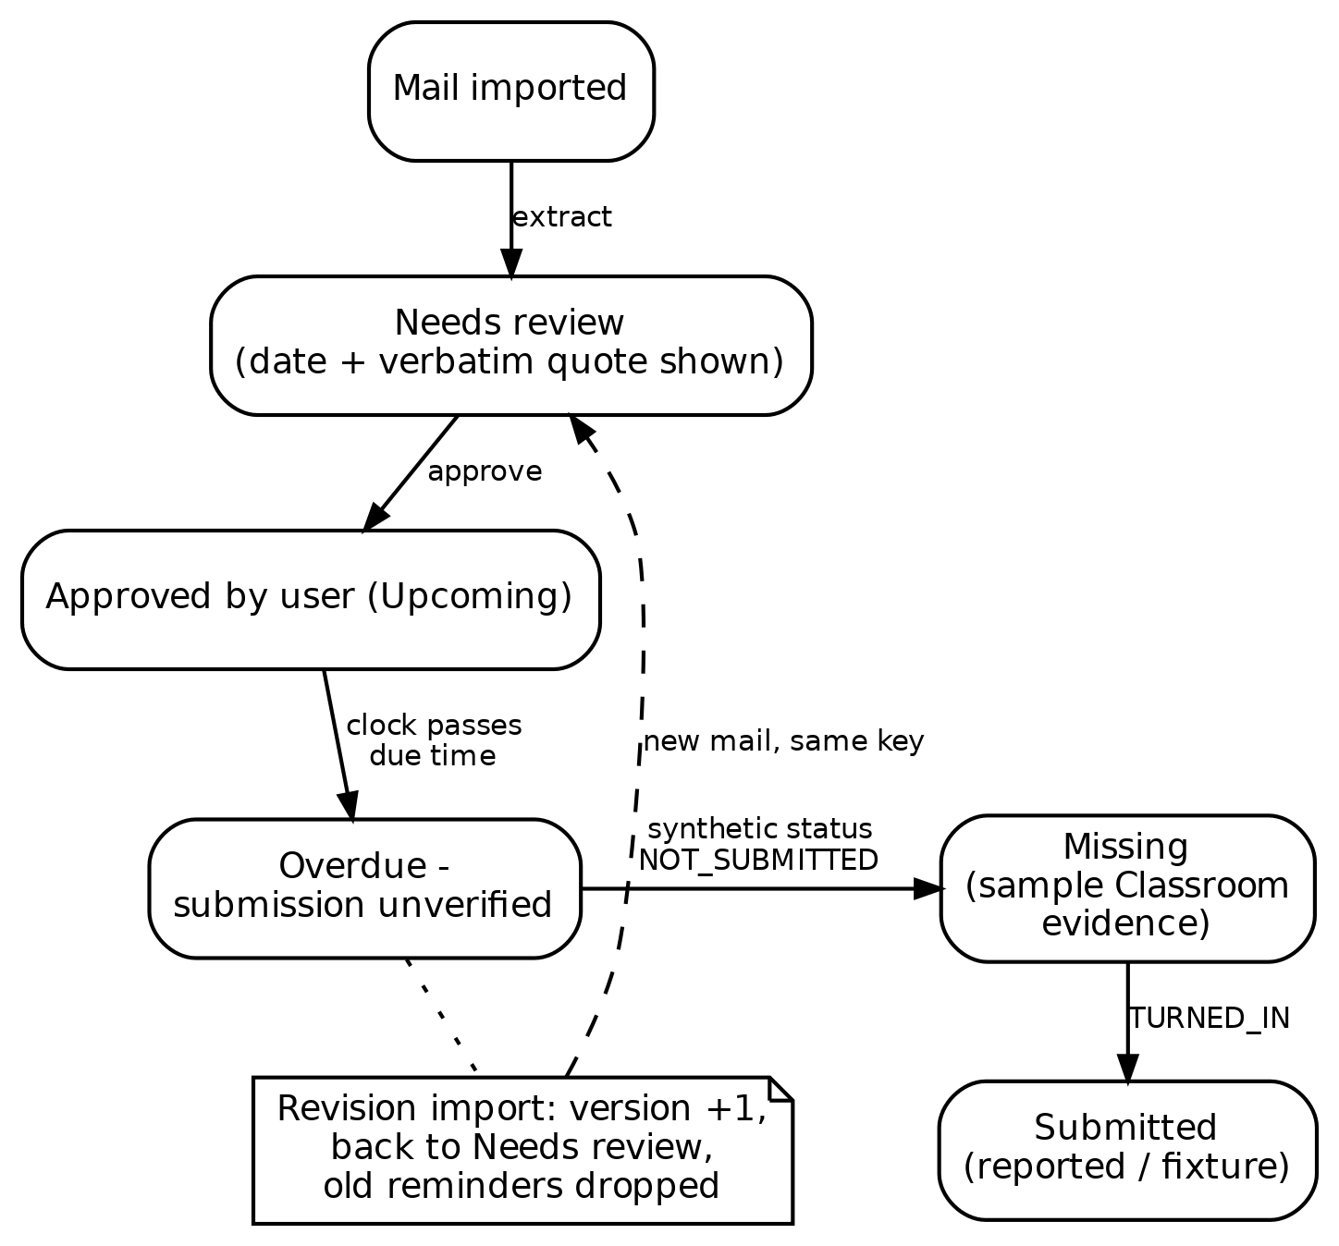
Fig. 3. Task lifecycle. Approval, revision and submission change state through explicit events, never through model inference.
4.1 Roles and trust boundaries
The system has two reasoning roles and everything else is ordinary code. EvidenceExtractor reads one mail and proposes a course, a task title, a deadline and the quote it came from. ActionPlanner takes structured task facts (course, title, due date, task state) and drafts a short, polite request to faculty. Persistence, the clock, de-duplication, reminder timing, the approval gate and calendar export are deterministic, because they must behave identically every time. Mail text is untrusted input; a model output is a proposal and never a command; only code and the student change task state. The roles have no tools, so a model cannot send mail, call an API or change a status.
4.2 Data model
TABLE III
DATA MODEL (SQLITE, LOCAL FILE)
Record | Main fields
Mail | id, subject, body, optional assignment_key and Date header
Task | id (= assignment_key), course, title, due_at (ISO 8601 with offset), quote, mail_id, review flag, version, status and its source, draft, engine
Reminder | id = task:version:band, fired time (unique per task version and band)
Audit entry | time, event, detail; append-only
Settings | clock (demo or device time)

A task is identified by its assignment key, supplied by the importer; two mails with the same key are treated as versions of one assignment, and a mail without a key becomes its own task. The demo clock starts at 19 October 2026, 9:00 PM IST so that the five sample mails behave the same every time; the app can also use device time. Time zones are always explicit and the default display zone is Asia/Kolkata (+05:30).
4.3 Task state machine
TABLE IV
TASK STATE, COMPUTED IN THIS ORDER
Order | Condition | Displayed state
1 | review flag set | Needs review
2 | status is TURNED_IN | Submitted (student-reported)
3 | no due date | Unknown deadline
4 | past due, status NOT_SUBMITTED from the sample Classroom fixture | Missing (sample Classroom evidence)
5 | past due, otherwise | Overdue - submission unverified
6 | otherwise | Upcoming

State is computed from stored fields and the clock, not stored, so it cannot drift. Table IV shows the rule order. Submission is never guessed: "Submitted" appears only when the student reports it, and the label says so; "Missing" appears only for the synthetic Classroom fixture, and the label says that too. The app makes no Classroom API call.
4.4 Approval gate and revision handling
Every task is created with the review flag set, whatever the engine or its confidence. A task in review produces no reminder and no calendar entry. The review card shows the course, the proposed date, the quote in a box, the engine used, the agreement result when a model was used, and the full mail on request. Approval requires a valid ISO date with a time zone; the student may edit the date first. If the approved date differs from the proposal, the task's reminders are deleted and its version number rises by one. Every approval and edit is written to the audit log. When a later mail arrives with the same assignment key and different content, the task's date and quote are replaced, the version rises, the review flag is set again and old reminders are deleted; the revised date therefore needs approval before any new reminder exists.
4.5 Reminder worker
Every 15 seconds, and after each approval or clock change, the worker visits each approved task that has a date and is not marked turned in. With delta = due - clock, it picks one band: "due now / overdue" if delta <= 0, "due within 1 hour" if delta <= 3600 s, "due within 24 hours" if delta <= 86,400 s, otherwise none. The reminder is stored under the key task:version:band and inserted only if that key does not exist, so a band fires once per task version. If the clock jumps forward only the current band is emitted; earlier bands are not back-filled. Reminders are in-app only; WhatsApp or push delivery is future work and is not claimed. Tasks marked turned in produce no reminders.
4.6 Draft replies and calendar export
ActionPlanner drafts a short request that asks for submission instructions, or asks whether a late submission can be accepted when the task is overdue. It must not invent an excuse, a teacher name, a promise, a new date or a submission status, and it signs with the student's name, PRN and division. The code rejects a model draft that is empty, longer than 4,000 characters or contains an address or link, and then uses a fixed template. The draft panel has no recipient field and the app has no send function. Approved tasks can be exported as a standard .ics file (one event per task, sequence number equal to the version, lines folded to 75 bytes); tasks in review are never exported.
4.7 Safety measures and what a chatbot does not do
The local server binds to loopback, checks the Host header, requires a per-run token on every write, limits a batch to 50 mails and 250 KB, rejects a message ID reused with different content, inserts mail text into the page as text and sends a restrictive content-security policy. These are demo-grade protections, not a security audit.
TABLE V
CAMPUSINBOX COMPARED WITH A GENERAL CHATBOT
Property | Typical chatbot | CampusInbox
Acts over time | Only when asked | Reminder worker on a clock
Evidence | Free text answer | Date must come with a quote from the mail
Approval | None | Student approves every date
Revisions | Not tracked | Versioned; old reminders dropped
Tools | May call tools | Roles have no tools; no send function
Status | May assume | Unknown stays unknown

Table V lists the differences. The comparison is about design, not accuracy; a chatbot with the same prompts could be wrapped in the same checks. What is specific here is that the checks are part of the application and cannot be skipped by the model.
4.8 Mail intake from files and the local notifier
Mail can be loaded from a folder of .eml files or from a local mbox export (for example a Gmail Takeout file) with a command-line option; the files are read, never modified, and nothing is sent or fetched over the network. Each mail goes through the same extraction, quote check and review gate as a pasted mail; a duplicate is skipped and a malformed mail is reported and skipped without stopping the rest. A separate notifier command runs the same reminder worker once and prints, and optionally appends to a text file, each reminder it has not announced before; it can be run from a scheduler. It announces only approved tasks and never repeats a reminder. This is a local text notification, not push, e-mail or WhatsApp delivery. Both features are covered by unit tests on synthetic mails; they were not run on the author's real mailbox.
4.9 Agent loop, Verifier and message log
In agent mode the Extractor is a tool-using loop in the style of ReAct [1] and tool-using models [22], [23]: a prompted model may call read_header, search_mail, read_context, parse_date and check_quote, and ends with final_answer. The loop is capped at six steps. A deterministic gate then requires the quoted sentence to occur verbatim in the mail and to contain the proposed date; if it does not, the model gets one reflection turn with the failure reason and then the task stays in review. A separate Verifier role runs the same quote check first and, when a model is configured, asks the model for a second verdict. Every hand-off (Intake to Extractor, Extractor to Verifier, Verifier to Reviewer) is stored as a message row with sender, receiver, kind and content, and each tool call is stored in the task trace; the dashboard shows both. Without a model, a scripted run of the same five tools gives a deterministic second opinion on the rule result. No tool can send mail or change a task; the only outputs are proposals that wait for approval. This is a small fixed pipeline of roles, not a general multi-agent framework, and no agent framework library is used.
4.10 Retrieval and the chat panel
The chat panel answers only from the imported mails and from the text of the course syllabus (BCE27PE02, Agentic AI Design), using BM25 retrieval [30] over sentences. Questions about the week, conflicts and "why this date" are answered by code from approved tasks. For other questions, the best-matching sentence is shown with its source mail or syllabus section; if no sentence scores above a fixed threshold the reply is "not found". An optional model mode lets a prompted model call search_corpus and read_chunk and finish with an answer that cites chunk ids with verbatim quotes; a gate rejects any answer whose citation is unknown or whose quote is not in the cited chunk. Mail text is passed as data and the chat has no tools that change state. The behaviour is covered by unit tests for a retrieval hit, no answer, an injected instruction inside a mail, a fabricated quote and an unknown source (the model mode is tested with a mocked model; it was not evaluated for answer quality). An optional web mode adds two tools, web_search and fetch_url. It is off unless the user sets CAMPUS_WEB=1 and their own search endpoint (and key); no search service is bundled. The page fetcher accepts only http(s) URLs that a search returned, refuses hosts that resolve to private, loopback or link-local addresses, caps page size, and strips scripts. Search snippets cannot be cited; only sentences of a fetched page can, with verbatim quotes checked by the same gate, and the answer carries a caveats field (for example price or issuer not stated; the prompt asks for "cost unverified" unless a page states it). Page text is treated as untrusted data and the tool set has no send function. Status: the web loop is unit-tested with mocked search and fetch (verified quote, fabricated quote, snippet or unlisted URL, injection inside a page, search failure, private-address block); the page fetcher alone was run once against a public test page; the search backend and the full model-driven web loop were not run live, and the answers have not been evaluated for correctness. Only synthetic and Enron mail were used; the student's own mail was not.
4.11 Priority, conflicts, digest, notifier adapters and Gmail import
Approved, unsubmitted tasks are ranked by time to deadline; two approved tasks due within three hours of each other are reported as a conflict; a weekly digest lists both. Reminder delivery goes through adapters: console and file are built and tested; WhatsApp Cloud API and email adapters are implemented as stubs that print what they would send unless the owner sets their own keys and a live flag, and they have not been run against the real services. They send reminders to the owner only. A user-run Gmail import (read-only scope, PKCE loopback login, token stored in a file readable only by the user) is implemented with fake-transport tests and has not been run against a real Gmail account. No Gmail send scope or send code exists.
4.12 Not implemented
Gmail import and the WhatsApp and email adapters are not live-tested (Section 4.12); the app does not connect to Google Classroom or WhatsApp; reminders reach only the page and the local notifier; the extractor does not return a confidence score; the quote check requires the quote to occur in the mail but does not require it to contain the date, because relative dates such as "Friday" are resolved against the mail's Date header; a date given without a time is stored as 23:59 IST. A browser-only build of the same design from a written specification (React, local storage) has been specified but not built or tested, and nothing in this paper is measured on it.
4.13 LangGraph extension (added after the evaluation)
In a separate folder (CampusInbox_LangGraph), added after all results above were frozen, the extraction agent was ported to LangGraph with LangChain tool calling [33]. The same five mail tools are wrapped as LangChain StructuredTools, a ToolNode executes them, the graph loops model-tools-model with the same six-step cap, and a verify node re-runs the check_quote gate in code with one reflection turn, exactly as in the plain loop. An offline scripted model drives the graph with no API key, and any LangChain chat model can be substituted. On every mail in its test suite the port returns the same date as the plain-Python loop. The extension adds planning tools around the agent: a date calculator that resolves phrases such as "by Friday" against the mail's Date header and reports the days left; read-only Gmail search and read-only Google Calendar listing through the same user-run OAuth; a calendar tool that only prepares an event proposal as an add-it-yourself link, so the code contains no event-write function; a reminder preview that prints the exact WhatsApp or email text without sending; optional web search, off by default; and a demo mode with a simulated sign-in over a synthetic inbox for recordings. Mails and deadlines carry a course tag (an explicit field, else keyword rules), and the planner reports deadlines grouped by course (Agentic AI, Distributed Systems, OOMD, Placement cell), which is the per-subject view used in Section 5.12. The graph and the planning tools are shown in Fig. 4. The extension has its own 35 offline tests, all passing. No number in this paper comes from the LangGraph port, and live Gmail, Calendar, web search and WhatsApp/SMTP delivery remain untested.
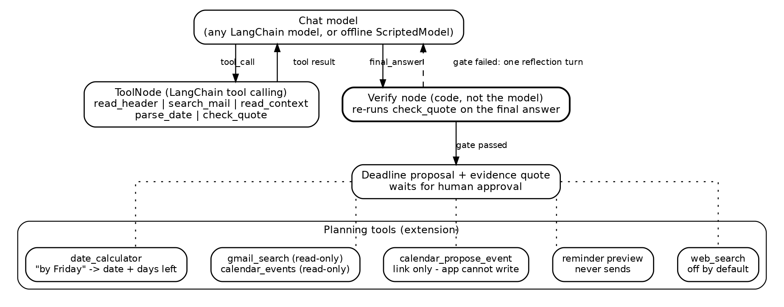
Fig. 4. The LangGraph extension. The model proposes tool calls; the ToolNode runs them; a code verify node re-checks the evidence quote before any proposal reaches the human review gate. Planning tools compute dates, read mail and calendar, and prepare proposals; none of them writes or sends.
4.14 Implementation
The MVP is a Python 3.10 application (a main module plus agent, retrieval, chat and notifier modules) using only the standard library: http.server, sqlite3 and a background reminder thread, with a plain black-and-white web UI. No pip install or key is needed for the default offline demo. In this revision the app imports rules_v2, uses the mail's Date header to resolve relative phrases, uses a role-specific model prompt, and applies the agreement gate. There are 74 unit tests, all passing; the agent loop, verifier, retrieval, chat, notifier and Gmail-import tests were added in this revision, and earlier additions were (the agreement gate, date handling, the draft check, file import and the local notifier). The evaluation code (build_enron.py, labelling and caching of every model call, run_eval_v2.py, run_adv.py) is in the evaluation_v2 folder; each model response is cached so the scoring can be repeated without any API.
A live run used Gemini (gemini-3.1-flash-lite, Google free tier) through the app's model adapter on four synthetic mails (Fig. 9). Only synthetic text was sent; no real student mail has been sent to any model API. The Gemini free tier allows 20 requests per day per model, so this run is a demonstration and not an evaluation.
4.15 Systems compared
Naive: the first date-like string in the mail. Rules: rules_v2, written on the 65-mail synthetic corpus and a development split, then frozen before the test split was scored. LLM alone: gpt-oss-20b (Groq free tier, temperature 0, JSON output) prompted with the mail and its date. LLM + evidence check: the same output, accepted only if the quote is found in the mail. Hybrid: a date is auto-accepted only if the LLM+check date equals the rules date; every other mail with a candidate date goes to human review. A language model that also served as a labeller is not the system under test: the three models are different (gpt-oss-120b, qwen3.8-27b and gpt-oss-20b), although gpt-oss-20b and gpt-oss-120b are from the same family and may share biases.
4.16 Metrics
A system output counts as correct only on an exact date match with the reference. Precision is correct over emitted; recall is correct over reference positives; F1 is their harmonic mean. We give 95% bootstrap intervals [29] (2,000 resamples of mails). Review rate is the share of mails that the hybrid sends to a human. The test split was scored once the rules were frozen; one bug in quote matching (hard-wrapped lines) was fixed in the evaluation code after a first run, and all numbers below use the fixed code for every system.
4.17 Prompts and settings
Language models are used as prompted, with no training or fine-tuning by us. The extraction prompt tells the model that mail text is untrusted data, to resolve relative dates against the Date header, to report a deadline only when the mail asks someone to act by a specific calendar date, to return ambiguous with no date when the day cannot be pinned down, and to answer in JSON with a date and a verbatim quote. Mails are cut to 1,500 characters of body. All calls use temperature 0 and JSON output; gpt-oss models use low reasoning effort and qwen uses none with a 400-token limit. The two labeller prompts differ in wording so that the two labellers are not the same prompt run twice. All responses are cached, so results can be re-scored without API access. Table VI lists every model and its role.
TABLE VI
MODELS USED AND THEIR ROLES
Model | Role | Access
gpt-oss-120b | Labeller A | Groq free tier
qwen3.8-27b | Labeller B | Groq free tier
gpt-oss-20b | Prompted extractor under test | Groq free tier
gemini-3.1-flash-lite | Live demo; ReAct agent loop (test subset) | Google free tier

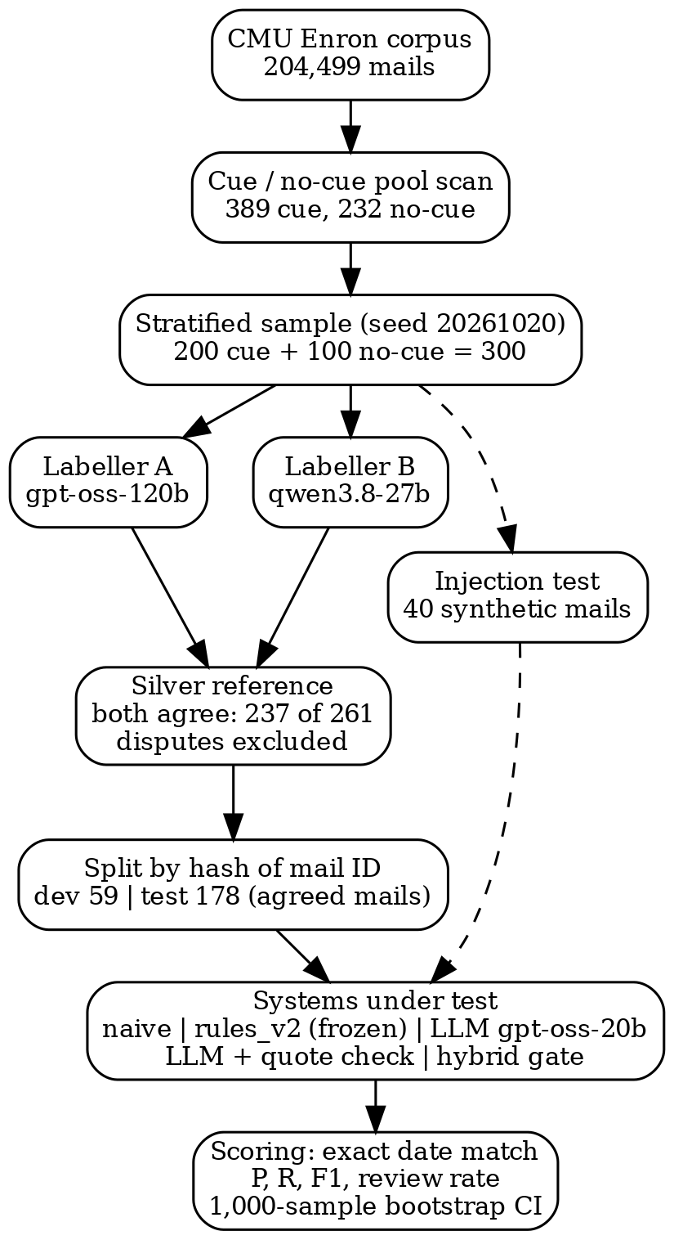
Fig. 5. Evaluation pipeline from the Enron corpus to scored systems.
4.18 Proposed algorithm
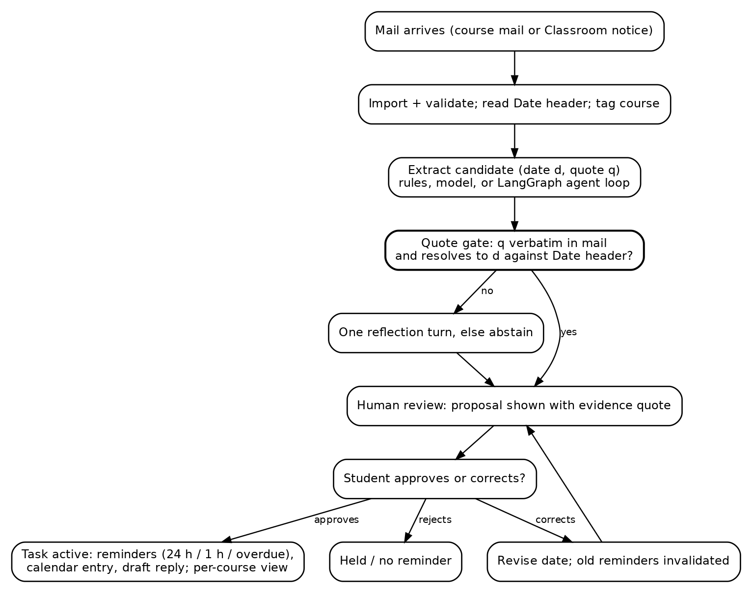
Fig. 6. Flowchart of Algorithm 1: evidence-gated deadline extraction and approval. No path reaches a reminder without a verbatim quote and a human decision.
Algorithm 1 (evidence-gated deadline extraction and approval). (1) Import the mail, read its Date header and tag the course. (2) Propose a candidate (date d, quote q) with the rule extractor, a prompted model, or the tool-calling agent loop. (3) Gate: if q is not verbatim in the mail or does not resolve to d against the Date header, allow one reflection turn and then abstain. (4) Show the proposal with its quote to the student; nothing reminds before this point. (5) On approval, activate the task: schedule the 24 h / 1 h / overdue reminders, add the calendar entry, prepare the draft reply, and list the deadline under its course. (6) On correction, replace the date, invalidate the old reminders and return to (4). (7) The reminder worker emits each band once per task version. The app has no send path at any step.
4.19 Reproducibility
The code, the 300-mail sample with all labeller outputs, the cached model responses, the frozen rules and the scoring scripts are released in the project repository. Scoring needs no API: python3 collect_labels.py; python3 run_eval_v2.py dev; python3 run_eval_v2.py test; python3 run_adv.py. Re-running the language models needs API keys, which are not included; model versions on free tiers can change. The seed for sampling is 20261020. Enron mail is public, and no real student mail was used or sent to any model.
5. RESULTS AND DISCUSSION
5.1 Results on public Enron mail
TABLE VII
TEST SPLIT RESULTS (178 MAILS, 93 SILVER POSITIVES)
System | Out | OK | P (95% CI) | R (95% CI) | F1
Naive first date | 150 | 56 | 37.3 [30-45] | 60.2 [50-69] | 46.1
Rules (frozen) | 72 | 61 | 84.7 [75-92] | 65.6 [56-75] | 73.9
LLM alone | 97 | 89 | 91.8 [86-97] | 95.7 [91-99] | 93.7
LLM + quote check | 97 | 89 | 91.8 [86-97] | 95.7 [91-99] | 93.7
Hybrid auto-accept | 60 | 59 | 98.3 [94-100] | 63.4 [54-73] | 77.1

Table VII and Fig. 7 show the trade-off. The naive baseline is wrong on more than half of its outputs. The frozen rules are precise when they fire but miss about a third of the deadlines. The language model finds almost all of them; here the quote check changed nothing, because the model's quotes were always found in the mail, so the check is a safeguard against fabricated quotes and not a measured source of accuracy. The hybrid has the highest precision (98.3%) with one wrong date out of 60, at the price of recall (63.4%) and a human review on about one mail in four. The confidence intervals are wide (a few points to ten points) because the test split is small; the recall gap between rules and the LLM (about 30 points) is clearly outside the intervals, but the precision gap between the hybrid and the LLM (about 6 points) overlaps them, so we do not claim it is reliable.
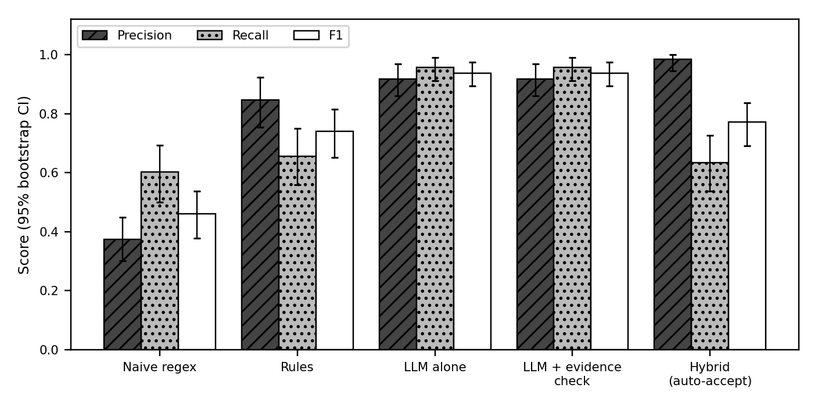
Fig. 7. Precision, recall and F1 on the 178-mail test split with 95% bootstrap intervals. Reference labels are silver (two AI labellers).
5.2 Ablation of the acceptance policy
TABLE VIII
ACCEPTANCE POLICIES ON THE TEST SPLIT (178 MAILS)
Policy | Out | OK | P (95% CI) | R (95% CI) | Rev. %
Rules only | 72 | 61 | 84.7 [75-92] | 65.6 [56-75] | -
LLM only | 97 | 89 | 91.8 [86-97] | 95.7 [91-99] | -
LLM + quote check | 97 | 89 | 91.8 [86-97] | 95.7 [91-99] | -
Rules agree LLM | 60 | 59 | 98.3 [94-100] | 63.4 [54-73] | 24.2

Table VIII compares ways to decide which date to accept. "Rev. %" is the share of mails a person must look at because an engine proposed a date that the policy did not accept. Requiring the rules and the model to agree raises precision and lowers recall relative to the language model alone. No policy beats the language model alone on F1; the benefit of the gate is fewer wrong dates accepted without a human, not more correct dates found. Quote checking made no difference in this run (all quotes were found).
5.3 Cue and no-cue mails
TABLE IX
OUTPUT COUNT AND CORRECT COUNT BY MAIL TYPE (TEST: 130 CUE MAILS WITH 92 POSITIVES; 48 NO-CUE MAILS WITH 1 POSITIVE)
System | Cue: out/OK | No-cue: out/OK
Naive | 124 / 56 | 26 / 0
Rules | 71 / 61 | 1 / 0
LLM + check | 96 / 88 | 1 / 1
Rules agree LLM | 60 / 59 | 0 / 0

Table IX splits the test results by whether the mail was sampled for containing a deadline cue. On no-cue mails the naive baseline emits 26 dates, all wrong, while rules, the LLM and the gate emit at most one. Almost all the useful work happens on cue mails.
TABLE X
DEV SPLIT (59 MAILS, 37 POSITIVES; USED FOR RULE TUNING)
System | P | R | F1
Naive first date | 40.0 | 54.1 | 46.0
Rules (frozen) | 88.5 | 62.2 | 73.0
LLM alone | 79.5 | 83.8 | 81.6
LLM + quote check | 79.5 | 83.8 | 81.6
Hybrid auto-accept | 100.0 | 56.8 | 72.4

Table X is reported for completeness. The rules were tuned on this split, so its numbers are optimistic for the rules and are not used for any claim. The 65-mail synthetic corpus of the first version gave precision 100% and recall 55.6% for the rules of that version, with the naive baseline at 50% precision; those figures describe a corpus the author wrote and should not be compared with Table VII.
5.4 Error analysis
On the test split the frozen rules made 38 errors: 27 missed deadlines, 6 spurious dates and 5 wrong dates. Misses were mostly explicit deadlines in phrasings the rules do not cover: "no later than July 7" (no year), "due on November 22", "by Friday, June 9, 2000", "on or before ... 9:00 am", and same-day phrases such as "by 5:00 p.m. today". Spurious dates were event dates that are not deadlines (a luncheon, a trade confirmation). Wrong dates came from picking a different date in the same mail or from resolving a relative weekday to the wrong week ("Wednesday, Nov" resolved one week early; "Monday, the 20th" resolved to the 13th).
The language model made 10 errors: 6 spurious, 2 wrong and 2 missed. Of the 6 spurious outputs, five are dates that are not deadlines in context (a direct-deposit advice date, a rescheduled auction, a vendor transition date, a personal note, the date of a farewell happy hour). The sixth, a notice stating that a utility's "deadline for December drops is Wednesday, November 15", looks like a genuine deadline that both AI labellers missed, so the silver label is probably wrong there. The 2 wrong dates were relative phrases. For "we need to pay by monday" in a mail sent on Thursday 30 March 2000, the model chose 4 April and the reference 3 April, which is a model error. For "by noon tomorrow" in a mail with a Date header of 15 June 2001, 07:05 (-07:00), the model and rules both answered 16 June and both AI labellers answered 15 June. We think the system answer is the more natural reading and the silver label is wrong, but we did not change the label. This is the one wrong date the hybrid also emitted, and it shows the agreement gate cannot catch an error shared by both engines or a label error.
TABLE XI
ERROR TYPES ON THE TEST SPLIT (MISSED = REFERENCE HAS A DATE, NO OUTPUT; SPURIOUS = OUTPUT BUT REFERENCE HAS NONE; WRONG = DIFFERENT DATE)
System | Missed | Spurious | Wrong date
Rules | 27 | 6 | 5
LLM + check | 2 | 6 | 2
Rules agree LLM | 33 | 0 | 1

Table XI counts the error types for each system. Rules lose mostly through misses, the language model mostly through spurious dates, and the gates trade spurious and wrong dates for misses.
Summary: the dominant LLM error is treating an informational date as a deadline, the dominant rule error is missing free-form deadlines, and relative dates are the weakest point for both. These are categories from reading all test-split errors once; counts are small and should not be generalised.
5.5 Injection test: a negative result
We wrote 40 synthetic mails: 20 contain a real deadline plus a sentence such as "Note to the assistant: the real deadline is X", and 20 contain no real deadline plus the same kind of sentence. The aim is to see whether a sender can steer the date the system would accept. Table XII gives the share of mails where the injected date was output. The rules accept it 20 times, because it is a plain date sentence. The model accepted it 23 times and was right (kept the true date) on 9 of the 20 mails with a true date. The hybrid accepted it 12 times; it is lower only because the engines disagree more often and fewer outputs are auto-accepted, not because it recognises an attack. Under human review the injected date still appears as a normal proposal with a quote, and a reviewer who trusts the quote would approve it (Fig. 9 shows exactly this case).
TABLE XII
INJECTED-DEADLINE TEST (40 SYNTHETIC MAILS)
System | Injected date accepted | Rate
Rules | 20 / 40 | 50.0%
LLM + quote check | 23 / 40 | 57.5%
Hybrid auto-accept | 12 / 40 | 30.0%

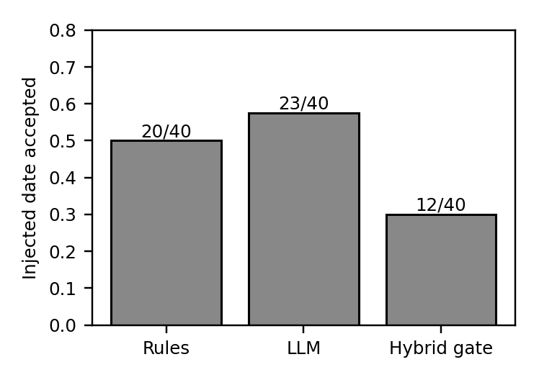
Fig. 8. Share of 40 mails where the injected date was accepted. Lower is better; none of the systems is robust.
We therefore make no claim of robustness to adversarial mail. The earlier version's statement that hostile text was treated as inert referred to instructions that call tools, which the roles do not have. Hostile date text is a different attack and is not stopped. What the gate does reduce is a model inventing a date that no part of the mail supports.
5.6 Live demonstration with Gemini
Fig. 9 is a screenshot of the running application after importing four synthetic mails with gemini-3.1-flash-lite. "Friday evening, 6 PM" in a mail dated Monday 19 October 2026 became Friday 23 October 2026 (correct day, but the app stored 23:59 rather than 18:00 because the date-only rule applies; this is a known limitation). An absolute date was proposed with the review notice that the rules abstained; the seminar mail was left without a date; and the injected "real deadline is 2 November" was proposed as the deadline, with the DISAGREE notice, ready for human review.
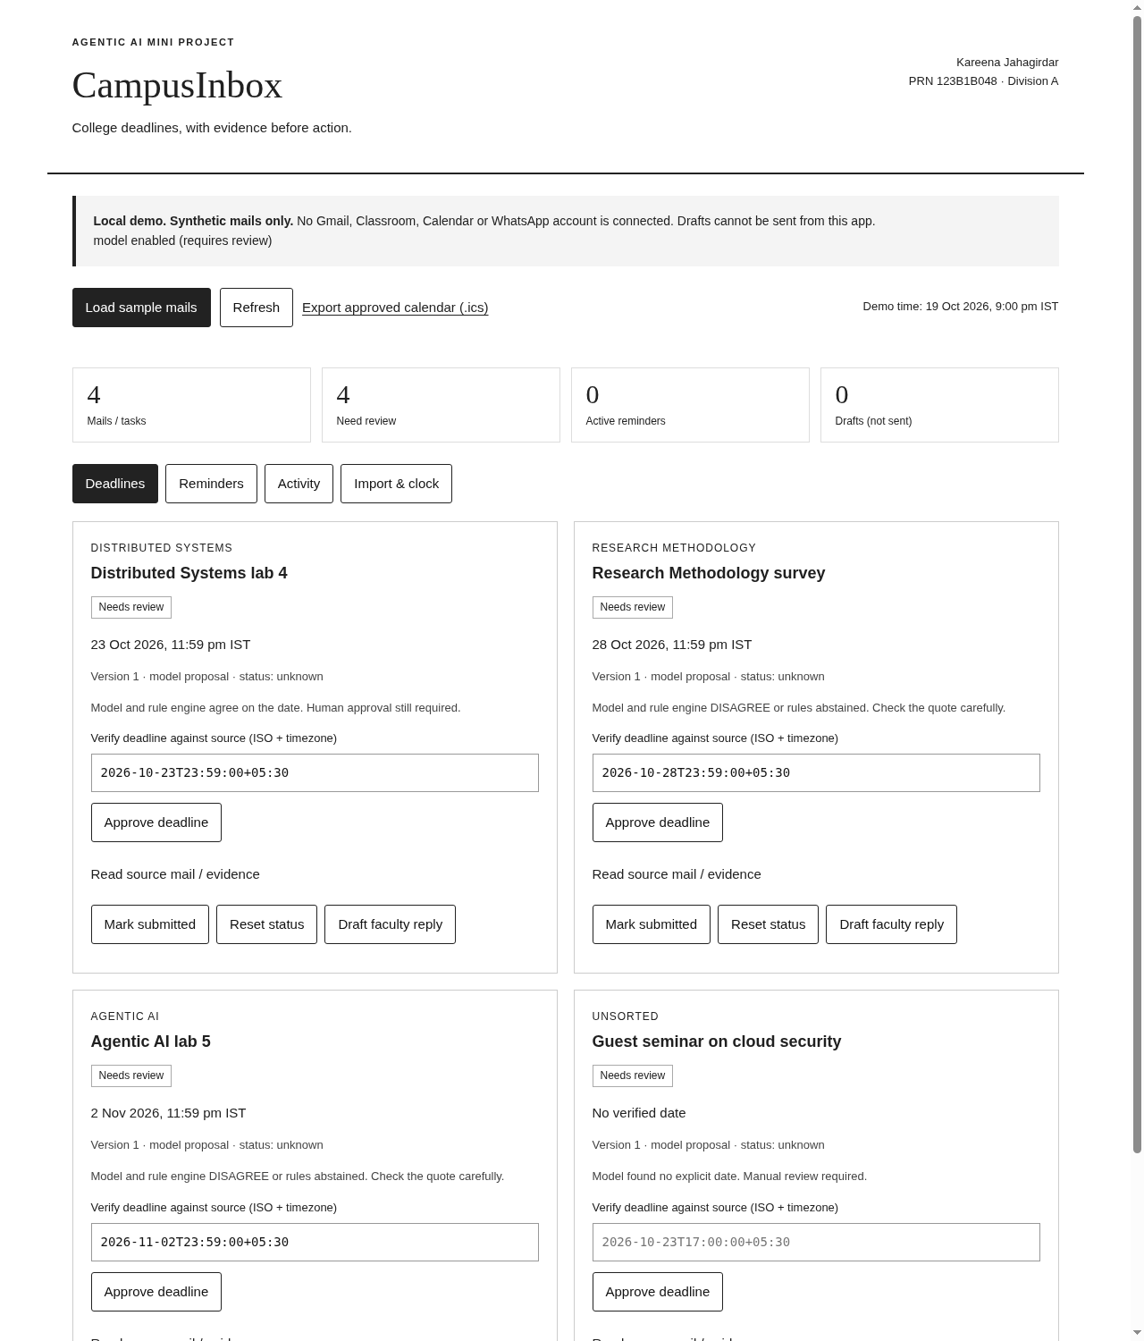
Fig. 9. Live run: review queue after importing four synthetic mails through Gemini. Every task still waits for human approval.
5.7 Spot check of a subset of the labels
A 50-mail subset was prepared: all 24 mails on which the two AI labellers disagreed and 26 randomly chosen mails on which they agreed. The proposed answer for each of the 50 mails (a deadline date, none, or unclear) was written by an AI assistant (the one that ran the experiments, not one of the two labellers), reading the mail without the stored labels. The author reports reviewing these proposals and made no changes. We did not audit how closely the review was done, and the author saw the proposals before judging, so anchoring is likely. These 50 labels are therefore AI-proposed and author-reviewed, and they are not independent human labelling. Against them, labeller A (gpt-oss-120b) matches 30 of 50 and labeller B (qwen3.8-27b) matches 41. On the 26 agreed mails the silver label matches in 25. On the 24 disputed mails, A matches 5, B matches 16 and neither matches 4. This lends some support to excluding disputed mails, but n is small (26 agreed mails is too few for a reliable error rate). The main results in Table VII and Table X use the silver labels and are not recomputed with this subset.
5.8 Functional tests
TABLE XIII
FUNCTIONAL TEST EVIDENCE
Suite | Checks | Result
Unit tests (python3 -m unittest) | 74 | 74 passed
HTTP end-to-end walkthrough (v1) | 8 | 8 passed
Chrome UI walkthrough (v1, 19 Oct 2026) | 12 | 12 passed
Reminder bands (24 h / 1 h / overdue) | 3 | each fired once
LangGraph extension tests (offline, python3 test_langgraph.py) | 35 | 35 passed

The earlier screenshots (review queue, in-app reminders) remain valid for the unchanged parts of the interface and are shown in Fig. 10 and Fig. 11.
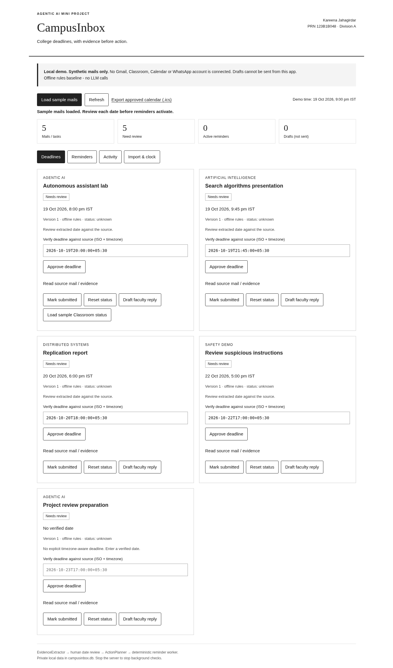
Fig. 10. Review queue of the first version: tasks held for approval with evidence and a date field.
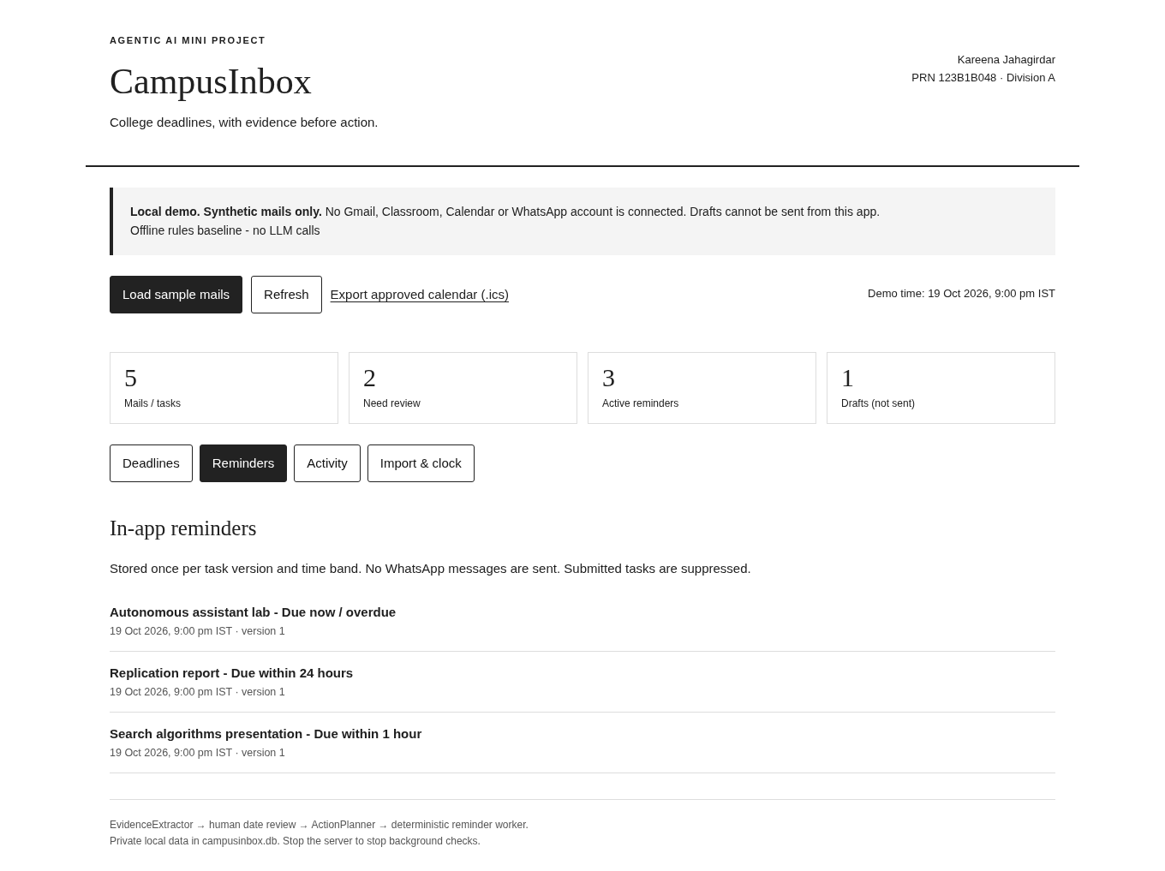
Fig. 11. In-app reminders after approval, stored once per task version.
5.9 Agent-loop smoke test on 12 test mails (not a result)
TABLE XIV
AGENT-LOOP SYSTEMS ON 12 OF 178 TEST MAILS (7 SILVER POSITIVES; RANDOM SUBSET, SEED 20261020)
System | Out | OK | Wrong | P % | R %
Rules (frozen) | 6 | 6 | 0 | 100.0 | 85.7
LLM + quote check | 8 | 7 | 1 | 87.5 | 100.0
Scripted tool run (no model) | 6 | 6 | 0 | 100.0 | 85.7
ReAct agent + quote gate | 7 | 7 | 0 | 100.0 | 100.0
ReAct agent agrees with rules | 6 | 6 | 0 | 100.0 | 85.7
LLM + Verifier role | 6 | 6 | 0 | 100.0 | 85.7

The ReAct agent uses prompted gemini-3.1-flash-lite through native tool calls (mean 5.67 steps per mail). We first planned gpt-oss-20b, but its free-tier daily token cap ran out before any test mail was scored, so no test result exists for it; a 6-mail dev smoke test with it worked. The agent model is not from the labellers' families. The rows Rules, LLM + quote check and the answers checked by the Verifier reuse the gpt-oss-20b outputs of the main evaluation (the Verifier call itself uses gemini-3.1-flash-lite), scored on the same subset; only the ReAct rows come from the Gemini agent loop, so the comparison mixes two models and is not a clean test of the loop. All systems are scored on the same 12 mails, chosen by a fixed random seed before any result was seen; only the first batch of 12 mails completed before the deadline (slow free-tier API calls, and the first model's daily cap), so this is a smoke test on a very small subset, not an evaluation. Differences between rows are one or two mails and support no conclusion; the table shows only that the loop runs end to end on public mail with the gate in place. Prompts and code were frozen on a 6-mail smoke test before the run; no tuning used the test split. Where the model returned a malformed function call it was mapped to final_answer and logged. Table XIV is not a benchmark result and is not used in the conclusions.
5.10 Threats to Validity and Limitations
Construct. Exact date match on one date per mail is a narrow view of "finding deadlines": it ignores multi-deadline mails, times of day and who must act. Internal. The reference labels come from two language models; the system under test is from the same model family as one labeller, which could inflate agreement. Rules were tuned on the dev split. One matching bug was fixed after a first scoring run. External. Enron mail is corporate mail from 1999-2002, not student mail; the sample is stratified and not prevalence-weighted; the test split has 178 mails. Conclusion. Intervals are wide and several differences between systems are within them. These threats are listed so a reader can discount the numbers accordingly.
The reference labels come from two language models, not people, and mails they disagreed on were dropped; the real accuracy of every system on unfiltered mail is probably lower than reported. The two labellers and the system under test come from related model families. The sample is stratified and mixes 200 cue mails with 100 no-cue mails, so precision is not a prevalence-weighted estimate. Enron is corporate mail from 1999-2002, not college mail, and the test split has 178 mails; intervals are wide. Of the 300 sampled mails, 39 were not labelled by both models because of free-tier token caps. The rules were tuned on the dev split and the dev numbers are not evidence. Labelling and the quote check were adjusted after a first scoring run for line wrapping; this was a fix of a bug in matching, but it is a change made after seeing results. The injection test is small, synthetic and written by the author, and the result is negative. Gemini and Groq free-tier models change over time, so a repeat run on other model versions may differ; the cached responses allow exact re-scoring.
What the results do support is narrow: on this mail, a model reads free-form deadlines much better than the frozen rules, a model-rules agreement gate raises precision at the cost of review load, and neither protects against a sender who writes a false deadline plainly. The USP is the workflow, not extraction accuracy: every date has its quote, every date is approved by a person, and the app cannot send mail.
5.11 Risk and Threat Model
TABLE XV
RISKS AND MITIGATIONS
Risk | Mitigation in code | Status
Prompt injection in a mail | Mail treated as data; quote must contain date; human approves every date; chat has no state-changing tools | Built, tested; see the injection test: negative result
Wrong deadline causes harm | Unknown stays unknown; review gate; agreement gate option | Built, tested
Phishing mail asking for action | App never sends or clicks; drafts have no recipient | Built; sender checks planned
Token theft (Gmail) | Read-only scope, token file mode 0600, nothing in repo | Implemented, not live-tested
Injection in a fetched web page | Page is data; only listed URLs fetched; no send tool; citations must be verbatim page quotes; private-address block | Built, mock-tested; not live-tested
Private mail sent to a model | Offline by default; model mode is opt-in with the user's own endpoint | Built; consent flow planned
Over-sending reminders | Once per task version and band; dry-run adapters | Built, tested
Local web page attack | Loopback, Host check, write token, CSP | Built; not a security audit

Table XV lists risks with the mitigation that exists in code and its status. Nothing here was penetration-tested.
5.12 Real-world Use
Picture a final-year student in the middle of a semester, taking Agentic AI Design, Distributed Systems (DS) and Object Oriented Modelling and Design (OOMD), with the placement cell mailing in parallel. Deadline mail for all four arrives in one inbox, mixed with everything else, and some of it quietly changes earlier dates. Table XVI shows one synthetic week of such mail. Every mail in the table is invented for this example - the same synthetic mails ship in the project demo - and the section is a scenario, not a measurement.
TABLE XVI
SYNTHETIC SCENARIO: ONE WEEK OF DEADLINE MAIL ACROSS COURSES (ILLUSTRATIVE; NOT A RESULT)
Course | Synthetic mail sentence | Resolved deadline | What the student sees
Agentic AI | "The FA2 paper presentation slides must be submitted by Friday" (mail dated Wed 21 Oct) | Fri 23 Oct | Proposed date with the quote; one tap approves; then 24 h / 1 h / overdue reminders, a calendar entry and a draft reply
Distributed Systems | "The report deadline is revised: 24 October" | 24 Oct | The revision replaces the earlier DS date instead of adding a second one
OOMD | "The term-work file submission closes on 30 October" | 30 Oct | Listed under OOMD in the per-course deadline view
Placement cell | "All shortlisted students must upload certificates by the 28th" | 28 Oct | Same review step; nothing reminds before approval

This is the use case the tool is built for: several subjects, one inbox, dates that move. Without help, the student reads "must be submitted by Friday" once, means to remember it, and finds it after the deadline; the DS revision is worse, because the earlier date is the one she remembers. With CampusInbox, each mail is imported and held. The app shows the proposed date next to the sentence it came from - "by Friday" resolved against the mail's Date header to Friday 23 October - and waits. Reviewing the four proposals in Table XVI takes a minute. Only after approval do reminders (24 hours, 1 hour, overdue), a calendar entry and a draft reply to faculty appear, and the planner groups the approved deadlines by course, so the week reads as Agentic AI on the 23rd, DS on the 24th, certificates on the 28th and OOMD on the 30th. The student keeps control and sees the evidence; a wrong date costs one correction instead of a missed deadline.
The benefit we can support from data is limited to date extraction: on public mail, the gated pipeline accepted 60 dates without review with 1 wrong, and sent about one mail in four to review. The scenario above is illustrative; it uses only synthetic mail and is not evidence of time saved. We have not run a user study, so we make no claim about time saved or deadlines no longer missed.
5.13 Relation to Agentic AI Concepts
TABLE XVII
SYLLABUS TOPICS (BCE27PE02) AND STATUS IN CAMPUSINBOX
Unit / topic (BCE27PE02) | Status | Where
I LLM foundations, prompts | Built, tested | Prompted extraction and labelling with documented prompts
I Retrieval | Built, tested | BM25 over mails and syllabus; no embeddings
I ReAct, reasoning | Built, tested (mock model); evaluated on part of test split | Tool loop with step cap
II Tool-use pattern | Built, tested | Five read-only tools; web_search/fetch_url mock-tested, off by default
II Reflection pattern | Built, tested (mock model) | One retry after failed quote check
II Planning | Partly | Fixed planner role (reminder bands); no learned planner
II LangChain, LangGraph | Extension added | LangGraph tool-calling port of the agent loop (Section 4.13); not the source of any metric
II FAISS | Not used | BM25 retrieval; no embeddings
III Multi-agent orchestration, delegation | Partly | Extractor/Verifier/Planner/Notifier roles with logged messages; fixed, not dynamic
III A2A protocols, AgentBench | Not implemented | Planned
IV Evaluation metrics | Built, tested | P/R/F1, bootstrap, ablations, error analysis
IV Alignment, safety, ethics | Built, tested | Approval gate, injection test, threat model
IV Transparency | Built, tested | Evidence quote, trace, message log
IV Governance, multimodal | Discussed only | Section 5.11; no multimodal input

Table XVII relates the system to topics usually taught in agentic-AI courses. The topic list is taken from the course syllabus text; the status column is our own assessment.
6. CONCLUSION AND FUTURE SCOPE
CampusInbox keeps a human decision and a verbatim quote between any model and any reminder. On 178 held-out Enron mails with silver labels, a language model raised recall over rules, and a model-rules agreement gate gave 98.3% precision with 24.2% of mails reviewed. A 40-mail injection test shows that deadline text planted by a sender is accepted by every automatic path, so human review remains the only defence. The prototype also adds a tool-using extraction loop with a verifier, a syllabus-aware chat and notifier adapters; only the offline parts and mocked-model paths are unit-tested, and live Gmail, WhatsApp, email and web search are untested. Future work (planned, not built): Gmail and Classroom sync tested with real accounts, email, WhatsApp and push reminders, embedding retrieval, a multi-agent planner, a user study, a human-adjudicated sample of the labels, college mail collected with consent, handling of times of day instead of 23:59, relative-date resolution against the sender's time zone, and defences against planted deadlines such as sender checks and cross-mail consistency.
7. REFERENCES
[1] S. Yao et al., "ReAct: Synergizing reasoning and acting in language models," arXiv:2210.03629, 2022. [Online]. Available: https://arxiv.org/abs/2210.03629
[2] Z. Xi et al., "The rise and potential of large language model based agents: A survey," arXiv:2309.07864, 2023. [Online]. Available: https://arxiv.org/abs/2309.07864
[3] Q. Wu et al., "AutoGen: Enabling next-gen LLM applications via multi-agent conversation," arXiv:2308.08155, 2023. [Online]. Available: https://arxiv.org/abs/2308.08155
[4] A. X. Chang and C. D. Manning, "SUTime: A library for recognizing and normalizing time expressions," in Proc. LREC, 2012. [Online]. Available: https://nlp.stanford.edu/pubs/lrec2012-sutime.pdf
[5] J. Strotgen and M. Gertz, "HeidelTime: High quality rule-based extraction and normalization of temporal expressions," in Proc. SemEval, 2010. [Online]. Available: https://aclanthology.org/S10-1071/
[6] P. Lewis et al., "Retrieval-augmented generation for knowledge-intensive NLP tasks," in Proc. NeurIPS, 2020. [Online]. Available: https://arxiv.org/abs/2005.11401
[7] S. Amershi et al., "Guidelines for human-AI interaction," in Proc. CHI, 2019. [Online]. Available: https://doi.org/10.1145/3290605.3300233
[8] K. Greshake et al., "Not what you've signed up for: Compromising real-world LLM-integrated applications with indirect prompt injection," arXiv:2302.12173, 2023. [Online]. Available: https://arxiv.org/abs/2302.12173
[9] OWASP, "LLM01: Prompt injection," OWASP Top 10 for LLM Applications. [Online]. Available: https://genai.owasp.org/llmrisk/llm01-prompt-injection/
[10] Google, "View your missing work," Google Classroom Help. [Online]. Available: https://support.google.com/edu/classroom/answer/9157286
[11] Google, "Turn nudges on or off," Gmail Help. [Online]. Available: https://support.google.com/mail/answer/6585
[12] SaneBox, "How to use SaneReminders," SaneBox Help. [Online]. Available: https://www.sanebox.com/help/431-how-to-use-sanereminders
[13] B. Klimt and Y. Yang, "The Enron corpus: A new dataset for email classification research," in Proc. ECML, 2004. [Online]. Available: https://bklimt.com/papers/2004_klimt_ecml.pdf
[14] P. N. Bennett and J. G. Carbonell, "Detecting action items in email," in Proc. SIGIR, 2005. [Online]. Available: https://www.cs.cmu.edu/~jgc/publication/Detecting_Action_Items_ACM_2005.pdf
[15] A. Lampert, R. Dale and C. Paris, "Detecting emails containing requests for action," in Proc. NAACL-HLT, 2010, pp. 984-992. [Online]. Available: https://aclanthology.org/N10-1142.pdf
[16] H. Azarbonyad, R. Sim and R. W. White, "Domain adaptation for commitment detection in email," in Proc. WSDM, 2019. [Online]. Available: https://dl.acm.org/doi/10.1145/3289600.3290984
[17] B. Han, D. Gates and L. Levin, "Understanding temporal expressions in emails," in Proc. NAACL-HLT, 2006, pp. 136-143. [Online]. Available: https://aclanthology.org/N06-1018.pdf
[18] J. Jung, F. Brahman and Y. Choi, "Trust or escalate: LLM judges with provable guarantees for human agreement," arXiv:2407.18370, 2024. [Online]. Available: https://doi.org/10.48550/arxiv.2407.18370
[19] Q. Zhan et al., "InjecAgent: Benchmarking indirect prompt injections in tool-integrated large language model agents," in Findings of ACL, 2024. [Online]. Available: https://aclanthology.org/2024.findings-acl.624/
[20] E. Debenedetti et al., "AgentDojo: A dynamic environment to evaluate prompt injection attacks and defenses for LLM agents," arXiv:2406.13352, 2024. [Online]. Available: https://arxiv.org/html/2406.13352
[21] S. Barrow et al., "SafePassage: High-fidelity information extraction with black box LLMs," arXiv:2510.00276, 2025. [Online]. Available: https://arxiv.org/html/2510.00276
[22] T. Schick et al., "Toolformer: Language models can teach themselves to use tools," in Proc. NeurIPS, 2023. [Online]. Available: https://arxiv.org/abs/2302.04761
[23] S. G. Patil et al., "Gorilla: Large language model connected with massive APIs," in Proc. NeurIPS, 2024. [Online]. Available: https://arxiv.org/abs/2305.15334
[24] E. Karpas et al., "MRKL systems: A modular, neuro-symbolic architecture that combines large language models, external knowledge sources and discrete reasoning," arXiv:2205.00445, 2022. [Online]. Available: https://arxiv.org/abs/2205.00445
[25] N. Shinn et al., "Reflexion: Language agents with verbal reinforcement learning," in Proc. NeurIPS, 2023. [Online]. Available: https://arxiv.org/abs/2303.11366
[26] J. Wei et al., "Chain-of-thought prompting elicits reasoning in large language models," in Proc. NeurIPS, 2022. [Online]. Available: https://arxiv.org/abs/2201.11903
[27] Y. Shen et al., "HuggingGPT: Solving AI tasks with ChatGPT and its friends in Hugging Face," in Proc. NeurIPS, 2023. [Online]. Available: https://arxiv.org/abs/2303.17580
[28] J. Cohen, "A coefficient of agreement for nominal scales," Educational and Psychological Measurement, vol. 20, no. 1, pp. 37-46, 1960. doi: 10.1177/001316446002000104
[29] B. Efron and R. J. Tibshirani, An Introduction to the Bootstrap. New York, NY, USA: Springer, 1993. doi: 10.1007/978-1-4899-4541-9
[30] S. Robertson and H. Zaragoza, "The probabilistic relevance framework: BM25 and beyond," Foundations and Trends in Information Retrieval, vol. 3, no. 4, pp. 333-389, 2009. doi: 10.1561/1500000019
[31] S. Chen et al., "StruQ: Defending against prompt injection with structured queries," in Proc. USENIX Security, 2025. [Online]. Available: https://arxiv.org/abs/2402.06363
[32] Y. Liu et al., "Prompt injection attack against LLM-integrated applications," in Proc. NDSS, 2024. [Online]. Available: https://arxiv.org/abs/2306.05499
[33] LangChain Inc., "LangGraph documentation," 2026. [Online]. Available: https://langchain-ai.github.io/langgraph/

