Analysis Specification on Grocery and stock management

Karsang Sherpa

0174416

Computing Project

Level 5 Diploma in Computing

Softwarica College of IT & E-Commerce

Kathmandu, Nepal

8th May 2019

**Introduction**

Before developing any project any developer should first go through this stage. Analysis is a process of collecting data and requirements from user for the product. During analysis the user are directly or indirectly involved in the process. Here the user puts his demands and the developer discuss the possible features that would available for their product. Analysis requires collection data to be processed which helps the developer to pledge the software development. Below are some points reasoning why the analysis stage is crucial for software development.

* It helps to find out and understand the requirement specification.
* During analysis you cooperate with the users and work together.
* Analysis helps to find out the problem and prevent them from occurring.
* It helps to make the system more efficient.

I have preferred to use SWOT analysis for our project. SWOT stand for strength, weakness, opportunity and threats. They all play an important role in our software development.

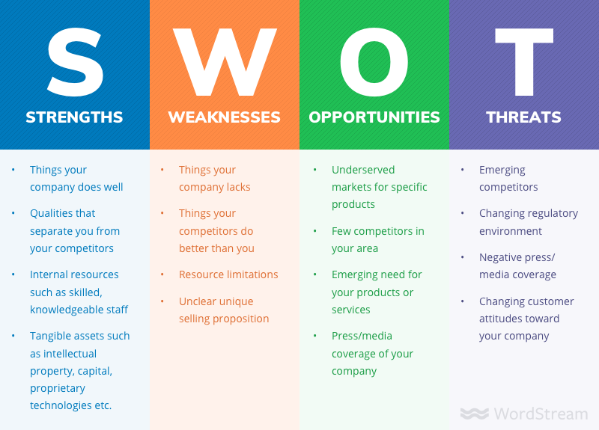

**Strength:** Every project have their own strength and qualities which separates them form other projects. These things helps the project to process well in the future. My project strength includes budget and cooperation with the user.

**Weakness:** Each project have their own weakness that keeps them apart from other project. Weakness can be defined in mays ways like limited budget, limited resources, lack of information etc. My project weakness includes not being able to access online since its desktop based application.

**Opportunity:** Opportunity meaning getting a chance to show that you can do better than others. So if possible always try to include more opportunities to any project. The opportunity that I will be taking advantage is Grocery stores are rising and getting bigger every year. So most possible many stores would be needing a software to keep their goods data and since my software is based on grocery and stock management I would be benefitted.

**Threats:** There are two types of possible threats you make face in an organization.

1. **Internal threat:** These threat are included inside the organization such as budget, efficiency, skills, resource and others are Internal Threat. These threats can be easily maintained. My project might face unexpected errors in the application near future.
2. **External threat:** These are occur outside the organization which cannot be maintained easily. External threats includes competitors, negative remarks, trend, culture etc. many people may actually be making software like mine or even better.

**Feasibility study**

This investigation holds the overall analysis of the undertaking and states how to actualize or whether the project is appropriate to continue further for the creating stage or not. It considers every parts of the task from begin and as far as possible and even after the sending procedure, so this investigation is extremely crucial stage in the examination procedure. It examines the expense and planning of the creating and organization of the task. Financial and legitimate terms are additionally talked about if the project is fit in the earth where it will be conveyed. There are numerous angles to be attainable in the task and regardless of whether one holds false then potential arrangements must be figured and build up the framework as indicated by it.

Economic feasibility: Here we discuss if our project is financially possible or not. This helps us to find out the total budget we require to continue our project. Since my project is under the budget I hold so it’s more than feasible.

Technical Feasibility: This feasibility defines if our project have all technical resources to continue the project. It also checks if the current hardware and software supports the software. Since I have all the things I technically need for my project I can continue developing my project.

Social Feasibility: This feasibility checks if the system is socially fit in the environment. Social standards and qualities, morals and good code and leads must be remembered that the framework won't block the surrounding's code. This study should to be done in all respects cautiously as it is an extremely touchy issue.

Legal Feasibility: Here we discuss if the project is lawfully acceptable .Government decisions in the system matters and there should be a proper study done regarding the terms and conditions of the state. Organization cannot step out of the boundary from these rules and regulations otherwise the project can be terminated.

**Requirements Analysis**

Functional requirements

Here we discuss about the functions that are the included in the system. As demanded by the user we try to keep every functions necessary for the system. Below are some functions that are included in the system:-

|  |  |  |  |  |
| --- | --- | --- | --- | --- |
| F.ID | Function | Data required | Dependency | Remarks |
| F1 | Registration | Username & password | N/A | To generate an admin |
| F2 | Admin control CRUD operation | Not required | F1 | For controlling data |
| F3 | Add staffs | Resume of the staff | F1 | To add staffs |
| F4 | Add item | Description of the item | F1 | To add items |
| F5 | Generate the total amount and bill | Price of the item | F4 | To Generate the total amount and bill |
| F6 | Check stock | Requires quantity of the item | F4 | To check whether there is enough item in stock |

Non-Functional Requirement

Non-functional requirement helps to improve the functional requirements. Below are some examples of non-functional requirements:-

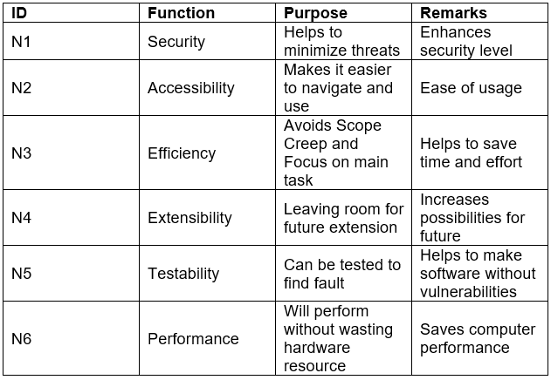

Moscow Prioritization

It is a technique to characterize the priorities required for the system. It distinguishes the necessary requirement needed for the system and excludes the other requirements. MOSCOW prioritization are separated into 4 categories.

Must Have: This are the requirements which are essential for the system. Without these requirements the system cannot function properly.

Should Have: When certain requirements are added the system happen to function well. This are requirements which are included in should have prioritization.

Could Have: This requirements are not much essential but including them can enhance the system. Depending on the MOSCOW prioritization this requirements can be overlooked if we have choose to ignore some requirements.

Won’t Have: Some requirements can be overlooked to maintain the system.

MOSCOW Prioritization for functional requirements:

|  |  |  |
| --- | --- | --- |
| **ID** | **Title** | **Prioritization** |
| F1 | Registration | Must have |
| F2 | Admin Control | Must have |
| F3 | Add staffs | Should have |
| F4 | Add items | Should have |
| F5 | Bill | Could have |
| F6 | Stock | Should Have |

MOSCOW Prioritization for non-functional requirements:

|  |  |  |
| --- | --- | --- |
| **ID** | **Title** | **Priority** |
| N1 | Security | Must Have |
| N2 | Accessibility | Must Have |
| N3 | Efficiency | Must Have |
| N4 | Extensibility | Should Have |
| N5 | Testability | Must Have |
| N6 | Performance | Must have |

## Software Requirement Specification

**Software Requirements**

* Windows 7, 8 or 10 / Linux / max OS

**Hardware Requirements**

* Intel processor i3 & over for Processor
* Ram should be 4 Gigabyte or over
* Intel HD 4600 & over for Video Card

# **Use Case Diagram**

Use case diagram is used to picture user’s interaction with the system which shows the relationship between the operators and different use cases in which the operators is involved.

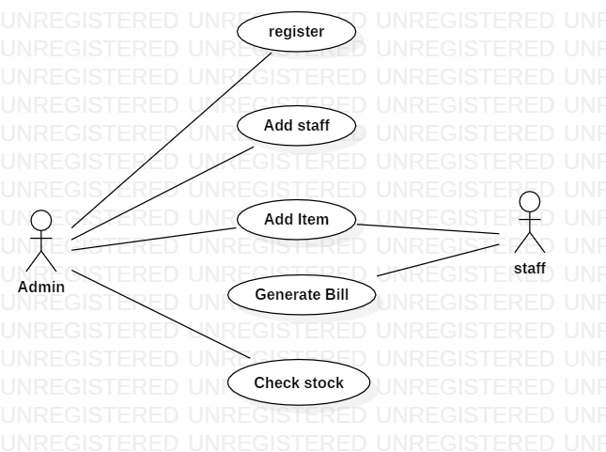

# NLA

Natural Language Analysis, NLA, is method through which we define Nouns, Verb and Adjective from a problem statement. NLA helps computers to comprehend and interpret the meaning from natural language.

* Nouns helps us to find Classes
* Verb helps us to find methods
* Adjective helps us to find attributes

**Our Scenario**

If you every setup a grocery and don’t know how to manage the bill and stocks. Grocery billing application is the perfect application that would be of use to you. Grocery billing application helps you to manage the bills and it also helps you to track your stocks so that your goods are always available whenever you want them. You can even add, remove staffs and items to keep a good record for things and schedule the staffs their time. Grocery billing system is a simple system which is handy in daily grocery stores. Admin has CRUD control over many data. He can edit, delete and add Game data. He is fully authorized to manage wallet of customers. He can edit and delete their user information as well as reviews.

Unfiltered selection

Nouns: grocery, bill, stock, staffs, items, admin

Verb: add, remove, billing, schedule

Filtered selection

|  |  |
| --- | --- |
| nouns | Admin, Staff, Items, Stock |
| verbs | Add, Remove, Billing |

