Project Proposal Report on

Grocery billing and stock management

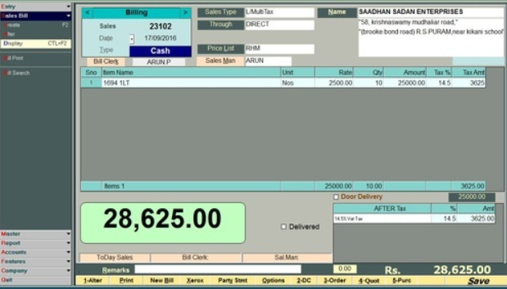

Submitted by

Karsang Sherpa

NCC ID: 00174416

Level 5 Diploma in Computing

Batch - 22 “B”

Softwarica College of IT and E-Commerce

Kathmandu Nepal

Submitted to

Niman

Contents

Overview 4

1.1 Introduction 4

1.2 Background 4

1.3 Description 4

1.3.1 Features of the project 4

Scope 5

2.1 Aims 5

2.2 Objectives 5

2.3 Overview of the scope 5

Development Methodology 6

Project Planning 8

4.1 Work Breakdown Structure 8

4.2 Time estimation 9

4.3 Milestones 9

4.4 Scheduling 10

Other project activities 12

5.1 Risk Management 12

Conclusion 14

# Table of figures

Figure 1 Waterfall Model 4

Figure 2 Work Breakdown Structure 6

Figure 3 Gantt chart 10

Figure 4 Gantt chart 11

Figure 5 Level of Likelihood with its value. 13

Figure 6 Level of consequences with its value 13

# Overview

## Introduction

If you every setup a grocery and don’t know how to manage the bill and stocks. Grocery billing application is the perfect application that would be of use to you. Grocery billing application helps you to manage the bills and it also helps you to track your stocks so that your goods are always available whenever you want them. Grocery billing system is a simple system which is handy in daily grocery stores.

## Background

People buy grocery every day for their daily day use. Before people use calculator to calculate the bill where they also required a copy to write every items and their price. This type of iteration consumes more time and effort and less productivity. So the grocery billing system includes all the features like adding items to the inventory and helps to manage the bill more quickly and easily.

## Description

Therefore, the overall concept of this project is to remove the traditional way of selling grocery items and made them easier to sell more safely and conveniently, quickly, and fairly by implementing an application where user can login and can sell and store items and keep track of their items.

## Features of the project

Here are some of the expected feature of the project:

* User will register themselves with their detail information.
* User will have to login to check their daily routine.
* User can easily update their information but cannot delete.
* Admin will be provided with separate email/username and password so they do not need to register themselves.
* The admin can add, delete and update all the items.
* The user able to check the prices of the items.
* The admin will be able to manage the stock.

# Scope

The part of the project planning that involves determining and documenting a list of specific project goals, deliverables, task, cost deadline, features, and functions is knows as project scope. The documentation of the project scope explains the boundaries of the project, establishes responsibility for each team member and sets up procedures for how completed work will be verified and approved.

## Aims

The main aims of the sell grocery billing and stock management is to allow the user to sell their items in fast, fair and convenient way.

## 2.2 Objectives

So, in order to achieve the aim of the project I have following objectives:

1. To allow the user to login and register.
2. To provide secure system for the user.
3. To make user friendly application.
4. To allow user to sell their items in fast, fair and convenient way.
5. To help the user to communicate with each other.
6. To manage stocks properly.

## 2.3 Overview of the scope

The boundary of the project is limited in certain way because this project is only based for our country only. However, the overall aim of the project is to create a web-based application to allow the user to sell their car in fast, fair and convenient way. This web-based application will be very useful because it will remove the traditional way of selling the car with lots of paperand will provide lots of benefit to the user.

# Development Methodology

Since our project is about grocery billing and stock management is an application where we need to follow the development methodology because it helps to develop the system/project by following each steps mentioned in it. There are lots of development methodologies available such as waterfall model, agile etc. I will be using Waterfall Methodology for this project.

Waterfall method is a classic approach to the system development method also knows as linear-sequential life cycle model because each phase must be completed fully before the next phase can begin and the phase do not overlap.(Level et al., 2018) It is very simple to use and understand. Since our project is a small project with the requirement already known I decided to use the waterfall model because waterfall model works well for the smaller project where requirement are very well understood.

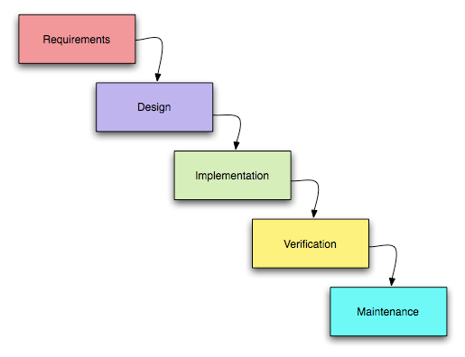

Figure 1 Waterfall Model

Here’s some advantage of waterfall model:

1. Simple, easy to use and understand.
2. Easy to manage because each phase has specific deliverables and a review process.
3. Phases are processed and completed one at a time they do not overlap.
4. Waterfall model works well for the smaller project where requirement are very well understood

The disadvantages of waterfall model are:

1. High amount of risk and uncertainty.
2. Once the project is in testing stage, it is very difficult to go back and change something that was not well thought out in the concept stage.
3. Not suitable for the project where requirement is at a moderate to high risk of changing
4. Not suitable for long and ongoing project.

As we know that design pattern is the reusable solution for software development. I will be using MVC (Model View Controller) design pattern and object-oriented approach using frameworkfor my project. In the project MVC pattern will help to separate the structure of the code into three different section where model represent the business logic and data, view is responsible to display the data provided by the model in specific format and controller handles the model and view layer to work together. The reason I will be using MVC pattern is because of faster development process also the modification does not affect the entire model.

# Project Planning

## 4.1 Work Breakdown Structure

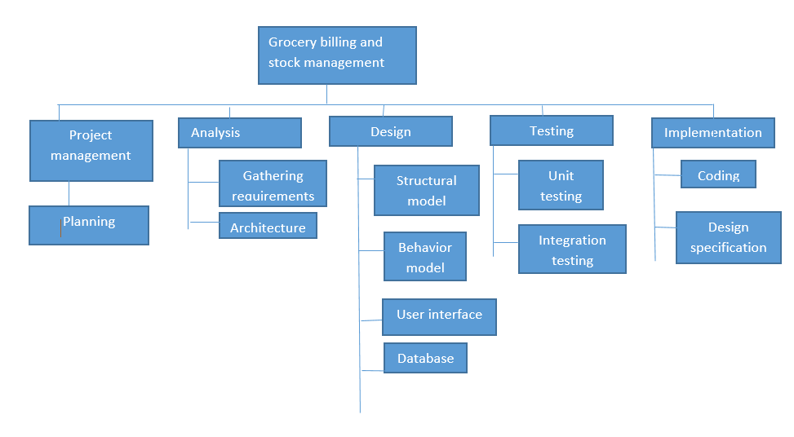

Figure 2 Work Breakdown Structure

A work break down structure is a used to break down a project into a manageable components. It helps to assist with accurate project organization, assigning responsibilities, accurate estimation of cost, risk and time also shows the project milestone. So as shown in the figure above I have made a work break down structure for my project by dividing the main task into different small task.

## Time estimation

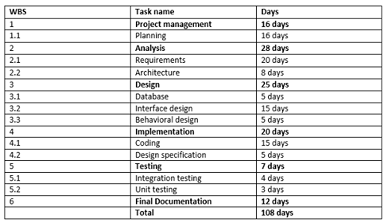

## 4.3 Milestones

## 

## Scheduling

A Gantt chart is a horizontal bar chart that is used frequently in project management to provide a graphical illustration of a schedule that helps to plan, coordinate and track the special tasks in a project.(The Economic Times, 2018) One of the major advantages of Gantt chart is its ability to monitor the progress of the project. We can use different tool to draw Gantt chart. I have also prepared Gantt char for this sell any car project using project libre which is shown below.

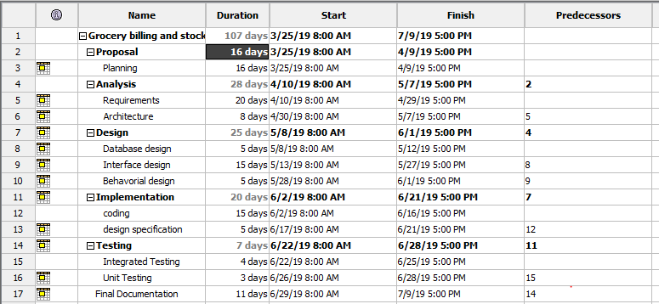

Figure 3 Gantt chart

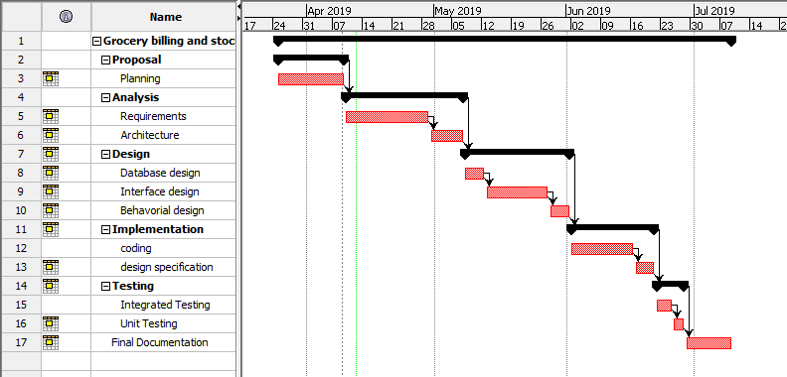

Figure 4 Gantt chart

# Other project activities

## 5.1 Risk Management

Risk

management is the process of identifying, analyzing an then responding to any risk that arises during the life cycle of the project to help the project remain on track and meet its goal. (Landau, 2018) Managing the risk should be the part of planning process to figure out the risk that might happen in the project and also how to control the risk if in fact it occur. So in order to manage the risk firstly all the risk must be identified with its impact of risk and then proper solution to those problem can be figure out. There are some steps for risk management they are:(Development, 2018)

1. Identify the risk
2. Analyze the risk
3. Evaluate or rank the risk
4. Treat the risk
5. Monitor and Review the risk
6. Identify the risk

In this phase we try to uncover, recognize and describe risks that might affect the project outcome. There are number of technique that we can use to identify the risk.

1. Analyze the risk

Once the risk are identified in this phase we determine the likelihood and consequences of each risk. We develop an understanding of the nature of the risk and its potential to affect the project goal and objectives.

1. Evaluate or rank the risk

In this phase or stage we evaluate or rank the risk by determining the risk magnitude, which is the combination of likelihood and consequences. We make decision about whether the risk is acceptable or whether it is serious enough to warrant the treatment.

1. Treat the risk

In this stage we assess our highest ranked risks and set out a plan to treat or modify these risk to achieve acceptable risk level.

1. Monitor and review the risk

In this stage we monitor, track and review the risk that occurs during the time of project.

Here are the risk that we might face during development process with its level of impact. So to identify the impact let us use level of likelihood and level of consequences table.

|  |  |
| --- | --- |
| **LIKELIHOOD** | **VALUE** |
| LOW | 1 |
| MEDIUM | 2 |
| HIGH | 3 |

Figure 5 Level of Likelihood with its value.

|  |  |
| --- | --- |
| **CONSEQUENCES** | **VALUE** |
| VERY LOW | 1 |
| LOW | 2 |
| MEDIUM | 3 |
| HIGH | 4 |
| VERY HIGH | 5 |

Figure 6 Level of consequences with its value

By multiplying the value of likelihood with the value of consequences the impact of risk can be calculated easily.

|  |  |  |  |  |  |
| --- | --- | --- | --- | --- | --- |
| **No** | **Risk** | **Likelihood** | **Consequences** | **Impact** | **Action** |
|  | Hard disk crash | 2 | 4 | 8 | Planning proper backup of files. |
|  | Natural Calamities | 1 | 4 | 4 | Using cloud storage, putting backup in different places |
|  | Time limitation | 2 | 3 | 6 | Work according to time schedule. |
|  | Unqualified employee | 2 | 3 | 6 | Providing proper training |
|  | Change in requirement | 1 | 5 | 5 | try to address the change requirement |
|  | Inaccurate estimation | 2 | 4 | 8 | Understanding all requirement at first before proposing a schedule |
|  | Unrealistic budget | 2 | 3 | 6 | Proper financial planning should be done |
|  | Design is infeasible | 1 | 5 | 5 | Design should be done according to the requirement. |

# 

## 5.2 Configuration Management

Configuration management refers to the process of handling the changes to a system in a way that it maintains integrity over time.(Digitalocean.com, 2018)Files and the folder related to the project will be arranged in systematic way so that it will be easier to access the file whenever necessary. The phases like analysis, design, coding, testing, documentation, and proposal will have different folders. A separate folder called backup will be created to store copy of all files. I will also be using **GitHub** to store the data and for regular backup so that it will be easier for data recovery in case of failure. Here is the screenshot of configuration management on my hard drive.

# Conclusion

At last I want to conclude that the project sell any car that I am going to build is going to solve the traditional problem for the people to sell their car using their paper work the user can sell their car quickly, conveniently and fairly by taking the advantage of the professional and without charge car inspection and the fast car buying service. To complete the project I have also done many analysis, time estimation , risk management , work breakdown structure etc. so that the project will be complete successfully without any project so that I want to conclude that now I am ready to start my project on sell any car.

# 