

**JPO PORTAL: ASSISTING UNEP TO RECRUIT THE RIGHT CANDIDATES**

**STUDENT NAME: NYODERO, ADIMA MESA**

**STUDENT NO: 076692**

An Information Systems Project Documentation submitted to the Faculty of Information Technology in partial fulfilment of the requirements for the award of a degree in Bachelor of Science Informatics and Computer Science.

Date of submission: September 2016

# Declaration

I declare that this project has not been submitted to any other University for the award of a Degree in Informatics and Computer Science.

Student Number: 076692

Signature:

Sign: ________________________ Date: ________________________

Supervisor’s Signature:

Sign: ________________________ Date: ________________________

# ABSTRACT

Human Resource has long been one of the key factors that influence a company’s performance and niche in the industry that it belongs to. The United Nations Environment Programme (UNEP) is one of the secretariat organizations mandated by the United Nations (UN) that bears the heavy task of monitoring the environment on a global scale. The Junior Professional Officers (JPO) play a very important role in ensuring that UNEP manages their responsibilities across its many divisions. The recruitment process of these officers takes a number of steps to ensure that the right candidates gets the position. Several steps are taken in the recruitment process of these officers to ensure that the right breed are selected.

This project will assist UNEP Human Resource (HR) Department to recruit the right candidates for the Junior Professional Level entry into the organization. This project seeks to automate this recruitment process and ease the burden of sifting through one’s email to search for the right candidate. The project will also employ the use of artificial intelligence and informatics as the applications come in to assist in getting some statistics for the HR Department.

The key outcomes of this project will include a web solution developed on the fastest PHP framework to ensure the best possible experience while dealing with the immense data that the organization interacts with. The main approach to developing this project will be prototyping and unit testing.

Table of Contents

Declaration i

ABSTRACT ii

Table of Figures vi

CHAPTER ONE: INTRODUCTION 1

1.1 Background of Study 1

1.2 Problem Statement 3

1.3 Aim 4

1.4 Research Objectives 4

1.5 Research Questions 4

1.6 Justification 4

1.7 Scope and Limitations 5

CHAPTER TWO: LITERATURE REVIEW 6

2.1 Introduction 6

2.2 Human Resource Management 6

2.3 UNEP’s Employee and Organizational Structure 9

2.3.1 Senior Management 9

2.3.2 Middle level Management 9

2.3.3 Other Employees 10

2.3.4 Junior Professional Officers (JPO) 10

2.4 Existing Human Resource Management Systems Recruitment Modules 11

2.4.1Workable Recruitment System 11

2.4.2iSmartRecruit 12

2.4.3Inspira Portal, United Nations 13

2.4.5 UNVKE Recruitment Portal, United Nations 14

2.5 Proposed System 15

CHAPTER THREE: METHODOLOGY 17

3.1 Introduction 17

3.2 System Development Methodology 17

3.3 System Analysis 18

3.4 Software Requirements Analysis 18

3.4.1 Functional Requirements 18

3.4.2 Non Functional Requirements 19

3.4.3 Use Case Diagram 20

3.4.4 Narrative Scenario 20

3.5 System Design 21

3.5.1 Interface design 22

3.5.2 Logicaldesign 22

3.6 Database design 22

3.7 Graphical Interface Design 22

3.7.1 Database Design 22

3.8 System Design Diagrams 23

3.8.1 Class Diagram 23

3.8.2 Database Schema 23

3.8.3 Sequence Diagram 23

3.9 System Implementation and Testing 23

3.9.1 Portal Deployment 24

3.9.2 Training 24

3.9.3 Execution 24

3.9.4 System Testing 24

3.10 Development Tools and Environment Used 26

3.10.1Microsoft Office Word 2016 26

3.10.2 Microsoft Visio 2016 26

3.10.3 Sublime Text 26

3.10.4 HTML, CSS and JavaScript 26

3.10.5 PHP 7 26

3.10.6 PHP Phalcon Framework 26

3.10.7 XAMPP 5.6.3 27

3.10.8 MySQL database management system 27

3.10.9 Github 27

3.10.10Browser 27

3.11 Hardware Requirements 27

3.12 Proposed System Modules 28

3.12.1 Authentication Module 28

3.12.2 Applicant Module 28

3.12.3 Government Module 28

3.12.4 Division module 28

3.12.5 Administrator module 28

3.12.6 Super Administrator Module 28

3.13 Deliverables 29

3.13.1 Project Proposal 29

3.13.2 System Documentation 29

3.13.3 Interactive JPO Portal 29

References 30

Appendix 33

Appendix A: Reference Document 1 33

Appendix B: Reference Document 2 34

# Table of Figures

Figure 2.1: Harvard Framework (Adopted from A Handbook of Human Resource Management Practice) 6

Figure 2.2: Organization Structure, UNEP (Adopted from http://www.unep.org/about/Structure/tabid/129623/Default.aspx) 8

Figure 2.4.4: Inspira Portal, UN (Adopted from https://inspira.un.org/psp/PUNA1J/EMPLOYEE/HRMS/h/?tab=DEFAULT) 13

Figure 2.4.5: UNVKE Recruitment Portal (Adopted from http://recruit.unvke.org/) 14

Figure 2.6: Conceptual Framework 16

# CHAPTER ONE: INTRODUCTION

## Background of Study

UNEP is the leading global environmental authority that sets the global environmental agenda, promotes the coherent implementation of the environmental dimension of sustainable development within the UN and serves as an authoritative advocate for the global environment(United Nations, 2016a). It was formed at the UN General Assembly Resolution of 1972(United Nations, 2016b). Although there was the endorsement and formulation of the environmental body, there was still a disconnect present from the social issues and environment issues in the 70s and 80s.

The Stockholm Conference of 1992 marked the formal acceptance by the international community that development and the environment are inextricably linked(United Nations Environment Programme, 2016f). This further streamlined the role and mandate that the organization is meant to undertake. It further stamped the role of the authority in organizational issues. The organization has been able to achieve a number of milestones from the year 2000 and beyond. The results and impacts of UNEP’s initiatives have had many adverse effects. These include international agreements to enhance environmental protection; periodic assessments and scientifically sound forecasts to support decision mailing and international consensus on the main environment threats and responses to them; support for more effective and international responses to environmental threats, including policy advice to governments and multilateral organizations; more effective coordination of environment matters within the UN system; greater awareness and capacity for environmental management among governments, the private sector and civil society and better understanding of the nexus between the environment and human security, poverty eradication and preventing and mitigating natural disasters(United Nations Environment Programme, 2016f).

The organization has five priority areas which are environmental assessment and early warning; development of policy instruments; enhanced coordination with environmental conventions; technology transfer and support to Africa(United Nations Environment Programme, 2016f).

To further execute its mandate, the organization is divided into divisions that execute their role that pertains to the environment. For sure, UNEP has established its presence around the world and is represented across the globe by six regional offices, Africa (Nairobi, Kenya); Asia and the Pacific (Bangkok, Thailand); Europe (Geneva, Switzerland); Latin America and the Caribbean (Mexico City, Mexico); North America ( Washington DC, USA) and West Asia (Manama, Barhain)(United Nations Environment Programme, 2016f).

To further understand the huge burden placed on the staff to deliver, their mission and mandate is listed below:

Mission: “To provide leadership and encourage partnership in caring for the environment by inspiring, informing, and enabling nations and peoples to improve the quality of life without compromising future generations” (United Nations Environment Programme, 2015).

Mandate: “To be the leading global environmental authority that sets the global environment agenda, that promotes coherent implementation of the environmental dimensions of sustainable development within the United Nations system and that serves as an authoritative advocate for the global environment” (United Nations Environment Programme, 2015).

The headquarters of the organization are housed in Gigiri Area, Nairobi, Kenya. To achieve the tasks and objectives set out for the organization, UNEP has to employ a large number of highly qualified and trained staff to achieve their mission and vision.

There exists a section of staff referred to as Junior Professional Officers within UNEP. There is no automated process for capturing applications and handling the recruitment and selection of JPOs.

The focal point for the JPO staff level is a HR employee who, among other duties, is assigned the role of JPO Coordinator. Once a position had been identified and a government has earmarked the job to be sponsored by them, they will send out an email to the JPO Coordinator and agree to the Terms of Reference of the job. Thereafter, the financing government will put up the job advert on their website while UNEP will also have it up on their website.

Interested candidates email their job applications to the associated government and as well as the JPO Coordinator. The applications that the governments receive from candidates will also be sent to the JPO Coordinator. The Coordinator then sends out the applications to the Hiring Manager or the HR/Admin Focal Point who will sift through the applications one by one and go through the selection process. They will then send the selected candidates to the JPO Coordinator who later sends them an email to confirm their selection. The governments will receive the list of all the applicants as well as the selected ones. This is for them to make their own selection in case the candidates do not satisfy their qualifications.

Some of the problems presented by the current system are that the system is tedious and manual for the involved parties; a lot of time is wasted through the back and forth communication between the JPO Coordinator, the governments and the Hiring Manager/HR Admin Focal point; reliance on emails alone takes a lot of time as parties may forget to check their emails on time. Slow servers may also cause disruption in communication and the lack of existence of an automated system easily allows the public to be taken advantage of by malicious conmen into giving funds for definite selection of the jobs. They may pry on innocent and unsuspected interested candidates.

## Problem Statement

Recruitment of JPOs is one of the core business of the HR team within UNEP. The department also deals with the management of government donations for the JPOs. As a result, of the number of chores in the team, HR Staff have no option but to go through thousands of emails hence receiving a heavier recruitment burden to them. This has led suspension of important activities conducted by the department to try and sift through numerous emails and documents from thousands of applicants. This leaves room for errors and not picking the correct candidates for the job that runs the risk of UNEP not meeting its expected goals.

## Aim

The aim of this project is to design, develop and test a system that will aid in the recruitment of JPOs within the UNEP HR Department.

## Research Objectives

1. To analyse the current method used at UNEP to streamline the operations between sponsoring governments for the JPOs and the UNEP HR Focal point.
2. To examine other recruitment portals used by the United Nations (UN).
3. To develop and test a web platform that will ease UNEP’s Human Resource Department in recruitment and selection process of JPOs.

## Research Questions

1. What is the current method used at UNEP to streamline the operations between sponsoring governments for the JPOs and the UNEP HR Focal point?
2. How do other recruitment portals used by UN work?
3. How can we develop a solution that will assist the HR Department to recruit and select the JPOs?

## Justification

There is a need for the HR department at UNEP to have a web application that will help the recruitment and selection process of the JPOs while also streamlining communication between governments and UNEP in regards to the candidates who get recruited for a job. UNEP is an organization that has a very global outlook and the use of web technology with an implementation of Artificial Intelligence in their HR department for this level will help them come up with a better policy to improve the organization and recruitment of the JPOs. The mission and vision of UNEP should not be downplayed. They need the best staff in order to make the world a better place, in terms of the environment.

## Scope and Limitations

This study focuses on the Human Resource department at UNEP, specifically the recruitment of the Junior Professional Officers. It also takes into account the governments that sponsor the positions and the applicants who are members of the countries where they have offices. However, this project will not reach into all the staff recruitment positions that require recruitment due to other systems being in place for such a wide scale of recruitments.

# CHAPTER TWO: LITERATURE REVIEW

## 2.1 Introduction

The main purpose of this chapter is to provide a comprehensive review of human resource management and its importance in an organization. It will also look at the employee and organizational character of UNEP, explain in detail the role of JPOs and their importance to the organization. It will also look at the existing recruitment systems used in organizations and also the UN, explain the current way of managing the JPOs and offer a solution based on the gaps that have been found during the study.

## 2.2 Human Resource Management

Human Resource Management (HRM) is designing formal systems in an organization to manage human talent for accomplishing future goals(Mathis, Jackson, & Valentine, 2013). The size of the organization does not really matter. Each organizations employees must be carefully recruited, selected, trained and managed in order to draw out the best of what they can offer to the organization. Every stage of recruitment of new employees requires careful thought, planning and consideration of the pros and cons of each candidate. Research on these matters and successful approaches of the same largely constitute to Human Resources Development. It is safe to assume that every manager in the organization is a HR Manager. They highly interact with this important department in order for company and department policies to be successfully sail through.

Often times, the HR Department in most companies will be overlooked and downplayed as one of the lesser departments. Priority will be given to other departments like Finance and sales as they are thought to be the ones that hold the biggest role in ensuring the success and continuity of the company. In real sense, however, HR can be described as the glue that holds the organization together. In order for an organization to exist, there has to be people. These people need to be managed in order to bring out the best of their professional and skills for the greater good of the organization.

It has been found through extensive and comprehensive research that the Human Resources Department’s policies heavily influence the direction that the whole company will take. A human resource plan helps avoid sudden disruptions in an enterprise’s production run. An organization that cannot identify and recruit the right skilled workforce that it will need in the next few years will be in danger of collapse (Saiyadain, 2009).

The importance of HRM is further illustrated in the figure below through a model developed by Harvard School of Beer(Armstrong, 2006).

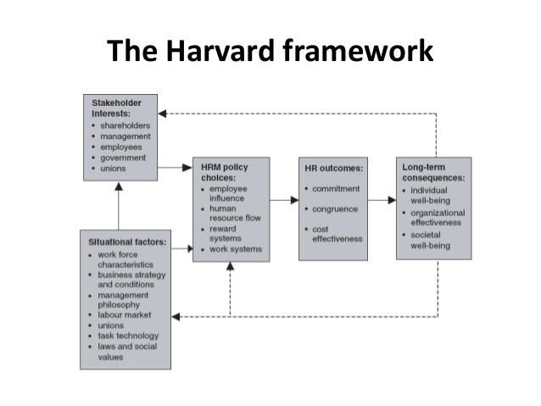

Figure 2.1: Harvard Framework (Adopted from A Handbook of Human Resource Management Practice)

To further break down the diagram above and emphasize the point on the importance of HRM, we see that the Human Resource policies directly influence the outcome which in turn have long term benefits to the organization. Companies must be able to seek out the best candidates using whatever means possible in order to achieve and expand their overall outcomes.

A core competency is a unique capability that creates high value at which an organization excels (Mathis et al., 2013). Employees form a core competency in the success of any organization. This can be seen in the success areas of any firm based on three main principles: productivity, customer service and quality and the organizational culture.

Productivity is the measure of the quantity of work produced against the resources that the company avails to the employees. High productivity will lead to high yields; Both profit based and overall organizational trust from shareholders and the society at large.

Customer Service and Quality is a major success area for any organization as the heart of the organization lies in its clients and customers. Retention of customers means gaining of more customers and building a relationship of trust between the business and the customers.

Organizational Culture is defined in one Mr. Bob Collymore’s[1] words where, in his address at the 10th Annual Strathmore Ethics Conference held in 2013, he defines organizational culture as, and I quote, “*… A corporate Culture refers to shared values, attitudes and standards which characterizes members of an organization…It is rooted in an organization’s goals, strategies and its structure. Its approach to its employees, customers and indeed its approach to the greater communities…*”. Organizational Culture provides behaviour to its employees, drawn by the Human Resource Department.

From the description of core competency of an organization above, we cannot ignore the role that HRM plays at the heart of an organization. In order for the above aspects of the core competency to be achieved, people management must be streamlined.

## 2.3 UNEP’s Employee and Organizational Structure

To promote and facilitate sound environmental management for sustainable management, UNEP’s global and cross-sectoral outlook is reflected in its organizational structure , activities and personnel(United Nations Environment Programme, 2016a).

Figure 2.2 below shows the organizational structure of UNEP(United Nations Environment Programme, 2016e).

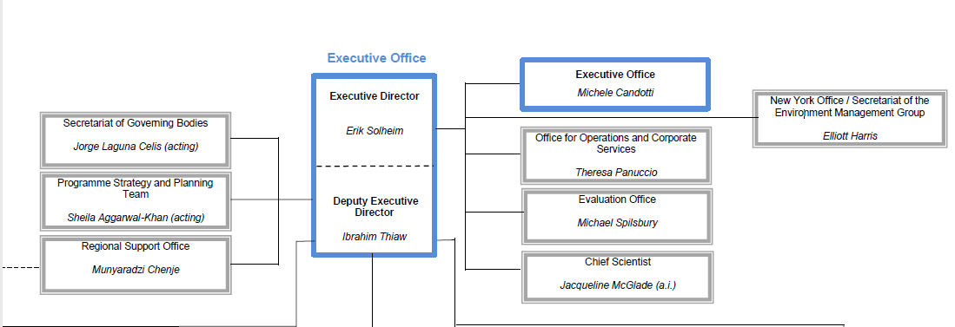

Figure 2.2: Organization Structure, UNEP (Adopted from http://www.unep.org/about/Structure/tabid/129623/Default.aspx)

The hierarchy and structure of the same in explained in detail below. The arrangement of the positions is based on hierarchy in the organization.

### 2.3.1 Senior Management

This team is chaired by the UNEP Executive Director and Under-Secretary-General of the United Nations, Erik Solheim, who took over from Achim Steiner in 2016. Mr. Steiner had served in this position for ten years.

Serving under the Executive Director is Ibrahim Thiaw, the UNEP Executive Deputy Director and Assistant Secretary-General of the United Nations.

Reporting to the two individuals is a team of 9 Directors, each in charge of the nine divisions present in UNEP. Serving under them are the Executive Secretaries(United Nations Environment Programme, 2016d).

### 2.3.2 Middle level Management

These managers consist of Professional Positions, in five steps, that is P2 to P5 positions within the organization.

UNEP also has general service positions, in four steps, that is G4 to G6 positions. These employees assist the Professionals in disbursing instructions and are mostly offer assistance to them.

### 2.3.3 Other Employees

#### 2.3.3.1 Project Positions

Project Positions are employees who are hired according to the projects that may arise and need extra assistance through the duration of the projects.

#### 2.3.3.2 Consultants

Consultants are employees who hired because of their expert knowledge required for a specific project. They are normally on board only until the project is completed.

#### 2.3.3.3 Junior Professional Officers

These employees are described in detail in section 2.3.4 below.

#### 2.3.3.4 Volunteers

These individuals offer their services in various technical areas. They are highly qualified in their areas of expertise with solid professional experience and motivated with a desire to help (United Nations Environment Programme, 2016b).

#### 2.3.3.5 Internships

Students from a wide range of disciplines are able to apply, depending on qualifications, are selected for internships that relate to the organization’s technical activities or to administrative or technical functions(United Nations Environment Programme, 2016b).

### 2.3.4 Junior Professional Officers (JPO)

The Junior Professional Programme (JPO) provides young professionals with hands-on experience in the international arena. JPOs are professional level staff whose applications for specific positions are submitted to UNEP through their specific governments. The governments finance their candidates through a period of two to three years, dependent on the job position and the duration of the contract. JPOs have the status of international civil servants and are subject to the United Nations staff rules and regulations set by the HR Department(United Nations Environment Programme, 2016c).

JPOs work with international and national staff and are involved in identification, design, implementation, monitoring and evaluation of UNEP projects and programmes.

## 2.4 Existing Human Resource Management Systems Recruitment Modules

A Human Resource Management System (HRMS) refers to the systems and processes intersection of Human Resources and Information Technology. Information Technology is employed to try and manage the processes related to HR, which includes employee resources, payroll, training, performance, resignation and resume tracking (Koch, 2015).

Below is a detailed description for some of the existing HRMS modules on Recruitment.:

### **2.4.1 Workable Recruitment System**

This is a standalone recruitment module that is designed for managing the HR process of recruitment.

The system allows the user to advertise on free and premium job boards with a single submission. This will help the HR Department to cut down on the amount of time spent while posting on both the free and premium job boards. Also, the system allows for the hiring staff to create a faster shortlist by pre-screening candidates with customizable application forms. The HR staff will first create an account, then post a job on the free and premium job boards in just a single click. Thereafter, once the interested candidates have applied, the HR staff is able to add other staff members who are involved in the hiring process.

The system allows for the HR Recruitment team to view the individual profiles of the candidates. One can view the comments that any member of the recruitment team has made about him. This offers a great way to track the thoughts of the HR team about a certain individual. It aids in better decision making. Given that the application is also available on mobile devices, the recruitment process by candidates can be carried out anywhere and anytime, hence helping the staff to avoid last minute pressures and hurried decisions about hiring the right candidate for the job.

The ability for addition of more staff members involved in the hiring process allows for collaboration among the HR Department without necessarily being physically present for a meeting. Candidates for the job are also divided into Qualified and Disqualified, where the HR recruitment team is able to view the complete profile of the candidates and view who has been eliminated based on certain criteria. The staff is also able to view how many jobs the specific candidate has applied for. There also exists a chat functionality on the system whereby the staff can discuss about a specific candidate before recruitment for the next stage. This system is mainly designed for the HR Department and the Applicants who create profiles and upload their documents required for the job.

Figure 2.4.1 below shows a screenshot of the Workable Recruitment System:

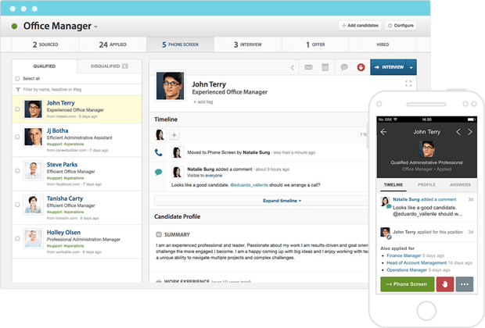

Figure 2.4.1: Workable Recruitment System (Adopted from <https://workable.com/recruiting-software?utm_source=capterra&utm_medium=cpc&utm_campaign=capterra_ppc&utm_content=recruiting>)

The pros of this system is that:

It allows a high collaborative effort among the HR Department of the organization.

It also saves time and cost as it eliminates the need for having physical meetings.

The cons of this system is that:

It is a bit complicated for the users to manoeuvre around, especially the ones who are challenged in terms of technology.

### **2.4.2 iSmartRecruit**

This system is the brainchild of iKraftSolutions. Just like the Workable Recruit System above, one is able to post the jobs that are vacant for interested candidates to apply.

The system is built as one single dashboard whose functionalities are incorporated into one interface that the user should navigate easily. The system integrates the use of jobs boards assist in posting of open jobs. Once the HR Staff has posted the job, they are able to import the resumes of the candidates onto the system, which will then be available at the disposal of the HR staff.

The system also has a management schedule for interviews that assists the HR Department to allocate times for candidates during their interviews. iSmartRecruit integrates a calendar where all pending tasks can be added by the HR Staff as a way of collaboration between the various staff involved in the recruitment process. To manage the large number of applicants, it provides for a comprehensive search function in order to quickly find a candidate. The system has integrated the use of analytics and provides a team report that is based on a certain period of time.

Figure 2.4.2 below shows a screenshot of the iSmartRecruit System:

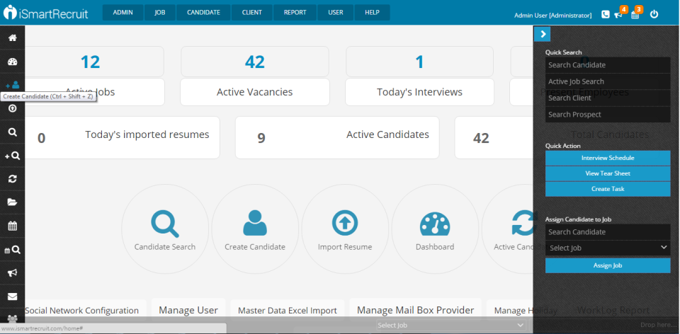

Figure 2.4.2: iSmartRecruit System Administrator’s page (Adopted from <http://www.capterra.com/recruiting-software/spotlight/143592/iSmartRecruit/iKraft%20Solutions>)

The pros of this system is that:  
 It has a very friendly user interface that is appealing to the users.

It handles an important aspect of the recruitment process, which is Interview Management. This makes work for the HR Staff easier.

The cons of this system is that:

The data analytics functions are too complicated for the user interpretation.

The dashboard approach by the system squeezes too many functionalities on the interface, therefore the system looks crammed.

### **2.4.3 Inspira Portal, United Nations**

This module is managed by the UN and handles the recruitment of all the employee categories described in Section 2.3 above apart from Volunteers and JPOs. An interested candidate is required to create an account on the portal. Once they log in, they are able to search for job openings based on the criteria that they choose to search by. One is able to view their profiles, their applications and also get notifications on the system.

On the HR staff side, they are able to view a list of all the applicants along with their Personal History Profile (PHP). From here, they can then export the files and selection for the candidates is done outside the system. The portal is also used by employees to fill in their performance appraisals once their contract is almost expiring.

Figure 2.4.4 below shows a screenshot of the Inspira Portal:  
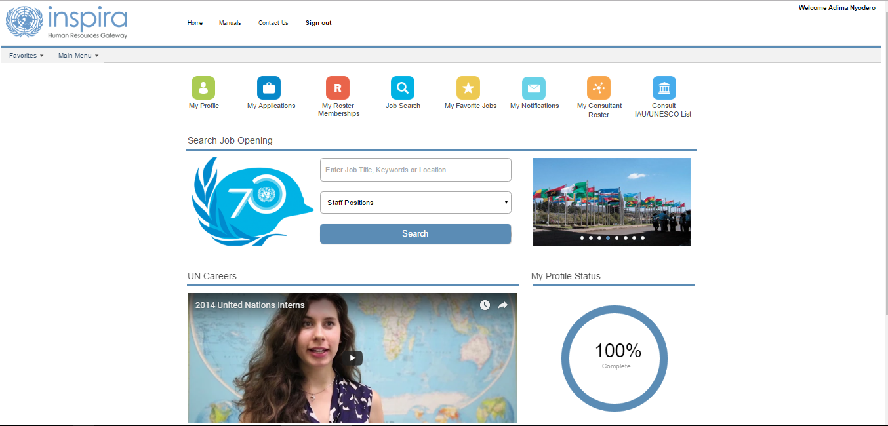

Figure 2.4.4: Inspira Portal, UN (Adopted from <https://inspira.un.org/psp/PUNA1J/EMPLOYEE/HRMS/h/?tab=DEFAULT>)

The pros of this system is that:

The user interface is quite simple and clear, therefore very easy to understand and navigate through.

The cons of this system is that:

It does not allow for the selection process of the candidates. Once they upload their PHPs, the HR Staff is tasked with managing the rest of the recruitment process offline.

### **2.4.5 UNVKE Recruitment Portal, United Nations**

This Recruitment Module is also managed by the UN and is mainly used for the recruitment of volunteers into the organization. Once an applicant navigates to the site, they are required to set up an account in order to proceed with the application. All volunteer opportunities, both national and international, are listed on the site and the interested candidates can be able to view the vacancies.

The candidate will then log in and complete their profile and attach a Personal History Profile form, which will be seen by the HR team. The team will then download the profile and conduct the selection process independently of the system.

Figure 2.4.5 below shows a screenshot of the UNVKE Recruitment Portal:  
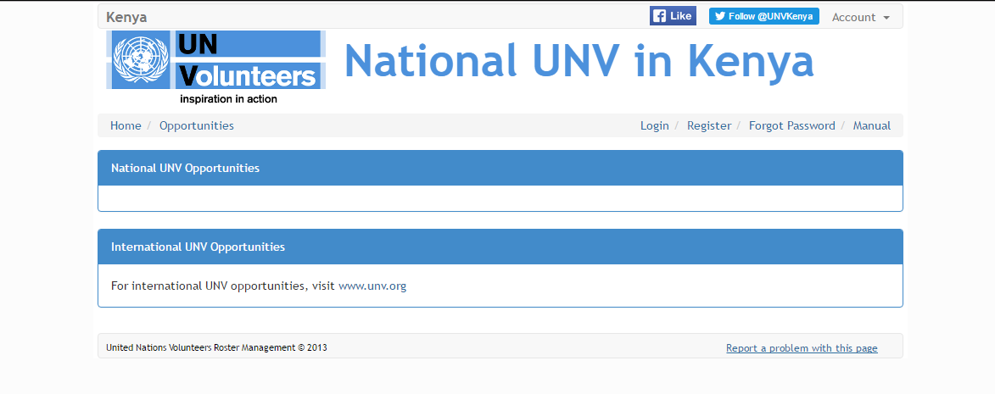

Figure 2.4.5: UNVKE Recruitment Portal (Adopted from <http://recruit.unvke.org/>)

The pros of this system is that:

The interface is easy to understand and navigate.

The job listings are placed on the first interface for the general public to view.

The cons of this system is that:

The selection process is conducted outside the portal, which may be tedious to the HR team.

## Proposed System

The proposed system will consist of an online platform divided into modules. The main focus will be capturing of the applicant’s documents and the selection process that the hiring manager has to conduct. The JPO Coordinator will also have very high interaction with the system to try and make their work bearable and easier. Governments will also have their own modules where they can view the Job Positions, their Terms of Reference as well as the candidates who have been selected for the jobs that they are applying for. Of great importance is the public page that will be on display for anyone who visits the site. This is to curb against conmen who would like to pry on the misinformed and ignorant public.

This public page will show the current vacancies and explain to interested parties on current vacancies, so they could view the terms of reference of the job. The JPO Coordinator will be given the functionality of creating a job, where the system generates a permanent job code for the new job. Thereafter, the coordinator will then open a job, define the opening period and the nationalities that are required for the job. This job code that is created is what will be used on the job advert as well as the public job.

Since different governments have a specific set of questions for different nationalities (Example, Belgium Government have specific questions for jobs where they are sponsoring Belgians as compared to jobs where they are sponsoring nationals from their Partner Countries), the JPO Coordinator will create a government and add questions according to the nationalities they are sponsoring. Interested applicants will be able to register and activate their accounts via their emails. The applicant will then enter the job code they wish to apply for. The smart system will sieve out disqualified nationals as well as prevent candidates from applying past the application period date.

The Hiring Manager/HR Admin Focal Point will log in and view the applicants and conduct the stages of the selection process through the system as well.

Through the brief explanation offered above, the system seeks to address the existing gaps that the current systems do not address. The proposed system will be easy to use and capture the important stages of the recruitment process to make the work of the HR Department easier and bearable.

## Conceptual Framework

A conceptual framework is a diagram that represents the proposed solution in a way that a person who lacks a background in Information Technology can be able to understand.

A conceptual framework models the proposed solution to show the way various users of the solution will interact with the system and who is dependent on who.

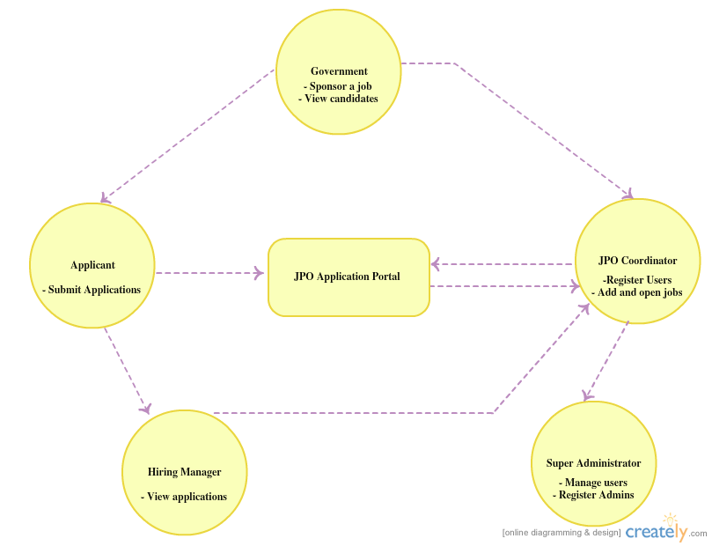

Figure 2.6: Conceptual Framework

# CHAPTER THREE: METHODOLOGY

## 3.1 Introduction

The classical meaning of methodology is a branch of epistemology[2] that studies scientific methods, that is, the systematic, theoretical analysis of the methods applied in science. In this case, computer science (F’x, 2013). In simpler terms, it is a system or broad principles or rules from which specific methods or procedures may be derived to interpret or solve different problems within a particular discipline (WebFinanceInc, 2016).

The two main methodologies used in system development are Structured System Analysis and Design (SSAD) and Object-Oriented Analysis and Design (OOAD). The development of the JPO Portal will make use of OOAD methodology.

## 3.2 System Development Methodology

The methodology that will be used in this project will be an Object Oriented Analysis and Design (OOAD). This approach looks at the whole system as a group of interacting objects. The notion of an object is centred on a piece of data and the operations or methods that could be used to define it. Object oriented design applies programming logic to application objects rather than writing sequential procedural code for the system(Quillin, 2001).

The choice of this approach is based on the fact that the system in question integrates different functionalities employed by a diverse group of people into one fully functional one. OOAD is able to represent this system as a group of interacting objects, a vital part of what the system is all about in terms of communication and doing away with emails as well as a tedious manual process. Second, this type of programming is modular as it provides the separation of duties within the system. The parties involved in the JPO Recruitment Process have distinct roles and using OOAD, this will be clearly seen.

Maintainability of the system is also faster and easier. As the system is modular, any future changes to any of the modules will be made without having to make a large scale change, reducing on time and cost. This ensures on higher quality of the software that will be developed as more time is used on specific modules.

OOAD methodology a life cycle comprising of four main phases. These phases are; Planning, Analysis, Design and Implementation.

The JPO Portal will employ the use of Prototyping. This is because even though the requirements were given, the client was not sure how the product would look like. Therefore, it was important that a model be created first which we would build on based on available user requirements. Conclusively, OOAD will be employed through prototyping to efficiently capture the expected functionalities.

## System Analysis

Systems Analysis is the process of studying a procedure or business in order to identify its goals and purposes and create systems and procedures that will achieve them in an efficient way(Circa, 2014).

## 3.4 Software Requirements Analysis

Software Analysis may be described as the way a system is expected to function and how it would handle different scenarios.

### 3.4.1 Functional Requirements

The functional requirements of a system describe the functionality or services that the system is expected to provide. The following are what is required of the JPO Portal per user:

#### 3.4.1.1 Applicant

This user is able to register and sign into the application portal.

This user can search for the job they are applying for as specified in the advert, tied to a specific required country.

This user can apply for the specific job, browse and add attachments as indicated in the form.

This user can only submit the application once all checkboxes are filled and all the documents required are attached.

This user can view all job applications and the status of the applications.

This user can view their accounts and have basic operations such as changing email, nationality and also password.

#### 3.4.1.2 Government

This user can only log in after manual account creation by the super administrator.

This user can only view all and selected applicants of the jobs that they sponsor.

This user can view all relevant information related to the JPO Programme.

#### 3.4.1.3 Hiring Manager

This user can only log in after manual account creation by the super administrator.

This user can view applicants by specific job codes.

This user is able to view and download attachments uploaded by the candidates.

This user is able to pick candidates for a job through the following criteria; Long list candidates, Short List candidates, select candidates for Interview, recommend candidates and finally select them for the job.

This user can be able to generate an excel sheet of the users at various stages of the selection process.

#### 3.4.1.4 HR/Admin Focal point

This user can only log in after manual account creation by the super administrator.

This user shares the same functionality as the Hiring Manager.

#### 3.4.1.5 JPO Coordinator

This user can add jobs and tie them to specific government along with the criteria for eligibility.

This user can view all jobs entered and their eligibility.

This user also shares the same functionality as the Hiring Manager and the HR/Admin Focal Point.

This user can add all users and give them credentials apart from applicants, who register into the portal.

This user can view all the users in the system, edit, deactivate and activate them.

This user can view governments and the number of jobs they sponsor.

This user can edit, deactivate and activate governments.

### 3.4.2 Non Functional Requirements

The non-functional requirements are [requirement](http://en.wikipedia.org/wiki/Requirement)s that specify the criteria that can be used to judge the operation of a system, as opposed to the specific behaviours. Non-functional requirements give a proper definition as to how a system is supposed to be. Below are some of the expectations of the system once it has been implemented:

#### 3.4.2.1 Authentication

The system should know the specific user that has logged in and direct them to their module.

#### 3.4.2.2 Speed

Due to the high number of applications, the system should be fast in order to avoid any delays in processing the data.

#### 3.4.2.3 User Friendly

The system should be easy to operate and have an appealing design for the users as some of them may not be tech-savvy.

#### 3.4.2.4 Security

The system should be able to withstand any malicious attacks aimed at it by malicious hackers.

#### 3.4.2.5 Scalability

The system should be able to expand and accommodate any future functionalities and requirements needed by the users.

#### 3.4.2.6 Availability and Accessibility

The system should be available for users to access any time they require access.

### 3.4.3 Use Case Diagram

A use case diagram can be defined as a graphical depiction of the interactions among the elements of a system for easier understanding of how the system should work and operate.  These elements include the actors, use case, associations and subsystems. The use case is a helpful methodology in the system analysis phase since it helps to identify, clarify, and organize the system requirements. The use case diagram puts much of its focus on the users of a system rather than the system itself. This helps to ensure that the real system needs and functionalities are dealt with correctly and hence simplifying system development. The use case diagram, therefore, stands out as the most appropriate diagram to use in the software analysis phase of the JPO Portal as it will help ensure that the users’ processes and needs are properly identified and correctly captured.

### Narrative Scenario

The applicants will access the portal and register and as a requirement, to activate their accounts in order to log in. For the other users, the super administrator manually creates accounts for them. They will then log into the system using the credentials provided to them by the super administrator.

The JPO Coordinator will access the system and creates a JPO, tying it to a specific government if there is a government that has earmarked the specific job. The system will automatically create a job code for the new job. The coordinator will then open the specific job and specify the application period and tie it to the specific government. This is to help in loading of the correct screening questions specified by the government. The coordinator will also input the nationalities associated with the said job. To add questions for a job position, the coordinator will first create a government. They will then add the questions for the government and has to indicate if the question has an extra attachment that the applicant has to attach as proof aside from the standard attachments or not.

To fill and submit an application form, the applicant logs into the application portal using their credentials. They will then enter the job code as given in the advert and that is also displayed on the public welcome page. The application form will load. It is important to note that the form will not submit unless all the boxes are checked and all the required documents are attached. On submission, the user is redirected to the **‘My Applications’** tab to see their application.

To viewing and screen applicants, The Hiring Manager, the HR/Admin Focal or JPO Coordinator log into the system. The user enters a job code in order to view applicants for the job. The page loads with the number of applicants together with their attachments that can be downloaded and viewed. The user is able to pick out the candidates eligible for the next screening stage. The user is also able to export the applicants at every stage to a CSV file/format so they can pick out the applicants offline and fill in the system at their own time. This is also to generate reports of the applicants.

To view applicants by the governments, the specific government logs into the system using credentials provided for by the JPO Coordinator. They enter the specific job code that they want to view applicants. They are only allowed to view applicants from jobs that they sponsor. hey then view all the applicants that applied for the job and their documents too. They can also view the selected applicants.

## System Design

System design is the process of defining the elements of a system such as the architecture, modules and components, the different interfaces of those components and the data that goes through that system. It is meant to satisfy specific needs and requirements of a business or organization through the engineering of a coherent and well-running system(Techopedia, 2016).

This phase is used to produce the main structure of the system. It consists of the proposed system modules and their relationships, the development approach to be used and the database structure. The design phase has three major categories. These include:

### **3.5.1 Interface design**

This involves designing the user interfaces that are user friendly and easy to use without complicating the process.

### **3.5.2 Logical design**

This will involve designing the logical flow of a system and defining the boundaries the system will have.

## 3.6 Database design

This will involve coming up with the database model diagram (class diagrams) and a database schema representation.

## 3.7 Graphical Interface Design

This step involves designing of the user interface that the users make use of when interacting with the system. The graphical user interface (GUI) is very important as it heavily determines the users’ attitude towards the system. The JPO Portal will consist of interactive pages that will make navigation through the website simple and straight-forward. The user interface will also include notifications and error messages to help accommodate the user’s actions. The color scheme will heavily employ UNEP’s official colors, white and blue in order to avoid confusing the user and to help them identify that the product is associated with UNEP. The GUI will be achieved through the use of Hyper-Text Markup Language (HTML), Cascading Style Sheets, JQuery and JavaScript.

### 3.7.1 Database Design

A database is an organized mechanism which has the capability to store information, and from which a user can retrieve stored information in an efficient and effective manner. The data being stored is the whole purpose of any database, and therefore, it must be protected. In this case, this is sensitive data that belongs to an international organization that must be protected.

The database design is a two level process. In the first step, user requirements are gathered and a database which will meet these requirements is designed. This is known as the Information Level Design(Auer, 2006).

The second step involves transferring the Information Level Design into a design for the specific DBMS that will be used to implement the system in question. This is known as Physical Level Design, which is concerned with the different characteristics of the DBMS that will be used(Auer, 2006).

## System Design Diagrams

### 3.8.1 Class Diagram

The Class Diagram will be used to provide an overview of the proposed system by describing the objects and classes that are within the system and the relationship between them.  The use of class diagrams helps to ensure that the developer visualizes the structure of his/her classes and how they will interact with each other before actually writing any code. This will ensure that the JPO Portal will be perfectly in line with the user requirements. The class diagram will play an integral role in the design process of the interactive JPO Portal.

### 3.8.2 Database Schema

A database schema can be defined as the skeleton structure that represents the logical view of the entire database(tutorialspoint.com, 2016). It will help to define how data in the database is organized and how the relations amongst the data are associated. The database schema effectively provides a graphical presentation of the database to be created by showing all the entities that make up the system, the different constraints and the associations between these entities. This will give me a very good understanding in how the database for the JPO portal will relate the users and manage their data.

### 3.8.3 Sequence Diagram

A sequence diagram is an interaction diagram that shows, for a particular scenario of a use case, the events that external actors generate, their order, and possible inter-system events.

Viewing the system in this kind way will assist me to view all the activities generated by the users so I can foresee the expansion of the system and scalability plans.

## 3.9 System Implementation and Testing

System Implementation and Testing entails installation of the new system, training users, and changeover from the current system to the new proposed system. It involves availing the system being developed to the users for testing purposes in order to determine whether or not it meets the requirements and specifications. It will also identify any changes required by the user as well as modification and correction of the system flow form the user’s point of view. The activities that will be carried out during the implementation and testing phase include unit testing, integration testing, user acceptance testing, system testing, system implementation and training of users: users will be trained on how to use the system in order to accomplish various tasks.

### 3.9.1 Portal Deployment

This step will involve moving the website from the local host which is my development space to a live server. The developer will be responsible for carrying out this activity to ensure the environment is okay and no functionalities have been tampered with.

### 3.9.2 Training

This phase will involve training the JPO Coordinator on how to carry out CRUD on the system, and it will also involve training the Hiring Manager/HR Admin Focal Point on how to carry out the selection process through the portal. The training will be carried out by the system developer.

### 3.9.3 Execution

This will involve the actual operation of the system. The execution phase will be performed by the different users of the system once the training is complete.

### 3.9.4 System Testing

#### 3.9.4.1 Test plan

A Test plan gives a clear indication of a series of preferable courses of action to be followed in accomplishing the different testing methods(Bartlett, 2016). The Test Plan serves as a blue print for the various actions that will be undertaken. The specific objectives of testing should be stated in terms which can easily be measured. This is important so as to ensure that the mean time to failure, the remaining defect density or frequency of occurrence, the cost to find and fix the defects are all included in the test plan.

#### 3.9.4.2 Unit testing

Unit testing will be used to ensure that each module performs as expected when in isolation. Functionalities such as user login, user registration, application for the job, and selection process of the applicants will all be tested individually to confirm that they are performing as per the user requirements specification.

#### 3.9.4.3 Integration testing

Integration testing will involve testing a number of already integrated modules to ensure that these modules are properly working together as expected. In this test, specific functional user requirements will be tested to see to it that the developed system meets the requirements, and that the correct system has been developed(Techpedia, 2008). Each user specific function would be thoroughly tested to ensure that they perform their tasks properly. The test will try to identify errors that are within inputs and outputs of these functions. The displayed results will also be carefully examined to ensure that they meet the user requirements. Since the portal is a highly interactive system, this testing will ensure that the data accessed from one module to the other is correct and accessible for the users permitted to access the data.

#### 3.9.4.4 Acceptance testing

This test will involve testing the system by keying in actual data, in order to properly assess how well a particular module meets its requirements. It will also involve looking for any missing or incorrect functionalities. For example, once a user keys in his correct details and activates their account, the test will check to see is the user can login in as expected.

#### 3.9.4.5 Validation testing

This test will involve testing the entire system as a whole with all of its code, class modules, forms and modules. This particular test is commonly known as System Testing or Black Box testing.

Black Box testing puts its focus on the functional requirements of the system(Guru99, 2016). This testing method tries to identify errors in the following areas; interface errors, errors present in incorrect functions or data structures, incorrect functions, performance and initialization errors and termination errors.

#### 3.9.4.6 System Testing

This is testing method involves integrating all the system modules and then testing the whole system to identify and correct errors. It will involve doing both validation and verification. This will involve testing the entire system to confirm whether or not all the modules are working in collaboration with each other, and that there are no conflicts between them.

The test will help verify the system functionality. This will be achieved by making sure that relevant tests have all been carried out; such as unit tests, integration tests and acceptance tests. This test will serve as the overall test of the system after the system has fully been developed, just before it is presented to the panel, where the panel will carry out an acceptance test with the system developer, and raise any changes they will want at the different system levels. The system test will help to ensure that all the functional and non-functional requirements of the system have been met.

## Development Tools and Environment Used

### **3.10.1 Microsoft Office Word 2016**

The project proposal and project documentation will be created with the use of Microsoft Office Word 2007. This is because Word is easy to use and offers a wide range of functionality in regards to document formatting. It also integrates third party plug-ins that are useful for referencing material.

### **3.10.2 Microsoft Visio 2016**

The design diagrams will be created using Microsoft Visio 2016, which offers a wide range of tools to represent all the logical designs involved in System Design. It provides the user with a wide range of units and options to choose from.

### **3.10.3 Sublime Text**

This is an open source text-editor that aids in web development. The text editor provides an easy to use interface and various helper packages. It also employs the use of colour code highlighting that will assist me in knowing when errors come up. It will also help me identify the syntax of various files, that is, PHP, HTML and Javascript.

### **3.10.4 HTML, CSS and JavaScript**

Hyper Text Mark-up Language (HTML) is a front-end programming language used to create web page structures. Cascading Style Sheets (CSS) on the other hand helps to style the web page and JavaScript helps to make the web page as interactive as possible.

### **3.10.5 PHP 7**

PHP (recursive acronym for PHP: Hypertext Pre-processor) is a widely-used open source multi-purpose scripting language that is commonly used for web development and it can also be embedded into HTML. PHP will be used in the backend development of the system. It is the most preferred choice due to its widespread use and comprehensive documentation.

### **3.10.6 PHP Phalcon Framework**

For my PHP development, I will use the Phalcon Framework. It is the fastest framework that exists at the moment. I have chosen this framework as it goes with my non-functional requirement of speed. I believe that this will handle the amount of data that the Portal will interact with at any given time. Phalcon also employs use of caching, an aspect that will significantly increase loading of data.

### **3.10.7 XAMPP 5.6.3**

XAMPP is a full-featured AMPP (Apache MySQL, PHP, Perl) package that is available on Linux as well as Windows. XAMPP provides an easy to use local development environment, however, it is not meant for production deployment. It comes with various packages such as, Apache Web Server, Perl, MySQL and PHP. The XAMPP environment will be used to test my server side scripts. The reason as to why the XAMPP is the most preferred development environment because it is easy to install and it contains packages that can help generate traffic reports and also accelerate PHP content. It also supports Phalcon Framework, which is my intended PHP Development Framework.

### **3.10.8 MySQL database management system**

This is the database management system that will be used to create the database the system will use to store all its information. The MySQL database has gained worldwide popularity as an open source database because of its high reliability, high performance and ease of use. The MySQL database is the most preferred database management system for this project due to the fact that it is open source, flexible and it provides an easy to navigate panel in phpmyadmin.

### **3.10.9 Github**

For collaboration purposes and tracking my work, I will employ the use of Github Student Pack. This pack also comes with free server space from Digital Ocean that I will take advantage of. Github will assist me to store my code and provide backup in case of unforeseen incidences.

### **3.10.10 Browser**

Since the application will have multiple users, I will use Chrome browser because it supports plug-ins that will help me to develop and debug my application in the easiest manner. Chrome browser offers a wide variety of plug-ins and it renders the code very well in terms of user interface management.

## 3.11 Hardware Requirements

I will make use of a personal computer with the following specifications:

Operating system - Windows 10 Professional 64bit

1 TB hard disk memory

8GB of RAM

## 3.12 Proposed System Modules

### **3.12.1 Authentication Module**

This module with handle the registration, logging in, activation of accounts and the resetting of passwords.

It will also detect the logged in user and manage their session as well as their right module they need to be redirected to.

### **3.12.2 Applicant Module**

Apply for a position and view the terms of reference for a job.

Browse and attach all required documents (P11 form, proof of nationality, cover letter).

View all jobs previously applied for.

Account information and basic operations – modify information and change password as well as the nationality.

### **3.12.3 Government Module**

View applicants and selected candidates.

View Information as needed by UNEP.

### **3.12.4 Division module**

Selection process.

View applicants and download attachments.

### **3.12.5 Administrator module**

View list of job positions entered.

Add a job position and upload terms of reference.

Open a job position.

Selection process.

View applicants and download attachments.

### **3.12.6 Super Administrator Module**

View all users, applicants and governments.

Edit users and governments, deactivate and activate users and governments.

Deactivate and activate applicants.

Add users and governments.

## 3.13 Deliverables

### **3.13.1 Project Proposal**

The project proposal is a detailed description of various activities that are aimed at solving a particular problem. The JPO Portal project will consist of a hard copy proposal document which will clearly define the existing problem, and measures that will be taken to solve the problem.

### **3.13.2 System Documentation**

A System Documentation is a detailed description created for the system users that clearly identifies components of the system, and how to make proper use of them. The project will include the system documentation for the JPO Portal.

### **3.13.3 Interactive JPO Portal**

The project will deliver an eye-catching, mobile responsive website, which will inform members of the public the jobs that are open and allow the interested applicants register and apply for jobs. It will also assist UNEP in managing the recruitment of JPOs in order to acquire the qualified and gifted pool of candidates fit to handle the positions.

# References

Armstrong, M. (2006). *A Handbook of Human Resource Management Practice*. Kogan Page Publishers.

Auer, L. (2006, September 18). Database Design and System Design. Retrieved September 19, 2016, from http://www2.amk.fi/digma.fi/www.amk.fi/opintojaksot/0303011/1146161367915/1146161680673/1146161836562/1146161929756.html

Bartlett, J. (2016, June 23). What is a Test Plan in Software Testing? Retrieved September 19, 2016, from https://blog.testlodge.com/what-is-a-test-plan-in-software-testing/

Circa. (2014). Definition of SYSTEMS ANALYSIS. Retrieved September 18, 2016, from http://www.merriam-webster.com/dictionary/systems+analysis

F’x. (2013, September 27). computer science - Methodology as a Body of Methods? - Academia Stack Exchange. Retrieved September 18, 2016, from http://academia.stackexchange.com/questions/13034/methodology-as-a-body-of-methods

Guru99. (2016). What is Black Box Testing? Retrieved September 19, 2016, from http://www.guru99.com/black-box-testing.html

koch, michelle. (2015, September 24). Processes in Human Resource Management. Retrieved September 19, 2016, from https://www.linkedin.com/pulse/processes-human-resource-management-michelle-koch

Mathis, R. L., Jackson, J. H., & Valentine, S. R. (2013). *Human Resource Management*. Cengage Learning.

Quillin, M. J. (2001, November 25). Object Oriented Analysis and Design: What is it? How Does It Work? Why is it used? Retrieved September 19, 2016, from http://www.umsl.edu/~sauterv/analysis/488_f01_papers/quillin.htm

Saiyadain. (2009). *Human Resources Management 4E*. Tata McGraw-Hill Education.

Techopedia. (2016). What is System Design? - Definition from Techopedia. Retrieved September 18, 2016, from https://www.techopedia.com/definition/29998/system-design

Techpedia. (2008, March). What is integration testing or integration and testing (I&T)? - Definition from WhatIs.com. Retrieved September 19, 2016, from http://searchsoftwarequality.techtarget.com/definition/integration-testing

tutorialspoint.com. (2016). DBMS Data Schemas. Retrieved September 19, 2016, from http://www.tutorialspoint.com/dbms/dbms_data_schemas.htm

United Nations. (2016a). About. Retrieved September 18, 2016, from http://www.unep.org/about/

United Nations. (2016b). General Assembly Resolutions 30th Session. Retrieved September 18, 2016, from http://www.un.org/documents/ga/res/27/ares27.htm

United Nations Environment Programme. (2015). About > About > Mission. Retrieved September 18, 2016, from http://www.unep.org/about/About/Mission/tabid/129645/Default.aspx

United Nations Environment Programme. (2016a). About > Structure. Retrieved September 18, 2016, from http://www.unep.org/about/Structure/tabid/129623/Default.aspx

United Nations Environment Programme. (2016b). Employment with UNEP - United Nations Environment Programme. Retrieved September 18, 2016, from http://www.unep.org/vacancies/default.asp?vac_level=Junior

United Nations Environment Programme. (2016c). Employment with UNEP - United Nations Environment Programme. Retrieved September 18, 2016, from http://www.unep.org/vacancies/default.asp?vac_level=Interns

United Nations Environment Programme. (2016d). UNEP Senior Management Team. Retrieved September 19, 2016, from http://www.unep.org/about/Leadership/SeniorManagement/tabid/129658/Default.aspx

United Nations Environment Programme. (2016e). UnepOrganigram.pdf. Retrieved September 18, 2016, from http://www.unep.org/pdf/UnepOrganigram.pdf

United Nations Environment Programme. (2016f). UNEPOrganizationProfile.pdf [public]. Retrieved September 18, 2016, from http://www.unep.org/PDF/UNEPOrganizationProfile.pdf

WebFinanceInc. (2016). What is a methodology? definition and meaning. Retrieved September 18, 2016, from http://www.businessdictionary.com/definition/methodology.html

# Appendix

## Appendix A: Time Schedule

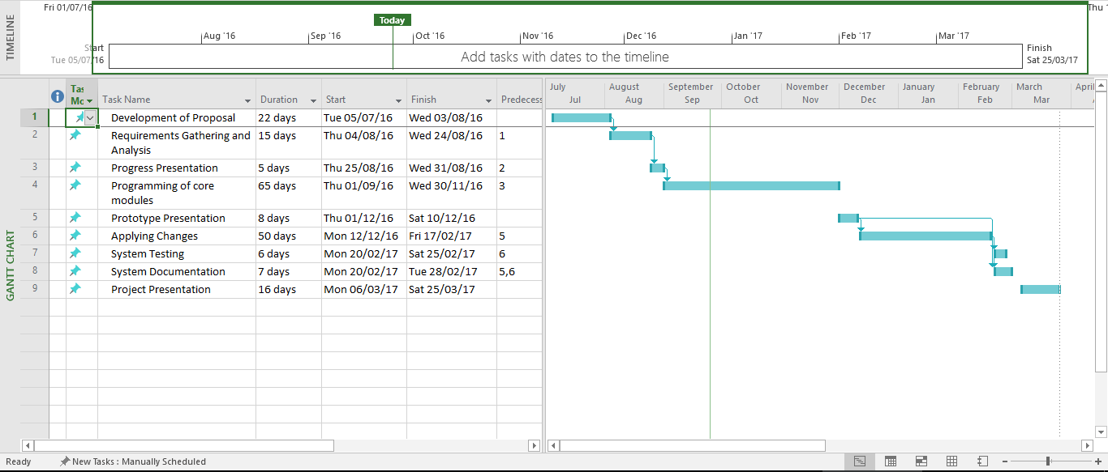

## Appendix B: Reference Document 1

|  |
| --- |
| **PROPOSAL FOR AN ON-LINE APPLICATION SYSTEM FOR JPOs** |
|  |
| ACCESS TO THE ONLINE SYSTEM TO BE GIVEN TO: |
| JPO Coordinator |
| The relevant Government (Belgium and the Republic of Korea) |
| The relevant Hiring Manager in UNEP |
| The relevant HR Focal Point in UNEP |
| Applicants |
|  |
| FIELDS REQUIRED |
| Name of Applicant |
| Email address of Applicant |
| JPO position code |
|  |
| SCREENING QUESTIONS FOR BELGIAN NATIONALS |
| Do you have EU citizenship? |
| Are you less than 32 years of age? |
| Do you have a Master’s Degree? A development-oriented employment history or previous experience in development is desired. |
| Do you have two years of relevant work experience? |
| Have you completed and succeeded in the Info cycle organized by BTC (Belgian Technical Cooperation) |
|  |
| SCREENING QUESTIONS FOR KOREAN NATIONALS |
| Are you a Korean National? |
| Do you have a National basic livelihood recipients certificate issued by the Government of the Republic of Korea (if so please attach)? |
| Are you proficient in the Korean Language? |
| Are you less than 32 years of age? |
| Do you have a Master’s Degree? |
| Do you have two years of relevant work experience? |
|  |
| SCREENING QUESTIONS FOR THE NETHERLANDS (EU APPLICANTS) |
| Do you have a university degree at MSc or MA level; or a degree at BSc or BA level plus a minimum of three years' relevant working experience? |
| Have you previously held a position as Associate Expert/Junior Professional Officer/Associate Programme Officer/Junior Expert? |
| Is the duty station for the position you are applying for outside your country of origin? |
| Do you have both an active and passive command of at least one of the official UN languages used in UNEP? |
| Do you have Dutch nationality or permanent residence status in the Netherlands; or have the nationality of another EU member State? |
|  |
| SCREENING QUESTIONS FOR THE NETHERLANDS (DEVELOPING COUNTRY APPLICANTS) |
| Do you have a university degree at MSc or MA level; or a degree at BSc or BA level plus a minimum of three years' relevant working experience? |
| Have you previously held a position as Associate Expert/Junior Professional Officer/Associate Programme Officer/Junior Expert? |
| Is the duty station for the position you are applying for outside your country of origin? |
| Do you have both an active and passive command of at least one of the official UN languages used in UNEP? |
| Are you a national of developing countries that appear on the list of countries eligible for the Dutch JPO Programme (see the advertisement)? |
| Has part of your academic training taken place in a developing country that appears on the list of eligible countries? |
| Do you possess another nationality of a non-eligible country or have permanent residence status in another non-eligible country? |
| Do you have permanent residence status in the Netherlands? |
| Are you able to demonstrate your interest in international cooperation? |
| Do you have a working knowledge of a second official language? |
|  |
| ALSO REQUIRED |
| Ability to browse for, and add, attachments |
| Applicants are required to attach their UN Personal History Form (P-11) |
|  |
|  |

## Appendix B: Reference Document 2

|  |  |  |  |
| --- | --- | --- | --- |
| **UNEP DIVISION/**  **OFFICE** | **JPO POSITION** | **CODE** | **DUTY STATION** |
| Division of Communication and Public Information (DCPI) | Associate Translation Specialist | DCPI-01 | Nairobi |
| Associate Graphic Designer (Info-graphics Specialist) | DCPI-02 | Nairobi |
|  | Associate Fundraising Specialist, Brand Building Section | DCPI-03 | Nairobi |
|  | Associate Campaigns Specialist | DCPI-04 | Nairobi |
|  | Associate Monitoring and Evaluation Specialist | DCPI-05 | Nairobi |
| Division of Environmental Law and Conventions (DELC) | Multilateral Environmental Agreements (MEAs) Support and Cooperation, Environmental Governance and Conventions Branch | DELC-01 | Nairobi |
| Associate Legal Officer, Poverty-Environment Initiative & DELC | DELC-02 | Nairobi |
| Associate Legal Officer, National Law Unit, Environmental Law Branch | DELC-03 | Nairobi |
| Division of Environmental Policy Implementation (DEPI) | Illegal Trade in Wildlife, Biodiversity Unit | DEPI-01 | Nairobi |
| Climate Finance Officer, Climate Change Adaptation Unit | DEPI-02 | Nairobi |
| JPO, Abidjan Convention Secretariat | DEPI-03 | Abidjan |
| Freshwater Ecosystems Officer, Freshwater Unit | DEPI-04 | Nairobi |
| Environmental Education & Training | DEPI-05 | Nairobi |
| Environmental Emergencies, DEPI/Joint UNEP/OCHA Environment Unit (JEU)/Regional Office | DEPI-06 | Geneva (1 year), Panama City or Bangkok (1 year) |
| Information and Communication Officer, Coordinating Unit for the Mediterranean Action Plan | DEPI-07 | Athens |
| Marine Ecosystems, Marine & Coastal Ecosystem Unit | DEPI-08 | Nairobi |
| JPO, Wastewater Management, Global Programme of Action for the Protection of the Marine Environmental from Land-based Activities Unit (GPA) | DEPI-09 | Nairobi |
| JPO, Poverty-Environment Initiative (ROAP) | DEPI-10 | Bangkok |
| Communications Officer | DEPI-11 | Kingston |

1. Chief Executive Officer of Kenya’s Telecommunications Giant, Safaricom
2. A branch of philosophy dealing in knowledge