35. Delete the group called badgroup:



36 .As you Super user, Set or change the password of root

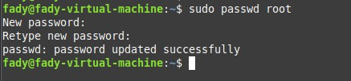

37.As you Super user, Try to remove all files in /tmp



38.Create a folder called /tmp/myteam and change its permissions to read only for the owner, and Group and Other didn’t have permission on it.

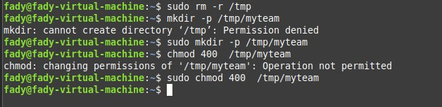

39.Log out and log in by another user

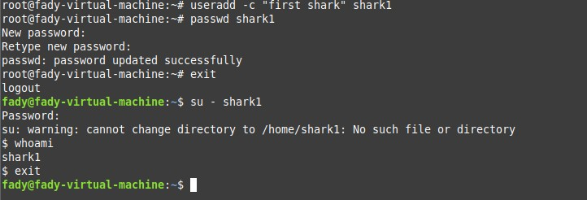

40.Try to access (by cd command) the folder (myteam)



41.Change the permissions of /tmp/mycv file to give owner read and write permissions and for group write and execute and execute only for the others (using chmod in 2 different ways )

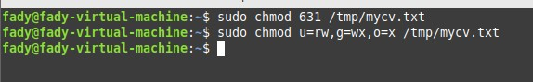

42.What are the minimum permission needed for :

a. Copy a file (permission for source file and and permission for target parent directory)

b. Delete a file

c. Change to a directory

d. List a directory content (ls command)

e. View a file content (more/cat command)

f. Modify a file content

**a. Copy a file**

* **Source file** → needs **read (r)** permission (to read its contents).
* **Target parent directory** → needs **write (w)** (to create the new file) **and execute (x)** (to access the directory).

Minimum: **file = r, dir = wx**

**b. Delete a file**

* **File itself** → permissions don’t matter.
* **Parent directory** → needs **write (w)** (to remove entry) **and execute (x)** (to access directory).

Minimum: **dir = wx**

**c. Change to a directory (cd)**

* Need **execute (x)** on the directory.

Minimum: **dir = x**

**d. List a directory content (ls)**

* To see filenames → need **read (r)** on the directory.
* To actually use ls effectively (see inode info, access file metadata) → also need **execute (x)**.

Minimum: **dir = rx**

**e. View a file content (more, cat)**

* **File** → needs **read (r)** permission.
* **Parent directory** → needs **execute (x)** (to access the file by name).

Minimum: **file = r, dir = x**

**f. Modify a file content**

* **File** → needs **write (w)** permission (to edit).
* **Parent directory** → needs **execute (x)** (to access it).
* If you want to **truncate** or **overwrite** → may also need **write (w)** on the directory (to update metadata).

Minimum: **file = w, dir = x** (practically often wx on dir).

43.Create a file with permission 444 in /tmp directory. Try to edit in it and to remove it? Note what happened.

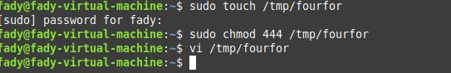

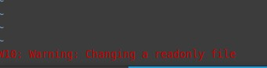

44.What is the difference between the “x” permission for a file and for a directory

Permission x on file meaning this file can be excuted as a script while on a directory it means that u can access inside the directory (you can cd inside of it ) and can access the files inside by names

45.List the All environment variables in your current shell.

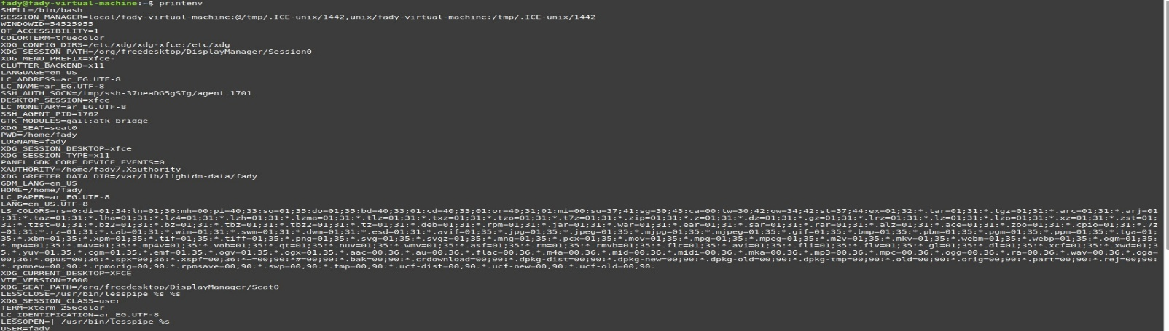

46.What are the commands that list the value of a specific variable?

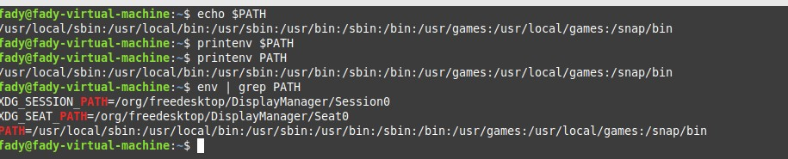

47.Display your current User name using Environment Variables.



48.Create a Bash shell alias named ls for the “ls –l” command, How to bypass this alias?

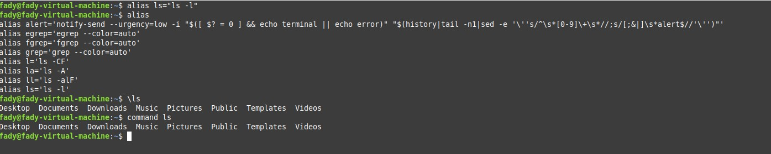

49.How to check if your internet connection is work?

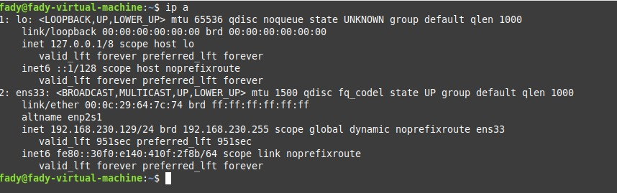

50.By editing /etc/hosts, make the URL www.iti-project-dep.com forward you to 195.10.10.2

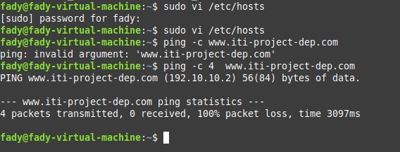

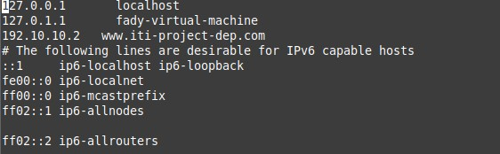

51.Count the number of users at your Machine

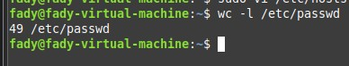

52.Search on user name “games” at your machine

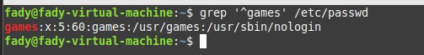

53.Get the logins names of Users.

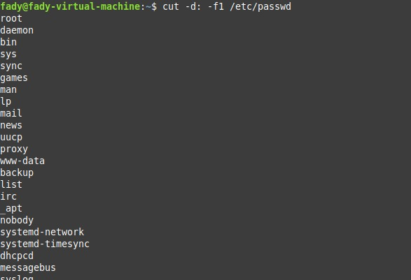

54.Get the full names (comment) of Users

