55.Issue the command sleep 100.

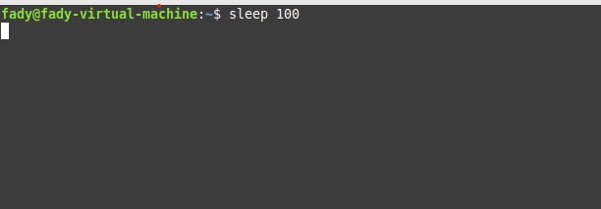

56.Stop the last command.

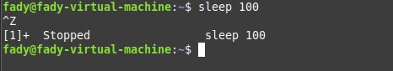

57.Resume the last command in the background

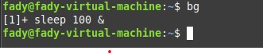

58.Issue the jobs command and see its output.

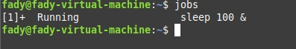

59.Send the sleep command to the foreground and send it again to the background.



60.Kill the sleep command.

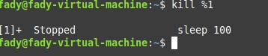

61.Display your processes only (process started by your username)

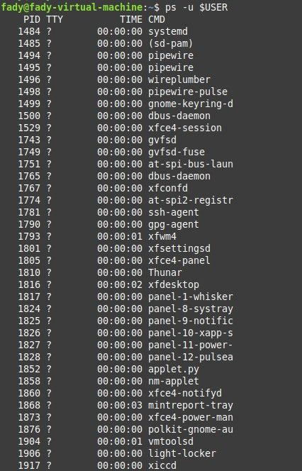

62.Use the pgrep command to list your processes only

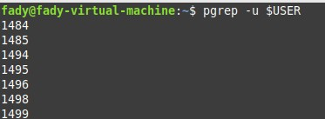

63.List the user commands(in /bin) and redirect the output to /tmp/commands.list



64.(based on previous Question) Count the number of user commands

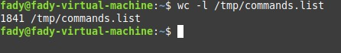

65.Start firefox application

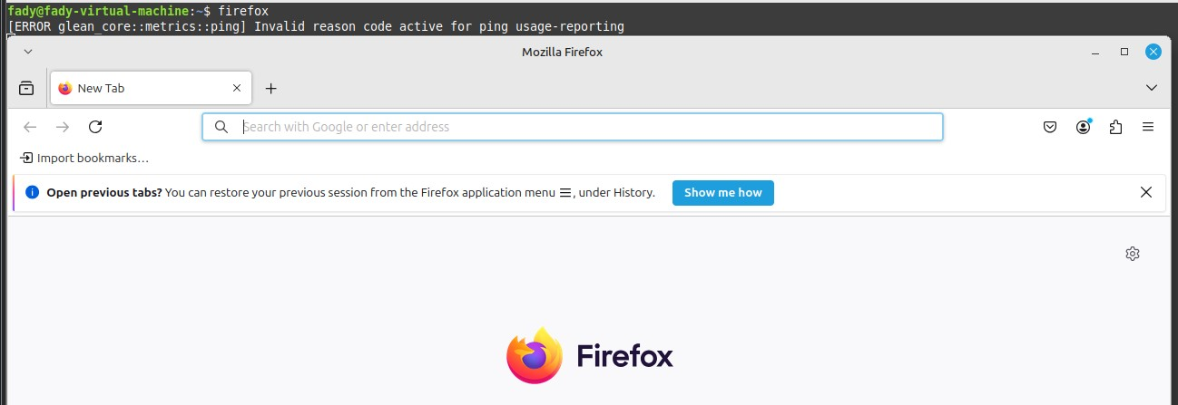

66.Send Signal kill to firefox

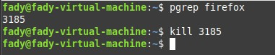

67.Get the logins name and full names (comment) of logins starts with “gu”.



68.Display the number of users who is logged now to the system.

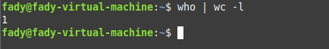

69.Display lines 7 to line 10 of /etc/passwd file

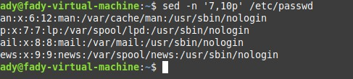

72.Kill your processes only (be care: save lab before command execution).



73. Sort /etc/passwd based on the full names of users and save output to external file.

