1. Install Apache HTTP server

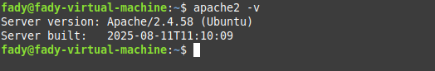

2. Create two simple html pages named “page1.html, page2.html” then use the suitable

directive to automatically redirect from localhost/page1.html to

localhost/page2.html.

Redirect /page1.html /page2.html

Then reload apache sudo systemctl reload apache2

3. Ask for user name and password when accessing a directory

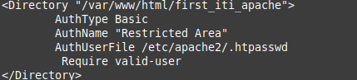

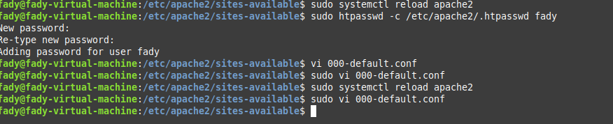

4. Apply authentication before downloading PDF files.

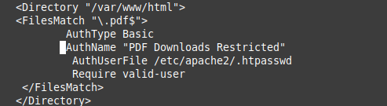

5. Create a directory then allow access to one of your classmates only.

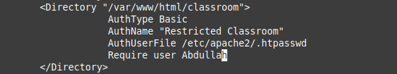

6. Disable listing the directory content *(hint use indexs)*

*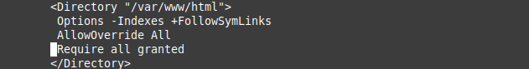*

7. Change the default index page to be default.html instead of index.html *(use*

*DirectoryIndex)*

*