1. Configure apache to use Worker MPM

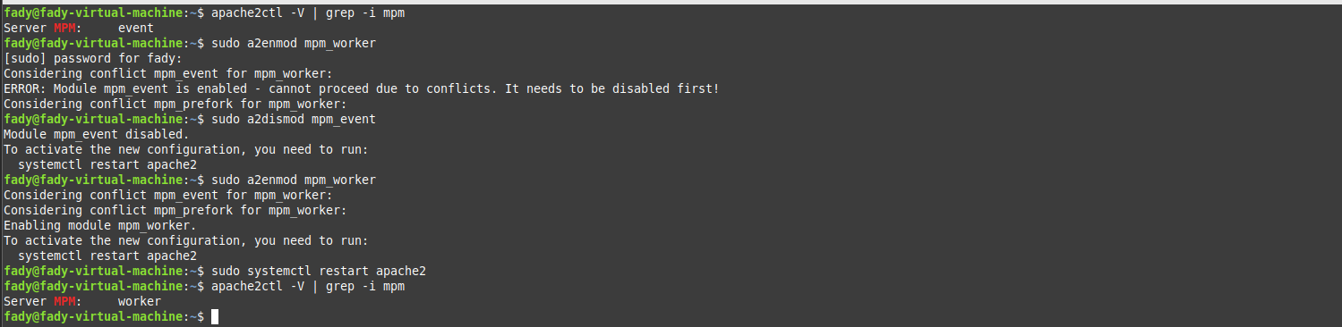

1. Check the status of rewrite_mod and enable it if it is enabled.

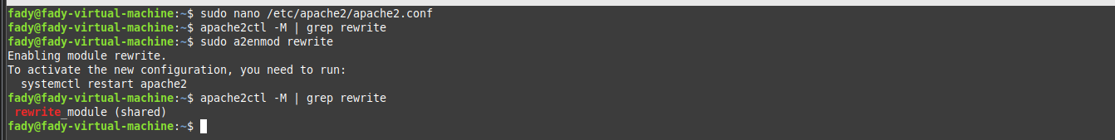

1. Write RewriteCond and RewiteRules for:

a. Deny access to http://localhost/page?queryString if queryString contains

the string forbidden.

b. Remove the Query String

c. Rewrite URLs like http://localhost/page1?var=val to

http://localhost/page2?var=val but do not rewrite if val isn't present.

d. Take a URL of the form http://localhost/path?var=val and transform it into

http://localhost/path/var/val.

e. Map http://localhost/example/one/two to

http://localhost/something.cgi?arg=one&other=two

f. (**Bonus**) Display a goodevening.html page if the time is after 6:00 PM and

goodmooring.html page if the time is before that

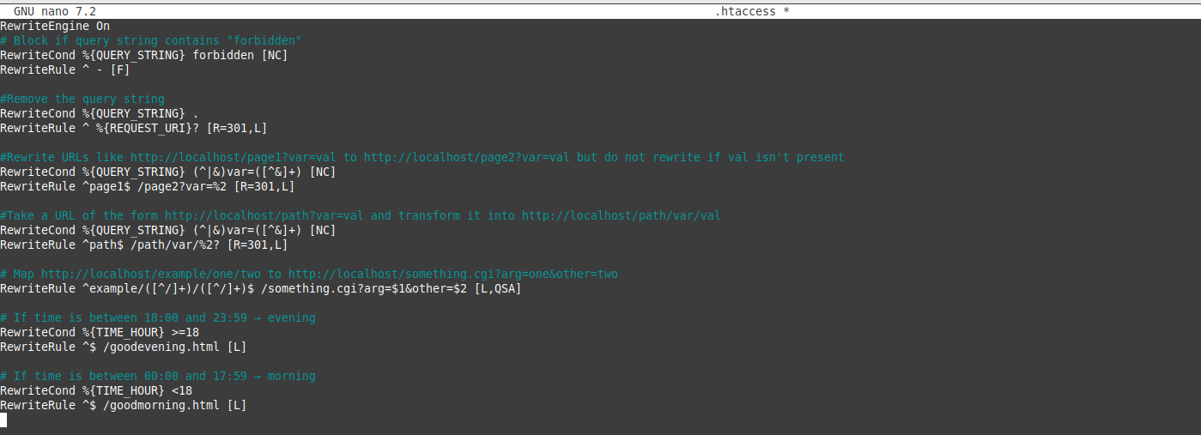

1. Create a virtual host for os.iti.gov.eg to redirect to a local directory in your server

