# Beer Permits In Nashville Over Time

* A brief articulation of your chosen topic and rationale
  + In this project we will be taking a look at the past issuing of beer permits in Nashville, TN to illustrate how Nashville’s growth has impacted the growth of local bars and beer sellers. We will be looking at the City of Nashville’s provided data on issued beer permits and creating visualizations to illustrate our findings.
* A link to your data set(s) and a screenshot of the metadata if it exists.
  + [https://data.nashville.gov/resource/3wb6-xy3j.**json**](https://data.nashville.gov/resource/3wb6-xy3j.json)
  + [https://data.nashville.gov/resource/3wb6-xy3j.**geojson**](https://data.nashville.gov/resource/3wb6-xy3j.geojson)
  + 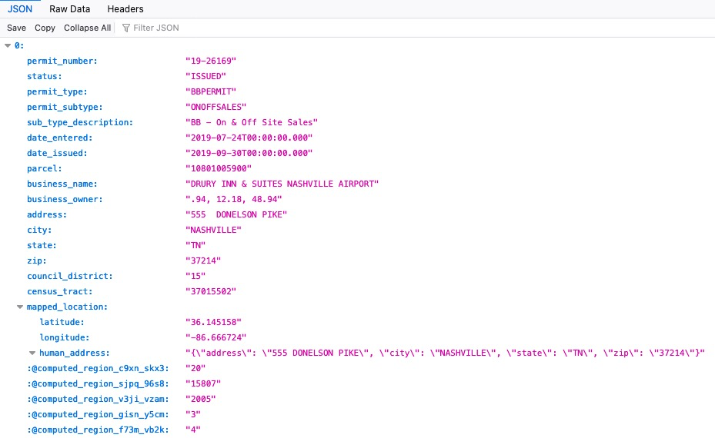
* 3 or 4 screenshots of relevant, “inspiring” visualizations that frame your creative fodder
  + 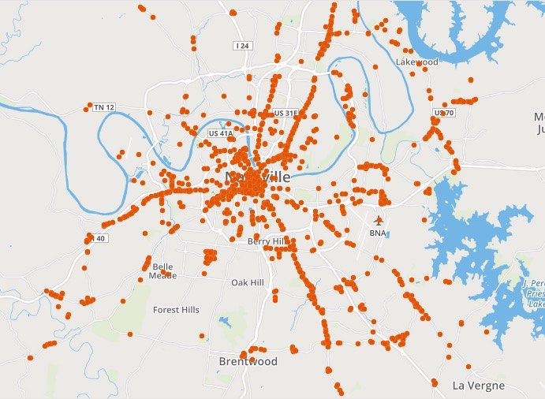
  + 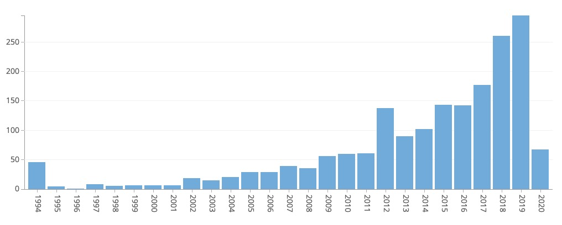
  + 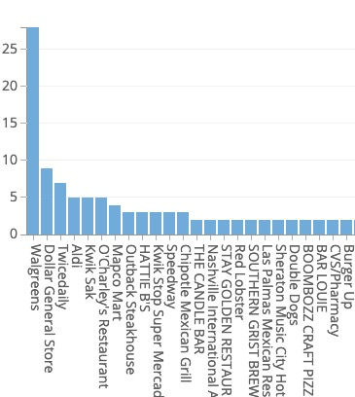
* A sketch of the final design
  + 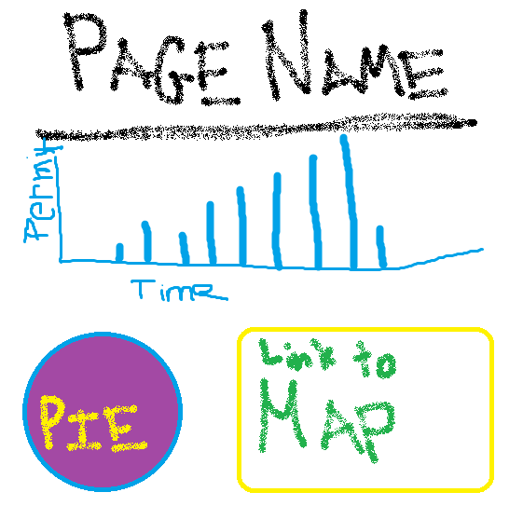
* A link to the primary GitHub repository you’ll be housing your work in
  + <https://github.com/ARMcK-hub/GeoHops>
* Roles & Responsibilities
  + Html/presentation- Karsten
  + API handling - Jon
  + Visualization styling / creation - Nick, Drew/Jon